# Visvesvaraya Technological University, Belagavi - 590018



**DBMS MINI PROJECT REPORT**

## ON

**“Handmade Product Management System”**

***Submitted by***

## HARSHARAJ B 4JK20IS019

**KIRAN KUMAR. V 4JK20IS023**

## Under the guidance of

**Mrs. Sivapuram Jayasri Mrs. Archana Priyadarshini Rao (Asst Professor, Department of ISE) (Asst Professor, Department of ISE)**

## DEPARTMENT OF INFORMATION SCIENCE AND ENGINEERING

**A. J. INSTITUTE OF ENGINEERING AND TECHNOLOGY Kottara Chowki, Mangalore – 574006, Karnataka.**

**2022-2023**

## A.J. INSTITUTE OF ENGINEERING AND TECHNOLOGY

**(A unit of Laxmi Memorial Education Trust®) NH-66, Kottara Chowki, Mangaluru -575006**

## DEPARTMENT OF INFORMATION SCIENCE AND ENGINEERING



CERTIFICATE

*This is to certify that the Mini project entitled* ***“Handmade Product Management System”***

*is a bonafide work carried out by*

***HARSHARAJ B 4JK20IS019***

***KIRAN KUMAR. V 4JK20IS023***

*Students of fifth semester Bachelor of Engineering in Information Science and Engineering, and submitted as a part of the course in DBMS Laboratory with Mini Project during the academic year 2022-2023.*

**----------------------------------**

**----------------------------------**

**----------------------------------**

## Mrs. Sivapuram Jayasri Mrs. Archana Priyadarshini Rao Dr. Suresha D Project Guide Project Guide Head of the Department

**Name of the Examiners Signature with Date**

1. ……………………………………… 1. ………………………………………

2. ……………………………………… 2. ………………………………………

# ABSTRACT

India is a country in which millions of people possess traditional skills and knowledge of producing handicrafts goods. Indian Handicrafts industry is highly labour intensive & decentralized. It provides maximum employment opportunities after the agriculture sector. Despite being a major contributor towards the country’s economy the industry has not achieved as much recognition as it deserves. Artisans are solely dependent on middle-man for the selling of their products. This creates a one-dimensional approach which minimises the profit and fails to display the skills of proud artisans. Internet marketing can help solve the problem of artisans in an efficient manner. Online Handicrafts Store is an e-commerce portal for artisans and individual handicrafts makers to retail their products online. Artisans would benefit by maximizing their profit as this eliminates the need for a middle- man and they will also avail the benefits of a wider target audience. With the right approach, skilled products of individual artisans will be readily made available to people in need of it. Going through various existing platforms there was a common theme of capitalism i.e. scope for minimal profits. Sellers can register on the website and provide details of their various products. After confirmation of authenticity their products will be readily available on the portal. The portal can be divided into two parts i.e. the front end which will be available to the user & the backend where data will be processed and maintained. The robust portal will provide convenience of ordering skilled handicraft products at the convenience of a computer system connected to the internet. Artisans can register as sellers and fill out a form pertaining to relevant details. The data will be entered into the databases and will be visible on the portal. Artisans will be kept in loop so as to maintain the availability of products and reduce the problems of online shopping.

**ACKNOWLEDGEMENT**

We dedicate this page to acknowledge and thank those responsible for the shaping of the project. Without their guidance and help, the experience while constructing the dissertation would not have been so smooth and efficient.

We sincerely thank the **Management of A. J. INSTITUTE OF ENGINEERING AND TECHNOLOGY** a unit of LAXMI MEMORIAL EDUCATION TRUST for all their continuous support.

We are extremely thankful to our **Principal Dr. Shantharama Rai C,** for his support and encouragement. We owe our profound gratitude to **Dr. Suresha D, Head of the Department**, Information Science and Engineering, whose kind consent and guidance helped us to complete this work successfully.

We sincerely thank **Mrs. Sivapuram Jayasri and Mrs. Archana Priyadarshini Rao, Assistant Professor**, Information Science and Engineering, for their guidance and valuable suggestions which helped us to fulfill the experiments prescribed by the university.

We would like to thank all our Information Science and Engineering staff members who have always been with us extending their support, precious suggestions, guidance and encouragement through the project.

We also like to extend thanks to our friends and family members for their continuous support.

- Harsharaj B: 4JK20IS019

Kiran Kumar V: 4JK20IS023

**TABLE OF CONTENTS**

|  |  |  |
| --- | --- | --- |
| **Chapter No.** | **Title** | **Page No.** |
| 1 | **Introduction**……………………………………………… | 01 |
|  | 1.1 Problem Definition………………………………... | 01 |
|  | 1.2 Objectives & Scope of Project…………………….. | 01 |
| 2 | **Software Requirement Specification**…………………... | 02 |
|  | 2.1 Functional Requirements………………………….. | 02 |
|  | 2.2 Hardware Requirements…………………………… | 02 |
|  | 2.3 Software Requirements……………………………. | 02 |
| 3 | **System Design**……………………………………………. | 05 |
|  | 3.1 ER Model………………………………………...... | 05 |
|  | 3.2 Schema Diagram…………………………………... | 06 |
|  | 3.3 Tables Description………………………………… | 06 |
| 4 | **Implementation**………………………………………….. | 12 |
|  | 4.1 Details of the Language…………………………… | 12 |
| 5 | **Screenshots**………………………………………………. | 13 |
|  | 5.1 Screenshots of Table Created…………………........ | 13 |
|  | 5.2 Screenshots of Front End………………………….. | 17 |
| 6 | **Conclusion and Future Work**…………………………... | 27 |
|  | 6.1 Conclusion……………………………………........ | 27 |
|  | 6.2 Future Work……………………………………….. | 24 |
| 7 | **References**………………………………………………... | 28 |

**LIST OF FIGURES**

|  |  |  |
| --- | --- | --- |
| **Figure No.** | **Title** | **Page No.** |
| Fig 3.1 | ER diagram For Handmade Products Management System | 05 |
| Fig 3.2 | Schema diagram For Handmade Product Management System | 06 |
| Fig 5.1.1 | Handmade Product Management System Database Table | 13 |
| Fig 5.1.2 | Category Table | 14 |
| Fig 5.1.3 | Customer Table | 14 |
| Fig 5.1.4 | Order Table | 14 |
| Fig 5.1.5 | Product Table | 15 |
| Fig 5.1.6 | Promo Table | 15 |
| Fig 5.1.7 | Setting Table | 15 |
| Fig 5.1.8 | Summary Table | 16 |
| Fig 5.1.9 | User Account Table | 16 |
| Fig 5.1.10 | Wishlist Table | 16 |
| Fig 5.2.1 | Admin Login Page | 17 |
| Fig 5.2.2 | Add New Product Page | 17 |
| Fig 5.2.3 | List Of Product Page | 18 |
| Fig 5.2.4 | Orders Page | 18 |
| Fig 5.2.5 | Add New Category Page | 19 |
| Fig 5.2.6 | Category Page | 19 |
| Fig 5.2.7 | Settings Page | 20 |
| Fig 5.2.8 | Users Page | 20 |
| Fig 5.2.9 | List Of Users Page | 21 |

|  |  |  |
| --- | --- | --- |
| Fig 5.2.10 | Report Page | 21 |
| Fig 5.2.11 | Website Front View Page | 22 |
| Fig 5.2.12 | Contact Us Page | 23 |
| Fig 5.2.13 | Customer Login Page | 23 |
| Fig 5.2.14 | Customer Sign Up Page | 24 |
| Fig 5.2.15 | Cart Page | 24 |
| Fig 5.2.16 | Wishlist Page | 25 |
| Fig 5.2.17 | Update Account Page | 25 |
| Fig 5.2.18 | Order Summary Page | 26 |
| Fig 5.2.19 | Order Information Page | 26 |

# LIST OF TABLES

|  |  |  |
| --- | --- | --- |
| **Table No.** | **Title** | **Page No.** |
| Table 3.3.1 | Customer | 07 |
| Table 3.3.2 | Order | 08 |
| Table 3.3.3 | Product | 08 |
| Table 3.3.4 | Summary | 09 |
| Table 3.3.5 | Wishlist | 09 |
| Table 3.3.6 | Setting | 10 |
| Table 3.3.7 | Promo | 10 |
| Table 3.3.8 | Category | 10 |
| Table 3.3.9 | User Account | 11 |

**CHAPTER 1**

# INTRODUCTION

Online Handicrafts Store is a web-based portal designed keeping in mind the dedication and hardwork of individual artisans and craftsmen. Aim is to incorporate modern technology to provide artisans with a platform to showcase their skills of crafts and cater to a wider range of audience. This approach reduces the cost of acquiring a middle-man and also provides an opportunity for a greater profit margin for the sellers. Sellers can directly register on the portal and showcase their skills to the world. The portal is a digital store where users can buy various products handcrafted by skilled artisans and individual manufacturers in accordance to their needs. The website is trendy and highly functional in accordance with the needs of a modern consumer. The administrator owns the right over the data displayed on the portal. Artisans register as sellers and send their products info to the administrator who manages the data at the backend.

## Problem Definition

Most skilled craftsmen lack a platform to sell their products and showcase their skill. In order to make their product available to a larger audience, local artisans rely on a middleman which further reduces their margin of profit. Further problems include the authenticity of a design or a product since it is not being registered. Lack of publicity automatically yields low demand. Low quality makers are trumping skilled craftsmen due their vastly superior presence in the market. An online web application for selling handicrafts online can be used to tackle these problems.

## Objectives & Scope of Project

Scope of this project directly revolves around welfare of individual artisans.

Few of them are :-

* + - This can be used by and for various individual artisans throughout the country.
    - Can be used anywhere any time as it is a web based application (user Location doesn’t matter).

**CHAPTER 2**

# SOFTWARE REQUIREMENT SPECIFICATION

Software requirement specification specifies the requirements required to run the given web application.

The detailed explanation is given below.

## Functional Requirement

The functional requirements are those requirements which are necessary to the eye of the user and the client. Here we try to make the module possible to accomplish the need of the desired function.

## Hardware Requirement Specification

* + - PROCESSOR: intel® Core™ i3-7100U
    - SPEED: 2.10 GB
    - RAM: 2.0 GB minimum
    - SPACE ON DISK: 15 GB minimum

## Software Requirement Specification

* + - XAMPP
    - VS code editor
    - SUBLIME
    - Programming Languages: PHP, SQL, CSS, JS.

## XAMPP

XAMPP is a free and open source cross-platform web server solution stack package developed by Apache Friends, consisting mainly of the Apache HTTP Server, Maria DB database, and interpreters for scripts written in the PHP and Perl programming languages. XAMPP stands for Cross-Platform (X), Apache (A), Maria DB (M), PHP (P) and Perl (P). It is a simple, lightweight Apache distribution that makes it extremely easy for developers

to create a local web server for testing and deployment purposes. Everything needed to set up a web server –   
server application (Apache), database (Maria DB), and scripting language (PHP) - is included in an extractable file. XAMPP is also cross-platform, which means it works equally well on Linux, Mac and Windows. Since most actual web server deployments use the same components as XAMPP, it makes transitioning from a local test server to a live server extremely easy as well.

## VISUAL STUDIO CODE

Visual Studio Code is a source-code editor made by Microsoft for Windows, Linux and mac OS. Features include support for debugging, syntax highlighting, intelligent code completion, snippets, code refactoring, and embedded Git. Users can change the theme, keyboard shortcuts, preferences, and install extensions that add additional functionality. Visual Studio Code includes multiple extensions for FTP, allowing the software to be used as a free alternative for web development. Code can be synced between the editor and the server, without downloading any extra software.

## SUBLIME

Sublime Text editor is used as an Integrated Development Editor (IDE) like Visual Studio code and NetBeans. The current version of Sublime Text editor is 3.0 and is compatible with various operating systems like Windows, Linux and MacOS. Users can customize it with themes and expand its functionality with plugins, typically community-built and maintained under free-software licenses. To facilitate plugins, Sublime Text features a web development. The editor utilizes minimal interface and contains features for programmers including configurable syntax highlighting, code folding, search-and- replace supporting regular-expressions, terminal output window, and more. It is proprietary software, but a free evaluation version is available.

## PHP

PHP is an acronym for "PHP: Hypertext Preprocessor". It is a widely-used, open source scripting language. PHP scripts are executed on the server and is free to download and use. It is powerful enough to be at the core of the biggest blogging system on the web (WordPress)!. It is deep enough to run large social networks! And is also easy enough to be a beginner's first server side language PHP performs system functions, i.e. from files on a system it can create, open, read, write, and close them. PHP can handle forms, i.e. gather data from files, save data to a file, through email you can send data, return data to the user. You add, delete, modify elements within your database through PHP. Access cookies variables and set cookies.

Using PHP, you can restrict users to access some pages of your website and it can encrypt data.

## SQL

SQL (Structured Query Language) is a standardized programming language that's used to manage relational databases and perform various operations on the data in them. SQL offers two main advantages over older read–write APIs such as ISAM or VSAM. Firstly, it introduced the concept of accessing many records with one single command. Secondly, it eliminates the need to specify how to reach a record, e.g. with or without an index. Originally based upon relational algebra and tuple relational calculus, SQL consists of many types of statements, which may be informally classed as sublanguages, commonly: a data query language (DQL), a data definition language (DDL), a data control language (DCL), and a data manipulation language (DML). The scope of SQL includes data query, data manipulation (insert, update, and delete), data definition (schema creation and modification), and data access control. Although SQL is essentially a declarative language (4GL), it also includes procedural elements. SQL implementations are incompatible between vendors and do not necessarily completely follow standards. In particular, date and time syntax, string concatenation and comparison case sensitivity vary from vendor to vendor. PostgreSQL and Mimer SQL strive for standards compliance, though PostgreSQL does not adhere to the standard in all cases. For example, the folding of unquoted names to lower case in PostgreSQL is incompatible with the SQL standard, which says that unquoted names should be folded to upper case.

**CHAPTER 3**

# 

# SYSTEM DESIGN

Software design is the process by which an agent creates specification of software artifact, intended to accomplish goals, using the set of primitive components and subject to constraints.

## ER Model

An entity set is a group of similar entities and these entities can have attributes. An entity is a table or attribute of a table in database, so by showing relationship among tables and their attributes, ER diagram shows the complete logical structure of a database.

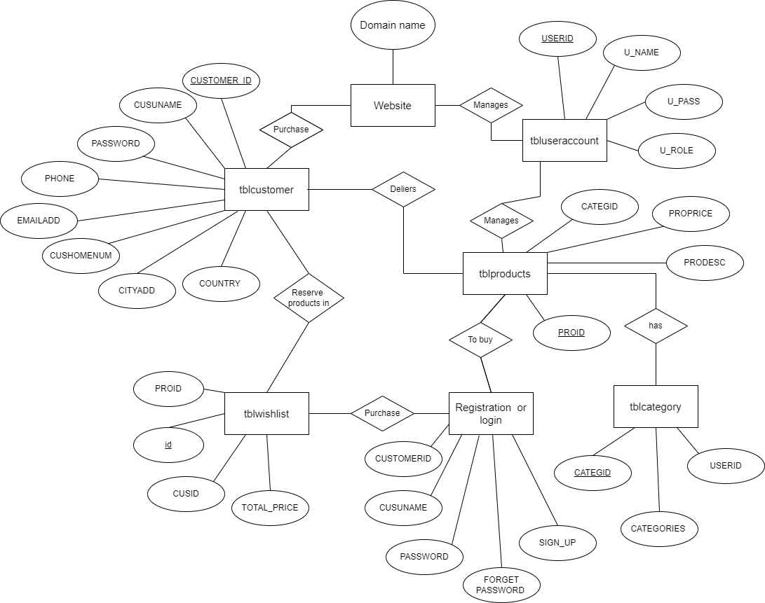

**Figure 3.1: ER Diagram for Handmade Product Management System**

## Schema Diagram

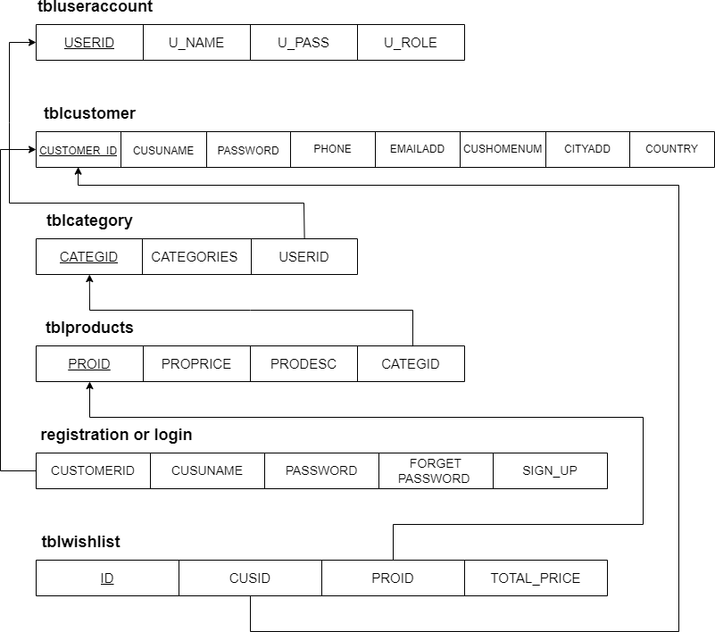

**Figure 3.2: Schema Diagram for Handmade Product Management System**

## TABLE DESCRIPTION

A table is a named original data base data set that is organized by rows and columns. The relational table

is a fundamental relational data base concept because tables are the primary form of a data storage. Columns form the table’s structure and rows form the content.

In table 3.3.1: CUSTOMERID, FNAME, LNAME, MNAME, CUSHOMENUM, STREETADD, BRGYADD, CITYADD, PROVINCE, COUNTRY, DBIRTH, GENDER, PHONE, EMAILADD, ZIPCODE, CUSUNAME, CUSPASS, CUSPHOTO, TERMS, DATEJOIN are

the attributes and CUSTOMERID is the primary key.

**Table 3.3.1: Customer**

|  |  |  |  |
| --- | --- | --- | --- |
| **ATTRIBUTE** | **DATA TYPE** | **CONSTRAINTS** | **DESCRIPTION** |
| CUSTOMERID | int | Primary key | Id given for Customer |
| FNAME | varchar |  | First Name |
| LNAME | varchar |  | Last Name |
| MNAME | varchar |  | Middle Name |
| CUSHOMENUM | varchar |  | Home Number |
| STREETADD | text |  | Street Address |
| BRGYADD | text |  | BRGY Address |
| CITYADD | text |  | City Address |
| PROVINCE | varchar |  | Province |
| COUNTRY | varchar |  | Country |
| DBIRTH | date |  | Date of Birth |
| GENDER | varchar |  | Gender |
| PHONE | varchar |  | Phone Number |
| EMAILADD | varchar |  | Email Address |
| ZIPCODE | int |  | Zip code |
| CUSUNAME | varchar |  | Customer User Name |
| CUSPASS | varchar |  | Customer Password |
| CUSPHOTO | int |  | Customer Photo |
| TERMS | varchar |  | Terms |
| DATEJOIN | varchar |  | Date of Join |

In table 3.3.2: ORDERID, PROID, ORDEREDQTY, ORDEREDPRICE, ORDEREDNUM,

UDERID are the attributes, ORDERID is the primary key and PROID, ORDEREDNUM UDERID are the foreign key.

**Table 3.3.2: Order**

|  |  |  |  |
| --- | --- | --- | --- |
| **ATTRIBUTE** | **DATA TYPE** | **CONSTRAINTS** | **DESCRIPTION** |
| ORDERID | int | Primary key | Order Id |
| PROID | int | Foreign key | Product Id |
| ORDEREDQTY | int |  | Ordered Quantity |
| ORDEREDPRICE | double |  | Ordered Price |
| ORDEREDNUM | int | Foreign key | Ordered Number |
| USERID | int | Foreign key | User Id |

In table 3.3.3: PROID, PRODESC, INGREDIENTS, PROQTY, ORIGINALPRICE, PROPRICE, CATEGID, IMAGES, PROSTATS, OWNERNAME, OWNERPHONE are the attributes,

PROID is the primary key and CATEGID is the foreign key.

**Table 3.3.3: Product**

|  |  |  |  |
| --- | --- | --- | --- |
| **ATTRIBUTE** | **DATA TYPE** | **CONSTRAINTS** | **DESCRIPTION** |
| PROID | int | Primary key | Product Id |
| PRODESC | varchar |  | Product Description |
| INGREDIENTS | varchar |  | Ingredients |
| PROQTY | int |  | Product Quantity |
| ORIGINALPRICE | double |  | Original Price |
| PROPRICE | double |  | Product Price |
| CATEGID | int | Foreign key | Category Id |
| IMAGES | Varchar |  | Images |
| PROSTATS | Varchar |  | Product Status |
| OWNERNAME | Varchar |  | Owner Name |
| OWNERPHONE | varchar |  | Owner Phone Number |

In table 3.3.4: SUMMARYID, ORDEREDDATE, CUSTOMERID, ORDEREDNUM, DELFEE, PAYMENT, PAYMENTMETHOD, ORDEREDSTATS, ORDEREDMARKS, CLAIMEDDATE,

HVIEW, USERIS are the attributes, SUMMARYID is the primary key and CUSTOMERID, ORDEREDNUM are the foreign key.

**Table 3.3.4: Summary**

|  |  |  |  |
| --- | --- | --- | --- |
| **ATTRIBUTE** | **DATA TYPE** | **CONSTRAINTS** | **DESCRIPTION** |
| SUMMARYID | int | Primary key | Summary Id |
| ORDEREDDATE | datetime |  | Ordered Date |
| CUSTOMERID | int | Foreign key | Customer Id |
| ORDEREDNUM | int | Foreign key | Ordered Number |
| DELFEE | double |  | Delivery Fees |
| PAYMENT | double |  | Payment |
| PAYMENTMETHOD | varchar |  | Payment Method |
| ORDEREDSTATS | varchar |  | Ordered Status |
| ORDEREDMARKS | varchar |  | Ordered Marks |
| CLAIMEDDATE | datetime |  | Claimed Date |
| HVIEW | tinyint |  | View |
| USERID | int |  | User Id |

In table 3.3.5: id, CUSID, PROID, WISHDATE, WISHSTATS are the attributes and id are the primary key.

**Table 3.3.5: Wishlist**

|  |  |  |  |
| --- | --- | --- | --- |
| **ATTRIBUTE** | **DATA TYPE** | **CONSTRAINTS** | **DESCRIPTION** |
| id | int | Primary key | Id |
| CUSID | int |  | Customer Id |
| PROID | int |  | Product Id |
| WISHDATE | date |  | Wishlist Date |
| WISHSTATS | text |  | Wishlist Status |

In table 3.3.6: SETTINGID, PLACE, BRGY, DELPRICE are the attributes and SETTINGID is the primary key.

**Table 3.3.6: Setting**

|  |  |  |  |
| --- | --- | --- | --- |
| **ATTRIBUTE** | **DATA TYPE** | **CONSTRAINTS** | **DESCRIPTION** |
| SETTINGID | int | Primary key | Setting Id |
| PLACE | text |  | Place |
| BRGY | varchar |  | BRGY |
| DELPRICE | double |  | Delivery Price |

In table 3.3.7: PROMOID, PROID, PRODISCOUNT, PRODISPRICE, PROBANNER,

PRONEW are the attributes, PROMOID is the primary key and PROID is the foreign key.

**Table 3.3.7: Promo**

|  |  |  |  |
| --- | --- | --- | --- |
| **ATTRIBUTE** | **DATA TYPE** | **CONSTRAINTS** | **DESCRIPTION** |
| PROMOID | int | Primary key | Promo Id |
| PROID | int | Foreign key | Product Id |
| PRODISCOUNT | double |  | Product Discount |
| PRODISPRICE | double |  | Product Discount Price |
| PROBANNER | tinyint |  | Product Banner |
| PRONEW | tinyint |  | New Product |

In table 3.3.8: CATEGID, CATEGORIES, USERID are the attributes and CATEGID is the primary key.

**Table 3.3.8: Category**

|  |  |  |  |
| --- | --- | --- | --- |
| **ATTRIBUTE** | **DATA TYPE** | **CONSTRAINTS** | **DESCRIPTION** |
| CATEGID | int | Primary key | Category Id |
| CATEGORIES | varchar |  | Categories |
| USERID | int |  | User Id |

In table 3.3.9: USERID, U_NAME, U_USERNAME, U_PASS, U_ROLE, USERIMAGE are

the attributes and USERID is the primary key.

**Table 3.3.9: User Account**

|  |  |  |  |
| --- | --- | --- | --- |
| **ATTRIBUTE** | **DATA TYPE** | **CONSTRAINTS** | **DESCRIPTION** |
| USERID | int | Primary key | User Id |
| U_NAME | varchar |  | Name of the User |
| U_USERNAME | varchar |  | Username |
| U_PASS | varchar |  | User Password |
| U_ROLE | varchar |  | User Role |
| USERIMAGE | varchar |  | User Image |

**CHAPTER 4**

# IMPLEMENTATION

Implementation is defined as specific set of activities designed to put into practice an activity or program of known dimensions. Implementation processes are purposeful and are described in sufficient details such that independent can detect the presence and strength of the specific set of activities related to implementation.

## Details of the Language

Our project is implemented using MySQL, CSS, JS, PHP. The reason we chose PHP because it has many advantages such as it is opensource, platform independent, application can easily be loaded which are based on PHP and connected to database.

## MySQL

Structured Query Language, commonly known as SQL, is a standard [programming language](https://www.thebalancecareers.com/what-does-a-computer-programmer-do-525996) for relational databases. Despite being older than many other types of code, it is the most widely implemented database language. Because SQL is so common, knowing it is valuable to anyone involved in computer programming or who uses databases to collect and organize information. Learn more about what SQL is and career opportunities in the field.

## CSS

CSS was first developed in 1997, as a way for Web developers to define the look and feel of their Web

pages. It was intended to allow developers to separate content from design so that HTML can perform more

of the function that it was originally based on the markup of content, without worry about the design.

## PHP

HP (recursive acronym for PHP: Hypertext Preprocessor) is a widely-used opensource general-purpose

scripting language that is especially suited for web development and can be embedded into HTML.

**CHAPTER 5**

**SCREENSHOTS**

The following screenshots includes database table structures and front-end view of a Handmade Product Management System. Database is used for Handmade Product Management System is XAMPP. The below tables used in Gym Evolution Management System database.

## Screenshots of Table Created

The following database mainly contains of 9 tables as shown in the figure namely tblcategory, tblcustomer, tblorder, tblproduct, tblpromopro, tblsetting, tblsetting, tblsummary, tbluseraccount, tblwishlist. The description of each table is shown below.

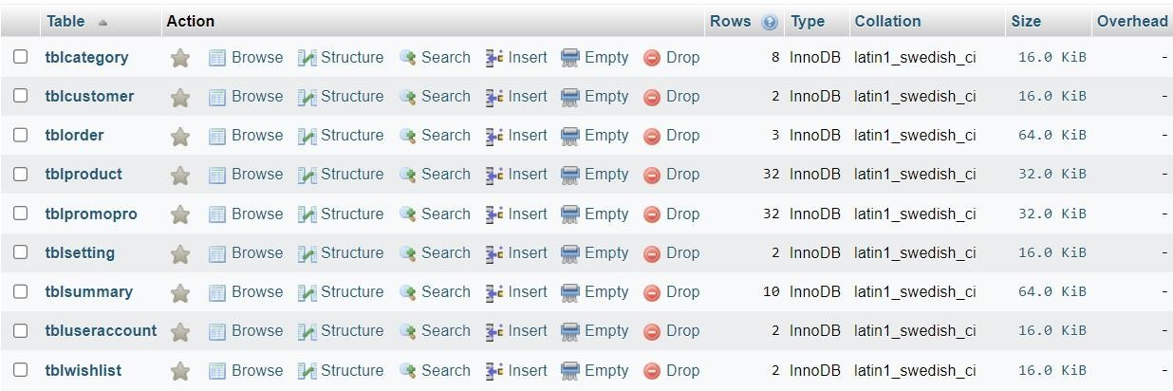

**Figure 5.1.1: Handmade Product Management System Database Table**

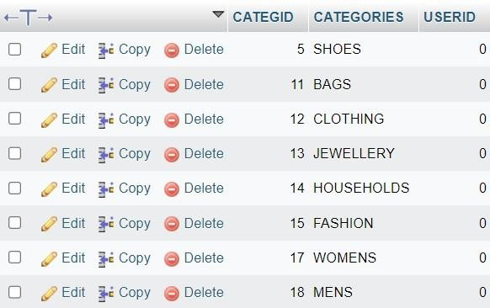

**Figure 5.1.2: Category Table**



**Figure 5.1.3: Customer Table**

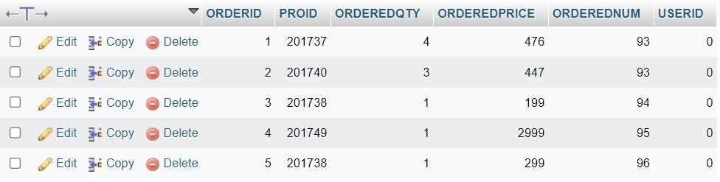

**Figure 5.1.4: Order Table**

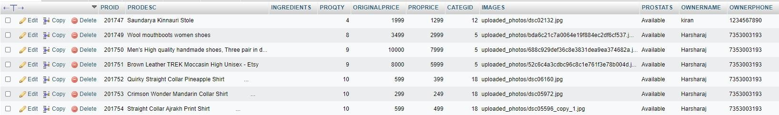

**Figure 5.1.5: Product Table**

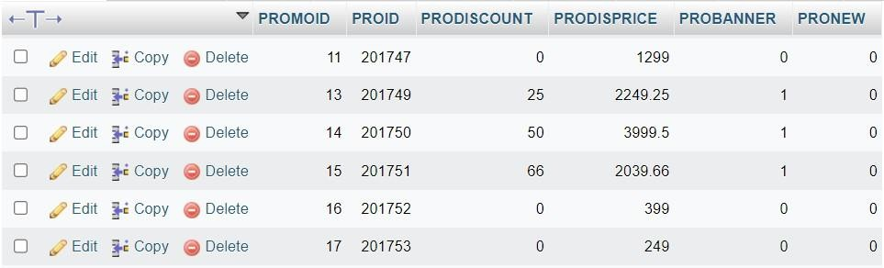

**Figure 5.1.6: Promo Table**

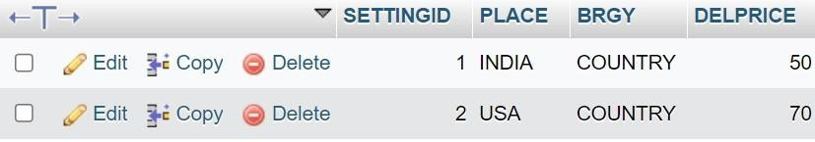

**Figure 5.1.7: Setting Table**

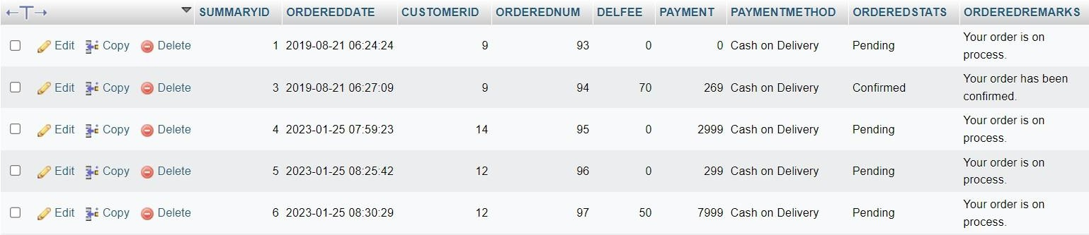

**Figure 5.1.8: Summary Table**



**Figure 5.1.9: User Account Table**

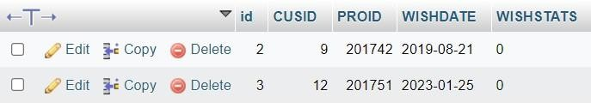

**Figure 5.1.10: Wishlist Table**

## Front-End Screenshots

This is the representation of how our front-end looks like when someone uses this project.

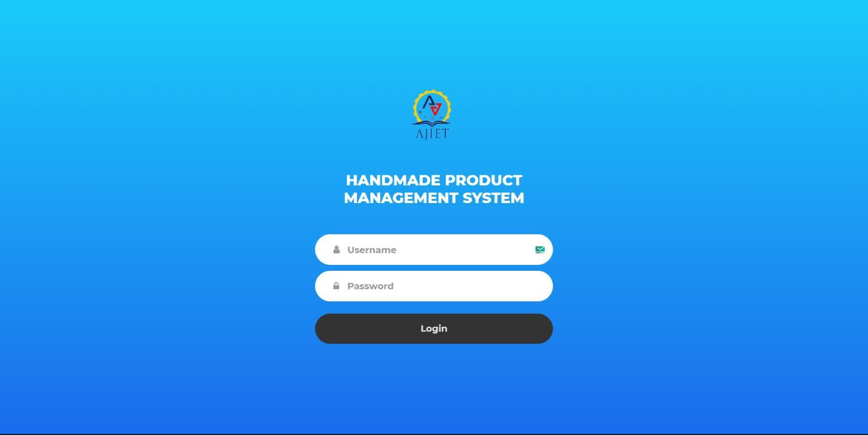

**Figure 5.2.1: Admin Login Page**

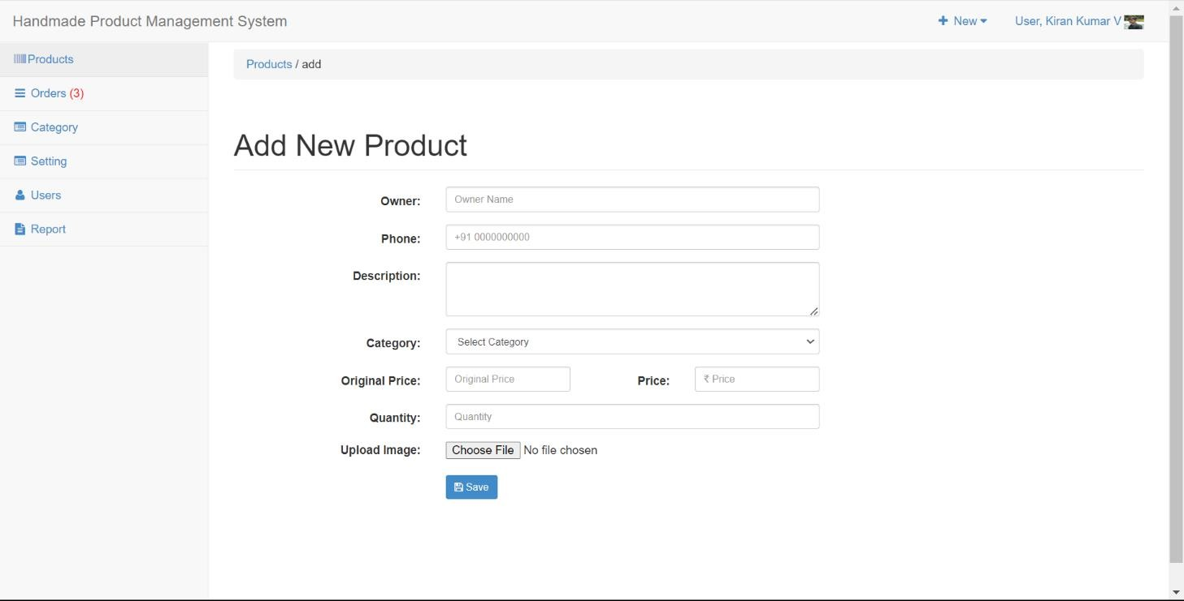

**Figure 5.2.2: Add New Products Page**

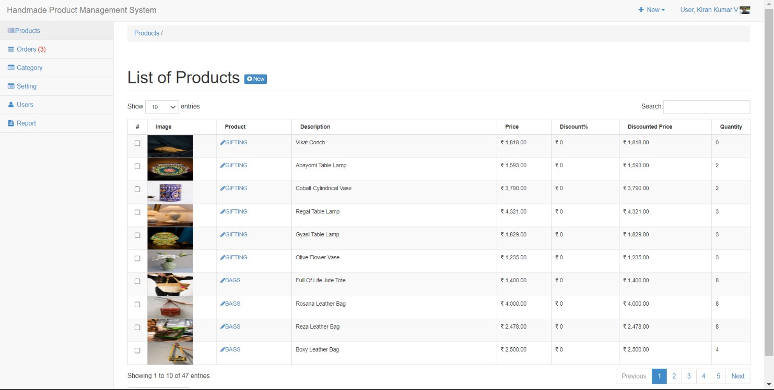

**Figure 5.2.3: List of Products Page**

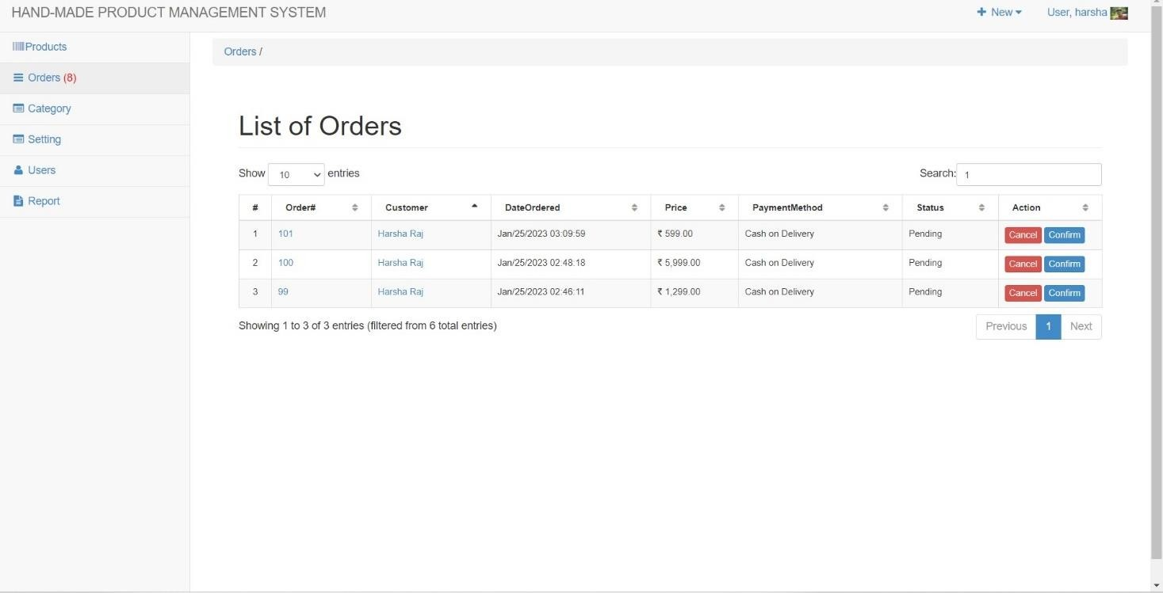

**Figure 5.2.4: Orders Page**

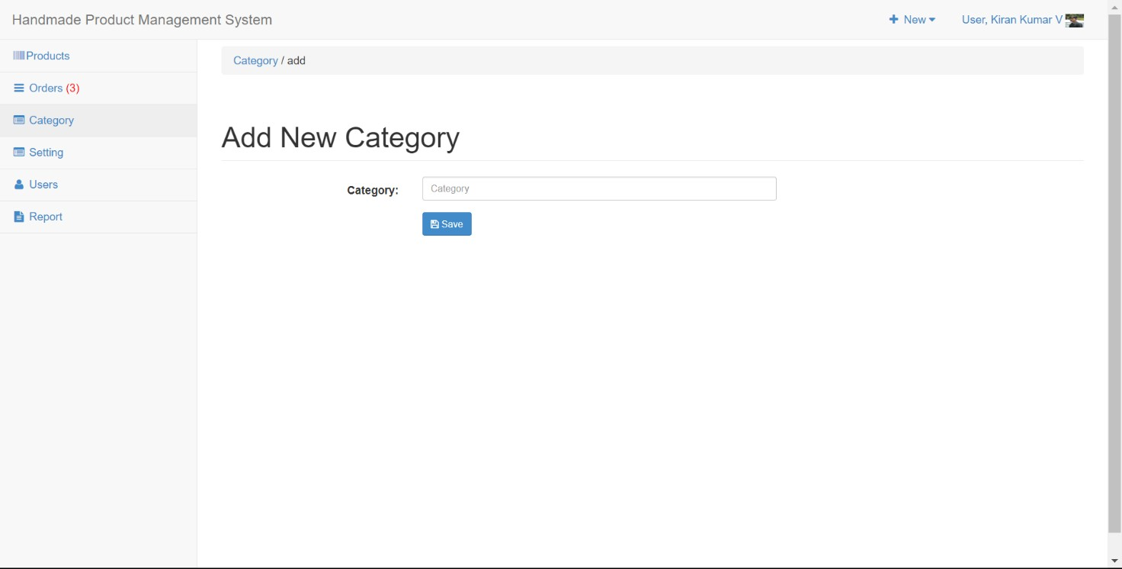

**Figure 5.2.5: Add New Category Page**

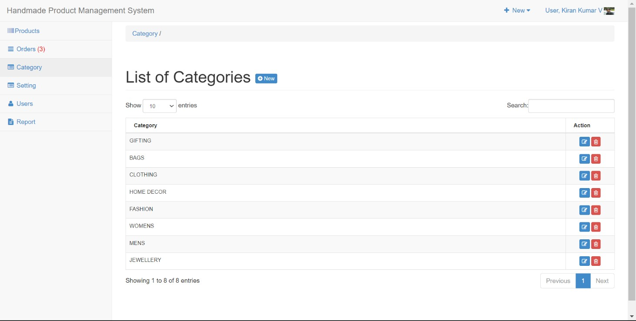

**Figure 5.2.6: Category Page**

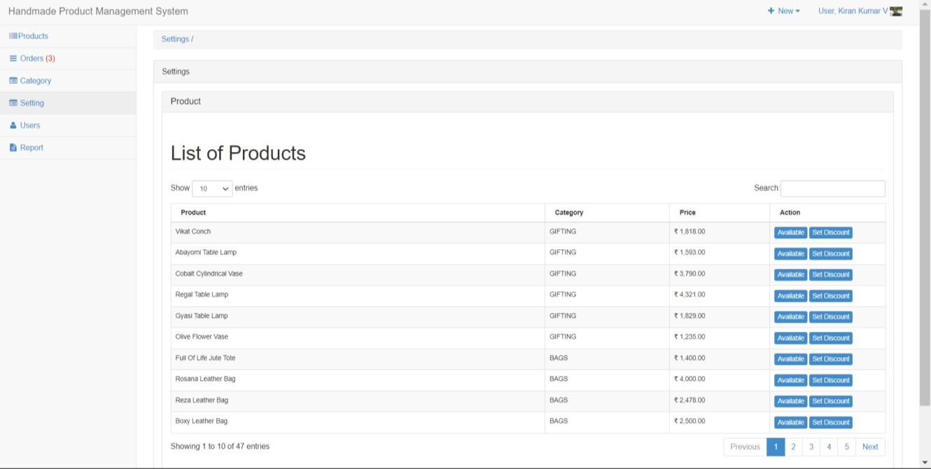

**Figure 5.2.7: Settings Page**

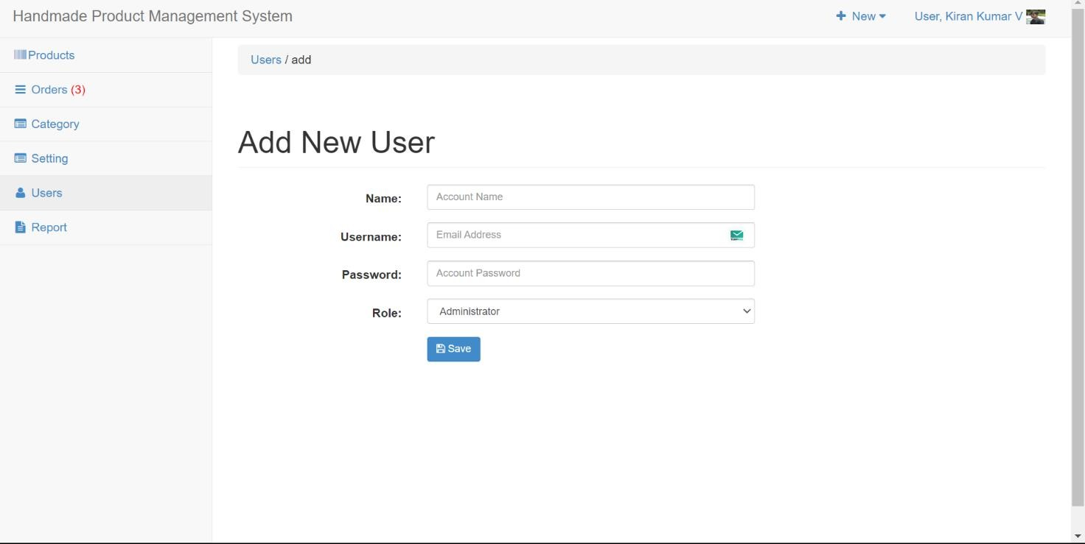

**Figure 5.2.8: Users Page**

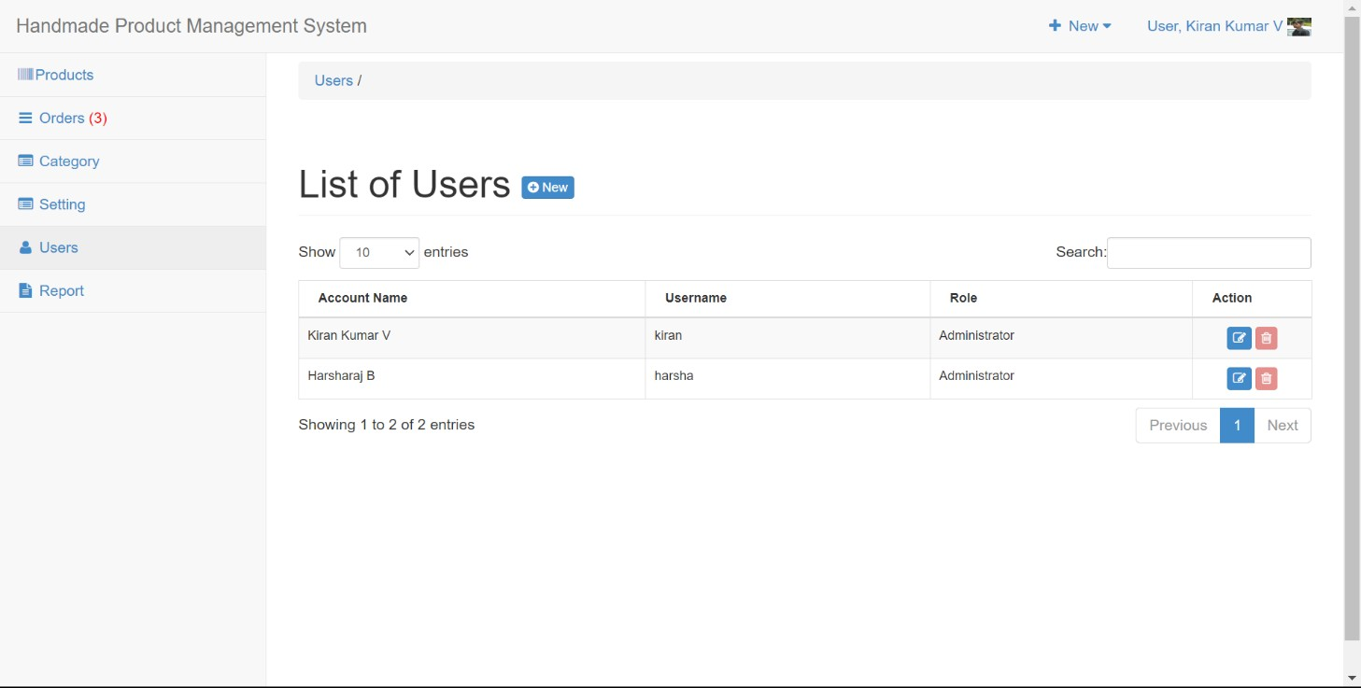

**Figure 5.2.9: List of Users Page**

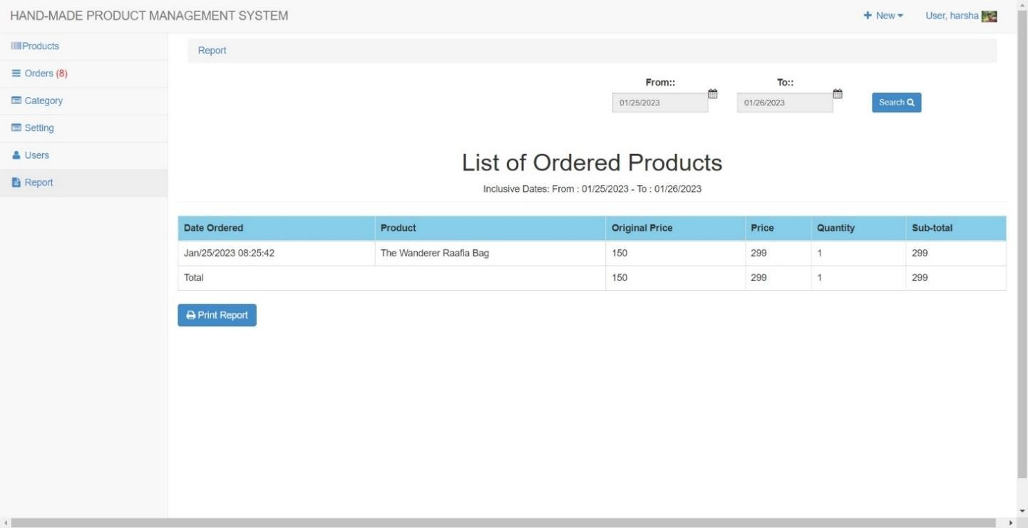

**Figure 5.2.10: Report Page**

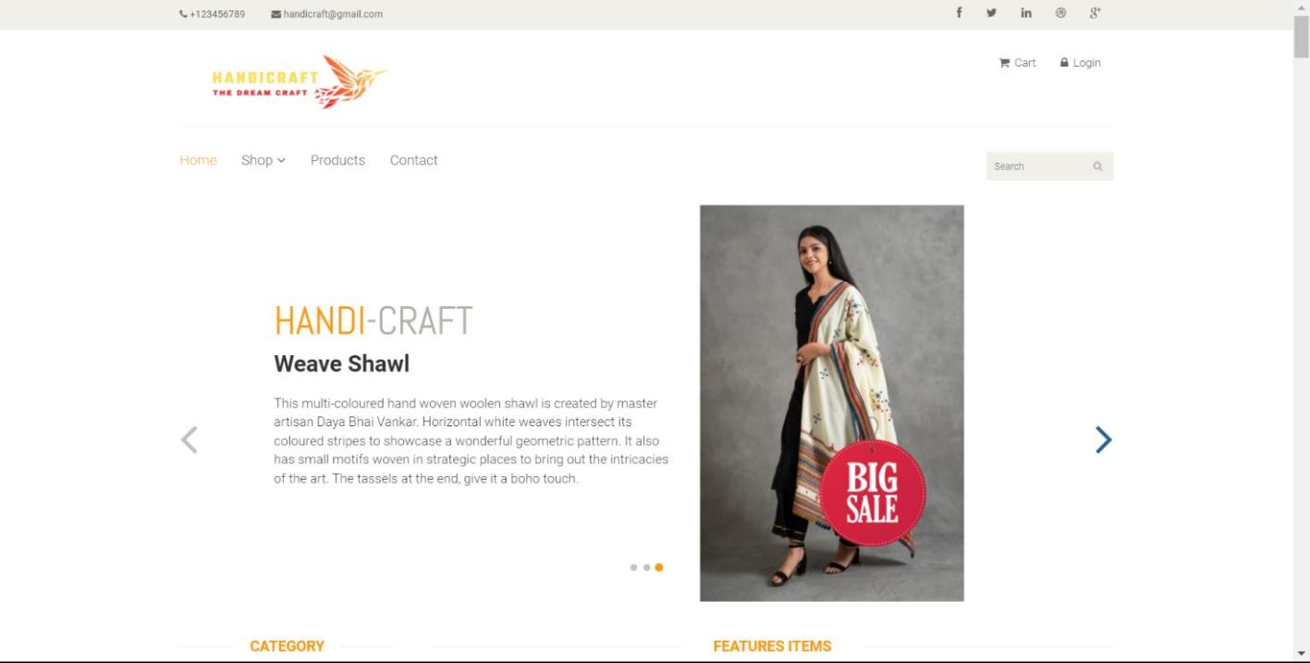

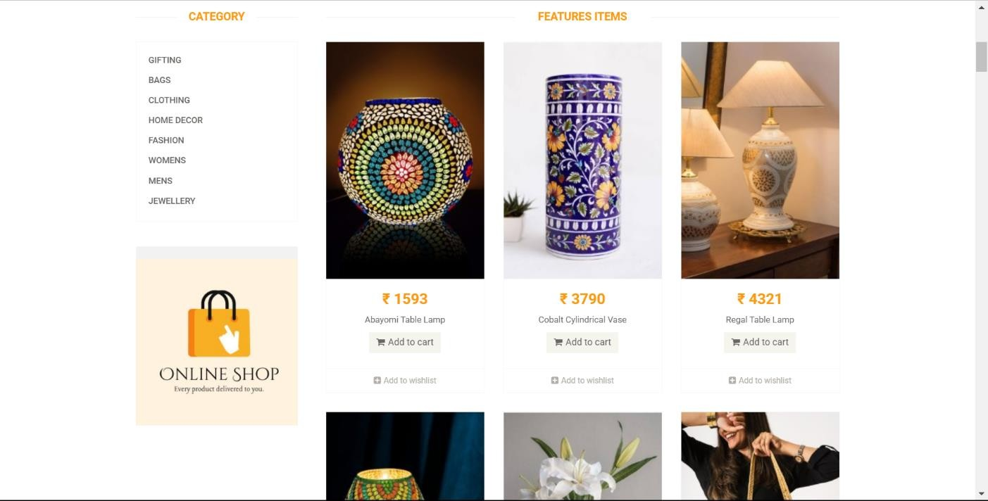

**Figure 5.2.11: Website Front View Page**

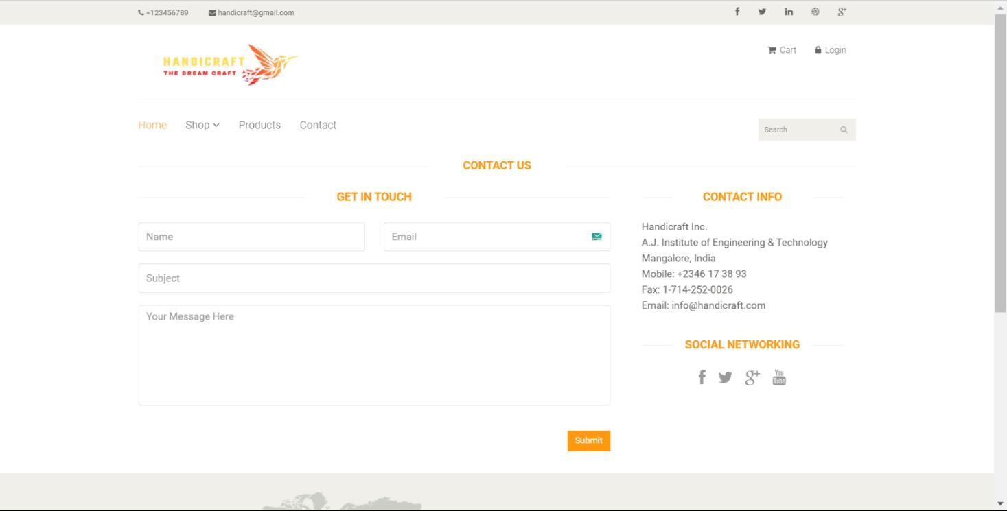

**Figure 5.2.12: Contact Us Page**

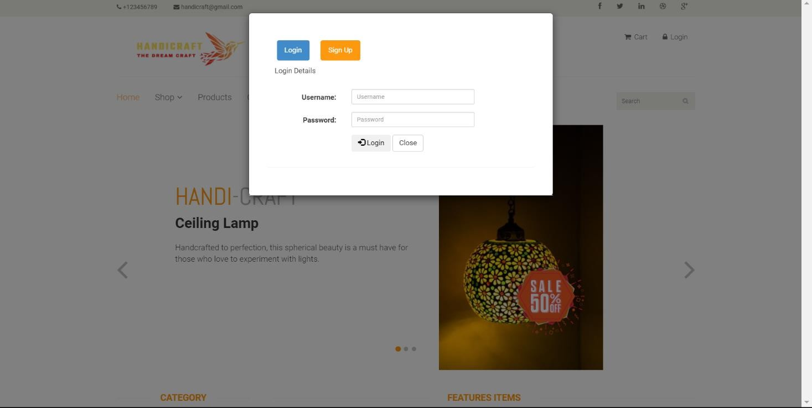

**Figure 5.2.13: Customer Login Page**

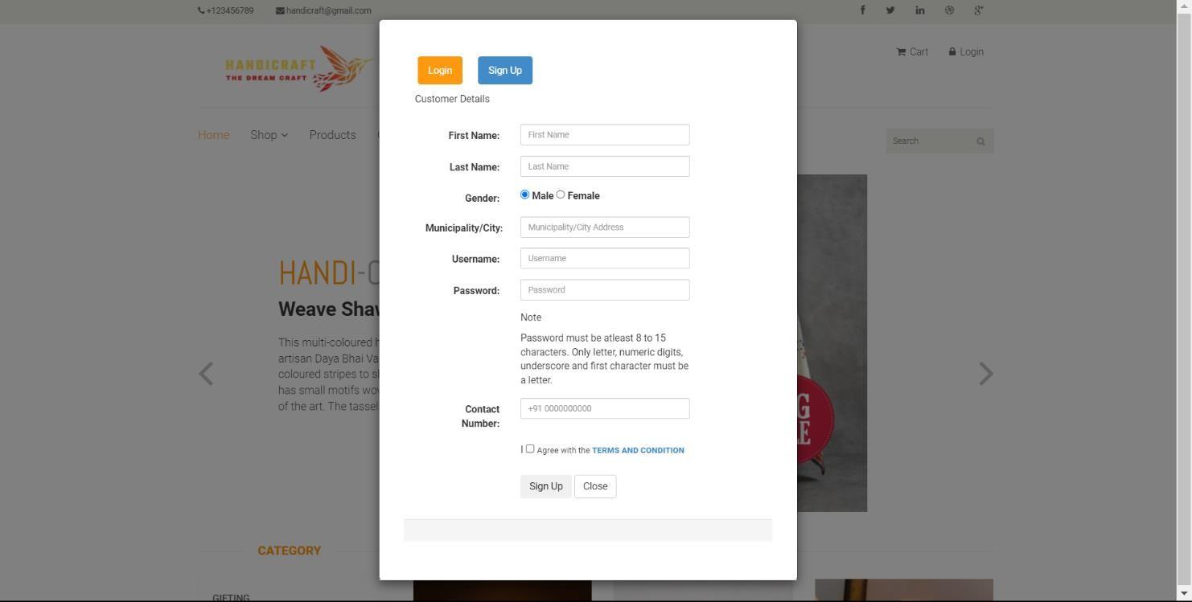

**Figure 5.2.14: Customer Sign Up Page**

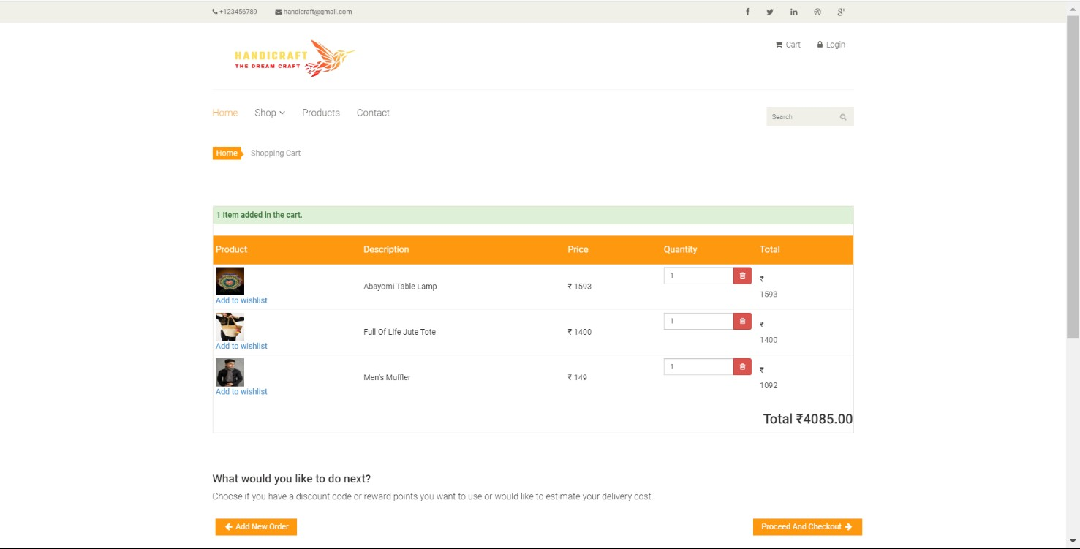

**Figure 5.2.15: Cart Page**

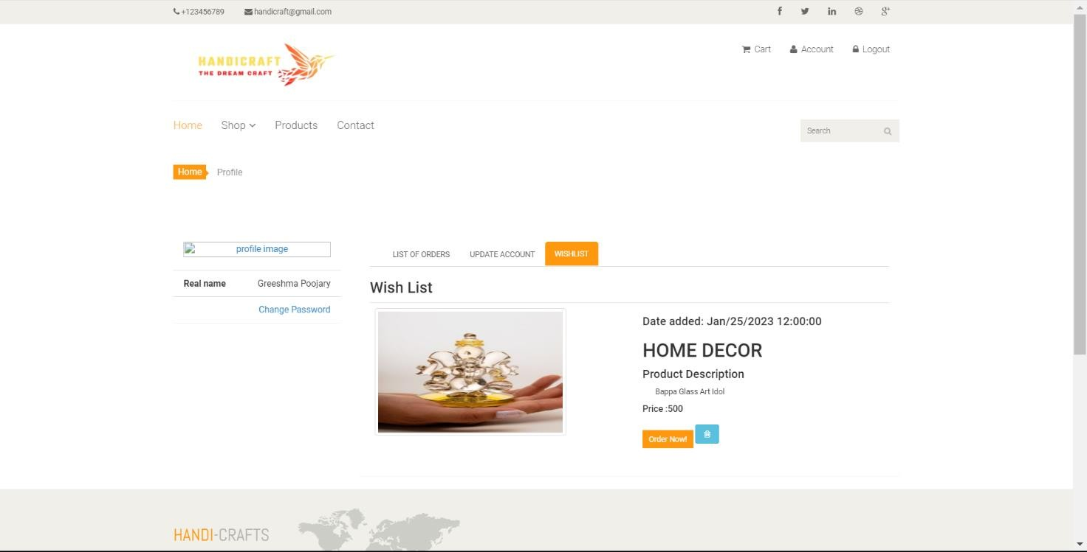

**Figure 5.2.16: Wishlist Page**

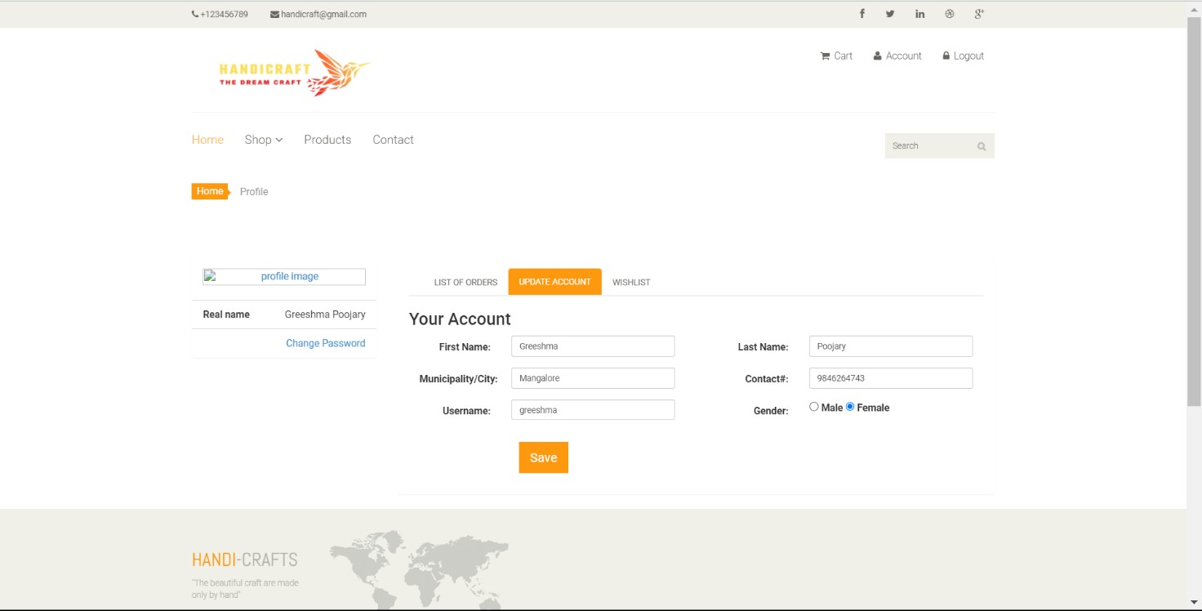

**Figure 5.2.17: Update Account Page**

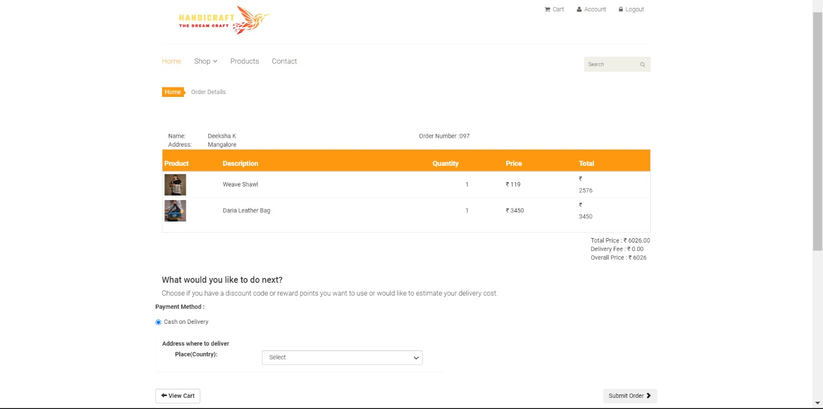

**Figure 5.2.18: Order Summary Page**

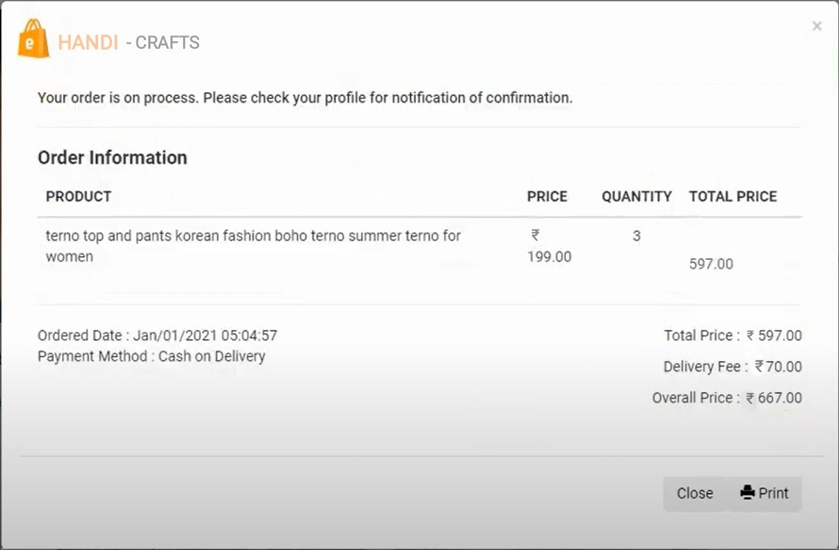

**Figure 5.2.19: Order Information Page**

**CHAPTER 6**

# CONCLUSION AND FUTURE WORK

## Conclusion

The following conclusions can be deduced from the development of the project:

* Online Handicrafts store will be an ease of access for everyone, i.e., customers as well as the artisans.
* Due to the pandemic, it is highly risky to go out for anything but with this e-commerce website people can admire and buy the fine work of the local craftsmen sitting at home.
* It will help the local craftsmen reach out to a wider audience who admire the real art. It will help them reach out to those people who respect the artwork but live far away and can’t travel to shop for them.

## Future Work

Online Shopping is largely about execution. But for anyone involved in the Online Shopping game, it is an environment that is constantly changing and upgrading as technologies improve and companies battle against each other to win a greater share of the pic. The future of Online Shopping is uncertain, but some things remain constant-delivery times will improve, customer service will get increasingly better, and product selection will become ever greater.

## Delivery Drones

Perhaps one of the most exciting developments in Online Shopping is to see drone delivery. Drones will in the future allow companies to deliver packages much more efficiently and quickly, with delivery times of just 60 or even 30 minutes from order entirely plausible. Drones will be sent out from distribution centers and travel directly to the delivery addresses provided, at significantly lower cost and logistical hassle than at present. Amazon, among others, are already seriously close to making this a reality across the entirety of their business, and it seems that others will be clambering to follow suit as quickly as possible.

# REFERENCES

1. Silberschatzkorth and Sudarshan, “Database System Concepts” 6th edition McGraw Hill, 2013.
2. Ramakrishnan and Gehrke, “Database Management Systems” 3rd Edition, 2014, McGraw Hill
3. <http://www.geeksforgeeks.org/php-tutorials/>
4. <https://www.tutorialspoint.com/>
5. <http://www.w3schools.com/Css/>
6. <http://www.javatpoint.com/>