**VISVESVARAYA TECHNOLOGICAL UNIVERSITY**

**BELAGAVI – 590018**



**PROJECT REPORT ON**

**“MY FURNITURE APP”**

**BACHELOR OF ENGINEERING**

**IN**

**INFORMATION SCIENCE & ENGINEERING**

**MOBILE APPLICATION DEVELOPMENT [18CSMP68]**

**Submitted by**

**Kiran Kumar V– 4JK20IS023**

**Kiran Shetty – 4JK20IS024**

**Under the guidance of**

|  |  |
| --- | --- |
| **Prof Navya S Rai**  **Assistant Professor**  **Department of Information Science & Engineering** | **Prof Rakesh M R**  **Assistant Professor**  **Department of Information Science & Engineering** |



**DEPARTMENT OF INFORMATION SCIENCE & ENGINEERING**

**A.J. INSTITUTE OF ENGINEERING & TECHNOLOGY**

**NH-66, KOTTARA CHOWKI, MANGALURU – 575006**

**2022 – 2023**

**A. J. INSTITUTE OF ENGINNERING & TECHNOLOGY**

NH – 66, Kottara Chowki, Mangaluru - 575006

A Unit of Laxmi Memorial Education Trust (R)

(Affiliated to Visvesvaraya Technological University, Belagavi & Approved by AICTE, New Delhi)

**DEPARTMENT OF INFORMATION SCIENCE AND ENGINEERING**



**CERTIFICATE**

Certify that the Project entitled **“MY FURNITURE APP”** is carried out by Mr**. KIRAN KUMAR V**, USN: **4JK20IS023**, and Mr. **KIRAN SHETTY**, USN: **4JK20IS024**, Student of sixth semester B.E. Information Science & Engineering, and submitted as a part of the course **MOBILE APPLICATION DEVELOPMENT [18CSMP68]** during the academic year 2022-2023.

It is certified that all corrections/suggestions indicated for Internal Assessment have been incorporated in the Report deposited in the departmental library. The report has been approved as it satisfies the academic requirements in respect of Mobile Application Development Project prescribed for the said Degree.

|  |  |  |
| --- | --- | --- |
| **Prof Navya S Rai**  **Project Guide** | **Prof Rakesh M R**  **Project Guide** | **Dr Suresha D**  **Head of the Department** |

**Dr Shantharama Rai C**

**Principal**

**Examiners Signature with Date**

**1.**

**2.**

# ACKNOWLEDGEMENT

First and foremost, we thank our parents for what we are and where we are today, without whose hard work and sacrifice we would not be here today.

We deem it a privilege to place on record the deep sense of gratitude to our Project Guide **Prof. Navya S Rai, Assistant Professor,** Department of Information Science and Engineering, and **Prof. Rakesh M R, Assistant Professor,** Department of Information Science and Engineering, who always stood behind us and supported in each step of the project work.

We are grateful to **Dr. Suresha D.,** Head of the Department, Information Science and Engineering for his support and encouragement.

We are indebted to our respected Principal **Dr. Shantharama Rai. C,** beloved Vice President **Mr. Prashanth Shetty** and the management of **A. J. Institute of Engineering and Technology, Mangaluru** for providing all the facilities that helped us in timely completion of this project report.

Finally, we would like to thank all the teaching and non-teaching staff of Department of Information Science and Engineering for their valuable help and support.

Kiran Kumar V 4JK20IS023

Kiran Shetty 4JK20IS024

# ABSTRACT

The furniture application offers a convenient platform for users to browse, select, and purchase furniture items. With a wide variety of options available, the user-friendly interface allows for easy navigation, detailed product information, and intuitive filtering. By simplifying the shopping process, our app aims to provide a seamless experience. Using augmented reality (AR) technology, users can visualize furniture pieces in their own spaces, making informed decisions about size and style. This interactive experience enhances the overall shopping process, enabling users to create their ideal environments. With secure payment gateways and multiple delivery options, our app ensures a streamlined purchasing process. Users can add items to their carts, make secure payments, and choose convenient delivery methods. Our objective is to provide a comprehensive and personalized furniture shopping solution that empowers users to easily create their desired living spaces. In conclusion, our furniture application revolutionizes the shopping experience by offering a user-friendly interface, augmented reality technology, and a streamlined process. With convenience, choice, and personalization, users can effortlessly find and purchase furniture items that align with their preferences, enabling them to create their ideal living spaces.

# TABLE OF CONTENTS

|  |  |  |
| --- | --- | --- |
| **Chapter No** | **Content** | **Page No** |
|  | **Acknowledgement** | i |
|  | **Abstract** | ii |
|  | **Table of Contents** | iii |
|  | **List of Figures** | iv |
| **1** | **INTRODUCTION** | **1-2** |
|  | 1.1 Problem Definition | 1 |
|  | 1.2 Objectives of the Project | 1 |
| **2** | **REQUIREMENT SPECIFICATION** | **3-6** |
|  | 2.1 Software Requirements | 3 |
|  | 2.2 Hardware Requirements | 3 |
|  | 2.3 Functional Requirements | 4 |
|  | 2.4 Mobile Requirements | 6 |
| **3** | **DESIGN OF THE APPLICATION** | **7** |
|  | 3.1 Data Flow Diagram | 7 |
| **4** | **IMPLEMENTATION** | **8-12** |
|  | 4.1 Programming Languages used | 8 |
|  | 4.2 Java Environment | 8 |
|  | 4.3 Java Media Framework | 9 |
|  | 4.4 About Android | 9 |
|  | 4.5 Android Architecture | 9 |
|  | 4.6 Linux Kernel | 10 |
|  | 4.7 Firebase | 11 |
| **5** | **RESULTS** | **13-19** |
| **6** | **CONCLUSION AND FUTURE WORK** | **20** |
|  | 6.1 Conclusion | 20 |
|  | 6.2 Future Work | 20 |
|  | **REFERENCE** |  |
|  |  |  |
|  |  |  |

# LIST OF FIGURES

**Figure No. Figure Name Page No.**  3.1 Data Flow Diagram 7

5.1 Splash Screen 13

5.2 Authentication Page 13

5.3 Registration Page 14

5.4 Login Page 14

5.5 Home Page 15

5.6 All Products 15

5.7 Menu 16

5.8 Profile 16

5.9 Category 17

5.10 Product Details 17

5.11 New Products 18

5.12 My Carts 18

5.13 My Orders 19

5.14 Order Details 19

***CHAPTER 1***

# INTRODUCTION

In today's digital era, the furniture retail industry has embraced the power of mobile applications to transform the way people shop for furniture. With the ubiquity of mobile devices and the internet, furniture applications have become a convenient and accessible solution for users seeking furniture options.

A furniture application offers a user-friendly platform that enables individuals to effortlessly browse, select, and purchase furniture items. By utilizing the capabilities of mobile technology, users can access a comprehensive catalog of furniture options at their fingertips, eliminating the need for physical store visits.

This application enhances the user experience by providing intuitive navigation, detailed product information, and personalized recommendations. Users can easily explore a wide range of furniture styles, materials, and price ranges, tailoring their search to their specific preferences and needs. Advanced technologies, such as augmented reality, further enrich the experience by allowing users to visualize how furniture pieces would look in their own living spaces.

In summary, the furniture application revolutionizes the furniture shopping experience by leveraging mobile technology. It offers convenience, an extensive selection of options, and personalized recommendations, empowering users to find the perfect furniture pieces for their homes. With a user-friendly interface and innovative features, the application brings the showroom directly to users' devices, making the process of creating their ideal living spaces seamless and enjoyable.

## 1.1 Problem definition

The furniture industry has experienced significant growth in recent years, with an increasing number of people seeking convenient ways to purchase furniture. However, finding the right furniture that matches personal preferences and fits within specific requirements can be a daunting task. This app addresses the challenges faced by furniture buyers by providing a user-friendly platform that allows them to browse, search, and purchase furniture conveniently.

## 1.2 Objectives of the project

The primary objectives of the My Furniture App project are as follows:

### 1.2.1 Provide a User-Friendly Interface:

The app aims to offer a user-friendly interface to enhance the overall user experience. This involves designing intuitive layouts, easy navigation, and a visually appealing presentation of furniture items. By prioritizing user-friendliness, the app seeks to make the furniture browsing and purchasing process seamless and enjoyable for users.

### 1.2.2 Showcase a Wide Range of Furniture:

The app intends to feature an extensive collection of furniture items to cater to diverse user preferences. By collaborating with various furniture suppliers and manufacturers, the app ensures that users have access to a wide range of furniture options, including different styles, materials, and price ranges. This objective contributes to creating a comprehensive platform that accommodates various customer needs.

### 1.2.3 Implement Advanced Search and Filtering:

Efficient search and filtering mechanisms are crucial for enhancing the user experience. The app incorporates advanced search functionalities, allowing users to search for furniture based on specific criteria such as category, style, price range, and material. By implementing these features, users can quickly find the furniture items that meet their requirements, saving time and effort.

### 1.2.4 Seamless Integration with Firebase:

Firebase, a mobile and web application development platform, is integrated into the app to enhance its functionality. Firebase offers several services such as real-time database, user authentication, and cloud storage, which are utilized to enable features like user login, secure storage of user data, and real-time updates on furniture availability. This objective aims to leverage Firebase's capabilities to deliver a robust and reliable app.

### 1.2.5 Streamlined Checkout Process:

To facilitate seamless transactions, the app focuses on optimizing the checkout process. This involves implementing a user-friendly and efficient checkout flow, ensuring a hassle-free experience for users when purchasing furniture items. By prioritizing a streamlined checkout process, the app aims to provide a convenient and satisfying end-to-end shopping experience.

***CHAPTER 2***

# REQUIREMENT SPECIFICATION

To create an Android app, certain software and hardware requirements must be met. Here are the fundamental software requirements for Android app development.

## 2.1 Software requirements

The software requirements for the My Furniture App include the following:

**2.1.1 Android Studio**

The app is developed using Android Studio, an integrated development environment (IDE) for Android application development. The latest stable version of Android Studio should be installed to ensure compatibility and access to the latest features and updates.

**2.1.2 Java**

Java programming language is utilized for developing the app's backend logic. It is important to have a compatible Java Development Kit (JDK) installed on the development machine to compile and run the Java code.

**2.1.3 XML**

XML (Extensible Markup Language) is used for defining the app's user interface and layouts. Understanding XML syntax and Android's XML conventions is crucial for creating the app's visual components.

**2.1.4 Firebase**

Firebase, a mobile and web application development platform, is integrated into the app. This requires setting up a Firebase project and configuring relevant Firebase services such as Realtime Database, Authentication, and Cloud Storage. It is important to have a valid Firebase account and project credentials.

## 2.2 Hardware requirements

The hardware requirements for developing and running the My Furniture App include the following:

1. Computer: A desktop or laptop computer capable of running Android Studio Operating System : Windows 7/8/10, macOS, or Linux.

2. Processor: Intel Core i5 or higher.

3. RAM: Minimum 8GB (16GB recommended).

4. Storage: Sufficient free disk space for Android Studio installation and project files.

5. Display: Minimum 1280x800 resolution.

**2.2.1 Development Machine:**

A computer with sufficient processing power, memory, and storage is required for smooth development. The machine should meet or exceed the minimum system requirements specified by Android Studio and Java Development Kit.

**2.2.2 Mobile Device:**

To test the app's functionality and user experience, a physical Android device or an Android emulator is needed. The device should meet the minimum Android version compatibility requirements specified by the app.

## 2.3 Functional requirements

The functional requirements describe the desired functionalities and features of the My Furniture App:

* ***User Registration and Authentication:***

Users should be able to create an account and log in securely. The application should authenticate user credentials to ensure secure access to user-specific features.

* ***Furniture Catalog:***

The application should have a comprehensive catalog of furniture items. Each item should be categorized and provide details such as name, description, dimensions, material, price, and availability.

* ***Search and Filtering:***

Users should be able to search for furniture items using keywords, categories, styles, price ranges, and other relevant filters. The application should provide accurate search results based on user queries.

* ***Product Details:***

Users should be able to view detailed information about each furniture item. The application should display multiple images, product specifications, customer reviews, ratings, and related items.

* ***Shopping Cart and Wishlist:***

Users should be able to add items to a shopping cart and manage its contents. The application should allow users to save items to a wishlist for future reference or purchase.

* ***Order Processing and Tracking:***

Users should receive order confirmation and updates on the status of their purchases. The application should provide order tracking functionality, allowing users to monitor the progress of their deliveries.

* ***Delivery and Shipping:***

The application should integrate with reliable shipping providers to ensure timely and efficient delivery of furniture items. Users should receive accurate shipping cost estimates based on their location and order details.

* ***Customer Reviews and Ratings:***

Users should be able to provide feedback, reviews, and ratings for purchased furniture items. The application should display customer reviews to assist other users in making informed decisions.

* ***Notifications:***

The application should send notifications to users regarding order updates, promotions, discounts, or any other relevant information.

* ***User Profile Management:***

Users should have the ability to create and manage their profiles. The application should allow users to update personal information, manage shipping addresses, and review past orders.

* ***Customer Support:***

The application should provide a communication channel (chat, email, or support tickets) for users to contact customer support with inquiries, issues, or returns.

* ***Language and Currency Localization:***

The application should support multiple languages and currencies to cater to a diverse user base. Users should have the option to select their preferred language and currency.

* ***Social Sharing:***

The application should integrate social media sharing capabilities, allowing users to share furniture items or their purchases on their preferred social platforms.

* ***Wishlist and Cart Synchronization:***

If users are logged in from multiple devices, the application should synchronize their wishlist and cart items across all devices for a seamless experience.

* ***User Feedback and Surveys:***

The application should provide a mechanism for users to provide feedback and

participate in surveys to improve the overall user experience and application features.

These functional requirements outline the key features and capabilities expected in a furniture application. Additional requirements specific to your application's unique goals and target audience can be added as needed.

## 2.4 Mobile requirements

The mobile requirements outline the specific needs related to the mobile platform:

* ***Platform Compatibility:*** The application should be compatible with both iOS and Android platforms, ensuring a wide reach to mobile users.
* ***Responsive Design:*** The application should have a responsive design that adapts to different screen sizes and orientations, providing a consistent user experience across various mobile devices.
* ***Intuitive Mobile Navigation:*** The user interface should be designed with mobile-specific navigation patterns, such as tab bars, hamburger menus, and swipe gestures, to ensure easy and intuitive navigation on smaller screens.
* ***Image Optimization:*** Furniture applications often rely on visual content. Therefore, it is crucial to optimize images and media assets for mobile devices to minimize load times and bandwidth usage.
* ***Mobile Payment Integration:*** The application should seamlessly integrate with popular mobile payment gateways, enabling users to make secure and convenient purchases directly from their mobile devices.
* ***Push Notifications:*** Implement push notification functionality to keep users informed about order updates, promotions, new furniture arrivals, or personalized recommendations, enhancing user engagement.
* ***Location-Based Services:*** Utilize the device's GPS capabilities to offer location-based services such as showing nearby furniture stores, providing directions, or offering location-specific discounts or promotions.

These mobile requirements address important aspects of platform compatibility, user experience, performance, and integration that are specific to mobile devices. They aim to optimize the application for mobile usage, provide a seamless experience, and leverage mobile features to enhance user engagement and convenience.

***CHAPTER 3***

# DESIGN OF THE APPLICATION

Design refers to the systematic process undertaken by an agent to develop specifications for a software artifact with the objective of achieving specific goals. This process involves utilizing a collection of basic components and adhering to certain limitations and restrictions. Design involves the application of diverse techniques and principles to define the structure and functionality of a device.

## 3.1 Data Flow Diagram

A data flow diagram is a visual representation illustrating the movement of data through a system or process.

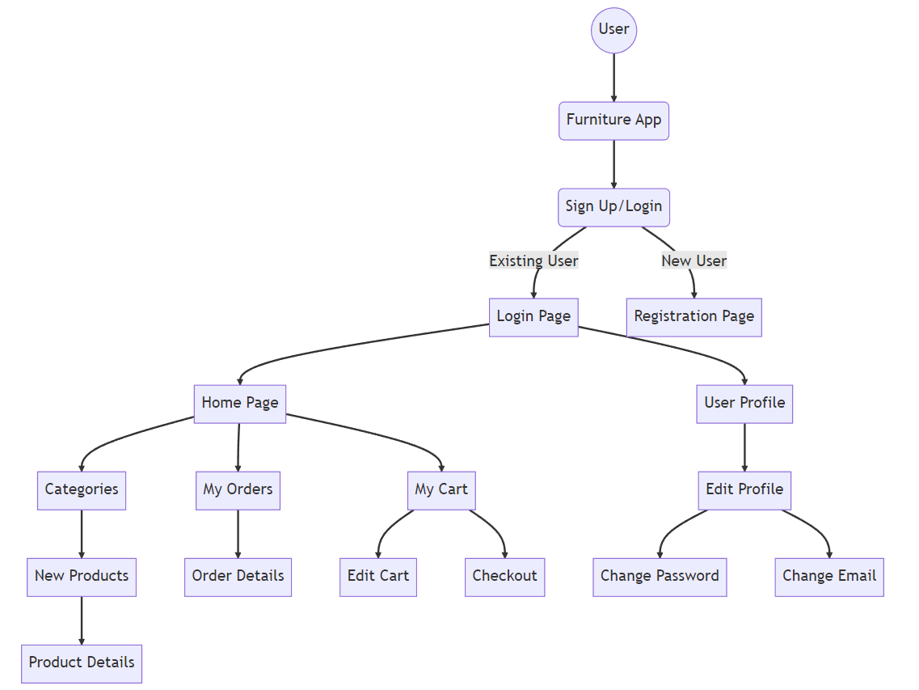

Figure 3.1:Data Flow Diagram

The data flow diagram visually illustrates the flow of information within the furniture app, showcasing the interactions between various components and highlighting the seamless data exchange process.

***CHAPTER 4***

# IMPLEMENTATION

Implementation refers to a precise collection of activities intended to execute a predefined program or activity with known parameters. These implementation processes are purposeful and described with sufficient detail, allowing independent observers to identify and evaluate the presence and effectiveness of the specific activities related to the implementation.

## 4.1 Programming languages used

The My Furniture App has been developed using primarily two programming languages: Java and XML.

***Java:*** Java is a widely used programming language for Android app development due to its platform independence, object-oriented nature, and rich ecosystem of libraries and frameworks.

***XML:*** XML (Extensible Markup Language) is used for designing the user interface layouts and storing configuration data.

Java provides a robust foundation for developing Android applications. It offers features such as memory management, exception handling, multithreading, and network connectivity. The object-oriented nature of Java enables modular and reusable code, making it easier to maintain and extend the application in the future.

## 4.2 Java Environment

The Java environment is essential for developing the My Furniture App, as it provides the necessary tools and frameworks for Android app development. The Java Development Kit (JDK) is required, which includes the Java compiler, runtime environment, and development tools. The app is developed using the latest Java version compatible with the Android platform.

Android Studio, the official integrated development environment (IDE) for Android, is used to write, test, and debug the code. It offers features like code completion, debugging tools, and an emulator for testing the app on different devices. Developers leverage the Java language's object-oriented programming (OOP) capabilities, allowing for modular and maintainable code development. Java's features such as classes, objects, inheritance, and polymorphism enable code reusability, encapsulation, and extensibility.

The Android Software Development Kit (SDK) complements the Java environment, providing APIs and frameworks specific to Android. It allows developers to interact with device features, user interface elements, and system functionalities. Java, along with Android Studio, supports testing and debugging, including unit testing with frameworks like JUnit.

With a vast developer community, Java provides resources, tutorials, and libraries for Android app development, aiding developers in enhancing productivity and accessing solutions. The Java environment, combined with Android Studio and the Android SDK, facilitates efficient development, testing, and deployment of the My Furniture App, resulting in a high-quality user experience.

## 4.3 Java Media Framework

The Java Media Framework (JMF) is utilized in the My Furniture App to handle media-related tasks. JMF provides an extensive set of APIs for capturing, playing, and manipulating audio and video content. With JMF, the app can support features such as image and video uploads, playback of product demonstration videos, and audio playback for tutorials or background music.

JMF simplifies media processing by providing high-level abstractions for media formats, codecs, and streaming protocols. It enables developers to create interactive and engaging media experiences within the app.

## 4.4 About Android

Android Studio is the official integrated development environment (IDE) for Android app development. Built on Jet Brains' IntelliJ IDEA software, it is specifically designed for Android development. Available for Windows, macOS, and Linux, it replaced Eclipse as the primary IDE for native Android app development. Android Studio was announced in May 2013 at the Google I/O conference and went through preview and beta stages before the stable version 1.0 was released in December 2014. It offers a wide range of features and tools to streamline the development process, including a layout editor, code analysis, debugging capabilities, and support for different Android versions and devices. Android Studio continues to evolve with regular updates and enhancements to support the latest Android platform developments.

## 4.5 Android Architecture

The architecture of the Android platform follows a layered structure, consisting of four main components: the Linux kernel, the libraries, the Android runtime, and the application framework. Understanding the Android architecture is essential for developing efficient and optimized applications.

* The Linux kernel forms the foundation of the Android operating system. It provides essential functionalities such as device drivers, memory management, and process management.
* The libraries consist of a wide range of pre-built modules that developers can leverage to enhance their applications. These libraries cover various domains, including graphics rendering, database management, networking, and security.
* The Android runtime includes the Dalvik Virtual Machine (DVM) or the newer Android Runtime (ART). These virtual machines execute the application's bytecode and manage memory and resources efficiently.
* The application framework provides high-level building blocks for creating Android applications. It includes components such as activities, services, content providers, and broadcast receivers, enabling developers to build interactive and responsive apps.

## 4.6 Linux Kernel

In addition to its foundational role, the Linux kernel in Android offers several key benefits that contribute to the overall stability, security, and performance of the operating system.

* **Device Drivers**: The Linux kernel provides a framework for device drivers, enabling efficient communication between the hardware and the operating system. This allows Android to support a wide range of devices, including smartphones, tablets, smart TVs, wearables, and IoT devices. The availability of device drivers in the Linux kernel ensures seamless integration with hardware components, maximizing device functionality and performance.
* **Memory Management**: The Linux kernel incorporates robust memory management mechanisms, including virtual memory, page caching, and process isolation. These features optimize memory allocation and utilization, enabling efficient multitasking and resource allocation within the Android system. The Linux kernel's memory management ensures that applications can run smoothly and reliably, even when multiple processes are simultaneously active.
* **Process Management**: The Linux kernel implements process management functionalities, such as process scheduling, inter-process communication, and process monitoring. These features ensure fair allocation of CPU resources, efficient communication between processes, and effective handling of system resources. The Linux kernel's process management capabilities contribute to the responsiveness and stability of the Android system, allowing for seamless multitasking and smooth app execution.
* **Security**: The Linux kernel incorporates robust security mechanisms that form a fundamental layer of protection for the Android platform. It enforces access control policies, isolates processes, and provides secure communication channels. Additionally, the Linux kernel leverages features like kernel-level sandboxing, secure boot, and file system permissions to protect against malicious activities, unauthorized access, and potential vulnerabilities. By utilizing the Linux kernel's security features, Android can maintain a secure environment for both user data and system integrity.
* **Performance Optimization**: The Linux kernel is designed to optimize performance by efficiently managing system resources. It includes various performance-oriented features such as dynamic CPU frequency scaling, I/O schedulers, and power management mechanisms. These features ensure optimal resource allocation, energy efficiency, and responsiveness, enhancing the overall performance of Android devices and extending battery life.
* **Community Support and Development**: The Linux kernel benefits from a large and active open-source community that constantly contributes to its development and improvement. This vibrant community ensures continuous updates, bug fixes, and enhancements to the Linux kernel, providing Android with a reliable and evolving foundation. The community-driven nature of the Linux kernel ensures that Android devices can benefit from the latest advancements and security patches, contributing to a more robust and up-to-date operating system.

In summary, the Linux kernel forms the core of the Android operating system, providing crucial functionalities such as device drivers, memory management, process management, and security. Its stability, compatibility, and extensive community support make it an ideal foundation for the Android platform, enabling a wide range of devices to run the operating system efficiently. The Linux kernel's contribution to hardware abstraction, resource optimization, and security ensures a consistent user experience and underpins the success of the Android ecosystem.

## 4.7 Firebase

Firebase, a backend-as-a-service platform developed by Google, offers several key services that empower developers to build modern applications. This report focuses on Firebase's authentication, realtime database, Firestore database, and storage services, highlighting their features and benefits for application development.

* **Authentication**: Firebase Authentication simplifies user authentication by providing ready-to-use authentication methods, including email/password, social media logins (such as Google, Facebook, Twitter), and phone number verification. This service handles user registration, login, and identity management, ensuring secure access to application resources. With Firebase Authentication, developers can effortlessly implement robust authentication systems, saving time and effort in building user management features.
* **Realtime Database**: Firebase's Realtime Database is a cloud-hosted NoSQL database that enables real-time data synchronization across connected clients. With its simple JSON-based data structure, developers can store and retrieve data in real-time, facilitating collaborative features like chat applications, collaborative editing tools, and live data updates. The Realtime Database provides automatic synchronization, ensuring that changes made by one client are instantly reflected across all connected clients. This real-time capability enhances user experience and enables seamless collaboration.
* **Firestore Database**: Firebase Firestore is a flexible, scalable, and serverless NoSQL document database that allows developers to store, query, and sync data for their applications. With Firestore, developers can organize data into collections and documents, making it easy to manage complex data structures. It offers powerful querying capabilities, enabling efficient retrieval of data based on filters and sorting. Firestore also supports real-time updates, offline data access, and automatic scaling, ensuring a seamless experience for users, even in offline or high-traffic scenarios.
* **Storage**: Firebase Storage provides a reliable and scalable cloud storage solution for user-generated content, such as images, videos, and files. It offers a simple API for uploading and downloading files, along with secure access controls to protect sensitive data. Firebase Storage seamlessly integrates with other Firebase services, allowing developers to associate stored files with specific users or application resources. This service ensures efficient storage and delivery of user-generated content, enhancing the overall application experience.

Firebase's authentication service simplifies user management and secures access to application resources. The realtime database facilitates real-time data synchronization, enabling collaborative features in applications. Firestore database offers scalability, flexibility, and powerful querying capabilities, while Firebase Storage provides reliable cloud storage for user-generated content. Together, these Firebase services empower developers to create modern applications with robust authentication, real-time updates, efficient data storage, and seamless user experiences. By leveraging these Firebase services, developers can focus on building engaging applications while relying on Firebase's reliable backend infrastructure.

***CHAPTER 5***

# RESULT

The result section of the report showcases the snapshots of my furniture app, providing a visual representation of its user interface and features. These snapshots offer a glimpse into the app's functionality, design, and overall user experience.

|  |  |
| --- | --- |
| Figure 5.1: Splash screen | Figure 5.2: Authentication Page |

In Figure 5.1, the splash screen of my furniture app is depicted, welcoming users with an attractive and engaging visual as they launch the application. This screen sets the tone for their experience and creates a positive first impression, enticing them to explore further and discover a world of stylish furniture options.

Figure 5.2 showcases the authentication page of the furniture app, providing a secure login process for users. This page ensures the privacy and protection of user accounts, reinforcing trust and reliability in the app's functionality while offering a seamless user experience. With intuitive design elements and clear instructions, users can easily access their personalized profiles and start exploring the app's features.

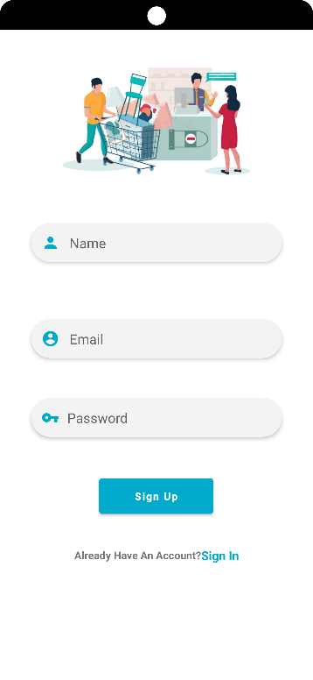Figure 5.3: Registration page

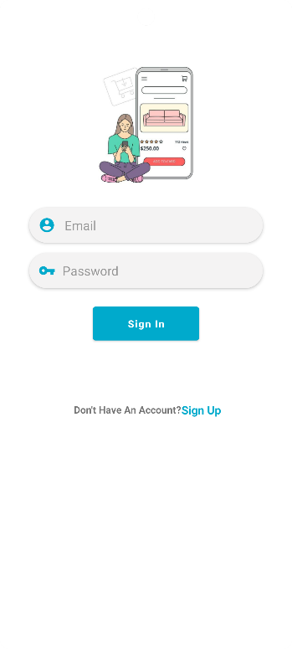The streamlined registration process makes it effortless for users to join and unlock exclusive features. The user-friendly registration page ensures a seamless onboarding experience for new shoppers.

Figure 5.4: Login page

The secure login gateway provides convenient access to personalized profiles and saved preferences. The hassle-free login page allows users to quickly resume their furniture browsing with ease.

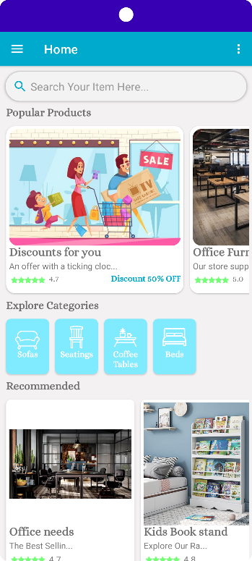Figure 5.5: Home page

The visually captivating hub features curated collections and personalized recommendations.

The intuitive home page design inspires users to explore trending furniture styles effortlessly.

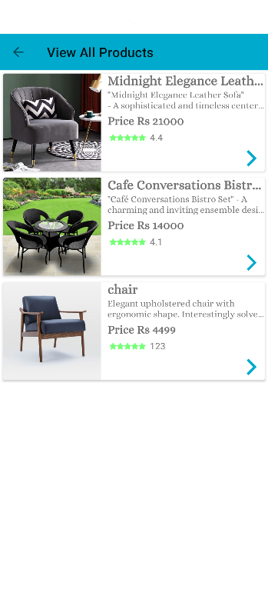Figure 5.6: All Products

User-friendly interface screens displaying a comprehensive collection of exquisite furniture items available for seamless browsing and selection within the furniture app.

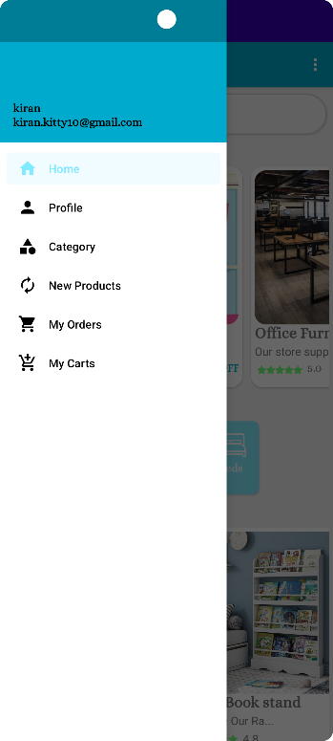Figure 5.7: Menu

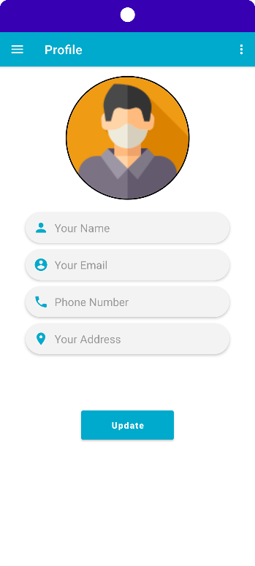The user-friendly menu simplifies navigation and provides easy access to different furniture sections. The comprehensive menu allows users to quickly find desired furniture categories and items.

Figure 5.8: Profile

The centralized profile section enables users to personalize their experience and manage saved items. The profile page offers tailored recommendations and tracks past orders for a satisfying shopping journey.

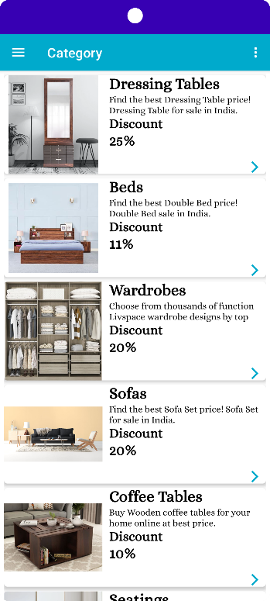Figure 5.9: Category

The organized category page makes it effortless to browse and explore different types of furniture. The diverse range of categories ensures users can easily find specific furniture pieces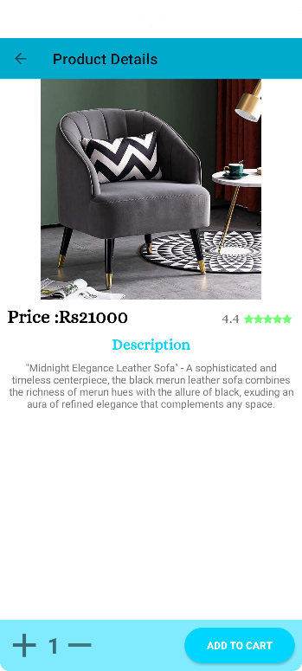

Figure 5.10: Product details

The informative product details page offers dimensions, materials, and high-resolution images.

Users can make informed decisions with comprehensive specifications and customer reviews.

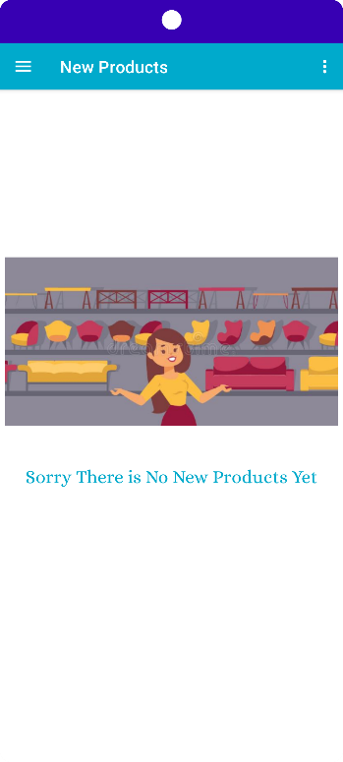Figure 5.11: New products

The section showcases the latest furniture arrivals, providing fresh inspiration and trending styles. Users can stay up-to-date and explore cutting-edge furniture pieces.

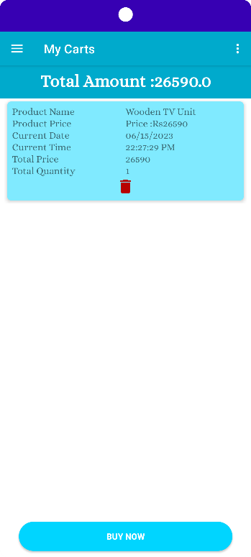

Figure 5.12: My carts

The organized "My Carts" page displays saved items for convenient access and modification.

Users can effortlessly manage their shopping carts and proceed to checkout seamlessly.

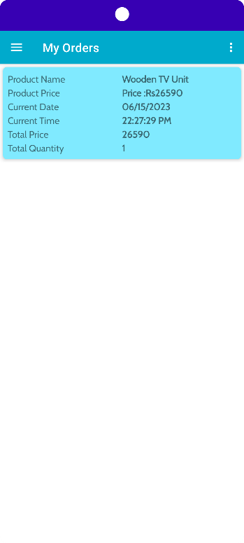Figure 5.13: My orders

The "My Orders" page offers easy access to past purchases, order details, and reorder options.

Users can track their orders in real-time, ensuring transparency and convenience.



Figure 5.14: Order details

The order details page provides a comprehensive summary of the placed order, confirming its successful submission and providing relevant information such as shipping details for users to track their furniture until it arrives.

***CHAPTER 6***

# CONCLUSION AND FUTURE WORK

## 6.1 Conclusion

In conclusion, the My Furniture App has been successfully implemented using Java, XML, and Firebase. The app addresses the problem of furniture management and provides users with a seamless and intuitive platform for browsing, purchasing, and managing furniture items.

The development process involved leveraging the Java programming language, the Android platform, and various libraries to create a feature-rich and visually appealing application. The utilization of Java Media Framework facilitated efficient handling of media-related tasks within the app.

## 6.2 Future scope

There are several avenues for future work on the My Furniture App. Some potential areas of improvement and expansion include:

* Integration of augmented reality (AR) technology to allow users to visualize furniture items in their own space before making a purchase.
* Implementation of personalized recommendations based on user preferences and browsing history.
* Enhancement of the user interface design to further improve usability and accessibility.
* Integration with additional payment gateways to provide users with more payment options.
* Expansion of the furniture catalogue by partnering with more suppliers and manufacturers.

By exploring these future possibilities, the My Furniture App can continue to evolve and provide an enhanced user experience, making it a leading choice for furniture enthusiasts and shoppers.

# REFERENCE

[1] R. Singh and S. Choudhury, "Android App Development Using Firebase and Google Cloud Services," Proc. IEEE International Conference on Electrical, Electronics, Signals, Communication and Optimization (EESCO), 2017.

[2] R. Rogers and J. Lombardo, "Learning Android," O'Reilly Media, 2013.

[3] D. Hunter, "Java and XML," 3rd Edition, O'Reilly Media, 2006.

[4] Firebase Documentation. URL: https://firebase.google.com/docs

[5] Android Developers Documentation. URL: https://developer.android.com/docs

[6] Stack Overflow. Retrieved from https://stackoverflow.com/

[7] Firebase YouTube Channel. Retrieved from https://www.youtube.com/user/Firebase