Seek and Geek

Clothes! We wear them all the time. But like many other aspects of human life, we overlook them and the innovation that took place to make it so. Sewing machines are a mechanical marvel, whether new and electronic or the old crank style sewing machine. I discovered how magnificent these were in a class last year. We had to think outside the box and employed a sewing machine.

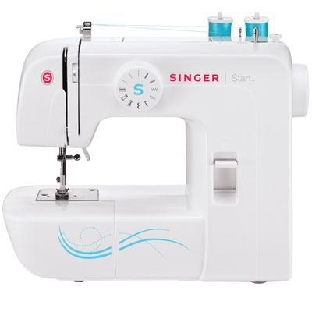Engineers can learn a lot about sewing machines because they are precision, high-durability products. Not only do they have to undergo the same motion over-and-over, but they need to do so rapidly and last a long time. They are also very cheap and affordable, a shining example of modern-day manufacturing.