White Paper

This year, the machine I will design is a desk. This desk should be able to transform between two positions: sitting position and standing position. I am designing this machine in order to improve upon my design skills, applying the new concepts I will learn through out the course of 2.70.

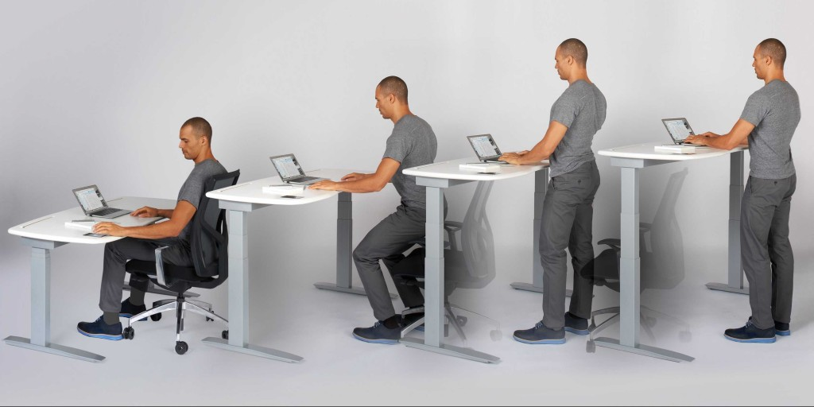

Example of the desk configurations. The desk I’m designing will go from the first configuration to the last configuration. It will be driven by stepper motors. Photo credit: <http://well9to5.com/wp-content/uploads/guy-adj-ht-standing-desk-1024x512.jpg>

The transformation would be activated by a switch and actuated by stepper motors. It will thus incorporate mechanical and electronic aspects. The desk should be fully functional, able to support the load of a laptop, and some books, without to much sway. It should transform slowly and go from about 3 ft. to 4-5 ft. It shouldn’t be too heavy, and most look stylish.