Preparation of configuration files:

1. Go to github and clone/download the following package.   
   <https://github.com/thekuchibhotlalab/process2p.git>
2. It contains analysis, behavior and preprocessing folder. (behavior folder is extra code that I have. Don’t bother) Add everything under preprocessing folder. Config, function and GUI folder are necessary, other files are copies of old code.
3. Make sure there is behavior, imaging and mouse folder under config folder. First, under mouse folder, add the information of the mouse to moustMaster.txt file. Add mouse name, name of imaging file (under imaging folder), behavioral configuration file (under behavior folder), and session configuration file (under mouse folder).
4. Create imaging configuration file based on the type of imaging you are doing. Use a new line to indicate new option keywords, use space to separate keywords (e.g. roiMethod) with values (e.g. axon,cell), using comma to separate multiple values. Multiple values are allowed in all channel, functional channel, roiType.
5. Create behavioral configuration file, which specifies the meaning of each column of behavior txt file from TDT. Right now it is not being used.
6. Create session configuration csv file in mouse folder. Refer to fzch001.csv as an example (cd016.csv etc. are old files). Should have imagingFile name, sbxpath, h5path, suite2ppath, dataPath, roiFile name, tcFile name and nFrames_oneplane. DataPath is the shared path the roiFile and tcFile. If roi and TC method are suite2p, just put blank or suite2p at the location. For multiple files (for multiple planes and channels), put space (not comma) between them. The order of the filename is (plane1chan1 plane2chan1 plane1chan2 plane2chan2). nFrames_oneplane is the number of frames of each plane of this file (separate by space). Currently func_createMouseConfig(mouse, h5path) automatically generate a template for excitatory project.

Preprocessing functions:

Only tuning curve is done at the current moment. This can be served as an example of how to interface the GUI with preprocessing functions. Tuning curve is revised and have a few new functions:

1. Figure 1 shows PSTH to each tone, figure 2 shows onset timing of tone-evoked activity. The peak of averaged tone-evoked activity is used for significance testing, which can be different for individual neurons.
2. Significance test is done by paired t-test(parametric)/sign-rank(non-parametric) test, and 1-way ANOVA (default). Paired tests compare peak tone-evoked activity of each trial to the immediate preceding frame before tone presentation. Tests are done for each tone separately, and default p value is set to 0.005. ANOVA compares 18 groups, including peak tone-evoked activity to 17 tones, and a baseline group of all the immediate preceding frames to a tone. Only cells with significance (p=0.05) and at least one tone different with baseline is selected. ANOVA is done by correcting the pretone baseline (by 10 frames preceding tone, default), or not corrected.
3. A ROC analysis is done for each tone each neuron comparing peak tone-evoked activity with baseline (10 frames preceding tone). The curve is displayed for the best tone of each neuron.

GUI usage

1. Open GUI by GUI_example. The GUI will open like below:

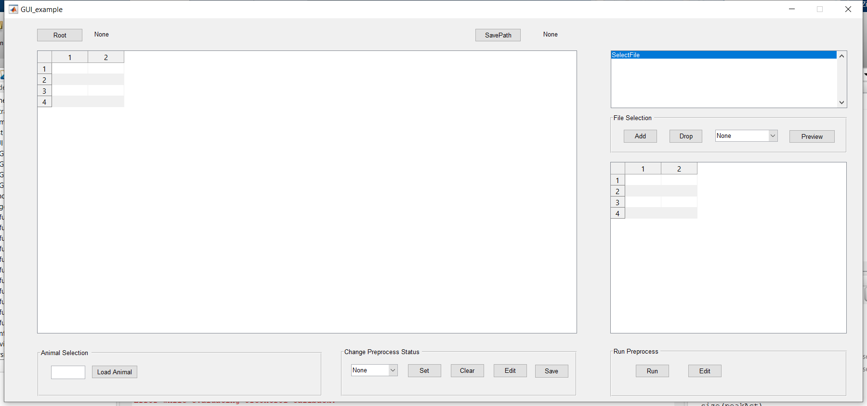

1. Select location of config folder to be root path

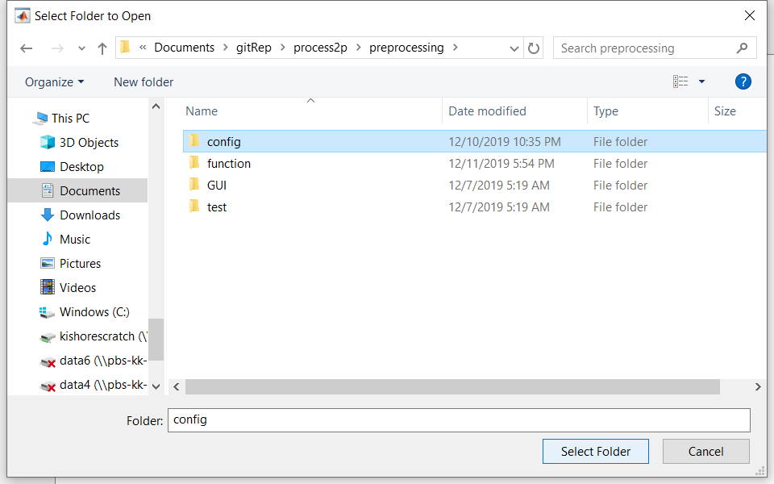

1. Specify savePath if needed (default is save with root). Type in animal name and press load animal to load the csv file of the animal.

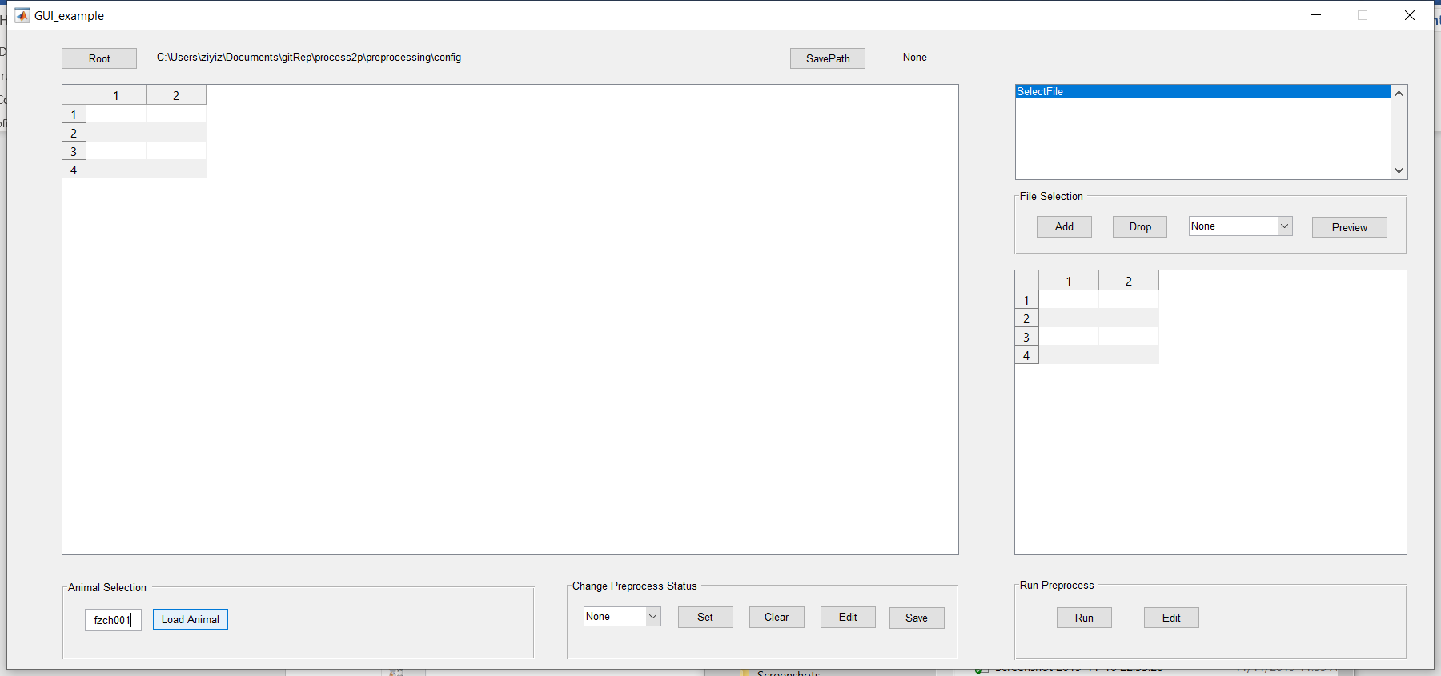

1. After loading, the table will appear on the left. Select a program to run, then select one or many sessions on the table, and add it to the list on top-right. Session name could be dropped.

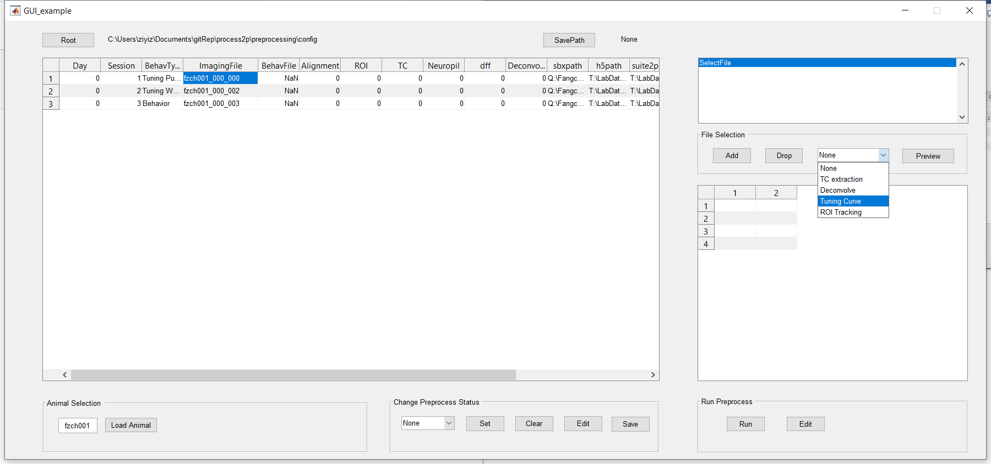

1. Click on preview to show the parameters for selected file and algorithm (not parameters only shows part of the parameters that are taken by the program).

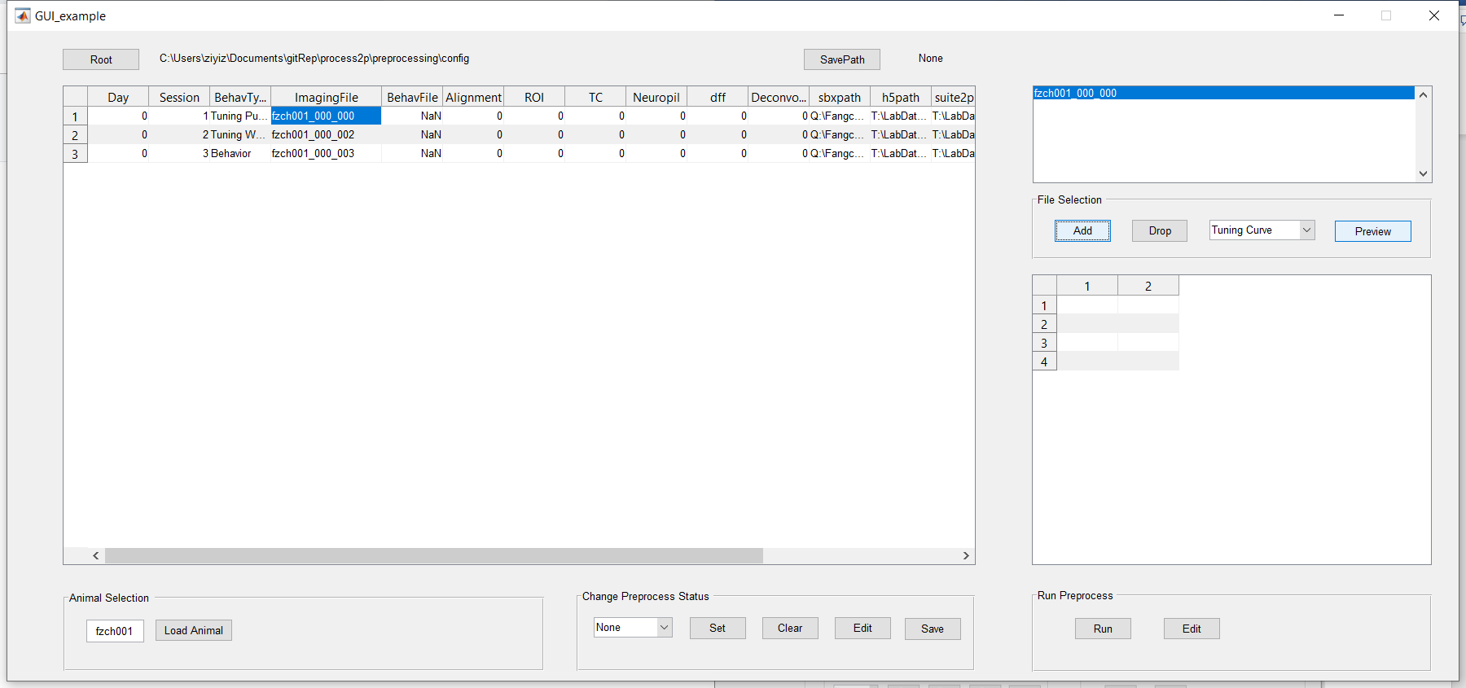

1. Run the program.

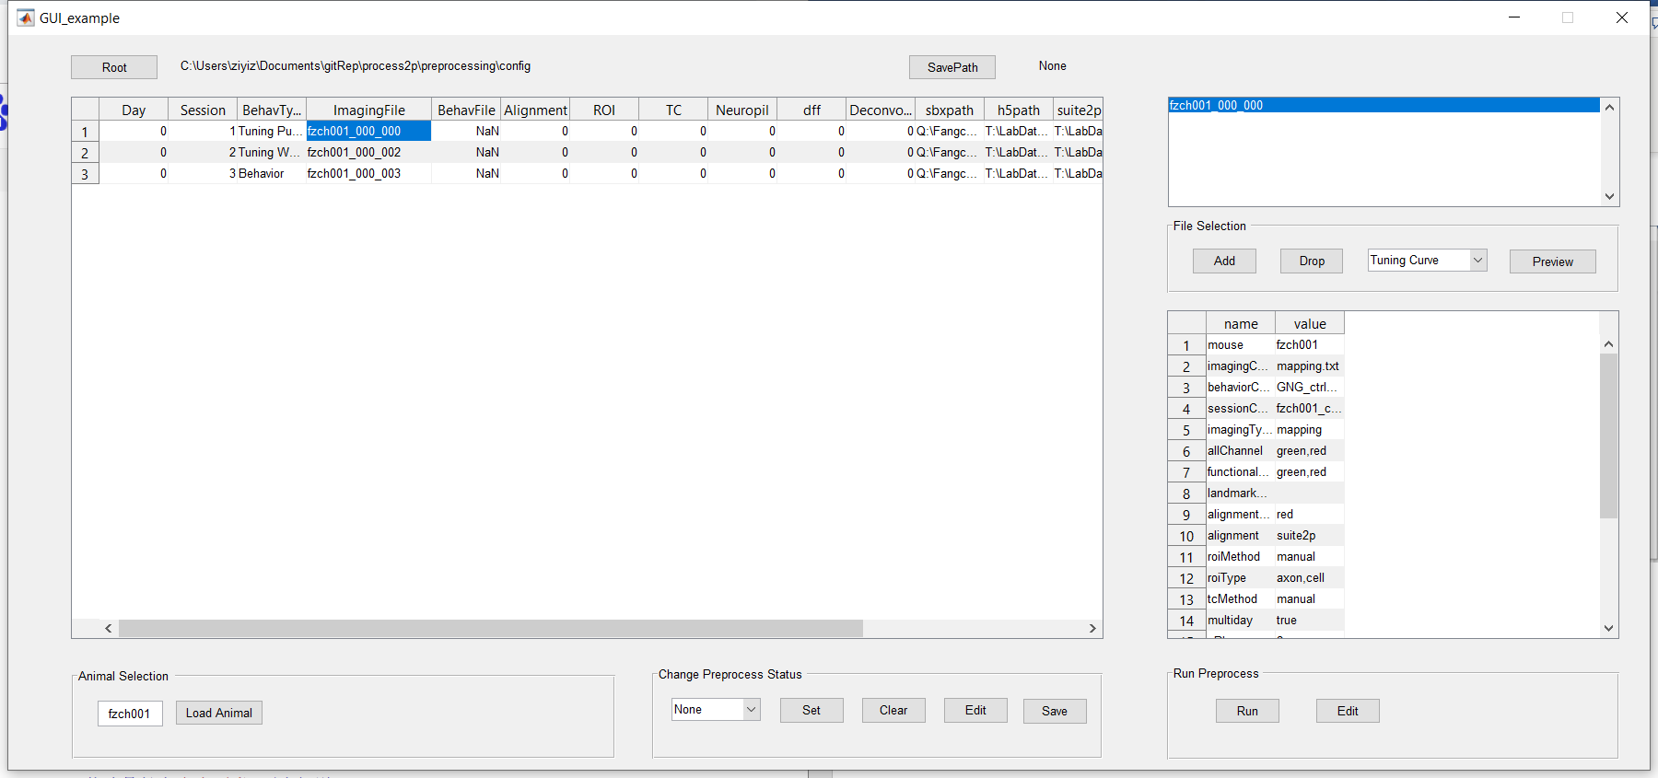

1. Other functionality: set specific columns of table as 1 (preprocessed), or clear them to 0 (un-preprocessed), or edit the table manually (can be toggled to ‘on’ or ‘off’ mode), and save the configuration file (overwrite old file).

