AI-3006

COMPUTER NETWORKS

**Prepared by:**

Kynat Mansha [**21I-0684**]

Uswah Siddique [**21I-0551**]

Laiba Asif [**21I-2560**]

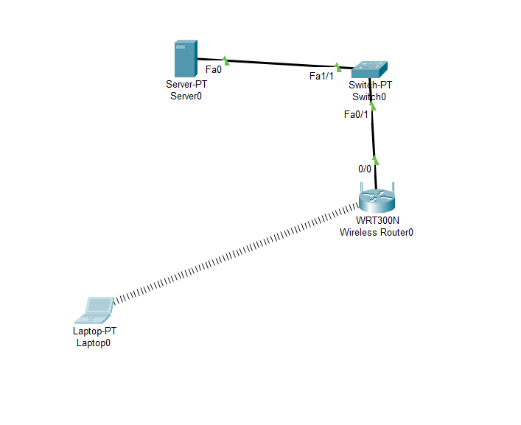

Placing a Laptop already having embedded functionality for wireless connectivity. It automatically links.

To connect the laptop-PT to the router WRT300N via browser, following steps were taken:

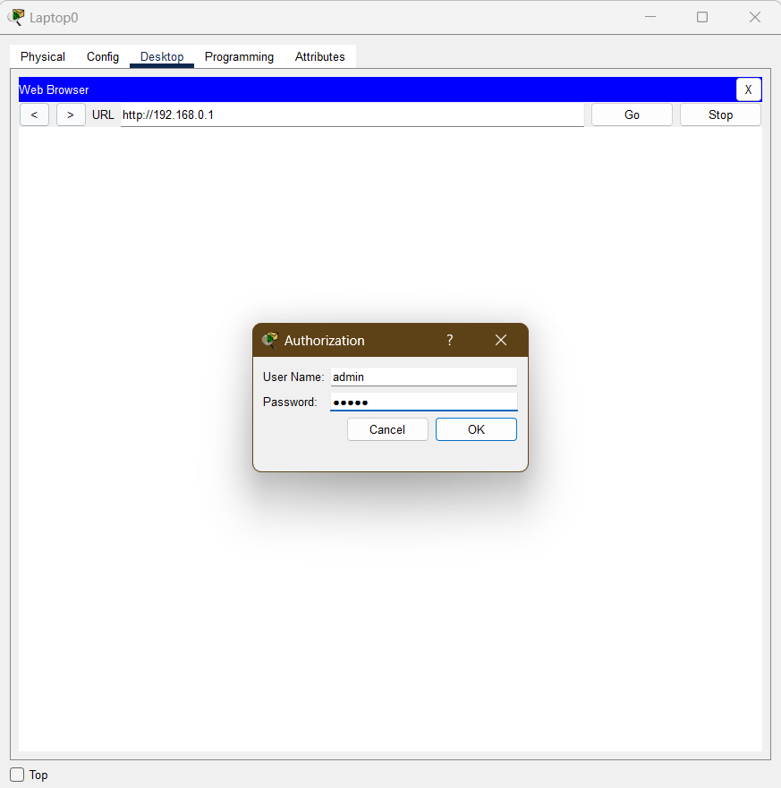

On the Laptop end, click on the laptop and navigate to the desktop. On the desktop click on the web browser and the following screens pops up. Type in the LAN code of the router into the URL and press Go. A mini screen pops up asking for the user name and the password. Enter “admin” as the user name and the password and press ok.

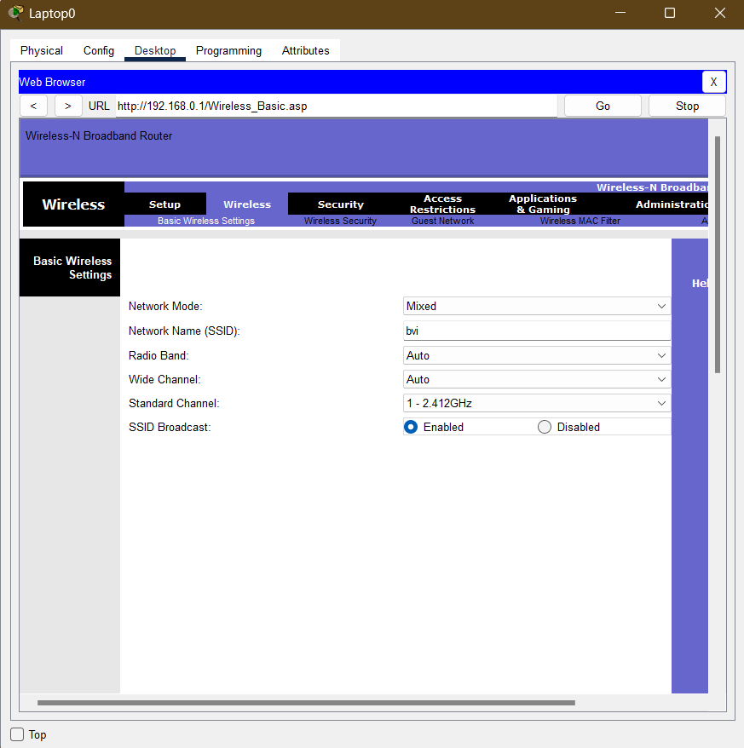

For changing the SSID to “bvi”, navigate to the “Wireless” option in the settings and below that, click on the “ Basic Wireless Settings”. There, look for Network Name (SSID), rename it as bvi, scroll down and press the save button to save the changes.

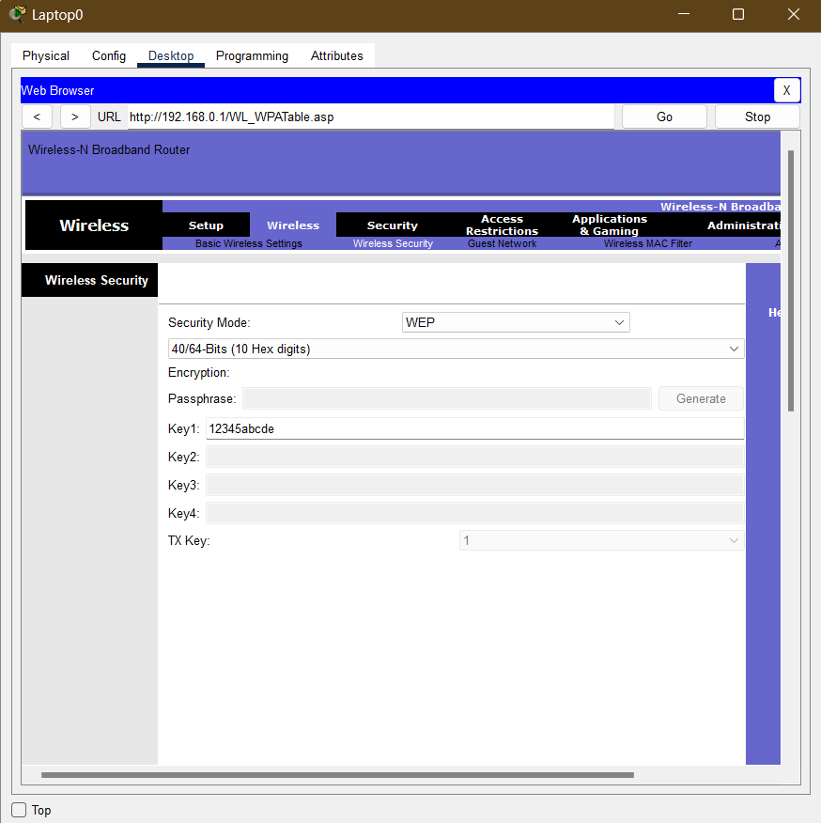

To enable WEP Wireless Security, navigate to “Wireless”, and click on the Wireless Security just below it. There, in the drop down for Security Mode select WEP, select in the lower drop down 10 Hex Digits option and type in the Key1 “12345abcde”. Scroll down and press save to save the changes.

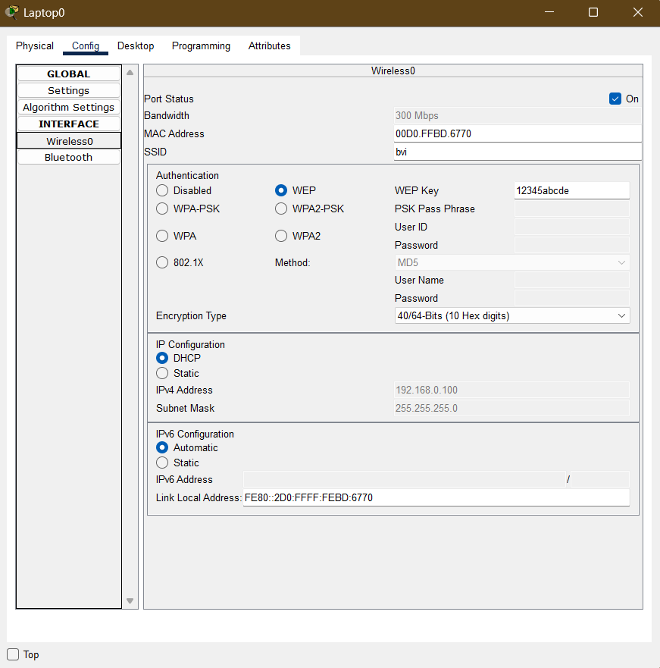

To configure your system wirelessly with WEP Wireless Security, Go to the config. Press the Wireless. On the many options in Authentication select WEP and enter your WEP Key.

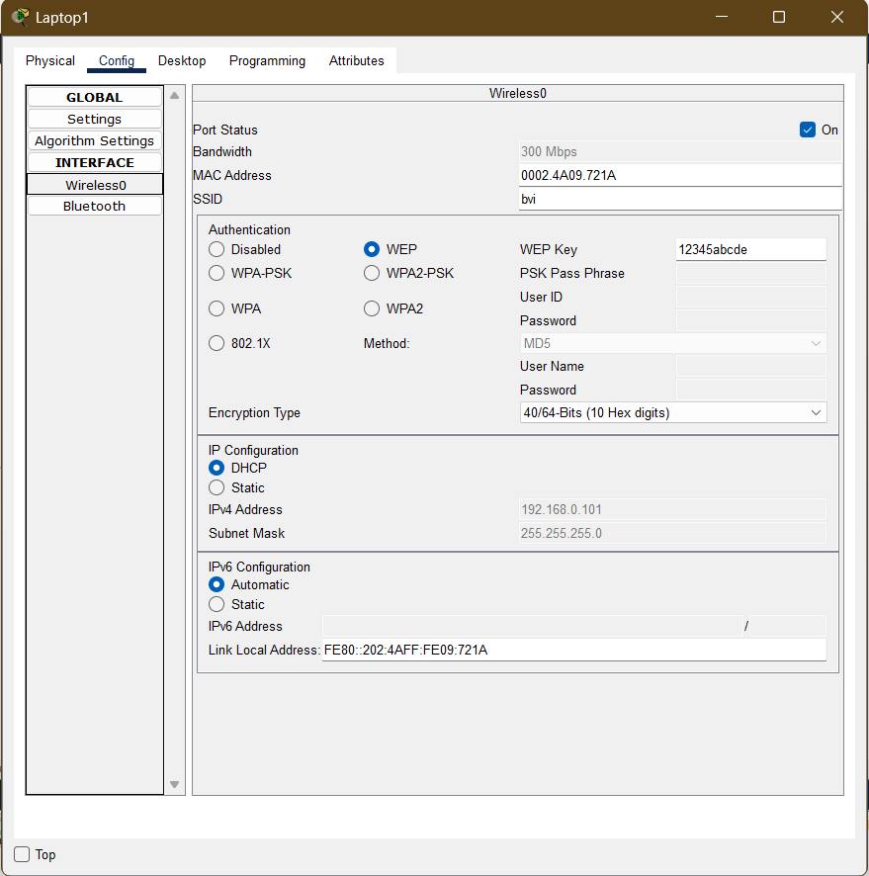

Repeat the same process in Laptop 1 too.

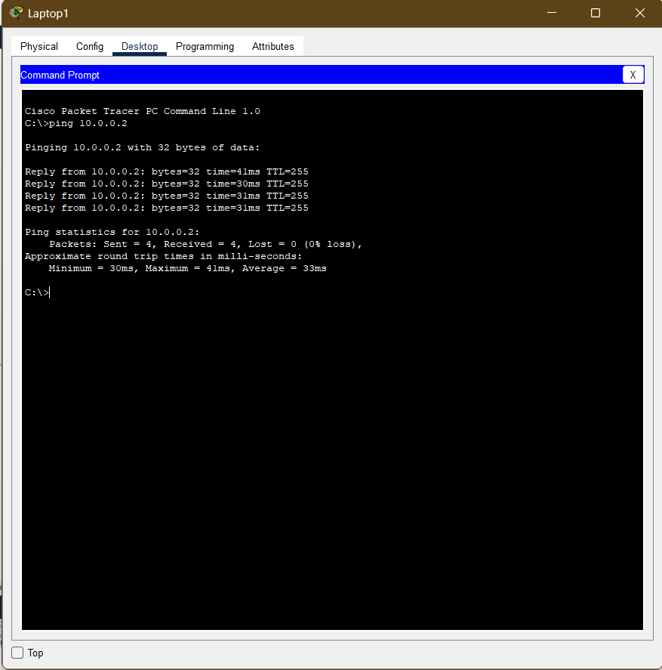

In Laptop1 , write the ping command to send a data packet to the server 10.0.0.2 and check if its a success.

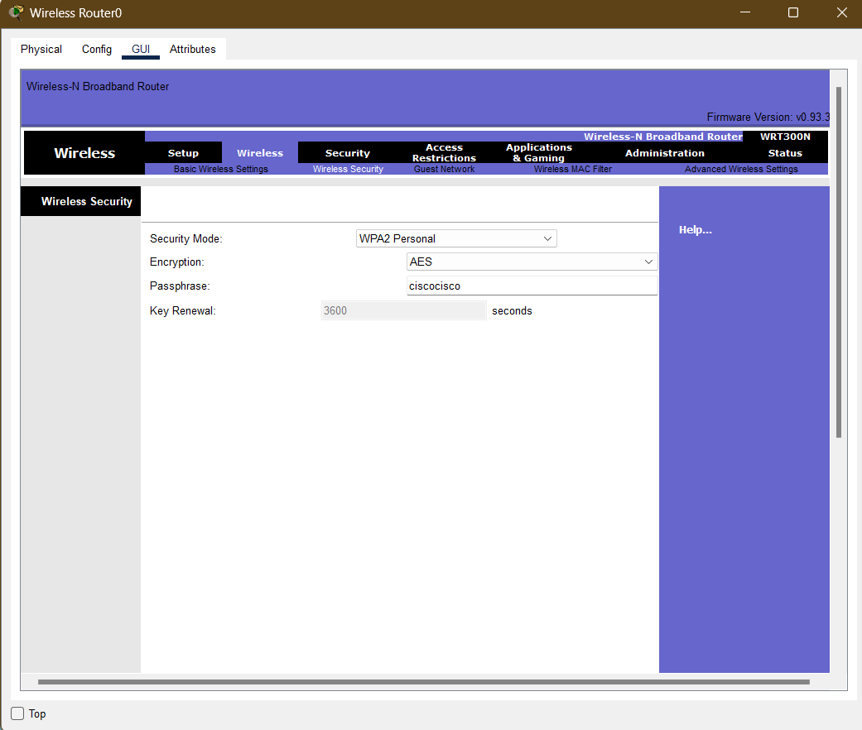

To change the security pattern to WPA2 PSK AES, follow the same instructions as for WEP, only in the Security Mode, select WPA2 Personal. It will demand Encryption and Passphrase from you. For Encryption, fill in AES and in Passphrase, fill in ciscocisco.

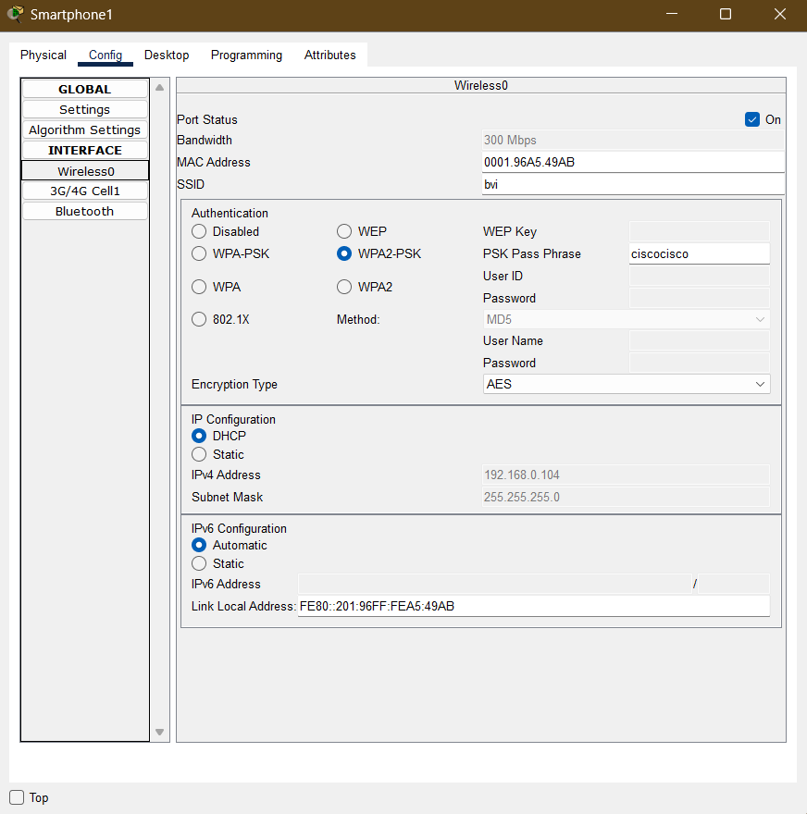

To connect smartphones to the network now, in the config, select Wireless, and in the Wireless, select WPA2-PSK and write “ciscocisco” in the PSK Pass Phrase.

Repeat the same process in smart phone 2.

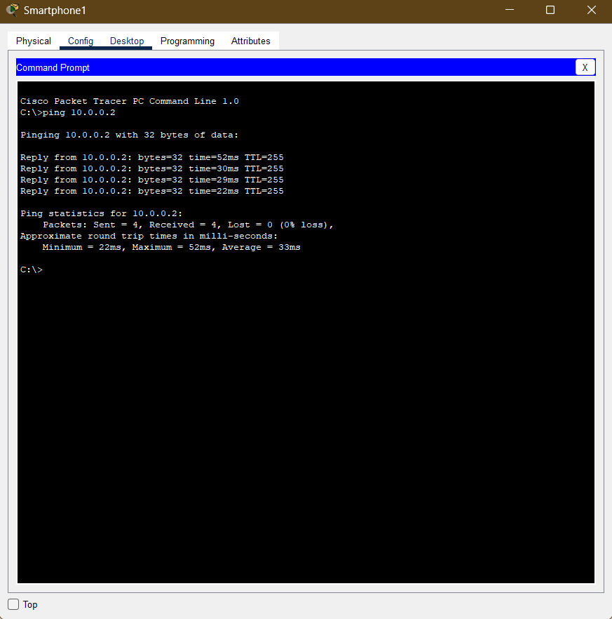

Ping the smartphone to server 10.0.0.2 and check if it's successful.

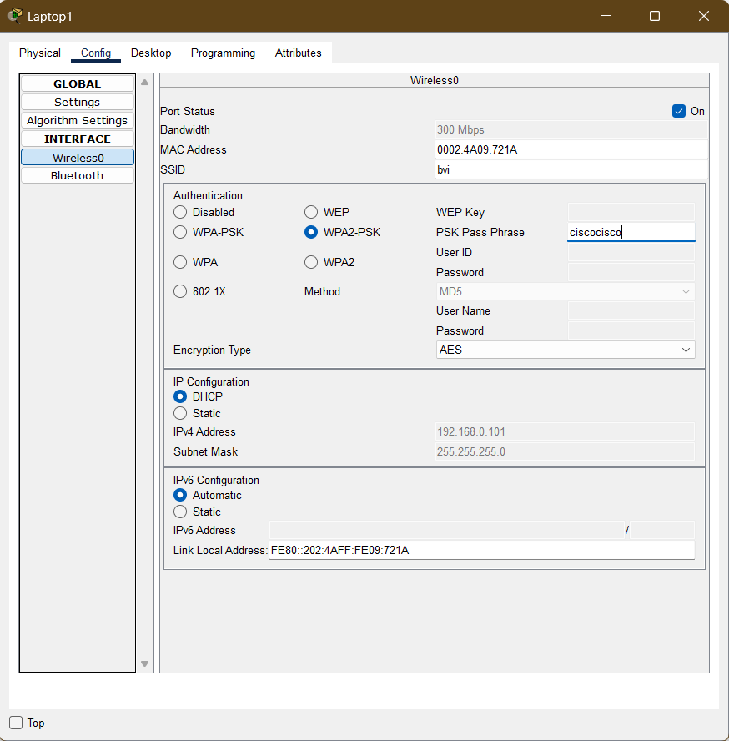

Repeat the same process for the Laptops too, and ping them to the server.

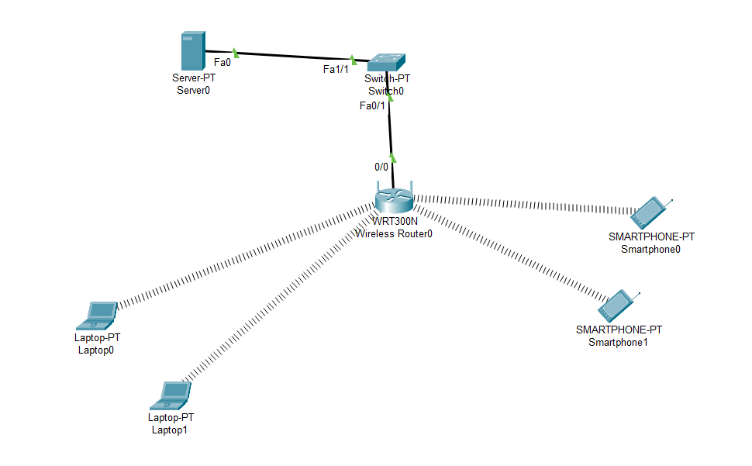

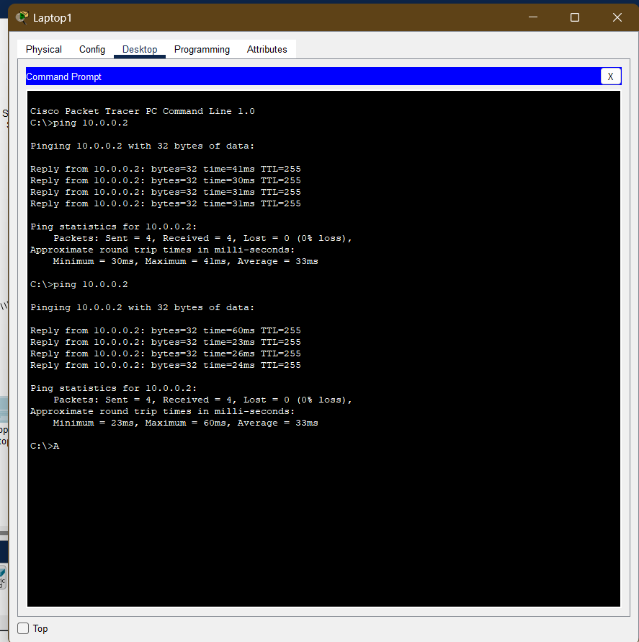

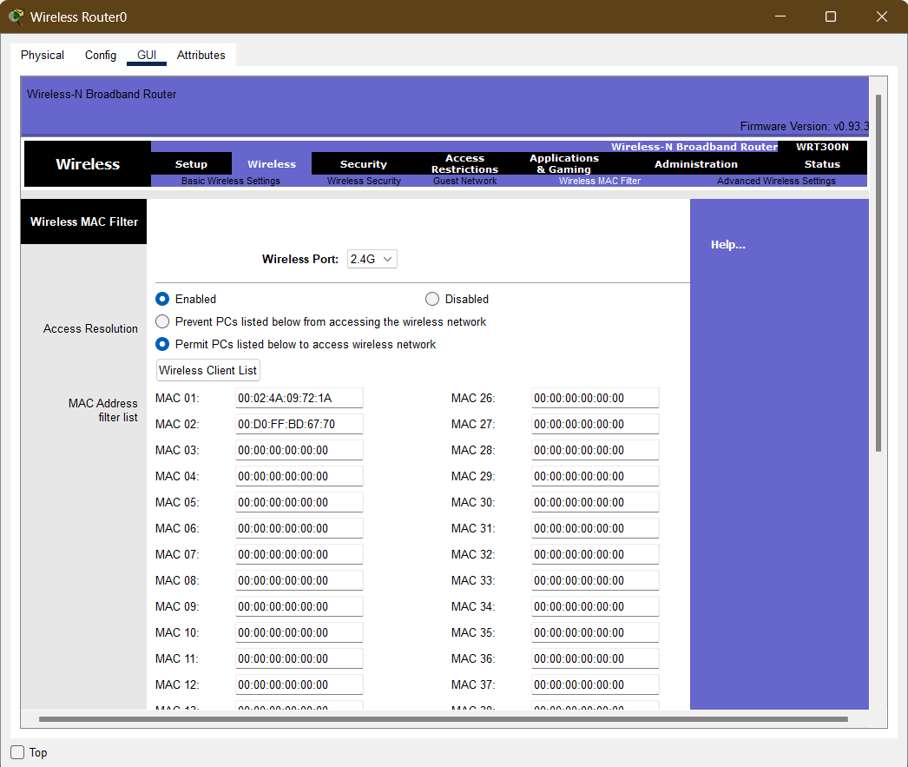

In mac filtering, go to the GUI of the Wireless Router, navigate to the Wireless and then to the Wireless MAC Filter. Click on enabled and Permit PCs listed below to access wireless networks.

Enter the MAC Addresses of the devices you want to allow access to the server through the router. In my case, I am allowing all the devices other than Laptop 1 and Laptop 2 to access the wireless network.

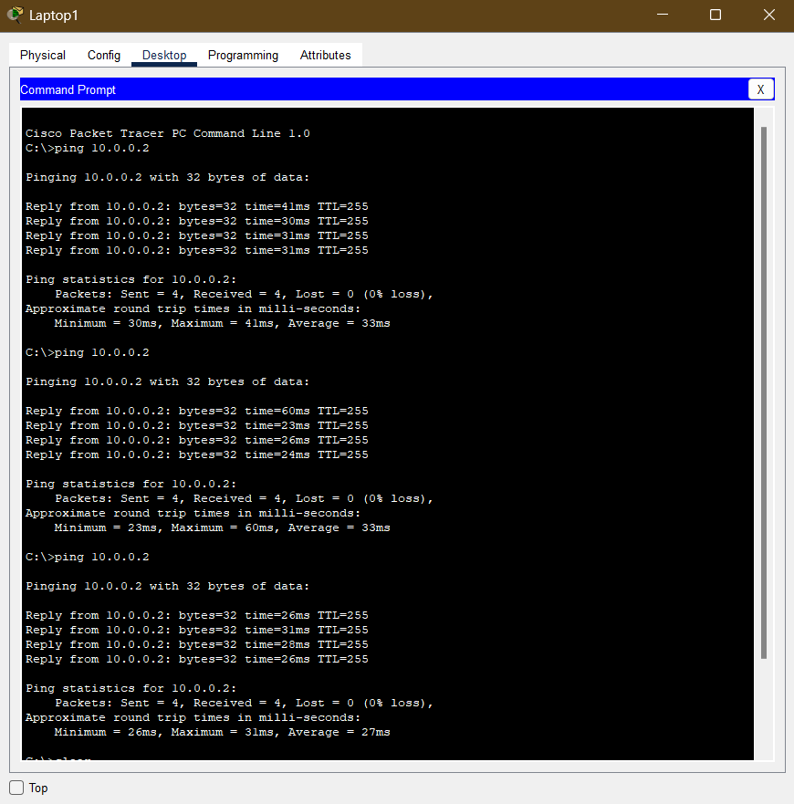

Ping Laptop 1 to server 10.0.0.2. It is a pass.

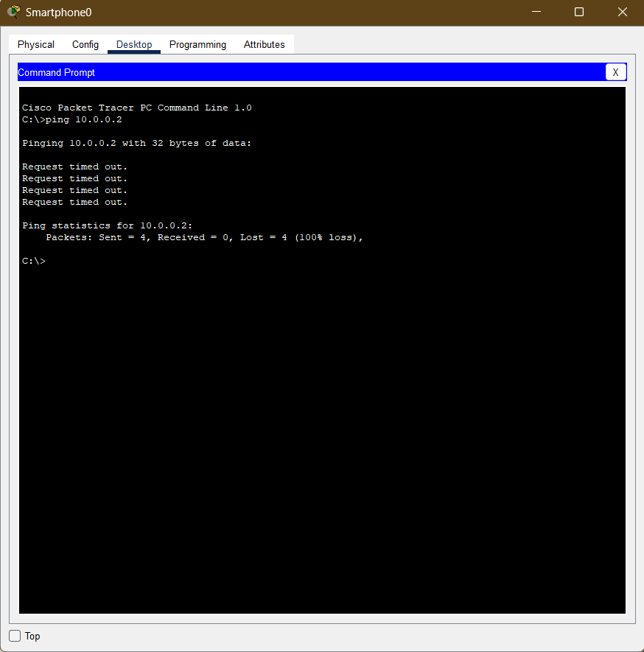

Ping server 10.0.0.2 to smartphone 0. Its a fail.

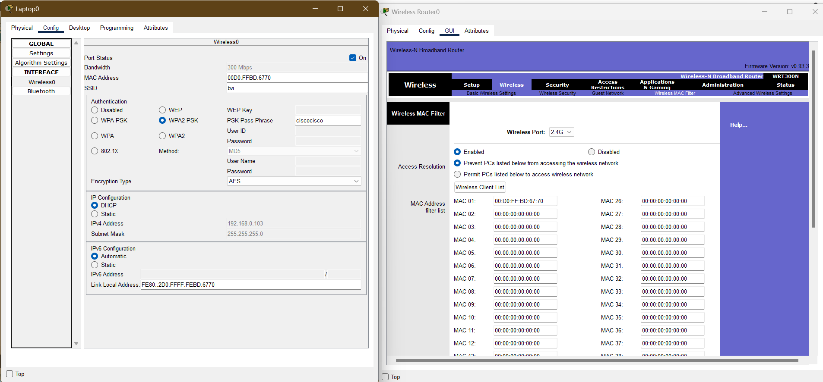

In mac filtering, go to the GUI of the Wireless Router, navigate to the Wireless and then to the Wireless MAC Filter. Click on enabled and Permit PCs listed below to access wireless networks.

Enter the MAC Addresses of the devices you want to allow access to the server through the router. In my case, i am allowing all the devices other than Laptop 0 to access the wireless network.

Ping the server 10.0.0.2 from the laptops and the smart devices. The Laptop 0 shall be a fail test.

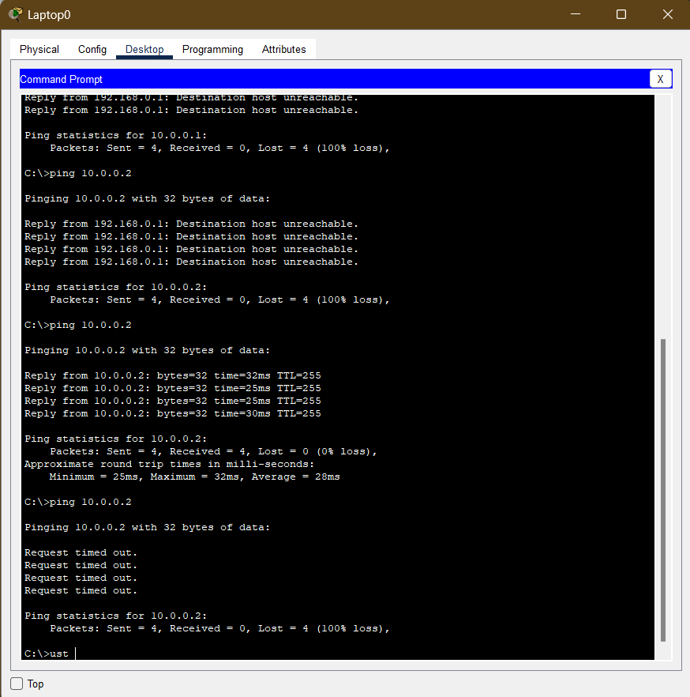

Ping from Laptop 0 is a fail.

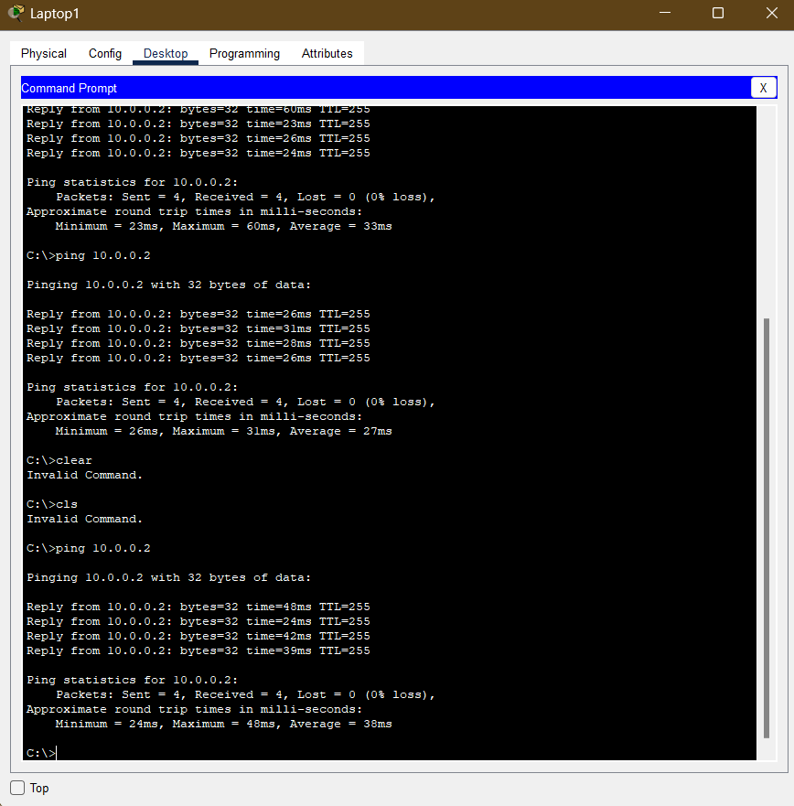

Ping from Laptop 1 is a fail.

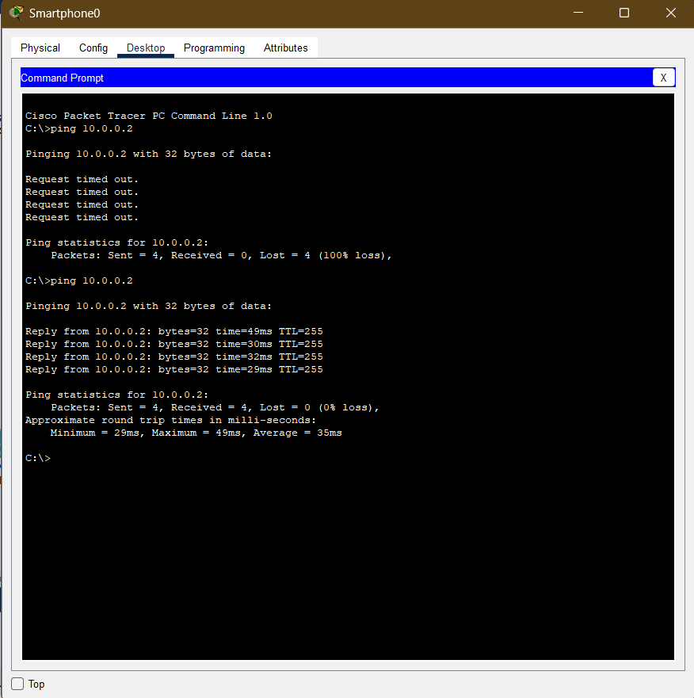

Ping from smart phone 0 is a pass

Visibility before

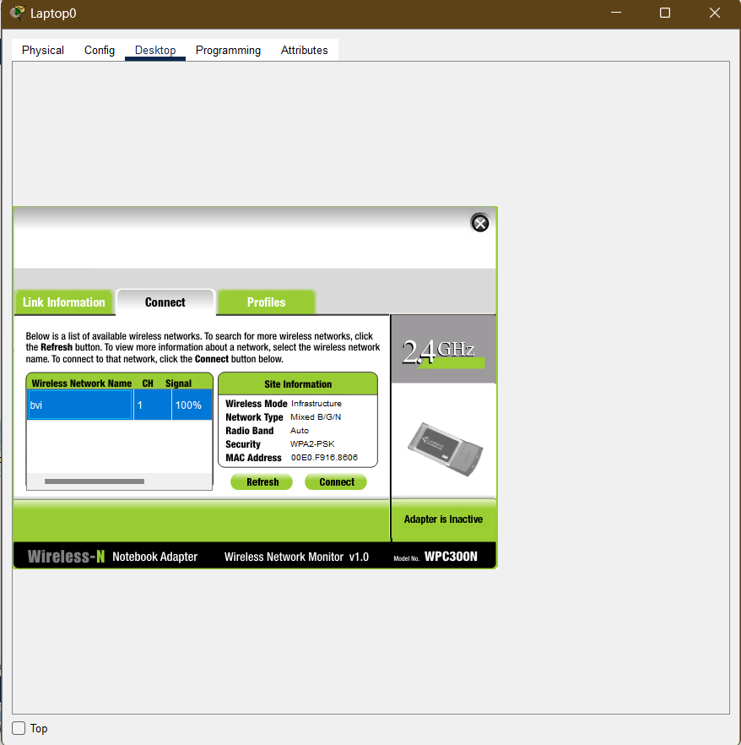

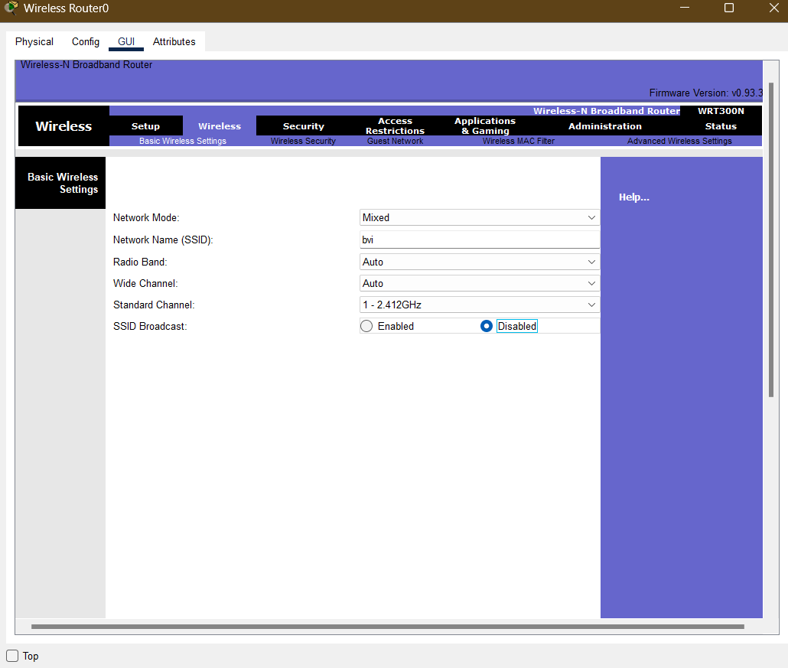

To disable visibility of SSID from Laptop 0, go to the router, Wireless and Basic Wireless Settings. Click on Disabled, scroll down and click save to save changes.

Visibility after

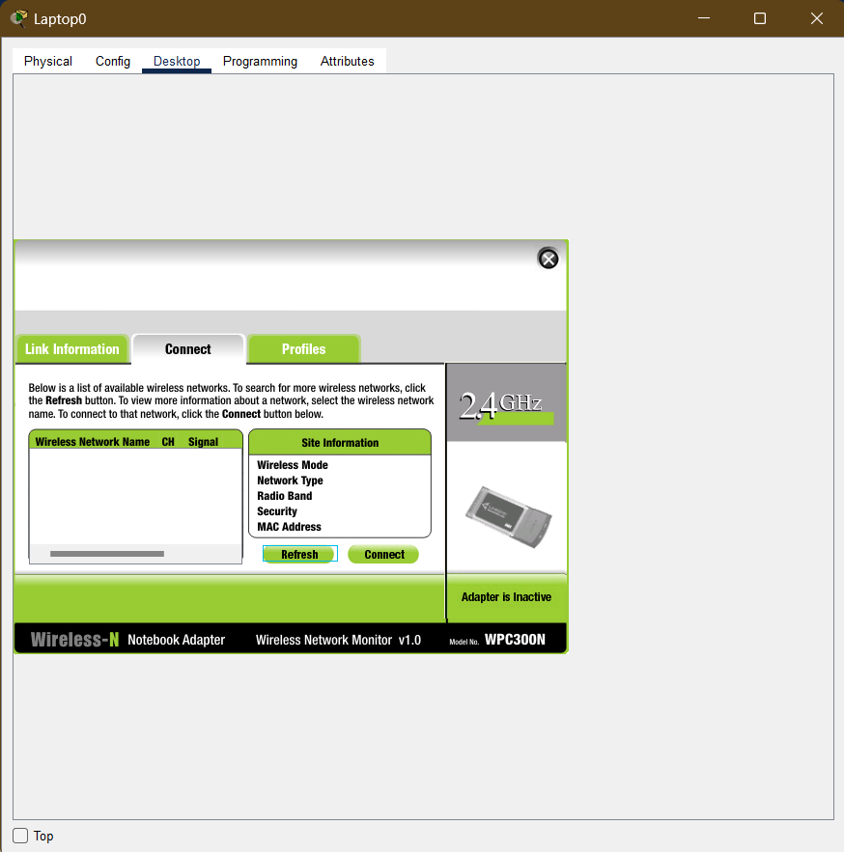

The SSID is no longer visible.