**H🙲M Configuration Dongle**

**EE464 – Senior Design I**

**Senior Design Project Proposal**

**Mohamed Ayoub**

**Harsh Dubey**

**10/22/2019**

Department of Electrical Engineering and Computer Science

South Dakota State University

# **Project Approval**

|  |  |  |
| --- | --- | --- |
| **Project Governance** | | |
| **Role** *(Add/delete as applicable)* | **Name(s)** *(First initial. Last name)* | **Approval Signature / Date1** |
| Customer | *M. Sickler* |  |
| Sr. Engineer 1 | *R. Fourney* |  |
| Project Manager | *S. Tan* |  |
| **Project Team** | | |
| **Name(s)** *(Last name, First name, Middle initial.)* | | **Approval Signature / Date** |
| Ayoub, Mohamed, M. | |  |
| Dubey, Harsh | |  |

# **Table of Contents**

Project Approval 2

Table of Contents 3

Proposal Summary 4

Introduction 5

Definition of Problem 5

Background 5

Scope of Proposal 5

In Scope 5

Out of Scope 6

Functional Design Requirements 6

Objectives 6

Specifications 6

Design Constraints 6

Proposed Technical Solution 7

Overview 7

Submodule Description 7

Microcontroller 7

LCD Screen 7

Push Buttons 8

USB Port & Power 8

Communication Protocol with the Host Device 8

Anticipated Required Resources 9

System level component list and cost estimate 9

Test and Laboratory Equipment 9

Proposed Performance Verification 9

Proposed Project Schedule 9

Plan of Action 9

References 11

# **Proposal Summary**

*Title: Daktronics Configuration Dongle*

*Team Members: Mohamed Ayoub*

*Harsh Dubey*

*Advisor: Dr. Robert Fourney*

Daktronics manufactures display controllers which are accessed over a network. If the network fails or the network settings are incorrectly configured, the remote display controller becomes inaccessible. The primary objective of the project is to build a configuration dongle that to plug into the display controller to reconfigure the controller’s network setting. This would require designing the dongle, with an appropriate, user interface and a communication protocol that the dongle can use to communicate with the display controller.

The configuration dongle would then be used to get the current system settings of the display controller and then display them on the Dongle’s LCD screen. Using push buttons installed on the dongle, the user can navigate through the settings and reconfigure the display controller network setting.

The team will collaborate with each other to design the communication protocol that the dongle will use to communicate with the display controller. After the protocol is designed, the team will design the dongle itself. The Dongle components will include a microcontroller, an LCD screen, and five push buttons. After testing and verifying the design and the communication protocol, the team will work on designing a PCB board and housing for the dongle.

# **Introduction**

## Definition of Problem

Daktronics is a company based in Brookings, South Dakota, United States that designs, manufactures, sells, and services video displays, scoreboards, digital billboards, and related products. The display controllers that Daktronics produces are normally accessed over a network using a web browser to control the video displays. If the network fails or the display controller’s network settings are not configured properly, the display controller become inaccessible. This prevents the user from accessing the display controller to implement necessary changes to the display. Reconfiguring the network settings to gain access to the display controller is time consuming if multiple display controllers are inaccessible at the same time. A device is needed to physically gain access to the current network settings of those controllers (host devices) and to reconfigure those network settings as needed.

## Background

One proposed solution is using a Wi-Fi dongle and having the display controller connect to the network generated by the Wi-Fi dongle, [5]. However, if the network settings are not configured properly it becomes difficult to access the display controller through any kind of network, [4].

Another solution is using a Bluetooth dongle to communicate with the display controller [1]. In this case, the technician would still have to change the configuration settings and this process is complex according to Daktronics. The technician could also use a smartphone and connect to the display controller using a USB cable and have an application software in the smartphone that can be used to change the network settings [2]. However, according to company policies, technicians can’t use their personal smartphones to change the settings of company products.

Therefore, developing a configuration dongle would be ideal, since it is cheap, compact, easy to carry, doesn’t need a network connection to talk to the host device, and can be powered by the host device.

## Scope of Proposal

The remainder of the proposal is divided into three major sections. The first section defines the design project by clearly stating a set of objectives, specifications, and design constrains. This section is followed by the technical solution section which first presents an overview of the design and associated submodules. This section presents a detailed description of those submodules and how it achieves to the objectives of the design project. The third subsection of the technical solution section presents a detailed list of the anticipated resources needed and their anticipated cost estimate. Finally, the last section presents the design project schedule and the plan of action which highlights the developed Gantt chart that will be necessary to complete the objectives of the design project.

The scope of this project focuses on the initial development of a system, called the “Configuration Dongle,” to display and configure the network settings of the host device. To avoid scope creep of the project, tasks have been separated into “in scope” and “out of scope” categories and are listed below.

### In Scope

Upon completion, the following items will be implemented in the design project:

* The Configuration Dongle will communicate with the host device by enumerating a standard Universal Serial Bus (USB).
* The Configuration Dongle will read the system name and type of the host device.
* The Configuration Dongle will be able to change the network mode of the host device.
* The Configuration Dongle will configure the network settings of the host device.

### Out of Scope

These are the concerns that are related to the project that the team is not responsible for, and are thus out of the scope of the project but will be considered as optional objectives:

* ProLink Master control.
* Read link-local Internet Protocol (IP) v6.
* Device component identification.
* Develop a firmware for the host device.

# **Functional Design Requirements**

## Objectives

The primary objective of the project is to develop and build a device (Configuration Dongle) that will communicate with Daktronics’s host device using USB to read and to configure the host device’s network settings. Another objective of the project is to design the communication protocol of the Configuration Dongle so that the beginning and end of a message can be detected unambiguously. Additionally, the device must be able to detect dropped or corrupted data and recover that data. Finally, the communication protocol of the device should be designed so it’s backward and forward compatible and should have the Capability Detection feature.

## Specifications

The specifications for the project are listed below:

1. The Configuration Dongle must include a 16x2 LCD display or a matrix OLED display to display the system information and current network settings of the host device.
2. The Configuration Dongle must include at least 3 push buttons on the right-hand side of the PCB.
3. The Configuration Dongle must include one USB port.
4. The Configuration Dongle must be 1.5” by 2.5” in size and no larger than 3” by 6”.
5. The Configuration Dongle must be able to read and write the IPv4 address of the host device under static mode.
6. The Configuration Dongle must be able to read and write IPv4 Netmask in Classless Inter-Domain Routing (CIDR) format.
7. The communication protocol between the Configuration Dongle and the host device must use at least 16-bit Cyclic Redundancy Check (CRC).

## Design Constraints

The design constraints of the project are listed below:

* The Configuration Dongle must be powered by a 0-5V rail.
* Team does not have prior experience with computer networks.
* Team does not have prior experience working with Linux.

# **Proposed Technical Solution**

## Overview

The proposed solution to the problem as defined and in accordance with the Functional Design Requirements is divided into several submodules. The LCD screen will be used to display the host device’s system information along with its network settings. The push buttons will be required for the user to configure the network settings of the host device. A custom communication protocol will be required to receive and send data between the host and the host device. The USB port will serve as a physical connection between the host device and the Configuration dongle to initiate the communication protocol and to power the Configuration Dongle. The system level block diagram is shown in Fig. 1.

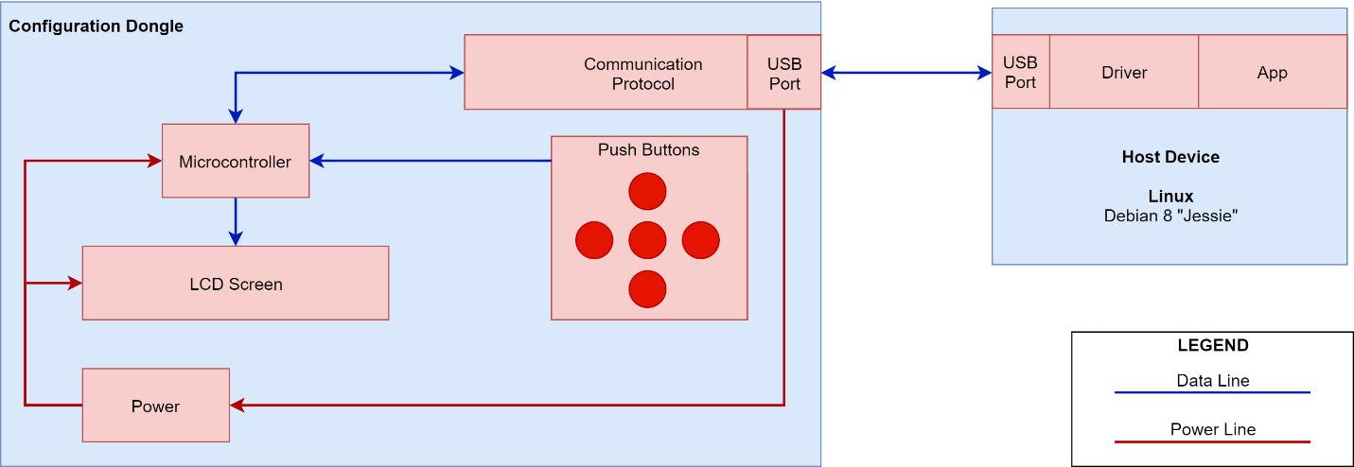

Figure 1. Design Project Block Diagram

## Submodule Description

This section is a detailed description of each submodule in the proposed block diagram, Fig. 1.

### Microcontroller

A microcontroller will be used to initiate the communication between the configuration dongle and the host device instead of a raspberry pie single board computer or a field programmable gated array (FPGA). Microprocessors and FPGA boards are bigger in size when compared to a microcontroller, raspberry pie-3 is 2.6” by 1.2”. Hence, a raspberry pie or an FPGA board can’t be used for dongle design since the dongle can only be a maximum size of 3” by 6” with all the sub-modules included.

To accomplish the objectives stated in the Functional Design Requirements section, a 32-bit microcontroller with a built-in USB stack will be used. The built-in USB stack will be used to enumerate the designed serial communication protocol, so that the configuration dongle can communicate with the host device using a USB port. A 32-bit microcontroller will make the transmission of data with the faming bits and 16-bit CRC faster. An 8-bit microcontroller will take 4 times longer in transmission time than a 32-bit microcontroller. Finally, the microcontroller will also be used to display the user entered instructions to the LCD screen.

### LCD Screen

An LCD screen that can display 16x2 characters, according to the specifications, will be used to provide an interactive user interface. The configuration dongle will receive current configuration settings from the host device and display them for the user. LCD screen will also display user commands and status of changed configuration, this would achieve the 1st specification of the project.

### Push Buttons

Push buttons will be used to allow the user to change the network settings of the host device. Push buttons are also compact in size when compared to a keypad. Additionally, the functionality of a keyboard is not required. A typical 3 by 3 numerical keypad is of size 2.75” by 3”, therefore it can’t be used in the configuration dongle design, since the dongle can only be a maximum size of 3” by 6” with all the sub-modules included.

Incorporating pushbuttons will achieve the 2nd specification of the project and will be used to send the user’s desired network settings for the host device to the microcontroller. The microcontroller will then communicate with the host device to overwrite the host device’s network settings with the desired network settings provided by the user.

### USB Port & Power

Since Daktronics’ host devices have USB ports built-in, the ports will be used to communicate with the configuration dongle and power the configuration dongle.

USB ports traditionally have four channels, two differential channels “D+” and “D-” which are used to receive and transmit data, while the other two channels, “Vbus” and “GND” are used to supply 0V-5V power. This will achieve the 3rd specification of the project.

### Communication Protocol with the Host Device

A serial communication protocol will be used to communicate with the host device. The protocol structure will be designed such that the message can be detected unambiguously. The protocol will be able to recover dropped data, will be extendable, and will be updateable.

For unambiguous data detection, the protocol will have message framing. The framing will denote the beginning and the end of the message. A 16-bit CRC polynomial will be used for error detection and error correction. To make the protocol extendable, an “extension” tag will be used to denote the message size of 8-bit, 16-bit, 32-bit and 64-bit. To make the protocol updateable, a “version” tag will be used to denote the protocol version. The “version” tag will make the protocol structure such that the future versions of the protocol will not disrupt older implementations. If a future version of the protocol introduces a new message type, then the older version of the system will be able to recognize it through “version” tag and will return an error without losing the message framing.

## Anticipated Required Resources

These are the resources that will be required to build and test the Configuration Dongle:

### System level component list and cost estimate

Table 1: Proposed Budget

|  |  |  |
| --- | --- | --- |
| Item Description | Retail ($) | Anticipated Expense ($) * |
| Microcontroller | ----------- | $15.86x2 |
| LCD screen | ----------- | $31.76x2 |
| USB Connector | ----------- | $3.84x2 |
| PCB | ----------- | $42 |
| Subtotal | ----------- | $144.92 |
| Total | ----------- | $173.90 |

* The actual expense may have been after an educational discount.

### Test and Laboratory Equipment

* PC with a Debian 8 “Jessie” operating system.
* Oscilloscope
* 5V Power Supply
* Signal Generator
* Bread Boards
* Microcontroller Development board
* 3D Printer
* PCB Design Software
* Light-emitting diodes (LEDs)
* Voltmeter

## Proposed Performance Verification

The oscilloscope will be used to debug the communication between the LCD screen and the microcontroller. The integrated development environment (IDE) will be used to primarily develop and debug the microcontroller code. The LCD screen along with LEDs will also be used to debug the microcontroller code. The user input will be tested by verifying that the input provided by the user is read into the memory of the microcontroller which will also be verified by displaying the input to the LCD screen. The communication protocol will be tested by sending data to the host device and verifying that the host device has received that data. The LCD screen will also be used to verify that the data being read by the microcontroller from the host device is being displayed to the LCD screen. A voltmeter will then be used to verify that the USB port is supplying 0V-5V to the microcontroller.

For the system level testing, a generic CDC driver will be installed on the host device (Linux Machine), for the Configuration Dongle to be identified by the host device. Additionally, changes will be made to the generic CDC driver to make the driver compatible with the Configuration Dongle. Then, an application will be developed on the host device to accept instructions from the Configuration Dongle. The application will then be used to test the functionality of the Configuration Dongle. This will include reading the current network settings of the host device and successfully displaying them on the LCD screen. Then allowing the Configuration Dongle to change the IPv4 address, netmask, and gateway using the push buttons and verifying that the new network settings are successfully updated in the host device.

# **Proposed Project Schedule**

## Plan of Action

To manage the tasks required to complete the project and to keep track of the objectives, a Gantt chart was created, Fig. 2.

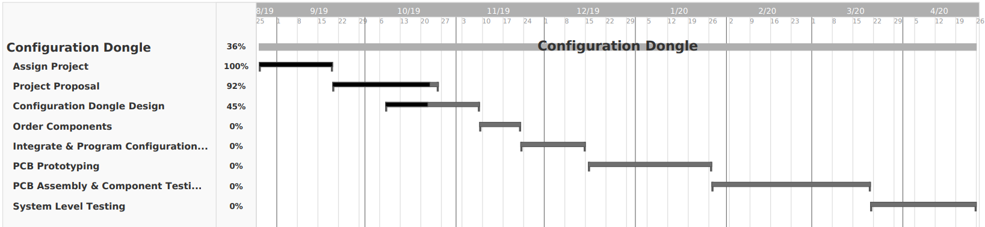

Figure 2. Proposed Project Plan in the form of a Gantt chat

The team will collaborate and work together a minimum of 15 hours each week to accomplish all the objectives of the project. The team will also meet regularly throughout each given week to work on the project and plan tasks for future weeks to accomplish short term goals. Additionally, the team will set milestones for each consecutive month to achieve long term goals and to stay ahead of schedule.

During the “Configuration Dongle Design” phase the team will design primarily the communication protocol between the Configuration Dongle and the host device. At the end of this phase the team will order all the parts necessary for the project. The team will then build and develop each submodule of the project and integrate them together using development boards. The team will then work on designing a prototype PCB. After the prototype PCB have been tested and all the changes have been finalized, the team will order a final version of the PCB. The final version of the PCB will be assembled, and each submodule will be tested to make sure all the submodules accomplish the objectives and the specification of the project. Finally, the team will enter the “System Level Testing”. In this phase a “Performance Verification” document will be created to test and verify that our system level testing achieves the objectives and specifications of the project.

Neither Moe nor Harsh is experienced with computer networks and Linux. To overcome these concerns, the team plans on researching and learning those topics using South Dakota State University’s available resources along with the resources available on the Internet.

# **References**

[1] Ferguson, Greyson, et al. “How to Connect a Printer Using Bluetooth.” *Techwalla*. Accessed on: Oct. 8, 2019. [Online]. https://www.techwalla.com/articles/how-to-connect-a-printer-using-bluetooth.

[2] Jonas. “Change Windows IP Address Settings Remotely with Psexec and Netsh.” *Jonamiki.com*, 26 Jan. 2018. Accessed on: Oct. 8, 2019. [Online]. http://jonamiki.com/2014/12/19/change-windows-ip-address-settings-remotely-with-psexec-and-netsh/.

[3] Mitchell, Bradley. “How to Change Your IP Address (And Why You Might Want To).” *Lifewire*, Lifewire, 4 Oct. 2019. Accessed on: Oct. 8, 2019. [Online]. https://www.lifewire.com/change-your-ip-address-818150.

[4] “Network Configuration.” *Network Configuration - an Overview | ScienceDirect Topics*. Accessed on: Oct. 8, 2019. [Online]. https://www.sciencedirect.com/topics/computer-science/network-configuration.

[5] Ruddy. “WiFi Dongle - What Is It and How Does It Work?” My Webspot - Pocket WiFi Rental, 10 Jan. 2019. Accessed on: Oct. 8, 2019. [Online]. https://www.my-webspot.com/blog/wifi-dongle-how-it-work/.