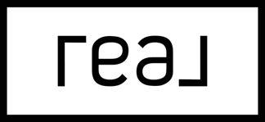
Hi Cynthia Galvan and Cristian Sequeira,
Now that your home at 2813 Riverside Gold Court is off the market, I’m sure you’ve had a wave of agents reaching out promising they can “get the deal done.”
You’ve heard this before. You’re not buying it.
Good. You shouldn’t.
You’re probably frustrated, disappointed, and tired of keeping your home show-ready for months with nothing to show for it. I get it. And I’m not here to add to the noise.
Here’s what I know after 8 years and 50+ home diagnostics given in the past four months: when a home doesn’t sell, it’s always for one of three reasons:
1. The pricing strategy didn’t reflect the market.
2. It didn’t get enough exposure to the right buyers.
3. It wasn’t presented in a way that made buyers want to act.
There are 10 marketing tactics that top-performing listings in your area use to sell for top dollar. Your listing is missing at least three of them.
I’ve put together a free, personalized breakdown for your home: what went wrong, what the current market data says, and what I’d do differently. It’s not a sales pitch. It’s an honest second opinion.
Scan the QR code and pick a time for a quick 15-minute call, Zoom, or in person meeting and I’ll walk you through exactly what I found. No pressure. No obligation.
If you decide not to relist, I respect that. But even if you never hire me, I want you to walk away knowing exactly why it didn’t sell… so you never have to wonder.
Straight talk,

Ryan Rose
Real Broker LLC · License S.0185572
(702) 747-5921 · ryan@rosehomeslv.com
No Pressure. No BS. Only Genuine.

