slicing experiment

load packages
library(tidyverse)
## ── Attaching packages ─────────────────────────────────────── tidyverse 1.3.2 ──
## ✔ ggplot2 3.3.6 ✔ purrr 0.3.4
## ✔ tibble 3.1.8 ✔ dplyr 1.0.10
## ✔ tidyr 1.2.1 ✔ stringr 1.4.1
## ✔ readr 2.1.3 ✔ forcats 0.5.2
## ── Conflicts ────────────────────────────────────────── tidyverse_conflicts() ──
## ✖ dplyr::filter() masks stats::filter()
## ✖ dplyr::lag() masks stats::lag()
library(ggplot2)
library (ggthemes)
library(rstatix)
##
## Attaching package: 'rstatix'
##
## The following object is masked from 'package:stats':
##
## filter
library(ggpubr)
library(emmeans)
library(dplyr)

import & bind data
## read sona and prolific data
prolific_data <- read_csv('data/prolific_data.csv')
## Rows: 15044 Columns: 31
## ── Column specification ────────────────────────────────────────────────────────
## Delimiter: ","
## chr (19): failed_images, failed_audio, failed_video, typeoftrial, trial_typ...
## dbl (6): subject, trial_index, time_elapsed, run_id, condition, subject_id
## lgl (5): success, timeout, Experiment, list_number, correct
## dttm (1): recorded_at
##
## ℹ Use `spec()` to retrieve the full column specification for this data.
## ℹ Specify the column types or set `show_col_types = FALSE` to quiet this message.
sona_data <- read_csv('data/sona_data.csv')
## Rows: 1596 Columns: 32
## ── Column specification ────────────────────────────────────────────────────────
## Delimiter: ","
## chr (19): failed_images, failed_audio, failed_video, typeoftrial, trial_typ...
## dbl (8): subject, trial_index, time_elapsed, run_id, condition, sona_id, s...
## lgl (4): success, timeout, correct, Experiment
## dttm (1): recorded_at
##
## ℹ Use `spec()` to retrieve the full column specification for this data.
## ℹ Specify the column types or set `show_col_types = FALSE` to quiet this message.
prolific_data_2 <- read_csv('data/slicing_data2.csv')
## Rows: 19168 Columns: 30
## ── Column specification ────────────────────────────────────────────────────────
## Delimiter: ","
## chr (19): failed_images, failed_audio, failed_video, typeoftrial, trial_type...
## dbl (5): subject, trial_index, time_elapsed, run_id, condition
## lgl (6): success, timeout, ip, Experiment, list_number, correct
##
## ℹ Use `spec()` to retrieve the full column specification for this data.
## ℹ Specify the column types or set `show_col_types = FALSE` to quiet this message.
ncol(prolific_data)
## [1] 31
ncol(sona_data)
## [1] 32
ncol(prolific_data_2)
## [1] 30
colnames(prolific_data)
## [1] "success" "timeout" "failed_images"
## [4] "failed_audio" "failed_video" "typeoftrial"
## [7] "subject" "trial_type" "trial_index"
## [10] "time_elapsed" "internal_node_id" "run_id"
## [13] "condition" "recorded_at" "source_code_version"
## [16] "ip" "user_agent" "device"
## [19] "browser" "browser_version" "platform"
## [22] "platform_version" "rt" "response"
## [25] "Experiment" "stimulus" "subject_id"
## [28] "trialcondition" "list_number" "correct"
## [31] "question_order"
colnames(sona_data)
## [1] "success" "timeout" "failed_images"
## [4] "failed_audio" "failed_video" "typeoftrial"
## [7] "subject" "trial_type" "trial_index"
## [10] "time_elapsed" "internal_node_id" "run_id"
## [13] "condition" "recorded_at" "source_code_version"
## [16] "ip" "user_agent" "device"
## [19] "browser" "browser_version" "platform"
## [22] "platform_version" "sona_id" "rt"
## [25] "stimulus" "response" "subject_id"
## [28] "trialcondition" "list_number" "correct"
## [31] "Experiment" "question_order"
colnames(prolific_data_2)
## [1] "success" "timeout" "failed_images"
## [4] "failed_audio" "failed_video" "typeoftrial"
## [7] "subject" "trial_type" "trial_index"
## [10] "time_elapsed" "internal_node_id" "run_id"
## [13] "condition" "recorded_at" "source_code_version"
## [16] "ip" "user_agent" "device"
## [19] "browser" "browser_version" "platform"
## [22] "platform_version" "rt" "response"
## [25] "Experiment" "stimulus" "trialcondition"
## [28] "list_number" "correct" "question_order"
## remove extra col.s and problematic col.
sona_data <- sona_data %>% select(!c(sona_id, subject_id, recorded_at))
prolific_data <- prolific_data %>% select(!c(subject_id, recorded_at))
prolific_data_2 <- prolific_data_2 %>% select(!c(recorded_at))
##bind prolific & sona data
data <- rbind(prolific_data, sona_data, prolific_data_2)

basic descriptives
## N(initial)
data %>% pull(subject) %>% unique()
## [1] 84465 NA 92411 7761 18876 74423 5046 29598 94711 44924 24188 78346
## [13] 35271 1546 49185 83237 9268 91293 61607 74333 61171 89511 34670 89599
## [25] 51917 78547 26802 77056 85526 51663 65580 39736 45037 33331 1697 29518
## [37] 44897 22539 63889 80903 96876 9830 7793 65641 22979 66400 74410 51373
## [49] 34785 19358 4995 25687 4637 88474 89776 95974 46579 90919 25382 84638
## [61] 44564 94518 56229 6361 36146 84549 69646 58356 68567 51653 32820 76910
## [73] 47187 40826 64364 27130 56104 31930 37820 87242 1360 98078 47633 31810
## [85] 20473 76360 69876 19246 3153 28769 71261 75473 57856 84929 88548 35168
## [97] 45711 11348 74533 73930 57761 51940 20638 32865 61841 81658 49984
## number of trials per subject: N(initial) = 106
data %>% group_by(subject) %>% count()
## # A tibble: 107 × 2
## # Groups: subject [107]
## subject n
## <dbl> <int>
## 1 1360 349
## 2 1546 314
## 3 1697 315
## 4 3153 349
## 5 4637 313
## 6 4995 313
## 7 5046 314
## 8 6361 349
## 9 7761 314
## 10 7793 314
## # … with 97 more rows
### caution: subject 'NA'

filtering and accuracy exclusion
##exclude filler, practice, and non-picture trials
data <- data %>% filter(typeoftrial=="picture" & !(trialcondition %in% c("filler", "practice")))
##calculate subject accuracy
data <- data %>% mutate(accuracy=ifelse(correct=="TRUE",1,0))
subject_accuracy <- data %>% group_by(subject) %>%
summarise(TaskAccuracy=mean(accuracy))
##exclude incorrect responses
data = data %>% filter(accuracy==1)
##exclude subjects with accuracy < 60% & incorrect responses
InaccurateSubjects <- subject_accuracy %>% filter(TaskAccuracy < 0.6)
data2 = data %>% filter(!subject %in% InaccurateSubjects$subject)
##total participants after exclusion: N = 98
data2 %>% pull(subject) %>% unique()
## [1] 84465 92411 7761 18876 74423 5046 29598 94711 44924 24188 78346 35271
## [13] 1546 49185 9268 91293 61607 74333 61171 89511 34670 89599 51917 78547
## [25] 26802 77056 85526 51663 65580 39736 45037 1697 29518 44897 22539 63889
## [37] 96876 7793 65641 22979 66400 74410 51373 34785 19358 4995 25687 4637
## [49] 89776 46579 90919 25382 84638 44564 94518 56229 6361 36146 84549 69646
## [61] 58356 68567 51653 32820 76910 47187 40826 64364 27130 31930 37820 87242
## [73] 1360 98078 47633 20473 76360 69876 19246 3153 28769 71261 75473 57856
## [85] 84929 88548 35168 45711 11348 74533 73930 57761 51940 20638 32865 61841
## [97] 81658 49984

log10 transformation & histograms
data2 <- data2 %>% mutate(rt = as.numeric(rt)) %>% mutate(log10_rt=log(rt, 10))
data2 %>% filter(rt <10000) %>% ggplot(aes(x=rt)) + geom_histogram(binwidth =20, fill="pink" ) + theme_economist() + labs(x="RT (ms)", y="frequency", title= "RT histogram")
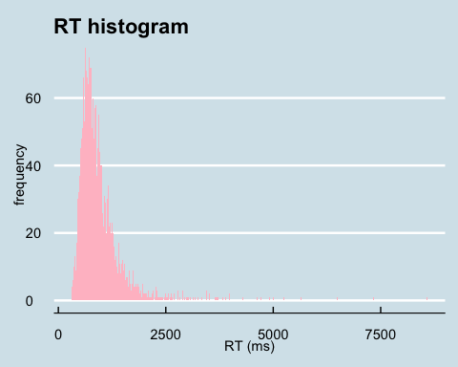
data2 %>% ggplot(aes(x=log10_rt)) + geom_histogram(binwidth =0.1, fill="pink" ) + theme_economist() + labs(x="log10(rt)", y="frequency", title= "RT histogram")
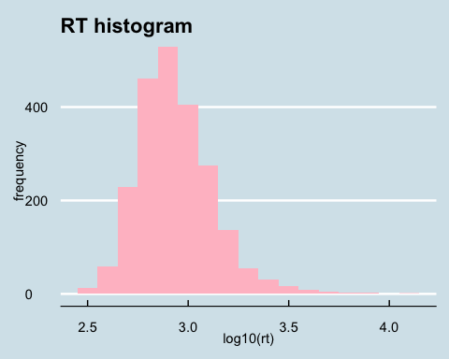

subject means
subject_means <- data2 %>% group_by(subject, trialcondition) %>% summarise(subj_meanLog=mean(log10_rt), subj_meanRT=mean(rt))
## `summarise()` has grouped output by 'subject'. You can override using the
## `.groups` argument.

outliers
outliers <- subject_means %>% group_by(trialcondition) %>% identify_outliers(subj_meanLog)
outlier_exclusion <- outliers %>% filter(is.extreme=="TRUE")
subject_means <- subject_means %>% filter(!subject %in% outlier_exclusion)
## 1 extreme outlier removed > N = 97
## subject_means <- subject_means %>% filter(!subject %in% outliers)

condition means, SEM calculation
condition_meansRT <- subject_means %>% group_by(trialcondition) %>% summarise(mean=mean(subj_meanRT), sd=sd(subj_meanRT))
n= subject_means %>% group_by(subject) %>% n_groups()
condition_meansRT <- condition_meansRT %>% mutate(SEM=sd/sqrt(n))

graph
condition_meansRT %>% separate(trialcondition, into = c("sentence_type","picture_type"), sep="-") %>% ggplot(aes(x=picture_type, y=mean, fill=sentence_type)) + geom_col(position = "dodge") + labs(x="picture type", y="RT (ms)", title = "RT interaction of picture and sentence type") + geom_errorbar(aes(ymin= (mean - SEM), ymax= (mean + SEM)), width=.25, position=position_dodge(width=0.9)) + theme_economist_white() + scale_fill_economist()
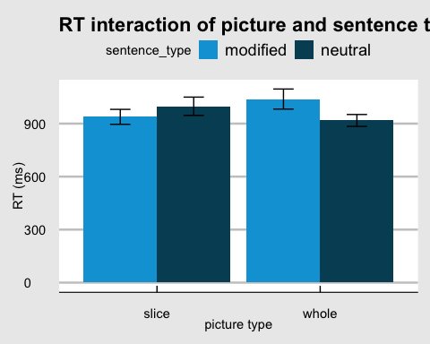
ggsave("slicing_graph1.jpeg")
## Saving 5 x 4 in image
subject_means_split <- subject_means %>% separate(trialcondition, into=c("sentence","picture"), sep="-")
subject_means_split <- subject_means_split %>% ungroup()
RManova <- anova_test(data = subject_means_split, dv=subj_meanLog, wid = subject, within = c(sentence, picture), effect.size = "pes")
get_anova_table(RManova)
## ANOVA Table (type III tests)
##
## Effect DFn DFd F p p<.05 pes
## 1 sentence 1 95 2.749 0.101000 0.028
## 2 picture 1 95 1.504 0.223000 0.016
## 3 sentence:picture 1 95 13.728 0.000355 * 0.126

conduct post-hoc tests (if needed)
##decomposing significant interaction
subject_means_split %>% group_by(picture) %>% anova_test(dv=subj_meanLog, wid = subject, within = sentence, effect.size = "pes") %>% get_anova_table() %>% adjust_pvalue(method = "bonferroni")
## # A tibble: 2 × 9
## picture Effect DFn DFd F p `p<.05` pes p.adj
## <chr> <chr> <dbl> <dbl> <dbl> <dbl> <chr> <dbl> <dbl>
## 1 slice sentence 1 96 4.65 0.034 * 0.046 0.068
## 2 whole sentence 1 95 11.3 0.001 * 0.106 0.002

