object-state-changes-and squashability

import packages
library(tidyverse)
## ── Attaching packages ─────────────────────────────────────── tidyverse 1.3.2 ──
## ✔ ggplot2 3.3.6 ✔ purrr 0.3.4
## ✔ tibble 3.1.8 ✔ dplyr 1.0.10
## ✔ tidyr 1.2.1 ✔ stringr 1.4.1
## ✔ readr 2.1.3 ✔ forcats 0.5.2
## ── Conflicts ────────────────────────────────────────── tidyverse_conflicts() ──
## ✖ dplyr::filter() masks stats::filter()
## ✖ dplyr::lag() masks stats::lag()
library(ggplot2)
library (ggthemes)
library(rstatix)
##
## Attaching package: 'rstatix'
##
## The following object is masked from 'package:stats':
##
## filter
library(ggpubr)
library(emmeans)
library(dplyr)

import data
##read prolific and sona data
prolific1 = read_csv("data/prolific_1.csv")
## Rows: 17701 Columns: 30
## ── Column specification ────────────────────────────────────────────────────────
## Delimiter: ","
## chr (19): failed_images, failed_audio, failed_video, typeoftrial, trial_typ...
## dbl (5): subject, trial_index, time_elapsed, run_id, condition
## lgl (5): success, timeout, ip, Experiment, correct
## dttm (1): recorded_at
##
## ℹ Use `spec()` to retrieve the full column specification for this data.
## ℹ Specify the column types or set `show_col_types = FALSE` to quiet this message.
prolific2 = read_csv("data/prolific_2.csv")
## Rows: 4256 Columns: 30
## ── Column specification ────────────────────────────────────────────────────────
## Delimiter: ","
## chr (19): failed_images, failed_audio, failed_video, typeoftrial, trial_typ...
## dbl (5): subject, trial_index, time_elapsed, run_id, condition
## lgl (5): success, timeout, ip, Experiment, correct
## dttm (1): recorded_at
##
## ℹ Use `spec()` to retrieve the full column specification for this data.
## ℹ Specify the column types or set `show_col_types = FALSE` to quiet this message.
sona_data = read_csv("data/sentence-content-judgement-sona.csv")
## Rows: 1562 Columns: 31
## ── Column specification ────────────────────────────────────────────────────────
## Delimiter: ","
## chr (19): failed_images, failed_audio, failed_video, typeoftrial, trial_typ...
## dbl (6): subject, trial_index, time_elapsed, run_id, condition, sona_id
## lgl (5): success, timeout, ip, correct, Experiment
## dttm (1): recorded_at
##
## ℹ Use `spec()` to retrieve the full column specification for this data.
## ℹ Specify the column types or set `show_col_types = FALSE` to quiet this message.
#compare number of columns: 30 vs 31
ncol(prolific1)
## [1] 30
ncol(prolific2)
## [1] 30
ncol(sona_data)
## [1] 31
colnames(prolific1)
## [1] "success" "timeout" "failed_images"
## [4] "failed_audio" "failed_video" "typeoftrial"
## [7] "subject" "trial_type" "trial_index"
## [10] "time_elapsed" "internal_node_id" "run_id"
## [13] "condition" "recorded_at" "source_code_version"
## [16] "ip" "user_agent" "device"
## [19] "browser" "browser_version" "platform"
## [22] "platform_version" "rt" "response"
## [25] "Experiment" "stimulus" "list_number"
## [28] "trialcondition" "correct" "question_order"
colnames(prolific2)
## [1] "success" "timeout" "failed_images"
## [4] "failed_audio" "failed_video" "typeoftrial"
## [7] "subject" "trial_type" "trial_index"
## [10] "time_elapsed" "internal_node_id" "run_id"
## [13] "condition" "recorded_at" "source_code_version"
## [16] "ip" "user_agent" "device"
## [19] "browser" "browser_version" "platform"
## [22] "platform_version" "rt" "response"
## [25] "Experiment" "stimulus" "list_number"
## [28] "trialcondition" "correct" "question_order"
colnames(sona_data)
## [1] "success" "timeout" "failed_images"
## [4] "failed_audio" "failed_video" "typeoftrial"
## [7] "subject" "trial_type" "trial_index"
## [10] "time_elapsed" "internal_node_id" "run_id"
## [13] "condition" "recorded_at" "source_code_version"
## [16] "ip" "user_agent" "device"
## [19] "browser" "browser_version" "platform"
## [22] "platform_version" "sona_id" "rt"
## [25] "stimulus" "response" "list_number"
## [28] "trialcondition" "correct" "Experiment"
## [31] "question_order"
#delete extra column in sona
sona_data <- sona_data %>% select(-c(sona_id))

bind Prolific + Sona
final_data = rbind(prolific1, prolific2, sona_data)

basic descriptives
final_data %>% pull(subject) %>% unique()
## [1] 81241 NA 77973 36136 62209 83288 57004 85835 53188 99915 69542 69828
## [13] 6903 866 98361 58810 56935 2004 24944 54589 28127 13294 32134 34705
## [25] 26326 622 64276 3749 47498 45280 70601 20292 2475 6219 75875 56420
## [37] 41201 14486 23632 60261 86063 39957 82820 94723 93281 93323 24856 93417
## [49] 7333 84410 87962 36339 28566 5637 44899 35745 86307 8328 48052 64524
## [61] 86113 26699 781 25870 52894 15911 7440 15923 75762 83953 87707 25370
## [73] 38548 54791 1798 5372 49182 70075 40717 14467 38134 69859 79139 55978
## [85] 19574 46129 33695 50974 2435 38529 30029 53686 74454 79577 26707 45203
## [97] 67220 87788 24075 71296 99038 99802 94288 3888 68576 71373
## N(initial) = 105
## note: R counts 'NA' as a participant
final_data %>% group_by(subject) %>% count()
## # A tibble: 106 × 2
## # Groups: subject [106]
## subject n
## <dbl> <int>
## 1 622 219
## 2 781 219
## 3 866 219
## 4 1798 219
## 5 2004 219
## 6 2435 219
## 7 2475 219
## 8 3749 219
## 9 3888 219
## 10 5372 219
## # … with 96 more rows
sona_data %>% pull(subject) %>% unique()
## [1] 71296 NA 99038 99802 94288 3888 68576 71373

exclusions
##exclude filler, practice, and non-picture trials
data <- final_data %>% filter(typeoftrial=="picture" & !(trialcondition %in% c("filler", "practice")))
##calculate subject accuracy
data <- data %>% mutate(accuracy=ifelse(correct=="TRUE",1,0))
subject_accuracy <- data %>% group_by(subject) %>% summarise(TaskAccuracy=mean(accuracy))
##exclude incorrect responses
data <- data %>% filter(accuracy==1)
##exclude subjects with accuracy > 60%
InaccurateSubjects <- subject_accuracy %>% filter(TaskAccuracy < 0.6)
data <- data %>% filter(!subject %in% InaccurateSubjects$subject)
##total participants after exclusion: N = 103 (2 excluded--33%, 58% accuracy)
data %>% pull(subject) %>% unique()
## [1] 81241 77973 36136 62209 83288 57004 85835 53188 99915 69542 69828 6903
## [13] 866 98361 58810 56935 2004 24944 54589 28127 13294 32134 34705 26326
## [25] 622 64276 3749 47498 45280 70601 20292 2475 75875 56420 41201 14486
## [37] 23632 60261 86063 39957 82820 94723 93281 93323 24856 93417 7333 84410
## [49] 87962 36339 28566 5637 44899 35745 86307 8328 48052 64524 86113 26699
## [61] 781 25870 52894 15911 7440 15923 75762 83953 87707 25370 38548 54791
## [73] 1798 49182 70075 40717 14467 38134 69859 79139 55978 19574 46129 33695
## [85] 50974 2435 38529 30029 53686 74454 79577 26707 45203 67220 87788 24075
## [97] 71296 99038 99802 94288 3888 68576 71373

transforming RT
##make rt numeric
data <- data %>% mutate(rt = as.numeric(rt))
## rt histogram ----does NOT look normally distributed (positive skew)
data %>% filter(rt <10000) %>% ggplot(aes(x=rt)) + geom_histogram(binwidth =20, fill="pink" ) + theme_economist() + labs(x="RT (ms)", y="frequency", title= "RT histogram")
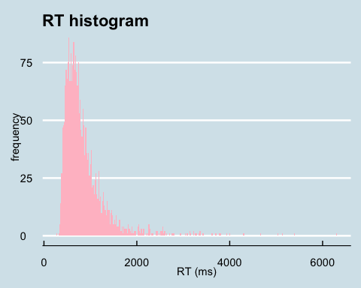
##rt log (base 10) transformation
data <- data %>% mutate(log10_rt=log(rt, 10))
##log10(rt) histogram
data %>% ggplot(aes(x=log10_rt)) + geom_histogram(binwidth =0.1, fill="pink" ) + theme_economist() + labs(x="log10(rt)", y="frequency", title= "RT histogram")
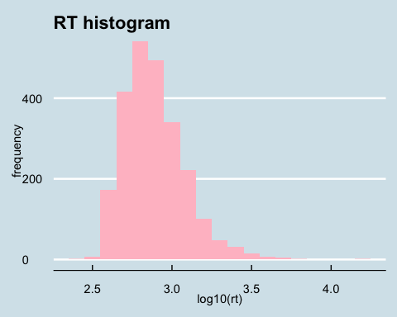
##looks fairly normal now

compute mean RTs
##Here are each subjects' means for all 4 conditions, and then the overall means for each condition...
subjectMeans<- data %>% group_by(subject, trialcondition) %>% summarise(subj_mean=mean(log10_rt), subj_meanRaw=mean(rt))
## `summarise()` has grouped output by 'subject'. You can override using the
## `.groups` argument.
conditionMeans <- data %>% group_by(trialcondition) %>% summarise(conditionMean=mean(log10_rt))

check assumptions

identify and remove outliers
outliers <- subjectMeans %>% group_by(trialcondition) %>% identify_outliers(subj_mean)
outlier_exclusion <- outliers %>% filter(is.extreme=="TRUE")
#filter extreme outliers
subjectMeans1 <- subjectMeans %>% filter(!subject %in% outlier_exclusion$subject)
##filtering all outliers
subjectMeans2 <- subjectMeans %>% filter(!subject %in% outlier_exclusion$subject)
subjectMeans1 %>% pull(subject) %>% unique()
## [1] 622 781 866 1798 2004 2435 2475 3749 3888 5637 6903 7333
## [13] 7440 8328 14467 14486 15911 15923 19574 20292 23632 24075 24856 24944
## [25] 25370 25870 26326 26699 26707 28127 28566 30029 32134 33695 34705 35745
## [37] 36136 36339 38134 38529 38548 39957 40717 41201 44899 45203 45280 46129
## [49] 47498 48052 49182 50974 52894 53188 53686 54589 54791 55978 56420 56935
## [61] 57004 58810 60261 62209 64276 64524 67220 68576 69542 69828 69859 70075
## [73] 70601 71296 71373 74454 75762 75875 77973 79139 79577 81241 82820 83288
## [85] 83953 84410 85835 86063 86113 86307 87707 87788 87962 93281 93323 93417
## [97] 94288 94723 98361 99038 99802
subjectMeans2 %>% pull(subject) %>% unique()
## [1] 622 781 866 1798 2004 2435 2475 3749 3888 5637 6903 7333
## [13] 7440 8328 14467 14486 15911 15923 19574 20292 23632 24075 24856 24944
## [25] 25370 25870 26326 26699 26707 28127 28566 30029 32134 33695 34705 35745
## [37] 36136 36339 38134 38529 38548 39957 40717 41201 44899 45203 45280 46129
## [49] 47498 48052 49182 50974 52894 53188 53686 54589 54791 55978 56420 56935
## [61] 57004 58810 60261 62209 64276 64524 67220 68576 69542 69828 69859 70075
## [73] 70601 71296 71373 74454 75762 75875 77973 79139 79577 81241 82820 83288
## [85] 83953 84410 85835 86063 86113 86307 87707 87788 87962 93281 93323 93417
## [97] 94288 94723 98361 99038 99802
## 14 outliers, 3 extreme outliers, 3 exclusions

check normality
##shapiro test
subjectMeans1 %>% group_by(trialcondition) %>% shapiro_test(subj_mean)
## # A tibble: 4 × 4
## trialcondition variable statistic p
## <chr> <chr> <dbl> <dbl>
## 1 Squashable_Normal subj_mean 0.982 0.182
## 2 Squashable_Smashed subj_mean 0.975 0.0521
## 3 Unsquashable_Normal subj_mean 0.980 0.128
## 4 Unsquashable_Smashed subj_mean 0.980 0.136
##all have p>0.05, but squash-Smashed condition is close at p=0.052. Data satisfies normality condition?
##qqplot....plots look fine, not perfect
subjectMeans1_split <- subjectMeans1 %>% separate(trialcondition, into=c("squashability","state"), sep="_")
ggqqplot(subjectMeans1_split, "subj_mean", ggtheme = theme_bw()) + facet_grid(squashability ~ state, labeller = "label_both")
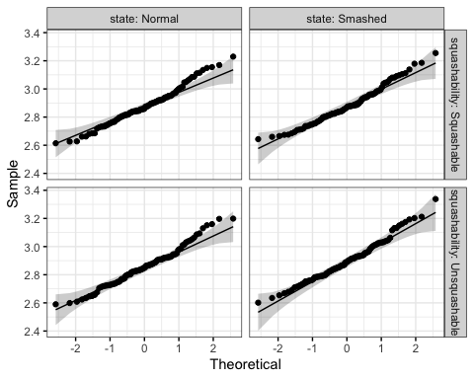

conduct repeated-measures anova
subjectMeans1_split <- subjectMeans1_split %>% ungroup()
RManova <- anova_test(data = subjectMeans1_split, dv=subj_mean, wid = subject, within = c(squashability, state), effect.size = "pes")
get_anova_table(RManova)
## ANOVA Table (type III tests)
##
## Effect DFn DFd F p p<.05 pes
## 1 squashability 1 100 0.017 0.896000 0.000172
## 2 state 1 100 15.650 0.000143 * 0.135000
## 3 squashability:state 1 100 12.013 0.000780 * 0.107000
##no significant main effect for squashability
##significant main effect for state, significant interaction
##no sphericity violation

conduct post-hoc tests (if needed)
##decomposing significant interaction
subjectMeans1_split %>% group_by(squashability) %>% anova_test(dv=subj_mean, wid = subject, within = state, effect.size = "pes") %>% get_anova_table() %>% adjust_pvalue(method = "bonferroni")
## # A tibble: 2 × 9
## squashability Effect DFn DFd F p `p<.05` pes p.adj
## <chr> <chr> <dbl> <dbl> <dbl> <dbl> <chr> <dbl> <dbl>
## 1 Squashable state 1 100 0.025 0.875 "" 0.000249 1
## 2 Unsquashable state 1 100 26.1 0.00000155 "*" 0.207 0.0000031
#### squashable: p.adj = 1.000
#### unsquashable: p.adj = .00000155 *, partial eta-squared=0.207 (large effect)
#### The RT for the unsquashable objects was significantly different depending on the state of the target object (smashed vs normal), but there was no significant difference found for squashable objects when comparing thee reaction times for normal vs smashed targets. This pattern in the the graph below shows that RTs for unsquashable objects were significantly slower when the target object was smashed compared to when they were normal. This suggests that the participants activated the normal but not the smashed state for the target object when primed by the sentence, despite the fact that a bowling ball was being dropped on it, causing a slower RT than when the normal object was shown. For the squashable objects, the data interpreted in line with the Horachak & Garrido study suggests that both the smashed and unsmashed sates were activated when primed by the bowling ball sentences, resulting in no difference between reaction times when a smashed vs normal image of thw squashable object was shown.

visualize log and raw RT pattern
conditionMeans <- subjectMeans1 %>% group_by(trialcondition) %>% summarise(rawRTmean=mean(subj_meanRaw), sd_r=sd(subj_meanRaw), LogRTmean=mean(subj_mean), sd_L=sd(subj_mean))
## SEM calculations
n= subjectMeans1 %>% group_by(subject) %>% n_groups()
conditionMeans <- conditionMeans %>% mutate(SEM_r=sd_r/sqrt(n), SEM_L=sd_L/sqrt(n))
##graphs
conditionMeans %>% separate(trialcondition, into = c("squashability","state"), sep="_") %>% ggplot(aes(x=squashability, y=rawRTmean, fill=state)) + geom_col(position = "dodge") + labs(x="object squashability", y="RT (ms)", title = "RT interaction of object state and squashability") + geom_errorbar(aes(ymin= (rawRTmean - SEM_r), ymax= (rawRTmean + SEM_r)), width=.25, position=position_dodge(width=0.9)) + theme_economist_white() + scale_fill_economist()
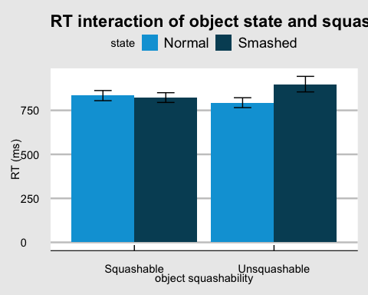
conditionMeans %>% separate(trialcondition, into = c("squashability","state"), sep="_") %>% ggplot(aes(x=squashability, y=LogRTmean, fill=state)) + geom_col(position = "dodge") + labs(x="object squashability", y="log10(RT)", title = "log10(RT) interaction of object state and squashability") + geom_errorbar(aes(ymin= (LogRTmean - SEM_L), ymax=(LogRTmean + SEM_L)), width=.25, position=position_dodge(width=0.9)) + theme_economist_white() + scale_fill_economist()
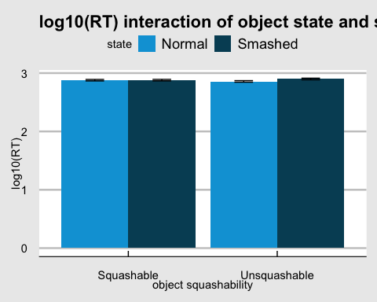 ## Demographic Info
d = final_data
demo = d %>% filter(typeoftrial %in% c("demo", "english") & response != "0") %>%
separate(response, into = c("demo1", "demo2", "demo3", "demo4"), sep = ":")
## Warning: Expected 4 pieces. Missing pieces filled with `NA` in 361 rows [2, 4,
## 5, 7, 9, 10, 12, 14, 15, 17, 19, 20, 22, 24, 25, 27, 29, 30, 32, 34, ...].
age = demo %>% filter(demo1 == "{\"Age\"") %>% select(demo2) %>%
mutate(age = as.numeric(gsub("[^[:digit:] ]", "", demo2)))
age %>% summarise(mean_age = mean(age))
## # A tibble: 1 × 1
## mean_age
## <dbl>
## 1 32.4
race = demo %>% filter(demo1 == "{\"Race\"") %>% select(demo2)
race %>% group_by(demo2) %>% count()
## # A tibble: 8 × 2
## # Groups: demo2 [8]
## demo2 n
## <chr> <int>
## 1 "[\"Asian\",\"White/Caucasian\"]}" 1
## 2 "[\"Asian\"]}" 4
## 3 "[\"Black/African American\",\"White/Caucasian\",\"More than once race\… 1
## 4 "[\"Black/African American\"]}" 20
## 5 "[\"More than once race\"]}" 5
## 6 "[\"Other\"]}" 3
## 7 "[\"White/Caucasian\",\"More than once race\"]}" 3
## 8 "[\"White/Caucasian\"]}" 68
gender_education = demo %>% filter(demo1 == "{\"Age\"") %>% select(demo3) %>%
separate(demo3, into = c("gender", "education"), sep = ",") %>%
mutate(gender = tolower(gender),
gender = gsub("[[:space:]]", "", gender))
gender_education %>% group_by(gender) %>%
count()
## # A tibble: 8 × 2
## # Groups: gender [8]
## gender n
## <chr> <int>
## 1 "\"cisgenderwoman\"" 1
## 2 "\"f\"" 1
## 3 "\"female\"" 52
## 4 "\"m\"" 1
## 5 "\"make\"" 1
## 6 "\"male\"" 47
## 7 "\"man\"" 1
## 8 "\"non-binary\"" 1
gender_education %>% group_by(education) %>%
count()
## # A tibble: 1 × 2
## # Groups: education [1]
## education n
## <chr> <int>
## 1 "\"Education\"" 105
first_lang = demo %>% filter(demo1 == "{\"English\"") %>% select(demo2)
first_lang %>% group_by(demo2) %>% count()
## # A tibble: 2 × 2
## # Groups: demo2 [2]
## demo2 n
## <chr> <int>
## 1 "\"No\"}" 6
## 2 "\"Yes\"}" 99
"18-19" =(age %>% filter(c(age) <= 19 & c(age) >= 18) %>% count())
"20-29" = (age %>% filter(c(age) <= 29 & c(age) >= 20) %>% count())
"30-39" = (age %>% filter(c(age) <= 39 & c(age) >= 30) %>% count())
"40-49" = age %>% filter(c(age) <= 49 & c(age) >= 40) %>% count()
"50-59" = (age %>% filter(c(age) <= 59 & c(age) >= 50) %>% count())
"60+" = (age %>% filter(c(age) >= 60) %>% count())

