Timothy Helfant

1. Pwd

Result --/home/sysadmin

1. cd /etc

result-- /etc

1. cd ~

result-- /home/sysadmin

1. cd /boot/grub

result-- /boot/grub

1. cd /..

result-- /

1. currently in /
2. ls -l /etc

result list of everything in /etc

1. ls -a /home

result--- . .. sysadmin

1. ls -h /boot
2. mkdir newdir
3. mkdir -p dir1/dir2/dir3
4. cp -r ~/dir1/. ~/newdir
5. touch newdir/{file1,file2,file3}.txt
6. echo “Saturday Sunday” > ~/newdir/weekend.txt
7. cd newdir

mv weekend.txt ../

1. vi weekend.txt

pressed I for insert

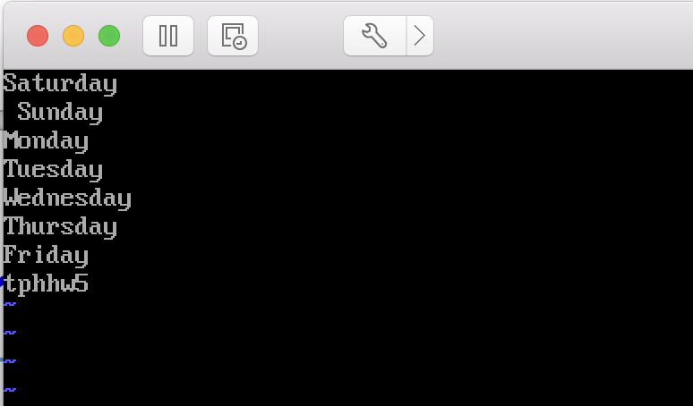

:wq to save and exit

1. mv weekend.txt week.txt
2. tail -n 5 week.txt

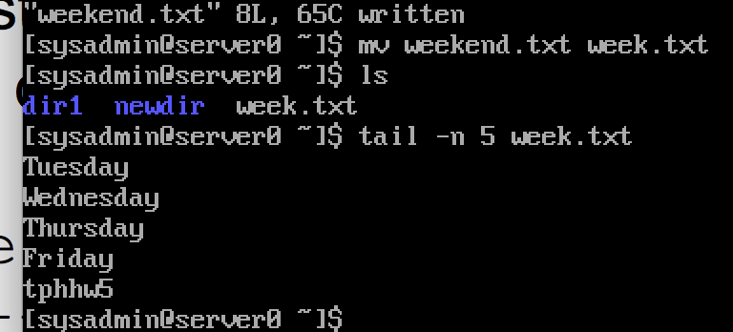

1. above
2. rm -r newdir dir1