Music Downloader Pseudo Plan

Patrick Olaires (thelibraryoflovenebula)

Table of Contents

Program Outline 3
1. Signal component 4
2. Soulseek component 4
3. File component 4

Program Outline
The program is abstracted into three main components. Each component differs in difficulty that challenges my current level of expertise. Each component is also responsible for a specific section of the program. Signal components operate the inputs, includes a watcher. The Soulseek component aims to work directly with the Soulseek program. File component handles the final touches with file organizations.

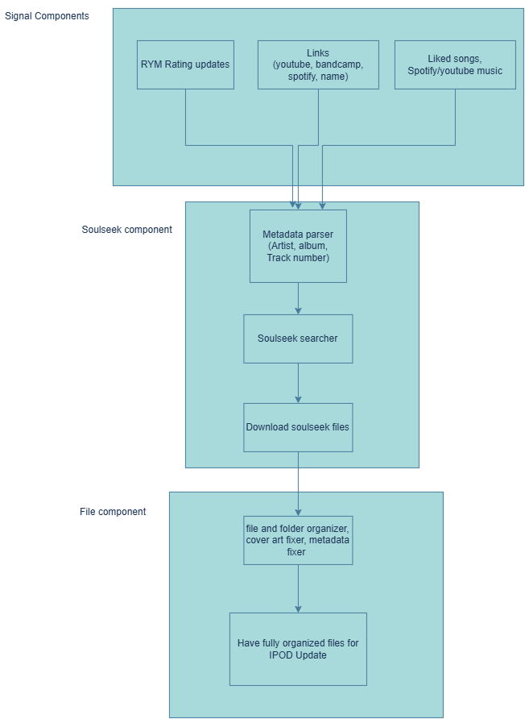

Signal component

Soulseek component

File component

Metadata of the completed downloads is manipulated and handled according to my standards in this component. It batches up downloads into waves/updates. Cutoff’s are updates to my iPod, meaning that a batch has been imported into my iPod. A counter must keep track of version updates.

File Output Guidelines:
- Naming Convention of folders -> artistName/albumName/tracks
- Track names - > trackNumber trackName
- Updates come in waves -> “4th impact” … Download… “5th impact”.... So on…

Applicable programs for this component:
- mp3Tag: application that enables scripting of manipulation with mp3 files
- SupltsZaire/rockbox-cover-art-fixer/: Github application that fixes cover art of files, to be displayable onto my iPod

