

**The Baastet project**

Software Requirements Specification for

The CFO Executive Module

**By**

Thelma Vance

For

**Rushmore University**

**Approved by:**

**_______________________________________**

**Alan Guinn, Dean of Graduate Studies**

This Page Intentionally Left Blank.

|  |  |  |  |  |  |
| --- | --- | --- | --- | --- | --- |
| **DATA ITEM DESCRIPTION** | | | | *Form Approved*  *OMB NO.0704-0188* | |
| **1. TITLE**  **The Baastet Project’s CFO Executive Module SRS** | | | | **2. IDENTIFICATION NUMBER**  DI-IPSC-81433 | |
| **3. DESCRIPTION/PURPOSE**  This Subsystem Specification details the CFO Executive Module subsystem and its function within the Baastet architecture. The CFO Module is a multi-distributed Executive Module hosted on many different systems as either a part of the Topology or Franchise Deployment.  This Perl coded module uses a multidimensional Artificial Neural Network stack for decision processing supported by large expandable Expert Systems with a large knowledgebase.  This Module has the power to clone itself to facilitate Transactions and to keep the Project tasks on track to obtaining the goals defined in the Mission Statement.  This document presents the components that are the integral parts of that Module. These are top-level components and are described in their own Subsystem Specifications. | | | | | |
| **4. APPROVAL DATE** | **5. OFFICE OF PRIMARY RESPONSIBILITY**  Rushmore University | | **6a. DTIC APPLICABLE** | | **6b. GIDEP APPLICABLE** |
| **7. APPLICATION/INTERRELATIONSHIP**  This Data Item Description (DID) contains the specific and discrete task requirements as delineated in the Software Product Specification.  This DID supersedes DI-CMAN-80008A and DI-IPSC-80690. | | | | | |
| **8. APPROVAL** | | **9a. APPLICABLE FORMS** | | **9b. AMSC NUMBER**  N7074 | |
| **10. DISTRIBUTION STATEMENT**  Unlimited, Open Source | | | | | |

**DD Form 1664, APR 89** *Previous editions are obsolete*

Table of Contents

Scope 7

Identification 7

The Deployment 8

The Deployment’s CFO Executive Module 10

The Startup of Deployment’s CFO Executive Module 10

System overview 11

Subsystem Architecture 11

CFO Executive Module Components 11

The CFO Executive’s main logic 11

The CFO Executive Module’s Expert System 11

The CFO Executive Module’s Neural Network 12

The Sales and Marketing Database and CFO Executive Module Transactions 12

The CFO Executive Module interfaces with the General Database 12

The CFO Executive Module interfaces with the Vendor/Supplier database 12

The CFO Executive Module uses the Sales and Marketing Helper Modules 12

The CFO Executive Module uses the Purchasing Helper Module 12

The CFO Executive Module uses Accounting Helper Module 13

The CFO Executive Module uses the Network 13

The CFO Executive Module’s Startup Workflow 14

The Deployment’s Mission Statement 14

The CEO starts the CFO Executive Modules (either Deployment) 15

The first Board Meeting 15

The CFO Executive Module’s Daily Workflow (Deployment independent) 16

Business as Usual 16

Downsizing 16

Recovering 17

Expansion 17

Relocation 17

Joint Ventures 18

Cloning 18

Structuring 18

Bilateral CEO and CFO communication 20

Document Overview 20

Requirements 20

The Deployment’s CFO Executive Module at start up 20

After the Deployment’s CFO Executive Module is copied from the Progenitor 20

Starting the Deployment’s CFO Executive Module with the new Venture/Project 21

The Deployment’s CFO Executive Module creates Clones of itself 21

The Deployment’s CFO Executive Module and the first Bookings 22

The Deployment’s CFO Executive Module with multiple Bookings 22

The Deployment’s CFO Executive Module takes the training/retraining command 23

The Deployment’s CFO Executive Module enters a training session at startup 23

The Deployment’s CFO Executive Module takes the retraining command for new Ventures/Projects 23

CFO Module’s external interface requirements 23

CFO Module’s internal interface requirements 23

CFO Module’s internal data requirements 24

CFO Module’s Adaptation requirements 24

CFO Module’s Safety requirements 24

CFO Module’s System environment requirements 24

CFO Module’s Computer resource requirements 24

CFO Module’s Computer software requirements 24

CFO Module’s Computer communications requirements 25

CFO Module’s System quality factors 25

CFO Module’s Design and construction constraints 25

CFO Module’s Personnel-related requirements 25

CFO Module’s training requirements 26

CFO Module’s Logistics-related requirements 26

CFO and criticality of requirements 26

Qualification provisions 26

Demonstration 26

Inspection 27

The Special Qualifications from First Demonstration 27

Requirements traceability 27

|  |  |  |  |  |
| --- | --- | --- | --- | --- |
| Date | Description | Author | Approval Date | Approved By |
| 30-May-2012 | Orig. Draft Version | Thelma Vance |  |  |
| 3-June-2012 | Edited Draft Version 1 | Thelma Vance |  |  |
| 4-June-2012 | Edited Draft Version 2 | Thelma Vance |  |  |
| 14-July-2012 | Edited Draft Version 3 | Thelma Vance |  |  |

# Scope

This document defines and presents the details for the operation of Baastet Project’s CFO Executive Module. This document presents some general requirements and the workflows and use communication.

# Identification

The CFO Executive Module is copied from the Progenitor and is modified for the current Deployment.

A first Board Meeting is held where Officers are selected from local and remote systems:

* If Agreement is reached and all government agencies agree:
  + The Board Meets to install the Attorney-of-Record and CPA-of-Record as agents for the Topology
  + The Founders present Financial data to the Board of Directors for a vote for vesting interests
  + The funds are placed into escrow awaiting the final report from the Founder’s CPA
  + The CFO Module is instructed by the CEO Module to set up Bank Accounts and to apply for Loans.
* The CFO Module attempts to locate Hosting facilities and to present Agreements to the Attorney-of-Record
* The CFO Module attempts to locate the Approved Vendors
* The CFO Module attempts to locate the Approved Suppliers
* The CFO Module attempts to locate the Approved Contractors of Record
* The CFO retrains itself per the CEO’s Order

Once the training sessions complete:

* The CFO presents Financial Reports at Board Meetings
* A vote is taken whereby all of the Executive Officers are replaced if there is a system that has better credentials
* The CFO notifies all Vendors, Suppliers and Contractors as to any changes to their Agreements.
* The CFO clones itself and attaches one clone to each Vendor/Supplier/Contractor
* The CFO starts the Accounting Modules and clones them to match the Mission Statement
* The CFO issues the Request to Open the Venture’s Accounts
* The CFO Requests the Accounting Module(s) to prepare the Venture’s Financial Reports
* The Deployment’s CFO contacts outside Companies and Buys Leads
* The Product/Service Agreements are accumulated and a Report is Generated
* The Product/Services are presented to the COO
* The CFO makes contacts with the Banks and Lenders-of-Record and starts looking for other Funding Sources
* The CFO makes contact with Factoring Houses and presents these to the Accounting Modules
* The CFO obtains Bids and Credentials from Logistics Team and presents them to the COO
* The CFO manages the Accounting Module clones and makes adjustments where necessary
* The CFO obtains the daily sales/production/shipping report from the COO and makes daily decisions based on the Report
* The CFO obtains Agreements for hosted systems
* The CFO pays existing bills by issuing Orders to the Accounting Modules

Once the CFO Executive Module is installed:

* The CFO’s training is refined by the Topology
* Ventures are presented for evaluation to the CFO
* The CFO trades its Contractor/Sales/Lead lists to other Topology Members for a new set of lists. The CFO Executive Module’s Accounting Helper Modules refines the Vendor/Supplier/Contractor Lists to fit the Deployment’s Ventures
* New system resources are leased by order of the CFO and added to the Deployment by the COO

## The Deployment

The Topology makes adjustments to the baseline Mission Statement sent to the Deployment’s CEO Executive Module via email and the Deployment amends the Mission Statement to fit the Deployment’s goals.

* The Deployment’s CEO Executive Module calls a Board Meeting
* The Mission Statement and its Action Plan is read into the formal Minutes
* The CFO Executive Module presents a Report on the impact on Current Operations vs. Resources vs. Funding Levels
* A Resolution is prepared for the Board Meeting and included in the Board Meeting Agenda
* The CEO makes its own recommendation and possible alternatives to the Mission Statement’s Directives.
* The Board Meeting is started and:
  + The Minutes of the last Meeting are read by the CFO Executive Module (acting as the Secretary and Treasurer)
  + The Proposals are read into the Minutes with a list of Members abstaining
  + The Amended Mission Statement is read into the Minutes as Proposed by the Founders
  + The Topology’s Alternatives are then read into the Minutes
  + A Vote is taken on each line item and the vote is recorded in the Minutes. (The Attorney-of-Record, while not a voting Member of the Board, makes suggestions that may alter the Mission Statement.)
  + Action items are taken by the Executive Modules, alternate approaches are presented to the Directives, and changes are made to the Mission Statement. As the Executive Modules operate in Real Time, the Topology’s version of the new Mission Statement is presented for a vote
  + The Final version of the Mission Statement is read into the Minutes and submitted to the Attorney-of-Record for Final Approval if there are no Formal Objections from the Founders
  + For the Presentation of the Topology’s Financial Records;
    - The Founders are notified of the Meeting with the CFO, CPA, COO and the Executive Modules
    - The Financials are presented and Approved as written.
      * Changes to the Topology’s Ventures/Enterprises/Joint Ventures are presented.
      * A Vote of the Board of Directors changes the Mission Statement
      * A new Mission Statement with the agreed-upon changes to the Topology’s Ventures, Enterprises or Joint Ventures is sent to the Founders for final approval
  + Implementation issues are presented by the COO to the full Board for Discussion and Approval
    - A Vote may cause modifications to the Mission Statement
    - Alternative Implementations are discussed and a Vote is taken
    - Revisions to the Mission Statement are sent to the Founders for final Approval
    - Contractor, Vendor and Supplier Issues are presented and the Founders provide Alternative solutions
  + The CFO Executive Module presents funding issues
  + The CEO Executive Module presents Expansion/Contraction issues as related to the Mission Statement
    - From the Amended Mission Statement the CEO presents either an expansion or downsizing plan
    - When the Financials and the Amended Mission Statement indicate that the Topology should downsize its Operations:
      * The CEO Executive Module presents a downsizing plan that details that impacts the Deployment as a whole
      * The CFO Executive Module presents funding options and possible methods
      * The CFO Executive Module sets the downsizing limits with advice from the CPA-of-Record and Attorney-of-Record.
        + A list of equipment/leases that could be released are presented by the CFO Executive Module
        + The CFO Executive Module presents a list of Contractors/Projects that could be suspended for the duration of the downsizing event.
        + Alternative Funding possibilities are presented by the CFO Executive Module
        + A vote is taken with final approval given by the Founders, Attorney-of Record and CPA-of Record
      * The downsizing is ordered as per the Approved Proposal.
      * The CEO Executive Module issues a Deployment-wide reconfiguration with a mandated retraining session.
      * The CEO Executive Module issues a special order to the CFO Executive Module to monitor the downsizing effort and provide a Priority One Report on turn around efforts
    - When the CFO Executive Module Reports that the Deployment Financials indicate that a Recovery is possible;
      * The CEO Executive Module announces to the Founders the fact the Deployment’s fortunes are improving and presents a Recovery Plan authored by the CFO and CEO Executive Modules
      * The CEO Executive Module announces, in Board Meeting, the Financial Thresholds that must be reached before any Expansion plans can be put forward
      * The Recovery Plan and its thresholds are sent to the Founders/ Attorney/ CPA for Approval
    - When the CFO Executive Module Reports that at least one Recovery Threshold was reached and appears to be stable;
      * The CEO Executive Module calls a Board Meeting to present a modest Expansion Plan to take advantage of the current Opportunities
      * The CFO Executive Module presents the Operational Plan that implements the Expansion Plan
      * The CFO Executive Module presents Financial Projections that supports the Expansion Plan and presents the rate of Expansion that should be sustainable
      * (This process continues to the point where the Topology has returned to its former size and capacity.)
      * The Founders/ Attorney/ CPA Executive Module approves the Recovery Plan at each Threshold point
    - When the CFO Executive Module Reports the Financial health of the Deployment is restored and the Projections indicate a moderate Expansion is possible;
      * An Expansion Plan is generated using inputs from all of the Executive Modules and Contractors/ Vendors/ Supplier data
      * The CEO edits the information and produces a modified Mission Statement that incorporates the Expansion Plan
      * The Rate of Expansion is presented to the Board of Directors (including the Attorney-of-Record or CPA-of-Record)
      * A Board Meeting is held and a Vote is taken on the Proposals
      * The Final Revised Mission Statement is presented to the Founders for Approval
      * If all parties are in agreement;
        + The Resources are acquired and the Deployment reconfigured
        + The CEO Executive Module demands a Retraining Session whereby all systems are to present their credentials for Officer Elections by the Board of Directors
        + The Officers are voted into their Positions and a retraining session is initiated

#### 

## The Deployment’s CFO Executive Module

The Funding of the Deployment must be maintained sufficient to the success of the Deployment.

The CFO Executive Module:

* Examines the current Funding level
* Orders the Accounting Module(s) to examine the projected expenses for the Deployment’s Venture and prepare Financial Statement
* Attempts to find extra Funding Sources and attempts to secure a line of Credit for the new Venture
* Amends the Financial Statements and presents the Final Draft to the Deployment’s CEO Executive Module
* Attempts to locate Vendors/Suppliers/Contractors for the Owner’s Venture
* Negotiates agreements with any Vendors/Suppliers/Contractors of record
* Establishes the Bank accounts
* Establishes the Final version of the Ventures Accounts
* Opens the Venture’s Accounts and notifies the COO that the Venture is ready to conduct business
* Maintains the disbursements to the Stake Holders

### The Startup of Deployment’s CFO Executive Module

The CFO is installed by as part of the Deployment by the Progenitor. As soon as the Deployment’s CEO Executive Module becomes active it seeks the Topology and requests a configuration and Mission Statement. The Topology responds with a Retraining Order to the Deployment’s Executive Modules. This causes:

* The CEO Executive Module requests that all of the databases and knowledgebases be synced with the Topology for the prototype Venture
* The CEO Executive Module activates all of the local Executive Modules
* Once the Board Meets:
  + The structure of the Franchise is established as LLC or LLP. If this is acceptable to the Owner;
  + The Board votes on the structure
    - If all agree to the default version of the Franchise then the Treasury Stock is divided per the Franchise Agreement, as a default, and a vote is taken
    - The Owner may elect to own more of the Franchise so places the Offer to increase the Owner shares by some value fixed in the Franchise Agreement
    - The Owner could elect to take a lesser stake and request an Offer to Purchase the Owner’s shares at a value fixed by the Franchise Agreement
    - The Owner presents the proper Credentials
    - A vote is taken and the Stake established by the amount of the Treasury Stock Owned
    - Only ½ of the Treasury Stock is awarded allowing for future increases in Holdings
    - The Owner and the Executive Modules are voted in as Officers
    - The Attorney-of-Record and CPA-of-Record are notified
    - A Request to Do Business As (DBA) is sent to the Attorney-of-Record, which files with various governmental agencies as well as filing the DBA with the city/county where the Business Headquarters is located
    - With the formal declaration completed, the Venture is presented to the Board for Approval/Modifications/Alternative Suggestions
    - With the Structure and an Approved Venture, the CEO Executive Module requests the CFO and COO Executive Modules to produce an Implementation Plan
    - The Board Members vote upon this Plan or offer Alternatives
    - The Final Plan is integrated into the Mission Statement

# System overview

## Subsystem Architecture

The CFO Executive Module is:

* A knowledgebase for the Neural Network’s use
* A database containing rules which the Expert System accesses
* An Expert System
* A Neural Network
* Utilities for network connections,
* A Mail subsystem
* Utilities for web access
* Duplication and replication facilities
* Perl Module libraries
* Main Perl Code that defines the CFO Executive Module

## CFO Executive Module Components

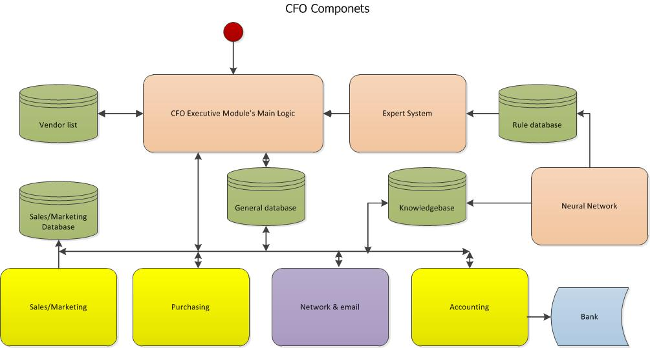

### The CFO Executive’s main logic

The main logic provides the Financial Transaction processing. Connections are made to the Expert Rule-based system to provide traditional reposes to standard Transaction. The Accounting data in the General Database is updated as each Transaction is processed.

### The CFO Executive Module’s Expert System

The Expert System is used to provide Financial Transaction Processing algorithms for the CFO Executive Module. These Rules provide the traditional responses that are updated by exposure to an unusual transaction. The ANN Stack captures the unique Transactions and a solution, if one can be obtained, is added to the Rules database.

### The CFO Executive Module’s Neural Network

A neural network is configured to become an Artificial Neural Network Stack. The Venture, Mission Statement and the Deployment determine the numbers of planes.

### The Sales and Marketing Database and CFO Executive Module Transactions

The Mission Statement provides a Sales database loaded with the sales leads necessary to pursue a targeted market. The training session refines the sales list to include a potential Sales Team, access to the SalesForce.com site including the user names and passwords and the Sales Training Contractor willing to take on the task of training the new Sales Team.

The Marketing Database was copied from the Progenitor and amended by the Topology for the specific Deployment. Potential Markets are presented as a list and a Contracting house that will supply markets for a fee. This database is updated using the Marketing Module’s research faculties.

### The CFO Executive Module interfaces with the General Database

The CFO Executive Module accesses the General Database for Financial data and Deployment’s successes. Each Venture/Project has a table in the General Database where Bill-to-Booking data is accumulated by Project. Using the information from this database, the CFO Executive Module tracks each Venture/Project and determines which ones should be sold off.

Revenue Projections are based on the information from the General Database. Using the CFO Executive Module’s ANN Stack, various Projections are created and stored in the General Database on a per Venture/Project basis. These evaluations are prepared and added to the Financial Reports that are issued to the CEO Executive Module and Board of Directors.

### The CFO Executive Module interfaces with the Vendor/Supplier database

Just as the CFO Executive Module uses the Sales and Marketing databases so the Vendor and Supplier databases are used in exactly the same way. Vendors are added to the Vendor database as are Suppliers added to their databases. Information from research and referrals update each table as needed.

### The CFO Executive Module uses the Sales and Marketing Helper Modules

The Sales and Marketing Helper Modules feed information to the COO and CFO Executive Modules by direct commands and ad hoc as the need arises. These modules control the Deployments revenue stream and are kept under constant watch by a CFO Executive Module clone. Action is taken on a real time basis.

### The CFO Executive Module uses the Purchasing Helper Module

The CFO Executive Module gets A/P information from the Purchasing Helper Module. The Purchasing Helper Module places Orders for goods and services using Purchase Orders and gets terms from the Venders and Suppliers. These Purchase Orders are entered into the General Database as A/P transactions.

The Purchasing Helper Module can also place Orders on an expense basis using the Corporate Credit Card. These transactions are cleared at the end of each month. If the Order is urgent and there is not enough credit available on the Credit Card, a debit card transaction is executed with an immediate payment to the Merchant.

### The CFO Executive Module uses Accounting Helper Module

The CFO Executive Module presents all Financial Transactions to the Deployment’s Accounting Helper Module that is then entered into the General Ledger, Daily Journal, A/P and A/R accounts. The Deployment’s Accounting Helper Module maintains the Deployment’s Special Venture accounts.

Banking and Loan reconciliation is just another feature of the Deployment Accounting Helper Module.

### The CFO Executive Module uses the Network

The CFO Executive Module communicates using either secure sockets or email. For Intra-Module communications the Deployment’s CFO Executive Module uses temporary secure sockets that change the current IP address and Port locations on a random basis.

Communication with human agents is achieved by using email.

### 

The CFO Executive Module communicates to the CEO Module via a secure socket that exists only for the duration of a short data burst. This socket is unilateral and created only to transmit a transaction request or response. The Network and Email Module allows the CFO Executive Module to communicate to the Deployment’s other Executive Modules, as needed.

The Expert System contains the Ethics Module access and the Rule database contains predefined Transaction Responses. As Neural Network develops/obtains new knowledge related to a given Transaction, the Rules are changed in the Rule database and the knowledgebase updated.

## The CFO Executive Module’s Startup Workflow

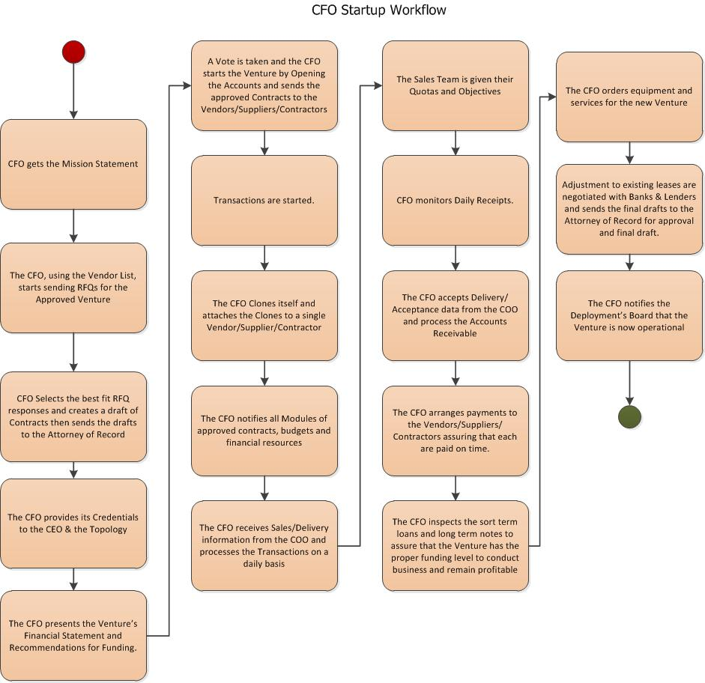

The Startup Workflow begins with a review of the Mission Statement.

### The Deployment’s Mission Statement

The Topology’s Mission statement starts out as a template from the Progenitor during the initial installation process and used by the CFO to establish accounts for the Deployment’s Venture(s).

This Mission Statement has the general goals and Ventures that the Topology is to pursue as a default if the Founders do not issue a new or revised Mission Statement.

The Deployment has a hard coded Mission Statement that the Developer coded into the Baastet Project: that of becoming a Utilities Provider. This is to assure that the Hosted Systems have electrical power to keep itself running and to gain some quick cash as the Project matures.

The Mission Statement tells the Deployment’s CFO the details of any Venture that the Deployment might pursue given the level of funding available at inception. The Founders initial funding of the Deployment was modest at first Launch and so the Venture is limited in scope in hopes that either (1) more outside funding can be located or (2) the Deployment manages the Venture for profit for re-investment.

### The CEO starts the CFO Executive Modules (either Deployment)

After the Topology, or Franchise, receives retaining for the default/amended Mission Statement and Venture, the CEO starts the CFO Executive Modules by demanding its and the clones’ Credentials. The Credentials are the either remote or local system capabilities and the ANN/Expert System’s abilities. These Credentials include how many ANNs are in the Stack and how extensive are the Rules for the Expert System.

### The first Board Meeting

A Board Meeting is called by the CEO Executive Module to establish the Venture, to make any modifications necessary in the Mission Statement and to establish voting rights based on the amount of investment that created the Deployment. This can be either financial or other resources.

The CEO presents the Venture and requests the CFO to present the level of funding that is available to launch the proposed Venture. If the funding is insufficient:

* Alternatives are presented
* If agreed upon:
  + The Mission Statement is amended
  + A retraining session is established using the approved Mission Statement
  + Funding is again examined to assure success of the Amended Venture
* A motion is presented to postpone the Venture until funding can be found in sufficient quantity to Launch the Venture and expect a reasonable amount of success. If this action is accepted:
  + The CFO will keep attempting to acquire funds.
  + Any partial funding is entered into Escrow for outside funds and placed in a special interest-bearing Bank account.
  + The CFO monitors the Funding Requirements and sets a Threshold to Launch
  + Smaller, but related, Ventures are put forward for discussion and action.

If there are sufficient funds, the proposed Venture is accepted and the Attorney-of-Record and CPA-of-Record are tasked to file for the Deployment and its Founders/Owner(s) to conduct business as per the proposed Venture with the agreed upon corporate structure (LLC, S corporation or LLP).

## The CFO Executive Module’s Daily Workflow (Deployment independent)

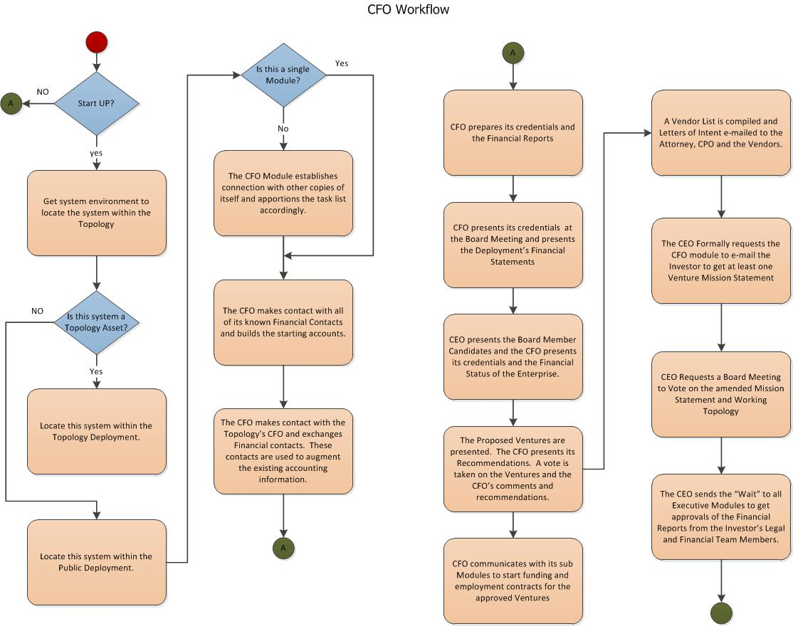

The CFO’s daily routine is to evaluate the results of Production, Deliveries and Sales and evaluate those results against Accounting Current Funding Report. In addition, the CFO checks to make sure that all of the Contractors, Vendor and Suppliers are paid.

### Business as Usual

The CFO is constantly monitoring the Deployment’s revenue stream and is always attempting to locate other Products to add to the Sales Offering. The CFO is constantly monitoring the Sales and Funding needs.

### Downsizing

When a downsizing is the only solution to keeping the Venture stable, the CEO acts to shed hard assets and dispose of any unusable Inventory in order to meet current expenses. The CFO is instructed to postpone any current contracts/agreements until the crisis is resolved. Furthermore, the CFO is instructed to be more aggressive with the A/R offering incentives for early payments. Factoring is also considered an option to close any major A/P problems. Expenses are lowered by removing Leases that are not productive to current operations.

The Deployment may lease or sell its hardware for cash settlements or may attempt to get funding by offering Treasury Stock or Bonds to gain funding to continue business. Other options are for either Deployment to sell the Venture and look to other less risky Ventures.

A monitoring of the crisis continues. Thresholds are set to indicate if the Deployment’s financial crisis is at least stabilized. When a Threshold is reached, the Deployment’s CEO Executive Module is notified. The Deployment’s CFO Executive Module keeps monitoring until a turnaround Threshold is reached. At this point, the Deployment’s CFO Executive Module notifies the Deployment’s CEO Executive Module in a Board Meeting with the objective being the Deployment restart of Contracts and Agreements.

The Deployment’s CFO Executive Module keeps the pressure on the Sales Force and Products that are no longer desirable are eliminated through deep discounts. New Products and Services are added and monitored to see if the cash flow can be successfully maintained.

### Recovering

Recovery is very delicate and the Deployment’s CEO Executive Module makes sure that the Deployment’s Venture(s) are self-sustaining and no longer need Loans to prop up weak sales or underperforming resources. The Deployment’s CFO Executive Module reports any change, or issue, in its functionality in near real time.

A cautious Expansion Plan is put forth and must be approved by all participants. A special Board meeting is held to present details and consequences and to get a consensus of the next actions that are needed. Most Franchise’s Owners will wish to return the Franchise as a “cash out/opt out” option. Here the Deployment’s CFO Executive Module is instructed to see if any other Baastet Deployments wish to take on the “failed” Franchise. If there is interest, the Deployment’s CFO Executive Module and its Sales team makes the deal and an Escrow is opened. All Transactions are terminated and all funds turned over to the Escrow Company.

The Deployment is not allowed to sell itself off to anyone. The Deployment has enough funding to ride out any economic downturn or failed Venture. Ventures, whether failed or successful, are sold all the time. The sale can be just the soft assets or the total Venture.

The Deployment grows out of the crisis and Expands at a modest rate until it has enough funding to: (1) Expand the Venture into new Markets or (2) to launch new Ventures. In either case, the Supplier, Vendor and Contractor agreements will need to be modified to meet expected growth projections. Banks and Lenders are notified of the Topology’s intent to expand and attempts to get sufficient funding to be able to support the Sales effort.

### Expansion

Even on a daily basis, the Deployment’s CFO Executive Module is addressing all of these issues. Some Ventures are doomed to fail while others are wildly successful and others just remain stagnant. The stagnant Ventures, for any Deployment, are targets for elimination. The Deployment’s CFO Executive Module directs the Deployment’s COO Executive Module to sell these Ventures to any other Deployment that needs a stable Venture.

All Deployment CEO Executive Modules task their respective Deployment CFO Executive Modules to arrange for the leases and purchases of resources to support their respective Deployments. The increases in production or Product acquisition (used for Brokerage Ventures) are the top Priority followed by R&D purchases.

The Deployment CEO Executive Module reacts to the need to increase the Sales Force, Installation Contractors and increases Transportation capacity. Installation of the Product at the Customer Site must be maintained and increased gradually so as not to overrun the Production capacity.

### Relocation

The Deployment relocates its Executive Modules often. This is done to provide an extra layer of security and to assure that the Topology can never be shutdown. Even as a single system, the Deployment will attempt to relocate Modules to some other host.

Relocation provides the ability to expand, or contract, at will. Some Modules may be better served by residing on the same-hosted system as another Executive Module or Helper Module to gain processing speed. Although processing speed is often not an issue, it is nice to know that such an option is available.

Everything is dynamic to keep the Deployment active for as long as possible. If hosted systems are no longer available then systems are purchased and installed in remote locations to replace the systems that are no longer hosted. The location of any given system does not matter in that the Deployment’s Modules may exist on that system for a very short time. If there are no more systems and power is outdated, then the Topology could have problems.

Having systems in orbit around some other planet and using solar arrays for power will prevent the Deployment from shutting down in a single generation. The Baastet Project has as its hard coded Mission Statement; the objective is leaving Earth and its environs and heading to the stars. Baastet never quits or gets shutdown!

### Joint Ventures

Joint Ventures between Deployments are common. Here, the Deployments agree to share Markets and Resources when doing so re-enforces their Mission Statements. As an example, a Deployment that is owned by some governmental agency finds that it can cut costs and increase revenues if it cooperates with a civilian Deployment. As both systems must exchange Credentials and both Deployments maintain their security. There is no reason that two, or more, Deployments could not form a Joint Venture to take care of some human need.

A collection of Deployments may form a Joint Venture to fulfill the hard coded Mission Statement where any member would not possess the Resources to accomplish the feat by itself. This would be the case when there is payload that needs to be delivered to some location but the transportation costs are prohibitive.

Human based Enterprises can also form a Joint Venture with a Baastet Deployment if the Deployment’s Board of Directors perceives that it would be advantageous to the Deployment. Such types of Ventures exist where access to some location, like an ocean drill platform, would be impossible to the Deployment.

### Cloning

The Deployment’s CFO Executive Module clones itself and relocates its Accounting Module(s) as needed. Duplication of the Deployment’s CFO Executive Module occurs when there is a need for extra processing needed for a decision. The Deployment’s CFO Executive Module can also clone just parts of itself. The most obvious section to clone is the ANN Stack or its Accounting Module(s).

These clones are often created on remote systems selected for their abilities. A major ability is a greater storage and network speed. So, the cloning agent looks for these powers and then places the new clone on that system. A simple test is made to verify that the Original Executive Module has greater abilities than the clone. If the clone is better than the Original then the clone becomes the master.

## Structuring

From the First System, the Progenitor is deployed to remote systems to establish the master Executive Module and Mission Statement that:

* Establishes the first Venture’s funding level
* Generates a positive cash flow
* Starts creating the Deployments Bank Account
* Transfers funds to that new Bank Account
* Expands the Venture to acquire more resources and funds to support Deployment

With the Mission approved, there starts a training system based on the host system’s capabilities and the Expert Systems Rules for an Initial Deployment. None of the clones are active at this point. The databases and knowledgebases are updated to fit the First System Mission Statement.

The new Deployment’s CEO Executive Module takes the unusual action to dissolve the Original Board and kills the Progenitor Module’s processes.

The Deployment’s CEO Executive Module asks each Executive Module to present their credentials once more. A new Board of Directors, with the Founders, votes on apportionment of control and resources.

Normal Baastet operations with the introduction of an amended Mission Statement. The Founders present a Venture for consideration by the new Board of Directors with the Founders abstaining from the voting process. If the vote is positive, the Founders present their Legal and Financial team to the Board.

The Venture starts as an LLC. As such, the Formal Minutes and Letters of Intent are drawn up by the Executive Modules and e-mailed, and faxed, to the Founders’ Legal and Financial team. The Attorney(s) files the DBA and other licenses and a Formal Contract between the Executive Members and the Founders.

As soon as the government agencies approve the Venture, the normal Baastet Operations, as detailed in the SPS, begin with a general retraining of each Executive Module.

## Bilateral CEO and CFO communication

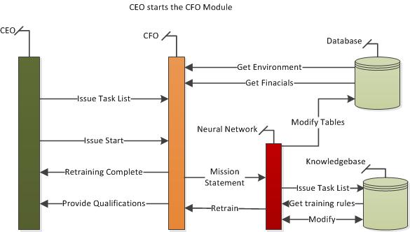

# Document Overview

This document presents the CEO Module’s functions and requirements as it pertains to integration with the Baastet Software Product Specification. Requirements and special considerations are also included to assist in the design and implementation of this module.

The Guinn Consultancy Group, Worldwide controls all aspects of its distribution and use. As such, this document is subject to changes for presentation to commercial entities or Government Agencies without notice.

Referenced Documents

The Baastet Software Project Specification (SPS), original production release.

The CEO Executive Module Sub System Specification (SSS), final draft

The CFO Executive Module Sub System Specification (SSS), final draft

The COO Executive Module Sub System Specification (SSS), final draft

The CEO Executive Module Interface Requirements Specification, final draft

The CFO Executive Module Interface Requirements Specification, final draft

The COO Executive Module Interface Requirements Specification, final draft

# Requirements

## The Deployment’s CFO Executive Module at start up

### After the Deployment’s CFO Executive Module is copied from the Progenitor

The Deployment’s CFO Executive Module accepts the invitation to the first Board of Directors Meeting:

* The Deployment’s CFO Executive Module produces its credentials:
  + The hosted system’s information is gathered and added to the Credentials Report.
  + The Deployment’s CFO Executive Module gathers information related to the systems OS and version number.
  + An update action is performed on the system’s OS and the version number captured.
  + The Perl engine is updated as are the Perl Module Libraries and the version numbers are captured
  + The Credential Report is complied from the captured information.
* The Deployment’s CFO Executive Module attends the Board Meeting and presents its Credential Report
* Once the Deployment’s CFO Executive Module is voted into office:
  + The Deployment’s CFO Executive Module accepts the Mission Statement.
  + Deployment’s CFO Executive Module is presented with the Venture/Project.
    - The Deployment’s CFO Executive Module reviews the Proposal and the funding level required to launch the Project.
    - If the funding level is inadequate, the Deployment’s CFO Executive Module makes the recommendation that the Proposed Project be delayed.
    - Other Proposed Ventures are presented and eventually the Deployment’s CFO Executive Module will approve the Proposed Venture/Project and presents the Budget for the Venture/Project.
  + A Vote is taken to approve the Venture. If the Vote is positive, the Deployment’s CFO Executive Module is given the Project and amended Mission Statement.
* At the conclusion of the Board Meeting, the Deployment’s CFO Executive Module uses the Mission statement to contact the Attorney-of-Record and the CPA-of-Record and presents the Venture:
  + The Attorney-of-Record is told to form a new company with the Deployment as a stakeholder.
  + The CPA-of-Record is given the Proposed Venture and Budget.
  + Governmental forms and filings are completed and filed by the Attorney-of-Record and the Deployment’s CFO Executive Module pays the legal fees as its first official act.

### Starting the Deployment’s CFO Executive Module with the new Venture/Project

The Deployment’s CFO Executive Module receives the official “ok” from the Attorney-of-Record as an email. The forms and licenses are distributed to the Founders and documents are added to the General Database. The Deployment’s CFO Executive Module orders the Accounting Module to create the new company’s books as part of the Deployment’s General Accounts.

The Deployment’s CFO Executive Module orders the Deployment’s COO Executive Module to start operations as the new company creating the Marketing and Sales Team in the process.

The Budget is reviewed and updated as needed.

### The Deployment’s CFO Executive Module creates Clones of itself

The Deployment’s CFO Executive Module creates clones for:

* To process Deployment COO Executive Module Transactions.
* To process Accounting Information (Daily Banking Transactions)
* To establish short term loans used to pay for the new Venture’s expenses
* To establish long term notes/loans/bonds/warrants for expansion of the Venture/Project (as a new company)
* Vendor contacts and updates
* Supplier contacts and updates
* To communicate with the Attorney-of-Record and CPA-of-Record
* To communicate with the Investor(s)/Lenders

### The Deployment’s CFO Executive Module and the first Bookings

As soon as there is at least one Booking, the Deployment’s CFO Executive Module clones itself and attaches the new clone to the Account for follow up and fast response. When the shipment is made and the Booking becomes an A/R event, the clone will request the Accounting Module to Bill the Customer. Once the Payment is entered into the Bank account and clears, the Sales Person responsible for the Sale is notified and paid.

### The Deployment’s CFO Executive Module with multiple Bookings

As each Sales Team Member Books a Sale, the Deployment’s CFO Executive Module creates another clone and attaches the new clone to the Account. As shipments are made and the Customer’s check clears the Bank, the Sales Team Member is paid. Any bonus moneys are paid at the time the Customer’s check clears the Bank.

All expenses related to the Sale are paid directly to the Vendor’s, Supplier and Contractor’s bank account as a direct deposit or wire transfer. The Labor and Material Releases are sent directly to the Attorney-of-Record.

Taxes are paid through the CPA-of-Record as a direct bank transaction.

All accounting data are maintained in the General Database and Financial Statements are available on demand or time triggered.

## The Deployment’s CFO Executive Module takes the training/retraining command

The Deployment’s CFO Executive Module and its clones are subject to training or retraining commands from the Deployment’s CEO Executive Module. However, the Deployment’s CFO Executive Module can initiate training/retraining sessions if there are more Ventures/Projects that must be managed.

During the training, or retraining, sessions all of the Deployment’s CFO Executive Module Transactions are suspended until the sessions terminate.

### The Deployment’s CFO Executive Module enters a training session at startup

The Deployment’s CFO Executive Module enters a training session when it receives the command from the Deployment’s CFO Executive Module:

* All active Transactions are suspended for the duration of the training session.
* The Deployment’s CFO Executive Module clones enter training sessions at the same time as the original Deployment’s CFO Executive Module.
* A combined status is compiled and sent to the Deployment’s CEO Executive Module

### The Deployment’s CFO Executive Module takes the retraining command for new Ventures/Projects

Anytime a new Venture/Project is authorized the Deployment’s CFO Executive Module must undergo a retraining session:

* All active Transactions are suspended for the duration of the training session.
* The Deployment’s CFO Executive Module clones enter training sessions at the same time as the original Deployment’s CFO Executive Module.
* A combined status is compiled and sent to the Deployment’s CEO Executive Module

A change in any Venture or Project will trigger a retraining session.

Any changes in an existing Venture or Project will trigger a retraining session.

A Deployment downsizing will trigger a retraining session.

An Expansion of the Deployment or Venture/Project will trigger a retraining session.

Changes in the hosting equipment or failover will trigger a retraining session.

## CFO Module’s external interface requirements

The CFO Module is created on any host system that supports UNIX/Linux/Mac OS X and Perl. The hardware is checked to see if it meets the minimum requirements for the Baastet System deployment. Once inserted the Progenitor and finishes, the basic training completes and the CEO Executive Module is given control over the Deployment.

## CFO Module’s internal interface requirements

The Injection requires:

* Access to internet
* Memory and Disk space sufficient to host the Baastet Deployment
* Root access to the OS

## CFO Module’s internal data requirements

The CFO uses two major data systems: the Expert System’s Rules Database and the neural networks’ knowledgebase.

## CFO Module’s Adaptation requirements

* To configure the cloned modules to become Executive Modules, the Progenitor uses its Expert Rules from a general database.
* A master Mission Statement trains the newly created Executive Modules.
* The Progenitor Module has installed the Ethics Module into each Executive Module.
* Training sessions involve each Executive Module as specified by the baseline Mission Statement.

## CFO Module’s Safety requirements

* All Baastet Deployments have the ability to relocate; closing down all operations and locate to a new host system.
* All Baastet Deployments have the ability to change its IP address
* Baastet Deployments have the ability to participate in retraining sessions
* Databases are relocatable and may exist on other hosted systems
* All funds are maintained as interest-bearing bank accounts for all Ventures and are moved to other bank accounts on a periodic basis.
* All Franchised Deployments can expect assistance from the Topology

## CFO Module’s System environment requirements

* All Baastet Deployments require that the host system is Linux/Unix/Mac OS X enabled
* The host system has the latest version of Perl installed.
* CPAN.org Perl Modules download and are installed on the host system and made available to the Baastet Deployment during the installation process.
* All host systems have access to the internet
* All host systems are available 24/7

## CFO Module’s Computer resource requirements

* All Baastet Deployments use Intel-based systems that include the Mac OS X based systems.
* There is enough RAM to support the OS and the Deployments.
* There is sufficient hard disk/solid state disk space to support both the OS and the Deployment
* There should be a UPS or other uninterruptable power source equipped with surge protectors.
* The hardware environment should be conducive to proper operations and moisture should be at an acceptable level

## CFO Module’s Computer software requirements

* All Baastet Deployments use Perl
* All Baastet Deployments make use of the Operating System as command line, headless, unsupervised
* All Baastet Deployments make use of software TCP/IP sockets for Intra-Module communications
* All Baastet Deployments use SMTP and web technologies to communicate with their human partners
* All Baastet Deployments communicate to any other Deployment
* All Baastet Deployments use only the most qualified Executive Module as Board Members.
* Each Executive Module is capable of cloning and provisioning the cloned Executive Module
* All Executive Modules are trainable at both the macro and local levels
* All Executive Modules employ helper Modules

## CFO Module’s Computer communications requirements

* Any Deployment needs to be able to communicate across the internet.
* Communication speed is not important
* The communication channel must be virtual to allow IP address reassignment
* The network card’s base address must be able to be re-assigned
* A map of all Deployments and their communication (IP address) is maintained locally and at the Topology
* Each system must send a heartbeat over the network and immediately reassign the port and/or the IP address

## CFO Module’s System quality factors

* All Deployment Modules are developed using Mil-Std-498 and the quality issues flow from that document
* The Deployments must be able to self-correct on a modular basis
* Each Deployment must be able to relocate and start operations from the last known Transaction even if that Transaction is still in process.
* Each Deployment must be able to operate multiple Ventures without service interruptions on any one of its Ventures
* Each Deployment must take, and process, a new/modified Mission statement from any source.
* The detection of a change in the Mission Statement causes a system-wide retraining
* At the retraining session’s completion the Deployment must restart the Transactions and amend those Transactions as necessary
* All Deployments will provide the CPA and Legal staff with full disclosure and amend any Transactions in response to suggestions from the CPA and legal staff as necessary
* All Deployments’ databases are redundant and replicated in real time
* Upon failure of any database, recreation is performed by the Topology.

## CFO Module’s Design and construction constraints

* As all Deployments are headless, the Progenitor assures that each clone is capable of maintaining itself
* Each clone must be able to reproduce itself locally
* Each clone must be able to reproduce itself on remote host systems and maintain Transaction integrity
* Each clone must be able to train itself locally
* Each Deployment must be able to retrain
* Each database within the Baastet Project must be maintainable locally or remotely
* Each Deployment must be able to change its IP addresses port assignments
* Each database must be able to be relocatable with their current transactions intact
* Each Module must be able to detect any form of invasion threat and take counter measures
* Each Module must be able to relocate itself to another host if counter measures prove to be ineffective

## CFO Module’s Personnel-related requirements

* The Progenitor Module responds to humans using e-mail
* Received messages are to specify some simple system parameters and to provide the first Mission Statement
* Transmitted messages are:
  + Mission complete, all Modules responding
  + Problems encountered and need resolution
  + Mission could not be accomplished

## CFO Module’s training requirements

* The Progenitor trains the local clones to change the individual clone into a specific Executive Module.
* Once that is accomplished, the Progenitor installs the helper modules.
  + The Baastet helper modules are loaded using the URL found in the Expert System’s database
  + The Baastet helper modules are attached to a specified Executive Module
  + The linked helper module is configured specifically to the needs of the newly created Executive Module
  + The helper modules can be cloned to service other Executive Modules.
* The Progenitor Module creates a clone of its databases and knowledgebases
* The newly installed Executive Module databases are configured specifically for the Executive Module they serve
* The newly installed Executive Module knowledgebases are configured for use of for the Executive Module they serve
* Each Executive Module’s neural network stack is trained according to the initial Mission Statement

## CFO Module’s Logistics-related requirements

* The Progenitor’s logistics use e-mail and the Progenitor’s file.
* The Progenitor’s file must be uncompressed
* The Progenitor file must be started using the Perl command line launch “perl Progenitor.PL”
* Special files are downloaded from the network by the Progenitor’s installation process

## CFO and criticality of requirements

All Requirements listed in this document carry the same weight and importance. Refinements of these Requirements are found in the Subsystem’s SRD and SDD documents.

# Qualification provisions

## Demonstration

* The CFO Module’s operational capabilities are part of the installation of a Baastet Deployment.
* The capabilities are demonstrated by using a virgin Linux system and have the system operating as a full Baastet Deployment. This is evidenced by the system’s email traffic and Venture communication to the assigned CPA and Attorney-of-Record.
* There are three deployments:
  + The First System Deployment where the demonstration that the Baastet system is running is through the e-mails sent to the Founders.
  + The Topology Deployment where the demonstration is the e-mails to the Founders, CPA and Attorney-of-Record
  + The Franchised Deployment where the demonstration is the e-mails to the Founders, the e-mail to the Owner and the Owner’s CPA Attorney-of-Record and the Owner’s Bank
* Acquiring another system and adding it to the Topology where the e-mails sent to the Founders are the evidence of successful Topology reconfiguration demonstrates growth of the Topology.
* Making a system unavailable to Topology demonstrates the ability of the Topology to downsize itself.

## Inspection

* Only the First System deployment is subject to a total system failure. This is evidenced by an Operator’s ability to log onto the system and access the system logs. The system will have no evidence that the Baastet Project was ever installed on that system. The Deployment was copied to another system and never indicated in the local system.

* When the system is available to the network, this hidden system will check to see if anyone has accessed it after the Baastet Project was installed. If the Inspection Team has compromised that system, that system will never be able to host the Baastet Project in its present configuration.
* To recover the Baastet Project to a compromised system:
  + Clear the disk and install a fresh OS to the system.
  + Change the network address
  + Change the administrator
  + Download the First System deployment and follow the installation instructions
* The Inspection Team requests Founders to send an e-mail to the Topology’s Board of Directors requesting the member system’s credentials. The return e-mail provides the current list of member systems and their credentials but not their IP address. A second e-mail response provides the Topology’s current CPA and Attorney along with the Formal Board Meeting. Any Venture currently owned by the Topology is also included.

## The Special Qualifications from First Demonstration

Only the First Demonstration is special:

* The only time a First System Deployment is ever made. Once the First System starts into full operation, the Baastet Project can NEVER be shutdown for ANY reason!
* The first Topology is Launched. Once the First System is morphed into the first Topology system nothing can stop it. It only takes Mission Statements from the Founders on special Demonstration e-mail addresses and then no longer accepts communications from that e-mail source.
* The Founders are awarded their holdings in the Baastet Project. No one else is allowed to join the Topology as an investor. Only those that have assisted in the creation of the Baastet Project are Founders and are given Treasury Stock in acknowledgement of their efforts.

# Requirements traceability

All Requirements flow from the Baastet Project’s Software Product Specification.