COL774 Assignment-1

Q1
Part(a)

Learning rate: tried many values and chose η=0.001
Stopping criteria: If value of cost in 2 consecutive iterations changes by less than ε=0.0000001 then stop.
I takes 89 iterations to converge at η=0.001

θ comes out to be [ 0.99653574 0.00134008]

Part(b)
Plotted training data and hypothesis function learned.
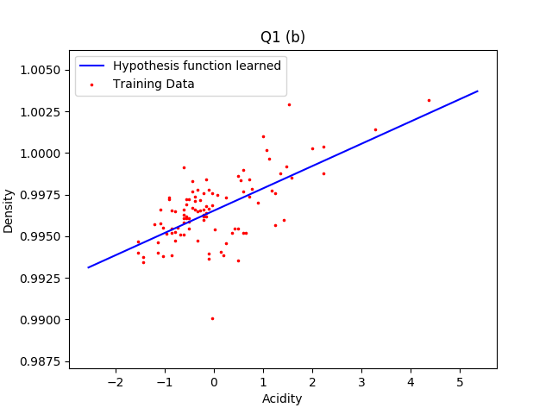
Part(c)

Plotted J(θ) and then plotted points at each iteration of gradient decent.

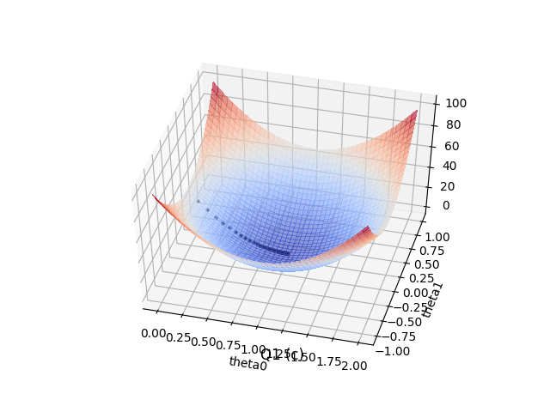

Plots of J(θ) vs θ
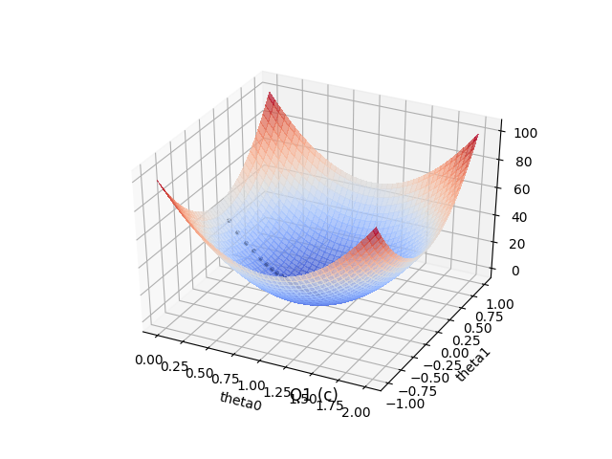
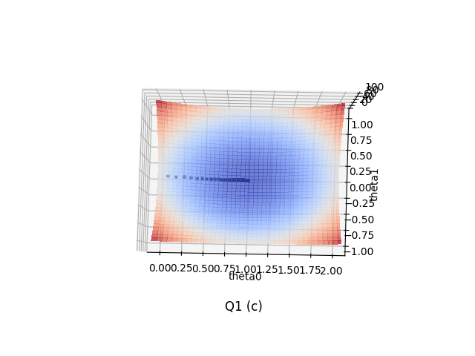
Part(d)
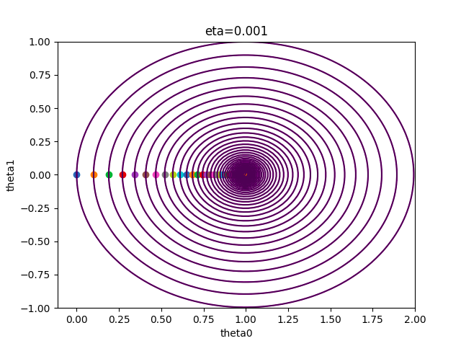
Plotted contour for cost function at each iteration.
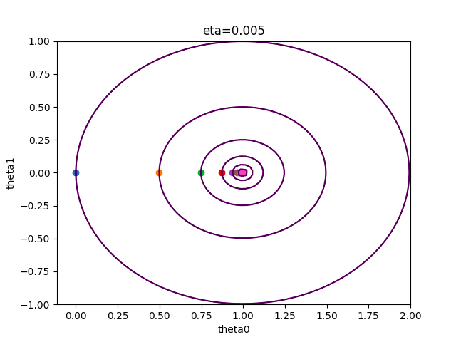
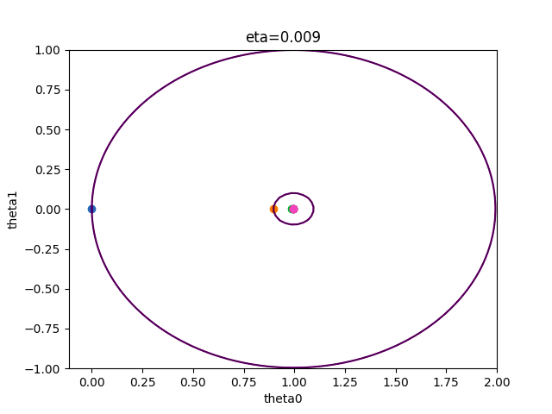

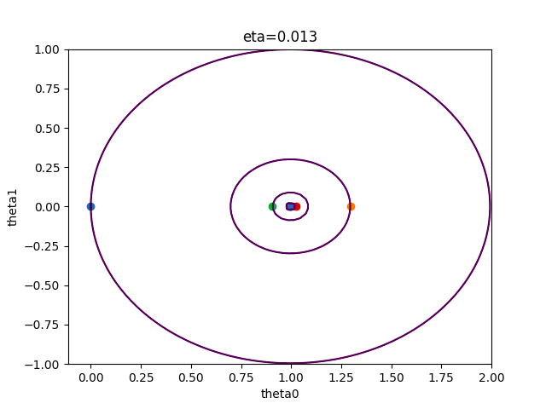
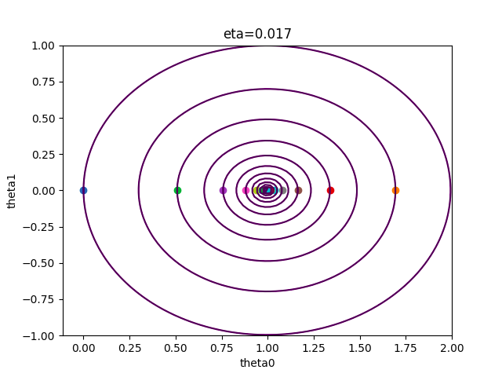
Part(e)
The step size increases from η=0.001,0.005,0.009 and it take less iterations to converge.

Algorithm starts oscillating initially when η=0.013

For η=0.013 and 0.017 it oscillates initially but converges eventually.

At η=0.021 and 0.025 it keeps diverging and does not converge.

Q2

Part(a)

Calculated θ using :
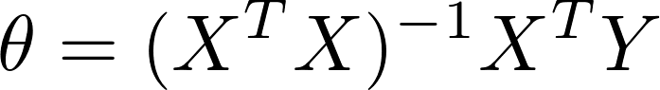
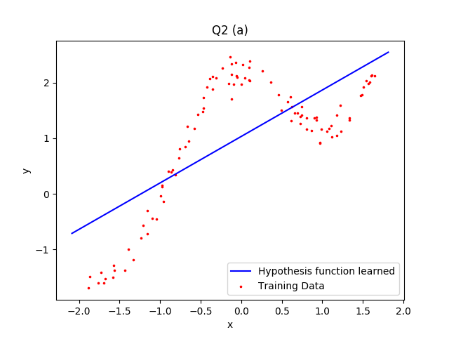

Part(b)

Calculated θ for each query point x where θ^{T}x has to be calculated using:

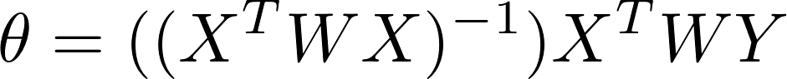

Where W is a m*m diagonal matrix, W is calculated for each query point x

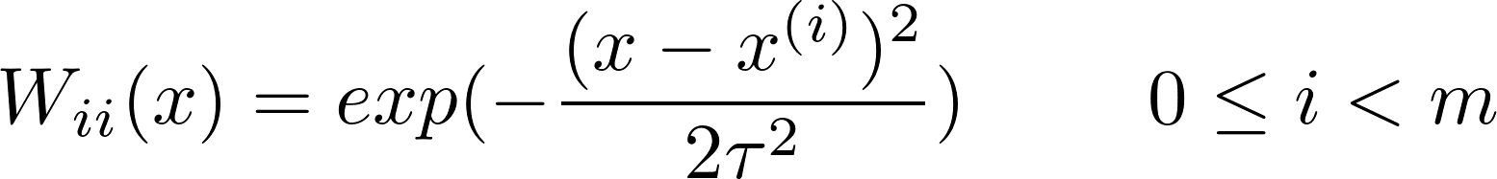

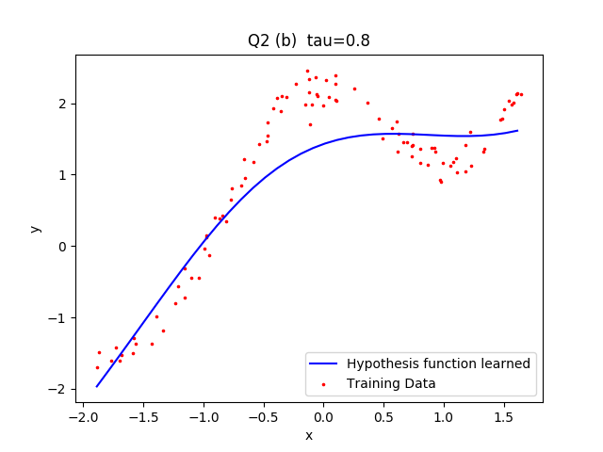

Part(c)
Tried tau={0.1,0.3,0.8,2,10} and plotted the hypothesis function learned.
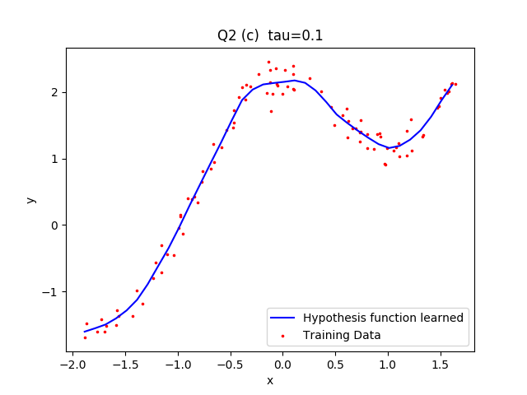

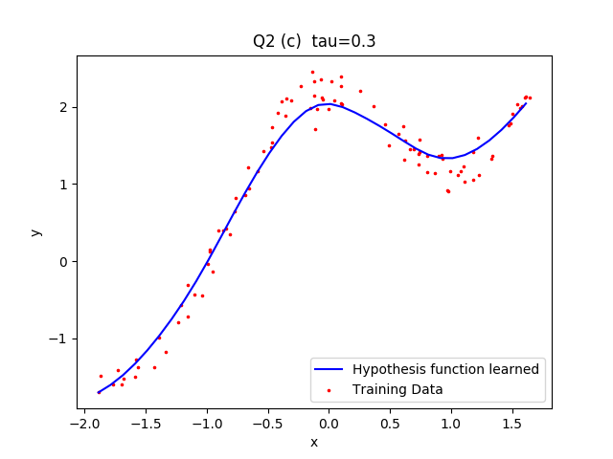
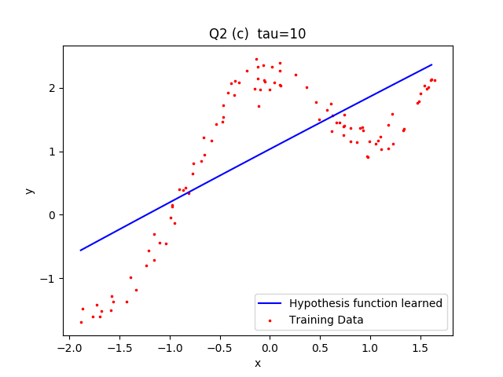
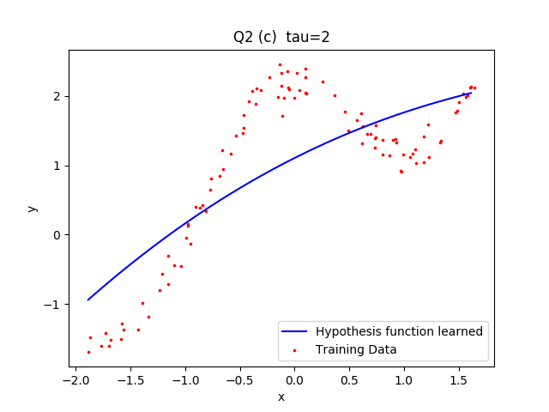
Out of tau={0.1,0.3,0.8,2,10}, I think tau=0.3 is best, because there is no overfitting and no underfitting.

When tau is too small, tau=0.1 then overfitting happens.
When tau is too large, tau=10 then underfitting happens and the function learned is almost a straight line.
For tau=2,10 the curve does not represent the data at all.

Q3

Part(a)
Implement Newton’s method for optimizing L(θ).
Used Newton’s method to find roots of L’(θ)

Convergence condition used: If L2 norm of difference between theta of 2 consecutive iterations is less than 0.000001 then stop

θ obtained is:
θ = [ 0.40125316 2.5885477 -2.72558849]

Part(b)

Plotted decision boundary learned with the training data.
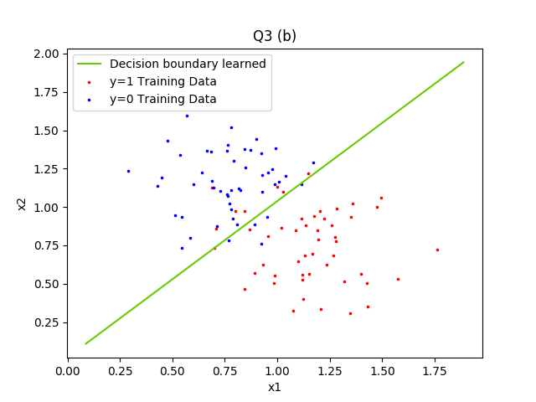

Q4
Alaska is 0 and Canada is 1

Part (a)

Calculated µ0, µ1, ∑ using the formulas told in class.

µ0=[-0.75529433 0.68509431]

µ1=[ 0.75529433 -0.68509431]

∑=[[ 0.42953048 -0.02247228]
[-0.02247228 0.53064579]]

Part (b)&(c)

When ∑0=∑1 the equation of separator is:

This is the equation of a straight line, plotted the above line.
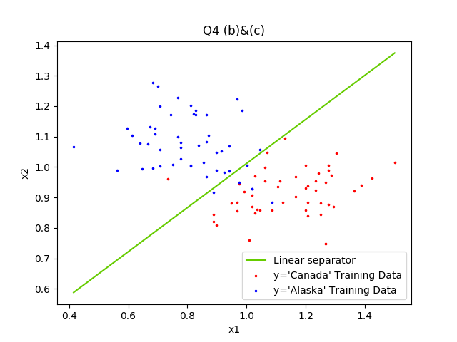
Part(d)

µ0 and µ1 are same as before.

Calculated ∑0 and ∑1 using the formula given in assignment pdf.

∑0=
[[ 0.38158978 -0.15486516]
[-0.15486516 0.64773717]]

∑1=
[[ 0.47747117 0.1099206 ]
[ 0.1099206 0.41355441]]

Part(e)

When ∑0≠∑1 the equation of separator is:

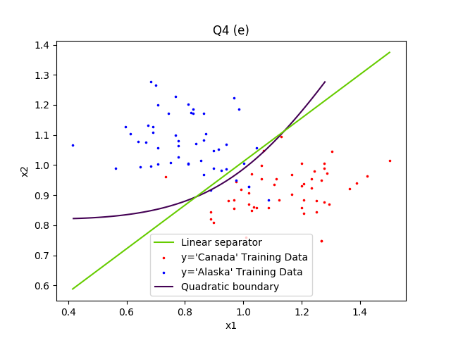
Plotted quadratic separator as a contour of above equation at Z=0

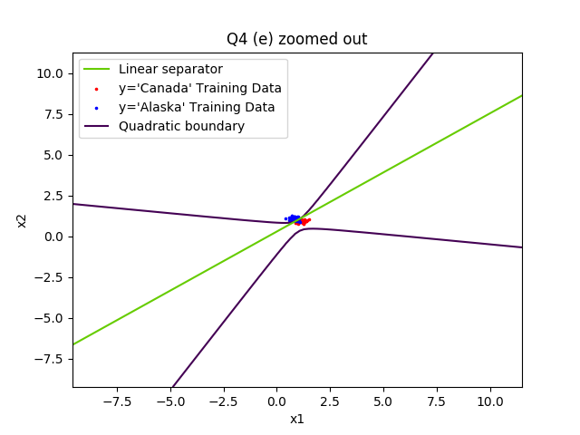

Part(f)

When ∑0=∑1 the equation of separator is a straight line because the quadratic terms cancel.
When ∑0≠∑1 the equation of separator is quadratic in x1 and x2.

The quadratic separator is actually a hyperbola, and it intersects linear separator at two points.

The linear separator classifies few ‘Alaska’ points as ‘Canada’ , but quadratic separator bends and correctly classifies those points as ‘Alaska’.

