REMOTE PROPERTY
WATCHDOG
Beta & Commercialization
Plan
Version 0.1
Evidence-led beta operations, pricing experiments, customer acquisition, support readiness, launch gates, and controlled post-launch growth.
Prepared for founder, product, engineering, customer research, support, security, and commercialization partners
July 13, 2026

COMMERCIAL OBJECTIVE
Prove that target property owners will install, trust, retain, and pay for a dependable watchdog that tells them when internet, cameras, recorders, or critical monitoring equipment stop protecting the property—without expanding enrollment faster than product evidence allows.

Document Control
Field | Value
Document | Remote Property Watchdog — Beta & Commercialization Plan
Version / status | v0.1 — founder review and beta planning baseline
Prepared | July 13, 2026
Audience | Founder, product, engineering, design, security, support, research, marketing, finance, and delivery partners
Authority | Normative beta-stage gates and commercialization hypotheses once approved; prices, targets, and channel allocations remain experiments until validated
Update cadence | After each beta stage, material pricing test, security gate, support-load review, or launch decision

Version history
Version | Date | Status | Summary
0.1 | 2026-07-13 | Draft | Initial beta and commercialization plan derived from the approved product, architecture, security, API, and execution-backlog documents.

Source documents
- Founder Product Brief v0.1
- Product Requirements Document v0.1
- User & Incident Flow Specification v0.1
- Technical Feasibility Prototype Specification v0.1
- Software Architecture Blueprint v0.1
- Data Model & API Specification v0.1
- Security, Privacy & Threat Model v0.1
- MVP Development Backlog v0.1
PLANNING STATUS
This document uses pricing, conversion, support, and retention targets as testable planning hypotheses—not financial forecasts or customer promises.

Document Map
Section | Primary output
1–4 | Commercial thesis, market wedge, principles, and beta evidence ladder
5–9 | Participant design, recruitment, onboarding, test program, and research operations
10–13 | Telemetry, scorecards, stage gates, pricing, packaging, and unit-economics controls
14–18 | Positioning, acquisition, partnerships, conversion, retention, and support operations
19–23 | Trust/legal readiness, launch gates, public launch, post-launch growth, and risks
Appendices | Reusable cohort scorecard, interview guide, survey, pricing experiments, launch checklist, KPI glossary, and 90-day action plan

How to use this plan
- Treat gates as evidence requirements. Do not expand enrollment because a calendar date arrived.
- Separate product truth from marketing. Every claim must reflect what the agent and cloud can actually prove.
- Track cohorts, not anecdotes. A vivid incident is useful, but decisions require repeatable behavior across properties.
- Keep pricing experimental. Test willingness to pay before optimizing plan complexity.
- Protect trust above growth. A security watchdog with unreliable alerts or misleading status can cause more harm than no product at all.

1. Executive Commercialization Summary
Remote Property Watchdog should enter the market as a narrowly focused protection-infrastructure monitor rather than a general network utility. Its initial commercial wedge is the property owner who depends on internet-connected cameras, recorders, routers, and hubs at a home, camp, barn, garage, workshop, rental, or small business—and worries that a disconnection, outage, power event, service failure, or suspicious sequence could leave the property unobserved.

1.1 Commercial promise
CORE PROMISE
Know when the systems protecting your property stop protecting it—and understand whether the evidence points to an internet outage, monitoring-computer failure, isolated device problem, recorder/camera failure, or an unusual sequence requiring attention.

1.2 First market wedge
Priority segment | Why the pain is acute | Product fit | Primary proof needed
Rural and exurban homeowners | Long response distances, unstable connectivity, barns/outbuildings, Starlink/DSL/cellular exposure. | Internet + camera/DVR + critical-device health with SMS escalation. | Alerts remain dependable across intermittent links and ordinary Windows PCs.
Camps and second homes | Property unattended for long periods; freeze, power, and security concerns compound. | Away mode, trusted contacts, incident history, optional UPS/cellular path later. | Remote onboarding and low support burden.
Workshops, garages, and small businesses | Equipment and inventory may be unattended outside business hours. | Critical chain monitoring and clear after-hours escalation. | Business owner understands alerts without IT staff.
Rental and property managers | Multiple sites, owner/manager contact chains, accountability. | Multi-property plan later in MVP or early post-MVP. | Permissions and support operations scale without ambiguity.

1.3 What is being sold
- Reassurance. The customer knows whether monitoring is active and whether the protection chain remains healthy.
- Timely awareness. Off-site notifications arrive when the property can no longer report through its primary internet path.
- Interpretation. The product groups symptoms into a useful incident instead of flooding the customer with device noise.
- Evidence. The customer receives an ordered timeline of observations, notifications, and restoration.
- Independence. The system monitors mixed brands without forcing replacement of the customer’s existing cameras or recorder.

2. Commercialization Principles
Principle | Required behavior | Commercial consequence
Reliability before reach | Enrollment pauses when critical alerting or restoration evidence is weak. | Slower early growth; stronger retention and reputation.
Honest uncertainty | Alerts distinguish observed facts, likely causes, and unresolved possibilities. | Avoids fear-based claims and reduces legal/support risk.
Protected state over account creation | Activation means the agent, monitored targets, and at least one alert path are actually ready. | Funnel metrics center on protection readiness, not vanity signups.
Software-first, hardware-aware | Launch with Windows software while validating demand for dedicated/cellular hardware. | Lower initial capital; future premium path remains open.
Controlled SMS economics | Push/email can carry routine events; SMS is a paid allowance or escalation. | Prevents unlimited variable cost and alert abuse.
No forced camera migration | Monitor existing equipment where technically possible. | Broader relevance and lower switching friction.
Support is part of product quality | Setup failures and misunderstood alerts are product defects, not merely customer problems. | Support telemetry directly feeds backlog priority.
Trustworthy marketing | Use real scenarios and product demonstrations without implying guaranteed crime prevention. | Stronger long-term brand and lower complaint risk.

COMMERCIALIZATION RULE
The company should never market a capability more confidently than the incident engine can classify it. “Possible disconnection” and “property stopped communicating” are often more valuable—and safer—than a dramatic but unsupported claim of tampering.

3. Commercial Objectives and Decision Questions

3.1 Objectives through commercial MVP
- Prove the outage-heartbeat mechanism and critical-device monitoring under controlled and real-property failures.
- Prove target users can install the agent, configure critical devices, verify notifications, and reach protected state.
- Prove alerts are understood, trusted, and acted upon without unacceptable false urgency or duplicate noise.
- Prove customers will pay a recurring subscription sufficient to cover cloud, messaging, payment, and support costs.
- Prove support, security, updates, incident operations, and rollback remain manageable as enrollment grows.
- Identify the strongest launch segment and acquisition channel before broadening positioning.

3.2 Decisions the beta must answer
Decision | Evidence required | Decision owner
Who is the best initial customer? | Activation, retention, willingness-to-pay, support load, and referral intent by segment. | Founder / Product
Which incidents create the most value? | Alert usefulness, urgency, action taken, and customer-reported consequences. | Product / Research
Is Windows software sufficiently dependable? | Uptime, sleep/reboot failures, update success, and readiness failures. | Engineering
Should RTSP/video-stall checks be launch scope? | Compatibility, credential burden, false positives, support demand, and willingness to pay. | Product / Engineering / Security
Which notification mix is sustainable? | Delivery success, SMS consumption, urgency, opt-out, and customer preference. | Product / Finance / Operations
What price and packaging work? | Trial conversion, plan choice, churn, price objection, and gross contribution. | Founder / Finance
When is public launch justified? | All launch gates current, named, evidenced, and approved. | Founder / Gate owners

4. Beta Evidence Ladder
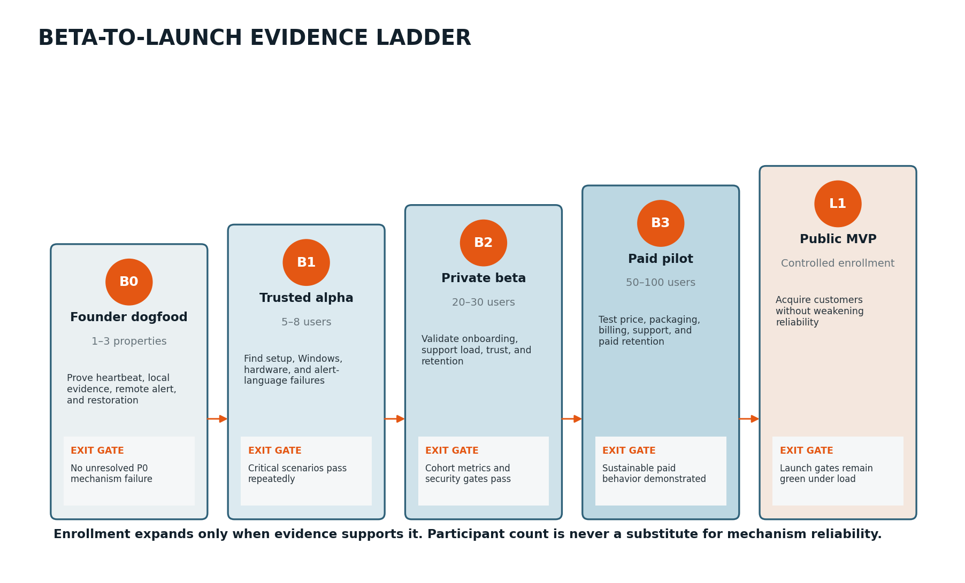
Figure 1. Enrollment expands only after each stage supplies the evidence required for the next.

4.1 Stage definitions
Stage | Enrollment | Primary objective | Minimum duration | Exit authority
B0 — Founder dogfood | 1–3 controlled properties | Prove core mechanism, local evidence, remote alert, restoration, and service continuity. | Until all controlled critical scenarios pass repeatedly; no calendar shortcut. | Founder + engineering
B1 — Trusted alpha | 5–8 known participants | Expose installation, Windows, ISP, router, camera, and alert-language failures. | At least 4 weeks after final major mechanism fix. | Product + engineering + security
B2 — Private beta | 20–30 invited participants | Validate onboarding, support, trust, telemetry, retention, and security/privacy operations. | 6–10 weeks with cohort tracking. | Cross-functional beta review
B3 — Paid pilot | 50–100 paying or deposit-backed participants | Validate pricing, packaging, billing, commercial support, and paid retention. | At least two billing cycles for monthly plans. | Founder + finance + product
L1 — Public MVP | Controlled public enrollment | Acquire and support customers while preserving all launch gates. | Continuous; enrollment may be throttled. | Founder + gate owners

4.2 Expansion rule
NO SILENT STAGE PROMOTION
A stage closes with a written evidence review. Open defects, false-alert patterns, support concentration, security findings, or unresolved unit economics must be explicitly accepted, mitigated, or used to hold enrollment.

5. Participant Profiles and Cohort Design

5.1 Required environment diversity
Dimension | B1 target | B2/B3 expansion target | Reason
Internet service | At least two types: cable/fiber and Starlink/DSL/cellular. | Balanced representation across stable and intermittent links. | Heartbeat thresholds and diagnosis behave differently.
Property type | Primary home plus one unattended property/outbuilding. | Homes, camps, barns, garages, rentals, small businesses. | Tests different urgency, absence, and contact patterns.
Camera system | At least two ecosystems and one DVR/NVR. | Wi-Fi cameras, wired DVR/NVR, hubs/base stations, mixed brands. | Discovery and health checks vary widely.
Windows device | Windows 10/11, desktop and laptop where appropriate. | Different updates, power plans, hardware age, and network adapters. | Agent continuity and sleep readiness are critical.
Technical confidence | Mostly founder-assisted. | Deliberate mix of novice, capable homeowner, and technical user. | Consumer readiness cannot be judged from experts alone.
Geography/timezone | One region is acceptable initially. | At least two time zones before public launch. | Scheduling, support, and incident presentation must remain correct.

5.2 Ideal participant attributes
- Owns or manages the property and has authority to install monitoring software.
- Uses at least one camera, DVR/NVR, hub, router, or other network device whose outage matters.
- Can describe what they currently fear missing while away.
- Will perform planned test scenarios and report whether messages were understandable.
- Accepts that beta software is not emergency dispatch, law enforcement, or a guaranteed security service.
- Is willing to provide structured feedback and allow privacy-safe operational telemetry.

5.3 Exclusions or special handling
Condition | Treatment
Medical, life-safety, fire, or legally mandated monitoring | Exclude from beta and clearly state product is not suitable for these uses.
Customer expects police dispatch or guaranteed crime prevention | Exclude or reset expectations before enrollment.
No always-on Windows device | Do not represent software monitoring as ready; record demand for future hardware.
Highly segmented enterprise network | Consider later technical pilot; do not distort homeowner onboarding around enterprise requirements.
Participant cannot safely perform outage/unplug tests | Use non-destructive simulation and observation only.
Unsupported camera credentials or proprietary cloud-only platform | Monitor network reachability where possible; disclose limits before protected state.

6. Recruitment and Screening

6.1 Recruitment order
- Founder properties. Use real cameras, DVRs, Starlink/router paths, and intentional unplug/severed-link simulations.
- Trusted local participants. Recruit people willing to tolerate direct support and rapid agent updates.
- Problem-aware waitlist. Use an application that captures property type, connectivity, equipment, fear scenario, and Windows availability.
- Installer and property-service referrals. Recruit through CCTV installers, rural IT providers, property managers, and security-minded trades.
- Paid pilot applicants. Select people who demonstrate both real need and willingness to pay—not only curiosity about free software.

6.2 Screening score
Criterion | 0 points | 1 point | 2 points
Problem intensity | General curiosity. | Some concern about outages. | Past failure, unattended property, or meaningful security dependency.
Environment value | Common single-device setup. | Useful ISP/device variation. | High-value target environment not yet represented.
Always-on host | No suitable PC. | PC can be configured. | Reliable desktop/mini-PC already always on.
Participation reliability | Uncertain availability. | Can complete surveys. | Will complete tests, interviews, and diagnostic follow-up.
Commercial signal | Only interested if permanently free. | Open to paying later. | States credible budget and problem urgency.
Safety/expectation fit | Expects emergency/security guarantee. | Needs expectation reset. | Understands beta limitations and purpose.

SELECTION GUIDANCE
Do not select only enthusiastic technical users. A private beta that excludes ordinary homeowners can produce excellent telemetry and a commercially unusable onboarding flow.

6.3 Waitlist application fields
- Name and contact information
- Property type and occupancy pattern
- Internet provider/type and backup connectivity
- Windows computer availability and typical sleep schedule
- Camera/DVR/hub brands and approximate device count
- Most concerning failure scenario
- Current method of learning about outages
- Willingness to perform controlled tests
- Expected monthly value range
- Consent to beta communications and research contact

7. Beta Onboarding and Protected-State Activation
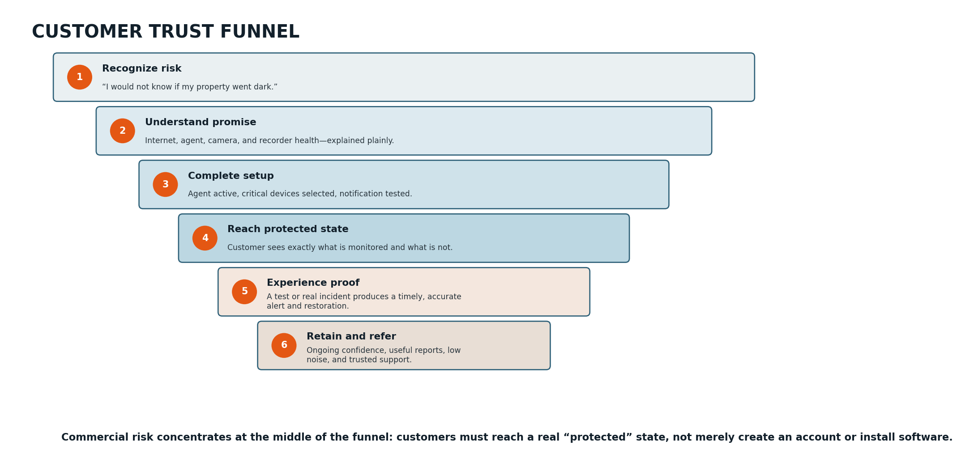
Figure 2. Commercial success requires customers to move from recognizing risk to reaching and trusting a real protected state.

7.1 Onboarding completion definition
ACTIVATED PROPERTY
A property is activated only when the agent is currently communicating, power/sleep readiness is acceptable, gateway and internet monitoring are active, at least one critical target is configured, at least one notification destination has been verified through an end-to-end test, and limitations are visible to the customer.

7.2 Guided onboarding sequence
Step | Customer action | System proof | Failure handling
1. Create property | Name property, timezone, and purpose. | Property isolated and presentation timezone set. | No monitoring claim yet.
2. Install agent | Download, install, and enroll Windows service. | Agent check-in, version, service state, and credential binding confirmed. | Clear repair path and diagnostic code.
3. Readiness check | Review sleep, startup, network, and cloud status. | System reports ready/degraded/not ready with reason. | Protected state blocked if continuity is unreliable.
4. Discover devices | Review router, recorder, cameras, hubs, and unknowns. | Inventory displays evidence/confidence and last seen. | Allow rename, ignore, retry, or manual target.
5. Select critical targets | Mark devices and dependency relationships. | Appropriate health checks scheduled. | Unsupported deep checks disclosed.
6. Configure contacts | Verify owner and optional trusted contacts. | Actual channel delivery receipts recorded. | Unverified destination cannot satisfy readiness.
7. Run protection test | Perform safe simulated device/internet event. | Incident, notification, acknowledgment, and restoration complete. | Setup remains incomplete if test cannot be trusted.
8. Enable monitoring | Choose Home/Away/Tamper behavior and maintenance rules. | Property status becomes protected with visible scope. | Customer sees exactly what remains unmonitored.

7.3 Onboarding targets
Metric | B1 target | B2 target | B3 / launch candidate target
Median time from account to protected state | Measured, no hard gate. | ≤ 30 minutes for supported ordinary setup. | ≤ 20 minutes.
Protected-state completion without live support | Measured. | ≥ 65%. | ≥ 80%.
End-to-end alert test completion | 100% of active beta properties. | ≥ 95% during onboarding. | ≥ 95%; failure blocks paid activation.
Unclear or abandoned device classification | Documented manually. | < 20% of discovered critical candidates. | < 10% for supported target profiles.
Sleep/readiness issue discovered after activation | Zero tolerated in controlled alpha. | < 5% and detected automatically. | < 2%.

8. Beta Test Program

8.1 Test categories
Category | Representative scenarios | Evidence collected
Core outage | Disconnect WAN/phone/coax/Starlink router path; block external connectivity; restore. | Heartbeat lease, cloud detection time, notification, local evidence replay, restoration.
Isolated device | Unplug camera, DVR/NVR, hub, switch port, or device power while internet remains healthy. | Target state, dependency checks, severity, customer interpretation.
Sequential failure | Disable multiple cameras or devices one at a time while gateway remains healthy. | Pattern correlation, deduplication, unusual-sequence language.
Agent continuity | Stop service, crash process, reboot PC, sleep/hibernate, update agent, change adapter. | Readiness, restart, agent-unavailable classification, local journal integrity.
Network ambiguity | DNS failure, one probe destination failure, IP change, router restart, Wi-Fi roam. | No false total-outage declaration; identity and confidence behavior.
Notification | Invalid destination, provider delay, opt-out, quota limit, quiet hours, escalation, acknowledgment. | Receipts, fallback, deduplication, consent, support visibility.
Operational failure | Cloud deploy, database delay, queue retry, messaging provider outage, rollback. | Degraded behavior, no cross-tenant impact, recovery evidence.
Security/privacy | Credential revocation, foreign-object access, tampered update, secret in diagnostic fixture. | Blocked access, audit, redaction, secure update behavior.

8.2 Real-property weekly test rhythm
Cadence | Activity | Owner
At enrollment | Baseline inventory, alert test, readiness confirmation, interview. | Beta operations + participant
Week 1 | One isolated-device test and one restoration review. | Participant
Week 2 | One property-wide internet test when safe. | Participant + support if needed
Week 3 | Away/Tamper Mode test and trusted-contact escalation. | Participant
Week 4 | Agent restart/update test, incident review, retention interview. | Engineering + research
Ongoing | Natural incidents captured; no artificial testing that risks property safety or equipment. | Participant / system

8.3 Incident feedback prompt
AFTER EVERY MATERIAL ALERT
Ask: Did the message arrive in time? Did you understand what was known? Did you know what to do? Was the severity appropriate? Did any message feel repetitive or alarming without evidence? What action did you take? Would this incident justify paying for the service?

9. Customer Research Operations

9.1 Research moments
Moment | Method | Question answered
Before installation | 20–30 minute problem interview. | What has failed before; what is feared; how they currently learn; value of faster awareness.
Immediately after onboarding | Short usability survey and observed setup notes. | Where trust or comprehension failed; time to protected state.
After first test incident | Five-minute incident survey. | Was the alert timely, clear, credible, and actionable?
Week 2 | Behavior interview. | Has the customer changed routines, contacts, or reliance on the product?
Week 4–6 | Retention and pricing interview. | What would make them cancel; what plan feels appropriate; what outcome matters most?
Cancellation or inactivity | Exit survey/interview. | Product failure, host limitation, price, low need, noise, privacy, or support problem?

9.2 Evidence hierarchy
- Observed behavior. Installation completion, protected state, alert action, usage, renewal, and referral outweigh stated enthusiasm.
- Incident-specific feedback. Comments immediately after a real or controlled alert are more reliable than abstract opinions.
- Cohort patterns. Repeated friction by environment, segment, or plan matters more than one unusual account.
- Interviews. Use to explain metrics and discover unmet needs, not to replace behavior.
- Feature requests. Record the job and consequence before accepting the requested solution.

9.3 Research ethics and privacy
- Research participation is voluntary and separate from essential service consent.
- Do not request surveillance footage unless a narrowly defined support case requires it and the participant chooses to provide it.
- Redact IPs, MAC addresses, contact information, and credentials from research notes where not needed.
- Use participant codes in shared analysis.
- Allow participants to withdraw from research without losing ordinary product access where feasible.

10. Telemetry, Analytics, and Data Boundaries

10.1 Minimum telemetry
Domain | Events / measures | Purpose
Activation | Account, property, install start/success, enrollment, readiness checks, notification test, protected state. | Measure funnel and setup failures.
Agent continuity | Check-ins, version, service restart, reboot, sleep risk, config apply, update result. | Measure false confidence and operational health.
Monitoring | Probe type, target class, state transition, duration, confidence, unsupported capability. | Measure detection quality without raw video.
Incident | Open, classify, revise, notify, acknowledge, restore, close, duplicate suppression. | Measure timing, trust, and correlation.
Notification | Channel, destination verification state, attempt, provider result, delay, escalation, opt-out. | Measure delivery and cost.
Support | Issue class, environment, resolution time, diagnostic bundle use, defect link. | Prioritize product work and support staffing.
Commercial | Trial start, plan view, checkout, conversion, renewal, downgrade, cancellation reason. | Measure willingness to pay and retention.

10.2 Prohibited or restricted telemetry by default
- Raw camera video or audio
- Camera credentials or router administration credentials
- Full packet capture
- Browser history or unrelated application activity
- Unbounded network port-scan results
- Message content beyond the product’s own alert templates
- Precise household-member behavior or occupancy inference
- Diagnostic data not tied to a defined product purpose

10.3 Analytics rules
Rule | Implementation consequence
UTC storage, local display | Cohort and incident calculations remain consistent across time zones.
Property-level denominators | Alert rates and failures are compared per property-week, not only per account.
Version/environment dimensions | Every defect and metric can be segmented by agent version, Windows, ISP type, and target class.
No silent metric redefinition | KPI query and definition versions are stored with reviews.
Beta flags | Controlled tests are distinguishable from natural incidents.
Privacy minimization | Collect the smallest event payload that answers the operational or product question.

11. Beta Scorecard and Success Metrics
METRIC CAUTION
Targets below are proposed decision thresholds. They should be refined after B0/B1 baseline data, but not weakened merely to declare success.

11.1 Reliability and alert quality
Metric | Definition | B2 gate candidate | Commercial launch candidate
Controlled critical-scenario detection | Required outage/device scenarios producing the correct incident class and alert. | ≥ 98%. | ≥ 99% across supported scenarios.
Urgent false-positive rate | Urgent incidents without sufficient supporting evidence per property-week. | < 3%. | < 1%.
Duplicate urgent notification rate | Extra urgent messages for one unchanged incident. | < 2%. | < 0.5%.
Median remote-outage alert time | Cloud lease expiry to first successful urgent channel delivery. | ≤ 3 minutes. | ≤ 2 minutes, with explicit threshold policy.
Restoration notification time | Confirmed heartbeat/target recovery to restoration message. | ≤ 3 minutes. | ≤ 2 minutes.
Agent continuity | Active beta time with service healthy or honestly degraded. | ≥ 99%. | ≥ 99.5% for supported always-on hosts.
Update success | Eligible agents completing staged update without manual repair. | ≥ 97%. | ≥ 99%.

11.2 Product and commercial quality
Metric | B2 gate candidate | B3 / launch candidate | Interpretation
Protected-state completion | ≥ 65% without live support. | ≥ 80%. | Can ordinary target users activate?
Day-30 active retention | ≥ 60% of activated properties. | ≥ 70% of paid pilot properties. | Does the product remain relevant after setup?
Alert usefulness | ≥ 80% rated useful/very useful. | ≥ 90% for urgent incidents. | Do messages create action or confidence?
Support burden | Baseline and top drivers identified. | Median ≤ 20 minutes/account/month; no single setup defect dominates. | Can the service be supported economically?
Trial-to-paid conversion | Not required in free beta. | Target 20–35%, segmented by acquisition source. | Does the problem justify recurring spend?
Paid month-2 retention | Not applicable. | ≥ 80% candidate threshold. | Early recurring-value signal.
Referral intent | Qualitative in B2. | ≥ 30% willing to refer a similar property owner. | Trust and segment fit.
Very-disappointed signal | Measured at exit/week 6. | ≥ 40% of target-segment active users. | Product indispensability indicator, not sole gate.

12. Stage-Gate Decision Process
Gate review | Required inputs | Possible decisions
Weekly beta health | Reliability metrics, open P0/P1 defects, support themes, security events, participant incidents. | Continue, pause new enrollment, hotfix, revert, or run targeted test.
B1 exit | Critical scenario matrix, continuity evidence, alpha feedback, security review, support notes. | Advance to B2, extend B1, or narrow scope.
B2 midpoint | Activation, alert quality, retention, support burden, environment gaps. | Adjust onboarding, thresholds, cohort mix, or feature scope.
B2 exit | Private-beta scorecard, privacy/security gates, incident reviews, launch-risk register. | Begin paid pilot, continue free beta, or stop/rework.
B3 pricing review | Conversion, plan choice, churn, SMS use, contribution model, objections. | Approve packaging, change price, change allowance, or extend pilot.
Public launch review | All six launch gates, operations rehearsal, rollback, legal/customer docs, capacity. | Open controlled enrollment, hold, or launch invitation-only.

12.1 Automatic enrollment pauses
- An urgent false-positive pattern with credible risk of causing panic or unnecessary emergency action.
- Lost or materially delayed outage/restoration notifications without customer-visible degraded status.
- Cross-property or cross-tenant data exposure.
- Unsigned or unsafe agent-update behavior.
- Notification consent or opt-out failure.
- Agent update causing widespread service failure or protected-state misrepresentation.
- Support backlog that prevents timely handling of active monitoring failures.
- Uncontrolled messaging cost or provider suspension risk.

12.2 Decision record
Field | Required content
Decision | Advance, hold, narrow, rollback, or stop.
Evidence window | Dates, cohort, agent versions, and environments included.
Metrics | Current values, targets, trend, and known data-quality limitations.
Open risks | Severity, owner, mitigation, and due date.
Customer impact | Who is affected and how they are informed.
Next review | Date or evidence trigger—not merely “later.”

13. Pricing and Packaging Experiments

13.1 Initial packaging hypothesis
Plan hypothesis | Illustrative price | Included value | Experiment question
Monitor | US$4.99–6.99/month | 1 property; core internet/agent monitoring; limited critical devices; email/push; small SMS allowance; shorter history. | Is a low-friction entry plan enough to convert problem-aware homeowners?
Protect | US$8.99–11.99/month | 1 property; larger critical-device allowance; SMS escalation; trusted contacts; Away/Tamper Mode; longer history; camera/DVR health where supported. | Is this the natural default plan and strongest value/price fit?
Multi-Property | US$16.99–24.99/month | Up to 3 properties; higher device/SMS limits; multiple contacts; longer retention; priority support. | Will camps, rentals, shops, and managers pay for consolidation?
Local / Trial | Free trial or limited local mode | Discovery/readiness or time-limited cloud protection; no indefinite high-cost SMS entitlement. | Which free experience demonstrates value without attracting only permanent free use?

13.2 Pricing test sequence
- Problem-value interview. Ask what the customer currently spends on cameras, internet, travel, monitoring, or property checks; do not begin by presenting a price.
- Landing-page price test. Show real plan boundaries to waitlist traffic and measure qualified starts—not deceptive checkout.
- Beta reservation or deposit. Use a refundable or credited commitment only with clear terms; compare stated interest to action.
- Paid pilot. Offer one or two simple plans; avoid four-way packaging complexity before behavior exists.
- Annual option. Test only after monthly retention is understood; use a simple discount rather than hiding cancellation friction.
- Post-pilot plan revision. Base changes on conversion, usage, support, and margin by cohort—not competitor imitation alone.

13.3 SMS and variable-cost rules
- No unlimited SMS in early plans.
- Routine state changes prefer in-app/push/email; SMS is urgent escalation or customer-selected critical delivery.
- Every plan shows included SMS and behavior when allowance is reached.
- Do not silently drop urgent alerts; use defined fallback and customer-visible quota status.
- Price allowances from measured all-in messaging cost with safety buffer.
- Prevent alert loops, unverified destinations, and abuse before scaling acquisition.

14. Unit Economics and Financial Guardrails

14.1 Contribution model
Input | Illustrative placeholder | Validation source
Monthly subscription revenue — Protect | US$8.99 | Paid pilot plan choice and conversion.
Cloud/database/observability | US$0.35/account | Measured staging and beta allocation.
Messaging allowance consumption | US$0.45/account | Actual channel mix and provider invoices; placeholder only.
Payment processing | US$0.56/account | Processor fee schedule and transaction mix.
Support reserve | US$1.50/account | Support minutes × loaded support cost.
Contribution before R&D/overhead | US$6.13 / 68% | Revenue less measured variable and service-delivery costs.

ILLUSTRATIVE ONLY
The table is not a forecast and does not use finalized provider pricing. Replace every placeholder with measured pilot data before approving public pricing.

14.2 Commercial guardrails
Guardrail | Candidate threshold | Response if missed
Non-support technical COGS | ≤ 15% of subscription revenue. | Optimize retention/storage/probes; renegotiate providers; revise allowances.
Messaging cost | ≤ 8% average; no account with unbounded consumption. | Change channel policy, thresholds, allowance, or overage design.
Payment cost | Track by price/plan; avoid very low monthly price with disproportionate fee. | Test annual billing or higher-value base plan.
Support cost | Target ≤ 20% at launch and declining with product fixes. | Pause channel scaling; fix onboarding/support drivers.
Gross contribution | Candidate ≥ 60% before R&D/overhead. | Reprice, narrow expensive features, or improve service delivery.
Refund/chargeback rate | Low and explained; every dispute reviewed. | Correct claims, billing clarity, cancellation, and support response.

14.3 Cost controls that must not weaken protection
- Never reduce heartbeat reliability or silently delay urgent incidents to save small infrastructure cost.
- Do not delete unresolved incident evidence solely to meet a storage target.
- Do not move critical classification entirely into a lower-cost unreliable external dependency.
- Throttle abusive or misconfigured accounts without degrading unrelated properties.
- Expose degraded providers and notification limits rather than reporting false success.

15. Positioning and Messaging

15.1 Category statement
WORKING CATEGORY
A remote property connectivity and security-infrastructure watchdog: software that monitors the internet path and the equipment your cameras depend on, then alerts you off-site when protection is interrupted.

15.2 Message hierarchy
Level | Message | Proof
Headline | Know when your security goes dark. | Live demo of internet/camera failure and off-site alert.
Problem | Cloud cameras cannot warn you after their internet or power path disappears. | Founder story and simple dependency-chain explanation.
Solution | A local watchdog monitors the chain and a cloud heartbeat detects silence. | Architecture explained without network jargon.
Differentiation | Not another camera brand, firewall, or general network scanner. | Works alongside existing equipment; plain-English incident grouping.
Trust | The product reports what it observed and what remains uncertain. | Example alerts, limitations, privacy boundary, incident history.
Action | Install, select critical devices, test alerts, and leave knowing what is monitored. | Protected-state checklist and test flow.

15.3 Candidate headlines and proof points
Headline / line | Best use | Required substantiation
Know when your security goes dark. | Primary brand/landing headline. | Reliable outage/device alerts and accurate protected-state status.
The moment your cameras stop watching, you start knowing. | Camera-focused campaign. | Camera/DVR target monitoring where supported.
Internet down. Camera unplugged. Recorder offline. Know before you get home. | Direct-response creative. | Each event class demonstrated and limitations disclosed.
Your property can’t call you. This can. | Remote-property story. | Cloud heartbeat and off-site delivery demonstrated.
Monitoring for the equipment doing the monitoring. | Category education. | Dependency-chain visualization and critical-device setup.

15.4 Claims to avoid
- “Prevents break-ins” or “stops intruders.”
- “Always knows when someone tampers with a camera.”
- “Guaranteed instant alerts.”
- “Works with every camera/router.”
- “Replaces an alarm company.”
- “Proves your internet provider or another person caused the outage.”
- “Emergency service” or “life-safety monitoring.”

16. Customer Acquisition Strategy

16.1 Channel priority
Channel | Why it fits | First experiment | Scale condition
Founder-led story and demonstrations | Authentic origin problem; product behavior is visually understandable. | Short videos showing unplugged camera, lost internet, alert, and restoration. | Qualified waitlist and protected-state conversion.
Search/content | Users actively search after camera or internet failures. | Pages for “camera offline no notification,” “know if cabin internet is down,” and similar jobs. | Organic traffic converts to qualified trial at sustainable effort.
Rural/property communities | High concentration of camps, Starlink, barns, cameras, and self-installed systems. | Educational posts and beta recruitment without spam/fear tactics. | Low support-risk, high-retention cohort.
CCTV/security installers | They already diagnose offline cameras and customer anxiety. | Installer advisory interviews and referral pilot. | Referrals activate cleanly; installer economics are workable.
Property managers / rental operators | Multi-property need and accountable contacts. | Small managed-property pilot. | Permissions, support, and pricing fit validated.
Paid social/search | Can target problem-aware language but may attract fear-driven low fit. | Small capped tests after funnel telemetry is reliable. | CAC payback and retention outperform content/partner alternatives.

16.2 Acquisition experiment scorecard
Measure | Definition
Qualified lead rate | Visitors who match property, equipment, host, and problem criteria.
Cost per protected property | Channel spend divided by properties reaching protected state—not account creations.
Time to protected state | Median and support-assisted percentage by channel.
Day-30 retained protected property | Activated property still monitoring and not cancelled/inactive.
Paid conversion and plan mix | By source, segment, and setup environment.
Support minutes and defect rate | Acquisition channels that bring incompatible users may be expensive despite cheap leads.
Referral rate | New qualified applicants attributed to active customers/partners.

16.3 Content pillars
- Failure education. Why internet-connected cameras can disappear without a useful warning.
- Practical setup. Router, UPS, wired versus Wi-Fi, DVR placement, and critical dependency basics.
- Incident interpretation. How to distinguish property-wide silence from one offline camera.
- Remote-property readiness. Camps, barns, workshops, rentals, and rural connectivity.
- Product proof. Controlled tests, real incident timelines, restoration, and transparent limitations.
- Trust and privacy. What data stays local, what reaches the cloud, and what the company does not collect.

17. Partnerships and Channel Development
Partner type | Value to partner | Value to product | Pilot structure
CCTV installers / integrators | Fewer surprise “camera offline” calls; recurring service opportunity. | Device expertise, qualified customers, installation insight. | 5–10 referred sites; installer dashboard deferred unless evidence supports.
Rural IT / Starlink installers | Adds ongoing monitoring after installation. | Connectivity environments and trusted local referrals. | Referral fee or co-branded pilot after direct beta.
Property managers | Visibility across unattended sites and trusted contacts. | Multi-property validation and higher-value accounts. | Small fixed cohort with named manager/admin roles.
Insurance/security ecosystem | Potential loss-prevention relevance. | Credibility and distribution, but long sales cycle. | Research only until claims, reliability, and legal posture mature.
Hardware/UPS vendors | Complementary power and connectivity evidence. | Future UPS and cellular/hardware integrations. | Technical integration evaluation; no launch dependency.

17.1 Partner rules
- Do not promise a partner portal or white-label platform before direct customer fit is proven.
- Partner incentives should reward activated, retained properties—not raw leads.
- The customer must understand who provides software support and who provides equipment/service support.
- No partner may make unsupported security, insurance, law-enforcement, or life-safety claims.
- Partner access to customer data requires explicit role design, authorization, and audit—not shared credentials.

18. Conversion, Retention, and Referral

18.1 Trial design
Element | Recommended starting design | Reason
Duration | 14–30 days beginning at protected-state activation, not account creation. | Customer should not lose trial time while troubleshooting installation.
Credit card | Test both no-card private beta and card/deposit paid pilot. | Measure friction versus low-intent free use.
Required proof event | End-to-end alert test before trial is considered active. | Ensures customer experiences core value.
SMS | Small included test/urgent allowance. | Demonstrates value while controlling cost.
End-of-trial | Clear reminder, plan choice, data/monitoring consequences, and cancellation. | Trustworthy billing and lower disputes.
Grace period | Short, explicit, with continued critical visibility where economically feasible. | Avoid abrupt unexplained protection loss.

18.2 Retention mechanisms
- Persistent protected-state confidence and last-confirmed-healthy status.
- Low-noise incident and restoration history.
- Monthly uptime/reliability summary that is useful even when nothing dramatic occurs.
- Periodic alert-path test reminders.
- Device replacement/reclassification guidance when monitoring becomes degraded.
- Trusted contacts and Away/Tamper Mode tied to real property routines.
- Support that resolves the root setup issue rather than repeatedly silencing alerts.

18.3 Cancellation learning
Cancellation reason | Product response
No longer need / property sold | Offer clean export/deletion; no aggressive save attempt.
Computer not always on | Record hardware demand; explain dedicated-device path when available.
Too many alerts | Review thresholds, incident grouping, and target selection; treat repeated cases as product defect.
Missed or late alert | Urgent reliability review; preserve evidence and communicate honestly.
Price | Identify value gap versus budget; test plan/allowance, not automatic discount.
Privacy concern | Clarify data boundary; review whether collection can be reduced.
Setup too difficult | Measure step and environment; prioritize onboarding or compatibility.
Switched to integrated security service | Learn which bundled outcome mattered and whether partnership is appropriate.

18.4 Referral trigger
ASK AFTER PROOF
Request a review or referral after a successful setup/test, a clearly handled real incident, or a support resolution—not immediately after account creation. The customer should have evidence to recommend, not merely enthusiasm about the idea.

19. Support and Beta Operations

19.1 Support model by stage
Stage | Support posture | Tools required
B0 | Founder/engineering direct handling. | Raw logs, local database inspection, scenario notes.
B1 | High-touch scheduled onboarding and rapid issue triage. | Account/property health, version, diagnostic bundle, issue template.
B2 | Documented support queue with severity, ownership, and response targets. | Support console, consented diagnostics, knowledge base, status page.
B3 | Commercial-style support, billing handling, provider incident process. | Runbooks, canned-but-honest messages, escalation, refunds/credits policy.
L1 | Published support scope and capacity-based enrollment. | On-call ownership, incident communications, analytics, backlog integration.

19.2 Support severity
Severity | Example | Beta response target | Required action
S0 — Security/privacy emergency | Cross-tenant access, credential exposure, unsafe update. | Immediate escalation. | Contain, preserve evidence, suspend affected path, incident process.
S1 — Protection failure | Missed urgent outage, false protected state, widespread agent failure. | Rapid same-day response; active incident ownership. | Diagnose, communicate, mitigate/rollback, create P0 defect.
S2 — Degraded monitoring | One target unsupported, notification destination failing, repeated false device state. | Same business day when possible. | Restore or clearly mark degraded; capture environment.
S3 — Setup/usability | Naming, discovery, onboarding, report question. | Within published beta support window. | Guide customer and classify product friction.
S4 — Request/idea | New integration, feature, reporting preference. | Acknowledge and research. | Record job, segment, frequency, and impact.

19.3 Beta communications
- Welcome and beta-limitations message
- Scheduled maintenance and agent-update notice where material
- Active service incident notice and restoration
- Known-issue bulletin for affected environments
- Weekly or biweekly beta update with changes and requested tests
- Stage-end thank-you, findings, next-step, and pricing transition notice

20. Trust, Legal, and Customer-Protection Readiness

20.1 Customer-facing documents required before paid pilot
Document / control | Required content
Beta participation terms | Experimental nature, support scope, limitations, data handling, feedback, termination, and no life-safety/emergency use.
Privacy notice | Data categories, purposes, local/cloud boundary, processors, retention, rights, deletion, security contact.
Terms of service | Subscription, acceptable use, account security, service limitations, warranties/disclaimers reviewed by counsel, termination, disputes.
Messaging consent | Verified destinations, notification purpose, frequency variability, opt-out/help handling, trusted-contact authorization.
Billing disclosure | Price, renewal cadence, trial conversion, cancellation, refunds/credits, taxes, plan limits.
Compatibility and limitations | Supported Windows/environment assumptions, host must remain on, unsupported cameras, no emergency dispatch.
Incident language guide | Approved observed/inferred/possible wording and prohibited unsupported claims.
Vulnerability reporting path | Security contact and coordinated reporting process.

20.2 Review areas before public sale
- Messaging registration, consent, opt-out, and destination-verification obligations
- Privacy and consumer-data obligations in target jurisdictions
- Automatic renewal, trial, cancellation, refund, and price-display requirements
- Security incident and breach-response obligations
- Accessibility and nondiscrimination expectations for customer workflows
- Use of testimonials, incident stories, and security claims
- Partner/referral disclosures and installer responsibilities
- Insurance coverage appropriate to software, cyber, privacy, and professional risk
COUNSEL REQUIRED
This plan identifies review areas but is not legal advice. Paid pilot and public-launch documents should be reviewed by qualified counsel for the jurisdictions and channels used.

21. Commercial Launch Readiness
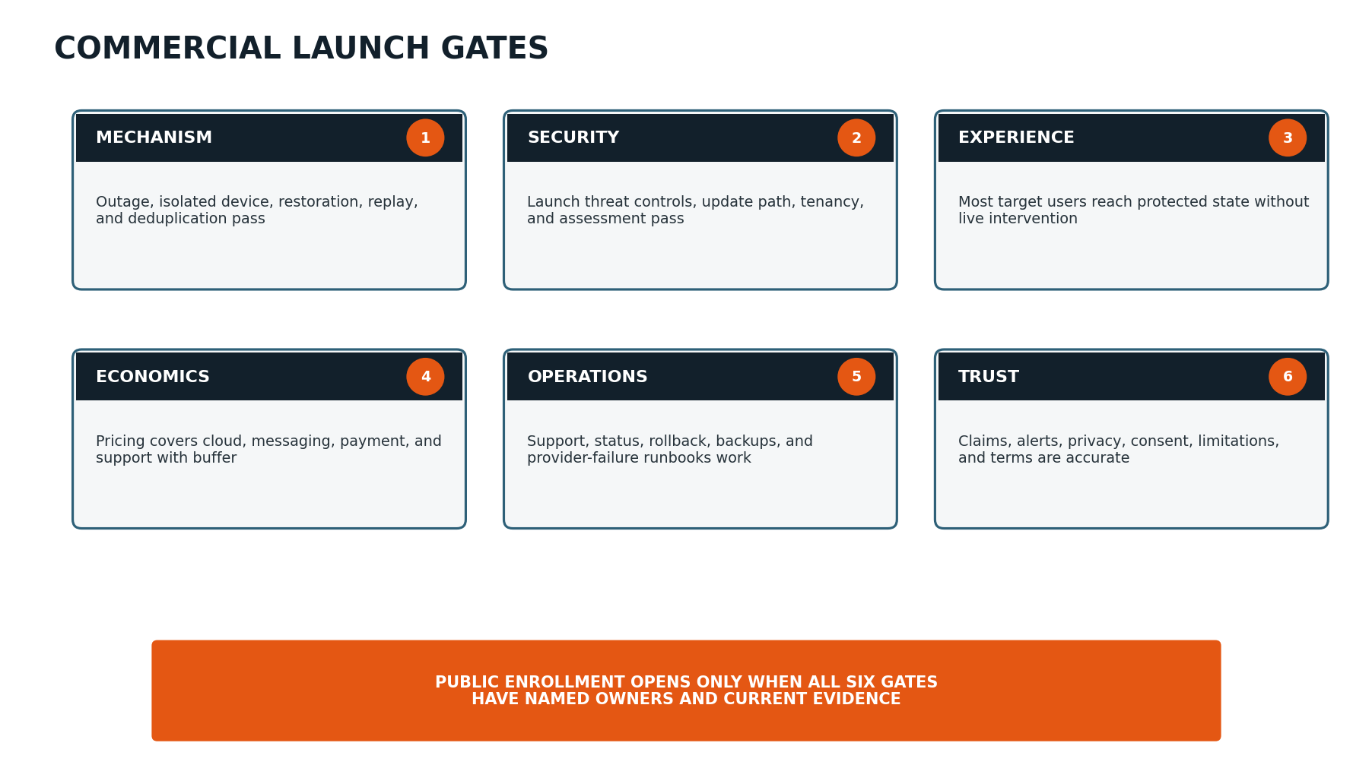
Figure 3. Public enrollment requires current evidence across mechanism, security, experience, economics, operations, and trust.

21.1 Launch gate checklist summary
Gate | Minimum evidence | Owner
Mechanism | Controlled and natural incident evidence; alert/restoration timing; low false/duplicate rates; supported-scope matrix. | Engineering + Product
Security | Threat-model P0s complete; tenancy tests; signed updates; external assessment; response process. | Security + Engineering
Experience | Activation and protected-state targets; accessible critical workflows; known compatibility limits. | Product + Design
Economics | Paid conversion; plan/allowance behavior; measured cost; support burden; billing reconciliation. | Founder + Finance
Operations | Backups, rollback, status, provider failover/degradation, support coverage, on-call ownership. | Operations + Engineering
Trust | Approved claims, terms, privacy, consent, limitations, support expectations, and incident language. | Founder + Counsel + Product

21.2 Launch blocker examples
- Customer dashboard shows “protected” when the agent is sleeping or stale.
- No reliable way to distinguish notification provider failure from successful delivery.
- Critical update path is unsigned or rollback is unproven.
- A beta cohort requires routine founder intervention to reach protected state.
- Pricing leaves insufficient room for messaging/support under normal usage.
- Cancellation, opt-out, deletion, or trusted-contact consent behavior is unclear.
- Marketing claims camera tampering detection beyond supported evidence.

22. Public Launch Plan

22.1 Pre-launch — 6 to 8 weeks
Workstream | Actions | Exit evidence
Product | Freeze launch scope; close P0 defects; publish compatibility; run regression and capacity tests. | Signed release candidate and gate package.
Operations | Rehearse provider outage, rollback, support escalation, status communication, and billing incident. | Timed runbook exercises completed.
Commercial | Finalize plans, checkout, trial, cancellation, annual option if justified, and usage messaging. | End-to-end paid sandbox and live micro-charge test.
Trust | Complete policy/counsel review, security assessment, claims review, and customer limitations. | Approved customer documents.
Acquisition | Build landing page, demo, founder story, waitlist segmentation, case studies, and onboarding emails. | Qualified launch list and channel tracking.
Customer success | Prepare setup guide, alert examples, troubleshooting, and first-response templates. | Support team completes mock onboarding and incidents.

22.2 Launch week
- Open in controlled batches. Invite a capped number from the highest-fit waitlist segment; do not open an unlimited floodgate.
- Watch the protected-state funnel live. Review install, readiness, alert-test, and support failures at least daily.
- Maintain a launch incident room. Named product, engineering, support, and communication owners.
- Publish proof, not hype. Use a clear demo, customer stories with permission, and limitations.
- Pause acquisition when necessary. A broken activation or reliability gate takes priority over media momentum.
- Capture every objection. Separate price, trust, compatibility, host, and low-need objections.

22.3 First 30 launch days
Cadence | Review
Daily | Service health, S0/S1 incidents, activation failures, SMS cost, support queue, checkout failures.
Twice weekly | Cohort conversion, alert quality, false/duplicate patterns, cancellation, acquisition quality.
Weekly | Launch gate refresh, roadmap decisions, public known issues, capacity, customer communications.
Day 30 | Go/hold/expand decision for enrollment cap and channels.

23. Post-Launch Growth and Roadmap Evidence
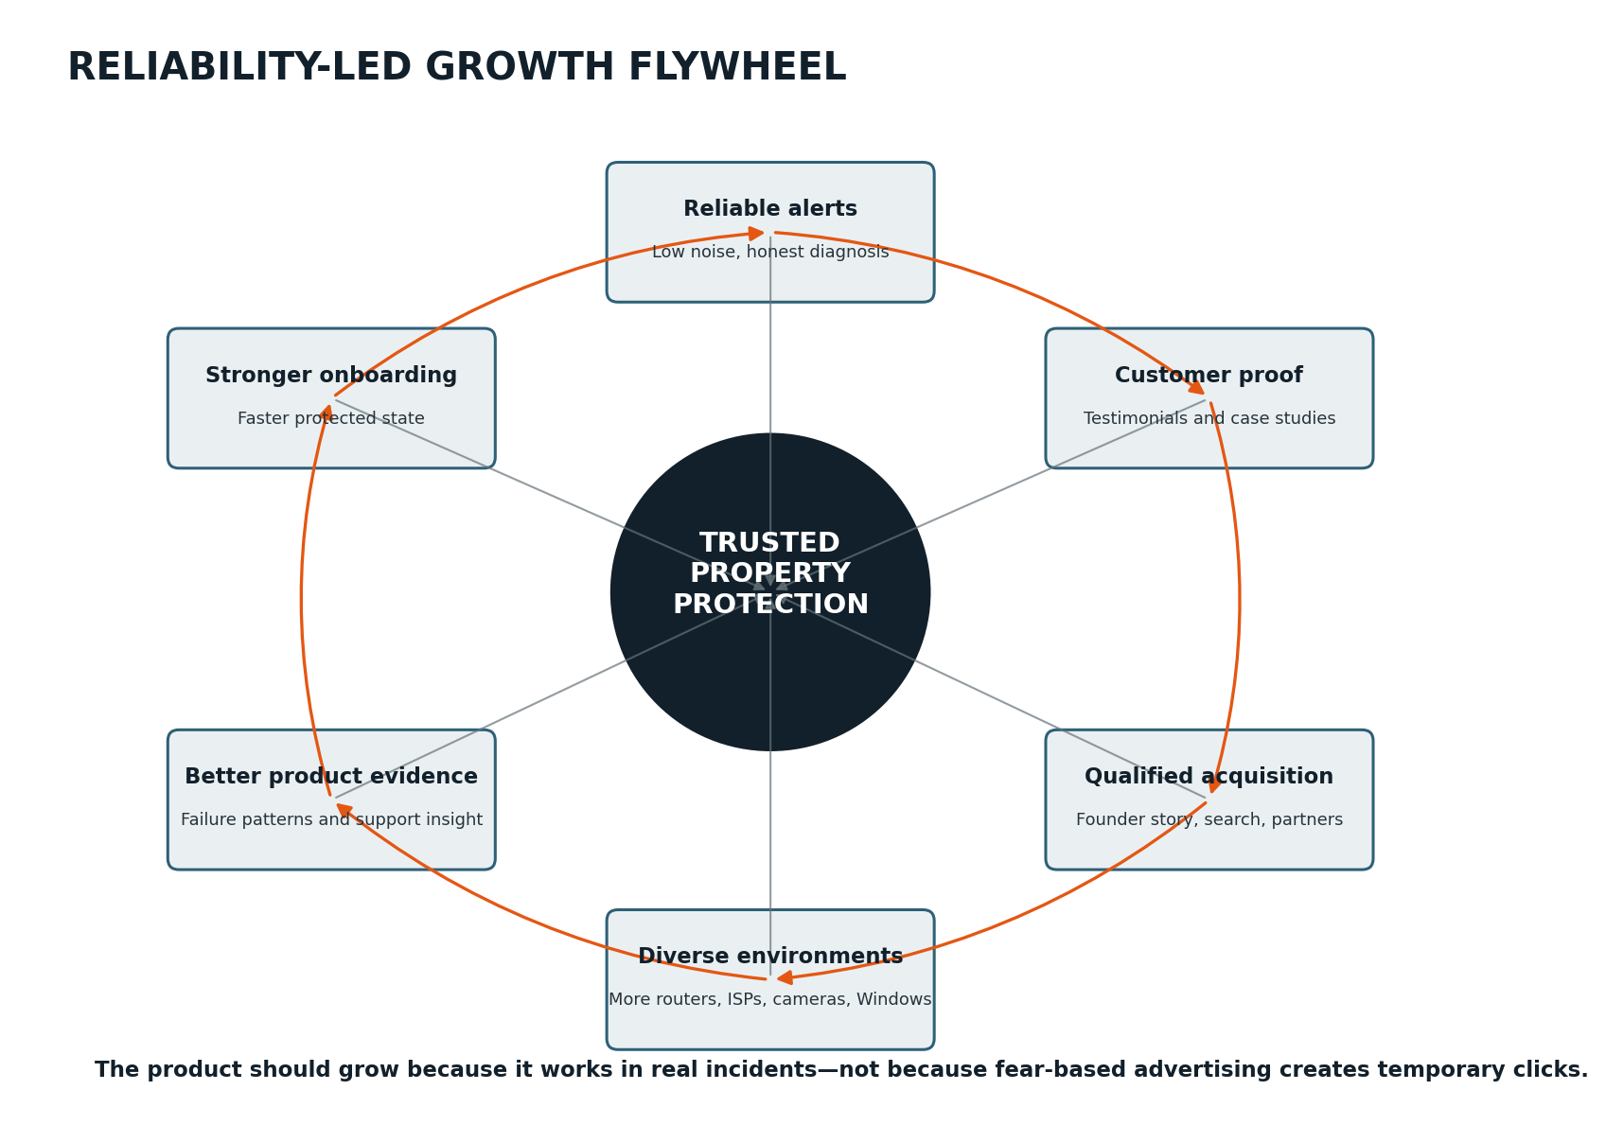
Figure 4. Reliability creates customer proof, better acquisition, more diverse evidence, stronger onboarding, and continued product improvement.

23.1 Expansion priority framework
Candidate expansion | Evidence required before commitment
Dedicated monitoring appliance | High cancellation/lead loss from no always-on PC; willingness to pay for hardware; support reduction case.
Cellular fallback | Customers need distinction between power/internet/host failure; recurring data economics and hardware feasibility.
Broader RTSP/ONVIF camera health | Compatibility success, manageable credential/security model, low false alarms, premium willingness to pay.
UPS/power integration | Meaningfully improves classification and action; common supported devices/interfaces.
Native mobile app | Push, acknowledgment, and incident interaction require capabilities not served well by responsive web.
Multi-property / installer console | Paid demand, authorization model, support ownership, and partner economics validated.
macOS/Linux agents | Qualified demand large enough to justify release/security/support surface.
Environmental sensors | Clear adjacency to core property watchdog without diluting positioning.

23.2 Roadmap scoring
Factor | Question | Weight guidance
Core protection impact | Does it prevent or clarify a meaningful blind spot? | High
Demand evidence | How many qualified active/paid customers exhibit the job? | High
Reliability risk | Can it be made dependable without corrupting core alerts? | High negative
Support burden | Will setup/compatibility create disproportionate support? | High negative
Revenue / retention | Does it improve willingness to pay, conversion, or retention? | Medium-high
Strategic differentiation | Does it strengthen the property-watchdog category? | Medium
Engineering/security cost | What new attack surface, platform, or provider dependence is introduced? | Medium-high negative

24. Commercial Risk Register
Risk | Early signal | Mitigation / decision
Customers see product as redundant with camera apps | Low conversion despite high concern; “my camera already alerts me.” | Demonstrate connection-loss blind spot and multi-brand infrastructure monitoring.
Windows host is not dependable enough | Sleep/offline agent incidents dominate support. | Improve readiness; narrow supported host profile; accelerate hardware validation if demand supports.
False urgent alerts destroy trust | Low usefulness ratings, alert disabling, cancellations. | Conservative classification, confirmation windows, dependency correlation, enrollment pause.
Missed alerts create reputational or legal harm | Natural incident not detected or delivered. | Preserve evidence, incident response, scope/claims discipline, testing, insurance/counsel.
SMS economics or compliance block scaling | High variable cost, provider filtering, consent failures. | Allowance/escalation model, verified destinations, provider abstraction, counsel review.
Camera integrations become support swamp | Brand-specific failures and credential confusion. | Launch with reachability/selected supported checks; publish matrix; price premium integrations.
Free users consume support without conversion | High signup, low protected state, no payment intent. | Time-limited trial, screening, paid pilot commitment, self-service readiness.
Acquisition becomes fear-based | Cheap clicks but low trust, complaints, poor retention. | Founder-led education, proof, clear limits, review creative and partner claims.
Competitor adds similar feature | Feature comparison pressure. | Own category through incident interpretation, protected state, property use cases, support, and evidence.
Founder support does not scale | Founder is required for every install/incident. | Instrument support, create runbooks, fix dominant friction, cap enrollment.
Security incident undermines core promise | Unusual access, credential/update issue, data exposure. | Launch security gates, minimal cloud data, response plan, external assessment.
Price too low to sustain reliability | Good conversion but poor margin/support capacity. | Measure costs, repackage, raise price for new customers, preserve service quality.

24.1 Stop or pivot criteria
- Core outage mechanism cannot meet acceptable alert quality across supported environments.
- Target customers consistently perceive insufficient value even after experiencing a successful proof incident.
- The always-on Windows requirement excludes most otherwise-qualified customers and no viable hardware path exists.
- Support and compatibility cost cannot be reduced to a sustainable level at plausible pricing.
- Security/privacy requirements cannot be met within available capability or capital.
- The strongest demand is for a materially different product; evidence supports a deliberate reposition rather than feature creep.

25. Resource and Budget Planning

25.1 Minimum functional roles
Role | Beta responsibility
Founder / Product owner | Segment, scope, claims, pricing, stage decisions, participant relationships.
Windows/agent engineer | Service continuity, installer, probes, local evidence, updates.
Cloud/full-stack engineer | Heartbeat, incidents, notifications, dashboard, billing, observability.
Security reviewer/engineer | Threat controls, tenancy, update path, assessment remediation, response.
Product designer/researcher | Onboarding, incident comprehension, interviews, accessibility, synthesis.
Beta operations/support | Recruitment, onboarding, queue, diagnostics, communications, cohort records.
Legal/accounting advisors | Terms/privacy/messaging/billing review and financial controls as needed.

25.2 Budget categories
- Cloud hosting, database, queues, observability, backups, domains, email, SMS, and status service
- Code signing, security tools, independent assessment, and vulnerability handling
- Billing/payment fees and limited refund/credit reserve
- Participant incentives, test hardware, UPS/router/camera variations, and travel where needed
- Design/research and accessibility review
- Customer support tooling and support labor
- Legal, insurance, privacy, messaging, and commercial advice
- Launch content, demo production, capped acquisition experiments, and partner materials

25.3 Capital discipline
SPEND SEQUENCE
Spend first on mechanism reliability, security, test environments, and protected-state onboarding. Spend on broad paid acquisition only after conversion and support telemetry are trustworthy. Spend on custom hardware only after software beta proves the demand and the always-on-host limitation is quantified.

26. Immediate 90-Day Execution Plan
Window | Commercial / beta work | Product / operational evidence
Days 1–30 | Name working beta; create waitlist application; recruit B0/B1; draft beta terms/consent; prepare interview and incident survey. | R0 mechanism demonstration; scenario matrix; agent readiness; basic cohort tracking.
Days 31–60 | Run trusted alpha; publish private setup guide; collect problem/onboarding interviews; build landing-page message tests; define pricing cards. | Weekly reliability reviews; top setup defects; alert-language revisions; support categories.
Days 61–90 | Decide B1 exit; recruit balanced B2 cohort; prepare support queue, status page, privacy notice, SMS controls, and pricing/deposit experiment. | B2 release candidate; security gate review; telemetry dashboard; protected-state funnel; stage decision record.

26.1 First ten actions
- Approve this plan’s stage names, decision owners, and non-negotiable enrollment pauses.
- Create a one-page beta participant application and screening score.
- Identify the first three controlled properties and equipment/ISP matrix.
- Create the B0 incident test schedule from the prototype specification.
- Draft the onboarding protected-state checklist and actual notification test.
- Create a beta issue taxonomy and support evidence template.
- Draft the founder story, category statement, and one product-demo script.
- Build a simple cohort scorecard with reliability, activation, trust, and support metrics.
- Define one initial paid-pilot plan and one alternate price; do not create a complex pricing page yet.
- Schedule the first formal stage-gate review before recruiting beyond trusted alpha.

Appendix A — Beta Participant Scorecard
Field | Example / allowed values
Participant ID | B2-017
Segment | Rural primary home / camp / workshop / rental / small business
Environment | ISP type, router, Windows version/host type, camera/DVR/hub types
Problem intensity | Past incident / unattended property / general concern
Protected-state date | UTC timestamp + local display
Onboarding | Minutes, live support Y/N, blockers
Tests completed | Internet, isolated target, escalation, restart/update, restoration
Natural incidents | Count, classifications, usefulness, action
Alert quality | Timeliness, clarity, credibility, urgency, duplication
Support | Tickets, minutes, root causes, defects
Commercial | Price shown, plan choice, deposit/payment, objections
Retention | Active day 7/30/60, cancellation reason
Research | Interview dates, key quote paraphrases, permission flags
Risk flags | Expectation mismatch, life-safety use, unsupported environment, privacy concern

Appendix B — Interview Guide

B.1 Problem interview
- Tell me about the property and what you depend on cameras or internet-connected equipment to protect.
- Have you ever discovered a camera, recorder, router, line, or internet service had failed? How did you find out?
- What is the worst realistic consequence of not knowing for several hours or days?
- How do you currently check whether the property is still connected?
- Who else should know when something fails?
- What products or services have you tried, and what was missing?
- What would make you distrust an alerting product?
- What would a dependable solution be worth relative to the cameras/internet/property risk?

B.2 Post-onboarding interview
- At what point did you feel the property was actually protected?
- Which step was confusing, technical, or uncomfortable?
- Did you understand what data was collected and what stayed local?
- Which devices did you expect to see that were missing or unclear?
- Did the alert test feel like convincing proof?
- Would you leave this running without checking it daily? Why or why not?

B.3 Retention/pricing interview
- What value have you received since installation, including peace of mind?
- Which alert or report mattered most?
- What would make you turn monitoring off or cancel?
- Which plan description best matches the way you use it?
- What price feels inexpensive, reasonable, expensive-but-considerable, or too expensive?
- Who else do you know with the same problem?

Appendix C — Incident Feedback Survey
Question | Response format
Did the notification arrive early enough to be useful? | Yes / somewhat / no + optional timing comment
How clear was what the system observed? | 1–5
How clear was what remained uncertain? | 1–5
Was the severity appropriate? | Too low / right / too high
Did you receive duplicate or unnecessary messages? | No / yes + count
What did you do after receiving it? | Multi-select + free text
Was the restoration message useful? | 1–5 / not received
How confident are you that the incident timeline is accurate? | 1–5
Would this specific incident justify paying for the product? | Definitely / probably / unsure / probably not / definitely not
Anything alarming, misleading, or missing? | Free text

Appendix D — Pricing Experiment Cards
Experiment | Variants | Primary metric | Guardrail
Entry price | US$5.99 vs US$7.99 for core plan. | Qualified paid conversion. | Retention/support/margin by variant.
Default plan | Monitor default vs Protect default. | Plan selection and checkout completion. | No misleading feature hiding.
Trial commitment | No-card 14-day vs card/deposit after protected state. | Protected-to-paid conversion. | Refund/dispute and support quality.
SMS allowance | 2 vs 10 included urgent messages. | Plan value and actual consumption. | No silent drop; cost cap.
Annual offer | Monthly only vs annual with simple discount. | Annual adoption and refund/cancellation sentiment. | Do not mask weak monthly retention.
Hardware interest | Software-only price vs software + estimated appliance range. | Qualified willingness to buy hardware. | No preorder until feasibility/terms are ready.

Appendix E — Paid Pilot Readiness Checklist
Area | Ready when
Product | Agent, heartbeat, incidents, notifications, restoration, onboarding, and protected-state flow pass.
Security | Credential, tenancy, consent, update, diagnostic, logging, and response controls pass.
Operations | Support queue, status page, provider incidents, rollback, backups, and customer communications rehearsed.
Commercial | Plan, price, allowance, billing, trial, cancellation, credits/refunds, and reconciliation tested.
Trust | Beta terms, privacy, messaging consent, limitations, compatibility, and claims approved.
Research | Cohort consent, scorecard, interview schedule, surveys, and decision review scheduled.
Capacity | Enrollment cap matches engineering and support availability.
Exit | Written criteria for conversion to public launch, extension, refund, or shutdown.

Appendix F — Public Launch Checklist
Area | Launch evidence
Release | Signed release candidate, compatibility matrix, rollback, update canary, regression evidence.
Reliability | Alert, restoration, duplicate, false-positive, continuity, and capacity targets current.
Security | Assessment findings closed/accepted, vulnerability intake, incident response, backup/restore.
Customer experience | Accessible onboarding, protected-state proof, limitations, knowledge base, cancellation.
Notifications | Consent, verification, provider status, quotas, fallback, templates, receipts, opt-out.
Billing | Live checkout, renewals, taxes where applicable, webhook replay, cancellation, refunds, reconciliation.
Support | Coverage, severity, runbooks, diagnostic bundle, known issues, escalation owners.
Marketing | Claims substantiated, demo accurate, case-study permission, channel tracking, enrollment cap.
Legal/privacy | Terms, privacy, messaging, billing, retention/deletion, partner disclosures reviewed.
Decision | All gate owners approve current evidence and launch-day rollback criteria.

Appendix G — KPI Glossary
KPI | Definition
Qualified applicant | Applicant matching target property/problem, supported host, expectation, and participation criteria.
Activated property | Property reaching the protected-state definition.
Protected-state completion rate | Activated properties ÷ properties beginning agent enrollment.
Controlled detection success | Correct material incident outcomes ÷ required controlled scenarios executed.
Urgent false-positive rate | Unsupported urgent incidents ÷ active property-weeks.
Duplicate urgent notification rate | Extra urgent deliveries for unchanged incidents ÷ urgent incidents.
Time to remote alert | Cloud evidence/lease threshold to successful customer delivery, with threshold policy disclosed.
Day-30 retained property | Activated property still actively monitoring at day 30, excluding planned closure.
Support minutes/account | Human handling time attributed to active account in period.
Cost per protected property | Acquisition spend ÷ properties reaching protected state.
Trial-to-paid conversion | Paid subscriptions ÷ eligible trials ending in period.
Paid month-2 retention | Paid accounts renewing/remaining paid after second monthly cycle.
Gross contribution | Subscription revenue less directly attributable cloud, messaging, payment, and support delivery cost.

Appendix H — Final Decision Summary
RECOMMENDED PATH
Proceed through founder dogfood, trusted alpha, private beta, and a simple paid pilot before public launch. Position the product around remote-property protection infrastructure, not general network scanning. Keep SMS controlled, onboarding proof-based, claims evidence-led, and enrollment capped by reliability/support capacity.

Decision area | v0.1 recommendation | Revisit when
Initial platform | Windows agent + responsive web dashboard. | B2 host-failure and demand data.
Initial segment | Rural/unattended property owners with cameras/recorders. | B2 retention and paid-pilot conversion by segment.
Primary paid plan | One default Protect plan around US$8.99–11.99/month. | B3 price and cost evidence.
SMS | Included allowance + escalation; no unlimited plan. | Measured use and provider economics.
RTSP/video-stall | Experimental/limited supported scope until compatibility is proven. | B1/B2 false-positive and support data.
Hardware | Research and prototype later; do not block software beta. | Qualified lost demand due to always-on PC.
Public enrollment | Controlled/capped, not unrestricted launch. | All six gates stay green under real load.

