REMOTE PROPERTY
WATCHDOG
Security, Privacy &
Threat Model
Version 0.1
Security architecture, privacy-by-design rules, abuse cases, risk treatment, and launch assurance for the Windows agent and cloud control plane.
Prepared for founder, product, engineering, and security review
July 13, 2026

SECURITY OBJECTIVE
Protect customers from unauthorized access, deceptive alerts, privacy overreach, supply-chain compromise, and cross-property exposure while preserving the product’s ability to detect outages when a property can no longer communicate.

Document Control
Field | Value
Document | Remote Property Watchdog — Security, Privacy & Threat Model
Version / status | v0.1 — founder and engineering review
Prepared | July 13, 2026
Audience | Founder, product, engineering, security reviewers, future legal/privacy counsel, and beta operations
Authority | Normative for security and privacy behavior when approved; superseded only by a later version or signed Architecture Decision Record
Review cadence | At prototype gate, before private beta, before public launch, after material architecture changes, and after significant security incidents

Version history
Version | Date | Status | Summary
0.1 | 2026-07-13 | Draft | Initial security, privacy, and threat model derived from the approved product, flow, prototype, architecture, and API specifications.

Source documents
- Founder Product Brief v0.1
- Product Requirements Document v0.1
- User & Incident Flow Specification v0.1
- Technical Feasibility Prototype Specification v0.1
- Software Architecture Blueprint v0.1
- Data Model & API Specification v0.1

Decision vocabulary
Term | Meaning
MUST / MUST NOT | Mandatory requirement for the referenced release or system boundary.
SHOULD / SHOULD NOT | Strong recommendation; deviation requires a documented reason and risk owner.
MAY | Permitted option, not a commitment.
P0 | Launch-blocking control or requirement.
P1 | Required for public launch unless risk is explicitly accepted.
P2 | Post-launch hardening or scale control.
Security incident | Suspected or confirmed compromise of platform, agent, credentials, software supply chain, customer data, or security controls.
Property incident | Customer-facing outage or device failure. It is not automatically a platform security incident.

IMPORTANT BOUNDARY
The product may report observable disconnection patterns or possible tampering. It must not state that a person committed sabotage, trespass, or another crime unless a qualified human reaches that conclusion from independent evidence.

Document Map
Section | Primary output
1–3 | Security posture, scope, principles, assumptions, and trust boundaries
4–7 | Assets, data classification, threat actors, methodology, and attack surface
8–12 | Threat scenarios and required technical controls across agent, cloud, dashboard, providers, and integrations
13–16 | Privacy model, identity, cryptography, secrets, logs, monitoring, and audit
17–20 | Secure development, supply chain, incident response, continuity, abuse prevention, and compliance readiness
21–24 | Security testing, launch gates, risk register, traceability, and open decisions
Appendices | Normative security/privacy requirements, data classes, playbooks, and review checklists

HOW TO USE THIS SPECIFICATION
Engineering should treat requirement IDs as acceptance criteria. Product should use the privacy and customer-language rules when writing flows and alerts. Operations should use the playbooks and risk register. Any control deferred from a launch gate requires a named owner, deadline, and explicit acceptance of residual risk.

1. Executive Security Posture
Remote Property Watchdog occupies a sensitive but deliberately constrained position: it observes the availability of equipment inside a customer’s home or property, sends operational metadata to a cloud service, and may alert trusted contacts when security infrastructure stops communicating. The product must earn trust by collecting less than it technically could, making no unnecessary inbound connection to the property, isolating each customer, and describing uncertainty honestly.

1.1 Recommended posture
- Outbound-only property connectivity. The agent initiates authenticated TLS connections over standard HTTPS. The product does not require router port forwarding or expose an inbound management listener to the internet.
- Operational metadata, not surveillance content. Raw video, audio, screenshots, camera credentials, and detailed packet contents are outside the default cloud data boundary.
- Per-agent workload identity. Every installed agent receives its own revocable credential and cannot impersonate another property by changing a property identifier.
- Immutable evidence, revisable interpretation. Observed events remain append-only; incident classification and confidence may change when outage-replay evidence arrives.
- Least privilege and tenant isolation. User, support, service, and background-worker access is limited to the minimum organization, property, operation, and duration required.
- Secure and reversible updates. Agent binaries and update metadata are signed; rollout can be staged, paused, revoked, and rolled back.
- No certainty theater. The system distinguishes verified facts, likely causes, possible causes, and unknown states.

1.2 Highest-consequence failures
Failure | Potential harm | Required posture
Cross-tenant data exposure | A customer sees another property, device inventory, incident, contact, or phone number. | Treat as a severe security incident; enforce tenant scoping in data access and tests.
Compromised update channel | Malicious software is delivered to agents running inside customer networks. | Signed artifacts, protected signing keys, staged release, independent verification, emergency revocation.
Credential or session takeover | Attacker remotely sees property status, changes contacts, suppresses alerts, or exports data. | Strong identity controls, step-up checks for sensitive actions, audit, revocation, and anomaly detection.
False or suppressed outage alerts | Customer acts on a false emergency or receives no warning during a real event. | Multi-signal confirmation, idempotent notification jobs, provider receipts, escalation rules, health monitoring.
Privacy expansion by convenience | The platform begins storing video, credentials, or detailed LAN information without necessity. | Data-purpose review, local-first processing, explicit opt-in, retention limits, and architecture review.

1.3 Security success definition
SUCCESS CRITERION
A realistic attacker who compromises one customer account, one agent credential, one notification provider token, or one application component should not automatically obtain unrestricted access to all customers, all property data, the software-signing pipeline, or the ability to silently suppress monitoring platform-wide.

2. Scope, Assumptions, and Exclusions

2.1 In scope
- Windows background service, installer, local journal, configuration cache, update mechanism, and support bundle.
- Agent registration, per-agent authentication, heartbeat and event ingestion, configuration synchronization, command acknowledgment, and durable replay.
- Cloud APIs, web dashboard, identity integration, tenant authorization, incident engine, notification pipeline, databases, object storage, caches, queues, and operational tooling.
- SMS, email, push, identity, billing, update-hosting, observability, and other external providers used by the product.
- Device discovery, gateway/internet checks, service checks, and optional camera/DVR integrations including credentials retained locally.
- Customer onboarding, trusted-contact consent, exports, deletions, support access, beta operations, and software-development supply chain.

2.2 Explicitly outside the default security boundary
- Physical security of the customer’s building, computer, router, cables, cameras, or power supply.
- Security of third-party camera firmware, router firmware, Windows itself, or the customer’s local administrator account.
- Police, emergency dispatch, alarm monitoring, guaranteed response, or proof that a crime occurred.
- Cloud storage or analysis of video, audio, still images, facial data, or other surveillance content.
- Penetration testing, vulnerability exploitation, password auditing, or deep packet inspection of customer networks.
- Protection when every local monitor is powered off and no independent cloud heartbeat was recently available; optional future hardware/cellular services may change this boundary.

2.3 Assumptions
Assumption | Security implication
The monitoring PC may be administered by the property owner or another local administrator. | A local administrator can stop, uninstall, inspect, or alter the agent. The product can detect loss of communication but cannot promise resistance against an administrator with full host control.
The customer LAN may contain untrusted or compromised devices. | Discovery and health checks must parse hostile responses safely, use bounded timeouts, and never trust device-provided names or metadata.
Internet and messaging providers fail independently. | Notifications require retries, provider abstraction, delivery receipts where available, and status visibility.
IP addresses and device names change. | Authorization and identity must never depend solely on customer-supplied IP, MAC, hostname, or property identifiers.
Some data is inherently sensitive even without video. | Property names, device inventory, outage times, public IP, contacts, and away status require protection and minimization.

3. Security and Privacy Principles
Principle | Required interpretation
Minimize before protecting | Do not collect data merely because it may be useful later. Define purpose, retention, and access before collection.
Local first | Perform high-frequency probing, credential use, and detailed raw evidence processing on the property agent when feasible.
Outbound only | Avoid inbound router exposure. Remote features use cloud-mediated, authenticated, outbound connections.
Least privilege | Every user, agent, service, worker, support tool, and provider credential receives the minimum permissions required.
Fail safe, not silently | Security-control failure should become visible through health checks, audit, alarms, or degraded-mode indicators.
Evidence over accusation | Report observations and confidence. Do not infer human intent beyond evidence.
Secure defaults | Monitoring, privacy, consent, retention, and access settings start in the safest practical state.
Revocable trust | Sessions, agent credentials, provider keys, update releases, support grants, and integrations can be revoked quickly.
Separation of duties | Software signing, production administration, billing support, and data-access approval should not depend on one unrestricted account.
Test the boundary | Tenant isolation, authorization, replay resistance, and notification correctness require automated negative tests.

3.1 Non-goals
The product is not designed to make the customer’s network invulnerable, replace endpoint security, guarantee continuous communication, identify a perpetrator, or serve as a certified alarm system. Marketing, onboarding, alert language, and contracts should preserve these boundaries.
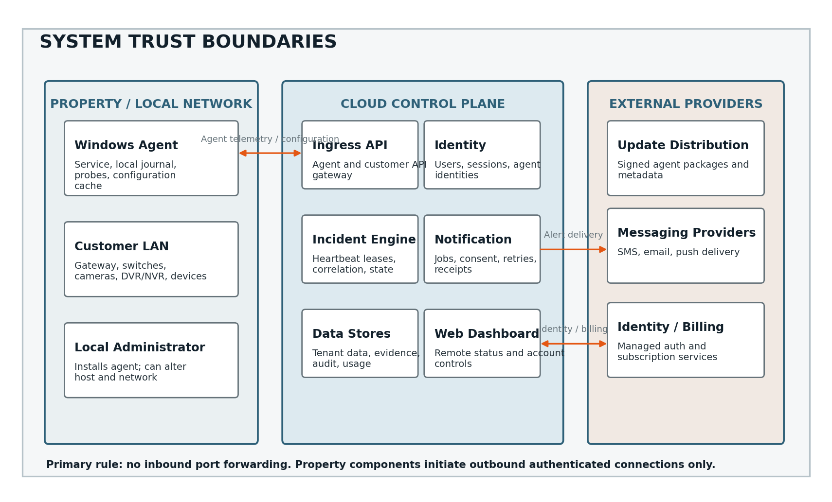
Figure 1. System trust boundaries and primary outbound-only communication paths.

3.2 Trust-boundary rules
- Customer-provided identifiers are never sufficient authorization. Server-side organization and property membership determine access.
- Agent credentials are scoped to one registered agent and property assignment; reassignment requires a controlled workflow.
- Cloud services treat agent telemetry and device-derived strings as untrusted input.
- External provider callbacks are authenticated or verified, replay-protected where possible, and idempotently processed.
- Support personnel do not obtain automatic access to customer properties merely by holding a support role.
- Build systems and signing systems are separate from the runtime application trust path.

4. Assets and Data Classification

4.1 Protected assets
Asset | Why it matters | Minimum protection
Customer accounts and sessions | Remote property visibility and control of alerts/contacts. | Strong authentication, secure sessions, revocation, audit, anomaly review.
Agent credentials | Authorize ingestion and configuration for a specific property edge. | Per-agent secrets/keys, protected storage, rotation, revocation, no logging.
Property and device metadata | Can reveal location context, security equipment, routines, and outage windows. | Tenant isolation, encryption, minimization, access logging, retention.
Trusted-contact phone/email data | Personal data and abuse target for unwanted messages. | Consent records, encryption, masking, restricted support access, deletion.
Incident and evidence history | May reveal when a property was unprotected or unattended. | Tenant isolation, purpose limitation, export controls, retention.
Camera/DVR credentials | Could grant access to surveillance equipment. | Local storage where possible, OS-protected secrets, never general cloud logging.
Signing keys and update metadata | Compromise enables software supply-chain attack. | Offline/HSM-backed key custody, separation of duties, immutable release records.
Provider and infrastructure secrets | Could enable data access, message abuse, or service disruption. | Central secrets manager, short-lived credentials, rotation, scoped IAM.
Audit and security telemetry | Needed to detect compromise and reconstruct events. | Tamper-resistant storage, limited access, synchronized time, retention.

4.2 Data classes
Class | Examples | Default storage | Default retention direction
D0 — Public | Marketing copy, product documentation, public status page. | Public systems | As business requires
D1 — Operational low sensitivity | Software version, capability flags, aggregate service metrics without customer identifiers. | Cloud and local | Short to moderate
D2 — Customer operational | Property label, device alias/type, current state, latency summary, incident timestamps. | Cloud system of record; raw detail local | Purpose-based; customer-visible
D3 — Sensitive customer | Phone/email contacts, public IP, detailed device inventory, away-mode status, exported incident reports. | Encrypted cloud; restricted access | Minimize and expire
D4 — Restricted security | Agent secrets, camera credentials, provider keys, signing material, recovery codes. | Dedicated protected stores; many items local only | Shortest practical; rotate/revoke
D5 — Surveillance content | Video, audio, images, biometric or behavioral content. | Not collected in MVP | Not applicable

CLASSIFICATION RULE
A field is classified by the harm caused through disclosure or misuse, not by whether it looks technically ordinary. An outage timestamp, public IP address, or away-mode flag may be sensitive in the context of an unattended property.

4.3 Data handling requirements
ID | Priority | Requirement | Verification
SEC-001 | P0 | Every persisted field MUST have an owner, purpose, classification, retention rule, and access path. | Schema review
SEC-002 | P0 | D4 secrets MUST NOT appear in application logs, analytics, support bundles, crash reports, or customer exports. | Automated secret scanning
SEC-003 | P0 | D5 surveillance content MUST NOT be collected or uploaded in MVP. | Network and code review
SEC-004 | P1 | Support interfaces MUST mask D3 contact and network data by default. | Role test
SEC-005 | P1 | Deletion and retention jobs MUST be idempotent, observable, and tested against backups and derived stores. | Lifecycle test

5. Threat Actors and Misuse Profiles
Actor | Capability / motivation | Primary concerns
Opportunistic internet attacker | Credential stuffing, scanning, commodity malware, API abuse. | Account takeover, denial of service, message abuse, exposed admin tools.
Targeted property intruder | Wants cameras or connectivity disabled without owner awareness. | Physical disconnection, router reset, local PC shutdown, alert suppression through stolen credentials.
Malicious or careless local administrator | Full Windows or network administrative access. | Agent disablement, credential extraction attempts, configuration manipulation, evidence deletion.
Compromised LAN device | Returns malformed protocol data, scans the agent, or attempts lateral movement. | Parser bugs, command injection, resource exhaustion, credential leakage.
Abusive customer | Uses messages to harass contacts, scans networks without authority, or creates excessive traffic. | SMS abuse, unauthorized monitoring, resource consumption, chargeback/fraud.
Compromised customer account | Attacker has password/session access but not local property access. | Viewing status, changing contacts, disabling alerts, exporting incident history.
Malicious insider / overprivileged contractor | Legitimate operational access used improperly. | Cross-tenant access, secret theft, log tampering, customer surveillance.
Supply-chain attacker | Targets dependencies, build runners, update storage, signing, or developer accounts. | Malicious agent or cloud deployment, stolen signing key, dependency compromise.
External provider compromise | Identity, SMS, email, billing, cloud, or observability provider is breached. | Token theft, callback spoofing, metadata exposure, notification manipulation.

5.1 Attacker capability limits
The model does not assume the system can defeat an attacker with persistent physical possession of the monitoring PC and administrator rights. Instead, it requires rapid cloud-side detection when the agent stops communicating, evidence preservation before and after loss, revocation of stolen agent credentials, and honest classification of unknown causes.

6. Threat Modeling Method
Threat analysis combines STRIDE for technical threats, privacy-harm analysis for data use, and abuse-case review for product misuse. Each threat is evaluated against confidentiality, integrity, availability, authenticity, customer safety, privacy, and trust.
Category | Question applied to this product
Spoofing | Can an attacker impersonate a user, agent, provider callback, support operator, device, or property?
Tampering | Can telemetry, configuration, incidents, contacts, notifications, binaries, or audit records be altered?
Repudiation | Can a sensitive action occur without reliable attribution and time evidence?
Information disclosure | Can property, device, contact, credential, or incident data cross an authorization boundary?
Denial of service | Can an attacker make monitoring or notifications unavailable or unaffordable?
Elevation of privilege | Can a low-privilege user, service, agent, or support role gain broader access?
Privacy harm | Can data collection, inference, retention, or sharing exceed reasonable customer expectations?
Abuse / deception | Can the service be used to harass contacts, produce misleading alerts, or create false confidence?

6.1 Risk scoring
Dimension | Scale
Likelihood | 1 Rare; 2 Unlikely; 3 Plausible; 4 Likely; 5 Expected without controls
Impact | 1 Minor; 2 Limited; 3 Material; 4 Severe; 5 Catastrophic / multi-tenant / supply-chain
Risk score | Likelihood × Impact. 15–25 Critical/High; 8–14 Medium; 1–7 Low, adjusted for detectability and blast radius.
Treatment | Avoid, mitigate, transfer, accept, or defer with owner and deadline.

6.2 Review triggers
- Adding mobile applications, hardware appliances, cellular fallback, remote commands, or customer-defined integrations.
- Uploading camera credentials or any surveillance content to the cloud.
- Changing identity, cloud provider, notification provider, payment provider, or update distribution mechanism.
- Introducing third-party webhooks, public APIs, remote shell/support features, or marketplace plugins.
- Expanding from one customer property to installers/MSPs with delegated multi-tenant administration.
- Material security incident, penetration-test finding, or newly discovered attack path.

7. Attack Surface Inventory
Surface | Untrusted inputs / actions | Primary controls
Windows installer and service | Installer arguments, local ACLs, service control, environment, registry, local IPC. | Signed installer, least-privilege service, ACL review, secure install path, no unsafe command concatenation.
LAN discovery and probes | Hostnames, banners, mDNS/SSDP/UPnP data, TCP responses, RTSP/ONVIF responses. | Bounded parsers, strict timeouts, output encoding, no shell invocation, rate limits.
Agent-to-cloud API | Heartbeats, events, replay batches, registration, config version, support bundle metadata. | Per-agent auth, schema validation, size limits, idempotency, rate limits, tenant binding.
Customer web/API | Passwords/sessions, profile changes, contacts, monitor config, exports, billing actions. | Managed identity, authorization, CSRF/XSS defenses, step-up auth, audit, throttling.
Provider callbacks | Delivery receipts, identity events, billing webhooks. | Signature verification, replay window, event IDs, least-privilege endpoint.
Notification content | Property/device labels, phone/email destinations, URLs. | Template encoding, content minimization, verified destinations, anti-abuse controls.
Update pipeline | Source code, dependencies, CI runners, artifacts, manifests, CDN/storage. | Protected branches, isolated builds, SBOM, signing, provenance, staged rollout, rollback.
Support and admin tools | Search, impersonation, data export, credential reset, incident actions. | Separate roles, just-in-time grant, approval for high-risk access, immutable audit.

CRITICAL DESIGN CONSTRAINT
Device-provided text must be treated as attacker-controlled even on a home LAN. A malicious hostname, RTSP banner, SSDP field, or ONVIF response must not become HTML, a shell command, a log-control sequence, or an unbounded memory allocation.

8. Windows Agent Threat Analysis

8.1 Installation, privilege, and persistence
Threat | Consequence | Required treatment
Unsigned or replaced installer | Malware gains trusted access to customer LAN. | Code-sign installer; publish checksums; verify update metadata; warn on signature failure.
Overprivileged service account | Agent compromise becomes full host compromise. | Run with minimum Windows privileges; isolate privileged operations; document required rights.
Writable program directory or DLL search path | Local user replaces executable/library. | Program Files ACLs; safe DLL loading; signed binaries; integrity checks where practical.
Unprotected local IPC or tray interface | Low-privilege user changes config or extracts secrets. | Authenticated/ACL-restricted named pipe or loopback channel; validate every request.
Service stop/uninstall without cloud visibility | Monitoring silently disappears. | Cloud heartbeat expiry; planned maintenance state; audit local stop reason when available.

8.2 Local secrets and configuration
- Agent credentials and locally stored camera/DVR credentials MUST use Windows-protected secret storage or equivalent OS-bound encryption.
- Secrets MUST be separated from general configuration, excluded from backups/support bundles unless explicitly encrypted, and never echoed in diagnostics.
- Configuration received from cloud MUST be schema-validated, versioned, bounded, and applied transactionally with rollback to last-known-good state.
- The agent MUST reject commands or configuration not scoped to its own registered identity and supported capability set.

8.3 Probe-engine safety
ID | Priority | Requirement | Verification
SEC-020 | P0 | Probe implementations MUST avoid invoking a shell with device-controlled or customer-controlled text. | Static review
SEC-021 | P0 | Every network operation MUST have connect/read deadlines, response-size limits, cancellation, and concurrency limits. | Fault injection
SEC-022 | P0 | Malformed device responses MUST fail closed without crashing the service or corrupting the journal. | Fuzz test
SEC-023 | P1 | Discovery rates MUST be bounded to avoid disrupting small networks or resembling unauthorized scanning. | Traffic test
SEC-024 | P1 | Device labels and protocol metadata MUST be safely encoded before UI, log, notification, or export rendering. | Injection test
SEC-025 | P1 | Optional credentialed camera checks MUST use local credential references; cloud configuration MUST NOT contain plaintext credentials. | Config inspection

8.4 Local evidence integrity
The SQLite journal is not a forensic-grade tamper-proof system against a local administrator. It should nevertheless provide crash-safe transactions, monotonically increasing local sequence numbers, timestamps from a monitored clock, checksums or chaining where practical, and durable replay after connectivity returns. Cloud ingestion records the time and agent identity associated with replayed evidence.

9. Cloud and API Threat Analysis

9.1 Tenant isolation
LAUNCH BLOCKER
Cross-tenant authorization defects are unacceptable. Every property-scoped query and mutation must derive organization/property access from authenticated identity and server-side membership, not from an identifier supplied by the browser or agent.

ID | Priority | Requirement | Verification
SEC-030 | P0 | All customer-data access MUST be tenant-scoped in the service layer and enforced by automated negative authorization tests. | Integration suite
SEC-031 | P0 | Agent ingestion MUST bind the authenticated agent identity to its assigned property server-side. | Spoofing test
SEC-032 | P0 | Direct object references MUST return no data when the caller lacks property authorization, regardless of object UUID knowledge. | IDOR test
SEC-033 | P0 | Background jobs MUST carry explicit tenant/property context and reject missing or conflicting context. | Worker test
SEC-034 | P1 | Database row-level security or equivalent defense-in-depth SHOULD be evaluated for the most sensitive tenant tables. | ADR / test

9.2 Input integrity and replay
Threat | Control
Duplicate or reordered agent events | Agent sequence numbers, event IDs, idempotency keys, and monotonic processing rules.
Fabricated incident from compromised agent | Agent-scoped trust, anomaly detection, bounded impact to one property, visible evidence source, credential revocation.
Oversized replay batch or decompression bomb | Request/body limits, bounded decompression, quotas, streaming parsing, backpressure.
Webhook replay or forgery | Provider signature verification, timestamp window, unique provider event ID, idempotent handling.
Mass assignment / hidden fields | Explicit request schemas and server-owned fields; reject unknown or immutable fields.
Injection into queries, logs, or templates | Parameterized database access, structured logging, output encoding, template allowlists.

9.3 Denial of service and cost abuse
- Rate limits must distinguish unauthenticated, user, organization, agent, provider, and support traffic.
- Notification queues require per-plan quotas, per-incident deduplication, destination throttles, and emergency provider kill switches.
- Heartbeat processing should be lightweight, partitionable, and tolerant of reconnect storms after regional internet restoration.
- Expensive operations such as exports, reports, speed tests, and broad discovery should run asynchronously with limits.
- Public endpoints must have bot/abuse protection without making legitimate outage recovery depend on brittle challenges.

10. Account, Dashboard, and Support Threat Analysis

10.1 Customer identity
Action | Required protection
Sign-in and session creation | Managed identity or hardened implementation; secure cookies; session rotation; brute-force and credential-stuffing protection.
Change password or identity factors | Recent authentication; revoke relevant sessions; security notification.
Add/change trusted phone or email | Destination verification, consent, step-up authentication, audit, and cooling-off or notice where practical.
Disable monitoring or escalation | Prominent confirmation, recent authentication, audit, and notice to existing primary contact.
Export incidents or account data | Recent authentication; tenant authorization; expiring download; audit; sensitive-field review.
Delete property/account | Recent authentication; clear consequences; staged deletion/recovery window where appropriate; audit.
Invite organization member | Role limits, verified invite, expiration, audit, and no privilege greater than inviter may grant.

10.2 Browser and frontend controls
- Use secure, HttpOnly, SameSite cookies for sessions when browser architecture permits; do not store long-lived bearer tokens in localStorage.
- Implement CSRF protections for state-changing cookie-authenticated requests.
- Encode all property names, device labels, provider messages, and diagnostic text at output; apply a restrictive Content Security Policy.
- Do not embed secrets or high-privilege service credentials in frontend code.
- Sensitive pages should avoid unnecessary third-party scripts and prevent referrer leakage.
- Logout, session revocation, password reset, and identity-provider changes must have clear and testable behavior.

10.3 Support access
SUPPORT RULE
Support personnel should see enough to diagnose delivery and service health, but not automatically browse detailed device inventories, away status, contact values, or incident evidence. Elevated access must be time-limited, justified, audited, and preferably customer-authorized.

ID | Priority | Requirement | Verification
SEC-040 | P0 | Production admin access MUST use individual identities, MFA, and centrally logged authorization. | Access review
SEC-041 | P1 | Customer-data support access MUST be separate from general support role and use just-in-time elevation. | Role exercise
SEC-042 | P1 | High-risk actions such as session revocation, contact override, or data export MUST create immutable audit events. | Audit test
SEC-043 | P1 | Support tools MUST not expose agent, provider, camera, or signing secrets. | UI inspection

11. Notification and Trusted-Contact Threat Analysis

11.1 Threats
Threat | Customer harm | Mitigation
Unauthorized contact enrollment | Victim receives unwanted or alarming messages. | Verify destination; record consent; notify account owner; easy opt-out except essential transactional limits.
SMS pumping / message flood | Cost, harassment, provider suspension. | Quotas, per-destination rate limits, incident deduplication, anomaly alarms, provider spending caps.
Suppressed delivery | Customer assumes protection while messages fail. | Delivery receipts, fallback channel, test function, notification-health status, escalation.
Message-content leakage | Lock-screen notification reveals property details. | Minimal default text; user-configurable privacy; secure dashboard link; avoid full address/device inventory.
Spoofed provider callback | False delivery state or arbitrary workflow activation. | Verify signatures/timestamps; idempotency; least-privilege callback handler.
Unsafe links | Phishing risk or token disclosure. | Use owned domains, short-lived opaque links, no credentials in URLs, consistent message format.

11.2 Consent and destination lifecycle
1. Account owner enters a destination and intended role.
2. System sends a verification challenge or consent message.
3. Destination confirms; system records timestamp, method, purpose, and applicable terms version.
4. Owner selects eligible event types and escalation timing.
5. Sensitive changes trigger notice to existing verified destinations.
6. Opt-out, removal, number recycling, provider failure, or account deletion deactivates future messaging as appropriate.
NOTIFICATION LANGUAGE
Alerts should identify the monitored property only as specifically as necessary. A lock-screen SMS should not announce that a named residence is vacant, list all disabled cameras, or reveal a precise address by default.

12. Software Supply Chain and Update Security
Because the agent runs continuously inside customer networks, the update system is a top-tier trust boundary. A compromised signing or release pipeline can turn a safety product into a distribution channel for malware.
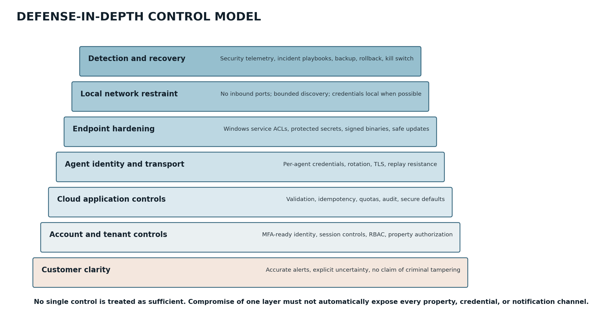
Figure 2. Defense-in-depth controls from customer-facing clarity through local network restraint and recovery.

12.1 Required update properties
ID | Priority | Requirement | Verification
SEC-050 | P0 | Every production installer and update package MUST be code-signed with a protected organizational certificate. | Signature verification
SEC-051 | P0 | The agent MUST verify signed update metadata and artifact integrity before installation. | Tamper test
SEC-052 | P0 | Signing credentials MUST be isolated from routine developer workstations and CI jobs. | Key custody review
SEC-053 | P0 | Release rollout MUST support staged cohorts, pause, rollback, and emergency revocation. | Release drill
SEC-054 | P1 | Builds SHOULD produce an SBOM and reproducible or verifiable provenance artifacts. | CI evidence
SEC-055 | P1 | Dependencies MUST be pinned/locked, scanned, and reviewed for license and security risk. | Pipeline review
SEC-056 | P1 | Protected branches, mandatory review, and least-privilege CI identities MUST guard production releases. | Repository audit

12.2 Emergency update controls
- Ability to halt update publication without stopping normal monitoring.
- Ability to mark a specific version blocked and direct affected agents to a known-good version.
- Independent communication channel for customer notice if the application platform is suspected compromised.
- Documented certificate/key compromise procedure, including replacement and trust migration.
- Retention of immutable release manifests, approvals, artifact hashes, and signer identity.

13. Privacy-by-Design Model
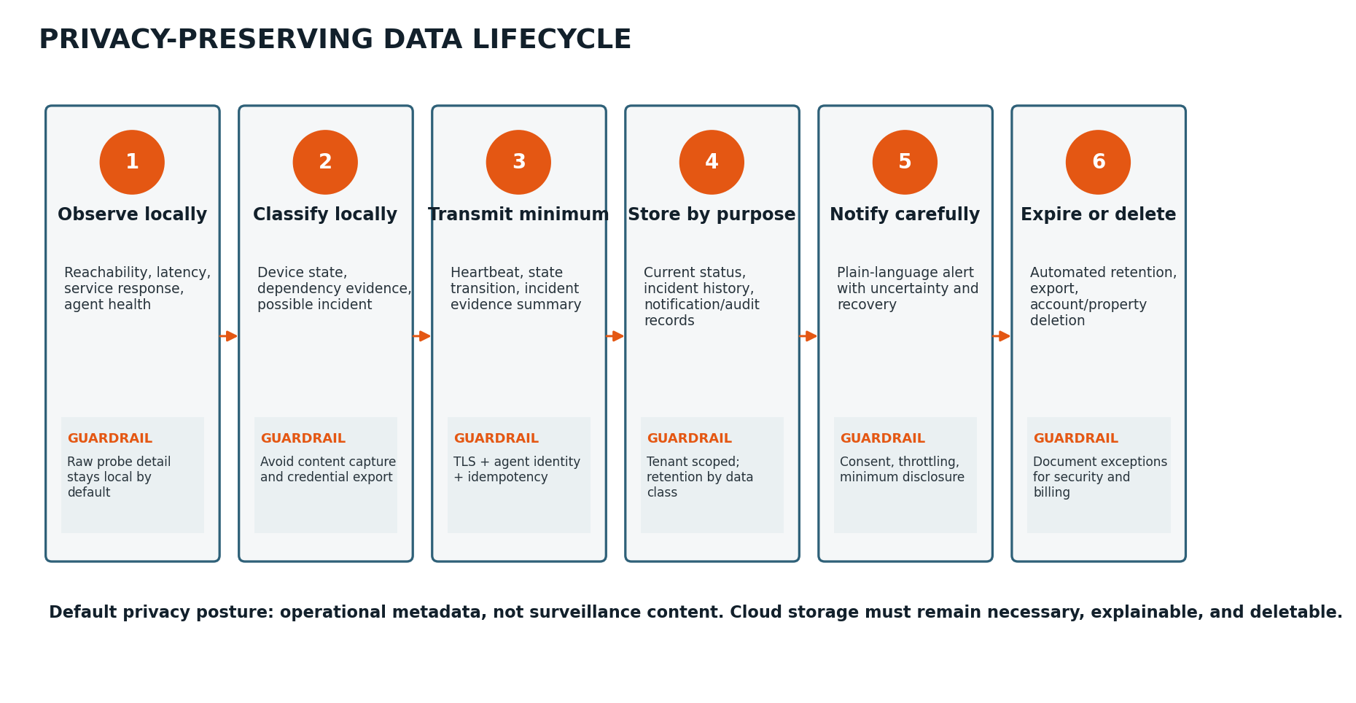
Figure 3. Privacy-preserving flow from local observation through purpose-limited deletion.

13.1 Purpose limitations
Data purpose | Allowed use | Disallowed expansion without new review/consent
Service operation | Determine agent/device state, correlate incidents, deliver alerts, show history. | Advertising profiles, unrelated behavioral analytics, sale of customer data.
Reliability improvement | Aggregate failure rates, latency, crash signatures, delivery performance. | Retaining detailed customer network data indefinitely for speculative analysis.
Security and abuse prevention | Detect account compromise, scraping, message abuse, malicious agents, and platform attacks. | Using security telemetry to infer occupancy or lifestyle for unrelated purposes.
Billing and entitlement | Track plan, SMS usage, quotas, invoices, and fraud signals. | Combining billing data with property behavior beyond legitimate business need.
Customer support | Diagnose reported issues with least data necessary and recorded access. | Unrestricted browsing of customer properties or contacts.

13.2 Privacy risks unique to the product
Risk | Example | Required response
Occupancy inference | Away Mode or recurring device patterns suggest when a property is unattended. | Restrict access; minimize notification text; avoid unnecessary analytics; shorter retention.
Security-layout inference | Device inventory exposes camera, DVR, router, and switch topology. | Collect only monitored inventory; tenant isolation; masked support access; export warning.
Contact harm | Trusted contact receives alarming messages without informed consent. | Verification, consent record, clear sender identity, opt-out and removal.
Unexpected content collection | A diagnostic feature begins capturing frames, audio, URLs, or protocol payloads. | Prohibit by default; privacy review; explicit opt-in; separate storage and retention if ever introduced.
Sensitive labels | Customer names a device “Nursery Camera” or property with a full address. | Treat labels as sensitive; minimize lock-screen use; safely encode; permit aliases.

13.3 Privacy requirements
ID | Priority | Requirement | Verification
PRIV-001 | P0 | Cloud collection MUST be limited to fields required for an approved product, security, billing, or support purpose. | Data inventory
PRIV-002 | P0 | Raw video, audio, still images, and biometric content MUST NOT be collected in MVP. | Traffic inspection
PRIV-003 | P0 | Camera/DVR credentials MUST remain local by default and MUST NOT be included in general telemetry. | Secret scan
PRIV-004 | P1 | Customers MUST be able to view, correct where applicable, export, and delete their property/account data subject to documented exceptions. | Lifecycle test
PRIV-005 | P1 | Retention MUST differ by data purpose; “keep forever” is not an acceptable default. | Retention job test
PRIV-006 | P1 | Product analytics MUST avoid raw device labels, full IP addresses, contact details, and detailed incident evidence unless necessary. | Analytics schema review
PRIV-007 | P1 | Privacy notices MUST accurately describe local versus cloud processing and provider disclosures. | Content/legal review

14. Identity, Authentication, and Authorization

14.1 Human identity
- Use a mature identity provider or a thoroughly reviewed implementation. MFA should be available before public launch and required for privileged operational accounts.
- Password-reset and account-recovery flows must not reveal account existence unnecessarily or permit support to bypass identity proofing casually.
- Sessions must have server-side revocation, rotation after authentication changes, inactivity/absolute limits appropriate to risk, and secure cookie configuration.
- Sensitive mutations require recent authentication or step-up verification: contact changes, alert suppression, organization ownership transfer, exports, and deletion.

14.2 Workload identity
Identity | Scope | Lifecycle
Agent credential | One agent registration and assigned property; ingest/config only. | Created at enrollment, stored OS-protected, rotated, revoked on uninstall/reassignment/compromise.
Cloud service identity | Specific service resources and operations. | Short-lived platform credentials where possible; managed IAM; no shared developer keys.
CI/CD identity | Build, artifact, deployment, or signing step only. | Environment-scoped; protected; audited; removed from developer runtime.
Provider credential | Specific provider account, environment, and API capability. | Secrets manager; rotation; spending/usage alerts; test and production separation.

14.3 Authorization model
Role | Typical permissions | Explicit restrictions
Organization owner | Manage organization, properties, members, plan, and high-risk settings. | Cannot retrieve restricted platform secrets or other organizations.
Property admin | Manage assigned property monitors, policies, contacts, and incidents. | No unrelated property or organization ownership actions.
Viewer / responder | View assigned status and acknowledge incidents. | No sensitive configuration, contacts, billing, exports, or deletion unless granted.
Support | View service health and masked account metadata. | No default detailed property browsing; no secret access; no silent impersonation.
Security/operations admin | Time-limited production operations under audit. | No routine customer browsing or software-signing authority.

15. Cryptography and Secret Management

15.1 Transport and storage
- All agent, dashboard, provider, and administrative communication must use current TLS configurations with certificate validation.
- Sensitive cloud databases, backups, queues, and object storage must use provider-supported encryption at rest; application-level encryption should be evaluated for D4 or especially sensitive D3 fields.
- The product must not design custom cryptographic algorithms or invent a proprietary key-exchange protocol.
- Agent secret storage should use Windows DPAPI, Credential Manager, TPM-backed keys, or an equivalent reviewed mechanism appropriate to deployment.

15.2 Secret inventory
Secret | Preferred custody | Rotation / revocation expectation
Agent enrollment token | Short-lived, one-time, cloud-generated. | Expires quickly; single use; no reuse across properties.
Agent long-term credential | OS-protected local store + server record/public key. | Periodic or event-driven rotation; immediate revocation supported.
Camera/DVR password | Local protected store only by default. | Customer-controlled; removable; never logged/exported.
Database/service credentials | Cloud workload identity or managed secret store. | Automated short-lived credentials where possible.
SMS/email/push provider keys | Central secret manager, environment scoped. | Scheduled and incident-driven rotation; spending and anomaly alerts.
Code-signing key | HSM or strongly isolated signing service. | Separate custody, auditable use, compromise playbook.

ID | Priority | Requirement | Verification
SEC-070 | P0 | Secrets MUST NOT be committed to source control, baked into images, printed in CI logs, or included in client applications. | Automated scanning
SEC-071 | P0 | Production and non-production secrets MUST be isolated. | Environment review
SEC-072 | P1 | Secret access MUST be individually attributable and logged for privileged operations. | Audit review
SEC-073 | P1 | Credential rotation MUST be tested as an operational procedure, not only documented. | Rotation drill

16. Logging, Detection, Audit, and Observability

16.1 Logging principles
- Use structured logs with event type, correlation ID, tenant/property reference where appropriate, actor identity, result, and reason code.
- Never log authentication tokens, passwords, camera URLs containing credentials, full payment data, or unrestricted request bodies.
- Mask phone/email/public-IP data in routine logs and support views unless the exact value is necessary for a privileged task.
- Synchronize system clocks and record both event occurrence time and ingestion time for replayed evidence.
- Separate customer-visible incident evidence from internal security telemetry and operational debugging logs.

16.2 Security detections
Detection | Example trigger | Response
Account takeover indicators | Impossible travel, repeated failed login, new device plus contact change, unusual export. | Step-up, session revocation, customer notice, investigation.
Agent credential abuse | One credential from implausible locations, unexpected version/capability, excessive events. | Quarantine agent identity, preserve evidence, require re-enrollment.
Cross-tenant access anomaly | Authorization denial spike or query returns mixed tenant IDs. | Page security/on-call; contain deployment; investigate as potential breach.
Notification abuse | Message volume spike, repeated destination enrollment, provider fraud signal. | Throttle/disable destination or account; spending cap; review.
Support/admin misuse | Unusual customer searches, bulk exports, off-hours elevation. | Revoke access, preserve audit, security review.
Supply-chain anomaly | Unexpected artifact hash, signing event, dependency change, runner behavior. | Stop release; revoke artifact; rotate credentials; incident process.

16.3 Audit events
Event family | Minimum fields
Authentication | Actor, method, result, session/device context, time, risk signal.
Authorization-sensitive action | Actor, organization/property, action, target, before/after summary, result, reason.
Contact/consent change | Destination reference/masked value, verification state, consent version, actor, time.
Monitoring suppression/config change | Policy/target, old/new state, actor, channel, reason.
Support/admin elevation | Requestor, approver if used, scope, purpose, start/end, actions performed.
Agent lifecycle | Enrollment, assignment, credential rotation, revocation, version, uninstall/stop when observed.
Release lifecycle | Commit/build, artifact hashes, approvals, signer, rollout cohort, pause/rollback.

17. Secure Development Lifecycle

17.1 Engineering controls
ID | Priority | Requirement | Verification
SEC-080 | P0 | Code changes to authentication, authorization, crypto, update, billing, notifications, and data deletion MUST receive review by an appropriately qualified second person. | Repository policy
SEC-081 | P0 | Automated tests MUST include cross-tenant negative authorization, idempotency, replay, and malformed-input cases. | CI gate
SEC-082 | P0 | Static analysis, dependency scanning, secret scanning, and artifact vulnerability scanning MUST run in CI. | CI evidence
SEC-083 | P1 | Critical parsers and network-response handlers SHOULD receive fuzz or property-based testing. | Test report
SEC-084 | P1 | Production infrastructure MUST be defined as code and reviewed; console-only drift SHOULD be detected. | Drift report
SEC-085 | P1 | Security acceptance criteria MUST trace to backlog items and release gates. | Traceability review

17.2 Environment separation
Environment | Data and access rule
Developer local | Synthetic data; no production secrets; limited test-provider credentials.
Automated test | Ephemeral/synthetic tenants; isolated credentials; destructive tests allowed.
Staging | Production-like configuration with synthetic or expressly approved test data; separate providers/accounts.
Production | Least-privilege access, MFA, change control, audit, protected data, and controlled break-glass.

17.3 Vulnerability management
- Maintain an inventory of components, versions, images, dependencies, and externally reachable services.
- Define remediation targets by severity and exploitability, with an exception workflow and owner.
- Provide a security contact and coordinated vulnerability disclosure channel before public launch.
- Distinguish vulnerability reports from customer outages; preserve reporter confidentiality and respond consistently.
- Evaluate whether a public bug bounty is appropriate only after triage and remediation capacity exists.

18. Security Incident Response
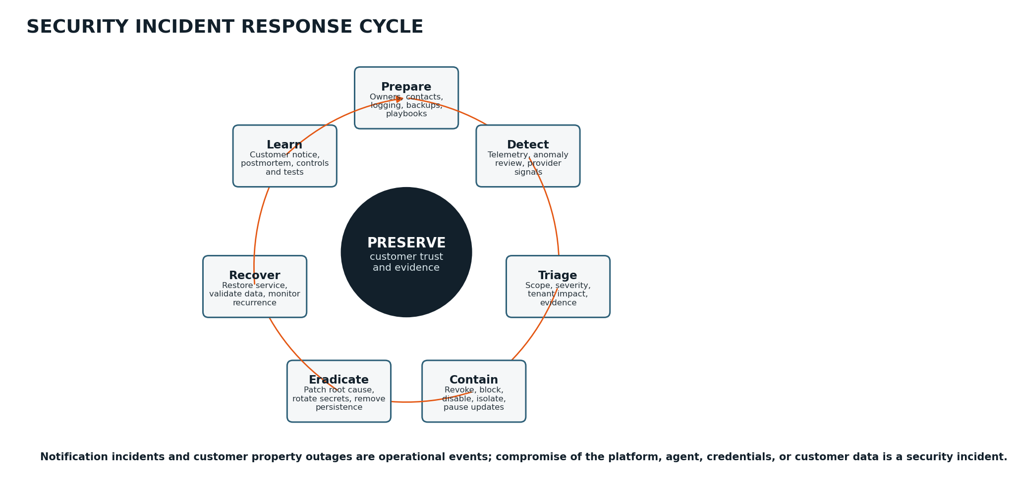
Figure 4. Security incident response cycle centered on preserving customer trust and evidence.

18.1 Severity model
Severity | Example | Target posture
SEV-1 Critical | Confirmed or likely multi-tenant exposure; signing-key compromise; malicious production deployment; widespread authentication bypass. | Immediate executive/security ownership, containment, preserve evidence, customer/legal assessment, continuous response.
SEV-2 High | Single-tenant sensitive data exposure; privileged account compromise; provider credential abuse; sustained notification suppression. | Rapid on-call response, contain affected identities/services, assess notice, root cause and corrective action.
SEV-3 Medium | Limited vulnerability with controls, suspicious access, localized availability/security degradation. | Triage, mitigation plan, monitor, document.
SEV-4 Low | Minor misconfiguration, low-risk finding, no observed exploitation. | Backlog with owner and due date.

18.2 Minimum incident roles
Role | Responsibility
Incident commander | Owns priorities, decisions, timeline, handoffs, and closure.
Technical lead | Investigates and executes containment/eradication/recovery.
Communications lead | Coordinates customer, provider, internal, and public communications.
Privacy/legal advisor | Assesses affected data, contractual duties, and notification obligations; external counsel may fill role.
Scribe/evidence custodian | Maintains timeline, decisions, artifacts, hashes, and chain-of-custody notes.

18.3 Initial response checklist
1. Open an incident record and assign commander, technical lead, and scribe.
2. Preserve relevant cloud, identity, provider, CI/CD, signing, and audit evidence; avoid destructive cleanup before collection.
3. Determine affected tenants, agents, data classes, versions, regions, and time window.
4. Contain access: revoke sessions/keys, disable provider credentials, pause releases, quarantine agents, or isolate services as required.
5. Establish a trusted communications channel independent of potentially compromised systems.
6. Assess customer impact and whether notifications, status-page updates, provider escalation, law-enforcement contact, or legal advice are appropriate.
7. Recover from known-good artifacts and validate authorization, data integrity, notifications, and monitoring.
8. Complete a blameless post-incident review with corrective controls, owners, deadlines, and regression tests.
EVIDENCE CAUTION
Routine logs are operational evidence, not guaranteed legal evidence. When an event may involve criminal conduct, insurance, or litigation, preserve original records, document collection, and obtain qualified advice rather than overstating forensic certainty.

19. Availability, Business Continuity, and Recovery

19.1 Security-relevant availability
Availability is part of the security promise because prolonged platform failure can prevent customers from learning that their property is offline. The design should degrade visibly and preserve local evidence rather than silently discarding events.
Failure | Expected behavior
Cloud ingestion unavailable | Agent journals events locally with bounded storage, backoff, and health indication; replays idempotently after recovery.
Notification provider unavailable | Queue persists; retry with backoff; use alternate channel/provider where configured; expose delayed/failed delivery.
Identity provider unavailable | Existing sessions may continue within policy; sensitive account changes may be unavailable; monitoring/alerting should continue.
Database failure | Fail over or restore according to recovery design; avoid accepting changes that cannot be durably stored.
Regional cloud outage | Heartbeat loss may create false property-offline incidents; architecture should use multi-zone resilience and consider independent regional confirmation.
Bad agent release | Pause rollout, block version, rollback, communicate, and prevent repeated update loops.

19.2 Recovery requirements
ID | Priority | Requirement | Verification
SEC-090 | P0 | Critical cloud data MUST have tested backup and restore procedures with documented RPO/RTO targets before public launch. | Recovery drill
SEC-091 | P0 | Notification jobs and incident state MUST be durable across process restarts and deployments. | Chaos test
SEC-092 | P1 | The agent MUST survive restart/crash without losing committed evidence or duplicating notifications after replay. | Restart test
SEC-093 | P1 | A platform-wide maintenance or incident state MUST prevent misleading property-specific tamper wording. | Scenario test

20. Abuse Prevention and Compliance Readiness

20.1 Product misuse controls
Misuse | Control
Monitoring a network without authorization | Terms and onboarding attestation; local installation/admin requirement; limit broad scanning; abuse-report channel.
Harassing a phone number through alerts | Destination verification/consent, rate limits, opt-out, account suspension, provider abuse monitoring.
Using labels/alerts for threats or hateful content | Template restrictions, content length/character controls, abuse response, avoid arbitrary user message bodies in SMS.
Creating false evidence of tampering | Evidence source attribution, immutable observation history, classification confidence, no accusation language.
Reselling without customer consent | Organization/member roles, delegated administration model only when intentionally built, clear customer ownership.
Resource/cost abuse | Plan limits, quotas, anomaly detection, payment/fraud controls, network-probe limits.

20.2 Compliance readiness — not legal conclusions
The company should obtain qualified legal and privacy advice before public launch, particularly for privacy notices, SMS consent, consumer subscription terms, breach-notification duties, data-processing agreements, retention, children/minors, and expansion beyond the United States. This document defines technical readiness, not legal compliance.
Readiness area | Technical/operational preparation
Privacy transparency | Accurate data inventory, local/cloud diagram, provider list, purposes, retention, rights workflow, contact channel.
Consumer messaging | Destination verification, consent evidence, sender identification, opt-out handling, quiet-hour/escalation design as appropriate.
Security incident notice | Affected-data inventory, tenant impact query, contact records, incident timeline, counsel/communications playbook.
Data-processing vendors | Provider inventory, security review, contract/DPA tracking, subprocessor-change process.
Account deletion/export | Authenticated request flow, machine-readable export where appropriate, deletion across active/derived stores, documented backup expiration.
Subscription/billing | Clear renewal/cancellation behavior, entitlement audit, minimal payment data through payment provider.

21. Security Verification and Testing Plan

21.1 Automated security tests
Test family | Minimum coverage
Authorization matrix | Every customer and support endpoint across owner/admin/viewer/no-membership/other-tenant cases.
Agent identity | Wrong property ID, revoked credential, cloned credential, expired enrollment token, replayed registration, capability mismatch.
Input robustness | Malformed JSON, unknown fields, extreme lengths, invalid Unicode, device-controlled injection strings, oversized batches.
Idempotency/replay | Duplicate event, reordered sequence, provider callback replay, retry after timeout, reconnect storm.
Notification abuse | Rapid incident churn, repeated destination changes, quota exhaustion, provider outage, duplicate receipts.
Secret leakage | Repository, build logs, runtime logs, support bundles, crash reports, analytics payloads, package contents.
Data lifecycle | Retention expiration, export, deletion, tenant closure, provider data, cache/search/backup handling.
Update integrity | Modified artifact, modified manifest, wrong signer, downgrade, blocked version, interrupted update, rollback.

21.2 Independent assessment
- Architecture and threat-model review before the prototype becomes a public beta.
- Focused penetration test before public launch, covering customer/API authorization, agent enrollment/identity, web security, provider callbacks, and update verification.
- Windows service and installer review for privilege, ACL, local IPC, secret storage, DLL loading, and update safety.
- Privacy review of actual telemetry, logs, analytics, support views, exports, and deletion—not only written policy.
- Remediation verification for all critical/high findings and documented acceptance for residual medium findings.

21.3 Adversarial scenarios
Scenario | Pass condition
Attacker changes property UUID in an authorized API request. | No cross-property data or action; denial is logged without leaking existence.
Agent credential is copied to a second machine. | Anomaly becomes visible; blast radius remains one agent/property; credential can be revoked and re-enrolled.
Malicious LAN device returns script tags and control characters as hostname. | No execution, broken logs, notification injection, or export corruption.
SMS provider sends callback twice and out of order. | One logical delivery state; no duplicate escalation.
Customer account is taken over and alerts are disabled. | Sensitive action requires step-up and generates notice/audit to existing verified contact.
Update package is altered after signing. | Agent rejects package and remains on known-good version.
Cloud outage causes many missed heartbeats. | Platform identifies systemic event and suppresses misleading possible-tampering classifications.

22. Security and Privacy Launch Gates

22.1 Prototype gate
Gate | Exit evidence
Per-agent identity | Registration, secure local storage, revocation, and property binding demonstrated.
Outbound-only operation | No inbound port forwarding; packet capture confirms expected destinations and payload classes.
Local journal safety | Crash/restart/replay without corruption or uncontrolled duplicate notifications.
Secret hygiene | No secrets in logs, telemetry, support bundle, code repository, or package.
Incident honesty | Systemic cloud failure and unknown cause do not produce accusatory tamper claims.

22.2 Private beta gate
Gate | Exit evidence
Tenant isolation | Automated authorization matrix and independent review pass.
Customer identity | Secure session/recovery; MFA-ready; step-up for sensitive changes.
Notification consent | Verified destinations, opt-out/removal, rate limits, delivery status, test flow.
Data inventory/privacy notice | Actual telemetry and provider flows documented and matched to product behavior.
Secure updates | Signed installer/update, staged rollout, pause/rollback drill.
Incident response | On-call contacts, severity model, evidence access, provider revocation, and tabletop exercise.

22.3 Public launch gate
Gate | Exit evidence
Independent security test | Critical/high findings resolved and retested; residual risks accepted.
Backup and recovery | Successful restore drill and notification-queue durability exercise.
Vulnerability disclosure | Published security contact and internal triage/remediation process.
Operational access | MFA, individual accounts, JIT/break-glass, logging, quarterly access review.
Legal/privacy readiness | Qualified review of notices, terms, SMS practices, subscriptions, vendor contracts, and incident obligations.
Metrics and alarms | Security, provider cost, delivery, authorization-denial, and cross-tenant anomaly alerts tested.

NO SILENT WAIVERS
A failed P0 gate cannot be treated as “good enough” through an undocumented decision. Deferral requires a written risk statement, compensating control, owner, deadline, and explicit founder approval.

23. Initial Security Risk Register
ID | Risk | L | I | Score | Primary treatment | Owner | Status
R-01 | Cross-tenant authorization flaw | 3 | 5 | 15 High | Enforce tenant context; negative tests; independent review. | Engineering/Security | Open
R-02 | Compromised agent update pipeline | 2 | 5 | 10 High | Signed artifacts, isolated signing, provenance, staged rollout, rollback. | Engineering/Founder | Open
R-03 | Account takeover suppresses alerts | 3 | 4 | 12 High | MFA-ready identity, step-up, notices, session revocation, audit. | Product/Engineering | Open
R-04 | SMS abuse or cost attack | 4 | 3 | 12 High | Consent, rate limits, quotas, spending caps, anomaly alarms. | Operations/Product | Open
R-05 | Cloud outage misclassified as property tampering | 3 | 4 | 12 High | Systemic-event detection, platform health correlation, conservative wording. | Engineering/Product | Open
R-06 | LAN parser vulnerability compromises agent | 3 | 4 | 12 High | No shell, bounded parsers, fuzzing, least privilege, sandbox where practical. | Agent Engineering | Open
R-07 | Camera credentials leak through logs/support | 2 | 5 | 10 High | Local protected storage, redaction, secret tests, no cloud telemetry. | Agent/Cloud | Open
R-08 | Support insider views sensitive property data | 2 | 4 | 8 Medium | Masked default, JIT elevation, audit, access reviews, alerts. | Operations/Security | Open
R-09 | Agent cloned or credential stolen | 3 | 3 | 9 Medium | OS protection, agent anomaly detection, revocation/re-enrollment. | Agent/Cloud | Open
R-10 | Data retained beyond stated purpose | 3 | 3 | 9 Medium | Data inventory, retention jobs, deletion tests, provider review. | Product/Privacy | Open
R-11 | Unverified trusted contact receives alarming alerts | 3 | 3 | 9 Medium | Verification, consent record, owner notice, opt-out/removal. | Product/Operations | Open
R-12 | Local administrator tampers with evidence | 4 | 2 | 8 Medium | Document limitation, cloud heartbeat, sequence/checksums, replay timestamps. | Product/Agent | Accepted with mitigation
R-13 | Dependency or CI compromise | 2 | 5 | 10 High | Lockfiles, scanning, protected runners, SBOM, provenance, signing separation. | Engineering | Open
R-14 | Provider callback forgery/replay | 3 | 3 | 9 Medium | Signature/timestamp validation, event IDs, idempotency. | Cloud Engineering | Open
R-15 | Property/away-status disclosure in lock-screen message | 3 | 3 | 9 Medium | Minimal templates, privacy mode, aliases, dashboard detail. | Product | Open

23.1 Risk acceptance rules
- Critical or high residual risk affecting tenant isolation, updates, secrets, or notification integrity requires founder approval and should normally block public launch.
- Accepted risk must state affected release, rationale, compensating controls, owner, review date, and trigger for reopening.
- Risk scores are prioritization aids, not substitutes for judgment about customer safety, blast radius, or irreversible harm.

24. Traceability and Open Decisions

24.1 Threat-to-control traceability
Threat family | Key requirements / controls | Primary verification
Cross-tenant exposure | SEC-030–034; RBAC; server-side tenant context; support restrictions. | Authorization matrix, penetration test, audit review.
Agent spoofing/replay | Per-agent identity; SEC-031; sequence/idempotency; revocation. | Clone/replay tests, credential rotation drill.
Supply-chain compromise | SEC-050–056; protected CI/signing; staged rollout. | Tampered artifact tests, release drill, key custody review.
Secret disclosure | SEC-002, 025, 070–073; local storage; redaction. | Secret scans, support bundle inspection, log review.
Notification abuse/failure | Consent, quotas, receipts, deduplication, fallback. | Provider fault simulation, pumping test, consent workflow test.
Privacy overcollection | PRIV-001–007; D5 exclusion; local-first processing. | Telemetry capture review, data inventory, deletion test.
Misleading tamper classification | Evidence confidence, systemic-event correlation, language rules. | Incident scenario suite and product copy review.

24.2 Open security decisions
Decision | Options to evaluate | Decision deadline
Agent authentication primitive | High-entropy bearer secret with rotation vs. asymmetric key pair/mTLS; consider operational complexity and clone detection. | Before prototype cloud registration is finalized
Local secret store | DPAPI machine/user scope, Windows Credential Manager, TPM-backed key, or hybrid. | Before credentialed camera prototype
Identity provider and MFA | Managed identity vendor vs. self-hosted components; passkeys/TOTP/recovery strategy. | Before private beta onboarding
Database tenant defense | Service-layer scoping only vs. row-level security for selected tables. | Before production schema freeze
Support elevation | Customer-approved access, JIT platform role, dual approval for exports, or combinations. | Before beta support begins
Telemetry retention | Exact windows by class and plan; security-log retention; backup expiration. | Before privacy notice
Update signing custody | Commercial code-signing service/HSM, certificate type, approval process, and emergency migration. | Before first external installer
Notification privacy mode | Default level of property/device detail in SMS/push and trusted-contact messages. | Before alert UX freeze

Appendix A — Normative Security Requirements Catalog
ID | Priority | Requirement
SEC-001 | P0 | Persisted fields have owner, purpose, classification, retention, and access path.
SEC-002 | P0 | Restricted secrets never enter logs, analytics, support bundles, crash reports, or exports.
SEC-003 | P0 | Surveillance content is excluded from MVP collection.
SEC-004 | P1 | Support views mask sensitive contact/network data by default.
SEC-005 | P1 | Retention/deletion jobs are idempotent, observable, and tested.
SEC-020 | P0 | Probe implementations do not invoke shells with untrusted text.
SEC-021 | P0 | Network operations have deadlines, size limits, cancellation, and concurrency limits.
SEC-022 | P0 | Malformed device responses cannot crash service or corrupt journal.
SEC-023 | P1 | Discovery traffic is bounded and non-disruptive.
SEC-024 | P1 | Device metadata is safely encoded for UI/log/notification/export.
SEC-025 | P1 | Credentialed checks use local secret references, not cloud plaintext.
SEC-030 | P0 | Customer-data access is tenant scoped and negative-tested.
SEC-031 | P0 | Authenticated agent identity is server-bound to property assignment.
SEC-032 | P0 | Unauthorized object identifiers reveal no data or action.
SEC-033 | P0 | Background jobs carry explicit tenant/property context.
SEC-034 | P1 | Database row-level defense is evaluated for sensitive tables.
SEC-040 | P0 | Production admin uses individual identity, MFA, and audit.
SEC-041 | P1 | Customer-data support access uses separate JIT elevation.
SEC-042 | P1 | High-risk actions create immutable audit records.
SEC-043 | P1 | Support tools do not expose restricted secrets.
SEC-050 | P0 | Production installer and update packages are code-signed.
SEC-051 | P0 | Agent verifies signed metadata and artifact integrity.
SEC-052 | P0 | Signing credentials are isolated from routine developer/CI contexts.
SEC-053 | P0 | Rollout supports stages, pause, rollback, and revocation.
SEC-054 | P1 | Builds produce SBOM/provenance where practical.
SEC-055 | P1 | Dependencies are locked, scanned, and reviewed.
SEC-056 | P1 | Protected branches/review/least-privilege CI guard releases.
SEC-070 | P0 | Secrets are absent from source, images, CI logs, and clients.
SEC-071 | P0 | Production and non-production secrets are isolated.
SEC-072 | P1 | Privileged secret access is attributable and logged.
SEC-073 | P1 | Credential rotation is operationally tested.
SEC-080 | P0 | Sensitive code areas require qualified second-person review.
SEC-081 | P0 | CI includes cross-tenant, replay, idempotency, and malformed-input tests.
SEC-082 | P0 | CI runs static, dependency, secret, and artifact scans.
SEC-083 | P1 | Critical parsers receive fuzz/property-based testing.
SEC-084 | P1 | Production infrastructure is reviewed as code and drift monitored.
SEC-085 | P1 | Security acceptance criteria trace to release gates.
SEC-090 | P0 | Critical cloud data has tested backup/restore with RPO/RTO.
SEC-091 | P0 | Notification jobs and incident state survive restarts/deployments.
SEC-092 | P1 | Agent restarts preserve evidence and avoid duplicate notifications.
SEC-093 | P1 | Platform-wide incidents suppress misleading property-specific tamper wording.

Appendix B — Normative Privacy Requirements Catalog
ID | Priority | Requirement
PRIV-001 | P0 | Cloud collection is limited to approved product, security, billing, or support purposes.
PRIV-002 | P0 | Raw video, audio, still images, and biometric content are not collected in MVP.
PRIV-003 | P0 | Camera/DVR credentials remain local by default and never enter general telemetry.
PRIV-004 | P1 | Customers can view, correct where applicable, export, and delete data subject to documented exceptions.
PRIV-005 | P1 | Retention differs by purpose and is automatically enforced.
PRIV-006 | P1 | Analytics excludes raw labels, full IPs, contacts, and detailed evidence unless necessary.
PRIV-007 | P1 | Privacy notices accurately describe local/cloud processing and provider disclosures.
PRIV-008 | P1 | Trusted-contact messaging records verification, consent, purpose, and opt-out/removal state.
PRIV-009 | P1 | Notification templates minimize occupancy, address, and security-layout disclosure.
PRIV-010 | P1 | Support access to sensitive data is masked, purpose-limited, and audited.

Appendix C — Priority Incident Playbooks
Playbook | Immediate actions
Suspected cross-tenant exposure | Disable affected endpoint/feature if necessary; preserve request/audit/database evidence; identify affected tenants and fields; revoke implicated sessions; patch and negative-test; assess notice with counsel; monitor recurrence.
Agent signing key or update compromise | Stop releases; remove update metadata/artifacts; revoke/replace signing trust according to plan; identify installed versions; communicate through independent channel; distribute known-good recovery; investigate build/signing systems.
Customer account takeover | Revoke sessions; secure identity account; reverse unauthorized contacts/settings where verified; preserve audit; notify customer through known channel; examine export and suppression actions.
SMS/provider abuse | Disable affected credentials/destinations/accounts; apply spending cap; preserve provider logs/receipts; rotate key if exposed; coordinate with provider; restore controlled delivery.
Provider or cloud outage causing false alerts | Declare systemic incident; correlate missed heartbeats; suppress or reclassify property-specific tamper wording; status communication; replay and reconcile after recovery.
Camera credential leakage | Revoke/remove leaked credential; identify stores/logs/exports; instruct customer to rotate camera/DVR password; patch source; purge where possible; assess affected properties.

Appendix D — Security Review Checklist
Review area | Questions / evidence
Architecture | Trust boundaries current; no new inbound property exposure; tenant context explicit; secrets and data stores identified; failure modes documented.
Agent | Least privilege; signed binaries; secure IPC; protected secrets; bounded probes; no shell injection; crash/replay tested; update rollback works.
API/cloud | Authentication and authorization negative tests; idempotency; validation; rate limits; provider callback verification; background job tenant scope.
Dashboard | Secure session; CSRF/XSS/CSP; step-up actions; masked sensitive data; export/delete authorization; no secrets in client.
Notifications | Destination verification/consent; dedup; quotas; minimal content; provider receipts; fallback/failure visibility; abuse controls.
Privacy | Actual telemetry captured and reviewed; data purpose/class/retention assigned; D5 excluded; deletion/export tested; provider inventory accurate.
Operations | MFA/admin access; JIT/break-glass; audit; backups/restores; incident contacts; key rotation; cost alarms; status communications.
Supply chain | Protected source/CI; dependencies locked/scanned; artifacts signed; provenance/SBOM; staged rollout; emergency revoke/rollback.

APPROVAL RECORD
Before each release gate, record the reviewer, date, evidence links, unresolved findings, risk owners, and explicit approval. The checklist is not complete merely because every row has a checkmark; evidence must demonstrate the behavior.

Appendix E — Customer-Safe Security Language
Situation | Preferred wording | Avoid
Single camera offline | “Driveway Camera stopped responding. Internet and other monitored devices remain online. Check camera power, cable, or device health.” | “Someone unplugged your camera.”
Whole property stops communicating | “The property monitoring agent stopped communicating. Possible causes include internet loss, power loss, computer shutdown, or equipment disconnection.” | “Your phone line was cut.”
Sequential critical-device failures | “Several monitored security devices went offline one at a time while internet remained available. This pattern is unusual. Review the incident timeline.” | “An intruder is disabling your cameras.”
Platform outage | “Our monitoring service is experiencing an outage. Property status may be delayed; we will update you when service is restored.” | Property-specific tamper warnings generated from missing cloud heartbeats.
Agent manually stopped when observable | “Monitoring service stopped on the property computer at 1:16 AM. The system cannot determine who stopped it.” | “Monitoring was sabotaged.”

Approval and Next Actions
This v0.1 threat model is intended to guide the prototype, architecture decisions, security backlog, and private-beta gates. It should be updated as implementation reveals actual provider choices, data payloads, endpoint privileges, update mechanisms, and operational practices.

Immediate next actions
1. Assign owners to all P0 requirements and open high risks.
2. Resolve the agent authentication, local secret storage, identity provider, and update-signing decisions before their implementation paths harden.
3. Convert launch gates and normative requirements into the MVP development backlog with verification tasks.
4. Create a telemetry/data inventory from the first prototype packet captures and logs; compare actual behavior against this specification.
5. Schedule an architecture/security review after the heartbeat and replay vertical slice is operational.
6. Prepare the independent assessment scope before private beta rather than immediately before public launch.
NEXT DELIVERABLE
The next planned product-development document is the MVP Development Backlog v0.1, which should convert the PRD, prototype, architecture, API, and security requirements into prioritized epics, user stories, engineering tasks, dependencies, acceptance criteria, and launch blockers.

