Remote Property Connectivity &
Security Watchdog
Software Architecture Blueprint
Production architecture, runtime boundaries, data model, security, reliability, deployment, and technical decisions
ARCHITECTURE OBJECTIVE
Define a production-capable, privacy-conscious architecture that can detect property communication loss and critical-device failures, alert off-site, preserve evidence through outages, and evolve from a focused MVP without premature enterprise complexity.
Document field | Value
Version | v0.1
Status | Founder and engineering review draft
Prepared for | MVP architecture review, implementation planning, and engineering estimation
Date | July 12, 2026
Product stage | Post-feasibility design / pre-MVP build

Document purpose
This blueprint translates the approved product brief, PRD, user and incident flows, and prototype specification into an implementable system design. It defines component responsibilities and decision boundaries while preserving flexibility where prototype evidence is still required.

Document Control

Version history
Version | Date | Owner | Summary
v0.1 | July 12, 2026 | Founder / Product / Architecture | Initial production software architecture blueprint.

Source documents
Source | Version | Architecture use
Founder Product Brief | v0.1 | Vision, target market, commercial wedge, product principles, and scope boundaries.
Product Requirements Document | v0.1 | Functional requirements, incident model, nonfunctional requirements, privacy, and acceptance criteria.
User & Incident Flow Specification | v0.1 | User-visible states, alert flows, escalation, restoration, and evidence review.
Technical Feasibility Prototype Specification | v0.1 | Hardest mechanisms, failure simulation, prototype contracts, and go/no-go evidence.

Decision status
Interpretation
This is a recommended target architecture, not proof that every component is feasible. Items labeled “prototype-gated” must remain reversible until measured in the feasibility build. Technology versions should use the currently supported long-term release available when implementation begins.

Architecture decision vocabulary
Label | Meaning
Committed | Required by the product model or security boundary; changing it would require PRD approval.
Recommended | Preferred design for the MVP unless prototype or staffing evidence supports another option.
Prototype-gated | Must be validated before production commitment.
Deferred | Not required for the first sellable release; architecture should not block it.

Document Map
1 Executive Architecture Summary
2 Architectural Drivers and Constraints
3 System Context and Trust Boundaries
4 Logical Architecture
5 Windows Monitoring Agent
6 Cloud Control Plane
7 Web Dashboard and Customer Experience
8 Data Architecture
9 Communications and API Contracts
10 Incident Detection and Correlation
11 Notification Architecture
12 Camera, DVR/NVR, and Device Integration
13 Security Architecture
14 Privacy and Data Governance
15 Reliability, Resilience, and Recovery
16 Performance and Scalability
17 Observability and Support Operations
18 Deployment, DevOps, and Environments
19 Agent Installation, Updates, and Lifecycle
20 Multi-Tenancy, Plans, and Billing Boundaries
21 Technology Recommendations
22 Architecture Decision Records
23 Failure Modes and Degraded Operation
24 MVP Build Slices and Evolution Path
25 Architecture Acceptance Gates
Appendices: Reference contracts, schemas, state machines, and checklists

1. Executive Architecture Summary

1.1 Recommended architecture
The recommended first production architecture is a Windows-first edge agent connected to a cloud control plane through outbound HTTPS. The agent performs all LAN discovery and device health checks locally, stores high-frequency evidence in a local SQLite journal, and sends only summarized heartbeats, state transitions, and incident evidence required for remote alerting. The cloud owns identity, property configuration, agent lease status, incident correlation across missed heartbeats, notification delivery, billing state, and the remote dashboard.
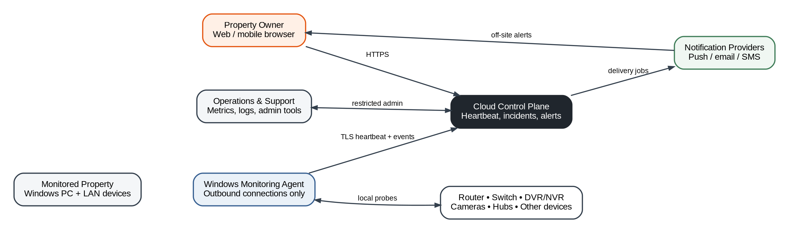
Figure 1. System context and primary communication paths.

1.2 Core architectural choices
Choice | Decision | Reason
Edge execution | Run a durable Windows Service on the property computer. | LAN access and device probes require local execution; service mode survives logout and supports crash recovery.
Connectivity | Outbound TLS only; no customer port forwarding. | Reduces attack surface and installation friction.
Cloud shape | Begin as a modular monolith with separate background workers. | Preserves clear module boundaries without early microservice cost.
Local persistence | SQLite event journal plus transactional outbox. | Supports outage evidence, replay, idempotency, and simple deployment.
Cloud persistence | Managed relational database as system of record. | Incidents, users, subscriptions, and notification state are transactional and relational.
Alerts | Provider-neutral push, email, and SMS adapters. | Avoids vendor lock-in and allows cost-aware routing.
Camera credentials | Encrypted locally and not uploaded by default. | The cloud does not need surveillance credentials to deliver the core value.
Video handling | No video upload or cloud recording in MVP. | Avoids unnecessary privacy, storage, and compliance exposure.

1.3 Architecture quality priorities
- Alert reliability and evidence integrity outrank feature breadth.
- Uncertainty must be represented explicitly; architecture must not turn incomplete observations into claims of tampering.
- A complete property communication loss must still be detected by the cloud after the property cannot transmit.
- The agent must degrade safely when Windows sleeps, the service crashes, cloud access fails, or devices ignore specific probe types.
- Customer network credentials and detailed LAN data should remain local unless there is a documented product requirement and explicit consent.
- MVP components must be operable by a small engineering team and support a controlled private beta.

2. Architectural Drivers and Constraints

2.1 Product drivers
Driver | Architectural consequence
Remote outage alerting | Cloud must evaluate agent heartbeats independently of the property network.
Single-device failure detection | Agent must maintain per-device baselines and use multiple probe methods.
Possible disconnection patterns | Observations require time correlation, dependency awareness, and confidence rules.
Consumer installation | One installer, guided setup, auto-start, self-diagnostics, and minimal firewall changes.
Paid SMS escalation | Notification orchestration must understand plan entitlements, consent, cost limits, and deduplication.
Unattended properties | Agent service, local journal, and cloud lease must tolerate long-running operation with minimal intervention.
Brand-neutral cameras | Integration layer must support generic reachability first and optional protocol adapters later.

2.2 Hard constraints
- Initial agent target: supported Windows 10/11 systems on x64 hardware.
- No inbound connection from the cloud to the customer LAN for normal operation.
- No claim that a network failure proves criminal activity.
- Monitoring accuracy depends on the host remaining powered, awake, and connected; the user experience must disclose this dependency.
- The first release supports one active primary agent per property; multi-agent redundancy is deferred but anticipated.
- The first release does not require router-vendor APIs, packet capture, deep traffic inspection, or full vulnerability scanning.
- The system must remain useful on rural, intermittent, high-latency connections.

2.3 Prototype-gated assumptions
Assumption | Evidence required before commitment
60-second heartbeat is affordable and reliable. | Measured cloud cost, jitter behavior, missed-heartbeat false positives, and battery/network impact.
Three missed leases provide acceptable alert latency. | Physical internet cuts, Starlink interruptions, router reboots, PC sleep, and provider outages.
A Windows Service can remain stable on consumer machines. | Multi-day soak tests, reboots, user logout, upgrades, antivirus interaction, and crash recovery.
Generic device checks are accurate enough. | Representative camera, recorder, hub, router, and sleeping-device tests.
Optional RTSP handshake is supportable. | Credential security, model compatibility, timeout behavior, and false-alarm rate.

3. System Context and Trust Boundaries

3.1 Actors and external systems
Actor / system | Role | Trust posture
Property owner | Configures monitoring, receives alerts, reviews incidents. | Authenticated customer; least privilege within owned properties.
Trusted contact | Receives selected escalation messages. | Limited notification recipient; no dashboard access unless separately invited.
Windows agent | Measures the LAN and reports evidence. | Individually registered workload identity.
Cloud platform | Evaluates leases, stores incidents, delivers alerts. | Primary remote control plane; hardened and audited.
Notification provider | Delivers push, email, or SMS. | External processor receiving only channel-required data.
Camera / DVR / router | Probe targets on the private network. | Untrusted or semi-trusted local devices; never assumed secure.
Support operator | Diagnoses account and agent problems. | Privileged role with audited, time-limited access.

3.2 Trust boundaries
- Boundary A - Customer LAN: devices may be misconfigured, compromised, intermittent, or physically disconnected.
- Boundary B - Agent host: local administrators can stop or alter software; tamper resistance can raise friction but cannot guarantee integrity against an administrator.
- Boundary C - Public internet: all traffic is authenticated and encrypted; the cloud never assumes source IP proves identity.
- Boundary D - Cloud tenant boundary: every data access path must enforce user, organization, and property ownership.
- Boundary E - Third-party messaging: only the minimum recipient and message content should leave the platform.
- Boundary F - Support operations: sensitive diagnostics require explicit customer action or documented support access.
Security reality
A software-only agent cannot be made invulnerable to someone with administrator access or physical control of the host. The product detects loss of communication and records observable shutdown behavior where possible; it must not promise forensic certainty.

4. Logical Architecture
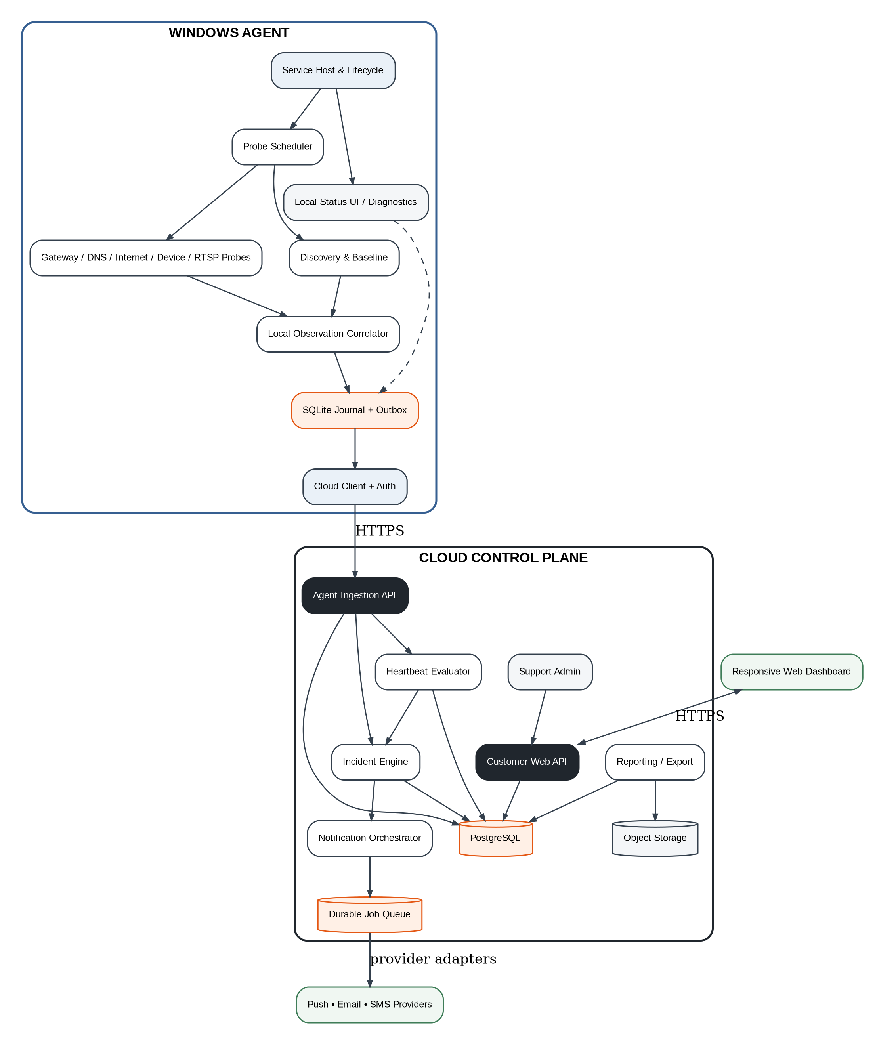
Figure 2. Recommended logical components for the Windows agent and cloud control plane.

4.1 Architectural style
The MVP cloud should be implemented as a modular monolith: one deployable API application and one or more worker processes sharing versioned domain modules and a relational database. Modules communicate through explicit interfaces and durable jobs rather than direct cross-module table manipulation. This yields simple deployment and debugging while preserving a path to extract high-volume modules later.

4.2 Module ownership
Module | Owns | Must not own
Identity & tenancy | Users, sessions, property membership, roles. | Probe logic or notification provider details.
Agent management | Registration, credentials, version, lease, capabilities. | Customer billing or incident wording.
Monitoring configuration | Targets, policies, schedules, Away Mode state. | Raw local credentials or video data.
Incident engine | Incident lifecycle, evidence, confidence, severity. | Direct provider API calls.
Notification orchestration | Routing, consent, throttling, receipts, retries. | Incident classification rules.
Reporting | Aggregates, exports, monthly uptime evidence. | Authoritative incident state.
Billing & entitlement | Plan, limits, SMS allowance, feature gates. | Provider-specific network probing.
Support operations | Audited admin actions and diagnostics. | Unlogged direct database modifications.

4.3 Dependency rule
Rule
Domain modules may publish durable events and call stable application interfaces. They must not reach into another module’s persistence tables or import provider-specific SDKs into domain logic.

5. Windows Monitoring Agent

5.1 Process model
Process / component | Responsibility | Failure behavior
Windows Service host | Lifecycle, startup, shutdown, recovery, single-instance enforcement. | Windows Service Control Manager restarts; crash event recorded on next startup.
Probe scheduler | Schedules checks using policy, jitter, and per-target backoff. | Missed cycles are recorded; no uncontrolled catch-up storm.
Discovery engine | Safe LAN inventory and baseline enrichment. | Degrades to configured target monitoring if discovery is blocked.
Probe adapters | Gateway, DNS, HTTP, TCP, ICMP where allowed, RTSP experiment. | Each adapter has bounded timeouts and circuit breakers.
Observation correlator | Converts raw outcomes into local states and transitions. | Keeps raw evidence locally if cloud unavailable.
SQLite repository | Configuration cache, samples, events, incidents, outbox. | Transactions; integrity check and recovery procedure.
Cloud client | Registration, auth, heartbeat, batch replay, config sync. | Exponential backoff with jitter; never blocks local probes indefinitely.
Local status UI | Read-only status, readiness, diagnostics, alert test launch. | Service continues if UI is closed.

5.2 Service lifecycle
- Installer creates a machine-level service account context, restricted data directory, firewall-safe outbound access, and automatic delayed start.
- Service validates local database, agent identity, clock sanity, active network interface, and configuration schema.
- Scheduler begins with a short randomized delay to avoid synchronized fleet spikes.
- Agent loads baselines, resumes unfinished outbox work, and sends a startup event identifying whether the prior shutdown was planned.
- On normal shutdown, the service writes a final local event and attempts a best-effort cloud signal without delaying Windows shutdown excessively.
- On restart after an unplanned stop, the agent reports the observed gap and preserves uncertainty about its cause.

5.3 Probe scheduling
Probe class | Default cadence | Timeout / confirmation | Notes
Gateway reachability | 15 seconds | 2-3 attempts within 15 seconds | Fast local signal; adapt if gateway blocks ICMP.
Internet endpoints | 30 seconds | Multiple independent endpoints | Avoid a single vendor endpoint becoming the product’s outage detector.
DNS resolution | 60 seconds | At least two names / resolvers where possible | Separates DNS failure from complete internet loss.
Critical devices | 30-60 seconds | Policy-based consecutive failures | Use strongest historically successful probe.
Noncritical inventory | 5-15 minutes | No immediate alert | Lower cost and noise.
RTSP/service health | 60-180 seconds | Strict timeout, no continuous stream | Only for explicitly configured devices.
Cloud heartbeat | 60 seconds | Lease window set by policy | Heartbeat may piggyback summarized state.

5.4 Device identity and baseline
A device record must distinguish identity evidence from mutable addressing. MAC address, stable local hostname, user label, protocol fingerprints, and observed network interface are evidence fields; IP address is an observation. The baseline stores which probes normally succeed so a camera that ignores ping but serves RTSP is not falsely declared offline.
Evidence | Use | Caution
MAC address | Local identity anchor and vendor hint. | Randomization and bridged devices can reduce stability.
IP address | Current routing target. | DHCP changes; never use as sole durable identity.
Hostname / mDNS / NetBIOS | Customer-friendly naming and correlation. | May be missing, duplicated, or user-controlled.
Open service response | Strong availability evidence. | Service can remain up while device function is impaired.
User confirmation | Authoritative label and criticality. | User can misidentify a device; allow correction.

5.5 Local persistence and outbox
- Every state transition and outbound event is written in the same SQLite transaction as its outbox record.
- Outbox records include a globally unique event ID, monotonic local sequence, observed-at time, payload schema version, and retry state.
- The cloud accepts duplicate deliveries idempotently and acknowledges the highest contiguous sequence received.
- High-frequency samples are compacted locally; incident transitions and evidence anchors are retained longer.
- Database files are protected by operating-system ACLs; secrets are encrypted using Windows-protected key material rather than plain SQLite fields.

5.6 Local status and readiness
Readiness check | Customer-visible state
Service running | Protected / service stopped
Cloud lease current | Connected / delayed / disconnected
Computer sleep risk | Ready / monitoring will pause during sleep
Agent version | Current / update available / unsupported
Gateway identified | Ready / setup required
Alert test | Verified / not yet tested
Critical target baseline | Healthy / learning / incomplete

6. Cloud Control Plane

6.1 Cloud responsibilities
- Authenticate users and agents and enforce tenant/property ownership.
- Receive idempotent heartbeats and event batches.
- Maintain an expiring lease for every active agent.
- Open communication-loss incidents when lease policy is breached.
- Correlate agent-replayed evidence with cloud-observed gaps after restoration.
- Manage incident state, customer acknowledgments, Away Mode, and notification escalation.
- Persist minimal operational history, subscription entitlements, consent, and delivery receipts.
- Provide a responsive dashboard and audited support tools.

6.2 Service decomposition
Service | Deployment form | Scaling trigger
Customer API | Stateless web process | Requests per second and dashboard latency.
Agent ingestion API | Stateless web process or isolated route group | Fleet heartbeat throughput or different security profile.
Lease evaluator | Background worker with partitioned ownership | Number of active agents and evaluation interval.
Incident worker | Durable-event consumer | Incident/event volume or complex correlation.
Notification worker | Durable job consumer | Provider rate limits and retry backlog.
Report worker | Asynchronous worker | Export volume and scheduled reporting.

6.3 Heartbeat lease model
Figure 3. Heartbeat lease, cloud-side outage detection, and post-restoration evidence replay.
Field | Purpose
agent_id | Stable registered workload identity.
sequence | Monotonic sequence for duplicate and gap detection.
sent_at / observed_at | Separates local observation time from transmission time.
lease_seconds | Server-authoritative expected interval plus grace policy.
agent_version / capabilities | Supports compatibility and staged rollout.
gateway_state / internet_state | Coarse current state, not raw probe data.
pending_event_count | Signals local replay backlog.
previous_shutdown | Planned, unplanned, unknown, or not applicable.

6.4 Lease evaluator correctness
- Use database or distributed lease ownership so only one worker evaluates a given agent at a time.
- Base expiry on server receipt time, not customer clock alone.
- Require idempotent transition from current to overdue to incident-open.
- Apply a short confirmation window and suppress duplicate notifications across worker retries.
- On recovery, match the incident to the same agent/property and wait briefly for replayed local evidence before final classification where product timing permits.
- Never close an incident solely because one late heartbeat arrives if follow-up confirmation fails.

6.5 Modular monolith boundaries
Recommended MVP
One relational database, one versioned API codebase, and separately scalable workers. Do not introduce a service mesh, event-streaming platform, or distributed cache until measured load or operational isolation justifies it.

7. Web Dashboard and Customer Experience

7.1 Frontend responsibilities
- Account and property setup, agent registration, and monitoring-readiness checks.
- Device inventory, critical target selection, labels, dependency chain, and check policies.
- Current protection state with explicit timestamp and confidence.
- Incident timeline, evidence facts, likely causes, notifications, acknowledgment, and restoration.
- Notification recipients, consent, escalation rules, quiet periods, and plan limits.
- Away/Tamper Mode activation and scheduled behavior.
- Monthly reliability reports, incident export, subscription, and support bundle generation.

7.2 State presentation contract
UI state | Required display
Protected | Last confirmed heartbeat, agent readiness, critical target summary.
Learning | Which targets lack baseline and when enough evidence is expected.
Degraded | Specific limitation such as cloud delay, sleeping device, or blocked probe.
Incident active | Confirmed facts first, confidence, affected chain, time, next action.
Communication lost | Last contact time and plausible causes without claiming which occurred.
Restoring | Connectivity returned; local evidence reconciliation still pending.
Unsupported | Agent version, OS, or configuration requires action.

7.3 Near-real-time updates
The dashboard may use server-sent events or WebSockets for active sessions, but all information must remain retrievable through ordinary authenticated APIs. Real-time transport is an enhancement, not the system of record. Reconnect behavior must re-fetch authoritative incident state rather than assuming no messages were missed.

7.4 Accessibility and mobile behavior
- Critical state and severity must not rely on color alone.
- Incident text must be readable on a phone without horizontal tables.
- Every timestamp should show property time zone and allow exact UTC inspection in exports.
- Alert actions must be large, explicit, and resistant to accidental monitoring disablement.
- The dashboard must disclose stale data prominently rather than displaying an old “healthy” state as current.

8. Data Architecture

8.1 Core domain entities
Entity | Purpose | Primary relationships
User | Authenticated human account. | Memberships, notification endpoints, acknowledgments.
Organization | Billing and collaboration boundary; may initially equal one user. | Users, subscriptions, properties.
Property | Monitored location and time-zone boundary. | Agents, networks, devices, incidents.
Agent | Installed monitoring identity and current lease. | Property, versions, capabilities, events.
Network | Observed LAN context and gateway. | Property, interfaces, devices.
Device | Customer-recognized target with identity evidence. | Network, probes, dependencies, incidents.
Monitor policy | Cadence, confirmation, schedule, criticality. | Device/property and plan entitlements.
Observation | Raw or summarized probe outcome. | Primarily local; selected evidence uploaded.
Incident | Customer-visible episode and lifecycle. | Property, affected devices, evidence, notifications.
Notification | One intended delivery and its status. | Incident, endpoint, provider receipt.
Subscription | Plan and feature entitlement state. | Organization and usage counters.

8.2 Cloud relational schema principles
- Use immutable identifiers independent of customer labels and IP addresses.
- All tenant-owned records include organization_id and property_id where appropriate; indexes begin with the ownership boundary for high-volume tables.
- Soft deletion is limited to customer configuration where recovery is useful; security and billing events use append-only audit records.
- Incident evidence records are immutable after creation; corrections append superseding interpretation events.
- Provider payloads and secrets are not stored in unrestricted general-purpose columns.
- Schema migrations are backward-compatible with at least the previous supported agent version during rolling upgrades.

8.3 Local-versus-cloud data boundary
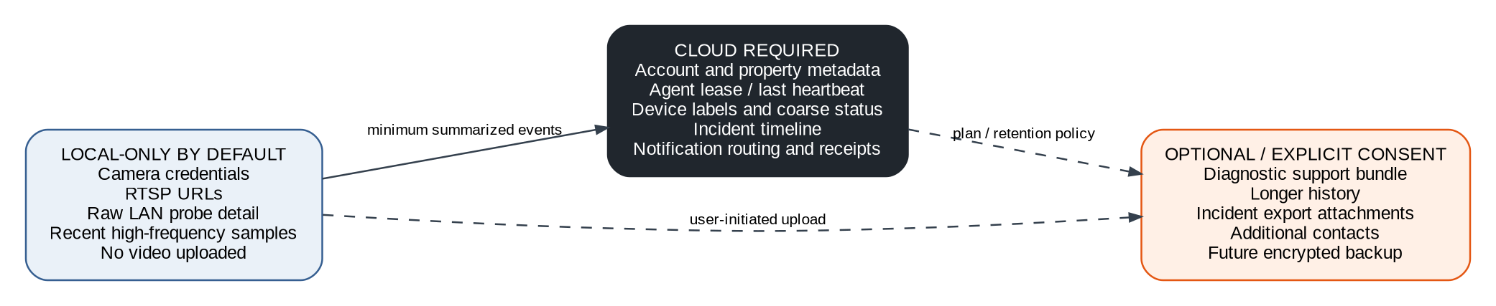
Figure 4. Recommended data minimization boundary.

8.4 Retention model
Data class | Default retention hypothesis | Notes
Local high-frequency probe samples | 7-14 days | Compacted sooner when disk budget is reached.
Local transitions and outage evidence | 90 days or configurable | Uploaded summary may outlive local detail.
Cloud heartbeats | Short rolling window, e.g. 7-30 days | Store aggregates rather than every heartbeat indefinitely.
Cloud incidents | At least 12 months on paid plans | Longer history may be a plan feature.
Notification receipts | 12-24 months | Supports disputes, support, and consent records.
Audit events | Policy-driven, at least 12 months | Privileged access and configuration changes.
Support bundles | Auto-expire in days | User-visible expiration and deletion.

8.5 Database choice
A managed PostgreSQL-compatible relational service is recommended for the cloud system of record because the workload is dominated by transactional relationships, time-bounded queries, incident state transitions, tenant filtering, and reporting. SQLite is recommended locally because it is embedded, transactional, widely supported, and sufficient for a single-agent journal. A dedicated time-series database is not required for the MVP; aggregate samples in relational tables or object storage until measured volume justifies a specialist store.

9. Communications and API Contracts

9.1 Transport principles
- Agent-to-cloud uses HTTPS over standard outbound port 443.
- Every request is authenticated as a registered agent and includes schema version, request ID, and idempotency key where state may change.
- Payloads are compact JSON for the MVP; binary serialization is deferred unless measured bandwidth or CPU requires it.
- Compression may be enabled for event replay batches, not for tiny heartbeats where overhead outweighs benefit.
- Server responses include explicit retryability and minimum supported agent version.
- Cloud commands are retrieved through short polling or piggybacked responses; the cloud does not initiate LAN connections.

9.2 Agent registration
- Customer signs in and creates or selects a property.
- Dashboard issues a short-lived, one-time installation code bound to the property.
- Agent generates a device keypair locally and exchanges the installation code for an agent identity and refresh credential.
- Cloud stores the public key or hashed credential material, capabilities, and registration metadata.
- Long-lived secrets are stored using Windows-protected storage; the one-time code is erased.
- Agent credentials can be revoked from the dashboard and rotated automatically.

9.3 Reference heartbeat payload
POST /v1/agent/heartbeats
Idempotency-Key: hb_01J...
{
"schema_version": 1,
"agent_id": "agt_...",
"sequence": 18422,
"observed_at": "2026-07-12T22:30:00Z",
"agent_version": "0.1.0",
"capabilities": ["gateway", "dns", "device_tcp"],
"state": {
"gateway": "reachable",
"internet": "reachable",
"critical_devices_degraded": 0
},
"outbox_pending": 0
}

9.4 Reference event-batch contract
Requirement | Design
Ordering | Per-agent monotonic sequence; batch may contain contiguous events.
Deduplication | Globally unique event_id and agent_id + sequence uniqueness.
Partial acceptance | Server returns accepted through sequence and per-event permanent errors.
Replay | Agent retains unacknowledged events and retries with backoff.
Schema evolution | Envelope version plus event-type version. Unknown optional fields ignored.
Size limit | Bounded batch count and compressed body size; split safely.
Clock handling | Preserve observed_at but use received_at for lease and ordering safeguards.

9.5 Customer API
Resource | Representative operations
/properties | Create, view, update time zone and protection settings.
/agents | Register, view readiness, revoke, request diagnostics.
/devices | List, label, mark critical, set dependency and probe policy.
/incidents | List, read timeline, acknowledge, add note, export.
/notifications | Manage endpoints, consent, test, escalation rules.
/subscriptions | Plan, usage, entitlements, payment portal handoff.
/support-bundles | Generate short-lived diagnostic package with explicit consent.

10. Incident Detection and Correlation

10.1 Evidence pipeline
Figure 5. From raw observations to customer-facing incident language.

10.2 Authority split
Situation | Authoritative component | Reason
Local device state while agent is online | Agent | Only the agent can directly observe the LAN.
Whether the agent is checking in | Cloud | Cloud can observe absence after the property loses internet.
Initial complete communication-loss incident | Cloud | Must occur when nothing at the property can transmit.
Post-restoration cause refinement | Cloud using agent replay | Combines cloud gap with locally preserved evidence.
Customer labels and criticality | Cloud configuration, cached locally | Customer intent must remain consistent across reinstall and dashboard.

10.3 Incident state machine
State | Entry | Allowed next states
Suspected | Confirmation threshold reached but policy delay remains. | Open, canceled as transient.
Open | Confirmed incident created and initial alert policy evaluated. | Updated, acknowledged, restoring.
Acknowledged | Customer or trusted operator confirms awareness. | Updated, restoring.
Restoring | Connectivity or device response returned; confirmation pending. | Open if relapse, resolved.
Resolved | Restoration confirmed and final message sent. | Closed, reopened only as new linked incident.
Closed | Retention state after review window. | No mutation; append notes/audit only.

10.4 Classification model
Incident category | Minimum confirmed facts | Permitted likely-cause language
Property communication lost | Cloud lease expired for active agent. | Internet outage, power loss, computer shutdown/sleep, agent failure, or physical disconnection.
Internet unavailable, LAN available | Agent reaches gateway and local targets but independent internet checks fail. | ISP/line/router-WAN problem is likely.
Gateway unavailable | Agent network interface remains active but gateway probes fail. | Router power, cable, interface, or gateway failure.
Single critical device unavailable | Other network anchors remain healthy; target fails its learned probes. | Device power, cable, network, or device failure.
Recorder unavailable | DVR/NVR target fails while related network anchors remain healthy. | Recorder power, cable, service, or device failure.
Video service impaired | Device responds but configured video/service check fails. | Camera/recorder service or stream malfunction.
Unusual sequential failures | Multiple critical targets fail separately within policy window while network remains otherwise healthy. | Possible intentional disconnection or shared infrastructure problem; do not assert tampering.

10.5 Confidence
Confidence | Definition | Customer wording
Confirmed fact | Direct observation meeting validation rules. | “The driveway camera stopped responding at 8:42 PM.”
High-confidence interpretation | Multiple independent observations strongly support one class. | “This appears limited to the camera rather than a property-wide outage.”
Possible cause | Plausible but not distinguishable with available evidence. | “Possible causes include power, cable, device failure, or disconnection.”
Unknown | Evidence is insufficient or contradictory. | “The property stopped communicating; the cause is not yet known.”

10.6 Correlation rules
- Group downstream device symptoms beneath a higher-level gateway or property communication incident when timing and dependency support it.
- Do not send one alert per camera when all cloud-dependent devices vanish simultaneously.
- Maintain a configurable correlation window and document why symptoms were grouped.
- Treat Away/Tamper Mode as a severity and timing modifier, not as proof of hostile action.
- Preserve evidence that contradicts the current interpretation; classification may be revised after local replay.
- Every customer-facing incident must expose the timestamp of the last confirmed healthy observation.

11. Notification Architecture

11.1 Orchestration flow
- Incident engine publishes an IncidentOpened, IncidentUpdated, or IncidentResolved durable event.
- Notification orchestrator evaluates property policy, severity, Away Mode, acknowledgment state, plan entitlement, consent, quiet periods, and rate limits.
- A notification intent is persisted before provider delivery.
- Provider adapter sends using an idempotency key where supported.
- Delivery receipt or terminal error is recorded and exposed in the incident timeline.
- Retryable failures use bounded exponential backoff; permanent failures prompt endpoint correction through another available channel.
- Resolution messages reference the original incident rather than creating unrelated alerts.

11.2 Channel strategy
Channel | Use | Architecture notes
Web push / app push | Fast standard alert where supported. | Low marginal cost; token lifecycle and browser limitations require fallback.
Email | Detailed incident and account messages. | Good auditability; slower and spam-filter dependent.
SMS | Paid escalation for high-priority or unresolved incidents. | Explicit consent, phone verification, allowance, provider compliance, and strict deduplication.
Trusted contact | Secondary escalation after configured delay. | Limit content to the property and incident facts authorized by owner.

11.3 Deduplication and flood control
- Unique notification key: incident_id + transition_version + endpoint_id + template_version.
- One parent incident suppresses redundant child-device alerts unless a child changes the meaning or required action.
- Provider timeout does not imply failure; reconcile delivery status before resending where supported.
- Per-property and per-recipient rate limits protect customers during flapping or configuration mistakes.
- A flapping incident should update one timeline and use cooldown rules rather than opening dozens of incidents.
- SMS budget exhaustion must fail over to push/email and clearly inform the customer before protection is silently reduced.

11.4 Template contract
Required element | Example
What happened | “Driveway camera stopped responding.”
Where | “Swanville property.”
When | “8:42 PM EDT; last confirmed healthy 8:41 PM.”
What remains working | “Router, internet, and two other cameras are still online.”
Confidence / uncertainty | “This appears limited to the camera. Possible causes include power, cable, or device failure.”
Action | “Open incident” or “Contact property.”

12. Camera, DVR/NVR, and Device Integration

12.1 Layered health model
Layer | Question | Example probes
Network presence | Can the device be addressed on the LAN? | ARP evidence, IP mapping, local name.
Host reachability | Does the host respond through any learned method? | ICMP where allowed, TCP connect.
Service reachability | Is an expected management or media service accepting connections? | HTTP/HTTPS, RTSP port, vendor-neutral TCP.
Protocol health | Can a lightweight protocol request succeed? | RTSP OPTIONS/DESCRIBE, ONVIF discovery later.
Functional health | Is the intended security function operating? | Frame-change or recorder-status adapter in later releases.

12.2 Integration adapter contract
Interface concern | Requirement
Credential handling | Credentials supplied by the user remain encrypted locally by default.
Timeouts | All operations are cancellable and bounded.
Evidence | Adapter reports facts and error categories, not customer-facing conclusions.
Capability detection | Adapter declares supported checks and required configuration.
Baseline | Successful methods and normal response timing are learned.
Version isolation | Vendor/protocol libraries are wrapped so replacement does not alter incident domain code.
Safety | No configuration changes, reboot commands, or exploit-style scanning in MVP.

12.3 RTSP MVP boundary
Prototype-gated
RTSP should remain optional until testing proves that a short handshake can be implemented across representative devices without storing cloud credentials, creating excessive traffic, or falsely declaring failure. Continuous streaming and cloud frame storage are out of scope.

12.4 Dependency chain
The device graph supports parent relationships such as internet → router → switch → recorder → camera. Dependencies are customer-confirmed or inferred with confidence, never silently treated as certain. Correlation uses the graph to suppress downstream noise and explain the likely fault domain.

13. Security Architecture

13.1 Security objectives
- Prevent unauthorized access to property status, devices, incident history, and contacts.
- Prevent one tenant or property from reading or modifying another tenant’s data.
- Prevent forged agents from sending evidence for a property.
- Protect local camera credentials and cloud tokens at rest.
- Make notification and monitoring configuration changes attributable and auditable.
- Limit damage if an agent, support account, messaging provider, or cloud component is compromised.
- Provide secure signed updates and a revocation path for vulnerable agent versions.

13.2 Agent identity
Control | Recommended design
Bootstrap | Short-lived one-time installation code scoped to property.
Long-term identity | Per-agent keypair or strong rotating credential; no shared fleet secret.
Storage | Windows-protected secret storage and restrictive filesystem ACLs.
Transport | TLS with normal certificate validation; optional request signing for high-value endpoints.
Rotation | Automatic credential rotation and dashboard-initiated revoke.
Replay protection | Sequence, timestamp tolerance, nonce/idempotency, and server-side duplicate detection.
Version control | Cloud can block known-vulnerable versions while allowing safe upgrade flow.

13.3 Customer authentication and authorization
- Use a mature identity provider or well-maintained framework rather than custom password cryptography.
- Require verified email; support multi-factor authentication before broad launch.
- Enforce role checks server-side for every property operation.
- Sensitive actions - disabling monitoring, changing phone numbers, exporting diagnostics, revoking agents - require recent authentication.
- Sessions use secure, HTTP-only cookies or appropriately protected tokens; browser storage must not hold long-lived secrets.
- Support operators use separate accounts, stronger MFA, least privilege, and immutable access audit.

13.4 Cloud controls
Area | Minimum control
Secrets | Managed secret vault; no secrets in source, images, logs, or client bundles.
Database | Encryption at rest, private network path where practical, least-privilege roles, backups.
API | Rate limits, input validation, size limits, structured authorization, safe error responses.
Build pipeline | Dependency scanning, signed artifacts, protected branches, reproducible release metadata.
Infrastructure | Infrastructure as code, environment separation, patching, restricted admin access.
Logging | Redaction of tokens, credentials, RTSP URLs, phone numbers beyond operational need.
Incident response | Credential revoke, provider disable, release rollback, customer notification procedure.

13.5 Threat model highlights
Threat | Primary mitigation | Residual risk
Attacker forges “healthy” heartbeats | Per-agent authentication, sequence, key rotation. | Compromised agent host can still lie.
Attacker reads camera credentials from cloud | Do not upload them by default. | Local administrator may access decrypted credentials.
Tenant crossover | Ownership filters, centralized authorization, tests, database constraints. | Implementation bugs require continuous testing.
SMS abuse / cost attack | Verified endpoints, quotas, rate limits, anomaly detection. | Provider compromise or account takeover.
Malicious device response | Strict parsers, bounded payloads, sandboxed adapter behavior. | Unknown protocol library vulnerabilities.
Update supply-chain attack | Code signing, release approvals, rollback, key protection. | Signing-key compromise remains high impact.

14. Privacy and Data Governance

14.1 Privacy-by-design rules
- Collect only data required to detect, explain, notify, bill, support, and improve reliability.
- Do not upload packet contents, browsing history, video, audio, or camera credentials for the core service.
- Clearly distinguish locally stored diagnostic detail from cloud account history.
- Require explicit, revocable consent for SMS and optional support uploads.
- Provide property and account deletion workflows with documented retention exceptions.
- Expose data age and retention behavior to the customer rather than hiding indefinite collection.
- Do not use household network inventory for advertising or data brokerage.

14.2 Data classification
Class | Examples | Handling
Public | Marketing pages, published documentation. | Normal integrity controls.
Internal | Aggregate service metrics, non-customer runbooks. | Employee access only.
Confidential customer | Device labels, property status, incident history, contacts. | Tenant authorization, encryption, limited logs.
Restricted secret | Agent credentials, auth tokens, local camera credentials. | Vault or OS-protected storage; never analytics/logging.
Potentially sensitive location data | Property name, address if supplied, time zone, outage patterns. | Minimize collection, role-limit access, audit exports.

14.3 Support bundle
A support bundle must be generated locally or from cloud operational metadata only after the customer initiates it. Before upload, the UI lists included categories, redacts credentials and tokens, assigns a short expiration, and shows who can access it. The bundle receives a one-time identifier and every support view is audited.

15. Reliability, Resilience, and Recovery

15.1 Reliability targets for MVP beta
Measure | Initial target | Notes
Cloud API availability | 99.9% monthly beta objective | Excludes planned beta maintenance with notice.
Heartbeat ingestion latency | p95 under 2 seconds when cloud healthy | Measured from receipt to durable record.
Communication-loss alert latency | Typically 2-5 minutes | Policy depends on heartbeat and confirmation settings.
Duplicate customer notifications | Under 0.1% of incident transitions | No duplicate SMS for provider timeouts.
Local event loss after unplanned restart | Zero committed transitions | SQLite transaction and outbox acceptance test.
Restoration message | Within 2 minutes after confirmed recovery | May wait briefly for evidence replay.

15.2 Local resilience
- Service recovery actions configured through Windows Service Control Manager.
- All network and device operations have deadlines and cancellation.
- Probe failures cannot crash the service process; adapters are isolated by exception boundaries and resource limits.
- Cloud outage does not stop local monitoring or local incident journaling.
- Disk-budget guardrails compact samples before filesystem exhaustion.
- Configuration updates are versioned and applied atomically with rollback to last-known-good configuration.
- Clock jumps are detected and annotated; monotonic durations are used where possible.

15.3 Cloud resilience
- Stateless API instances behind a managed TLS endpoint.
- Managed database with automated backups and point-in-time recovery.
- Durable notification and incident jobs with visibility timeout / lease semantics.
- Idempotent workers and transactional outbox/inbox patterns for cross-module events.
- Multi-zone deployment where available before general availability.
- Provider circuit breakers and channel fallback.
- Documented rollback and incident response procedures tested before paid launch.

15.4 Disaster recovery hypothesis
Objective | Target hypothesis
Recovery point objective | 15 minutes or better for cloud transactional data.
Recovery time objective | 4 hours for regional service restoration during early paid launch.
Agent continuity | Local monitoring continues and replays when cloud returns.
Notification continuity | Alternative provider or documented degraded mode for prolonged provider outage.

16. Performance and Scalability

16.1 Load model
Architecture sizing should use active agents rather than registered accounts. At a 60-second heartbeat, 10,000 active agents produce roughly 167 heartbeat requests per second before retries and event batches. This load is straightforward for stateless APIs and a well-indexed relational database if heartbeats are compact and historical rows are aggregated rather than retained indefinitely.

16.2 Scale dimensions
Dimension | MVP strategy | Later trigger
Active agents | Stateless horizontal API scaling. | Separate ingestion service when security or throughput differs materially.
Lease evaluation | Database-indexed due-time scan with worker partition. | Dedicated scheduler partitions or queue when scan latency rises.
Heartbeats history | Current lease plus short rolling data. | Time-series or object aggregates for large fleet analytics.
Incident events | Relational append-only timeline. | Partition high-volume tables by time/property.
Notifications | Durable queue and multiple workers. | Per-provider queues and regional routing.
Reports | Asynchronous generation. | Dedicated analytical store when monthly reports burden primary DB.

16.3 Backpressure
- Agents apply exponential backoff with jitter when cloud responds with retryable errors or rate limits.
- Cloud returns explicit retry-after guidance and accepts bounded event batches.
- Notification workers respect provider rate limits and prioritize severe active incidents over reports.
- A dashboard outage must not block heartbeat ingestion.
- Report generation and noncritical analytics are disabled or slowed before incident and notification paths are impaired.

17. Observability and Support Operations

17.1 Telemetry
Signal | Examples | Privacy rule
Metrics | Heartbeat acceptance, overdue leases, incident openings, queue lag, delivery success. | Use IDs or aggregates; no credentials or full device labels.
Logs | Request IDs, state transitions, provider error category, admin action. | Structured redaction; avoid payload dumps.
Traces | Ingestion to incident to notification latency. | Sample and redact attributes.
Agent diagnostics | Service uptime, probe duration, database health, backlog. | Detailed bundle stays local unless customer uploads.
Business metrics | Activation, alert test completion, incident acknowledgment, churn. | Separate from sensitive operational detail.

17.2 Required dashboards
- Fleet agents current, delayed, overdue, unsupported version, and replay backlog.
- Heartbeat ingestion rate, latency, error rate, and database pressure.
- Incident openings by category, false-positive feedback, flapping, and average alert latency.
- Notification queue lag, success, retry, permanent failure, and cost by channel.
- Agent release adoption, crash rate, install failure, and rollback activity.
- Support access, diagnostic bundle creation, and privileged action anomalies.

17.3 Support tools
Capability | Guardrail
View account/property summary | Role limited; sensitive fields masked.
View agent last contact/version | No direct LAN access.
Trigger alert test | Customer confirmation or support permission.
Request diagnostic bundle | Customer-initiated approval; short expiration.
Revoke agent credential | Strong confirmation and audit.
Resend non-SMS notification | Deduplication and customer-visible timeline.
Impersonation | Avoid if possible; if implemented, explicit banner, time limit, immutable audit.

18. Deployment, DevOps, and Environments
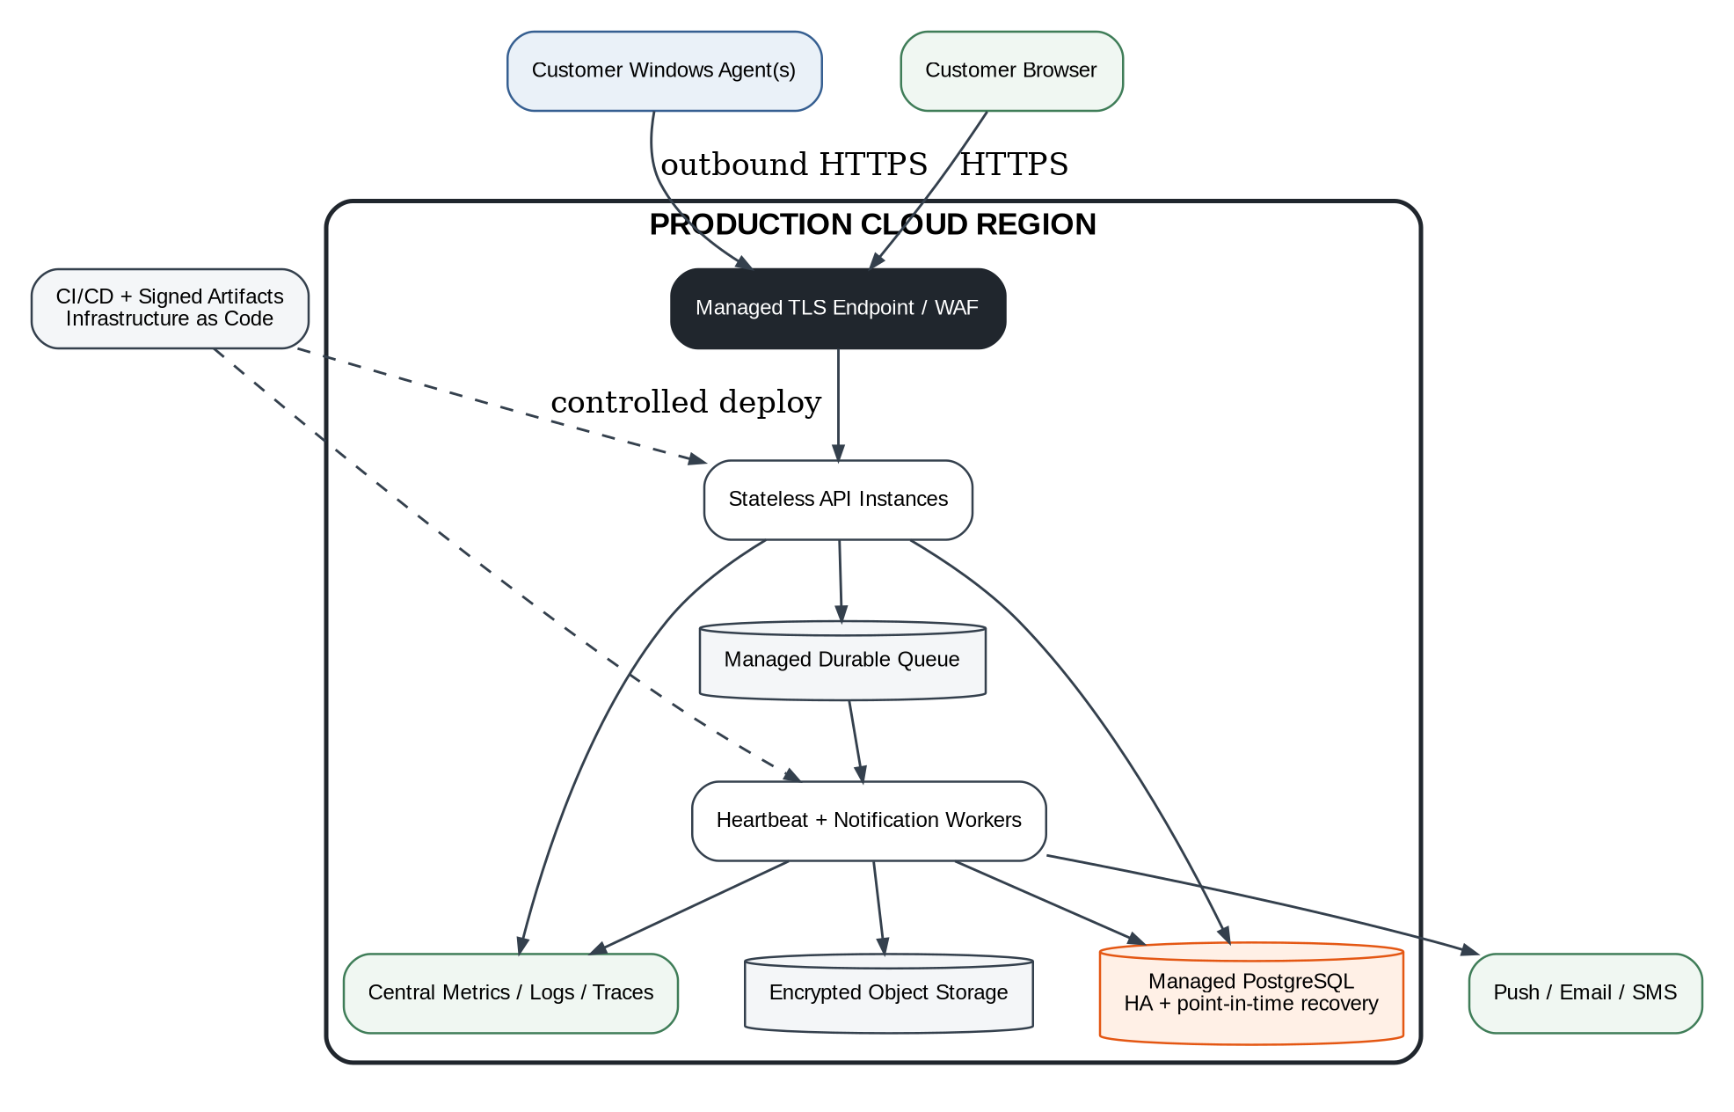
Figure 6. Recommended production deployment topology.

18.1 Environments
Environment | Purpose | Data policy
Local development | Developer agent simulator, cloud modules, automated tests. | Synthetic data only.
Integration | End-to-end contracts, migrations, provider sandboxes. | Synthetic or consented test data.
Staging | Production-like deployment and release validation. | No production customer database copy.
Production | Customer service. | Restricted access and monitored changes.
Beta ring | Feature flags and agent rollout cohort within production controls. | Real beta users with explicit expectations.

18.2 CI/CD pipeline
- Compile and unit-test agent, cloud, and dashboard.
- Run static analysis, dependency vulnerability checks, secret scanning, and license inventory.
- Build immutable versioned artifacts and software bill of materials.
- Run database migration compatibility and API contract tests.
- Run agent simulator failure scenarios against an ephemeral environment.
- Sign Windows installer and binaries using protected signing process.
- Deploy cloud to staging, run smoke and synthetic outage tests.
- Promote with approval, canary percentage, health gates, and automatic rollback conditions.
- Roll agent update through internal, alpha, beta, and broad rings.

18.3 Infrastructure as code
- Cloud networking, databases, storage, queues, identities, monitoring, and alert policies are versioned as code.
- Production changes require review and recorded deployment identity.
- Secrets are references to managed vault entries, not values in templates.
- Backup restore and new-environment creation are automated enough to rehearse disaster recovery.
- Cost tags and budgets are mandatory for messaging, database, logging, and egress services.

19. Agent Installation, Updates, and Lifecycle

19.1 Installer requirements
Requirement | Implementation intent
Elevation | Request administrator rights only for service install, protected directory, and uninstall.
Code signing | Signed installer and binaries; display verified publisher.
Prerequisites | Bundle or safely install required runtime; avoid fragile manual dependencies.
Configuration | Use one-time property code; no manual API keys.
Sleep readiness | Detect and explain sleep/hibernate conflicts; do not silently change user settings without consent.
Uninstall | Offer removal of local history and revoke cloud identity.
Repair | Repair service and files without deleting identity/history unless chosen.

19.2 Update strategy
- Signed update manifest over TLS with version, hash, minimum OS, release ring, and rollback metadata.
- Download to a staging directory, verify signature/hash, stop service briefly, replace atomically, restart, and health-check.
- Preserve previous version for bounded rollback.
- Never apply an unverified update even when the installed version is obsolete.
- Cloud supports at least one prior agent protocol version during staged rollout.
- Emergency revocation can stop vulnerable versions from submitting trusted evidence while still providing a clear upgrade path.

19.3 Tamper-awareness boundary
Honest promise
The service can auto-start, record planned shutdowns, detect unexpected heartbeat loss, restrict ordinary users from casually changing files, and alert when monitoring is disabled while connectivity remains. It cannot guarantee resistance to a local administrator, malware with equivalent privilege, or physical destruction of the host.

20. Multi-Tenancy, Plans, and Billing Boundaries

20.1 Tenant model
Use Organization as the billing and collaboration boundary even if the first interface presents a simple individual account. A property belongs to one organization. Users receive roles through organization or property membership. This avoids a disruptive data-model change when couples, employees, installers, or property managers are introduced.

20.2 Entitlement service
Entitlement | Possible limit / behavior
Properties | One on basic plan; multiple on property/pro plan.
Active agents | One primary agent per property in MVP.
Critical devices | Plan-specific count while basic inventory remains broader.
History retention | 30 days, 12 months, or longer by plan.
SMS | Included allowance, pay-as-you-go overage, or high-priority escalation only.
Trusted contacts | Count and escalation depth.
Camera protocol checks | Premium feature due support complexity.
Reports / exports | Basic summary versus extended evidence report.

20.3 Billing isolation
- Billing provider tokens and payment details remain with the provider; cloud stores customer/subscription identifiers and status.
- A billing webhook is authenticated, idempotent, and recorded before entitlement change.
- Service degradation for payment failure must not erase history or create sudden silent loss of active security alerts; use clear grace policy.
- SMS usage is metered transactionally before send authorization and reconciled with provider receipts.
- Plan changes create auditable entitlement events used by the notification engine.

21. Technology Recommendations

21.1 Preferred stack
Layer | Recommendation | Rationale / alternative
Windows agent | C# on the current supported .NET LTS; native Windows Service. | Strong Windows lifecycle, installer, async networking, and shared contracts. Go is acceptable if team evidence strongly favors it.
Agent local DB | SQLite through a maintained provider. | Embedded transactional journal with no separate service.
Cloud API/workers | ASP.NET Core on the same supported .NET LTS. | Shared domain contracts and operational simplicity. Another mature backend is acceptable if staffing dictates.
Cloud DB | Managed PostgreSQL-compatible service. | Relational integrity, JSON support, reporting, and ecosystem.
Durable jobs | Managed queue or database-backed durable job mechanism. | Start simple; provider-neutral abstraction.
Dashboard | TypeScript responsive web app with a mature component framework. | Strong ecosystem and mobile browser reach; server-rendered alternative acceptable.
Hosting | Managed container or application platform before Kubernetes. | Lower operational burden for a small team.
Telemetry | OpenTelemetry-compatible metrics, logs, and traces. | Portable instrumentation and correlation.
Infrastructure | Declarative infrastructure as code. | Repeatability, review, disaster recovery.

21.2 Technologies explicitly not required for MVP
- Kubernetes or a service mesh.
- Kafka or a large event-streaming platform.
- A separate time-series database.
- A mobile native app before the web experience proves demand.
- Packet capture, deep packet inspection, or an embedded penetration-testing suite.
- Router port forwarding or a reverse tunnel into the customer LAN.
- Cloud storage of video, audio, or camera credentials.

21.3 Build-versus-buy
Capability | Recommendation
Authentication | Buy/use mature managed identity or proven framework.
SMS/email/push delivery | Use providers behind internal adapters.
Billing | Use a payment/subscription provider.
Cloud database/backups | Managed service.
Incident logic and device baseline | Build; this is core differentiation.
Windows service and local journal | Build; core reliability and product behavior.
Generic network discovery | Use OS APIs and narrowly licensed libraries; review licenses before redistribution.
Observability | Use managed or open standard tooling, not custom telemetry storage.

22. Architecture Decision Records

22.1 Initial ADR register
ADR | Status | Decision
ADR-001 | Recommended | Windows Service is the initial edge runtime.
ADR-002 | Committed | Normal operation uses outbound HTTPS only.
ADR-003 | Recommended | Cloud begins as modular monolith plus workers.
ADR-004 | Recommended | SQLite local journal and transactional outbox.
ADR-005 | Recommended | Managed PostgreSQL cloud system of record.
ADR-006 | Committed | Camera credentials remain local by default.
ADR-007 | Committed | No video upload or recording in MVP.
ADR-008 | Prototype-gated | Heartbeat cadence and overdue threshold.
ADR-009 | Prototype-gated | RTSP handshake support in launch scope.
ADR-010 | Recommended | Provider abstraction for notifications and billing.
ADR-011 | Recommended | Organization/property multi-tenant model from first migration.
ADR-012 | Deferred | Hardware or cellular watchdog extension.

22.2 ADR template
ADR-XXX — Decision title
Status: Proposed | Accepted | Superseded | Rejected
Context: What force or problem requires a decision?
Decision: What will be done?
Consequences: Benefits, costs, and operational effects.
Alternatives: What was considered and why not selected?
Evidence: Prototype measurements, incidents, or customer requirements.
Review trigger: What future condition requires reconsideration?

23. Failure Modes and Degraded Operation
Failure | Expected system behavior | Customer communication
Property internet cut | Cloud lease expires; communication-loss incident and off-site alert. | Cause unknown until recovery; list plausible causes.
One camera unplugged | Agent confirms other anchors healthy, target fails learned probes. | Device-specific alert with limited fault domain.
Agent service crashes | Windows restarts service; cloud may open agent communication incident if gap exceeds threshold. | State that monitoring computer/agent stopped communicating, not that internet definitely failed.
Computer sleeps | Heartbeats stop; readiness previously warned. On resume, replay gap. | Identify sleep if OS evidence is available; otherwise remain uncertain.
Cloud API unavailable | Agent journals locally and retries; local monitoring continues. | Dashboard may be stale; avoid false property incident caused by internal evaluator outage.
Database unavailable | Ingestion returns retryable error; agents retain outbox; cloud incident processing pauses safely. | Platform status communication if prolonged.
SMS provider outage | Retry or fall back to push/email according to policy. | Timeline shows SMS delivery problem.
Device flaps | Cooldown and one incident timeline; adaptive confirmation. | Report unstable connectivity without alert storm.
Agent disk nearly full | Compact samples, preserve transitions, surface degraded readiness. | Prompt maintenance before evidence retention is impaired.
Clock incorrect | Use server receipt for leases and annotate local timestamps. | Warn that local event times may be inaccurate.

24. MVP Build Slices and Evolution Path

24.1 Vertical build slices
Slice | End-to-end capability | Exit evidence
A. Agent identity and lease | Install service, register property, send heartbeat, show last contact. | Reboot/upgrade soak and duplicate-safe ingestion.
B. Communication-loss alert | Cloud lease expiry opens incident and sends test email/SMS. | Physical internet cut with correct alert and restoration.
C. Local device monitoring | Configure target, baseline probe, detect isolated failure. | Camera/DVR unplug tests with no network-wide misclassification.
D. Evidence replay | Journal events through outage and reconcile after return. | Timeline preserves local facts and refines cloud incident.
E. Dashboard onboarding | Guided setup, critical devices, readiness, alert test. | First-time user completes setup without engineer assistance.
F. Away Mode and escalation | Policy changes severity/timing and trusted contact flow. | No duplicate or unauthorized SMS.
G. Reports and billing | History, usage, plan entitlement, simple payment flow. | Paid pilot can be operated and supported.

24.2 Evolution roadmap
Stage | Likely additions | Architectural preparation already included
Private beta | Windows agent, core probes, cloud heartbeat, web dashboard, email/SMS. | Modular modules, tenant IDs, provider abstractions.
First paid release | Push, stronger device identity, reports, installer polish, MFA. | Durable jobs, audit events, entitlement layer.
Camera-health expansion | ONVIF/RTSP adapters, recorder checks, model compatibility. | Local adapter boundary and local secret storage.
Multi-property / installer | Organizations, roles, fleet views, delegated setup. | Organization/property tenant model.
Hardware watchdog | Low-power appliance, UPS/cellular integrations. | Agent capability model and multiple agent types.
Multi-agent resilience | Primary/secondary agents and quorum interpretation. | Agent-per-property records and cloud correlation.

25. Architecture Acceptance Gates

25.1 Before MVP implementation
Gate | Pass condition
Prototype reliability | Controlled scenarios demonstrate stable service, journal replay, and acceptable false-positive rate.
Heartbeat policy | Alert latency and grace window selected from measured tests.
Data boundary | Founder approves what stays local and what is uploaded.
Security review | Agent registration, secret storage, tenant authorization, and update signing design reviewed.
Notification economics | SMS consent, delivery, cost controls, and plan allowance modeled.
Licensing review | Redistributed discovery/protocol libraries cleared for commercial use.
Supportability | Diagnostics, logs, and rollback are sufficient for a small beta.

25.2 Before private beta
- All P0 end-to-end flows pass automated and physical failure tests.
- No known path exposes camera credentials, agent secrets, or tenant data across accounts.
- Signed installer, update rollback, database backup restore, and provider failure procedures are tested.
- Dashboard always distinguishes current, stale, learning, degraded, and incident states.
- Every SMS is consented, verified, metered, deduplicated, and recorded.
- A support operator can diagnose common installation and alert failures without direct LAN access.
- Beta terms accurately state the dependency on power, internet, and the Windows host.

25.3 Open founder and engineering decisions
Decision | Owner | Required by
Final product name and property terminology | Founder / Brand | Dashboard wireframes.
Free and paid plan boundaries | Founder / Product | Billing and entitlement implementation.
Included SMS allowance and escalation defaults | Founder / Finance / Product | Paid pilot.
RTSP in MVP versus post-launch | Engineering / Product | End of prototype.
Cloud provider and region | Engineering | Infrastructure build.
Authentication and billing providers | Engineering / Product | Customer account implementation.
Retention defaults | Product / Privacy | Beta terms and database policies.
Support access model | Founder / Security | Private beta operations.

Appendix A. Reference Domain Events
Event | Producer | Primary consumers
AgentRegistered | Agent management | Monitoring configuration, audit.
HeartbeatReceived | Ingestion | Lease evaluator, telemetry.
AgentLeaseOverdue | Lease evaluator | Incident engine.
ObservationTransitioned | Agent / ingestion | Incident engine, timeline.
IncidentOpened | Incident engine | Notification, dashboard, audit.
IncidentUpdated | Incident engine | Notification, dashboard, reporting.
IncidentResolved | Incident engine | Notification, reporting.
NotificationRequested | Notification orchestrator | Provider worker.
NotificationDelivered | Provider worker | Timeline, usage, support.
MonitoringModeChanged | Customer API | Agent config, incident policy, audit.
AgentCredentialRevoked | Agent management | Ingestion, audit.

Appendix B. Reference Local SQLite Tables
Table | Purpose | Key fields
agent_identity | Registered agent identity and configuration version. | agent_id, key reference, property_id.
targets | Local cached devices and monitor policy. | device_id, current IP, criticality, expected probes.
probe_samples | Short-lived raw outcomes. | target_id, probe_type, observed_at, result, latency.
state_transitions | Durable local status changes. | transition_id, target_id, from/to, evidence.
local_incidents | Offline local grouping when cloud unavailable. | incident_local_id, category, opened/resolved.
outbox | Unacknowledged cloud events. | sequence, event_id, type, payload, retry.
config_versions | Atomic cloud configuration cache. | version, applied_at, checksum.
service_events | Startup, shutdown, crash-recovery clues. | event_type, timestamp, prior_session.

Appendix C. Reference Cloud Tables
Table | Selected fields / notes
organizations | id, name, billing_customer_id, status.
users | id, identity_subject, verified_email, status.
memberships | organization_id, user_id, role, property scope.
properties | id, organization_id, name, time_zone, monitoring_mode.
agents | id, property_id, credential status, version, capabilities, last_seen, lease_due.
devices | id, property_id, label, identity evidence, criticality, dependency parent.
monitor_policies | target, cadence, confirmation, schedule, notification policy.
incidents | id, property_id, category, severity, confidence, state, opened/resolved.
incident_events | incident_id, immutable type, observed_at, received_at, evidence JSON.
notification_endpoints | user/contact, channel, verified, consent metadata.
notifications | incident transition, endpoint, provider, status, cost/usage reference.
subscriptions | organization_id, plan, status, entitlement version.
audit_events | actor, action, target, timestamp, request context.

Appendix D. Architecture Review Checklist
- Does every customer-visible state have one authoritative owner?
- Can a property communication-loss alert occur when the property cannot transmit?
- Can every outbound event be retried without duplicate customer impact?
- Can cloud downtime occur without losing local evidence?
- Are camera credentials and video excluded from cloud flow by default?
- Are tenant and property checks centralized and testable?
- Are all probes bounded, cancellable, and isolated from service crashes?
- Can old and new agent versions coexist during rollout?
- Can a failed cloud or agent release be rolled back safely?
- Is every privileged action and notification configuration change audited?
- Can support diagnose common failures without unrestricted access?
- Does the system explain uncertainty instead of inferring intent?
- Is each deferred feature supported by an extension point rather than prebuilt complexity?
- Are cloud cost drivers measurable per active property and per notification channel?

