Q3 2026 Field Report
Northwind Solar installed 18.2 MW in the third quarter, up 28% on Q2. Revenue reached $41.6 million, and the field team closed 412 service tickets.

Summary
Revenue grew in every region. The North region grew fastest because two school districts signed in July. Margins held at 31% even though panel prices rose in August.
The full data set is at example.com/q3-report.

Revenue by region
Region | Q2 revenue | Q3 revenue | Change
North | $9.8M | $13.1M | +34%
South | $11.2M | $12.4M | +11%
East | $8.1M | $9.0M | +11%
West | $6.4M | $7.1M | +11%

Installations
Installed capacity grew for the fourth quarter in a row.
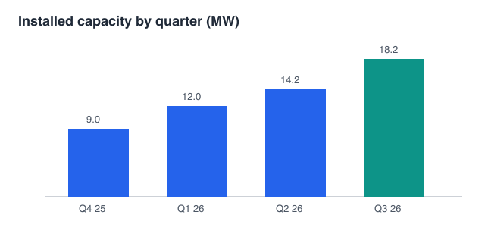

Highlights
- Two school districts in the North region (6.4 MW)
- A cold-storage warehouse in the South region (2.1 MW)
- First battery retrofit for an existing customer

Risks
- Panel prices rose 6% in August and may rise again.
- Two inspectors leave in October.
- Grid connection waits in the East region are now 11 weeks.

Next steps
Hire two inspectors before November. Lock Q4 panel prices this month.
Review revenue by region again in January.

Ticket counts come from the service desk export of 3 October 2026.

