**Embedded Thin-Film Resistors for Medical Electronics**

Introduction

The use of embedded passive components in the printed circuit board industry have expanded exponentially over the past several years, primarily in response to a need for smaller, thinner and denser electronic circuitry, and nowhere has this demand appeared to have become greater than in the medical electronics industry. In this article, we will review some of our own experiences with the application of one specific embedded passive material known as OhmegaPly®, a thin-film resistive material manufactured by Ohmega Technologies,Inc.

Thin-Film Embedded Resistive Materials

OhmegaPly® is the trade name for a Thin-Film embedded resistive material produced by electroplating a Nickel-Phosphorous compound (NiP), onto a copper foil substrate. This plated foil substrate may then be bonded to a variety of dielectric materials.

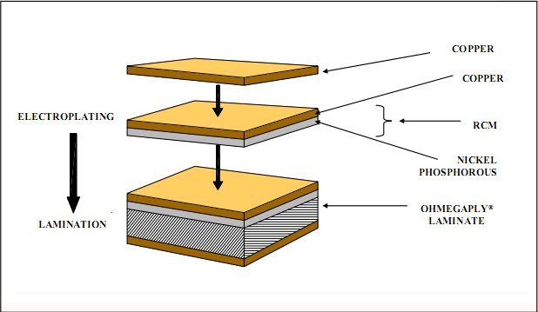

Utilizing conventional subtractive print-and-etch techniques, a single circuit layer may be created, comprising conductive copper foil traces integrally connected with the desired resistive elements. The subsequent circuit layer may be used as an inner layer of a multilayer printed circuit board, or as a surface layer in conventional circuit construction. We have successfully bonded this OhmegaPly® material to PTFE (Teflon), Polyamides (rigid and flexible), FR-4 epoxy-glass, along with several other exotic materials. The OhmegaPly® material is currently available in ½ oz (18 micron) and 1 oz (35 micron) copper foils, with sheet resistivities of 10, 25, 50, 100 and 250 Ohms per square inch being currently available.

Reliability

As medical electronic circuit reliability is of the utmost importance, the utilization of OhmegaPly® materials can substantially enhance circuit board reliability by the reduction or elimination of discrete resistors as well as the problems associated with fluxes, soldering and washing. Additionally, reducing the area required for discrete resistors yields a smaller and/or thinner circuit board, and in addition, double-sided surface-mount circuit boards may be reconfigured as single-sided. Such resistive materials have been utilized extensively for more than 30 years in a variety of critical applications, repeatedly exhibiting outstanding long-term reliability.

Applications

One such medical application we encountered required a multilayer flexible circuit cable utilizing the OhmegaPly® resistive film. We obtained an OhmegaPly® resistive copper material comprised of ½ oz copper with a 10 ohm per square inch resistive coating, and with the use of a press, bonded the film to one side of a flexible Kapton substrate. The remaining side of the Kapton substrate was laminated with conventional ½ oz copper foil.

Applying standard imaging and etching processes to both sides of the flexible Kapton strip yielded the required copper foil traces on one side of the strip, and a combination of copper and resistive traces on the remaining side. The strips were then electrically tested to ensure compliance with customer specifications. The next step was to apply a protective coating to the resistive elements in order to prevent possible mechanical damage during handling and application. We completed this process with an additional resistance test to verify the value and integrity of the resistive film.

Another specific application utilizing the OhmegaPly resistive film involved a medical imaging memory controller, where the film provided a series of termination resistors within 5 internal logic planes of a 14-layer multiplayer FR4 glass epoxy circuit board. The termination resistors were designed to be in close proximity to the integrated circuits in order to improved impedance matching and reduce propagation delay. Additionally, the embedded resistors serve to reduce EMI, which is often associated with chip or through-hole resistors.

Conclusion

The stringent reliability goals set forth by the medical industry and others, comes on the heels of increasing demands for more dense, cost-competitive, compact and sophisticated printed circuit boards. Our expertise is exhibited in our ability to adapt to and incorporate advanced manufacturing technologies, and it is of paramount importance that we remain ahead of these key drivers in an ever-evolving industry. Embedded passive technologies, such as OhmegaPly®, represents just one part of the growing arsenal of tools being made available in order to meet or exceed customer specifications, designs and expectations.