Considerations for the Thermal Management of Printed Wiring Boards

By Brigitte Lawrence, BRIGTFLEX , Inc.

The drivers in the electronic packaging market continue to push for higher density, better performance, and improved reliability. When performance includes thermal management, generic substrate and board processing options may not be sufficient.

The design hurdles are ever increasing power density, as packages get smaller and hotter. Higher frequencies and data rates are reducing efficiency and more energy is lost to heat. Higher-wattage components are raising junction temperatures and reducing component reliability.

Thermal Management

To address these thermal management concerns, we need to understand the material's thermal impedance. This value is the sum of a material's inherent resistance to heat transfer or thermal resistance, plus the imperfections at material interfaces which further impede heat transfer, or interfacial resistance. System reliability is absolutely critical, especially for applications such as medical technology and flight hardware, where safety is paramount. System failures, regardless of the application, will equal lost revenue and affect a company's bottom line and reputation.

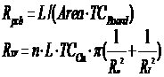 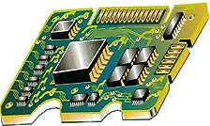

The use of heavy metal backplanes, thermal vias, thermal coins, heat spreaders, heat risers, and conductive adhesives are all proven ways in which materials can be used to reduce junction temperatures. Additionally, active cooling and water-cooling are also effective. Any or all of these methods can, however, adversely affect the cost, size, weight, reliability, and electrical performance of RF circuits.

The Arrhenius Chart tells us that, with every 10°C increase in temperature, failure rates at the component-level will double:

HV HBT Reliability - Arrhenius Chart

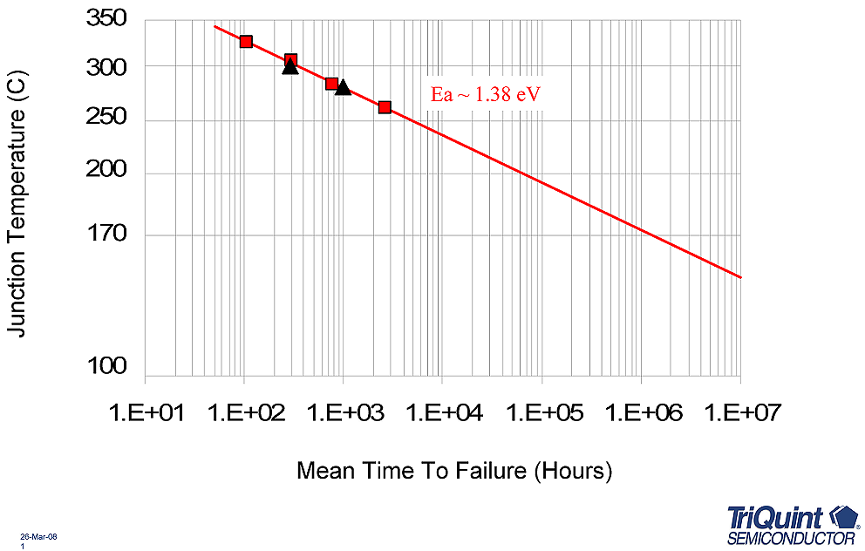

Thermal Management Solutions for Digital & High-output LED Designs

One solution for digital and LED designs that would complement all of these approaches would be the use of substrates materials with high thermal conductivity. These epoxy based substrate materials like Arlon® 91ML, will help limit the maximum temperature the component will see by dissipating and spreading the heat in plane. These substrates will also dissipate heat faster to metal planes like a heatsink or thermal coin. Materials with in plane thermal conductivity of 2 – 4 W/mK can increase the ability of the board to spread heat 10 to 20 times more efficiently than conventional epoxy materials with in plane thermal conductivity in the range of 0.2 W/mK. The use of thin dielectrics with good electrical strength and low thermal resistance, provide the perfect solution for the LED and other high power applications

Thermal Management Solutions for Power RF Designs

The same thermal management concerns exist in the RF design arena. This is particularly true in active component designs like power amplifiers. The use of thermal vias to transfer heat is common on digital designs but may impact signal integrity on RF designs. While thick heatsinks and copper coins can be effective in reducing board temperatures, they also add additional cost and weight. By designing with materials that have high thermal conductivity, the materials and fabrication costs could be reduced by the use of thinner heatsinks or coins. Reducing the maximum surface temperature of the boards should increase component reliability. Reducing surface temperature is achieved by spreading the heat away from components and reducing hot spots. In addition to reducing junction temperatures thermally conductive PTFE materials like Arlon’s TC600, will provide a thermally stable dielectric constant over temperature. This property insures that the dielectric constant will not shift over temperature and impact the impedance values of the circuit. A stable dielectric constant will reduce reflections and dead bandwidth.

Conclusion

Using thermally-conductive materials can increase component reliability by reducing junction temperatures. This helps engineers reduce the limitations to improved designs in high-power LED illumination, high-speed logic circuits and power RF applications. Brigitflex has developed an expertise with many of the materials designed for thermal management concerns of high-power LED, digital, and RF designs, using single-sided, multilayer and rigid flex constructions. The use of high thermal conductivity materials to improve heat transfer in both RF and digital designs is now a common solution, with both the epoxy-based and PTFE based materials. The consensus of many of the engineers in these markets has been positive regarding the use of these ceramic-filled 'prepregs' and laminates.

Brigitflex is working with suppliers of these types of substrates, like the Materials for Electronics Division of Arlon, to meet the thermal requirements in variety of applications. Vendor relationships are important; our collaboration with Arlon, and our other suppliers, has been key to our successes, from prototyping through production. Our ability to provide conceptual engineering and total-in house manufacturing capability here in the United States has been important for both our military and commercial customers. All materials at Brigitflex are lead-free solder process-friendly.

Special thanks to:

Russ Hornung,

Technical Marketing Manager,

Arlon, Materials for Electronics Division

References:

Russ Hornung, Arlon Materials

"Expanding the Thermal Management Tools

for RF Infrastructure & Power Amplifiers"

IWPC, October 18, 2007

Eli Reese, TriQuint Semiconductor

IWPC, November, 2005