Exploring a City Map Ontology With Semantic Query Languages for Support Learning of Spatial Orientation Skills of Visually Impaired Users

Alicja Rojek
University of Siedlce, Faculty of Exact and Natural Sciences
Poland
ar85287@stud.uws.edu.pl

Dariusz Mikułowski
University of Siedlce, Faculty of Exact and Natural Sciences
Poland
dariusz.mikulowski@uws.edu.pl

Abstract: This paper presents an approach to exploring a city map ontology using semantic query languages to support the development of spatial orientation skills among visually impaired users. The proposed method leverages an ontology describing urban objects (e.g., streets, sidewalks, crossings, and buildings) and their spatial relations, with particular emphasis on adjacency. A prototype application was developed to query the ontology and extract relational data, which were subsequently transformed into a graph representation and imported into a Neo4j database. Graph-based pathfinding algorithms were then applied to generate routes between selected locations. As a result, a set of routes was created and further optimised for accessibility and usability by blind users. The study demonstrates the feasibility of integrating ontology-based representations with graph processing techniques and indicates the potential for further research on the performance of semantic query languages and the development of training-oriented simulation environments.

Introduction

Spatial orientation is one of the key skills a blind person should master to function as a full-fledged, independent citizen. However, the practical mastery of related skills constitutes a significant challenge, especially for individuals who have recently lost their sight or who have previously been under the care of others and did not have to struggle with this problem. Moving independently in an urban environment without sight is stressful and requires mastering many skills. Furthermore, it is necessary to develop perceptiveness and techniques for dealing with encountered difficulties, e.g., in situations where the user does not know exactly where they are or has accidentally entered the roadway in an unauthorised place.

A step toward solving these problems may be the creation of specialised simulation environments that support users in training basic spatial orientation skills under less stressful conditions. Various technologies available in today's computer science can be used to build such environments; for example, Virtual Reality supported by three-dimensional binaural sounds (Mikułowski and Szuba 2025). One approach that appears promising is the use of ontologies to represent city infrastructure, additionally tailored to the specific needs of a future blind user. Following this trend, we propose a city ontology model to address the spatial orientation needs of blind people. Such ontology can then be searched using queries in one of the known ontology query languages, such as SPARQL, RDQL, or OWL-QL. In the proposed solution, we searched the ready-made city ontology using both SPARQL queries and the JENA library and compare the results. We place primary emphasis on the adjacency relation and use queries to find all individuals connected by it. Subsequently, the obtained triples are exported to the NEO4J graph database. Thanks to this, we can determine routes between any two points in the city using popular graph search algorithms such as Dijkstra's or A *. This procedure can help to construct route-planning engines in future simulation environments supporting the development of the target user's spatial orientation skills.

Related Work

Ontologies play a key role in the representation and integration of geospatial data, providing a semantic basis for interoperable information systems. As indicated by (Sun et al., 2019), ontologies enable the unification of heterogeneous data sources and support their sharing and integration. A similar approach is developed by (He et al., 2025), proposing a framework ontology for smart city systems that enables the integration of urban data from various domains and their effective use in urban applications.

In the context of geospatial data access, (Figueiredo et al., 2013) propose an ontological approach to data management in a distributed environment that enables semantic queries in peer-to-peer systems. Meanwhile, (Zhang and Miller, 2005) analyse the performance of query languages for ontologies, identifying significant differences in efficiency, which is important when designing systems that explore large sets of semantic data. An extension of ontology applications is their integration with machine learning methods, as shown in the work of (Rajbhandari et al., 2019), where an ontological approach supports the semantic interpretation of image data.

An important area of ontology application is in systems supporting blind people, particularly for spatial orientation. In his context (Mikułowski, 2017) proposes using ontologies in a virtual sound reality environment to support orientation learning, enabling the creation of structural models of space and educational scenarios. A development of this research is the work of (Mikułowski and Szuba, 2025), which used binaural sound in a VSR environment to achieve a more immersive experience that supports the development of orientation skills.

Parallelly, approaches based on virtual and multisensory environments are being developed. As early as (Lahav and Mioduser, 2000) showed that multi-sensory virtual environments can effectively support the building of cognitive maps by blind people. Contemporary research, such as that by (Guerreiro et al., 2023), focuses on the design of auditory representations in VR and identifies key parameters that affect the perception of objects and their behaviours. In turn, (Bredmose et al., 2022) analyse the importance of the physical elements of urban space for blind people, identifying which are crucial for orientation and safety.

Despite numerous studies on geospatial ontologies and systems for people with vision impairments, there remains a gap in integrating semantic models of space with mechanisms for their exploration and graph-based route-planning methods. In particular, there are few works that combine urban ontologies, semantic query languages, and graph algorithms to generate and optimise routes tailored to the needs of blind people. This work addresses this gap by proposing an approach that integrates these elements in a coherent experimental environment.

City Map Ontology

The basis for the experiment we conducted as part of the research was a specially constructed ontology representing the city infrastructure. It was adapted so that the classes that constitute it, the concepts collected within it, and the relations could be useful to the final blind user.

In the ontology, classes are defined in an inheritance hierarchy such that several main classes, such as CityComponents, ElementsOfCityArchitecture, InfrastructureForPedestrians, and RoadInfrastructure, are inherited by more detailed classes, such as CityHall, CrossRoad, or Pavement. These classes form the basis for defining individuals, which were specified for a fragment of the city consisting of several streets. Example individuals include: bikePath3MajaR (shown in Figure 1), blockOfFlatsKazimierzaPulawskiego, and clinicDerek-DentalSiedlceKazimierzaPulawskiego114. An essential component of the ontology consists of 4 defined relations, namely: hasDirectNeighbor (a relation indicating that an individual has direct neighbors), isLocatedOn (indicating that an object is located on another object, e.g., an advertising pillar stands on a sidewalk), hasLocation (indicating that an individual has a GPS location and address), and recordedInTheLocation (indicating that a recorded sound has been assigned to the object to describe it for the blind user). Such a sound can be a description generated by a speech synthesiser or an emitted sound signal, e.g., a signal sent by a moving car or acoustic traffic signaling at a pedestrian crossing. A selected fragment of the ontology in the Protege view is shown in Figure 1.

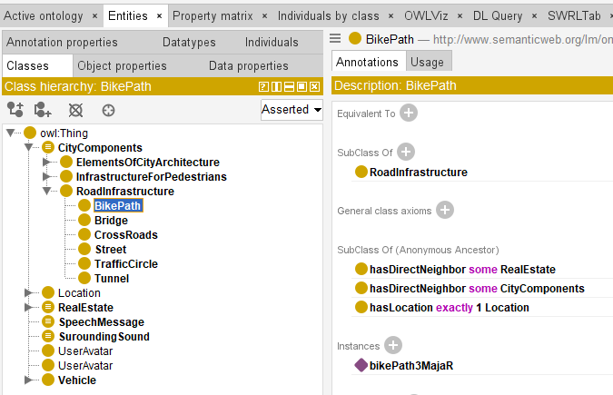
Figure 1. A class hierarchy with annotations for a selected class.

This ontology was encoded in RDF/OWL; therefore, its content is formally represented as triples (subject – predicate – object). The ontology was saved to a file, allowing it to be loaded or a modified version to be saved within the created application. An example triple showing that a recorded sound has been assigned to "stop 02" is shown in Figure 2.

Figure 2. An example triple from the ontology.

System Architecture and Methodology

Three main elements were needed to conduct the experiment: an application for exploring the ontology, an export to a CSV file, and a NEO4J database for determining routes using the graph method. The main architectural scheme for the experimental environment is shown in Figure 3.

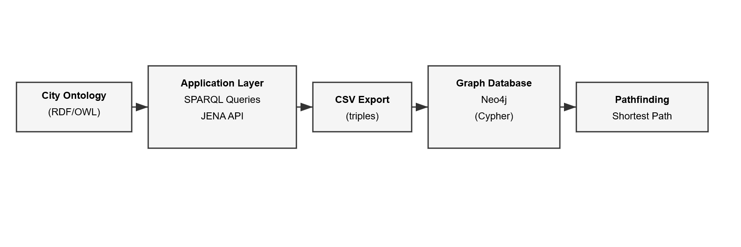
Figure 3. An architecture of experimental environment.

The desktop application allows exploration and modification of the ontology, execution of queries, and export of results to a CSV file. The application was implemented in Java, and its engine for operating on the ontology was the official JENA API. On the main screen, one can select a class and then load it into the application. All individuals of that class will be shown. A new class can also be added. The application also features a menu with to load and save the ontology, add a new relation, search for a class, and search for relations for a selected individual. The application's main screen is shown in Figure 4.

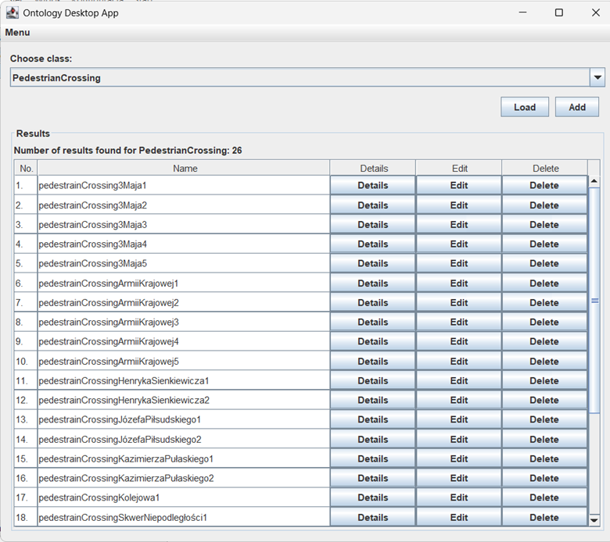
Figure 4. A main screen of ontology exploration desktop application.

Searching for relations, classes, and individuals is implemented using two methods: via SPARQL queries and using the JENA API. In addition to the search results, the time required to perform the operation is also shown. Searching for a specific relation for a selected individual is particularly important because it generates a resulting data set containing a list of all objects and their adjacency relations with other objects, in the form of triples. This result can be saved to a CSV file in the search window. The screen with the results of an example search for adjacency relations for a selected object is shown in Figure 5.

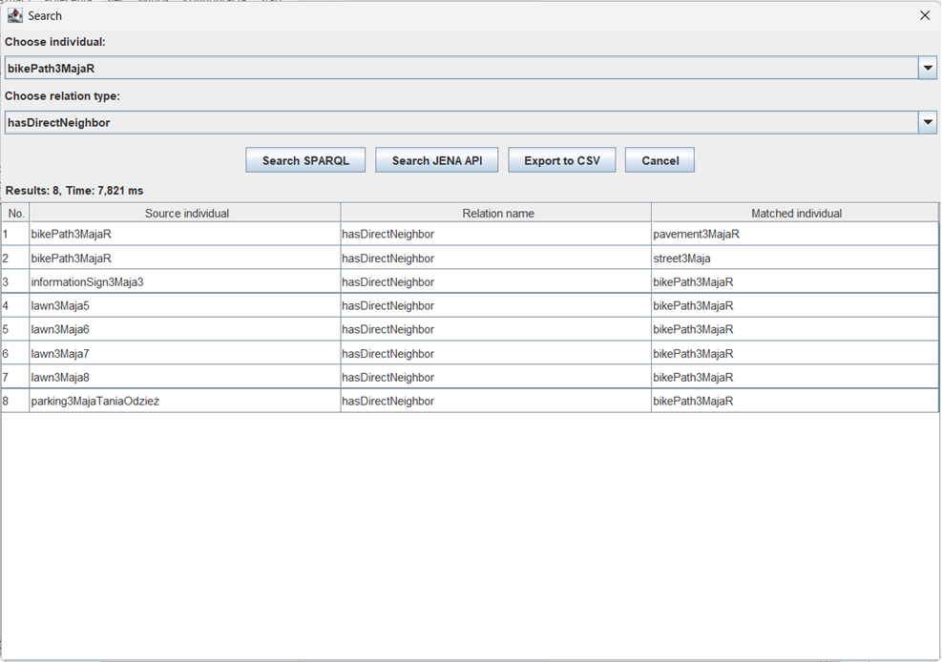
Figure 5. Searching individuals and relations in the application

The next step of the experiment involved searching the ontology for all individuals connected to other objects via the adjacency relation and exporting the results to a CSV file. Subsequently, this file was imported into a locally installed NEO4J graph database. After a successful import, an adjacency graph was created in the NEO4J database from the loaded individuals. The nodes in this graph were the discovered individuals (points in the city), and the edges were the adjacency relations between them. Then, 10 sample routes were generated between 20 randomly selected points in the graph. To determine the routes, the DIJKSTRA algorithm and the A algorithm built into the database system were used. The generated routes were saved to a resulting text file as lists of consecutive individuals. Finally, the routes were analysed for their usefulness in navigating a blind person. Therefore, it was decided to reject several routes with too many nodes. The main conclusion that emerged at this stage is that, to enable future personalisation of determined routes and automatic rejection of incorrect routes, it will be necessary to assign appropriate weights to graph edges. Routes prepared for a blind user should be as simple as possible to navigate, have the longest possible stretches on the same sidewalks, and feature as few pedestrian crossings, turns, and points, such as complicated intersections or roundabouts, as possible.

Results

The ontology defined for the experiment represents a fragment of the city in the immediate vicinity of the university, covering 5 main streets. In the current version of the ontology, 60 classes are defined, 5 of which are general classes from which the remaining classes inherit. Four relations and 16 further data properties were also defined. Using these, 431 individuals were created. In the next stage, all individuals with adjacency relations were exported to a CSV file and then imported into the NEO4J database. As a result of this operation, a graph consisting of 235 nodes and 235 edges was obtained, the weights of which were set to a value of 1. The database system also showed that 493 relationships were created, and the entire process was completed after 198 ms. Subsequently, 10 nearest paths were generated between 20 randomly selected points. The paths had an average of 5 nodes each. An example of the searched path is shown in Figure 6.

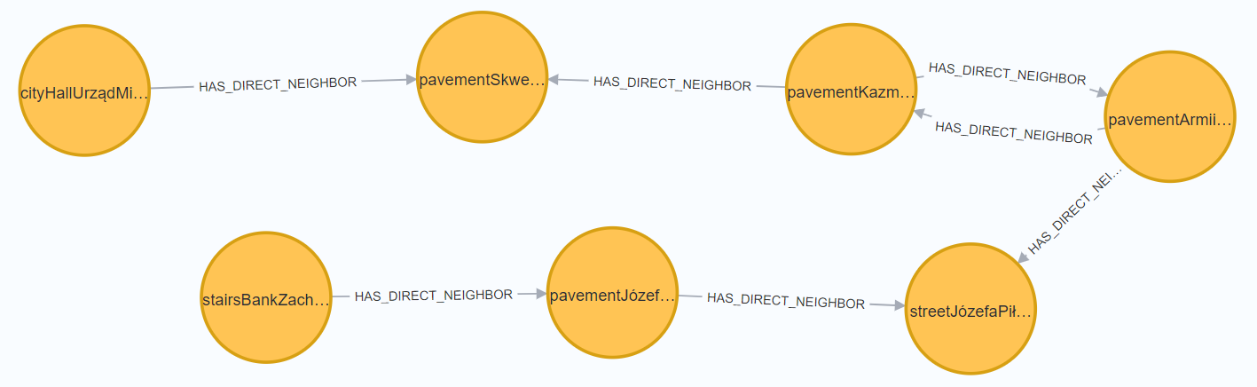 Figure 6. Example of a graph representation of the computed shortest path.

This experiment, although conducted on a small scale, showed that it will be necessary to optimise the generated routes for a blind person's needs. By tuning the edge weights, it will be necessary to avoid complex intersections and ambiguous points, and to favor continuous sidewalks and landmarks (e.g., signals, stops).

Discussion and Conclusions

The experiment described in this work is a pilot study conducted as part of a master's thesis; therefore, its scale is not large. It is intended to show the usefulness of this method toward its future continuation and modification. The experiment demonstrated the advantages of a modular approach combining a dedicated application for exploring the ontology, exporting data to a graph database, and using nearest-path algorithms to support the creation of training routes for a blind person learning spatial orientation in laboratory conditions. Such an approach offers significant opportunities for scaling and customisation.

The main limitations of this experiment are the limited number of created routes and the need for manual ontology modelling. The lack of sensory data makes it difficult to populate the ontology with specific data. This imperfection can be mitigated by automatic image recognition methods and OCR, developing the automatic generation of RDF fragments for subsequent import into the ontology. Technologies such as Lidar can also be applied.

During the experiments, it was noted that SPARQL queries take longer to execute the first time on a given ontology, whereas subsequent queries run much faster. This might be caused by loading the ontology into memory for the first time. The JENA API was faster regarding the first query, and in subsequent ones, its execution time was comparable. However, SPARQL will likely run faster on a large ontology because it operates in batches and does not need to keep the entire ontology in memory at all times.

We can summarise that the entire pipeline implemented during the experiment works and generates routes. This confirms the significant potential of this method for constructing engines for future simulation systems that support user route planning. In subsequent steps of the experiment, it is planned to expand the ontology, develop automated mechanisms to populate it with data, and conduct experiments on a larger dataset. It is also planned to generate a set of routes and test them with blind users. This may allow integration of solutions from this experiment with simulation systems that support the teaching of spatial orientation to blind people using VR.

References

A Bredmose, A., Grangaard, S., Lygum, V.L., & Hansen, A.R. (2022). Mapping the importance of specific physical elements in urban space for blind and visually impaired people. Journal of Urban Design, 28, 139-154.

Figueiredo, R., Pitta, D., Salgado, A.C., & Souza, D.Y. (2013). Geographic Data Access in an Ontology-based Peer Data Management System. J. Inf. Data Manag., 4, 146-155.

Guerreiro, J., Kim, Y., Nogueira, R., Chung, S., Rodrigues, A., & Oh, U. (2023). The Design Space of the Auditory Representation of Objects and Their Behaviours in Virtual Reality for Blind People. IEEE Transactions on Visualisation and Computer Graphics, 29, 2763-2773.

He, X., Kuai, X., Li, X., Qiu, Z., He, B., & Guo, R. (2025). Smart City Ontology Framework for Urban Data Integration and Application. Smart Cities.

Lahav, O., & Mioduser, D. (2000). Multi-sensory virtual environment for supporting blind persons' acquisition of spatial cognitive mapping, orientation, and mobility skills.

Mikułowski, D. (2017). An Approach for Ontologically Supporting Space Orientation Teaching of Blind Pupils Using Virtual Sound Reality. International Conference on Interactive Collaborative Learning.

Mikułowski, D., & Szuba, B. (2025). Supporting the Development of Spatial Orientation Skills of Blind People Using Binaural Sounds in the VSR Game. Studia Informatica. System and information technology.

Rajbhandari, S., Aryal, J., Osborn, J., Lucieer, A., & Musk, R. (2019). Leveraging Machine Learning to Extend Ontology-Driven Geographic Object-Based Image Analysis (O-GEOBIA): A Case Study in Forest-Type Mapping. Remote. Sens., 11, 503.

Sun, K., Zhu, Y., Pan, P., Hou, Z., Wang, D., Li, W., & Song, J. (2019). Geospatial data ontology: the semantic foundation of geospatial data integration and sharing. Big Earth Data, 3, 269 - 296.

Zhang, Z., & Miller, A. (2005). Ontology Query Languages for the Semantic Web: A Performance Evaluation. Journal of Web Semantics.

