CREATE CONSTRAINT object_name_unique IF NOT EXISTS
FOR (o:Object)
REQUIRE o.name IS UNIQUE;

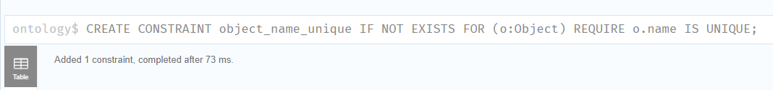LOAD CSV WITH HEADERS FROM 'file:///ontology.csv' AS row FIELDTERMINATOR ';'
MERGE (s:Object {name: row.Source})
MERGE (t:Object {name: row.Target})
MERGE (s)-[:HAS_DIRECT_NEIGHBOR]->(t);
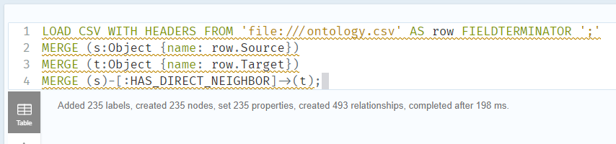
MATCH (a:Object)-[r:HAS_DIRECT_NEIGHBOR]-(b:Object)
RETURN a, r, b
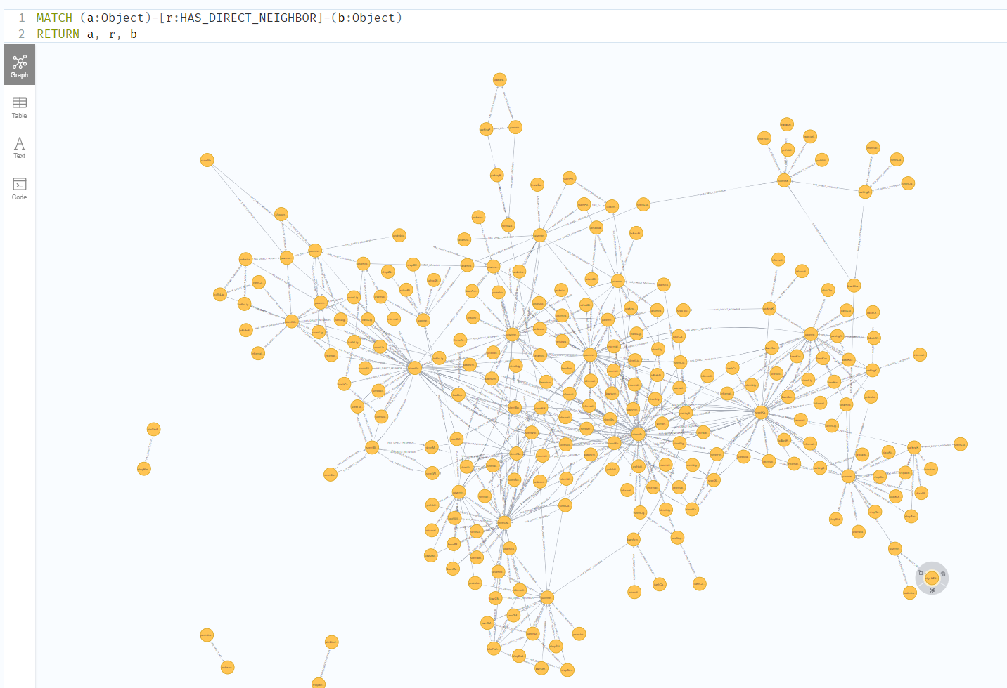
MATCH (start:Object {name: 'stairsBankZachodniWBK'}),
(end:Object {name: 'cityHallUrządMiastaSkwerNiepodległości'})
MATCH p = shortestPath((start)-[:HAS_DIRECT_NEIGHBOR*]-(end))
RETURN p;
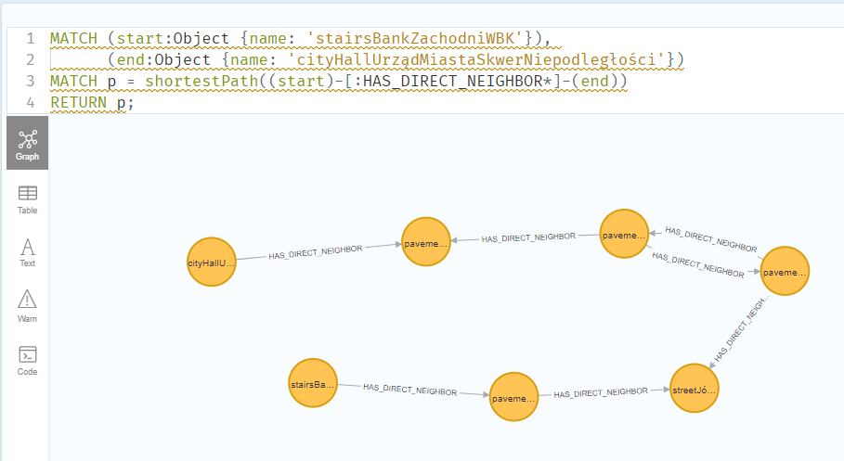CALL gds.graph.project(
'ontologyGraph',
'Object',
{
HAS_DIRECT_NEIGHBOR: {
orientation: 'UNDIRECTED'
}
}
)
YIELD graphName, nodeCount, relationshipCount;
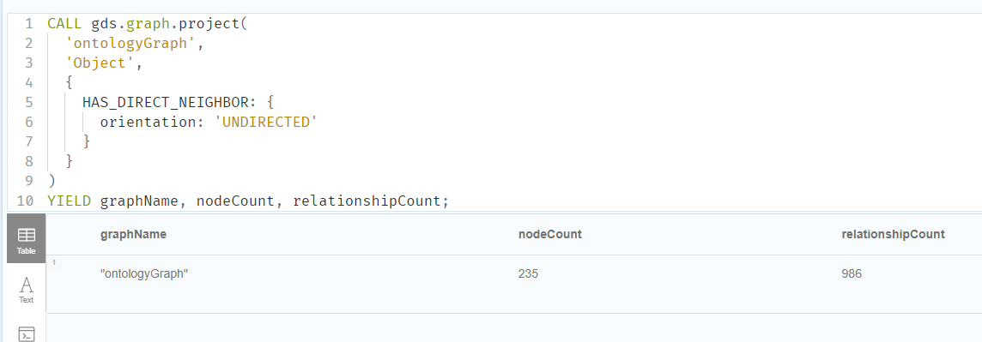MATCH (source:Object {name: 'stairsBankZachodniWBK'}),
(target:Object {name: 'cityHallUrządMiastaSkwerNiepodległości'})
CALL gds.shortestPath.dijkstra.stream('ontologyGraph', {
sourceNode: id(source),
targetNode: id(target),
relationshipWeightProperty: null
})
YIELD index, sourceNode, targetNode, totalCost, nodeIds, costs, path
RETURN
[nodeId IN nodeIds | gds.util.asNode(nodeId).name] AS path,
totalCost;
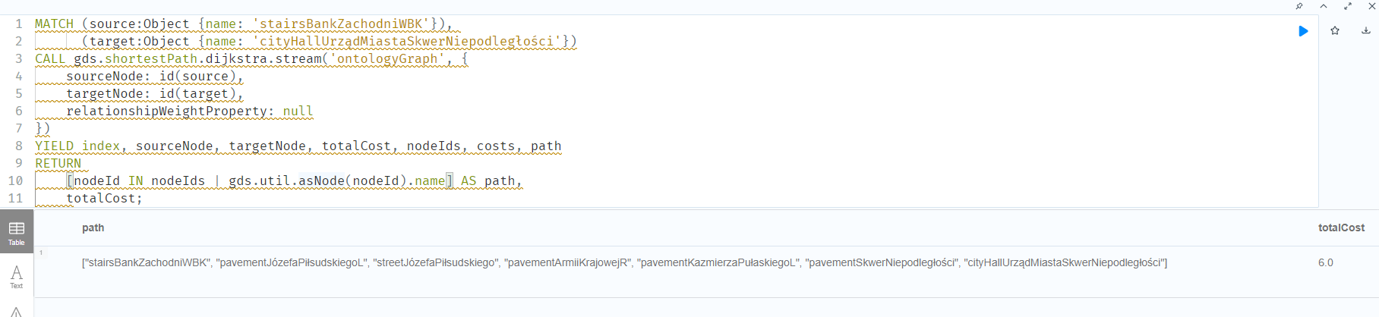MATCH (source:Object {name: 'stairsBankZachodniWBK'}),
(target:Object {name: 'cityHallUrządMiastaSkwerNiepodległości'})
CALL gds.shortestPath.dijkstra.stream('ontologyGraph', {
sourceNode: id(source),
targetNode: id(target)
})
YIELD nodeIds
RETURN [nodeId IN nodeIds | gds.util.asNode(nodeId)] AS nodes;

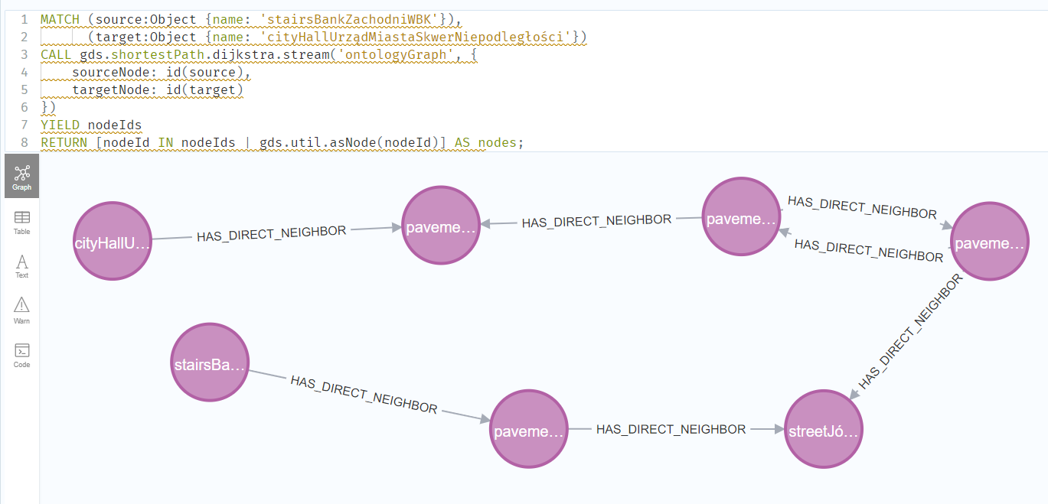Started streaming 1 records after 14 ms and completed after 24 ms.
Astar wymaga latitude I longitude
Yens
MATCH (source:Object {name: 'stairsBankZachodniWBK'}),
(target:Object {name: 'cityHallUrządMiastaSkwerNiepodległości'})
CALL gds.shortestPath.yens.stream('ontologyGraph', {
sourceNode: id(source),
targetNode: id(target),
k: 3
})
YIELD nodeIds, totalCost
RETURN [nodeId IN nodeIds | gds.util.asNode(nodeId).name] AS nodes,
totalCost;

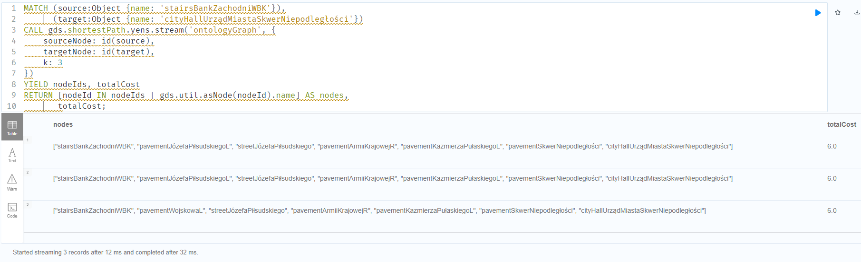Started streaming 3 records after 12 ms and completed after 32 ms.
allShortestPaths
MATCH (source:Object {name: 'stairsBankZachodniWBK'})
CALL gds.allShortestPaths.dijkstra.stream('ontologyGraph', {
sourceNode: id(source)
})
YIELD targetNode, nodeIds, costs
RETURN gds.util.asNode(targetNode).name AS targetNodeName,
[nodeId IN nodeIds | gds.util.asNode(nodeId).name] AS pathNodes,
costs AS pathCosts;
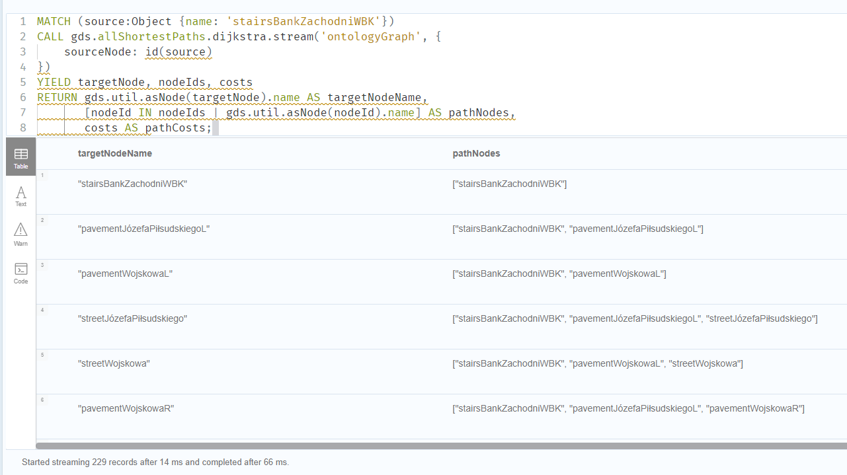
Started streaming 229 records after 14 ms and completed after 66 ms.
Wyniki tylko dla konkretnego targetnode
MATCH (source:Object {name: 'stairsBankZachodniWBK'})
CALL gds.allShortestPaths.dijkstra.stream('ontologyGraph', {
sourceNode: id(source)
})
YIELD targetNode, nodeIds, costs
WHERE gds.util.asNode(targetNode).name = 'cityHallUrządMiastaSkwerNiepodległości'
RETURN gds.util.asNode(targetNode).name AS targetNodeName,
[nodeId IN nodeIds | gds.util.asNode(nodeId).name] AS pathNodes,
costs AS pathCosts;

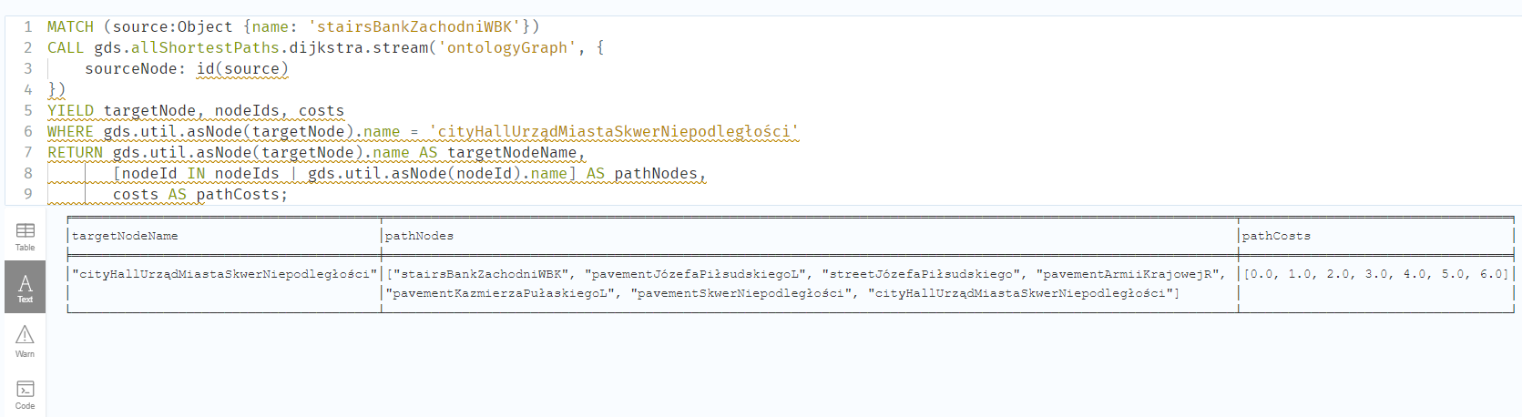Started streaming 1 records after 11 ms and completed after 29 ms.

