Figures and Tables
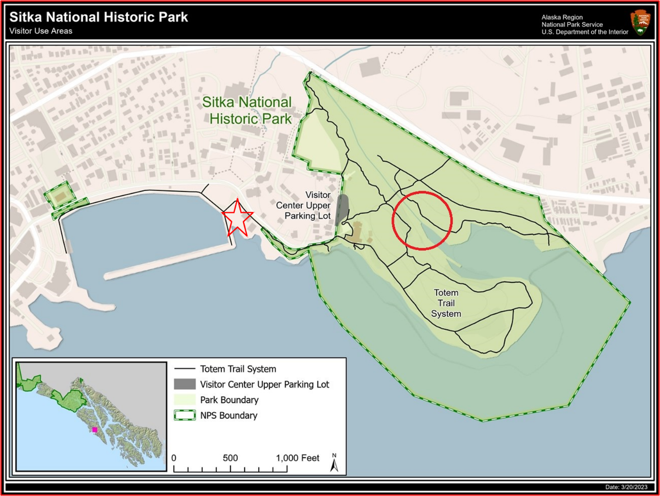

Figure 1: Location of Sheldon Jackson Hatchery (red star) and the mouth of the Indian River (red circle) in Sitka. The two highlighted points are approximately 1,650 ft (503m) apart.

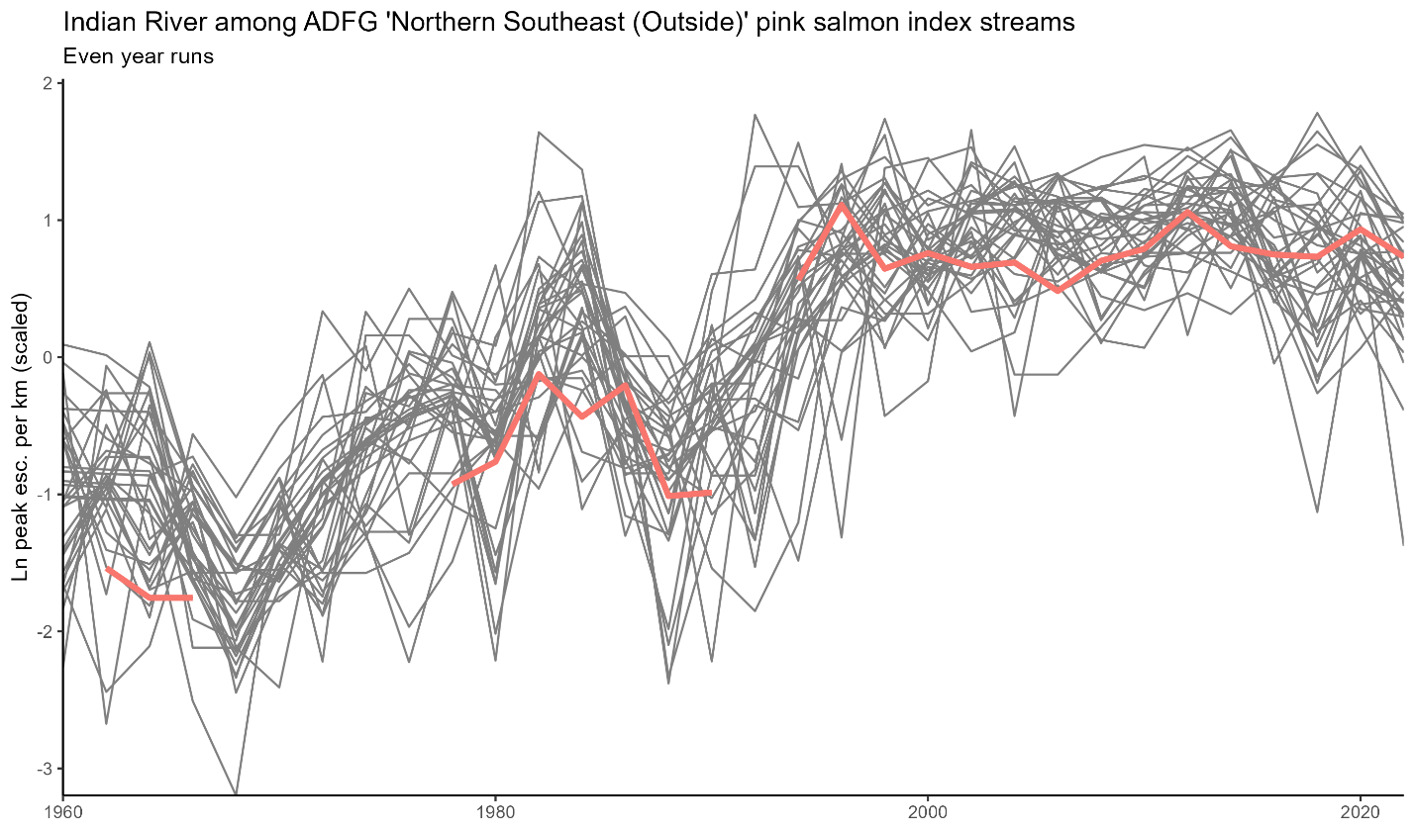
Figure 2: Even-year peak pink salmon escapement from 1960 to 2022 in Indian River and 35 index streams across ADFG’s designated Northern Southeast (Outside) region. Indian River counts highlighted. Spawner counts are scaled against stream length (km), then log transformed and standardized at the level of each stream.

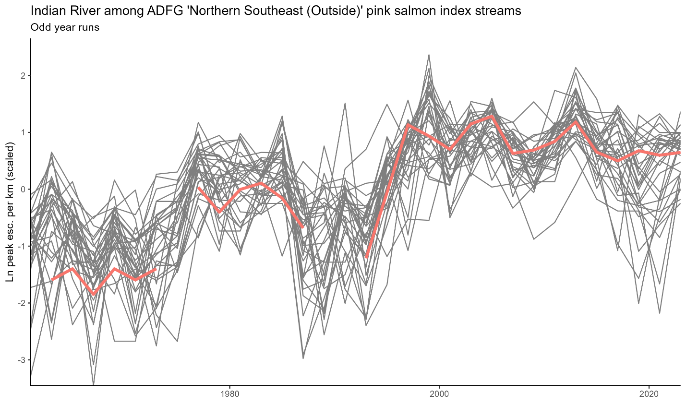Figure 3: Odd-year peak pink salmon escapement from 1960 to 2023 in Indian River and 35 index streams across ADFG’s designated Northern Southeast (Outside) region. Indian River counts highlighted. Spawner counts are scaled against stream length (km), then log transformed and standardized at the level of each stream

.

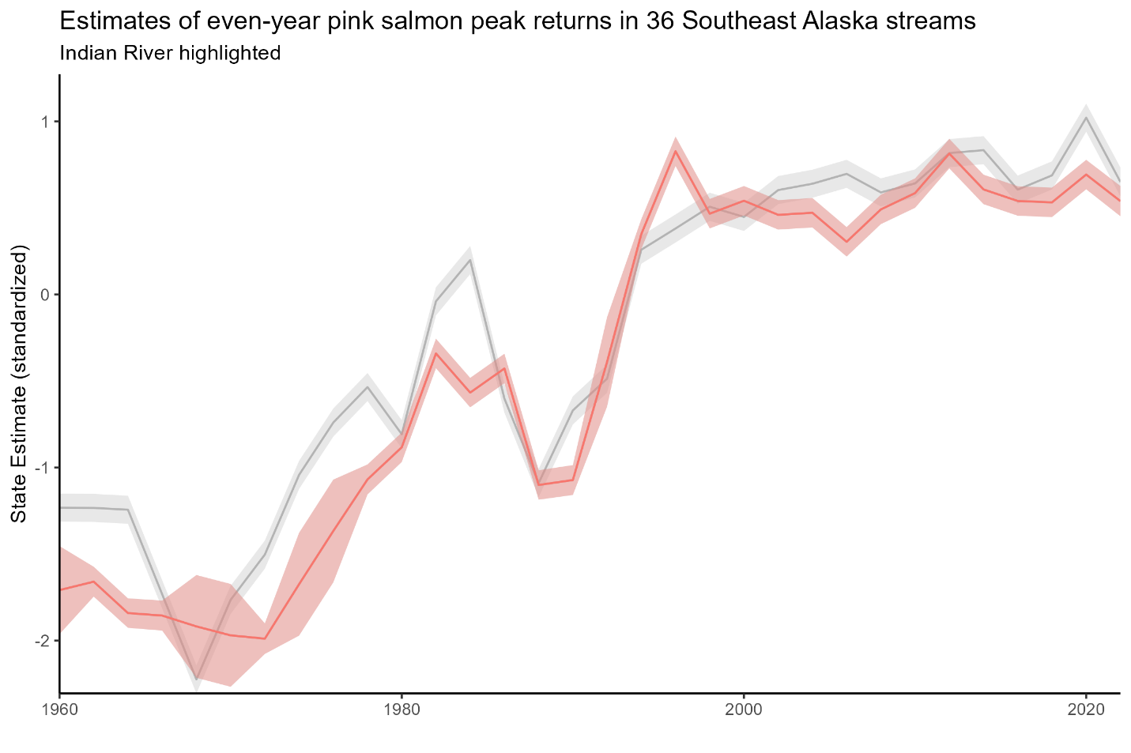
Figure 4: MARSS model results estimating the underlying states of even-year pink salmon abundance at Indian River (highlighted in pink) and throughout ‘north southeast (outside)’ region (grey). Abundance estimates are scaled by stream length and z-standardized at the stream level.

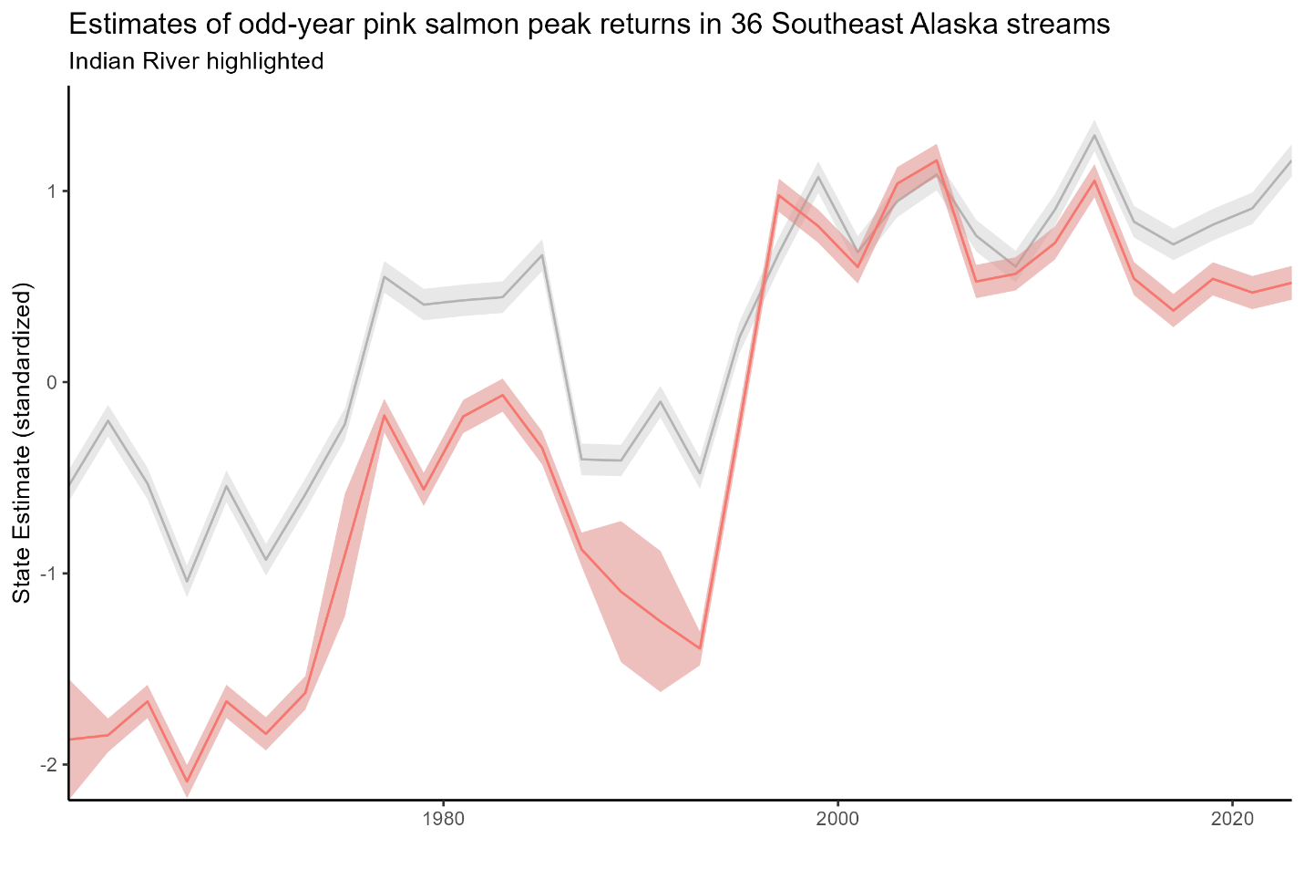
Figure 5: MARSS model results estimating the underlying states of odd-year pink salmon abundance at Indian River (highlighted in pink) and throughout ‘north southeast (outside)’ region (grey). Abundance estimates are scaled by stream length and z-standardized at the stream level.

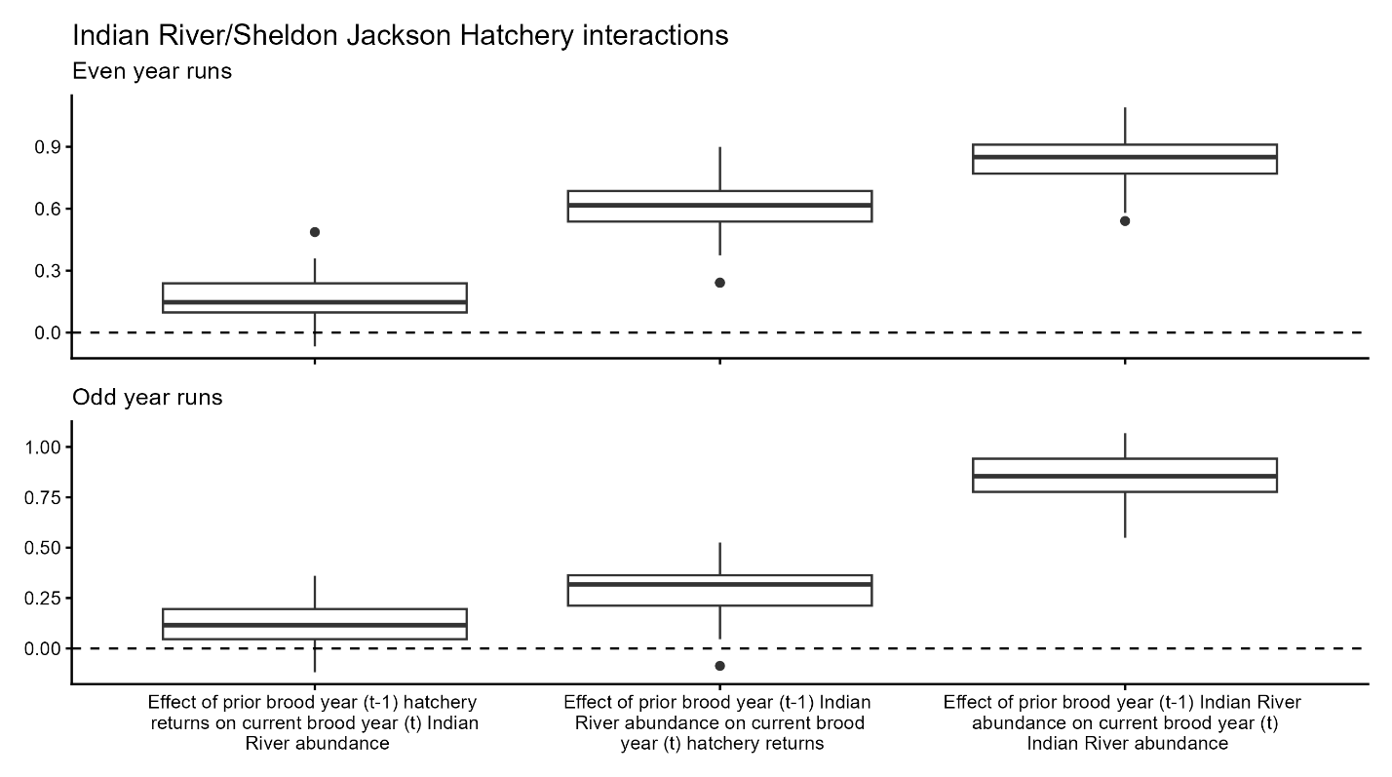Figure 6: Estimated effect of brood year-to-brood year interactions between Indian River pink salmon runs and Sheldon Jackson Hatchery pink salmon releases.
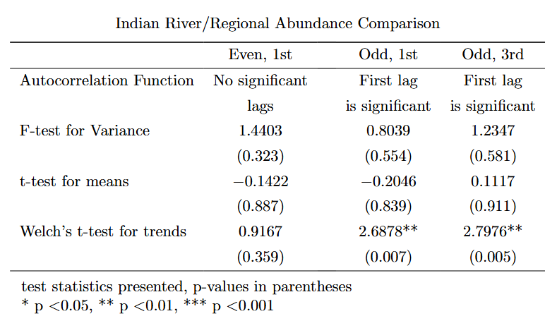
Table 1: Statistical test results comparing time series data. Each column describes a comparison between fitted states of Indian River pink salmon abundance to fitted states of an “average” pink salmon index stream in ADFG’s ‘north southeast (outside)’ region.

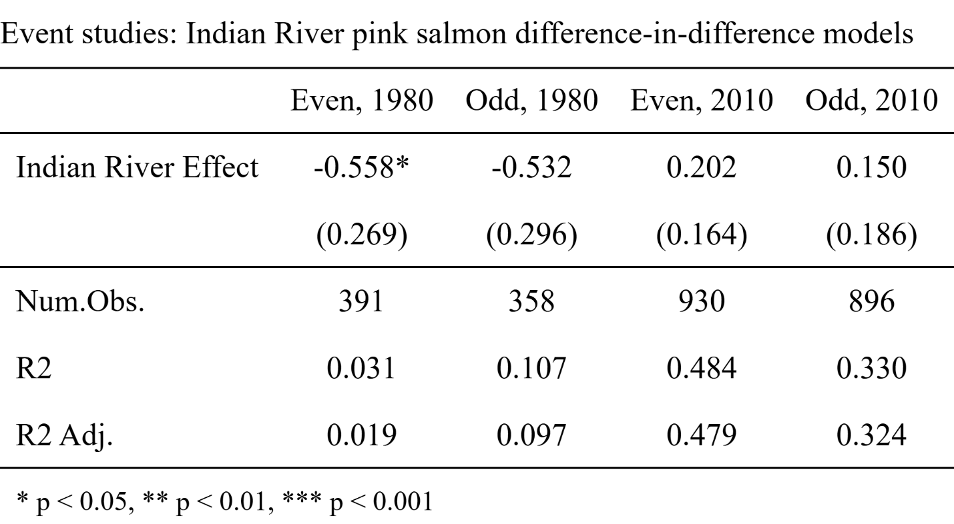
Table 2: Event studies evaluating the effect of Indian River on pink salmon abundances during pre-treatment periods. Parallel trends assumption holds in all cases except for even-year runs prior to 1980. It is necessary to construct a synthetic control group for this model.

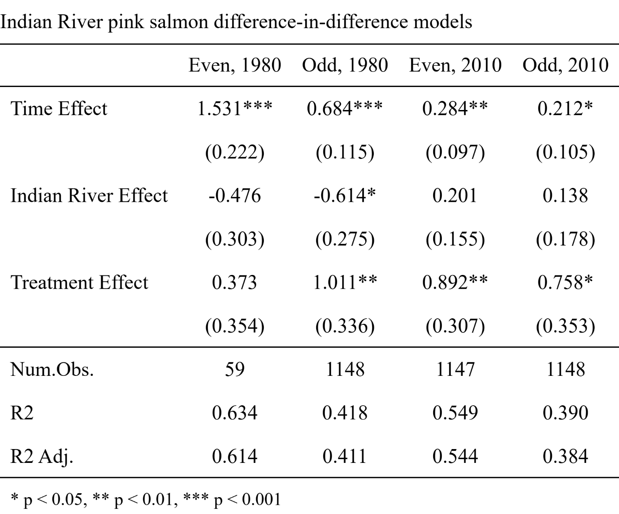

Table 3: Difference-in-difference results estimating the impact of Sheldon Jackson Hatchery operations on Indian River pink salmon abundances. Standard errors in parentheses.

References
Alaska Department of Fish and Game. 2024a. Commercial Salmon Fisheries – Southeast Alaska & Yakutat Research: Pink Salmon. Available at: https://www.adfg.alaska.gov/index.cfm?adfg=commercialbyareasoutheast.salmon_research_pink (accessed December 14, 2024)
Alaska Department of Fish and Game. 2024b. Mark Recovery Laboratory – Otolith Marking. Available at: https://mtalab.adfg.alaska.gov/OTO/marking.aspx (accessed December 14, 2024)
Beckett, K., E. Elle, C. Kremen, A. Sherwood, S. McComb, T. G. Martin. 2022. Hyperabundant black-tailed deer impact endangered Garry oak ecosystem floral and bumblebee communities. Global Ecology and Conservation 38: 14pp.
Cunningham, S. 2021. Causal Inference: The Mixtape. Yale University Press, 352 pp.
Gende, S. and B. Carter. 2015. Straying rates of pink salmon into the Indian River, Sitka National Historical Park. Final Report – ADF&G Permit # SF2015-225. National Park Service, 11 pp.
Gibson, K., K. Skov, S. Kegley, C. Jorgensen, S. Smith, and J. Witcosky. 2008. Mountain Pine Beetle Impacts in High-Elevation Five-Needle Pines: Current Trends and Challenges. USDA Forest Service – Forest Health Protection, 40 pp.
Holmes, E. E., E. J. Ward, and K. Wills. 2012. MARSS: Multivariate Autoregressive State-space Models for Analyzing Time-series Data. The R Journal 4(1): 11-19.
Knudsen, E. E., P. S. Rand, K. B. Gorman, D. R. Bernard, W. D. Templin. 2021. Hatchery-origin stray rates and total run characteristics for Pink Salmon and Chum Salmon returning to Prince William Sound, Alaska in 2013-2015. Marine and Coastal Fisheries 13(1): 41-68.
Manhard, C. V., J. E. Joyce, W. W. Smoker, and A. J. Gharrett. 2017. Ecological factors influencing lifetime productivity of pink salmon (Oncorhynchus gorbuscha) in an Alaskan stream. Canadian Journal of Fisheries and Aquatic Sciences 74(9): 1325-1336.
Mantua, N. J., S. R. Hare, Y. Zhang, J. M. Wallace, and R. C. Francis. A Pacific Interdecadal Climate Oscillation with Impacts on Salmon Production. Bulletin of the American Meteorological Society 78(6): 1069-1079.
Miller, K. M., S. J. Perles, J. P. Schmit, E. R. Matthews, A. S. Weed, J. A. Comiskey, M. R. Marshall, P. Nelson, N. A. Fisichelli. 2023. Overabundant deer and invasive plants drive widespread regeneration debt in eastern United States national parks. Ecological Applications 33: 24pp.
Moore, J. H., L. Gibson, Z. Amir, W. Chanthorn, A. H. Ahmad, P. A. Jansen, C. P. Mendes, M. Onuma, C. A. Peres, M. S. Luskin. 2023. The rise of hyperabundant native generalists threatens both humans and nature. Biological Reviews 98(5): 1829-1844.
National Park Service. 2025a. Organic Act of 1916. Available at: https://www.nps.gov/grba/learn/management/organic-act-of-1916.htm (accessed March 27, 2025)
National Park Service. 2025b. Sitka National Historical Park. Available at: https://www.nps.gov/sitk/index.htm (accessed March 18, 2025)
Quinn, T. P. 2018. The Behavior and Ecology of Pacific Salmon and Trout, Second Edition. University of Washington Press, 547 pp.
Sambaraju, K. R., D. W. Goodman. 2021. Mountain pine beetle: an example of a climate-driven eruptive insect impacting conifer forest ecosystems. CABI Reviews: 18pp.
Sergeant, C. J., J. R. Bellmore, C. McConnell, J. W. Moore. 2017. High salmon density and low discharge create periodic hypoxia in coastal rivers. Ecosphere 8(6): 16pp.
Sergeant, C. J., J. R. Bellmore, R. A. Bellmore, J. A. Falke, F. J. Mueter, and P. A. H. Westley. 2023. Hypoxia vulnerability in the salmon watersheds of Southeast Alaska. Science of the Total Environment 896: 12pp.
Stopha, M. 2015. An Evaluation of the Sheldon Jackson Salmon Hatchery for Consistency with Statewide Policies and Prescribed Management Practices. Alaska Department of Fish and Game, Division of Commercial Fisheries, 42 pp.
Thornton, T. F. 1998. Traditional Tlingit Use of Sitka National Historical Park. National Park Service, 170 pp.
Tillotson, M. D., T. P. Quinn. 2017. Climate and conspecific density trigger pre-spawning mortality in sockeye salmon (Oncorhynchus nerka). Fisheries Research 188: 138-148.
Van Alen, B. W. 2000. Status and Stewardship of Salmon Stocks in Southeast Alaska. In E. E. Knudsen, Steward, C. R., MacDonald, D. D., Williams, J. E., Reiser, D. W. Sustainable Fisheries Managemnt – Pacific Salmon, 161-193. Lewis Publishers.

