Hyperabundance of a native species: Pink Salmon in Sitka National Historical Park

Brian McGreal
Quantitative Ecology and Resource Management
University of Washington
Seattle, WA

Scott M. Gende
U.S. National Park Service
Alaska Regional Office
Juneau, AK

Mark D. Scheuerell
U.S. Geological Survey, Washington Cooperative Fish and Wildlife Research Unit
School of Aquatic and Fishery Sciences
University of Washington
Seattle, WA

Thomas P. Quinn
School of Aquatic and Fishery Sciences
University of Washington
Seattle, WA

Hyperabundance of native species within their natural range can pose a difficult management challenge. Whether due to direct human influence on their environments, or from indirect human influence due to shifting climate regimes, hyperabundance of native species can be as perilous to an ecosystem as incursion from an invasive species. This study examines the case of pink salmon (Oncorhynchus gorbuscha) in Sitka National Historical Park’s Indian River, the life history of which leads to two genetically distinctly runs inhabiting the same stream in even and odd years. Though native to the river, both runs of pink salmon have seen number of fish returning to spawn in late summer grow exponentially in recent decades. These potentially hyperabundant runs create the risk of hypoxia events, putting fish and other resident species reliant on the river at risk. The U.S. National Park Service mandates the maintenance of population densities such as they would occur within a “natural range of variation,” meaning the potential hyperabundance of pink salmon may prompt the need for management action. A nearby hatchery, which releases 3 million pink salmon fry each year, may be contributing to the abundance of pink salmon in Indian River. Using pink salmon escapement data collected by the Alaska Department of Fish and Game, this study determines whether the increased numbers of pink salmon observed at Indian River are typical of trends in the wider region (i.e., a natural range of variation), or whether hatchery operations may be driving the hyperabundant runs in recent years. Analysis using state space models finds that odd-year runs of pink salmon at Indian River diverge significantly from regional expectations, although conclusive evidence that this divergence is driven by hatchery releases is not clear. Even-year runs do not display the same divergence in behavior and seem to be in line with pink salmon abundances elsewhere in the region.
Introduction
Conservation issues related to individual species are often the result of either the scarcity of a native plant or animal species, or of an abundance of non-native (exotic, invasive) species, with either scenario capable of imperiling the ecosystems in which they occur (Ellison et al. 2005, Gallardo et al. 2015, Jeschke et al. 2014). However, harm to ecosystems can also be driven by the hyperabundance of a native species, due either to shifting regional trends in habitat suitability, to direct (and often anthropogenic) intervention, or to a combination of these factors (Sambaraju and Goodsman 2021, Beckett et al. 2022, Moore et al. 2023). Purple sea urchin (Strongylocentrotus purpuratus) hyperabundance in the northern Pacific can lead to the devastation of kelp (Macrocystis pyrifera) forests, critical ecosystems upon which countless marine species depend. This hyperabundance has been driven in the past by a direct anthropogenic intervention: the decimation of Pacific sea otter (Enhydra lutris) populations during the 18th and 19th centuries due to the high value placed on otter pelts by the maritime fur trade. Otter populations have never recovered along much of the North American Pacific coast, and as a result ‘urchin barrens’ are a common feature in shallow coastal regions off the west coast of North America (Estes 2015). More recently, another hyperabundant species, the mountain pine beetle (Dendroctonus ponderosae), has caused catastrophic destruction of coniferous forests throughout its native range, the Rocky Mountains. While the mountain pine beetle’s life history has always involved causing damage to the inner bark of conifers, cold winter temperatures have previously limited the insects’ numbers and, by extension, their impacts on Rocky Mountain forests. However, as shifting climate patterns have led to warmer winters and longer summers, the mountain pine beetle has flourished and in doing so has devasted large swathes of forest habitat in Canada and the US (Gibson et al. 2008). Unlike the direct human intervention responsible for hyperabundant purple urchins, the mountain pine beetle has proliferated due to a shifting trend in habitat suitability (albeit one that is due indirectly to human activities).
If a hyperabundance of a native species occurs within a conservation area, it may trigger the need for management action designed to protect other species within the same ecosystem. For example, the National Park Service (NPS) has operated under a mandate to preserve the resources under their stewardship such that they represent ‘vignettes of primitive America’. For natural resources, particularly those that vary in space and time, the management target has historically been to maintain abundances within a ‘natural range of variation’ (National Park Service 2025a). Notable occurrences in which native species fall outside this natural range of variation include the above-mentioned mountain pine beetle in Yellowstone, Grand Teton, and Rocky Mountain National Parks, and white-tailed deer (Odocoileus virginianus) in many midwestern and eastern national parks, capable of intense foraging on vegetation and the depletion of resources on which other species depend (Gibson et al. 2008, Miller et al. 2023, National Park Service 2023).
While there is little debate that these hyperabundances create the need for management action, the point at which the abundance of some endemic species exceeds the natural range of variation, thereby triggering a need for management action, can be difficult to ascertain. Park managers finding themselves confronted with such issues must make careful and informed decisions based on the best scientific information available as they seek to interpret and implement the mandate to preserve resources in a natural condition. Hyperabundant native species are not given anywhere near the same attention as invasive species in scientific literature, and identifying these instances as they occur is challenging (Valéry et al. 2013). While historical presence, abundance, or range of a species is useful when available, these data are often non-existent or sorely lacking (Carey et al. 2012).
With these ideas in mind, my research is focused on a population of pink salmon (Oncorhynchus gorbuscha, Cháas’) that has seen dramatic increases in population density in recent decades, and whose spawning grounds fall largely within the boundaries of a small national park in Alaska’s southeastern panhandle. Sitka National Historical Park (SITK) is a small 112-acre coastal park located (as the name suggests) in Sitka, Alaska. Originally designated a National Monument in 1910 for the purpose of conserving the site of an 1804 battle between the native Tlingit Kiks.ádi clan and Russian colonizers, today the park is managed to preserve not only the historical battleground, but the ecosystems and natural resources present in the surrounding area. These include mature spruce-hemlock forests and the Indian River (Kaasda Héen), the main reach and intertidal area of which fall within park boundaries (National Park Service 2025b). Since time immemorial, the Indian River has been the location of a fishing camp and harvesting site for the Kiks.ádi clan, and particularly valued for its close proximity to the clan’s winter villages, as well as for hosting runs of a variety of Pacific salmon species, including chum (O. keta, Téel), coho (O. kisutch, L’ook), Chinook (O. tshawytscha, T’á), and pink salmon (Thornton 1998). Pink salmon are the most abundant species at Indian River, typically returning to spawn in August. After hatching in the winter, juvenile pink salmon immediately enter the ocean in spring, making no use of freshwater as rearing habitat. All members of the brood then return to spawn in autumn of the following year at two years of age. This leads to two genetically distinct runs of salmon inhabiting the same stream in even numbered and odd numbered years (Quinn 2018). Unlike in regions further north or south, the rivers of northern southeast Alaska see even- and odd-year pink salmon runs that are approximately equal in abundance (Alaska Department of Fish and Game 2024a).
Although pink salmon have always been abundant at Indian River, their numbers have increased rapidly in the last 30 years. The Alaska Department of Fish and Game (ADFG) peak escapement surveys have estimated that, since 1980, Indian River pink salmon abundance has increased from run of several thousand to runs regularly exceeding 100,000 fish annually (Stopha 2015). High abundances of salmon are concerning to park managers because, particularly when occurring at the same time as low in-stream flows, these densities can impact the Indian River’s ability to sustain other resident fish species by crashing in-stream dissolved oxygen concentrations, both through the direct consumption of oxygen while alive and through the respiration of decomposing microbes following their death (Sergeant et al. 2023). In stream systems free of hatchery influence, there are natural regulators (density dependence) that bring the population back into balance when the number of returning spawners exceeds a stream’s carrying capacity. For example, at very high densities, females arriving later in a spawning season dig up nests (redds) made by early arriving females, so the stream has a natural limit to production (McNeil 1964). Hypoxia events are also not limited to stream systems in which natural abundances are supplemented by hatchery strays. High salmon densities are a naturally occurring phenomenon across the Pacific Rim, and incidences of high densities leading to low egg to fry survival and reduced recruitment or contributing to depleted in stream oxygen levels have been recorded throughout southeast Alaska. In such an instance, females may die before spawning due to lowered oxygen levels (Sergeant et al. 2017, Tillotson and Quinn 2017). In either of these scenarios, the numbers of spawners returning in subsequent years would be constrained. These constraints weaken with the introduction of straying fish from hatcheries, and the question becomes whether these natural processes and resulting swings in salmon abundance, are exaggerated by strays from nearby hatcheries to the point where the stream ecosystem is disturbed.
The initial increases in Indian River pink salmon abundance observed in the 1980s coincided with the commencement of operations at Sheldon Jackson Hatchery (SJH), a pink salmon hatchery located approximately 1 km from the mouth of the Indian River. The hatchery is currently operated by the not-for-profit Sitka Sound Science Center but was originally established in 1975 by Sheldon Jackson College (Stopha 2015). The college, initially “laid out as a kind of utopian experiment in assimilating Natives into ‘civilized’ Christian living”, was at its inception granted water rights from the Indian River (Thornton 1998). Today, water is taken from a diversion upriver of SITK’s boundaries to maintain hatchery operations. This water is used to rear salmon fry, which imprint on its distinct chemical signature, and also during spawning season, when more of this diverted Indian River water is released into the bay near the hatchery to attract returning fish. In late summer, returning hatchery fish tend to aggregate in large schools just offshore, where commercial fisherman partnered with the hatchery purse seine the fish and sell the catch for the purposes of cost recovery. At its inception the hatchery was permitted to propagate 1 million pink salmon eggs each year, a number that was increased to 3 million eggs in 2010, most of which survive and are released as fry to the ocean. While these eggs are extracted from hatchery broodstock, the original stock of eggs was sourced from pink salmon at the Indian River (even years) and nearby Starrigavan Creek (odd years) (Stopha 2015).
If all pink salmon reared at the hatchery returned to the hatchery, the population dynamics of salmon in the Indian River would be unaffected by hatchery operations. However, homing by salmon isn’t perfect, and in fact is likely an evolved trait that allows fish to colonize new habitats when they become suitable for spawning (Quinn 2018). Straying, whereby a juvenile salmon that was produced in one stream (or hatchery) strays into a different stream as an adult to spawn, is likely a common phenomenon for hatchery fish, but whether hatcheries increase the proportion of fish that stray is less clear (Knudsen et al. 2021). Evidence suggests that the Indian River is no exception, and indeed it is possible that the Indian River sees higher than average levels of straying due to the proximity of SJH and the hatchery fish being reared in Indian River water (Figure 1). While it has been shown that both the purposeful and incidental introduction of hatchery salmon into streams with native populations can contribute to increased abundances (Anderson et al. 2014, McMillan et al. 2023, May et al. 2024).
Hatchery-origin fish at Indian River can be distinguished from natural-origin fish because all pink salmon released by SJH are subject to otolith marking (Stopha 2015, Alaska Department of Fish and Game 2024b). Surveying efforts at Indian River have at times found stray pink salmon from Sheldon Jackson Hatchery making up one third of all individuals sampled in a given year. However, rates observed vary considerably, perhaps due to the time of year pink salmon are sampled, with some surveys observing rates of straying closer to 10% (Gende and Carter 2015).

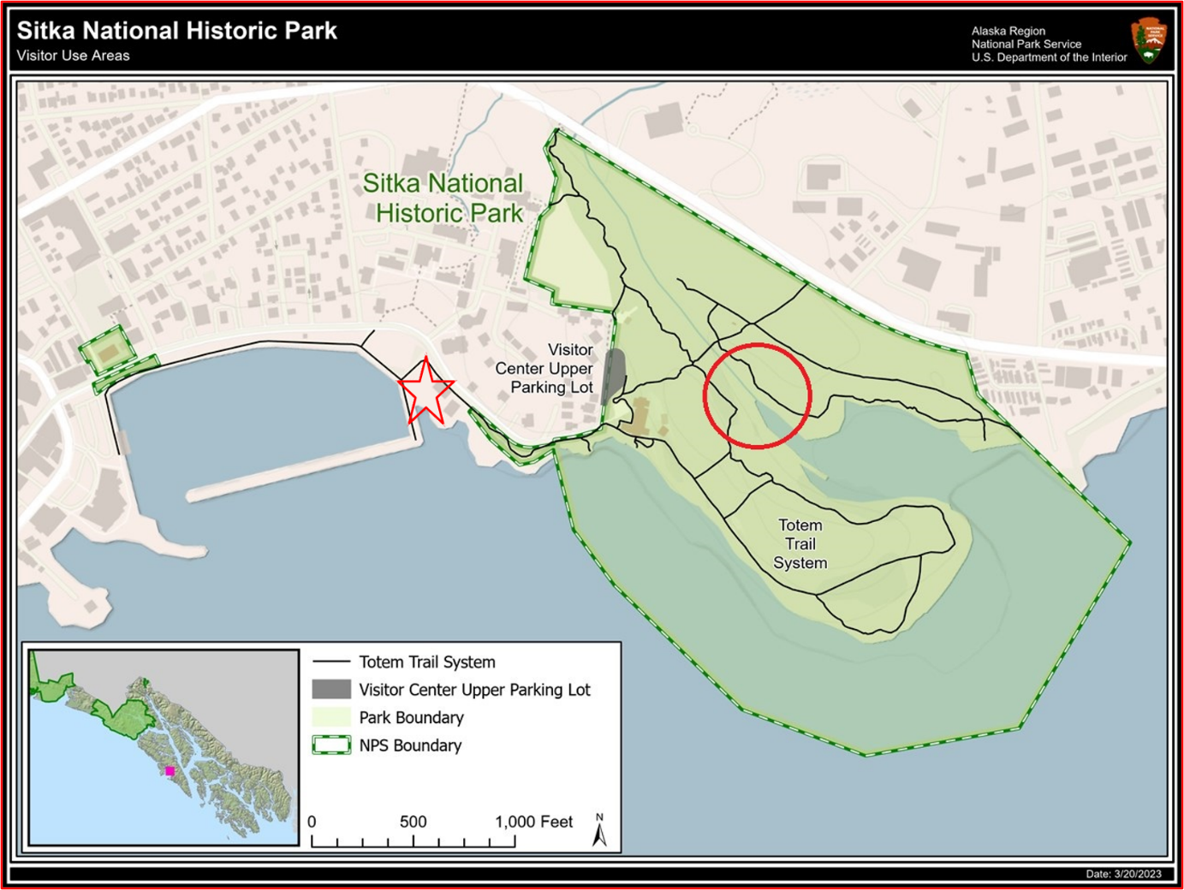

Figure 1: Location of Sheldon Jackson Hatchery (red star) and the mouth of the Indian River (red circle) in Sitka. The two highlighted points are approximately 1,650 ft (503m) apart. Credit: National Park Service, modified to include river mouth and hatchery location.

The possibility that pink salmon being reared and released by Sheldon Jackson hatchery may be contributing to the high abundances of fish observed at the Indian River in recent decades cannot be ignored. However, it is also critical to note that these high densities may be naturally occurring phenomena, influenced by variation in stream conditions, ocean productivity, predation intensity, and commercial harvests, among other factors (Manhard et al. 2017). ADFG conducts regular monitoring of pink salmon ‘index streams’ throughout southeast Alaska for the primary purpose of managing the commercial fishery (index streams being specifically selected to reflect natural conditions and a lack of undue anthropogenic influences). This extensive monitoring effort provides a regional backdrop against which abundances observed at Indian River may be compared. Between 1960 and 2023, pink salmon escapement has increased throughout what ADFG designates as the ‘Northern Southeast (Outside)’ region (in which the Indian River is located). The agency has recorded peak pink salmon escapement annually at 35 index streams in this region, as well as at Indian River, albeit with gaps in the time series. Along with other streams in the region, Indian River has seen an increase in peak escapement over the period of observation (Figure 2).
My research seeks to assess whether the abundances of pink salmon observed in recent decades at Indian River exist within a natural range of variation relative to pink salmon streams
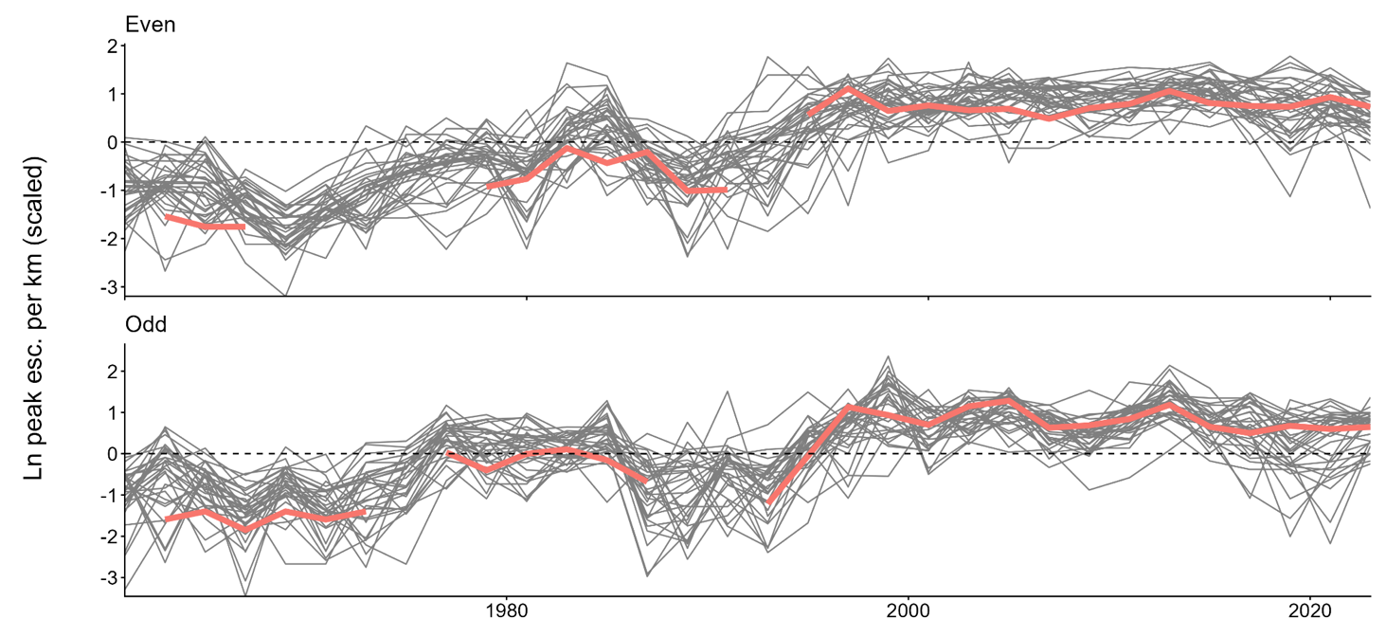

Figure 2: Even- and odd-year peak pink salmon escapement from 1960 to 2022 in Indian River and 35 index streams across ADFG’s designated Northern Southeast (Outside) region. Indian River counts highlighted. Spawner counts are scaled against stream length (km), then log transformed and standardized at the level of each stream.

elsewhere in the region, and to evaluate if and to what extent Sheldon Jackson Hatchery operations have driven the increased abundances observed since 1980. If Indian River pink salmon abundances do not exist within a natural range of variation, then it follows that a model which specifies estimates Indian River abundance as separate from that of the wider region would fit the observed data significantly better than a model which estimates pink salmon abundance throughout the region and does not allow for the Indian River to be treated as separate. If the commencement (or 2010 expansion) of hatchery operations has significantly increased pink salmon population densities at Indian River, then this effect could be observed by specifying a model of hatchery operations which controls for both the effect of time period (pre- and post-commencement of operations) and the effect of treatment (considering Indian River the treated group). Finally, the impact of hatchery releases on Indian River abundances may be evaluated by specifying a model which allows for both peak escapement and hatchery releases in the previous brood year to influence the number of pink salmon returning to Indian River to spawn in the current brood year, with the size and significance of the effect of prior-year hatchery releases providing insight as to if and what influence the volume of hatchery releases has on wild abundance. Each of these approaches is discussed in greater detail in the following section.
Methods
Data
ADFG conducts annual aerial surveys of approximately 700 streams in southeast Alaska to monitor pink salmon escapement (Van Alen 2000). These streams, referred to by ADFG as index streams, are chosen because they are believed to reflect the natural condition of pink salmon populations in the region. Index streams are grouped into three sub-regions: south southeast, north southeast (inside), and north southeast (outside). The last group is composed of 35 streams in the vicinity of Sitka and the Indian River along the ocean-facing coasts of Baranof and Chichagof islands and a few smaller islands in the area. Surveys are conducted via fixed-wing aircraft throughout the late summer pink salmon spawning season, with the name of the biologist conducting the survey recorded in about 75% of observations. A subset of these stream surveys is subject to validation by foot counts which are used to assess the accuracy of ADFG’s aerial survey efforts (A. Dupuis, ADFG, personal communication, August 19, 2024). In addition to these aerial surveys, SJH files annual reports with ADFG which include the number of salmon juveniles reared and released, the number of hatchery-raised adult salmon which survive the marine environment, the hatchery’s contributions to common property commercial fisheries (as well as sport and subsistence fisheries), and numbers of adult fish which return to the hatchery and are taken as cost recovery or as broodstock (L. Wilson, ADFG, personal communication, July 9, 2025).
Due to their life history of immediately migrating into the ocean as juveniles, the marine environment is critical rearing habitat for pink salmon (Heard 1991). Therefore, including some measure of ocean climate and productivity in models of pink salmon abundance may go a long way towards explaining year-to-year variations in returning adults. The Pacific Decadal Oscillation, a recurring pattern of Northen Pacific sea surface temperature, has been shown to be robustly correlated with salmon production regimes off the coast of Alaska (Mantua et al. 1997). As such, we leverage data on ocean climate in the form of PDO as recorded by the US National Oceanic and Atmospheric Administration (NOAA).
Survey data used in this study covers the period from 1960 to 2023. Due to the proximity of SJH and the accompanying potential of hatchery fish to affect wild fish abundance estimates, the Indian River is not one of ADFG’s index streams. Nonetheless, ADFG has still intermittently monitored pink salmon escapement in the stream to provide the most complete data possible on pink salmon in the region. Data are available from Indian River from 1962-67, 1969, 1971-73, 1977-88, 1990, and from 1993-2023 (n = 54 annual observations). Annual reports from Sheldon Jackson Hatchery are available from 1975 onwards, commensurate with the establishment of the hatchery. NOAA PDO data included in this research likewise covers the period from 1960 to 2023.

MARSS Models
Multivariate autoregressive state-space (MARSS) models are well suited for analyzing long running time series survey data and able to mathematically distinguish observation error from error arising from stochasticity in the underlying state of a system. This is accomplished through a model structure with two components: a process equation which models one or more true but unobserved states, and an observation equation which models the relationship between these unobserved states and the observed data and captures error resulting from imperfect detection. The observation equation is generically formulated as follows:
y_{t} = Zx_{t} + a + Dd_{t,} + v_{t}, where v_{t}∼MVN(0,R)
In the above, observed data in a given time period (y_{t}) are used to estimate the underlying state of a system of interest (x_{t}). Z determines which time series observations will inform which underlying states in the process equation. In the case of Indian River and the 35 index streams in its vicinity, specifying Z as a 36x36 identity matrix would allow each time series to be representative of a separate (in this case stream-level) state, while specifying Z as a 36x1 vector of 1s would force all-time series in the data to represent samples from one comprehensive underlying state. This critical feature allows these models to be used to determine how many true underlying states a set of observations represents, by comparing goodness of fit between various specifications of Z. The vector a allows for the existence of some degree of offset between the observed data and the underlying state process to be asserted or captured (depending on whether a is specified or estimated), and any correlation in observation error between time series is defined by the off-diagonal elements in R, the variance-covariance matrix. The vector d_{t} represents covariate data related to the sampling procedure, with D capturing the effect of these covariates.
The observation equation is linked to the autoregressive process equation through the estimates of underlying states (x_{t}). The process equation connects time steps in state processes by estimating terms for both x_{t} (in conjunction with the observation equation) and x_{t−1}. The process equation is formulated as follows:
x_{t} = Bx_{t−1} + u + Cc_{t} + w_{t}, where w_{t}∼MVN(0,Q)
Here, B defines the interaction between state estimates through time (i.e., x_{t} and x_{t−1}). If B is specified as an identity matrix, u then represents trends in the underlying state(s), otherwise B and u together determine the underlying mean and how quickly the time series would return to the mean following some perturbation. The variance of process errors as well as the (possible) covariance between them is defined by Q. Finally, c_{t} and C respectively represent covariate data related to the state process and the effect of said covariates.
MARSS models are very useful when parsing data collected by different observers operating in differing conditions (weather, time of day, time of year, etc.), where those conditions could potentially bias the observations being made. Furthermore, MARSS models allow for gaps in the observed time series, like those present in the Indian River data, while retaining the ability to make inferences about the underlying state (Holmes et al. 2012, Scheuerell et al. 2015).

Regional Abundance
We began by assessing whether abundances of pink salmon observed at Indian River are consistent with those abundances seen elsewhere in the region, with no attention paid to the existence of the hatchery. I accomplished this by specifying two separate MARSS models of pink salmon abundance at Indian River and the surrounding region. The first estimates two underlying state processes, treating the underlying state of Indian River pink salmon abundance separately from that of the wider region. The second uses all available data (abundance observations from Indian River and ADFG’s 35 north southeast (outside) index streams) to estimate one underlying state process of pink salmon abundance throughout the region. A comparison of how well each model fits the abundance data will either lend support to or undermine the notion that Indian River pink salmon abundances significantly differ from those observed elsewhere in the region throughout the study period. Data are standardized at the stream level so that streams of varying available pink salmon habitat may be directly compared. No offset is estimated for the observation process, but the model allows for distinct trends in both underlying states. Covariate data relating to observers (d_{t}) and the prior year’s ocean climate via lagged PDO (c_{t}) are included, resulting in the model described below.
y_{t} = Zx_{t} + Dd_{t,} + v_{t}, where v_{t}∼MVN(0,R)
x_{t} = Bx_{t−1} + u + Cc_{t} + w_{t}, where w_{t}∼MVN(0,Q)
Depending on the specification of Z, I am able to estimate either one or two underlying state processes of pink salmon abundance. These separate model specifications are compared for goodness of fit using AICc, a criterion which is well suited for evaluating models fitted on relatively sparse data (i.e., the small number of observations at Indian River) (Burnham et al. 2010).
The above description of an approach comparing a one-state model to a two-state model as a means of determining whether pink salmon abundances at Indian River differ substantially from those observed elsewhere in the reason is made additionally complicated by the life history of pink salmon leading to the existence of genetically distinct populations in the same stream in even- and odd-year runs. This means that four models must be fit to evaluate whether abundances at Indian River are exhibiting behaviors atypical of an equivalent pink salmon stream in the region. The first is the equivalent of the abstract two-state model, where for each run (even and odd) the underlying state process of pink salmon at Indian River is estimated separately from the underlying state of the wider region, meaning the model estimates four state processes total. Next, the equivalent of the abstract one-state model is specified such that, for each run, all 35 index streams and Indian River are treated as representative of one underlying state, leading to the model estimating two state processes total. There are two other important cases to consider: It is possible that, due to some variation in the underlying genetics of each run, odd-year runs at Indian River exhibit substantial variation in annual abundance from those of streams in the wider region, while even-runs at Indian River generally fall within the region’s natural range of variation, or vice versa. To evaluate these cases, two three-state models are specified, in which Indian River abundance is estimated separately for one run, while the other is included as part of the regional underlying state. Evaluation of model fit using AICc then determines which of these model structures most closely fits the observed data.

Effect of Hatchery Operations
The timeline of SJH potentially impacting pink salmon abundance at Indian River is reasonably straightforward: hatchery operations begin in 1975, meaning that given the short life cycle of pink salmon, the first returning adults would appear shortly thereafter (it is unclear from available documentation whether a brood of fish were released in 1975 or if that was the first year broodstock was taken from sources at Indian River and Starrigavan Creek). For the first three decades of its existence, SJH was permitted to propagate 1 million pink salmon eggs per year, with this number increased to 3 million in 2010. This then defines three distinct time periods of SJH production: pre-1975 with no hatchery operations, 1975-2009 with low level operations, and post-2010 with high level operations (Stopha 2015).
In order to take advantage of these distinct time periods I utilize a difference-in-difference (DD) framework. This quasi-experimental approach is designed to assess the effect of a treatment (in this case the operations of SJH) on an outcome of interest (pink salmon abundance at Indian River) and is commonly employed when evaluating the impact of an anthropogenic interventions on wild salmonid populations (Levin and Tolimieri 2001, Berejikian et al. 2025, Pearsons and Hillman 2025). DD modeling compares a treatment group to a control group across two time periods, pre- and post- intervention. The general structure of a difference-in-difference model is as follows:
y_{i,t} = β₀ + β₁D_{treatment} + β₂D_{post} + β₃D_{post}*D_{treatment} + e_{i,t}
In the above, i indexes whether an observation (y_{i,t}) relates to the treatment or control group, while t indexes whether that same observation comes from before or after the treatment is applied. D_{treatment} is equal to 1 when y_{i,t} is part of the treatment group and equal to 0 otherwise. Similarly, D_{post} is equal to 1 when y_{i,t} is observed after treatment is applied, and equal to 0 when y_{i,t} is observed before. These indicator variables allow for the estimation of a net effect of treatment on the treatment group (β₃) by first controlling for differing characteristics in the treatment and control group (β₁) and differences in the pre- and post-treatment time periods (β₂). Crucially, input data must cover both a control and treatment group, as well as time periods before and after the intervention of interest. It is important to note that in this case, and indeed in almost every application of DD modeling, true controls in the sense of those resulting from a randomized experimental design are unavailable. Instead, researchers must make do with treating what might be referred to as reference states as control groups. The assumption that these reference states are suitable proxies for randomized control groups, known as the parallel trends assumption, is bolstered through the application of event studies which evaluate whether trends in control and treatment groups are mathematically similar in the pre-treatment period (Cunningham 2021).
I applied a DD framework to this research by assigning observations of pink salmon abundances at Indian River as a treatment group and observations at ADFG’s other north southeast (outside) index streams as a control group. Pre- and post-1980 were evaluated to indicate the treatment period (allowing a couple of years for hatchery operations to ramp up). A statistically significant estimate of β₃ greater than 0 would indicate that SJH operations are exerting upward pressure on Indian River pink salmon abundance. However, even if an estimate is found to be statistically significant, the size of the effect must also be considered, as even a significant effect may not be responsible for a large impact on salmon abundance. A separate specification of the DD model will include an indicator variable related to periods pre- and post-2010, to assess the impact of heightened pink salmon production. As with the MARSS models of regional abundance, covariate data relating to observers and ocean climate are included in model specifications, with model fit evaluated using AIC. The best fit models are then evaluated to ensure that treatment and control groups are mathematically similar during the pre-treatment period (if these groups significantly differ, a synthetic control group may be constructed using a weighted average of untreated streams to match the Indian River’s pre-treatment trend).
To ensure that the parallel trends assumption holds between treatment and control groups during the pre-treatment period, I conducted event studies by structuring simple linear models to isolate the effect of Indian River on pink salmon abundances during pre-treatment periods, as illustrated below:
y_{i,t} = β₀ + β₁D_{Indian River} + e_{i,t}
Here, the variable D_{Indian River} indicates whether an observation was taken at Indian River (D_{Indian River} = 1) or elsewhere in the north southeast (outside) region (D_{Indian River} = 0). If indeed treatment and control groups are similar during the pre-treatment period, then the effect of Indian River on pink salmon abundances (β₁) should not be statistically significant. If these groups significantly differ, a synthetic control group is constructed using a weighted average of untreated streams to match the Indian River’s pre-treatment trend.

Effect of Hatchery Releases
The last stage of my research focuses on the effect of the number of fish released by the hatchery each year. While scarcity of available stray rate data makes a direct analysis of the impacts of straying impossible, the impacts of hatchery releases on pink salmon abundance at Indian River (as well as the inverse) are estimated via the same MARSS models described above. It is important to consider the effect of straying both to and from Indian River, as both would influence the abundances observed in stream. By specifying B as a 2x2 matrix with four unique elements, the effect of the number of fish returning to each system in time step t-1 on the number of fish returning to each system in time step t is isolated. It is important to note that, because escapement data are log-transformed, the B elements estimated will be associated with percent increases from one time step to the next. Parametric bootstrapping is employed to construct confidence intervals around these parameter estimates.
The state of the hatchery must also be considered, as regardless of the previous brood year’s returns, the hatchery will release a number of smolts which is as close as possible to their permitted maximum. For this reason, the element of B which would represent the interaction between the hatchery in time step t-1 and the hatchery in time step t is specified as 0. Instead, the model includes covariate data relating to smolts reared by the hatchery from eggs taken from the previous brood year’s broodstock and released the prior year. This allows the state of hatchery returners in the current year (x_{H,t}) to be composed of smolts reared from the previous brood (and released in the prior year), as well as wild born fish from Indian River straying to the hatchery. An example of such a model’s process equation written out in matrix form follows:
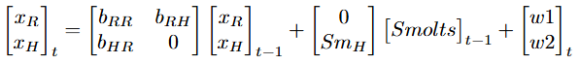
Of particular interest is the term b_{RH}, which describes the effect of fish returning to SJH in year t-1 on the abundance of fish returning to the Indian River in year t. Observation error is site specific, while process error is shared by both states (river and hatchery returners) due to fish encountering the same conditions throughout their lifespan at sea as well as the same commercial fishing effort upon their return.
Results
Regional Abundance
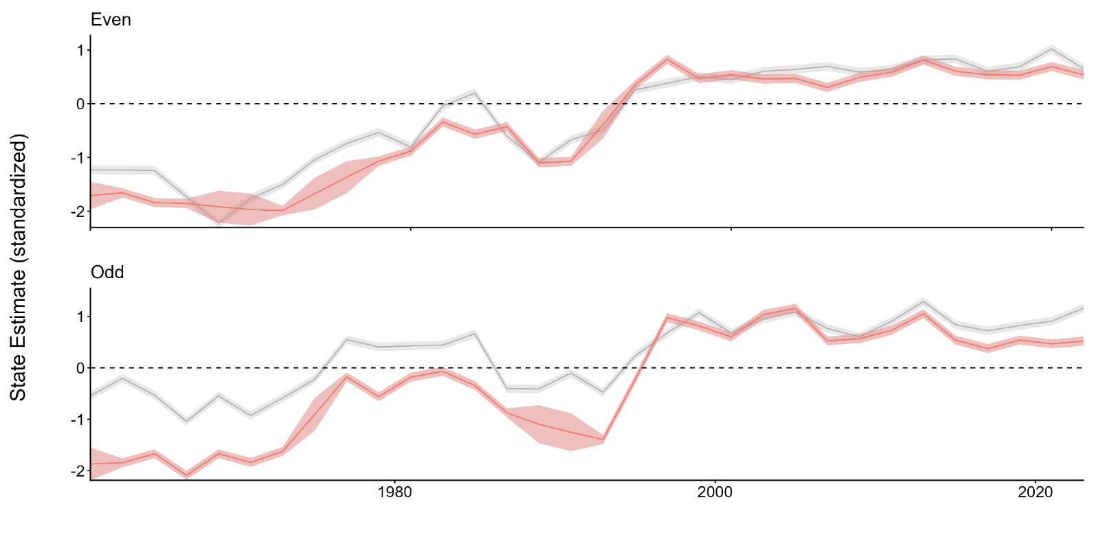

Figure 3: MARSS model results estimating the underlying states of even- and odd-year pink salmon abundance at Indian River (highlighted in pink) and throughout ‘north southeast (outside)’ region (grey). Abundance estimates are scaled by stream length and z-standardized at the stream level.

For both even- and odd-year runs, Indian River abundances at the beginning of the time series fall below what might be expected relative to the wider region. Even-year Indian River abundance in 1960 was estimated to be 0.476 standard deviations lower than the regional average, while odd-year Indian River abundance in 1961 was estimated to be 1.326 standard deviations lower. Over the course of the time series, Indian River abundances for both runs “catch-up” to what would be expected of an average pink salmon index stream, although odd-year Indian River runs take some time to accomplish this and do not exceed the statistical average until 1997. From the middle 1990s onward, both Indian River runs are closely aligned with the average index stream, exceeding the average in some years and falling short in others, but in either case not by an amount that appears drastic when visually appraised (Figure 3).

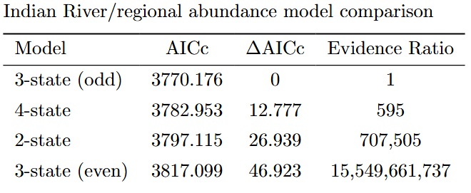
Table 1: Comparison of multi-state model specifications.

Pink salmon abundances observed in recent years at Indian River do not seem to deviate wildly from the regional average. However, plotting these time series is not enough to conclusively state that abundances at Indian River do not differ from those that would be expected of an average pink salmon index stream in the region in a statistically significant way. The best fit model allows includes a separate underlying state of Indian River pink salmon abundance in odd years, while estimating a single underlying state of pink salmon abundance throughout the region (including Indian River) in even years (Table 1). The difference in AICc of 12.777 between this model and the model with the second best fit (which allows for both even- and odd-year Indian River pink salmon abundance to be estimated as separate from regional abundances) means that, given the available data, this model can be said to be best with 99.84% confidence (Mazerolle 2006). Model specifications which estimated a single state of odd-year pink salmon abundance throughout the region performed abysmally by this standard, with infinitesimally small likelihoods of best fit. These findings suggest a scenario in which even-year pink salmon abundances at Indian River are very much in line with those that might be expected of an average stream in the north southeast (outside) region, while odd-year Indian River abundances differ significantly, appearing to fall below regional expectations throughout much of the time series (Figure 3).

Effect of Hatchery Operations
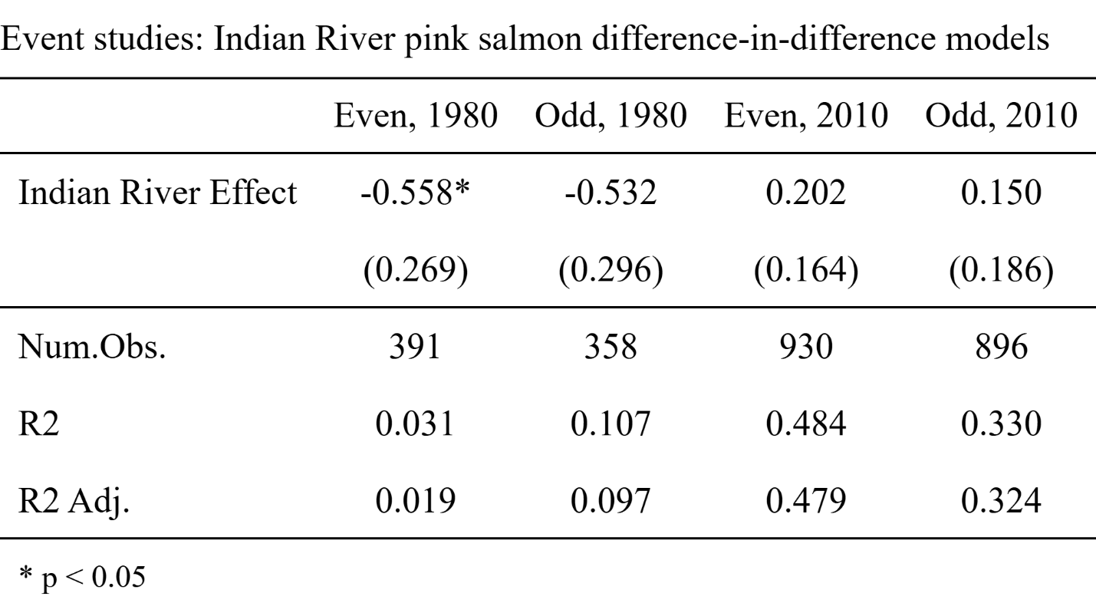
Table 2: Event studies evaluating the effect of Indian River on pink salmon abundances during pre-treatment periods. Standard errors reported in parentheses.

Difference-in-difference models for even- and odd-year runs considering post-1980 and post-2010 treatment periods were specified, with suites of covariate data relating to observers and ocean climate evaluated for best fit. To ensure the parallel trends assumption holds, the effect of Indian River in the pre-treatment period is estimated in all four models (Table 2). For even-year runs there exists some significant difference between trends at Indian River and elsewhere in the region prior to 1980. Due to this difference, a synthetic control group time series was constructed for comparison with the treatment group. All other models satisfy the parallel trends assumption.
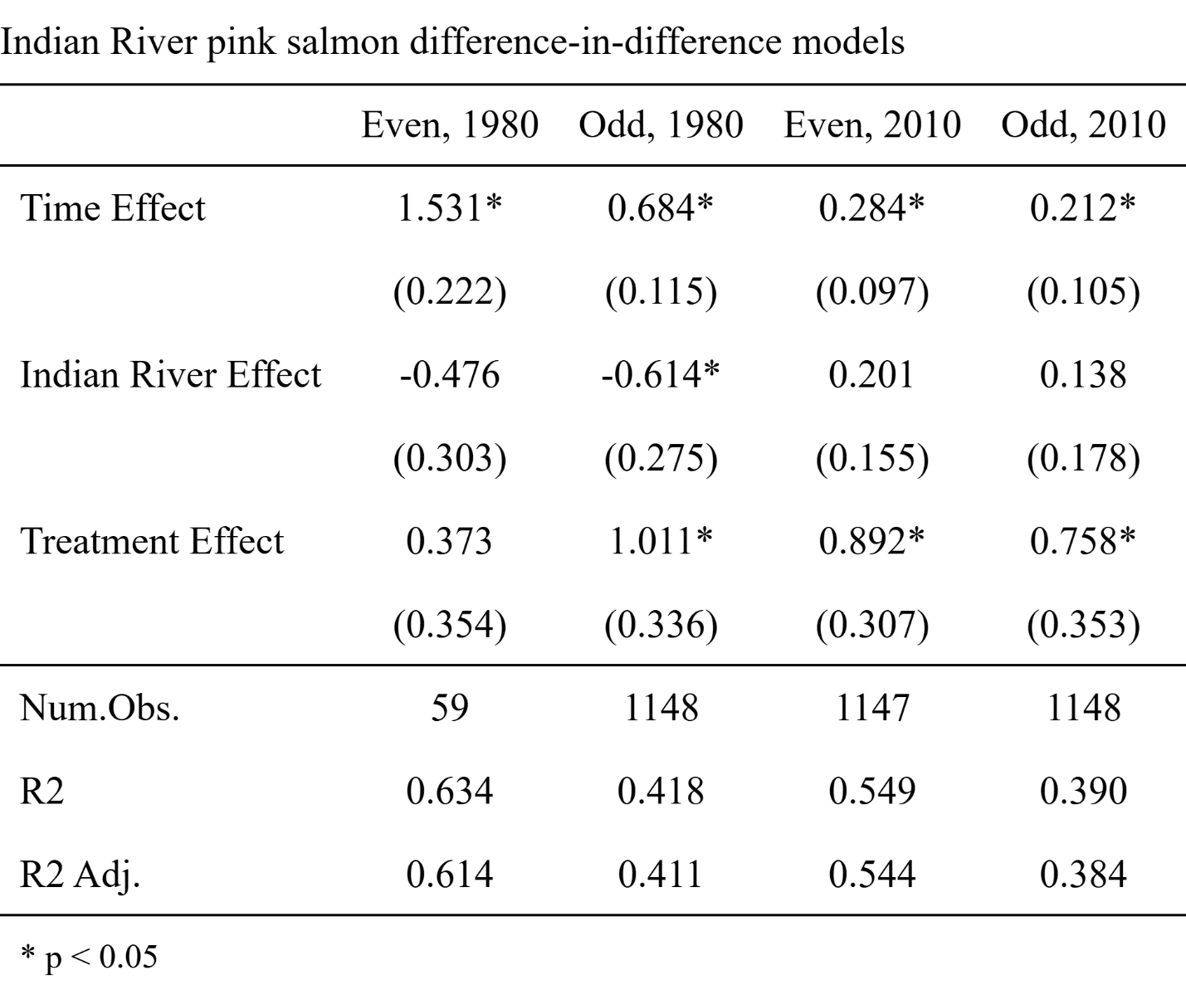

Table 3: Difference-in-difference results estimating the impact of Sheldon Jackson Hatchery operations on Indian River pink salmon abundances. Standard errors reported in parentheses.

The commencement of SJH operations in 1980 is shown to have driven a significant increase in odd-year pink salmon abundances at Indian River, while no significant impact is found affecting even-year runs. The expansion of permitted pink salmon releases from 1 million to 3 million in 2010 is shown to have driven significant increases in both even- and odd-year abundances (Table 3). The difference in time periods (pre- and post-1980, and pre- and post-2010) is found to be a significant driver of pink salmon abundances both at Indian River and throughout the north southeast (outside) region. This result is consistent with trends seen in ADFG’s survey data (Figure 2), as well as with the underlying states of pink salmon abundance estimated through MARSS modeling (Figure 3).

Effect of Hatchery Releases
The range of interaction effects of brood year t-1 on brood year t are found to be positive for both runs (Figure 4). The average effect of prior brood year hatchery returns on current brood year Indian River abundance, the parameter of greatest interest, was positive for both even- and odd-year runs, although this was the smallest of the three effects observed for each run, with point estimates of 0.089 and 0.04 respectively. In both cases enough parameter estimates fell below zero to diminish statistical confidence in the result, but in both cases a majority of bootstrapped parameter estimates were positive (94.2% in even-year runs, and 92% in odd-year runs). Not surprisingly the river shows a significant positive effect on itself for both odd- and even-year runs, with point estimates of 0.92 in even years and 0.96 in odd years. Both even- and odd-year hatchery returns are also significantly influenced by prior brood year Indian River abundances, with the model finding respective point estimates of 0.631 and 0.311. While the effect of prior brood year Indian River abundances on current brood year hatchery returns is stronger for both runs than its inverse, it is crucial to note that hatchery returns are greater than Indian River abundance much more often than not. This means that, despite the difference in
effect, the overall numbers of fish straying to a non-origin site could be roughly equal or even skewed towards hatchery-born fish returning to Indian River. In those brood years where Indian River abundances exceed hatchery returns, these effect sizes imply that the following brood year will see more fish from Indian River returning to the hatchery than vice versa.

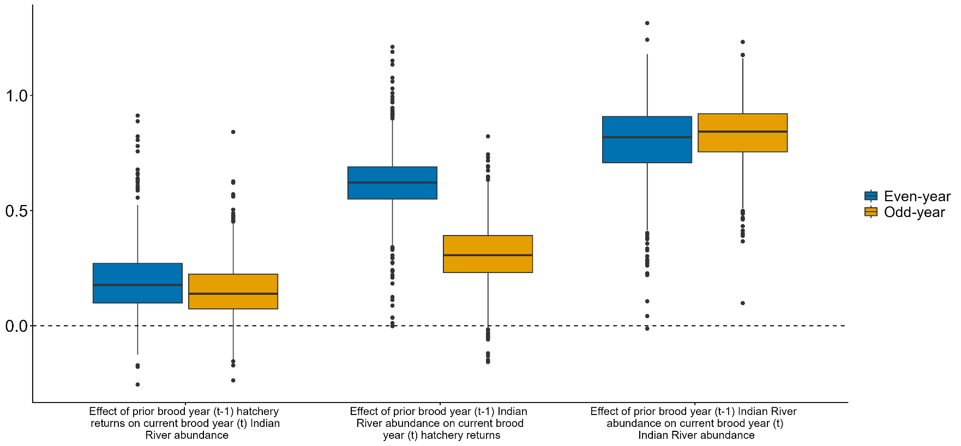

Figure 4: Estimated effect of brood year-to-brood year interactions between Indian River pink salmon runs and Sheldon Jackson Hatchery pink salmon releases

Discussion
Establishing at what point a species becomes overabundant in its native range is difficult, with extant literature on the subject diverging in how this determination is made (Lemoine et al. 2016, Moore et al. 2023, Holzner et al. 2025). As with Indian River pink salmon, often a species is not recognized as overabundant in its native range until such time as it begins to threaten other inhabitants of a shared ecosystem (Beckett et al. 2022, Brown et al. 2025). There is also distinct concern about the rapid growth in population of native species as a result of anthropogenic activity (although this is not necessarily a requisite for a species to be considered such), and is primarily focused on management of native species causing harm in ecosystems rather than assessment of the point at which a species might be considered overabundant (Brown et al. 2025, McComb et al. 2026).
Assessing whether a native species has exceeded some natural range of variation requires long term knowledge of a natural system, and determining whether overabundance of a native species might be driven by some anthropogenic intervention requires the consideration not only of that particular population in time, but also the consideration of relevant populations of the same species that have not been exposed to the same intervention (although this may not always be possible). In the case of pink salmon at Indian River, this task is made additionally complicated by the fact there two populations inhabiting the same environment (odd- and even-year runs) with potentially different life histories and characteristics. Pink salmon abundances are on the rise throughout their native range (likely due to warming sea surface temperatures observed in recent decades), and so if one seeks to determine whether high abundances observed at a particular site (like Indian River) falls outside a natural range of variation, it is important to consider the population dynamics of pristine sites throughout the neighboring region (Ruggerone and Irvine 2018). Given their shared heritage, the proximity of the origin sites (Figure 1), and the results of prior Indian River stray surveys, it is very likely that fish from SJH are making their way into Indian River as spawning adults (and vice vera), but it is also plausible that the primary driver of increased pink salmon abundances at Indian River is not SJH releases but the same factors driving increased abundances throughout the region (Gende and Carter 2015, Ruggerone et al. 2023).
While pink salmon densities observed at Indian River in recent decades are high compared to those that were recorded decades ago, more contemporary returns of adults to the Indian River in even years are largely in line with index streams in the surrounding region, whereas odd-year runs are not in line with broader regional patterns. The effect of hatchery releases on subsequent brood year Indian River abundances was not statistically significant for either run, but in both cases a convincing majority of bootstrapped parameter estimates were positive. Despite falling short of the 95% confidence threshold, it is worth considering the implications of a small but positive effect of hatchery releases on Indian River pink salmon abundance in the following brood year. For both runs, the effect of prior brood year Indian River abundances on current brood year hatchery returns is stronger than its inverse (Figure 4), but it is crucial to note that hatchery returns frequently exceed Indian River abundances, creating a situation wherein if there exists a small but positive effect of hatchery releases on subsequent brood year Indian River abundances, the overall numbers of fish straying to a non-origin site could be roughly equal or even skewed towards hatchery-born fish returning to Indian River. In those brood years where Indian River abundances exceed hatchery returns, these effect sizes imply that the following brood year will see more fish from Indian River returning to the hatchery than vice versa.
In even years, Indian River salmon are not out of the ordinary relative to the wider region. The commencement of hatchery operations was not associated with an increase in the numbers of spawning pink salmon at Indian River relative to the wider region, although the expansion of hatchery pink salmon releases in 2010 was associated a significant increase in Indian River abundances (Table 3). Indian River abundances were estimated to have a strong positive impact on pink salmon returning to the hatchery in the subsequent brood year, while an accompanying effect of hatchery releases on subsequent brood year Indian River abundances was estimated to be positive but fell short of statistical significance (Figure 4). Even if there exists a small but positive true effect of hatchery releases on subsequent brood year Indian River abundances in even-year runs, the difference between this effect and the effect of Indian River abundances on pink salmon returning to the hatchery in the subsequent brood year is large, meaning that even-year Indian River spawners would have to vastly outnumber hatchery releases in a given year in order for a net increase in Indian River abundance due to hatchery releases to occur in the following brood year. Taken together, these results imply there is little concern that even-year pink salmon abundances fall outside their natural range of variation at Indian River and indeed seem to be contributing to hatchery returns.
In odd years, the best fit model suggests that abundances at Indian River differ significantly from what would be expected of a similar stream in the region. Unlike even-year runs, both the 1980 commencement and 2010 expansion of hatchery operations are associated with significant increases in the numbers of pink salmon at Indian River, above and beyond what was happening elsewhere in the region during those periods. Like even-year runs, odd-year Indian River abundances had a significant effect on pink salmon returning to SJH in the subsequent brood year, as well as a positive effect of hatchery releases on subsequent brood year Indian River abundances that falls just short of statistical significance (Figure 4). It is worth noting that the gap between these effects is not so pronounced as in even-year runs, meaning that Indian River spawners would not have to heavily outnumber hatchery releases in a given year for a net increase in Indian River abundance due to hatchery releases to occur in the following brood year. While indications exist that odd-year pink salmon abundance at Indian River does not fall within the natural range of variation expected throughout the wider region, it is important to note that this difference may be due to the large differences between odd year time series observed in the first 30 years of the study period (Figure 3), which could suggest that SJH releases may not be a primary driver of this disparity. Indeed, it may be the case that hatchery origin pink salmon straying into the Indian River have bolstered in-river abundances in recent decades.
This work is intended first and foremost to provide management at SITK with a comprehensive description of both the impacts of SJH operations and of the population dynamics of pink salmon throughout the broader region. In even years, pink salmon abundances at Indian River are in line with those observed at ‘pristine’ index streams nearby. Thus, increases in their spawning densities are likely still within the natural range of variation. This is not to say that concerns about hypoxia events are invalid, but the possibility exists that interceding on behalf of Indian River’s other resident species may run contrary to the natural state of even-year pink salmon in northern Southeast Alaska. Available evidence suggests that there is likely no need for intervention to address even-year abundances. In odd years there exists more compelling evidence that SJH pink salmon releases could be exerting some influence over abundances at Indian River, although it may not be the most significant driver of high odd-year pink salmon population densities in odd years, as spawning abundances of these fish have been on the rise throughout the region for decades. Recall that in odd years, the effect of Indian River pink salmon abundance on hatchery returns in the subsequent brood year is lower than the effect observed in even years. If there exists some small but positive true effect of hatchery releases on subsequent brood year Indian River abundances, the difference between the magnitude of these effects in odd years would be far less than in even-years, meaning that odd-year Indian River abundances would be more susceptible to being inflated by hatchery releases. It is possible that limiting the number of SJH pink salmon moving into Indian River to spawn in odd years may be beneficial for maintaining the wild population in the park within their natural range of variation, but this is far from conclusive, and suggests the need for more consistent otolith sampling of odd-year Indian River spawners in order to more completely understand the impact of SJH releases.
Indian River pink salmon are not dissimilar to the case of the mountain pine beetle discussed in the introduction, the proliferation of which was not unique to the impacted National Parks, but which the affected parks nevertheless were compelled to address through interventions, such as insecticide use and the culling of susceptible trees (Frost 2009). Likewise, management at SITK may choose to address the proliferation of pink salmon at Indian River, even if it is largely in-line with regional expectations, to protect other resident aquatic species and the riverine ecosystem from hypoxia events.
Acknowledgements

The work presented would not have been possible without support from Sitka National Historical Park management and biologists. Mary Miller, Olivia Magni, Jordan Tanguay, and Zachary Jones have provided substantial guidance in understanding the ecological and cultural history of the park and its neighbors. Lauren Bell, Bill Coltharp, and Haley Jenkins of the Sitka Sound Science Center have likewise offered invaluable perspectives and background regarding the history and current state of hatchery operations. Finally, collaboration from Alaska Department of Fish and Game biologists Aaron Dupuis and Justin Priest has enabled this work to compare Indian River pink salmon abundances to those seen elsewhere in the vicinity of Sitka, a vital component of this research. This research has occurred on the ancestral homeland and with the approval of the Sitka Tribe of Alaska.

References
Alaska Department of Fish and Game. 2024a. Commercial Salmon Fisheries – Southeast Alaska & Yakutat Research: Pink Salmon. Available at: https://www.adfg.alaska.gov/index.cfm?adfg=commercialbyareasoutheast.salmon_research_pink (accessed December 14, 2024)
Alaska Department of Fish and Game. 2024b. Mark Recovery Laboratory – Otolith Marking. Available at: https://mtalab.adfg.alaska.gov/OTO/marking.aspx (accessed December 14, 2024)
Anderson, J. H., G. R. Pess, R. W. Carmichael, M. J. Ford, T. D. Cooney, C. M. Baldwin, and M. M. McClure. 2014. Planning Pacific Salmon and Steelhead Reintroductions Aimed at Long-Term Viability and Recovery. North American Journal of Fisheries Management 34: 72-93.
Beckett, K., E. Elle, C. Kremen, A. Sherwood, S. McComb, and T. G. Martin. 2022. Hyperabundant black-tailed deer impact endangered Garry oak ecosystem floral and bumblebee communities. Global Ecology and Conservation 38: 14pp.
Berejikian, B. A., M. J. Malick, J. Lee-Waltermire, M. R. Downen, K. K. Shelby, R. Endicott, and A. Batista. 2025. Conservation hatchery effects on the abundance and spawn timing of natural steelhead populations: a replicated before-after-control-impact experiment in the Hood Canal watershed. Canadian Journal of Fisheries and Aquatic Sciences 82: 1-16.
Brown, S. K., A. R. McIntosh, Z. B. Hamilton, and H. J. Warburton. 2025. Overlooked and underestimated: reframing restoration to include inconspicuous native invaders. Restoration Ecology 33(8): 7pp.
Burnham, K. P., and D. R. Anderson. 2002. Model selection and multimodel inference: A practical information-theoretic approach, 2nd ed. Springer-Verlag, 488 pp.
Burnham, K. P., D. R. Anderson, and K. P. Huyvaert. 2010. AIC model selection and multimodal interference in behavioral ecology: some background, observations, and comparisons. Behavioral Ecology and Sociobiology 65: 23-35.
Carey, M. P., B. L. Sanderson, K. A. Barnas, and J. D. Olden. 2012. Native invaders – challenges for science, management, policy, and society. Frontiers in Ecology and the Environment 10(7): 373-381.
Cunningham, S. 2021. Causal Inference: The Mixtape. Yale University Press, 352 pp.
del Monte-Luna, P., B. W. Brook, M. J. Zetina-Rejón, and V. H. Cruz-Escalona. 2004. The carrying capacity of ecosystems. Global Ecology and Biogeography 13: 485-495.
Ellison, A. M., M. S. Bank, B. D. Clinton, E. A. Colburn, K. Elliott, C. R. Ford, D. R. Foster, B. D. Kloeppel, J. D. Knoepp, G. M. Lovett, J. Mohan, D. A. Orwig, N. L. Rodenhouse, W. V. Sobczak, K. A. Stinson, J. K. Stone, C. M. Swan, J. Thompson, B. von Holle, and J. R. Webster. 2005. Loss of foundation species: consequences for the structure and dynamics of forested ecosystems. Frontiers in Ecology and the Environment 3(9): 479-486.
Estes, J. A. 2015. Natural History, Ecology, and the Conservation and Management of Sea Otters. Edited by Shawn Larson. Sea Otter Conservation 35-60. Academic Press.
Frost, H. C. 2009. Testimony regarding mountain pine beetles: Strategies for protecting the West (Oral testimony before the House Natural Resources Committee, Subcommittees on Water and Power and National Parks, Forests, and Public Lands). U.S. Department of the Interior. Available at: https://www.doi.gov/ocl/hearings/111/MountainPineBeetle_061609 (accessed March 20, 2026)
Gende, S. and B. Carter. 2015. Straying rates of pink salmon into the Indian River, Sitka National Historical Park. Final Report – ADF&G Permit # SF2015-225. National Park Service, 11 pp.
Gibson, K., K. Skov, S. Kegley, C. Jorgensen, S. Smith, and J. Witcosky. 2008. Mountain Pine Beetle Impacts in High-Elevation Five-Needle Pines: Current Trends and Challenges. USDA Forest Service – Forest Health Protection, 40 pp.
Gallardo, B., M. Clavero, M. I. Sánchez, and M. Vilà. 2015. Global ecological impacts of invasive species in aquatic ecosystems. Global Change Biology 22(1): 151-163.
Heard, W. R. 1991. Life History of Pink Salmon (Oncorhynchus gorbuscha). Edited by Groot, C. and L. Margolis. Pacific Salmon Life Histories 119-231. UBC Press.
Holmes, E. E., E. J. Ward, and K. Wills. 2012. MARSS: Multivariate Autoregressive State-space Models for Analyzing Time-series Data. The R Journal 4(1): 11-19.
Holzner, A., N. Ruppert, K. Ilham, S. S. K. Kaburu, A. L. K. Liston, A. Fuentes, and M. F. Hansen. 2025. Threatened synanthropes depend on intact forests: a critical evaluation of Moore et al. (2023). Biological Reviews 100: 1444-1451.
Jeschke, J. M., S. Bacher, T. M. Blackburn, J. T. A. Dick, F. Essl, T. Evans, M. Gaertner, P. E. Hulme, I. Kühn, A. Mrugala, J. Pergi, P. Pysek, W. Rabitsch, A. Ricciardi, D. M. Richardson, A. Sendek, M. Vilà, M. Winter, and S. Kumschick. 2014. Defining the Impact of Non-Native Species. Conservation Biology 28(5): 1188-1194.
Knudsen, E. E., P. S. Rand, K. B. Gorman, D. R. Bernard, and W. D. Templin. 2021. Hatchery-origin stray rates and total run characteristics for Pink Salmon and Chum Salmon returning to Prince William Sound, Alaska in 2013-2015. Marine and Coastal Fisheries 13(1): 41-68.
Lemoine, N. P., D. E. Burkepile, and J. D. Parker. 2016. Quantifying Differences Between Native and Introduced Species. Trends in Ecology & Evolution 31(5): 372-381.
Levin, P. S., and N. Tolimieri. 2001. Differences in the impacts of dams on the dynamics of salmon populations. Animal Conservation 4(4): 291-299.
Manhard, C. V., J. E. Joyce, W. W. Smoker, and A. J. Gharrett. 2017. Ecological factors influencing lifetime productivity of pink salmon (Oncorhynchus gorbuscha) in an Alaskan stream. Canadian Journal of Fisheries and Aquatic Sciences 74(9): 1325-1336.
Mantua, N. J., S. R. Hare, Y. Zhang, J. M. Wallace, and R. C. Francis. A Pacific Interdecadal Climate Oscillation with Impacts on Salmon Production. Bulletin of the American Meteorological Society 78(6): 1069-1079.
May, S. A., K. R. Shedd, K. M. Gruenthal, J. J. Hard, W. D. Templin, C. D. Waters, M. D. Adkison, E. J. Ward, C. Habicht, L. I. Wilson, A. C. Wertheimer, and P. A. H. Westley. 2024. Salmon hatchery strays can demographically boost wild populations at the cost of diversity: quantitative genetic modelling of Alaska pink salmon. Royal Society Open Science 11(7): 18pp.
Mazerolle, M. 2006. Improving data analysis in herpetology: using Akaike’s Information Criterion (AIC) to assess the strength of biological hypotheses. Amphibia-Reptilia 27: 169-180.
McComb, S., K. Beckett, T. Akerman, P. Arcese, D. Bedford, P. Dunwiddie, J. T. Fisher, T. Golumbia, E. K. Gonzales, R. Irvine, A. James, E. S. Long, J. Martin, S. Michel, W. Pelkey, T. Sylvester, S. Thomas, N. Thomas, and T. G. Martin. 2026. Decision analysis rooted in Indigenous and Western scientific knowledge identifies cost-effective strategies for managing hyperabundant deer to restore keystone places. People and Nature 8(1): 4-20.
McMillan, J. R., B. Morrison, N. Chambers, G. Ruggerone, L. Bernatchez, J. Stanford, and H. Neville. 2023. A global synthesis of peer-reviewed research on the effects of hatchery salmonids on wild salmonids. Fisheries Management and Ecology 30(5): 446-463.
McNeil, W. J. 1964. Redd Superimposition and Egg Capacity of Pink Salmon Spawning Beds. Journal of the Fisheries Board of Canada 21(6): 1385-1396.
Miller, K. M., S. J. Perles, J. P. Schmit, E. R. Matthews, A. S. Weed, J. A. Comiskey, M. R. Marshall, P. Nelson, and N. A. Fisichelli. 2023. Overabundant deer and invasive plants drive widespread regeneration debt in eastern United States national parks. Ecological Applications 33: 24pp.
Moore, J. H., L. Gibson, Z. Amir, W. Chanthorn, A. H. Ahmad, P. A. Jansen, C. P. Mendes, M. Onuma, C. A. Peres, and M. S. Luskin. 2023. The rise of hyperabundant native generalists threatens both humans and nature. Biological Reviews 98(5): 1829-1844.
National Park Service. 2023. Reducing deer numbers and removing invasive plants are key to long term forest health. Available at: https://www.nps.gov/cato/learn/news/reducing-deer-numbers-and-removing-invasive-plants-are-key-to-long-term-forest-health.htm (accessed March 17, 2026)
National Park Service. 2025a. Organic Act of 1916. Available at: https://www.nps.gov/grba/learn/management/organic-act-of-1916.htm (accessed March 27, 2025)
National Park Service. 2025b. Sitka National Historical Park. Available at: https://www.nps.gov/sitk/index.htm (accessed March 18, 2025)
Pearsons, T. N., and T. W. Hillman. 2025. Costs and benefits of a multi-generation captive broodstock Chinook Salmon hatchery program. North American Journal of Fisheries Management 45:402-419.
Quinn, T. P. 2018. The Behavior and Ecology of Pacific Salmon and Trout, Second Edition. University of Washington Press, 547 pp.
Ruggerone, G. T., and J. R. Irvine. 2018. Numbers and Biomass of Natural- and Hatchery-Origin Pink Salmon, Chum Salmon, and Sockeye Salmon in the North Pacific Ocean, 1925-2015. Marine and Coastal Fisheries 10(2): 152-168.
Ruggerone, G. T., A. M. Springer, G. B. van Vliet, B. Connors, J. R. Irvine, L. D. Shaul, M. R. Sloat, and W. I. Atlas. 2023. From diatoms to killer whales: impacts of pink salmon on North Pacific ecosystems. Marine Ecology Progress Series 719: 1-40.
Sambaraju, K. R. and D. W. Goodman. 2021. Mountain pine beetle: an example of a climate-driven eruptive insect impacting conifer forest ecosystems. CABI Reviews: 18pp.
Scheuerell, M. D., E. R. Buhle, B. X. Semmens, M. J. Ford, T. Cooney, and R. W. Carmichael. 2015. Analyzing large-scale conservation interventions with Bayesian hierarchical models: a case study of supplementing threated Pacific salmon. Ecology and Evolution 5(10): 2115-2125.
Sergeant, C. J., J. R. Bellmore, C. McConnell, and J. W. Moore. 2017. High salmon density and low discharge create periodic hypoxia in coastal rivers. Ecosphere 8(6): 16pp.
Sergeant, C. J., J. R. Bellmore, R. A. Bellmore, J. A. Falke, F. J. Mueter, and P. A. H. Westley. 2023. Hypoxia vulnerability in the salmon watersheds of Southeast Alaska. Science of the Total Environment 896: 12pp.
Stopha, M. 2015. An Evaluation of the Sheldon Jackson Salmon Hatchery for Consistency with Statewide Policies and Prescribed Management Practices. Alaska Department of Fish and Game, Division of Commercial Fisheries, 42 pp.
Thornton, T. F. 1998. Traditional Tlingit Use of Sitka National Historical Park. National Park Service, 170 pp.
Tillotson, M. D. and T. P. Quinn. 2017. Climate and conspecific density trigger pre-spawning mortality in sockeye salmon (Oncorhynchus nerka). Fisheries Research 188: 138-148.
Valéry, L., H. Fritz, and J. C. Lefeuvre. 2013. Another call for the end of invasion biology. Oikos 122: 1143-1146.
Van Alen, B. W. 2000. Status and Stewardship of Salmon Stocks in Southeast Alaska. In E. E. Knudsen, Steward, C. R., MacDonald, D. D., Williams, J. E., Reiser, D. W. Sustainable Fisheries Managemnt – Pacific Salmon, 161-193. Lewis Publishers.

