Hyperabundance of a native species: Pink Salmon in Sitka National Historical Park

Brian McGreal
Quantitative Ecology and Resource Management
University of Washington
Seattle, WA

Scott M. Gende
U.S. National Park Service
Alaska Regional Office
Juneau, AK

Mark D. Scheuerell
U.S. Geological Survey, Washington Cooperative Fish and Wildlife Research Unit
School of Aquatic and Fishery Sciences
University of Washington
Seattle, WA

Thomas P. Quinn
School of Aquatic and Fishery Sciences
University of Washington
Seattle, WA

Hyperabundance of native species within their natural range can pose challenges for management. Whether due to direct human influence on their environments or indirect influence through shifting climate regimes, hyperabundance of native species can be as perilous to an ecosystem as incursion from an invasive species. This study examines the case of pink salmon (Oncorhynchus gorbuscha) in Sitka National Historical Park’s Indian River. Though native to the river, pink salmon have seen exponentially increasing numbers of fish returning to spawn in late summer in recent decades on the biennial (i.e., odd and even numbered year) cycles characteristic of the species. These potentially hyperabundant runs create the risk of hypoxia events, putting fish and other resident species reliant on the river at risk. The U.S. National Park Service mandates the maintenance of population densities such as they would occur within a “natural range of variation,” meaning the potential hyperabundance of pink salmon may prompt the need for management action. A nearby hatchery, which releases 3 million pink salmon fry each year, may be contributing to the abundance of pink salmon in Indian River. Using pink salmon escapement data collected by the Alaska Department of Fish and Game, this study determined whether the increased numbers of pink salmon observed at Indian River are typical of trends in the wider region (i.e., the natural range of variation), or whether hatchery operations may be contributing to or causing the recent hyperabundance. State-space models indicated that odd-year runs of pink salmon at Indian River diverged significantly from regional expectations, although conclusive evidence that this divergence is driven by hatchery releases is not clear. Even-year runs did not display the same divergence in abundance and were consistent with pink salmon abundances elsewhere in the region.
Introduction
Conservation issues related to individual species are often the result of the scarcity of native plant or animal species or the abundance of non-native (exotic, invasive) species (Ellison et al. 2005, Gallardo et al. 2015, Jeschke et al. 2014). However, ecosystems can also be harmed by the hyperabundance of a native species, due either to shifting regional trends in habitat suitability, to direct (and often anthropogenic) intervention, or to a combination of these factors (Sambaraju and Goodsman 2021, Beckett et al. 2022, Moore et al. 2023). Hyperabundance of native purple sea urchin (Strongylocentrotus purpuratus) in the northern Pacific Ocean, driven by the depletion of Pacific sea otter (Enhydra lutris) populations by the maritime fur trade, has led to the devastation of kelp (Macrocystis pyrifera) forests, critical ecosystems upon which countless marine species depend (Estes 2015). The mountain pine beetle (Dendroctonus ponderosae), another hyperabundant species, has caused catastrophic destruction of coniferous forests throughout its native range, the Rocky Mountains. While in the past cold winter temperatures had limited their numbers and, by extension, their impacts on Rocky Mountain forests, shifting climate patterns have led to warmer winters and longer summers, allowing the mountain pine beetle to flourish and in turn devastate large swathes of forest habitat in Canada and the US (Gibson et al. 2008).
When a native species hyperabundance occurs within a conservation area, it may necessitate management actions to protect other species within the ecosystem. For example, the United States National Park Service (NPS) has operated under a mandate to “steward NPS resources for continuous change that is not yet fully understood, in order to preserve ecological integrity …” (Colwell et al. 2012). For natural resources, particularly those that vary in space and time, the NPS management target has historically been to maintain abundances within a ‘natural range of variation’ (National Park Service 2025a), but the point at which the abundance of an endemic species exceeds the natural range of variation, thereby triggering a need for management action, can be difficult to ascertain. Park managers finding themselves confronted with such issues must make careful and informed decisions based on the best scientific information available as they seek to interpret and implement the mandate to preserve resources in a natural condition. Hyperabundant native species are not given anywhere near the same attention as invasive species in scientific literature, and identifying these instances as they occur is challenging (Valéry et al. 2013). While information regarding historical presence, abundance, or range of a species is useful when available, these data are often non-existent or lacking (Carey et al. 2012).
With these ideas in mind, our research is focused on pink salmon (Oncorhynchus gorbuscha) in Sitka National Historical Park (SITK), populations of which have undergone dramatic increases in density in recent decades. SITK is a small (45 ha) coastal park in Sitka, Alaska, characterized by mature spruce-hemlock forests and the Indian River, the main reach and intertidal area of which fall within park boundaries (National Park Service 2025b). Since time immemorial, the Indian River (Kaasda Héen in Tlingit) has been the location of a fishing camp and harvesting site for the Kiks.ádi clan, and particularly valued for its close proximity to the clan’s winter villages, as well as for hosting runs of a variety of Pacific salmon species, including chum (O. keta), coho (O. kisutch), Chinook (O. tshawytscha), and pink salmon (Thornton 1998). Originally designated a National Monument in 1910 for the purpose of conserving the site of an 1804 battle between the native Tlingit Kiks.ádi clan and Russian colonizers, today the park is managed to preserve not only the historical battleground, but the ecosystems and natural resources present in the surrounding area.
Although pink salmon have historically been the most abundant salmon species at Indian River, their numbers have increased rapidly in the last 30 years. The Alaska Department of Fish and Game (ADFG) peak escapement surveys have estimated that, since 1980, Indian River pink salmon abundance has increased from run of several thousand to runs regularly exceeding 100,000 fish annually (Stopha 2015). Increases in Indian River pink salmon abundance, initially observed in the 1980s, coincided with the commencement of operations at Sheldon Jackson Hatchery (SJH), a pink salmon hatchery located approximately 1 km from the mouth of the Indian River (Figure 1). Currently operated by the not-for-profit Sitka Sound Science Center, the hatchery was originally established in 1975 by Sheldon Jackson College, with the initial broodstock sourced from pink salmon at the Indian River (even years) and nearby Starrigavan Creek (odd years). Indian River water is diverted upriver of SITK’s boundaries to maintain hatchery operations. This water is used to rear salmon fry, which imprint on its distinct chemical signature, and during spawning season this diverted Indian River water is released into the bay near the hatchery to attract returning fish. The hatchery was initially permitted to spawn 1 million pink salmon eggs each year, but that was increased to 3 million eggs in 2010, with most hatchery-reared embryos surviving to be released as fry to the ocean (Stopha 2015).
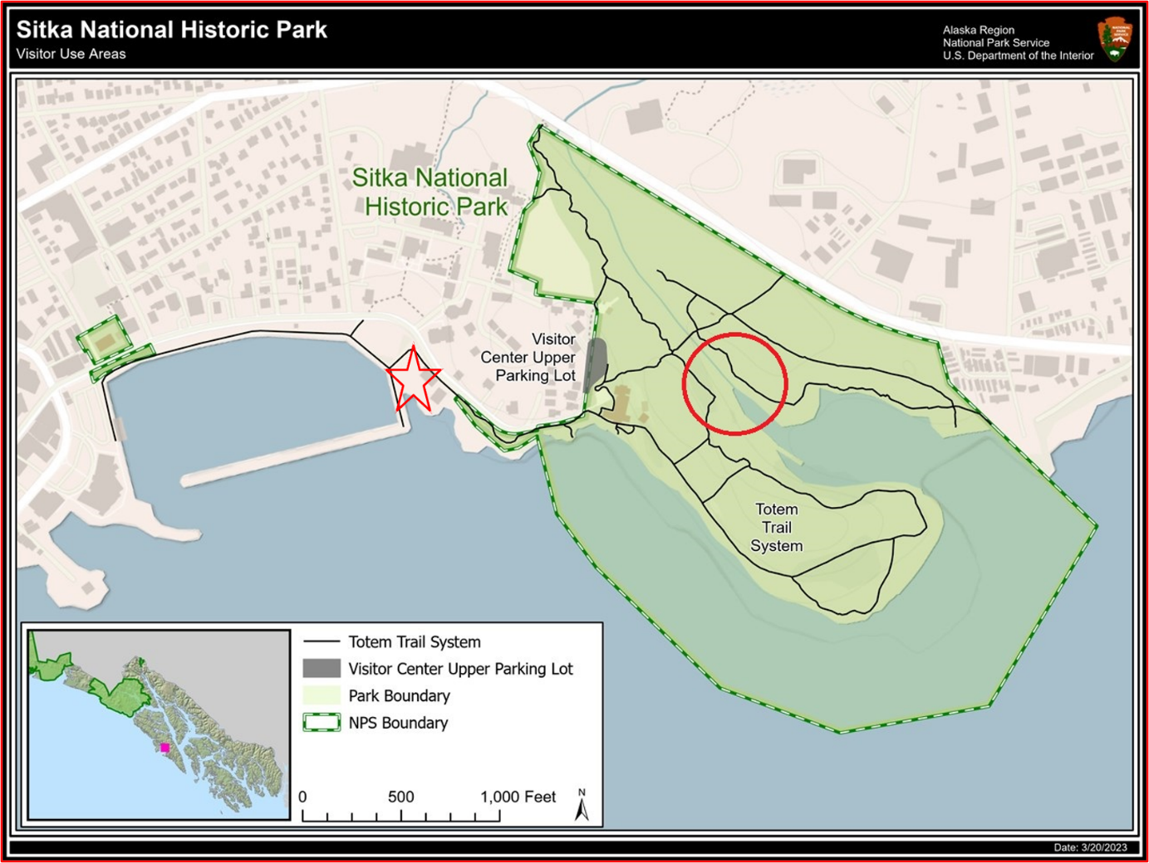

Figure 1: Location of Sheldon Jackson Hatchery (red star) and the mouth of the Indian River (red circle) in Sitka. The two highlighted points are approximately 1,650 ft (503m) apart. Credit: National Park Service, modified to include river mouth and hatchery location.

If all pink salmon reared at the hatchery returned to the hatchery, the population dynamics of salmon in the Indian River would be unaffected by hatchery operations. However, homing by salmon is imperfect and has adaptive value (Quinn 2018). It has been shown that both the purposeful and incidental introduction of hatchery salmon into streams with native populations can contribute to increased abundances (Anderson et al. 2014, McMillan et al. 2023, May et al. 2024). Evidence suggests that the Indian River is no exception, and indeed it is possible that the Indian River sees higher than average levels of straying due to the proximity of SJH and the hatchery fish being reared in Indian River water. All pink salmon released by SJH are subject to otolith marking, and survey efforts at Indian River have at times found stray pink salmon from Sheldon Jackson Hatchery making up one third of all individuals sampled in a year, although the rates of straying observed vary considerably (Gende and Carter 2015, Stopha 2015, Alaska Department of Fish and Game 2024b).
The possibility that pink salmon being reared and released by Sheldon Jackson hatchery may be contributing to the high abundances of fish observed at the Indian River in recent decades cannot be ignored. However, it is also critical to note that these high densities may be naturally occurring phenomena, influenced by variation in stream conditions, ocean productivity, predation intensity, and commercial harvests, among other factors (Manhard et al. 2017). ADFG conducts regular monitoring of pink salmon index streams throughout southeast Alaska for the primary purpose of managing the commercial fishery, selected specifically to reflect natural conditions and a lack of undue anthropogenic influences. This extensive monitoring effort provides a regional backdrop against which abundances observed at Indian River may be compared. Between 1960 and 2023, pink salmon escapement has increased throughout what ADFG designates as the ‘Northern Southeast (Outside)’ region (in which the Indian River is located). The agency has recorded peak pink salmon escapement annually at 35 index streams in this region, and at Indian River as well (albeit with gaps in the time series). Along with other streams in the region, Indian River has seen an increase in peak escapement over the period of observation (Figure 2).
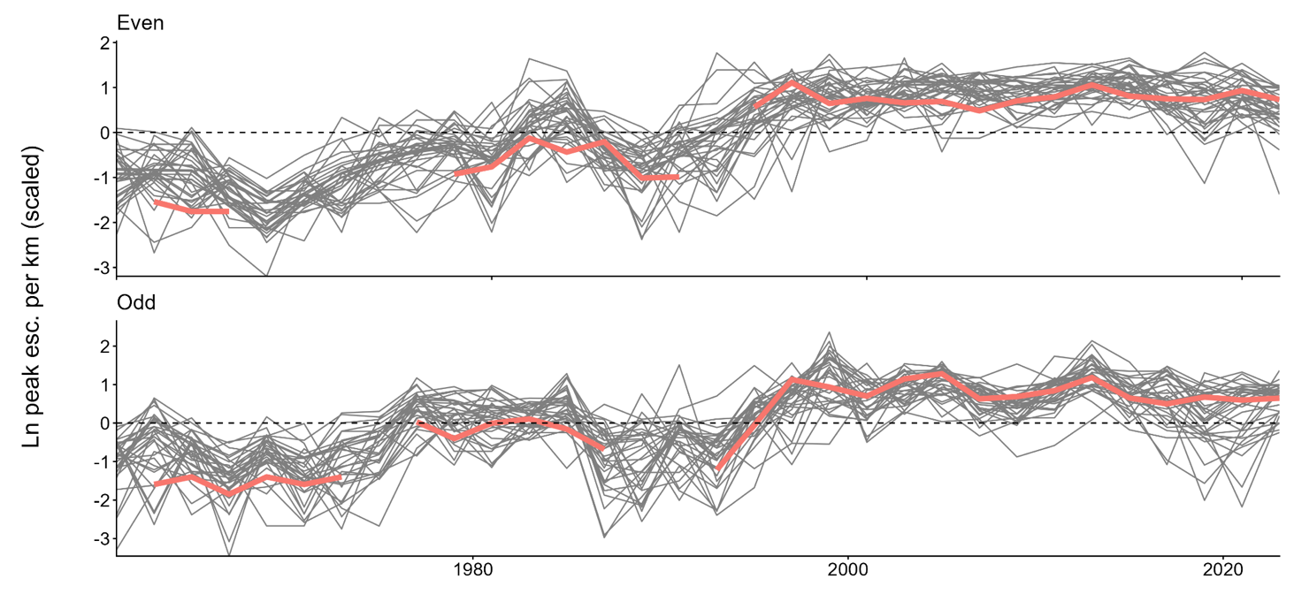

Figure 2: Even- and odd-year peak pink salmon escapement from 1960 to 2022 in Indian River and 35 index streams across ADFG’s designated Northern Southeast (Outside) region. Indian River counts highlighted. Spawner counts are scaled against stream length (km), then log transformed and standardized at the level of each stream.

High abundances of salmon are concerning to park managers due to their potential to contribute to hypoxic aquatic conditions. When a large run coincides with low stream flows and warm temperatures, dissolved oxygen concentrations may be diminished through both direct consumption of oxygen by living fish and the respiration of microbes decomposing their carcasses, with severe hypoxia events capable of compromising a stream’s ability to sustain other resident fish species (Murphy 1985, Sergeant et al. 2023). High salmon densities occur naturally across the Pacific Rim, and incidences of high densities contributing to depleted in stream oxygen levels have been recorded throughout southeast Alaska (Murphy 1985). In such an instance, females may die before spawning due to lowered oxygen levels (Sergeant et al. 2017, Tillotson and Quinn 2017). In this scenario, the numbers of spawners returning in subsequent years would be constrained, a constraint which could weaken with the introduction of straying fish from hatcheries.
My research seeks to assess whether the abundances of pink salmon observed in recent decades at Indian River exist within a natural range of variation relative to pink salmon streams elsewhere in the region, and to evaluate if and to what extent Sheldon Jackson Hatchery operations have driven increasing abundance since 1980. This is accomplished by evaluating three hypotheses. 1) Pink salmon population dynamics at Indian River are separate from those observed at ADFG index streams in the region. A state-space model which specifies pink salmon abundance at Indian River as separate from pink salmon abundance elsewhere in the region will better fit available data than a model which does not make this distinction. 2) The 1975 commencement and/or 2010 expansion of hatchery operations has had some measurable impact on Indian River pink salmon population densities. A difference-in-difference analysis will estimate a significant effect of treatment. And 3) the number of pink salmon juveniles released by SJH in brood year t-1 is impacting pink salmon abundance observed at Indian River in brood year t. An autoregressive model will estimate this “cross effect” as significant. Each of these approaches is discussed in greater detail in the following section.

Methods
Data
ADFG conducts annual aerial surveys of approximately 700 streams in southeast Alaska to monitor pink salmon escapement (Van Alen 2000). These streams, referred to by ADFG as index streams, are chosen because they are believed to reflect the natural condition of pink salmon populations in the region. Index streams are grouped into three sub-regions: south southeast, north southeast (inside), and north southeast (outside). The last group is composed of 35 streams in the vicinity of Sitka and the Indian River along the ocean-facing coasts of Baranof and Chichagof islands and a few smaller islands in the area. Surveys are conducted via fixed-wing aircraft throughout the late summer pink salmon spawning season, with the name of the biologist conducting the survey recorded in about 75% of observations. A subset of these stream surveys is subject to validation by foot counts which are used to assess the accuracy of ADFG’s aerial survey efforts. Survey data used in this study cover the period from 1960 to 2023. Due to the proximity of SJH and the accompanying potential of hatchery fish to affect wild fish abundance estimates, the Indian River is not one of ADFG’s index streams. Nonetheless, ADFG has often monitored pink salmon escapement in the stream to provide the most complete data possible on pink salmon in the region. Data are available from Indian River from 1962-67, 1969, 1971-73, 1977-88, 1990, and from 1993-2023 (n = 54 annual observations) (A. Dupuis, Alaska Department of Fish and Game, personal communication, August 19, 2024). Annual reports from Sheldon Jackson Hatchery are available from 1975 onwards, commensurate with the establishment of the hatchery. These reports include the number of juvenile salmon released each year, estimates of the number of hatchery-raised adult salmon which survive the marine environment, and numbers of adult fish which return to the hatchery and are taken as cost recovery or as broodstock (L. Wilson, ADFG, personal communication, July 9, 2025).
Because they immediately migrate into the ocean as juveniles, the marine environment is critical rearing habitat for pink salmon (Heard 1991). Therefore, including some measure of ocean climate and productivity in models of pink salmon abundance may help explain year-to-year variations in returning adults. The Pacific Decadal Oscillation, a recurring pattern of Northen Pacific sea surface temperature, has been correlated with salmon production regimes off the coast of Alaska (Mantua et al. 1997). As such, we include data on ocean climate in the form of PDO as recorded by the US National Oceanic and Atmospheric Administration (NOAA) to control for variations in the productivity of the marine ecosystems in which these fish matured, covering the period from 1960 to 2023.

MARSS Models
Multivariate autoregressive state-space (MARSS) models are well suited for analyzing long running time series survey data and able to mathematically distinguish observation error from error arising from stochasticity in the underlying state of a system. This is accomplished through a model structure with two components: a process equation which models one or more true but unobserved states, and an observation equation which models the relationship between these unobserved states and the observed data and captures error resulting from imperfect detection. The observation equation is generically formulated as follows:
y_{t} = Zx_{t} + a + Dd_{t,} + v_{t}, where v_{t}∼MVN(0,R)
In the above, observed data in each period (y_{t}) are used to estimate the underlying state of a system of interest (x_{t}). Z determines which time series observations will inform which underlying states in the process equation. In the case of Indian River and the 35 index streams in its vicinity, specifying Z as a 36x36 identity matrix would allow each time series to be representative of a separate (in this case stream-level) state, while specifying Z as a 36x1 vector of 1s would force all-time series in the data to represent samples from one comprehensive underlying state. This critical feature allows these models to be used to determine how many true underlying states a set of observations represent, by comparing goodness of fit between various specifications of Z. The vector a allows for the existence of some degree of offset between the observed data and the underlying state process to be asserted or captured (depending on whether a is specified or estimated), and any correlation in observation error between time series is defined by the off-diagonal elements in R, the variance-covariance matrix. The vector d_{t} represents covariate data related to the sampling procedure, with D capturing the effect of these covariates.
The observation equation is linked to the autoregressive process equation through the estimates of underlying states (x_{t}). The process equation connects time steps in state processes by estimating terms for both x_{t} (in conjunction with the observation equation) and x_{t−1}. The process equation is formulated as follows:
x_{t} = Bx_{t−1} + u + Cc_{t} + w_{t}, where w_{t}∼MVN(0,Q)
Here, B defines the interaction between state estimates through time (i.e., x_{t} and x_{t−1}). If B is specified as an identity matrix, u then represents trends in the underlying state(s), otherwise B and u together determine the underlying mean and how quickly the time series would return to the mean following some perturbation. The variance of process errors as well as the (possible) covariance between them is defined by Q. Finally, c_{t} and C respectively represent covariate data related to the state process and the effect of said covariates.
MARSS models are very useful when parsing data collected by different observers operating in differing conditions (weather, time of day, time of year, etc.), where those conditions could potentially bias the observations being made. Furthermore, MARSS models allow for gaps in the observed time series, like those present in the Indian River data, while retaining the ability to make inferences about the underlying state (Holmes et al. 2012, Scheuerell et al. 2015).

Regional Abundance
We began by assessing whether abundances of pink salmon observed at Indian River are consistent with those abundances seen elsewhere in the region, with no attention paid to the existence of the hatchery. We accomplished this by specifying two separate MARSS models of pink salmon abundance at Indian River and the surrounding region. The first estimates two underlying state processes, treating the underlying state of Indian River pink salmon abundance separately from that of the wider region. The second uses all available data (abundance observations from Indian River and ADFG’s 35 north southeast (outside) index streams) to estimate one underlying state process of pink salmon abundance throughout the region. A comparison of how well each model fits the abundance data will either lend support to or undermine the notion that Indian River pink salmon abundances significantly differ from those observed elsewhere in the region throughout the study period. Annual abundance data are scaled by stream length (fish per km) and then standardized at the stream level so that streams of varying available pink salmon habitat may be directly compared. No offset (a) is estimated for the observation process, but the model allows for distinct trends in both underlying states. Covariate data relating to observers (d_{t}) and the prior year’s ocean climate via lagged PDO (c_{t}) are included, resulting in the model described below.
y_{t} = Zx_{t} + Dd_{t,} + v_{t}, where v_{t}∼MVN(0,R)
x_{t} = Bx_{t−1} + u + Cc_{t} + w_{t}, where w_{t}∼MVN(0,Q)
Depending on the specification of Z, we estimate either one or two underlying state processes of pink salmon abundance. These separate model specifications are compared for goodness of fit using AICc, a criterion which is well suited for evaluating models fitted on relatively sparse data (i.e., the small number of observations at Indian River) (Burnham et al. 2010).
The above approach (comparing a one-state and two-state model to determine whether pink salmon abundances at Indian River differ substantially from those observed elsewhere in the region) is made additionally complicated by the life history of pink salmon. Pink salmon hatch in the winter and immediately enter the ocean as juveniles in spring, making no use of freshwater as rearing habitat. All members of a brood then return to spawn in autumn of the following year at two years of age (Heard 1991, Quinn 2018). This obligate two-year life cycle leads to genetically distinct runs of salmon inhabiting the same stream in even numbered and odd numbered years (Quinn 2018). Due to this, four models were fit to evaluate whether abundances at Indian River are exhibiting behaviors atypical of an equivalent pink salmon stream in the region. The first estimates four state processes total, treating the Indian River as a separate state from the region in both even and odd years. Next, a two-state model is specified, meaning that for each run all 35 index streams and the Indian River are treated as representative of one underlying state. Finally, it is important to consider that, due to some variation in the underlying genetics of each run, odd-year runs at Indian River differ in abundance from those of streams in the wider region while even-year runs do not, or vice versa. To evaluate these cases, two three-state models are specified, in which Indian River abundance is treated separately from the region for one run, while the other is included as part of the regional underlying state. Evaluation of model fit using AICc then determines which of these model structures most closely fits the observed data, and therefore if and how pink salmon population dynamics at Indian River differ from those observed at ADFG index streams elsewhere in the region.

Effect of Hatchery Operations
SJH hatchery operations began in 1975. For the first three decades of its existence, SJH was permitted to propagate 1 million pink salmon eggs per year, and this increased to 3 million in 2010. This then defines three distinct time periods of SJH production: pre-1975 with no hatchery operations, 1975-2009 with low level operations, and post-2010 with high level operations (Stopha 2015).
To take advantage of these distinct time periods we utilize a difference-in-difference (DD) framework. This quasi-experimental approach is designed to assess the effect of a treatment (in this case the operations of SJH) on an outcome of interest (pink salmon abundance at Indian River) and is commonly employed when evaluating the impact of an anthropogenic interventions on wild salmonid populations (Levin and Tolimieri 2001, Berejikian et al. 2025, Pearsons and Hillman 2025). DD modeling compares a treatment group to a control group across two time periods, pre- and post- intervention. It is important to note that in this case, and indeed in almost every application of DD modeling, true controls in the sense of those resulting from a randomized experimental design are unavailable. Instead, researchers must make do with treating what might be referred to as reference states as control groups. The assumption that these reference states are suitable proxies for randomized control groups, known as the parallel trends assumption, is bolstered through the application of event studies evaluating whether trends in control and treatment groups were similar in the pre-treatment period (Cunningham 2021).
We applied a DD framework using MARSS models to once again allow for observation error and to capture the autoregressive behavior of the underlying state processes. The matrix Z is specified to allow the treatment group (observations at Indian River) to be estimated as a separate state from the control group (observations made at ADFG’s other north southeast (outside) index stream), and the effect of treatment (C) is captured through inclusion of binary covariate data (c_{t}) indicating the post-treatment time period. Separate models consider two treatment periods: 1) the period related to the commencement of hatchery operations (runs which return post 1975/76), and 2) the period related to the expansion of permitted pink salmon production at SJH (runs which return post 2010/11). In addition to these covariates indicating the treatment period, covariates controlling for observer and for ocean climate via PDO are included to further isolate the effect of interest. Models are fit and evaluated using AICc to determine which specification best describes the data. By comparing the fit of a models which allow separate effects for the treatment period to be estimated at Indian River and throughout the wider region, models which assert one region wide effect of treatment period, and models which only allow for an effect of treatment at Indian River, it can be determined whether some additional effect of treatment at Indian River exists beyond that of the treatment period throughout the study area.
Because of the autoregressive character of state processes in MARSS models, an intervention occurring at a single time step can impact the time series many steps into the future. It is easy to imagine that a recurring intervention could impact the time series at multiple time steps, pushing it far from its original state. However, for a case in which a recurring intervention is driving the abundance of some natural population, there is likely to exist some upper limit beyond which the effect of an intervention would be negligible due to the carrying capacity of the ecosystem in which the population exists (del Monte-Luna et al. 2004). To thoroughly explore this possibility, iterations of binary covariate data indicating treatment period were constructed to model the effect of treatment in any number of consecutive years following the initial application. This procedure leads to many competing treatment specifications (23² sets of covariate data (c_{t}) in the post-1975 model).
To ensure that the parallel trends assumption holds between treatment and control groups during the pre-treatment period, event studies were conducted. Once again we specify MARSS models to consider the Indian River as 1) a separate state from the wider region, and 2) as part of a single underlying state represented by all streams in the region, and extend this structure to allow for even- and odd- year runs to exhibit different behavior in this regard, leading to four competing Z matrices. These models are then fit using only data from the pre-treatment period. If indeed treatment and control groups are similar during the pre-treatment period, a model which treats Indian River pink salmon abundances as part of a single underlying state represented by all streams in the region should fit the data best.

Effect of Hatchery Releases
The last stage of our research focuses on the effect of the number of fish released by the hatchery each year. Because available stray rate data is sparse, a direct analysis of the impacts of SJH strays on Indian River abundances is impossible. Instead, the impacts of hatchery releases on pink salmon abundance at Indian River (as well as the inverse) are estimated via the same MARSS models described above. It is important to consider the effect of straying both to and from Indian River, as both would influence the abundances observed in stream. By specifying B as a 2x2 matrix with four unique elements, the effect of the number of fish returning to each system in time step t-1 on the number of fish returning to each system in time step t is isolated. It is important to note that, because escapement data are log-transformed, the B elements estimated will be associated with percent increases from one time step to the next. Parametric bootstrapping is employed to construct confidence intervals around these parameter estimates.
The state of the hatchery must also be considered, as regardless of the previous brood year’s returns, it is assumed that the hatchery will release a number of smolts which is as close as possible to their permitted maximum. For this reason, the element of B which would represent the interaction between the hatchery in time step t-1 and the hatchery in time step t is specified as 0. Instead, the model includes covariate data relating to smolts reared by the hatchery from eggs taken from the previous brood year’s broodstock and released the prior year. This allows the state of hatchery returners in the current year (x_{H,t}) to be composed of smolts reared from the previous brood (and released in the prior year), as well as wild born fish from Indian River straying to the hatchery. An example of such a model’s process equation written out in matrix form follows:
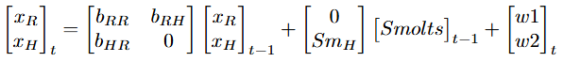
Of particular interest is the term b_{RH}, which describes the effect of fish returning to SJH in year t-1 on the abundance of fish returning to the Indian River in year t. Observation error is site specific, while process error is shared by both states (river and hatchery returners) due to fish encountering the same conditions throughout their lifespan at sea as well as the same commercial fishing effort upon their return.
Results
Regional Abundance
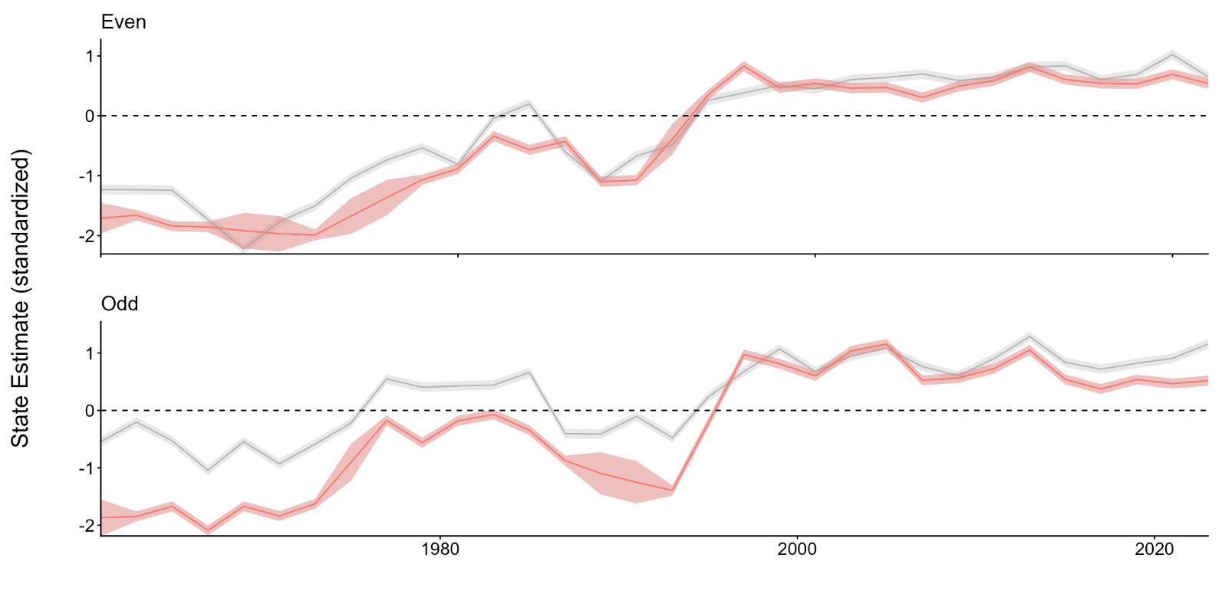

Figure 3: MARSS model results estimating the underlying states of even- and odd-year pink salmon abundance at Indian River (highlighted in pink) and throughout ‘north southeast (outside)’ region (grey). Abundance estimates are scaled by stream length and z-standardized at the stream level.

For both even- and odd-year runs, Indian River abundances at the beginning of the time series fall below what might be expected relative to the wider region. Even-year Indian River abundance in 1960 was estimated to be 0.476 standard deviations lower than the regional average, while odd-year Indian River abundance in 1961 was estimated to be 1.326 standard deviations lower. Over the time series, Indian River abundances for both runs “caught-up” to what would be expected of an average pink salmon index stream, although odd-year Indian River runs took some time to accomplish this and do not exceed the statistical average until 1997. From the middle 1990s onward, both Indian River runs are closely aligned with the average index stream, exceeding the average in some years and falling short in others, but in either case not by an amount that appears drastic when visually appraised (Figure 3). Pink salmon abundances observed in recent years at Indian River did not deviate significantly from the regional average. However, plotting these time series is not enough to conclusively state that abundances at Indian River do not differ from those that would be expected of an average pink salmon index stream in the region in a statistically significant way.

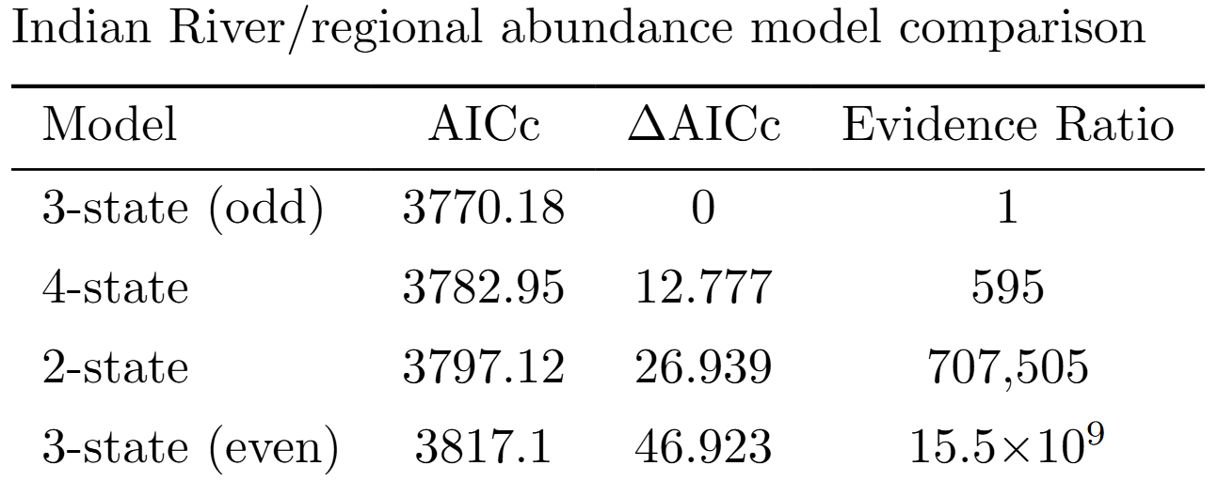
Table 1: Comparison of multi-state model specifications.

The best fit model allows includes a separate underlying state of Indian River pink salmon abundance in odd years, while estimating a single underlying state of pink salmon abundance throughout the region (including Indian River) in even years (Table 1). The difference in AICc of 12.78 between this model and the model with the second best fit (allowing even- and odd-year Indian River pink salmon abundance to be separated from regional abundances) means that this model the best with 99.84% confidence (Mazerolle 2006). Model specifications which estimated a single state of odd-year pink salmon abundance throughout the region performed abysmally by this standard, with infinitesimally small likelihoods of best fit. These findings suggest a scenario in which even-year pink salmon abundances at Indian River are very much in line with those that might be expected of an average stream in the north southeast (outside) region, while odd-year Indian River abundances differ significantly, appearing to fall below regional expectations throughout much of the time series (Figure 3).

Effect of Hatchery Operations
For both the post-1975 and post-2010 treatment periods, models which best fit the data were those specified to assert one region wide effect of treatment period for each run across all sites 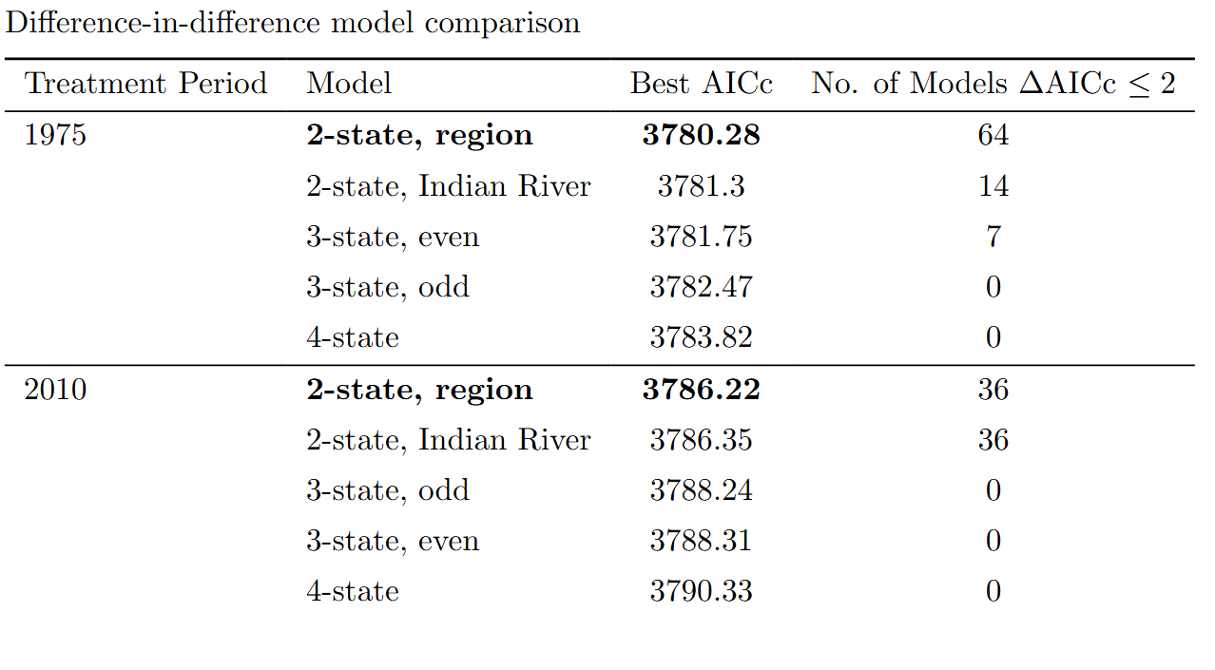
Table 2: Difference-in-difference results estimating the impact of Sheldon Jackson Hatchery operations on Indian River pink salmon abundances. Best fit model effect structure in bold. The lowest (best) AICc value for each effect structure is included, along with the number of models featuring said effect structure within 2 AICc of the best fit model.

(including Indian River), implying that in both treatment periods, any effect hatchery releases may be having on Indian River pink salmon abundances is not as impactful as the effect of the
treatment period itself. For the post-1975 treatment, over 75% of models within 2 AICc of the best fit model were specified with the same region wide effect structure. Conversely, while the post-2010 treatment best fit model was specified with the same region wide effect structure, fully half of the models that fell within 2 AICc of best fit were specified to only estimate an effect of treatment at Indian River (Table 2).

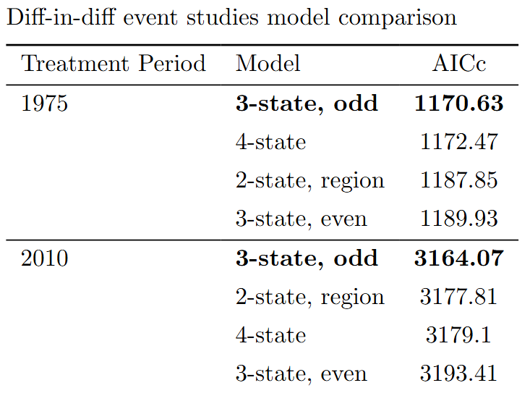
Table 3: Event studies evaluating the effect of Indian River on pink salmon abundances during pre-treatment periods. Best fit models in both treatment periods include separate states of Indian River and regional abundances in odd years and only one regional underlying state (including Indian River) in even years.

Event studies conducted to validate the parallel trends assumption revealed that, in both pre-treatment periods, best fit models were those specified with a 3-state structure, treating odd-year Indian River pink salmon runs as separate state from odd-year runs throughout the region (Table 3). This then means that the parallel trends assumption is not supported for odd-year abundances at Indian River and throughout the region, a very interesting finding when considered in conjunction with the best fit models described above (Table 2). These findings are consistent with the idea that the statistically significant difference observed between odd-year Indian River and regional abundances discussed in the last section is being driven by the Indian River falling below regional expectations in the pre-treatment period (Figure 3).

Effect of Hatchery Releases
All interaction effects of brood year t-1 on brood year t are positive for both runs (Figure 4). The average effect of prior brood year hatchery returns on current brood year Indian River abundance, the parameter of greatest interest, was positive for both even- and odd-year runs, although this was the smallest of the three effects observed for each run, with point estimates of 0.09 and 0.04 respectively. In both cases enough parameter estimates fell below zero to diminish statistical confidence in the result, but most bootstrapped parameter estimates were positive (94.2% in even-year runs, and 92% in odd-year runs). Not surprisingly, the river shows a significant positive effect on itself for both odd- and even-year runs (point estimates of 0.92 in even years and 0.96 in odd years), meaning that the strongest predictor of the size of an Indian River pink salmon is the size of the run in the previous brood year. Both even- and odd-year hatchery returns are also significantly influenced by prior brood year Indian River abundances, with the model finding respective point estimates of 0.631 and 0.311. While the effect of prior brood year Indian River abundances on current brood year hatchery returns is stronger for both runs than its inverse, it is crucial to note that hatchery returns are greater than Indian River abundance much more often than not. This means that, despite the difference in effect, the overall numbers of fish straying to a non-origin site could be roughly equal or even skewed towards hatchery-born fish returning to Indian River. In those brood years where Indian River abundances exceed hatchery returns, these effect sizes imply that the following brood year will see more fish from Indian River returning to the hatchery than vice versa.

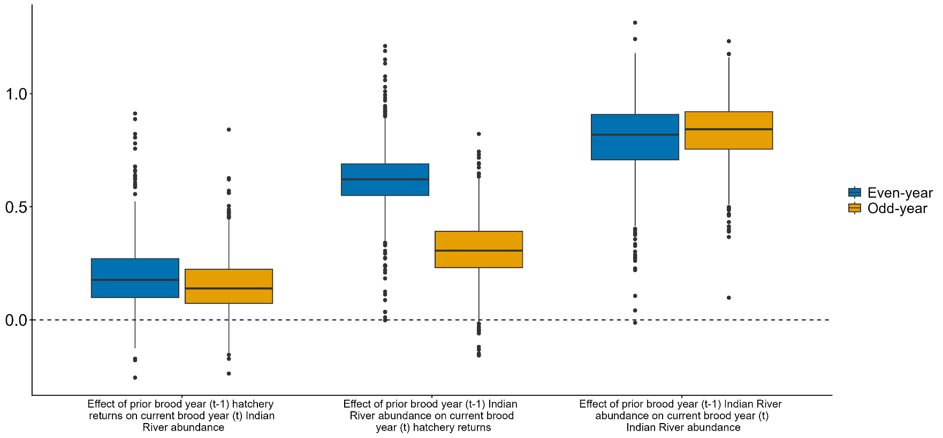

Figure 4: Estimated effect of brood year-to-brood year interactions between Indian River pink salmon runs and Sheldon Jackson Hatchery pink salmon releases

Discussion
An assessment of whether a native species has exceeded some natural range of variation requires long term knowledge of a natural system, and determining whether such overabundance resulted from some anthropogenic intervention also requires data on otherwise comparable populations of the species that have not been exposed to the same intervention. In the case of pink salmon at Indian River, this task is made additionally complicated by the fact there two populations inhabiting the same environment (odd- and even-year runs) with potentially different life histories and characteristics. My research evaluated three hypotheses to determine whether Indian River pink salmon population densities fall within a natural range of variation: 1) pink salmon population dynamics at Indian River are separate from those observed at ADFG index streams in the region, 2) the 1975 commencement and/or 2010 expansion of hatchery operations has had some measurable impact on Indian River pink salmon population densities, and 3) the number of pink salmon juveniles released by SJH in brood year t-1 is impacting pink salmon abundance observed at Indian River in brood year t. Evaluation of these hypotheses was approached to allow for odd- and even- year pink salmon runs to differ in their dynamics.
Across both runs pink salmon densities observed at Indian River in recent decades are higher than those recorded decades ago (Figure 2). The underlying state of Indian River abundances described by the best fit models is lower than the regional expectation at the outset of the time series but has largely ‘caught up’ to the regional state of pink salmon abundance in recent decades (Figure 3). Some effect of the 1975 commencement and hatchery operations was observed in both runs, with 18% of models within 2 AICc of the model of best fit specified to only include an effect of treatment at Indian River, although increased abundances in the pre- and post-treatment period seem to be predominantly driven by regional trends, as evidenced by the majority of best fit models specified to describe a single regional state. The expansion of hatchery operations in 2010 seems to have had a more discernable impact on Indian River abundances. While the bet fit model once again is specified to describe a single regional state, fully 50% of models within 2 AICc of best fit only include an effect of treatment at Indian River (Table 2). The effect of hatchery releases on subsequent brood year Indian River abundances was not statistically significant for either run, but in both cases a convincing majority of bootstrapped parameter estimates were positive. Meanwhile, the opposite effect (year t-1 Indian River abundances on year t hatchery returns) was positive and larger for both runs (Figure 4). However, hatchery returns frequently exceed in-river abundances, meaning that even if the effect of hatchery releases on subsequent brood year Indian River abundances is smaller than its opposite counterpart, the overall numbers of fish straying to a non-origin site could be roughly equal or even skewed towards hatchery-born fish returning to Indian River. In those brood years where Indian River abundances exceed hatchery returns, these effect sizes imply that the following brood year will see more fish from Indian River returning to the hatchery than vice versa.
In even years, Indian River pink salmon were within the expected range of abundance for the region. Difference-in-difference event studies found no separate state of Indian River abundances prior to either the 1975 commencement or 2010 expansion of hatchery operations, meaning that the impact of hatchery operations on even-year runs in the post-treatment period is likely negligible (Tables 2 & 3). Indian River abundances were estimated to have a strong positive impact on pink salmon returning to the hatchery in the subsequent brood year, while an accompanying effect of hatchery releases on subsequent brood year Indian River abundances was estimated to be positive not statistically significant (Figure 4). Even if there exists a small but positive true effect of hatchery releases on subsequent brood year Indian River abundances in even-year runs, the difference between this effect and the effect of Indian River abundances on pink salmon returning to the hatchery in the subsequent brood year is large, meaning that even-year Indian River spawners would have to vastly outnumber hatchery releases in a given year in order for a net increase in Indian River abundance due to hatchery releases to occur in the following brood year. Taken together, these results imply there is little concern that even-year pink salmon abundances fall outside their natural range of variation at Indian River and indeed seem to be contributing to hatchery returns.
In odd years, the best fit model suggests that abundances at Indian River differ significantly from what would be expected of a similar stream in the region. While evaluations of model fit do not explicitly indicate in what way these two states differ (greater or lesser), the model results imply that the difference may stem from Indian River abundances falling well below regional expectations for the first three or so decades of the time series (Figure 3). This suggests that SJH releases may indeed have bolstered in-river abundances in recent decades. Unlike even-year runs, event studies show that both the 1975 commencement and 2010 expansion of hatchery operations are associated with significant increases in the numbers of pink salmon at Indian River, beyond the increased abundances occurring elsewhere in the region during those periods (Tables 2 & 3). Like even-year runs, odd-year Indian River abundances had a significant effect on pink salmon returning to SJH in the subsequent brood year, as well as a positive effect of hatchery releases on subsequent brood year Indian River abundances that falls just short of statistical significance (Figure 4). It is worth noting that the gap between these effects is not so pronounced as in even-year runs, meaning that Indian River spawners would not have to heavily outnumber hatchery releases in a given year for a net increase in Indian River abundance due to hatchery releases to occur in the following brood year.
This work is intended to provide management at SITK with a comprehensive description of both the impacts of SJH operations and the population dynamics of pink salmon in the region. In even years, pink salmon abundances at Indian River have been comparable with those observed at index streams nearby. Increases in the Indian River spawning densities were within the natural range of variation. This does not invalidate concerns about hypoxia events, but interceding on behalf of Indian River’s other resident species may run contrary to the natural state of even-year pink salmon in northern Southeast Alaska. Available evidence suggests that there is likely no need for intervention to address even-year abundance. In odd years there was more compelling evidence that SJH pink salmon releases could be increasing abundances at Indian River, but they have been less important than other factors affecting pink salmon population densities in odd years, as populations have been increasing throughout the region for decades. In odd years, the effect of Indian River pink salmon abundance on hatchery returns in the subsequent brood year was lower than the effect observed in even years. If there exists some small but positive true effect of hatchery releases on subsequent brood year Indian River abundances, the difference between the magnitude of these effects in odd years would be far greater than in even-years, meaning that odd-year Indian River abundances would be more susceptible to being inflated by hatchery releases. It is possible that limiting the number of SJH pink salmon moving into Indian River to spawn in odd years may be beneficial for maintaining the wild population in the park within their natural range of variation, but this is far from conclusive, and suggests the need for more consistent monitoring of odd-year Indian River spawners in order to more completely understand the impact of SJH releases.
Establishing at what point a species becomes overabundant in its native range is difficult, with extant literature on the subject diverging in how this determination is made (Lemoine et al. 2016, Moore et al. 2023, Holzner et al. 2025). As in the case of Indian River pink salmon, a species is often not recognized as overabundant in its native range until such time as it begins to threaten other inhabitants of a shared ecosystem (Beckett et al. 2022, Brown et al. 2025). There is also distinct concern about the rapid growth in population of native species as a result of anthropogenic activity (although this is not necessarily a requisite for a species to be considered such) and is primarily focused on management of native species causing harm in ecosystems rather than assessment of the point at which a species might be considered overabundant (Brown et al. 2025, McComb et al. 2026). Indian River pink salmon are not dissimilar to the case of the mountain pine beetle discussed in the introduction, the proliferation of which was not unique to the impacted National Parks, but which the affected parks nevertheless were compelled to address through interventions, such as insecticide use and the culling of susceptible trees (Frost 2009). Likewise, management at SITK may choose to address the proliferation of pink salmon at Indian River, even if it does not exceed regional expectations, to protect other resident aquatic species and the riverine ecosystem from hypoxia events.

Acknowledgements

The work presented would not have been possible without support from Sitka National Historical Park management and biologists. Mary Miller, Olivia Magni, Jordan Tanguay, and Zachary Jones have provided substantial guidance in understanding the ecological and cultural history of the park and its neighbors. Lauren Bell, Bill Coltharp, and Haley Jenkins of the Sitka Sound Science Center have likewise offered invaluable perspectives and background regarding the history and current state of hatchery operations. Collaboration from Alaska Department of Fish and Game biologists Aaron Dupuis and Justin Priest has enabled us to compare Indian River pink salmon abundances to those seen elsewhere in the vicinity of Sitka, a vital component of this research. Finally, Sunny Jardine provided substantial expertise and guidance in the field of causal inference. This research has occurred on the ancestral homeland and with the approval of the Sitka Tribe of Alaska.

References
Alaska Department of Fish and Game. 2024a. Commercial Salmon Fisheries – Southeast Alaska & Yakutat Research: Pink Salmon. Available at: https://www.adfg.alaska.gov/index.cfm?adfg=commercialbyareasoutheast.salmon_research_pink (accessed December 14, 2024)
Alaska Department of Fish and Game. 2024b. Mark Recovery Laboratory – Otolith Marking. Available at: https://mtalab.adfg.alaska.gov/OTO/marking.aspx (accessed December 14, 2024)
Anderson, J. H., G. R. Pess, R. W. Carmichael, M. J. Ford, T. D. Cooney, C. M. Baldwin, and M. M. McClure. 2014. Planning Pacific Salmon and steelhead reintroductions aimed at long-term viability and recovery. North American Journal of Fisheries Management 34: 72-93.
Beckett, K., E. Elle, C. Kremen, A. Sherwood, S. McComb, and T. G. Martin. 2022. Hyperabundant black-tailed deer impact endangered Garry oak ecosystem floral and bumblebee communities. Global Ecology and Conservation 38: 14pp.
Berejikian, B. A., M. J. Malick, J. Lee-Waltermire, M. R. Downen, K. K. Shelby, R. Endicott, and A. Batista. 2025. Conservation hatchery effects on the abundance and spawn timing of natural steelhead populations: a replicated before-after-control-impact experiment in the Hood Canal watershed. Canadian Journal of Fisheries and Aquatic Sciences 82: 1-16.
Brown, S. K., A. R. McIntosh, Z. B. Hamilton, and H. J. Warburton. 2025. Overlooked and underestimated: reframing restoration to include inconspicuous native invaders. Restoration Ecology 33(8): 7pp.
Burnham, K. P., and D. R. Anderson. 2002. Model selection and multimodel inference: A practical information-theoretic approach, 2nd ed. Springer-Verlag, 488 pp.
Burnham, K. P., D. R. Anderson, and K. P. Huyvaert. 2010. AIC model selection and multimodal interference in behavioral ecology: some background, observations, and comparisons. Behavioral Ecology and Sociobiology 65: 23-35.
Carey, M. P., B. L. Sanderson, K. A. Barnas, and J. D. Olden. 2012. Native invaders – challenges for science, management, policy, and society. Frontiers in Ecology and the Environment 10(7): 373-381.
Colwell, R, S. Avery, J. Berger, G. E. Davis, H. Hamilton, T. Lovejoy, S. Malcolm, A. McMullen, M. Novacek, R. J. Roberts, R. Tapia, and G. Machlis. 2012. Revisiting Leopold: Resource Stewardship in the National Parks. National Park Service, 24 pp.
Cunningham, S. 2021. Causal Inference: The Mixtape. Yale University Press, 352 pp.
del Monte-Luna, P., B. W. Brook, M. J. Zetina-Rejón, and V. H. Cruz-Escalona. 2004. The carrying capacity of ecosystems. Global Ecology and Biogeography 13: 485-495.
Ellison, A. M., M. S. Bank, B. D. Clinton, E. A. Colburn, K. Elliott, C. R. Ford, D. R. Foster, B. D. Kloeppel, J. D. Knoepp, G. M. Lovett, J. Mohan, D. A. Orwig, N. L. Rodenhouse, W. V. Sobczak, K. A. Stinson, J. K. Stone, C. M. Swan, J. Thompson, B. von Holle, and J. R. Webster. 2005. Loss of foundation species: consequences for the structure and dynamics of forested ecosystems. Frontiers in Ecology and the Environment 3(9): 479-486.
Estes, J. A. 2015. Natural history, ecology, and the conservation and management of sea otters. Edited by Shawn Larson. Sea Otter Conservation 35-60. Academic Press.
Frost, H. C. 2009. Testimony regarding mountain pine beetles: Strategies for protecting the West (Oral testimony before the House Natural Resources Committee, Subcommittees on Water and Power and National Parks, Forests, and Public Lands). U.S. Department of the Interior. Available at: https://www.doi.gov/ocl/hearings/111/MountainPineBeetle_061609 (accessed March 20, 2026)
Gende, S. and B. Carter. 2015. Straying rates of pink salmon into the Indian River, Sitka National Historical Park. Final Report – ADF&G Permit # SF2015-225. National Park Service, 11 pp.
Gibson, K., K. Skov, S. Kegley, C. Jorgensen, S. Smith, and J. Witcosky. 2008. Mountain pine beetle impacts in high-elevation five-needle pines: current trends and challenges. USDA Forest Service – Forest Health Protection, 40 pp.
Gallardo, B., M. Clavero, M. I. Sánchez, and M. Vilà. 2015. Global ecological impacts of invasive species in aquatic ecosystems. Global Change Biology 22(1): 151-163.
Heard, W. R. 1991. Life History of Pink Salmon (Oncorhynchus gorbuscha). Edited by Groot, C. and L. Margolis. Pacific Salmon Life Histories 119-231. UBC Press.
Holmes, E. E., E. J. Ward, and K. Wills. 2012. MARSS: Multivariate Autoregressive State-space Models for Analyzing Time-series Data. The R Journal 4(1): 11-19.
Holzner, A., N. Ruppert, K. Ilham, S. S. K. Kaburu, A. L. K. Liston, A. Fuentes, and M. F. Hansen. 2025. Threatened synanthropes depend on intact forests: a critical evaluation of Moore et al. (2023). Biological Reviews 100: 1444-1451.
Jeschke, J. M., S. Bacher, T. M. Blackburn, J. T. A. Dick, F. Essl, T. Evans, M. Gaertner, P. E. Hulme, I. Kühn, A. Mrugala, J. Pergi, P. Pysek, W. Rabitsch, A. Ricciardi, D. M. Richardson, A. Sendek, M. Vilà, M. Winter, and S. Kumschick. 2014. Defining the impact of non-native species. Conservation Biology 28(5): 1188-1194.
Lemoine, N. P., D. E. Burkepile, and J. D. Parker. 2016. Quantifying differences between native and introduced species. Trends in Ecology & Evolution 31(5): 372-381.
Levin, P. S., and N. Tolimieri. 2001. Differences in the impacts of dams on the dynamics of salmon populations. Animal Conservation 4(4): 291-299.
Manhard, C. V., J. E. Joyce, W. W. Smoker, and A. J. Gharrett. 2017. Ecological factors influencing lifetime productivity of pink salmon (Oncorhynchus gorbuscha) in an Alaskan stream. Canadian Journal of Fisheries and Aquatic Sciences 74(9): 1325-1336.
Mantua, N. J., S. R. Hare, Y. Zhang, J. M. Wallace, and R. C. Francis. A Pacific interdecadal climate oscillation with impacts on salmon production. Bulletin of the American Meteorological Society 78(6): 1069-1079.
May, S. A., K. R. Shedd, K. M. Gruenthal, J. J. Hard, W. D. Templin, C. D. Waters, M. D. Adkison, E. J. Ward, C. Habicht, L. I. Wilson, A. C. Wertheimer, and P. A. H. Westley. 2024. Salmon hatchery strays can demographically boost wild populations at the cost of diversity: quantitative genetic modelling of Alaska pink salmon. Royal Society Open Science 11(7): 18pp.
Mazerolle, M. 2006. Improving data analysis in herpetology: using Akaike’s Information Criterion (AIC) to assess the strength of biological hypotheses. Amphibia-Reptilia 27: 169-180.
McComb, S., K. Beckett, T. Akerman, P. Arcese, D. Bedford, P. Dunwiddie, J. T. Fisher, T. Golumbia, E. K. Gonzales, R. Irvine, A. James, E. S. Long, J. Martin, S. Michel, W. Pelkey, T. Sylvester, S. Thomas, N. Thomas, and T. G. Martin. 2026. Decision analysis rooted in Indigenous and Western scientific knowledge identifies cost-effective strategies for managing hyperabundant deer to restore keystone places. People and Nature 8(1): 4-20.
McMillan, J. R., B. Morrison, N. Chambers, G. Ruggerone, L. Bernatchez, J. Stanford, and H. Neville. 2023. A global synthesis of peer-reviewed research on the effects of hatchery salmonids on wild salmonids. Fisheries Management and Ecology 30(5): 446-463.
Moore, J. H., L. Gibson, Z. Amir, W. Chanthorn, A. H. Ahmad, P. A. Jansen, C. P. Mendes, M. Onuma, C. A. Peres, and M. S. Luskin. 2023. The rise of hyperabundant native generalists threatens both humans and nature. Biological Reviews 98(5): 1829-1844.
Murphy, M. L., 1985. Die-offs of pre-spawn adult pink salmon and chum salmon in southeastern Alaska. North American Journal of Fisheries Management 5:302–308.National Park Service. 2023. Reducing deer numbers and removing invasive plants are key to long term forest health. Available at: https://www.nps.gov/cato/learn/news/reducing-deer-numbers-and-removing-invasive-plants-are-key-to-long-term-forest-health.htm (accessed March 17, 2026)
National Park Service. 2025a. Organic Act of 1916. Available at: https://www.nps.gov/grba/learn/management/organic-act-of-1916.htm (accessed March 27, 2025)
National Park Service. 2025b. Sitka National Historical Park. Available at: https://www.nps.gov/sitk/index.htm (accessed March 18, 2025)
Pearsons, T. N., and T. W. Hillman. 2025. Costs and benefits of a multi-generation captive broodstock Chinook Salmon hatchery program. North American Journal of Fisheries Management 45:402-419.
Quinn, T. P. 2018. The Behavior and Ecology of Pacific Salmon and Trout, Second Edition. University of Washington Press, 547 pp.
Ruggerone, G. T., and J. R. Irvine. 2018. Numbers and biomass of natural- and hatchery-origin Pink Salmon, Chum Salmon, and Sockeye Salmon in the North Pacific Ocean, 1925-2015. Marine and Coastal Fisheries 10(2): 152-168.
Ruggerone, G. T., A. M. Springer, G. B. van Vliet, B. Connors, J. R. Irvine, L. D. Shaul, M. R. Sloat, and W. I. Atlas. 2023. From diatoms to killer whales: impacts of pink salmon on North Pacific ecosystems. Marine Ecology Progress Series 719: 1-40.
Sambaraju, K. R. and D. W. Goodman. 2021. Mountain pine beetle: an example of a climate-driven eruptive insect impacting conifer forest ecosystems. CABI Reviews: 18pp.
Scheuerell, M. D., E. R. Buhle, B. X. Semmens, M. J. Ford, T. Cooney, and R. W. Carmichael. 2015. Analyzing large-scale conservation interventions with Bayesian hierarchical models: a case study of supplementing threatened Pacific salmon. Ecology and Evolution 5(10): 2115-2125.
Sergeant, C. J., J. R. Bellmore, C. McConnell, and J. W. Moore. 2017. High salmon density and low discharge create periodic hypoxia in coastal rivers. Ecosphere 8(6): 16pp.
Sergeant, C. J. 2018. Future Challenges for Salmon and the Freshwater Ecosystems of Southeast Alaska. Alaska Park Science 17(1): 41-47.
Sergeant, C. J., J. R. Bellmore, R. A. Bellmore, J. A. Falke, F. J. Mueter, and P. A. H. Westley. 2023. Hypoxia vulnerability in the salmon watersheds of Southeast Alaska. Science of the Total Environment 896: 12 pp. doi.org/10.1016/j.scitotenv.2023.165247
Stopha, M. 2015. An Evaluation of the Sheldon Jackson Salmon Hatchery for Consistency with Statewide Policies and Prescribed Management Practices. Alaska Department of Fish and Game, Division of Commercial Fisheries, 42 pp.
Thornton, T. F. 1998. Traditional Tlingit Use of Sitka National Historical Park. National Park Service, 170 pp.
Tillotson, M. D. and T. P. Quinn. 2017. Climate and conspecific density trigger pre-spawning mortality in sockeye salmon (Oncorhynchus nerka). Fisheries Research 188: 138-148.
Valéry, L., H. Fritz, and J. C. Lefeuvre. 2013. Another call for the end of invasion biology. Oikos 122: 1143-1146.
Van Alen, B. W. 2000. Status and Stewardship of Salmon Stocks in Southeast Alaska. In E. E. Knudsen, Steward, C. R., MacDonald, D. D., Williams, J. E., Reiser, D. W. Sustainable Fisheries Management – Pacific Salmon, 161-193. Lewis Publishers.

