Introduction
Conservation issues related to individual species are often the result of the scarcity of native plant or animal species or the abundance of non-native (exotic, invasive) species (Ellison et al. 2005, Gallardo et al. 2015, Jeschke et al. 2014). However, ecosystems can also be harmed by the hyperabundance of a native species, due either to shifting regional trends in habitat suitability, to direct (and often anthropogenic) intervention, or to a combination of these factors (Sambaraju and Goodsman 2021, Beckett et al. 2022, Moore et al. 2023). Hyperabundance of native purple sea urchin (Strongylocentrotus purpuratus) in the northern Pacific Ocean, driven by the depletion of Pacific sea otter (Enhydra lutris) populations by the maritime fur trade, has led to the devastation of kelp (Macrocystis pyrifera) forests, critical ecosystems upon which countless marine species depend (Estes 2015). The mountain pine beetle (Dendroctonus ponderosae), another hyperabundant species, has caused catastrophic destruction of coniferous forests throughout its native range, the Rocky Mountains. While in the past cold winter temperatures had limited their numbers and, by extension, their impacts on Rocky Mountain forests, shifting climate patterns have led to warmer winters and longer summers, allowing the mountain pine beetle to flourish and in turn devastate large swathes of forest habitat in Canada and the US (Gibson et al. 2008).
When a native species hyperabundance occurs within a conservation area, it may necessitate management actions to protect other species within the ecosystem. For example, the United States National Park Service (NPS) has operated under a mandate to “steward NPS resources for continuous change that is not yet fully understood, in order to preserve ecological integrity …” (Colwell et al. 2012). For natural resources, particularly those that vary in space and time, the NPS management target has historically been to maintain abundances within a ‘natural range of variation’ (National Park Service 2025a), but the point at which the abundance of an endemic species exceeds the natural range of variation, thereby triggering a need for management action, can be difficult to ascertain. Park managers finding themselves confronted with such issues must make careful and informed decisions based on the best scientific information available as they seek to interpret and implement the mandate to preserve resources in a natural condition. Hyperabundant native species are not given anywhere near the same attention as invasive species in scientific literature, and identifying these instances as they occur is challenging (Valéry et al. 2013). While information regarding historical presence, abundance, or range of a species is useful when available, these data are often non-existent or lacking (Carey et al. 2012).
With these ideas in mind, our research is focused on pink salmon (Oncorhynchus gorbuscha) in Sitka National Historical Park (SITK), populations of which have undergone dramatic increases in density in recent decades. SITK is a small (45 ha) coastal park in Sitka, Alaska, characterized by mature spruce-hemlock forests and the Indian River (Kaasda Héen in Tlingit), the main reach and intertidal area of which fall within park boundaries (National Park Service 2025b). Since time immemorial, the Indian River has been the location of a fishing camp and harvesting site for the Kiks.ádi clan, and particularly valued for its close proximity to the clan’s winter villages, as well as for hosting runs of a variety of Pacific salmon species, including chum (O. keta), coho (O. kisutch), Chinook (O. tshawytscha), and pink salmon (Thornton 1998). Originally designated a National Monument in 1910 for the purpose of conserving the site of an 1804 battle between the native Tlingit Kiks.ádi clan and Russian colonizers, today the park is managed to preserve not only the historical battleground, but the ecosystems and natural resources present in the surrounding area.
Pink salmon are the most abundant species at Indian River, typically returning to spawn in August. After hatching in the winter and completing their embryonic development below the surface of the stream gravel, juvenile pink salmon immediately enter the ocean in spring, making no use of freshwater as rearing habitat. All members of the brood then return to spawn in autumn of the following year at two years of age (Heard 1991, Quinn 2018). This obligate two-year life cycle leads to genetically distinct runs of salmon inhabiting the same stream in even numbered and odd numbered years (Quinn 2018). Unlike in regions further north or south, the rivers of northern southeast Alaska see even- and odd-year pink salmon runs that are approximately equal in abundance (Alaska Department of Fish and Game 2024a).
Although pink salmon have always been abundant at Indian River, their numbers have increased rapidly in the last 30 years. The Alaska Department of Fish and Game (ADFG) peak escapement surveys have estimated that, since 1980, Indian River pink salmon abundance has increased from run of several thousand to runs regularly exceeding 100,000 fish annually (Stopha 2015). High abundances of salmon are concerning to park managers because when they coincide with low stream flows and warm temperatures, these densities can impact the Indian River’s ability to sustain other resident fish species by decreasing dissolved oxygen concentrations through direct consumption of oxygen while alive and the respiration of microbes decomposing their carcasses (Murphy 1985, Sergeant et al. 2023). In stream systems free of hatchery influence, there are natural regulators (density dependence) that bring the population back into balance when the number of returning spawners exceeds a stream’s carrying capacity. For example, at very high densities, females arriving later in a spawning season dig up nests (redds) made by early arriving females, so the stream has a natural limit to production (McNeil 1964). Hypoxia events are also not limited to stream systems in which natural abundances are supplemented by hatchery strays. High salmon densities occur naturally across the Pacific Rim, and incidences of high densities leading to low egg to fry survival and reduced recruitment or contributing to depleted in stream oxygen levels have been recorded in southeast Alaska (Murphy 1985). In such an instance, females may die before spawning due to lowered oxygen levels (Sergeant et al. 2017, Tillotson and Quinn 2017). In either of these scenarios, the numbers of spawners returning in subsequent years would be constrained. These constraints weaken with the introduction of straying fish from hatcheries, and the question becomes whether these natural processes and resulting swings in salmon abundance, are exaggerated by strays from nearby hatcheries to the point where the stream ecosystem is disturbed.
The initial increases in Indian River pink salmon abundance observed in the 1980s coincided with the commencement of operations at Sheldon Jackson Hatchery (SJH), a pink salmon hatchery located approximately 1 km from the mouth of the Indian River. The hatchery is currently operated by the not-for-profit Sitka Sound Science Center but was originally established in 1975 by Sheldon Jackson College (Stopha 2015). The college, initially “laid out as a kind of utopian experiment in assimilating Natives into ‘civilized’ Christian living”, was at its inception granted water rights from the Indian River (Thornton 1998). Today, water is taken from a diversion upriver of SITK’s boundaries to maintain hatchery operations. This water is used to rear salmon fry, which imprint on its distinct chemical signature, and during spawning season this diverted Indian River water is released into the bay near the hatchery to attract returning fish. In late summer, returning hatchery fish tend to aggregate in large schools just offshore, where commercial fisherman partnered with the hatchery purse seine the fish and sell the catch for the purposes of cost recovery. The hatchery was initially permitted to spawn 1 million pink salmon eggs each year, but that was increased to 3 million eggs in 2010. Most of the embryos in the hatchery survive and are released as fry to the ocean. These eggs are currently extracted from hatchery broodstock, the original stock of eggs was sourced from pink salmon at the Indian River (even years) and nearby Starrigavan Creek (odd years) (Stopha 2015).
If all pink salmon reared at the hatchery returned to the hatchery, the population dynamics of salmon in the Indian River would be unaffected by hatchery operations. However, homing by salmon is imperfect and has adaptive value (Quinn 2018). It has been shown that both the purposeful and incidental introduction of hatchery salmon into streams with native populations can contribute to increased abundances (Anderson et al. 2014, McMillan et al. 2023, May et al. 2024). Straying, whereby a juvenile salmon that was produced in one stream (or hatchery) strays into a different stream as an adult to spawn occurs, but whether hatcheries increase the proportion of fish that stray is less clear (Knudsen et al. 2021). Evidence suggests that the Indian River is no exception, and indeed it is possible that the Indian River sees higher than average levels of straying due to the proximity of SJH and the hatchery fish being reared in Indian River water (Figure 1).
Hatchery-origin fish at Indian River can be distinguished from natural-origin fish because all pink salmon released by SJH are subject to otolith marking (Stopha 2015, Alaska Department of Fish and Game 2024b). Surveying efforts at Indian River have at times found stray pink salmon from Sheldon Jackson Hatchery making up one third of all individuals sampled in a year. However, rates observed vary considerably, perhaps due to the time of year pink salmon are sampled, with some surveys observing rates of straying closer to 10% (Gende and Carter 2015).

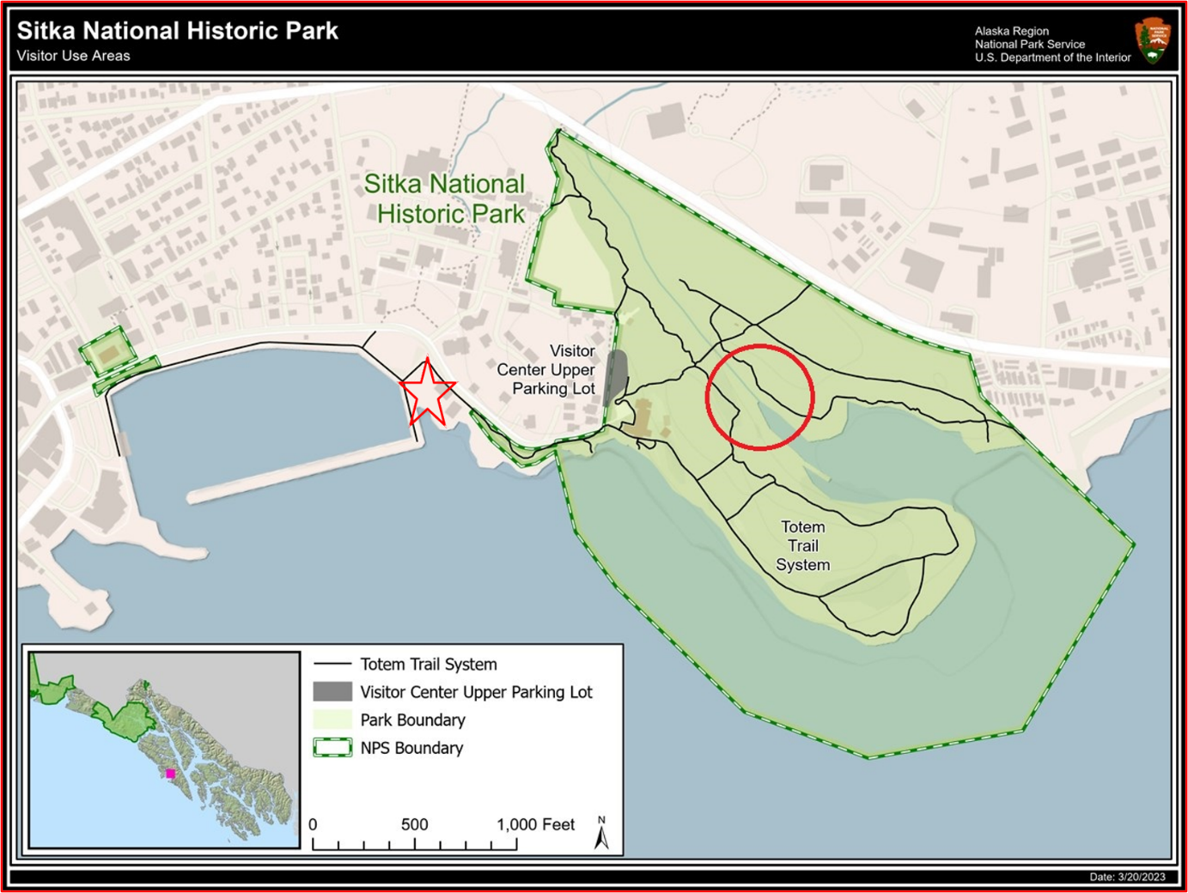

Figure 1: Location of Sheldon Jackson Hatchery (red star) and the mouth of the Indian River (red circle) in Sitka. The two highlighted points are approximately 1,650 ft (503m) apart. Credit: National Park Service, modified to include river mouth and hatchery location.

The possibility that pink salmon being reared and released by Sheldon Jackson hatchery may be contributing to the high abundances of fish observed at the Indian River in recent decades cannot be ignored. However, it is also critical to note that these high densities may be naturally occurring phenomena, influenced by variation in stream conditions, ocean productivity, predation intensity, and commercial harvests, among other factors (Manhard et al. 2017). ADFG conducts regular monitoring of pink salmon ‘index streams’ throughout southeast Alaska for the primary purpose of managing the commercial fishery (index streams being specifically selected to reflect natural conditions and a lack of undue anthropogenic influences). This extensive monitoring effort provides a regional backdrop against which abundances observed at Indian River may be compared. Between 1960 and 2023, pink salmon escapement has increased throughout what ADFG designates as the ‘Northern Southeast (Outside)’ region (in which the Indian River is located). The agency has recorded peak pink salmon escapement annually at 35 index streams in this region, as well as at Indian River, albeit with gaps in the time series. Along with other streams in the region, Indian River has seen an increase in peak escapement over the period of observation (Figure 2).
My research seeks to assess whether the abundances of pink salmon observed in recent decades at Indian River exist within a natural range of variation relative to pink salmon streams
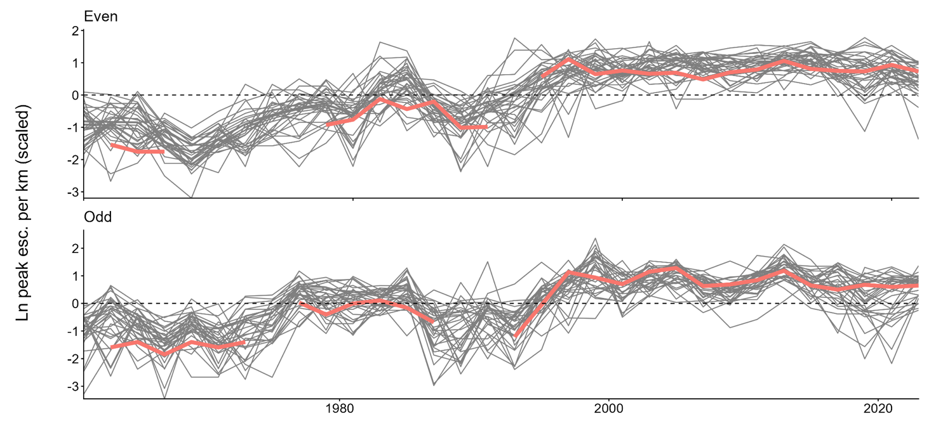

Figure 2: Even- and odd-year peak pink salmon escapement from 1960 to 2022 in Indian River and 35 index streams across ADFG’s designated Northern Southeast (Outside) region. Indian River counts highlighted. Spawner counts are scaled against stream length (km), then log transformed and standardized at the level of each stream.

elsewhere in the region, and to evaluate if and to what extent Sheldon Jackson Hatchery operations have driven increasing abundance since 1980. If Indian River pink salmon abundances exceed the natural range of variation, then it follows that a model which specifies estimates Indian River abundance as separate from that of the wider region would fit the observed data significantly better than a model which estimates pink salmon abundance throughout the region and does not allow for the Indian River to be treated as separate [This seems like a very complicated and lengthy way to say this. The Introduction is rather long and I think considerable trimming and condensation would help.]. If the commencement (or 2010 expansion) of hatchery operations has significantly increased pink salmon population densities at Indian River, then this effect could be observed by specifying a model of hatchery operations which controls for both the effect of time period (pre- and post-commencement of operations) and the effect of treatment (considering Indian River the treated group). Finally, the impact of hatchery releases on Indian River abundances may be evaluated by specifying a model which allows for both peak escapement and hatchery releases in the previous brood year to influence the number of pink salmon returning to Indian River to spawn in the current brood year, with the size and significance of the effect of prior-year hatchery releases providing insight as to if and what influence the volume of hatchery releases has on wild abundance. Each of these approaches is discussed in greater detail in the following section.

You need a clear, concise statement of goals and hypotheses here or the reader will not see where this is going. And I think a shorter Intro, in general, will help.

