Effect of Hatchery Operations
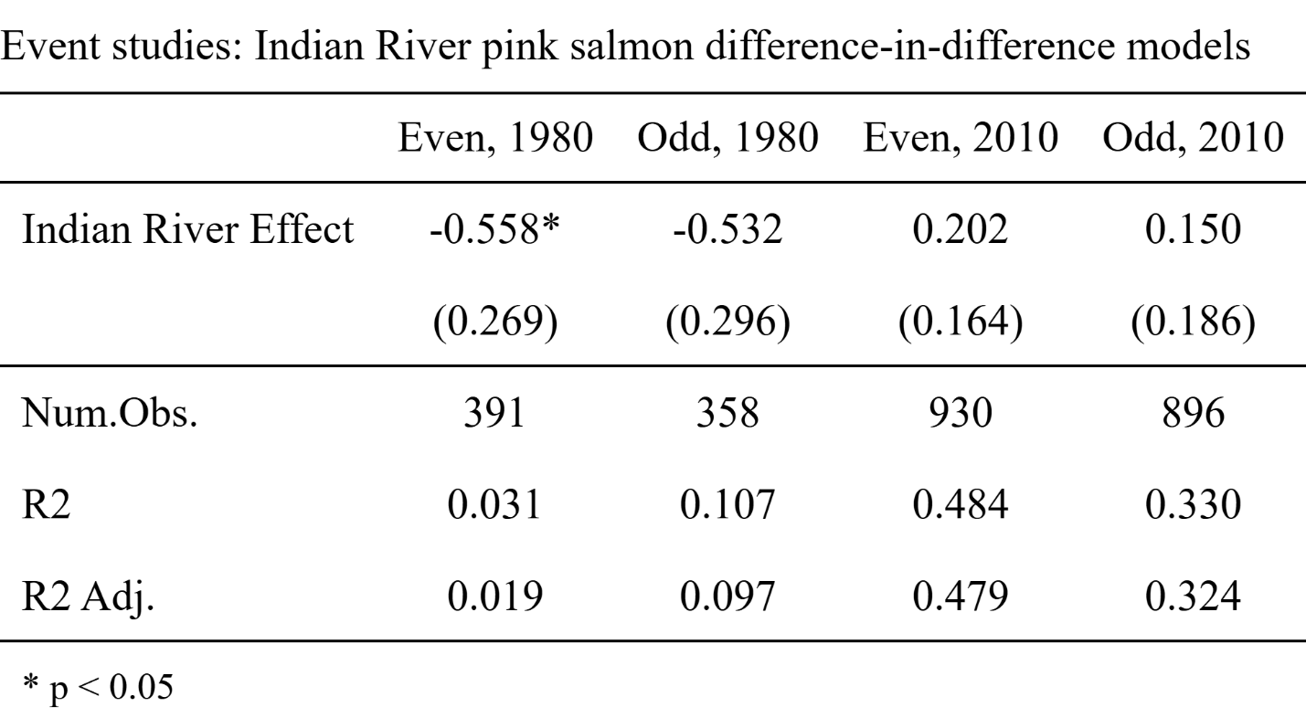
Table 2: Event studies evaluating the effect of Indian River on pink salmon abundances during pre-treatment periods. Standard errors reported in parentheses.

Difference-in-difference models for even- and odd-year runs considering post-1975 and post-2010 treatment periods were specified, with suites of covariate data relating to observers and ocean climate evaluated for best fit. To ensure the parallel trends assumption holds, the effect of Indian River in the pre-treatment period is estimated in all four models (Table 2). For even-year runs there exists some significant difference between trends at Indian River and elsewhere in the region prior to 1975. Due to this difference, a synthetic control group time series was constructed for comparison with the treatment group. All other models satisfy the parallel trends assumption.
The commencement of SJH operations in 1975 caused a significant increase in odd-year pink salmon abundances at Indian River, but no significant effect occurred for even-year runs. The expansion of permitted pink salmon releases from 1 million to 3 million in 2010 increased both even- and odd-year abundances (Table 3). The difference in time periods (pre- and post-1975, and pre- and post-2010) is found to be a significant driver of pink salmon abundances both at Indian River and throughout the north southeast (outside) region. This result is consistent with trends seen in ADFG’s survey data (Figure 2), as well as with the underlying states of pink salmon abundance estimated through MARSS modeling (Figure 3). 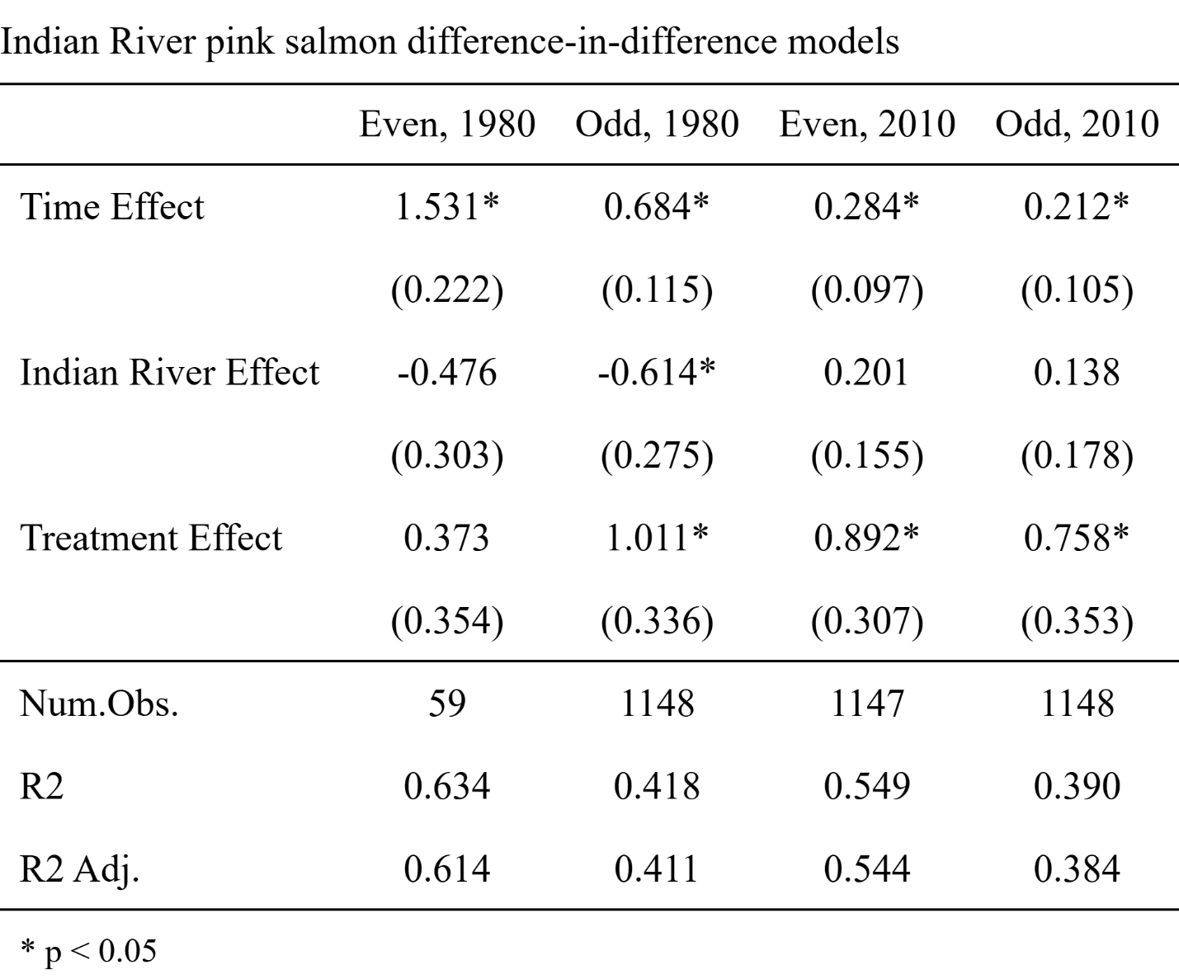
Table 3: Difference-in-difference results estimating the impact of Sheldon Jackson Hatchery operations on Indian River pink salmon abundances. Standard errors reported in parentheses.

Effect of Hatchery Operations
For both the post-1975 and post-2010 treatment periods, models which best fit the data were those specified to assert one region wide effect of treatment period for each run across all sites (including Indian River). This indicates that, in both treatment periods, any effect hatchery releases may be having on Indian River pink salmon abundances is not as impactful as the effect of the treatment period itself. In both cases, other model specifications fell within 2 AICc, of the best fit model

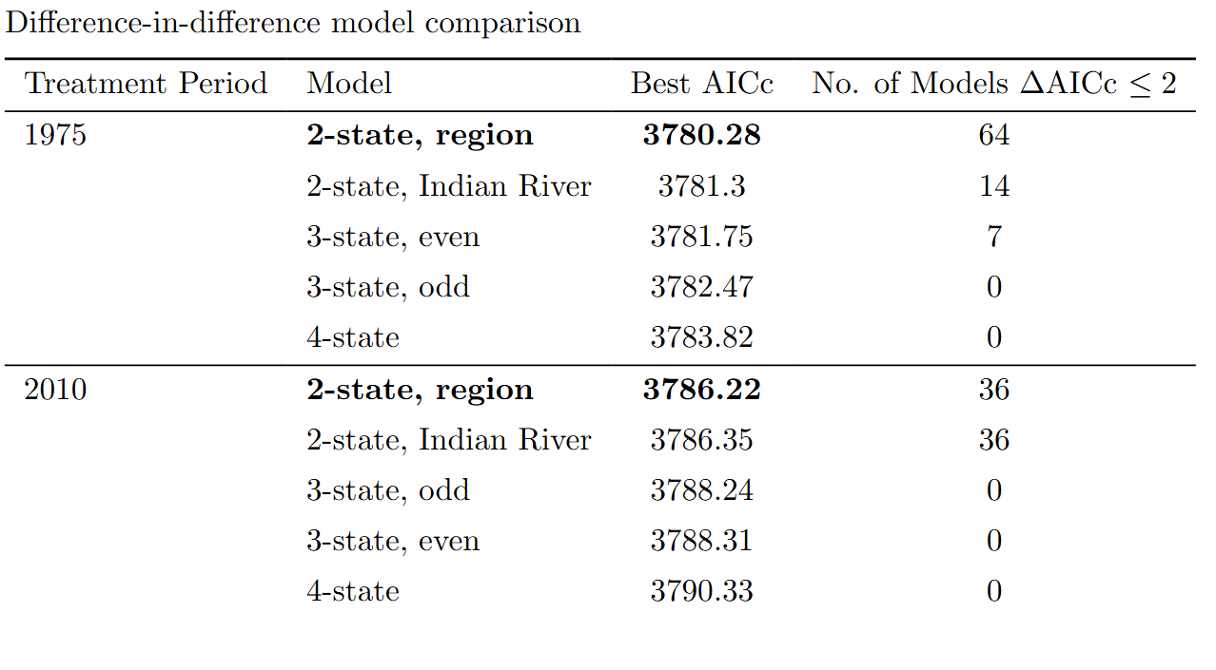Table 2: Difference-in-difference results estimating the impact of Sheldon Jackson Hatchery operations on Indian River pink salmon abundances.

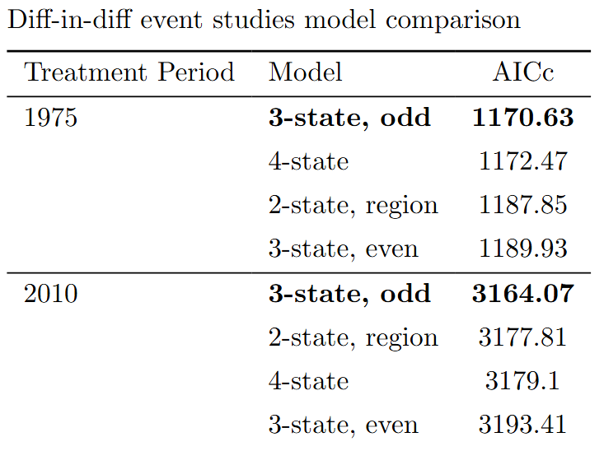
Table 3: Event studies evaluating the effect of Indian River on pink salmon abundances during pre-treatment periods.

