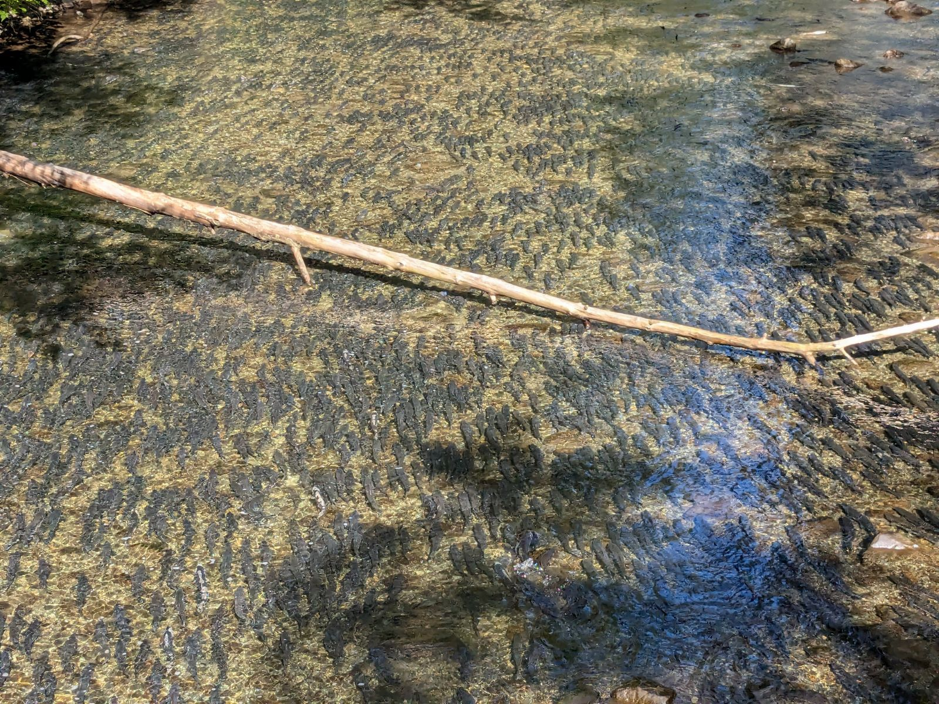

map of hatchery position relative to Indian River 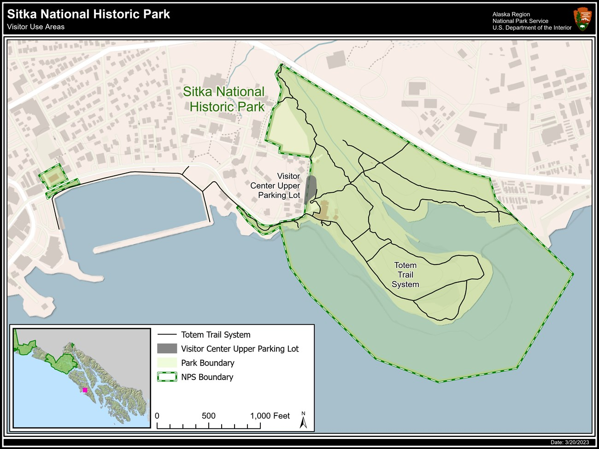 OTOLITH IMAGE 