Chapter 3
  - Introduction
The study and management of rare and elusive species or populations presents unique challenges. In professional environments characterized by finite time and resources, efforts to survey and/or regularly monitor such populations may come at great cost. As a result, understanding life histories and these groups’ roles in larger ecosystems becomes challenging, making potential targeted conservation efforts difficult to undertake and rife with uncertainty (Thompson 2013). The costs associated with efforts to survey rare and elusive species may be reduced given some foreknowledge of the likelihood associated with encountering populations at various locations. Moreover, in some cases there is “cryptic diversity” which is the existence of genuine diversity (e.g., genetic populations or species) that go undetected (May et al. 2023). To this end, research focused on predicting occupancy based on habitat features is not uncommon and provides important insight into where elusive species are most likely found, inferring distribution of species as varied as migratory wood ducks, fin whales, and desert dwelling mammals such as foxes and gazelles (Vale et al. 2016, Burnham et al. 2021, Zlonis et al. 2022). Unlikely as it may seem, one such rare and elusive population that has heretofore been overlooked in this field of research is coho salmon (Oncorhynchus kisutch, L’ook) in southeast Alaska.

Throughout their native range, coho salmon are most often associated with a spawning season beginning in the fall and concluding late in the calendar year or early in the new year (Theriault et al. 2010, Quinn 2018, Alaska Department of Fish and Game 2025). The late-season run-timing of fall coho tends to coincide with heavier rainfall and higher water levels in streams, providing an advantage to coho attempting to reach spawning grounds inaccessible to other Pacific salmon species (Quinn 2018). However, throughout this same range, there are known instances of far less abundant summer coho runs. In more southerly latitudes, spawning summer-run coho adults enter freshwater late in the summer. The Sol Duc and Quillayute rivers on Washington’s Olympic Peninsula are known for summer runs which typically begin in late September (National Park Service 2025c). Farther north these summer runs may begin even earlier in the year. Summer-run coho in southeast Alaska are present as early as late June, with large runs of fish occurring from June through August (Alaska Department of Fish and Game 2025).

Table 3.1 – Web of Science results of summer-run coho Boolean searches
“summer coho” | 5
“summer-run coho” | 0
“summer-run” AND “coho” | 13
While these summer-run coho runs are known to exist, research focusing on these runs specifically is paltry. Boolean searches of academic literature in Web of Science for the terms “summer coho”, “summer-run coho”, and “summer run” AND “coho”, return very few results. Among those articles returned by these searches, most are concerned either with juvenile coho rearing during summer, or with other salmonid species (such as steelhead and/or Chinook) being discussed in the same paper (Table 3.1). Summer coho runs also often go unmonitored by fisheries managers, with monitoring efforts typically concentrated later in the season when the vast majority of spawning coho return (T. Fish and A. Piston, personal communication, August 22, 2024).

Despite the lack of information described above, occurrences of summer coho runs are of great interest to fisheries managers. Monitoring these populations regularly would provide insight into what roles they play in the broader ecosystems to which they belong. Conservation efforts are almost always costly and are therefore often targeted to maximize impacts. For this targeting to be effective, managers and biologists must know where (and in the case of salmon when) a species or population can be found. The case of summer-run coho is very often additionally complicated by the presence of larger fall runs in nearby streams, leading to situations where, in the absence of more detailed knowledge, all coho are treated as fall run by default, even when found in streams during the summer (T. Fish and A. Piston, personal communication, August 22, 2024). Diversity in run timing has historically played a crucial role in salmonids’ genetic differentiation. Because the timing of both migration and spawning are highly heritable traits, populations of coho which have spent untold generations establishing genetic predispositions towards early runs will not be able to quickly adapt their life histories to take advantage of management decisions undertaken to conserve and protect fall-run populations (Quinn et al. 2016).

In the absence of coho salmon surveys conducted before the fall run, how might the locations of possible summer-run coho spawning grounds be identified? Anecdotal evidence suggests that summer-run coho are smaller than their fall-run cousins, potentially due to less time spent at sea feeding during summer months. This smaller size is used to navigate in-stream obstructions which act as barriers to other fish, therefore accessing spawning habitat that fall-run coho are unable to reach. These partial barriers must therefore be substantial enough that larger fall-run coho are unable to traverse them, despite the benefit of higher flows during fall months (T. Fish and A. Piston, personal communication, August 22, 2024). If such partial barriers could be remotely identified (particularly those with suitable coho spawning habitat upstream), it would provide a strong indication of where survey efforts might best be directed to assess the extent of these populations.

With all this in mind, my research will focus on identifying summer-run coho spawning habitat in southeast Alaska, specifically focusing on Prince of Wales and Revillagigedo Islands and the surrounding area. This region is characterized by high steep mountains descending rapidly to glacially carved fjords, leading to streams with drastic elevation changes occurring over relatively short distances (Smith 2016). Crucially, these terrain characteristics provide ample opportunities for the sort of partial barriers described above to occur.

Objectives
The purpose of this study is to develop a model to predict likely summer-run coho spawning habitat in southeast Alaska, incorporating presence-absence data of known partial barriers with detailed stream geomorphology data. These predictions will be cross-validated with existing data, but it may be necessary to simulate data to fully evaluate the predictive ability of the model. Beyond the initial stage of this work, partners at the Alaska Department of Fish and Game (ADFG) are available to ground truth model predictions, at which time the model may be refit and reevaluated for predictive efficiency.

  - Methods
My research will integrate data relating to the presence of summer-run coho with a richly detailed stream geomorphology data layer describing the physical characteristics of streams and rivers on Prince of Wales and Revillagigedo Islands, the nearby Cleveland Peninsula, and smaller neighboring islands (Figure 3.1).

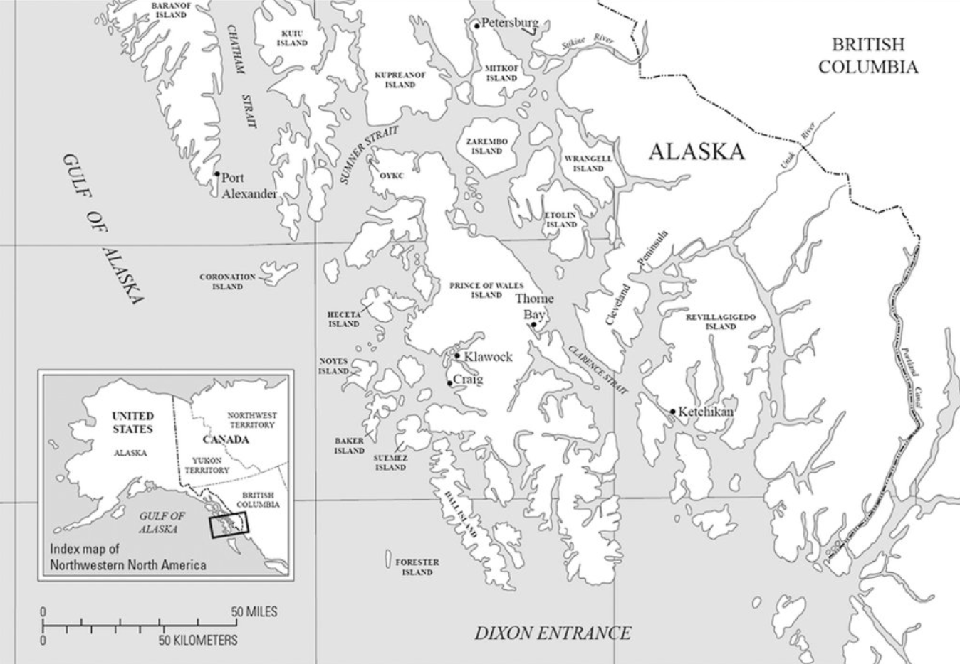
Figure 3.1: Southern southeast Alaska. Known summer-run coho spawning grounds and partial barriers are located on Prince of Wales and Revillagigedo Island and the Cleveland Peninsula.

Summer-run coho data provided by ADFG comes from two sources. The first dataset provides spatial locations of partial barriers known to ADFG biologists in streams known to host summer runs of coho, henceforth referred to as the barrier dataset. These are very reliable data and not only relate to the presence of summer-run coho, but also the precise location of barriers which ADFG biologists believe prevent the passage of fall-run coho. These data also contain information on stream systems known to only host fall-run coho populations, providing a contrast to streams of interest. Unfortunately, these data are sparse; at the time of this writing, research partners at ADFG have only been able to provide the locations of twenty such systems known conclusively to host or not host summer-run coho (although these research partners are actively working to confirm more).

To bolster these scarce data, a second dataset will be constructed by identifying early season coho appearing in ADFG survey efforts for other salmonid species, henceforth referred to as the survey dataset. In order to regulate fishing efforts in the region, ADFG has monitored salmon escapement in southeast Alaska since 1960. While ADFG’s coho salmon monitoring efforts do not begin in earnest until November, coho are recorded if they appear in surveys targeting salmonid species, for instance pink (O. gorbuscha, Cháas’) and chum (O. keta, Téel) salmon, which return earlier in the year. An observation (or repeated observations) of coho in a stream much earlier than fall-run coho would typically be found provides a strong indication that stream may host a population of summer-run coho. Parsing these data will likely provide many more observations of summer-run coho with which a model could be trained. However, this approach is circumstantial in nature and therefore much less conclusive than information on known summer-run coho populations in streams with known partial barriers.

Given knowledge of streams where summer-run coho are found, I will focus on the physical habitat characteristics to assess where summer-run coho are likely to be found in other stream systems. Stream level geomorphology to be used in this work come from TerrainWorks, a private research team dedicated to the development of “virtual watersheds” using remote sensed digital elevation models (DEMs). TerrainWorks’ virtual watersheds estimate physical stream characteristics enumerated at the level of approximately 100m reaches. These characteristics include (but are not limited to): length, area, gradient, valley width, floodplain width, distance from mouth and from source, maximum downstream gradient, mean annual flow, maximum downstream drop (denoting falls), mapped road crossings, and solar energy to stream reach. Stream flow, gradient, and valley constraint (the ratio of valley-floor width to maximum stream width) have been shown to be robust proxies for coho intrinsic habitat potential, and the addition of measures of downstream falls and gradients should allow models to account for the presence of partial barriers associated with summer-run coho (Burnett et al. 2007).

Redundancy analysis is a commonly used framework for predicting the spatial distribution of a species based on presence-absence data, but recent research has highlighted the potential of binomial generalized linear models (GLMs) to outperform redundancy analyses both in approaches to selecting spatial explanatory variables and in overall predictive accuracy (Carlos-Junior et al. 2020). This modeling approach is well suited to analyzing the barrier dataset which contains both presence and absence data for summer-run coho. The extent to which partners at ADFG are able to provide additional presence-absence data will likely influence this model’s predictive ability. In the absence of additional data, simulating new summer-run coho presence-absence and physical stream characteristic data based on the distributions seen in the small sample proved may be necessary in order to better evaluate the model’s fit and ability to make predictions.

The survey data set will contain no information on absence of summer-run coho beyond those few stream systems that can be included from the barrier dataset. This means that very little absence data will be available for analysis. While a binomial GLM applied to this data will be able to make predictions based on physical stream characteristics, it is difficult to assess the accuracy of models trained with presence-only data. A presence-background approach, which generates pseudo-absences from background data before proceeding through a typical presence-absence modeling framework, has been shown to be an effective way to evaluate model fit in this context (Li & Guo 2013).

  - Expected Results
This work is expected to predict stream networks most likely to host summer-run coho in southeast Alaska. Given the small sample size of known summer-run coho populations, scrutinizing the accuracy of these predictions becomes a critical part of this work. Evaluating this accuracy will be accomplished by comparing the outcomes of models trained with synthetic presence-absence data or models trained using the more comprehensive presence-only survey dataset to those systems enumerated in the barrier dataset. There is also the potential for evaluating a predictive model based on known summer-coho sites in Washington (such as on the Sol Duc and Quillayute River). Finally, ADFG research partners are available to ground truth model predictions after they have been refined using all data and statistical methods available.

  - Interpretation and Significance
This work will fill knowledge gaps in both the ecological understanding of summer-run coho as well as regulatory agencies’ ability to monitor and manage these fish. Being able to accurately predict which physical features of stream systems most likely indicate the presence of summer-run coho will make these populations easier to study, and therefore enable assessments of abundance, threat levels, genetic history, and positioning within ecosystems. It will also provide insight and better understanding of which geomorphological characteristics of streams are best suited to supporting these populations. At the same time, fisheries managers will be better equipped to regulate commercial and sport fishing activities in order to ensure the long-term survival of summer-run coho populations.

