Salmonid survey piece

Brian McGreal
Quantitative Ecology and Resource Management
University of Washington
Seattle, WA

Mark D. Scheuerell
U.S. Geological Survey, Washington Cooperative Fish and Wildlife Research Unit
School of Aquatic and Fishery Sciences
University of Washington
Seattle, WA

William K. Jaeger
Department of Applied Economics
Oregon State University
Corvallis, OR

(potentially)
Kasey Bliesner - ODFW
Jake Chambers - ODFW

Hyperabundance of native species within their natural range can pose a difficult management challenge. Whether due to direct human influence on their environments, or from indirect human influence due to shifting climate regimes, hyperabundance of native species can be as perilous to an ecosystem as incursion from an invasive species. This study examines the case of pink salmon (Oncorhynchus gorbuscha) in Sitka National Historical Park’s Indian River, the life history of which leads to two genetically distinctly runs inhabiting the same stream in even and odd years. Though native to the river, both runs of pink salmon have seen numbers of fish returning to spawn in late summer grow exponentially in recent decades. These potentially hyperabundant runs create the risk of hypoxia events, putting fish and other resident species reliant on the river at risk. The U.S. National Park Service mandates the maintenance of population densities such as they would occur within a “natural range of variation,” meaning the potential hyperabundance of pink salmon may prompt the need for management action. A nearby hatchery, which releases 3 million pink salmon fry each year, may be contributing to the abundance of pink salmon in Indian River. Using pink salmon escapement data collected by the Alaska Department of Fish and Game, this study determines whether the increased numbers of pink salmon observed at Indian River are typical of trends in the wider region (i.e., a natural range of variation), or whether hatchery operations may be driving the hyperabundant runs in recent years. Analysis using state-space models finds that odd-year runs of pink salmon at Indian River diverge significantly from regional expectations, although conclusive evidence that this divergence is driven by hatchery releases is not clear. Even-year runs do not display the same divergence in behavior and seem to be in line with pink salmon abundances elsewhere in the region.
Introduction
The conservation of salmon and trout for environmental, tribal, commercial, and recreational use is of tremendous importance to fish and wildlife agencies in the Pacific Northwest. Additionally, multiple Evolutionarily Significant Units comprising many salmonid populations are protected under the US Endangered Species Act of 1973 (National Oceanic and Atmospheric Administration 2025a). Since 1980, the state of Oregon alone has spent over $9 billion in the effort to protect and restore populations of steelhead trout (Oncorhynchus mykiss) and Pacific salmon (Oncorhynchus spp.) in the Columbia River Basin. However, the impacts of these restoration efforts remain difficult to quantify (Jaeger and Scheuerell 2023). To determine the value of investments like these, policymakers and fisheries managers need accurate assessments of the salmonid populations in question.
To assess the impact of conservation policy and interventions, various survey methods are employed to estimate the abundance of target species over time. Each method is accompanied by some cost and presumably characterized both by an inherent level of precision and potentially some inherent directional bias. Past studies have shown a positive relationship between the intensity of sampling efforts and the precision of abundance estimates in both aquatic and terrestrial species (Walsh et al. 2001, Nuno et al. 2013, Annear et al. 2024). This makes intuitive sense, and managers must balance the cost of more intensive sampling efforts against the level of precision they hope to achieve. While low levels of precision in survey methods lead to low confidence in point estimates of population abundance or forecasts, directional bias presents a more pernicious problem as it may lead to the mismanagement of imperiled species, invasive species, and commercially valuable populations, due to over- or under-estimation of their numbers (Tracey and Fleming 2022, Satterthwaite and Shelton 2023). Indeed, in the United States, decisions of whether to list or de-list species as endangered under the Endangered Species Act are based on abundance estimates that may be influenced by such bias (National Oceanic and Atmospheric Administration 2025b). It has been shown that when directional bias can be assessed, it may be corrected by combining multiple datasets using bias parameters to achieve more accurate measures of central tendency in abundance estimates (Polansky et al. 2023).
Spawning salmon and trout are surveyed in freshwater using a variety of methods (Knudsen 2000). Methods may vary from visual inspection of known spawning grounds to counts of salmon migrating up stream at fixed points to inferential methods estimating total escapement in a stream system based on periodic counts of spawners. Survey methods conducted at terminal spawning grounds include foot surveys of live fish, carcass counts, and visual inspection of salmonid nests known as redds (Johnson et al. 2007, Oregon Department of Fish and Wildlife 2024). Within streams, adult fish may be captured and counted at weirs before being released to continue their upstream migration (Anderson et al. 2015). A different survey approach involves capturing salmonids as juveniles and fitting them with small passive integrated transponders or PIT-tags. This enables tagged fish to be electronically counted as adults years later, as the return to their natal spawning grounds takes them past sensor arrays (Lamb et al. 2024). In more remote localities, aerial surveys are favored with fish being counted from fixed-wing aircraft, trading precision for the ability to survey sites which are otherwise very difficult to access (Walker 2015). Finally, these methods and more may be included in the estimation of total escapement through a variety of area-under-the-curve and peak spawner count estimation methods (English et al. 1992, Parken et al. 2003, Millar and Jordan 2013). Given this variety of survey methods dependent on various technology and statistical techniques, each method will be characterized by some degree of imprecision, and perhaps some intrinsic tendency to over- or under-estimate spawning salmonids.

Methods
Objective
My research seeks to measure the levels of precision and relative bias accompanying various survey methods by comparing observations from 68 populations of Chinook (O. tshawytscha) and coho salmon (O. kisutch) and steelhead trout throughout Oregon. These surveys were conducted by biologists from the Oregon Department of Fish and Wildlife (ODFW) from 1980 to 2022, using 31 distinct survey methods. The precision inherent to a survey method (and the associated variance of estimates derived from these surveys) directly impacts the ability to detect changes throughout time, as large confidence intervals may obscure shifting abundance regimes (Vallecillo et al. 2021). This work will also seek to determine whether directional bias exists in some survey methods, although bias estimates will necessarily be defined relative to other survey methods, as “true” censuses of the underlying salmonid populations do not exist. The intention of this research is to map the value of information, such that managers can better determine achievable levels of precision given some budget, or inversely the cost of some minimum level of precision in their estimates. To this end, a secondary goal of this work will be the development of a mathematical optimization tool which would allow fisheries managers to determine achievable levels of precision and potential directional bias in estimates based on some budget, or vice versa.

Data
Data include annual observations of “natural-origin salmon and steelhead abundance” or NOSA, covering 68 populations of Chinook and coho salmon and steelhead trout throughout Oregon from 1980 to 2022. Crucially, each observation also includes the method by which the abundance survey was conducted. Data have been collected through 31 unique survey methods (fully enumerated in the attached appendix). The data contain 2,924 individual observations, of which 848 are missing NOSA values almost entirely related to years in which no survey was conducted (15 observations confoundingly include a survey method along with a null value). While trends are difficult to observe visually, as seen in Figure 2.1, simple linear regressions evaluating the effect of time on the natural log of abundance describe 34 (half) of the surveyed salmonid populations as having no statistically significant change across the study period. Of the remaining 34 populations, 23 exhibit a statistically significant increase in abundance, while the other 11 show evidence of decline.
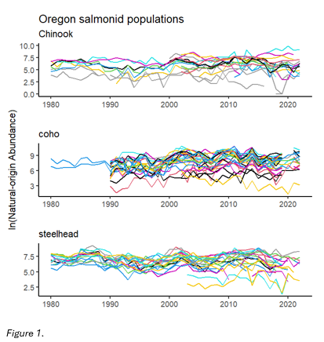
The accuracy of the linear regression estimates of trends in abundance described above are dependent on the precision of the observed data. The frequency with which survey methods are employed is not uniform across the study period, as described in Figure 2.2. While some methods such as redd counts have been widely used throughout the study period, other methods have seen drastic changes in usage. If different survey methods indeed exhibit varying levels of precision and/or inherent directional bias, the statistical significance estimated by simple regression models must be questioned.
Figure 2.1: Changes in abundance of individual salmonid populations from 1980 to 2022. Note that not all populations are represented throughout the entirety of the study period.

Because my goal is to isolate variance and bias in different survey methods, it is vital to distinguish variability in observations due to survey method from variation in the natural state of salmonid populations. Multivariate autoregressive state space (MARSS) models are well suited for this purpose, as they can mathematically distinguish observation error from process/state error and assign separate variance parameters to each. Recall that the generic MARSS model formulation and a description of all model terms is described in chapter 1 of this proposal.
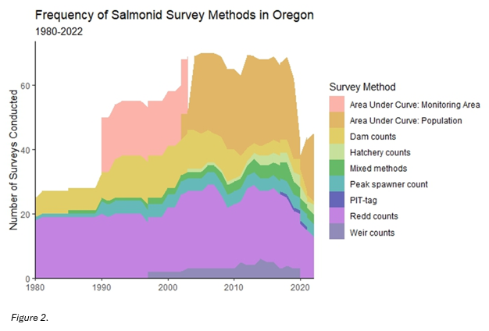

Figure 2.2: Groups of survey methods and the frequency of their employment from 1980 to 2022. The nine groups displayed in the figure are bins containing each of the 31 survey methods described in the data.

There exists the likelihood that some survey methods are endogenously related to the abundances they seek to estimate. For example, dam counts require that a dam be present. As dams are most often present at large streams capable of hosting large salmon runs, this survey method may inherently describe habitat characteristics that influence abundances. In theory, MARSS models should be able to statistically account for this potential endogeneity by mathematically partitioning the variance and bias originating due to the survey method (i.e., the accuracy of dam counts) from the variance and bias inherent in the underlying process being observed (i.e., natural fluctuations in a population’s abundance), especially given multiple populations being surveyed via the same method. Robustness checks using simulated data will be conducted to ensure that the models employed are indeed able to capably distinguish process error from observation error in those survey methods which may be endogenously related to salmonid abundance.
As well as modeling all three species together I will also model each salmonid species separately. This leads to three data subsets respectively containing 18 Chinook populations, 27 coho populations, and 23 steelhead populations. With data already sorted by species, each observation contains four crucial pieces of information: 1) an estimate of natural-origin spawner abundance (denoted mathematically from here on as y), 2) the population of interest (denoted with the subscript p), 3) the survey method used (denoted with the subscript s), and 4) the year of observation (denoted with the subscript t).
Applying the MARSS model structure to the analysis described above involves determining how best to structure spawner abundance data (y_{p,s,t}) and specify model parameters to isolate precision and bias in salmonid survey methods. Particular attention is paid to the inputs and parameterization of the observation equation. y_{t} is arranged such that each row relates to observations of population p by survey method s. Z is specified such that each population as identified in the data will correspond to a distinct underlying natural state. By specifying each population as an underlying state, the model will be able to assess variation in the natural state of the population as separate from variation in counts arising due to the survey method employed. The vector a contains a unique bias term for each survey method, irrespective of population. One method will be selected as a reference against which other methods will be measured, meaning that for this method a is set equal to zero. The matrix R is specified in a similar manner, with a unique r term for each method placed in the corresponding places along R‘s diagonal. Again, this is irrespective of population to capture the variation inherent in each survey method.
Below is an example of the observation equation written out in matrix form. In this example, two populations of salmonid have been surveyed with a total of five survey methods. As indicated by the y term subscripts, population one has been surveyed with methods one through four and population two with methods one, four, and five. Z is specified with two columns relating to the two populations which here are considered underlying states (x₁ and x₂). Survey method one has been selected as the reference method against which other methods’ directional bias will be measured. Therefore, in the vector a, those rows which correspond to an observation taken with method one are set equal to zero, while all other methods are represented by an a parameter which repeats as often as the method appears. Finally, R is specified so that each survey method is represented by an r parameter which again repeats as often as the method appears, in order to capture the variance inherent to each.
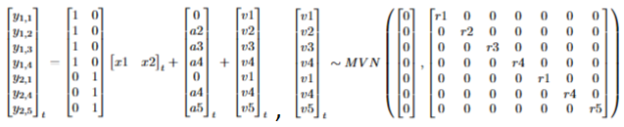
The process/state equation is more straightforward. It is constructed to be as parsimonious as possible, in that in this analysis it essentially acts as a receptacle for the natural variance in annual salmonid spawner returns. B is specified as an identity matrix, meaning the whole equation becomes a random walk. Whether the vector u is set to zero or allowed to estimate a trend in each population’s growth will depend on model fit. Finally, the terms along the diagonal of Q will be set equal to each other in initial model specifications, although the inclusion of other specifications (unequal population variances and allowing for equal variance and equal covariance terms) will also depend on model fit. Below is an example of the process/state equation written out in matrix form.
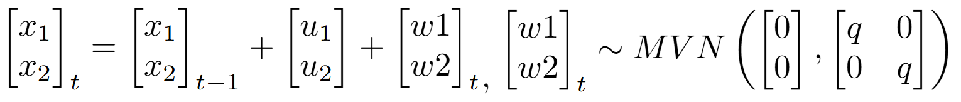
The various specifications of u and Q will be evaluated for best fit based on AICc, as this criterion is better suited than AIC for balancing fit with the many parameters MARSS models must estimate.
With these estimates in hand, the data presented in Figure 2.1 will then be adjusted to account for method bias in order to assess whether populations are indeed behaving in the way the figure portrays. Next steps will involve the evaluation of mixed survey method approaches commonly seen in the data. Many of the abundance estimates reported are derived from the combination of more than one survey method (see attached appendix). For example, Scappoose Creek winter steelhead are each year variously surveyed through either in-river weir counts, total redd counts * fish per redd estimate, or the combination of the two. This research will evaluate whether imprecision and/or directional bias produced by combining survey methods (such as those described above) is amplified or dampened compared to those associated with each constituent part. This work will also consider the efficiency of the same survey method in estimating populations that differ by orders of magnitude, as it is not hard to imagine the accuracy of a given method differing considerably when the number of fish present differ substantially.
The final stage of this research will consider the trade-offs between survey methods’ cost of implementation and accuracy as assessed by the MARSS models described above. Talks with ODFW research partners regarding the costs of survey methods are ongoing, with the hopes of building a dataset to better understand the inherent value of information associated with each survey method. While numerical data on costs may be impossible to establish, as the cost of implementing a particular method may differ widely from population to population, I hope at least to gather categorical information regarding survey method cost structures (i.e., ‘very high’, ‘high’, etc.) to illustrate the tradeoffs between methods. Given management agencies’ limited operating budgets, better understanding the cost of accuracy in salmonid surveys will allow fisheries biologists to decide how best funds should be allocated.
Results
This work will estimate levels of precision and directional bias in thirty-one commonly used salmonid survey methods. I expect some methods to be characterized by inherently higher levels of precision (i.e. weir counts, PIT-tagging) than others (i.e. redd counts), although it is likely that those more accurate estimates come with more significant costs. I also expect some methods to be characterized by inherent directional bias, which is of particular importance to understand when using these data to inform decision making.
Discussion
Understanding levels of precision in salmonid survey methods will enable fisheries managers to better understand the reliability of abundance estimates upon which they must make decisions. Understanding directional bias in these survey methods will help policymakers to more accurately determine the long-term cost-effectiveness of conservation efforts. As noted, decisions to list and de-list species under the US Endangered Species Act rely on population surveys of the sort this work is interrogating. Low precision in survey methods may lead to undetected shifts in population regimes, while consistent directional bias could lead to over- or under-estimation of target populations. Understanding how combining more than one method may influence the accuracy of abundance estimates will be of great use to fisheries biologists tasked with developing survey plans. Understanding these survey methods’ levels of precision and directional bias relative to each method’s implementation cost will further help fisheries managers in programming future salmonid survey efforts.
Acknowledgements

Acknowledgements related to this project. This should not be double spaced. I guess I should thank the rest of the committee if they aren’t going to be authors on this. Maybe Genoa Salami too?

References
Anderson, J. T., J. E. Merz, C. B. Watry, M. K. Saiki. 2015. Comparison of selected population characteristics of adult Chinook salmon during upstream passage through a resistance board weir and during salmon carcass surveys. California Fish and Game 101(1): 24-39.
Annear, A. R., M. A. Simonson, P. M. Dixon, M. J. Weber. 2024. Effects of sampling effort and data sources on precision of common carp and bigmouth buffalo population estimates. Fisheries Research 279: 12 pp.
English, K. K., R. C. Bocking, J. R. Irvine. 1992. A Robust Procedure for Estimating Salmon Escapement based on the Area-Under-the-Curve Method. Canadian Journal of Fisheries and Aquatic Sciences 49(10): 1982-1989.
Jaeger, W. K. and M. D. Scheuerell. 2023. Return(s) on investment: Restoration spending in the Columbia River Basin and increased abundance of salmon and steelhead. PLoS ONE 18(7): 21 pp.
Johnson, D. H., B. M. Shrier, J. S. O’Neal, J. A. Knutzen, X. Augerot, T. A. O’Neill, T. N. Pearsons. 2007. Salmon Field Protocols Handbook – Techniques for Assessing Status and Trends in Salmon and Trout Populations. American Fisheries Society in Association with State of the Salmon, 490 pp.
Knudsen, E. E. 2000. Managing Pacific Salmon Escapements: The Gaps Between Theory and Reality. In E. E. Knudsen, Steward, C. R., MacDonald, D. D., Williams, J. E., Reiser, D. W. Sustainable Fisheries Managemnt – Pacific Salmon, 237-272. Lewis Publishers.
Lamb, J. J., B. P. Sandford, S. G. Smith, G. A. Axel. 2024. Comparing standard- and reduced-size passive integrated transponder (PIT) tags for monitoring juvenile wild spring Chinook salmon. Transactions of the American Fisheries Society 153(4): 505-521.
Millar, R. B. and C. E. Jordan. 2013. A simple variance estimator for the trapezoidal area-under-the-curve estimator of the spawner abundance of Pacific salmon. Canadian Journal of Fisheries and Aquatic Sciences 70(8): 1231-1239.
National Oceanic and Atmospheric Administration. 2025a. Pacific Salmon and Steelhead: ESA Protected Species. Available at: https://www.fisheries.noaa.gov/species/pacific-salmon-and-steelhead/esa-protected-species (accessed May 18, 2025)
National Oceanic and Atmospheric Administration. 2025b. Listing Species Under the Endangered Species Act. Available at: https://www.fisheries.noaa.gov/national/endangered-species-conservation/listing-species-under-endangered-species-act (accessed May 27, 2025)
Nuno, A., N. Bunnefeld, E. J. Milner-Gulland. 2013. Matching observations and reality: using simulation models to improve monitoring under uncertainty in the Serengeti. Journal of Applied Ecology 50(2): 488-498.
Oregon Department of Fish and Wildlife Coastal Chinook Research and Monitoring Program. 2024. Field Method for Salmon Spawning Ground Surveys. 22pp.
Parken, C. K., R. E. Bailey, J. R. Irvine. 2003. Incorporating Uncertainty into Area-under-the-Curve and Peak Count Salmon Escapement Estimation. North American Journal of Fisheries Management 23(1): 78-90.
Polansky, L., L. Mitchell, K. B. Newman. 2023. Combining multiple data sources with different biases in state-space models for population dynamics. Ecology and Evolution 13(6): 12 pp.
Satterthwaite, W. H., A. O. Shelton. 2023. Methods for assessing and responding to bias and uncertainty in US West Coast salmon abundance forecasts. Fisheries Research 257: 14 pp.
Tracey, J. P., Fleming, P. J. S. 2023. Recounting bias can affect abundance estimates from intensive helicopter surveys of feral goats. Wildlife Research 50(5): 389-397.
Vallecillo, D., M. Gauthier-Clerc, M. Guillemain, M. Vittecoq, P. Vandewalle, B. Roche, J. Champagnon. 2021. Reliability of animal counts and implications for the interpretation of trends. Ecology and Evolution 11(5): 2249-2260.
Walker, S. 2015. Aerial Surveying for Salmon in Alaska. Alaska Fish and Wildlife News.
Walsh, P. D., L. J. T. White, C. Mbina, D. Idiata, Y. Mihindou, F. Maisels, M. Thibault. 2001. Estimates of forest elephant abundance: projecting the relationship between precision and effort. Journal of Applied Ecology 38(1): 217-228.
