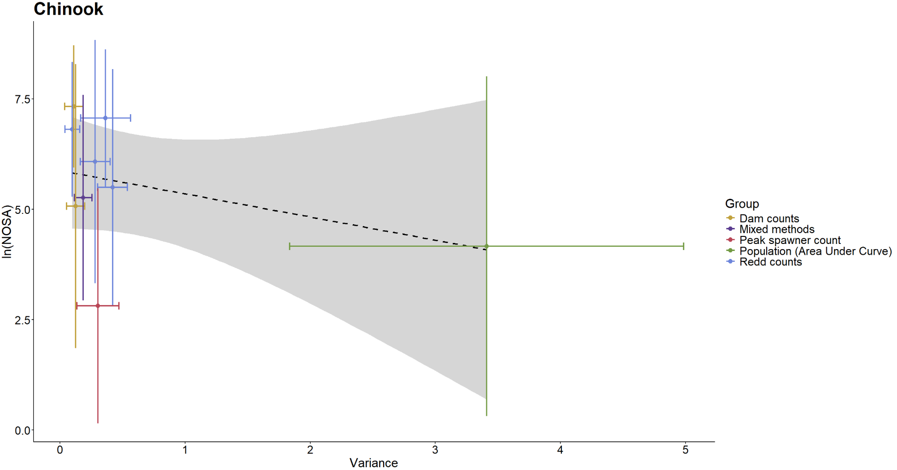 Figure B7: Relationship between variance associated with Chinook survey methods and population sizes being surveyed.
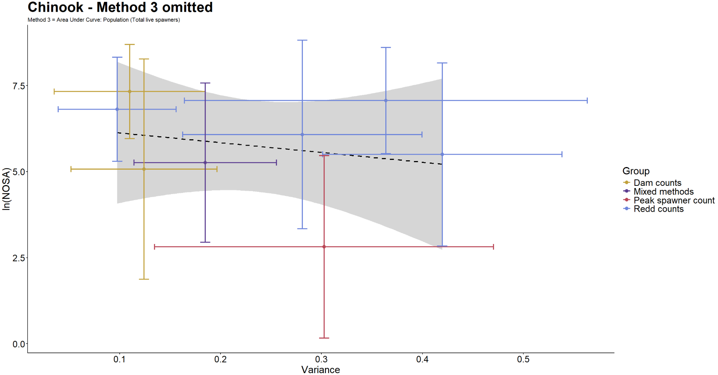 Figure B8: Relationship between variance associated with Chinook survey methods and population sizes being surveyed. ‘Area Under Curve: Population (Total live spawners) is omitted as an outlier.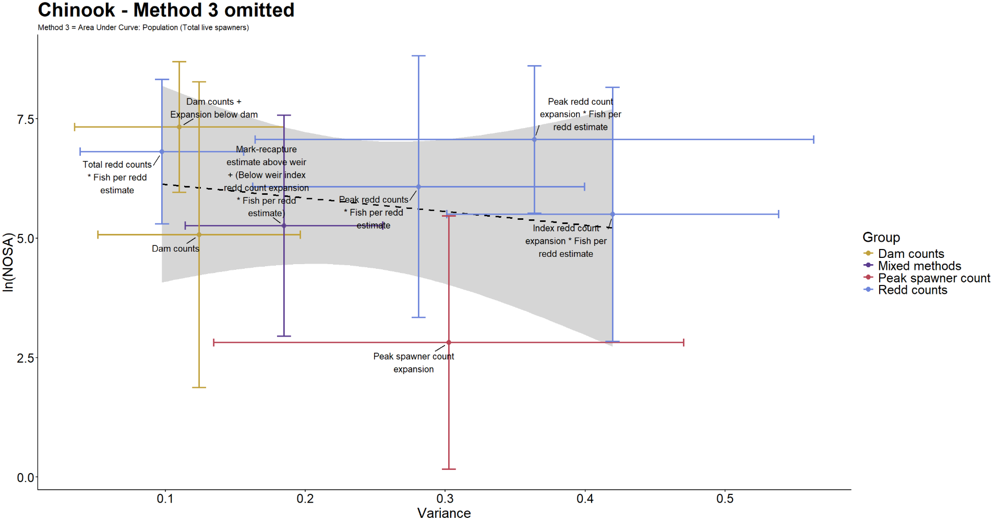 Figure B9: Relationship between variance associated with Chinook survey methods and population sizes being surveyed. ‘Area Under Curve: Population (Total live spawners) is omitted as an outlier. 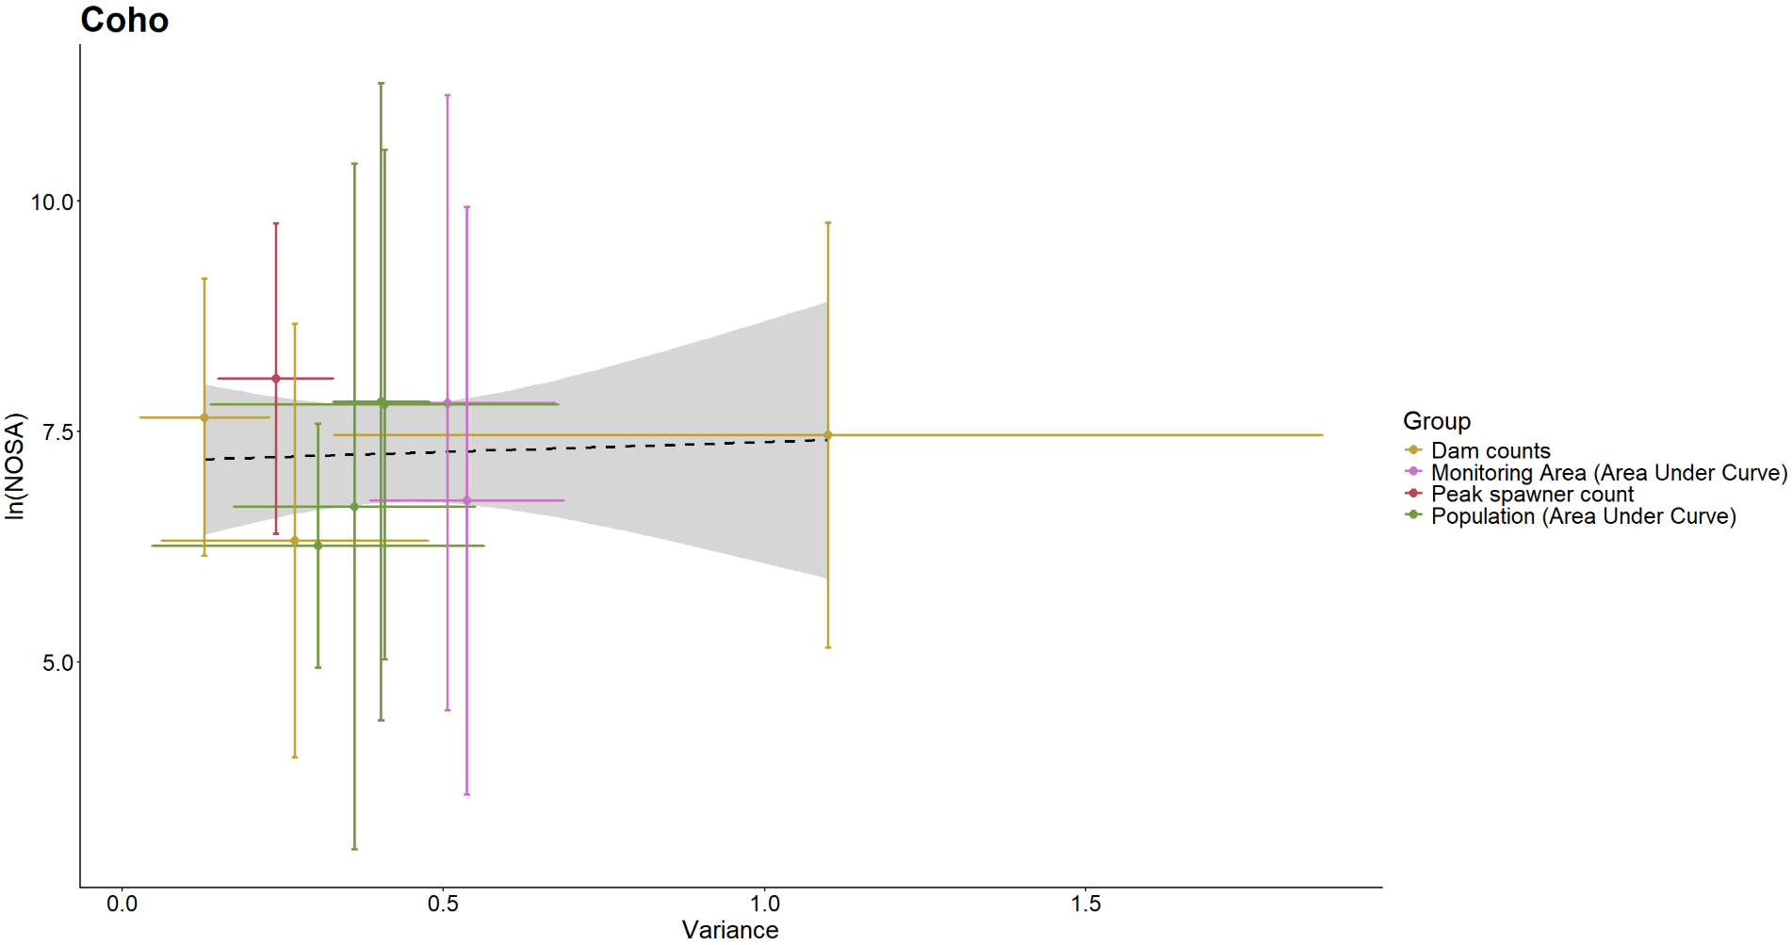 Figure B10: Relationship between variance associated with coho survey methods and population sizes being surveyed.
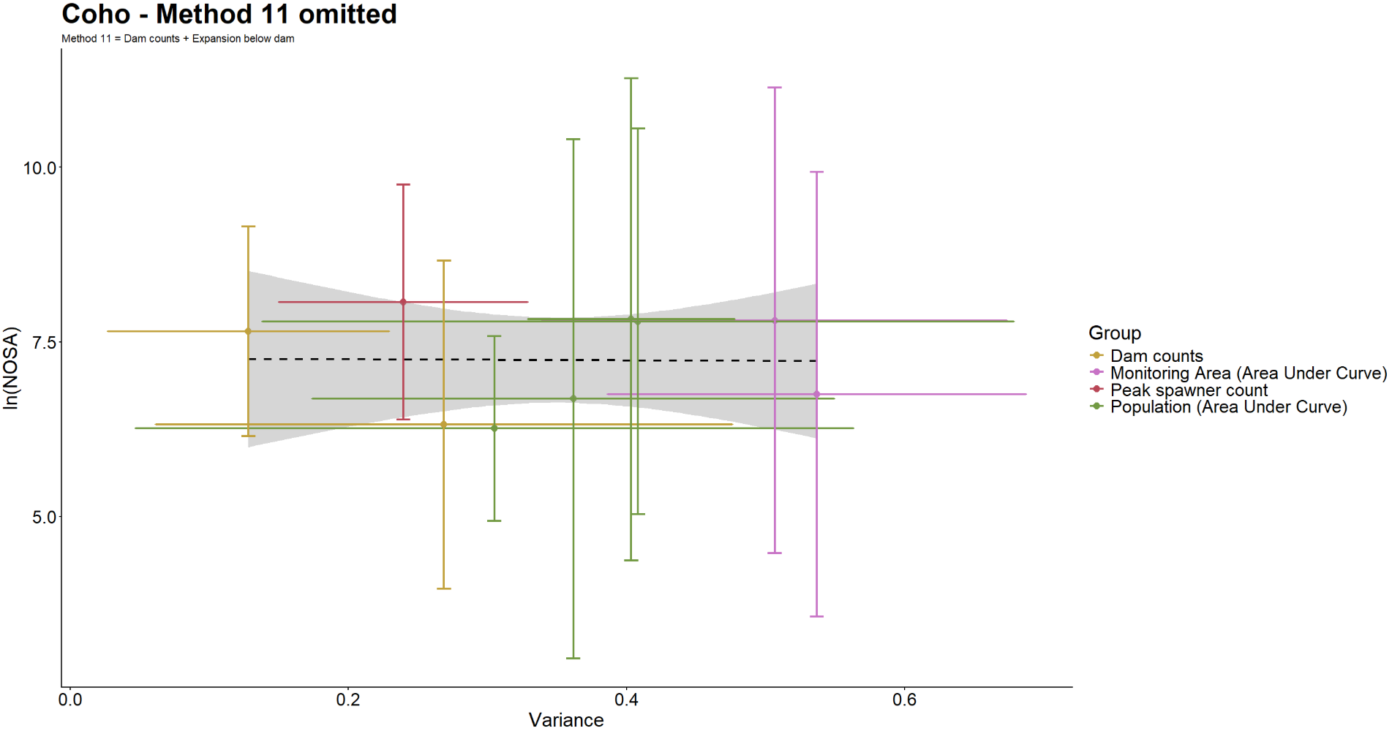 Figure B11: Relationship between variance associated with coho survey methods and population sizes being surveyed. ‘Dam counts + Expansion below dam’ is omitted as an outlier.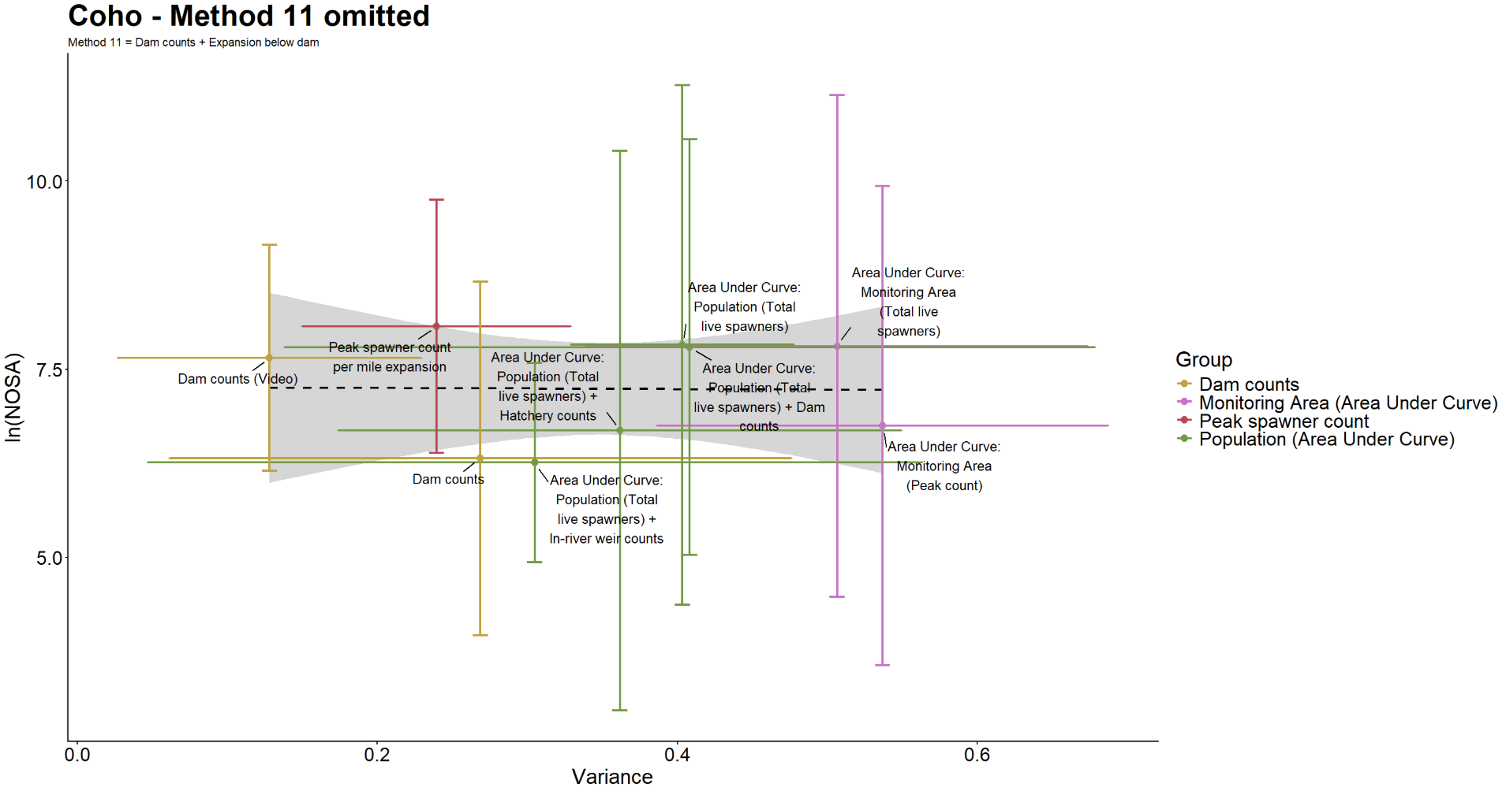 Figure B12: Relationship between variance associated with coho survey methods and population sizes being surveyed. ‘Dam counts + Expansion below dam’ is omitted as an outlier. 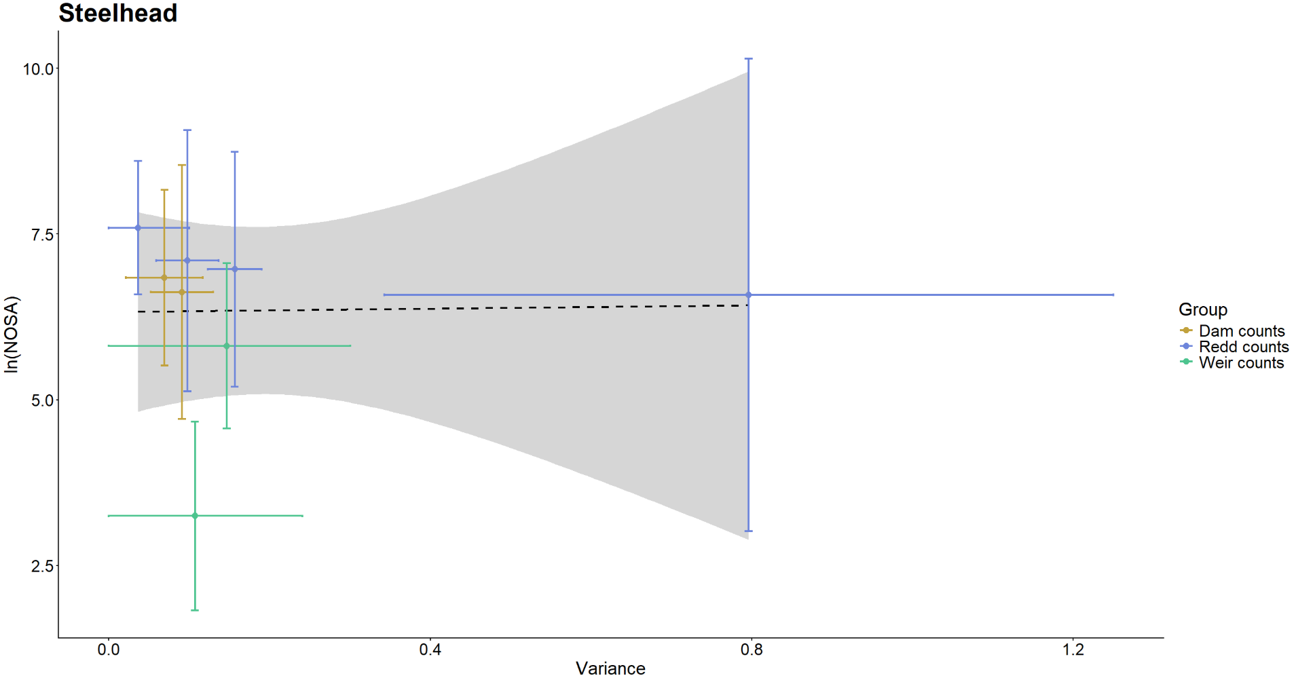 Figure B13: Relationship between variance associated with Steelhead survey methods and population sizes being surveyed. 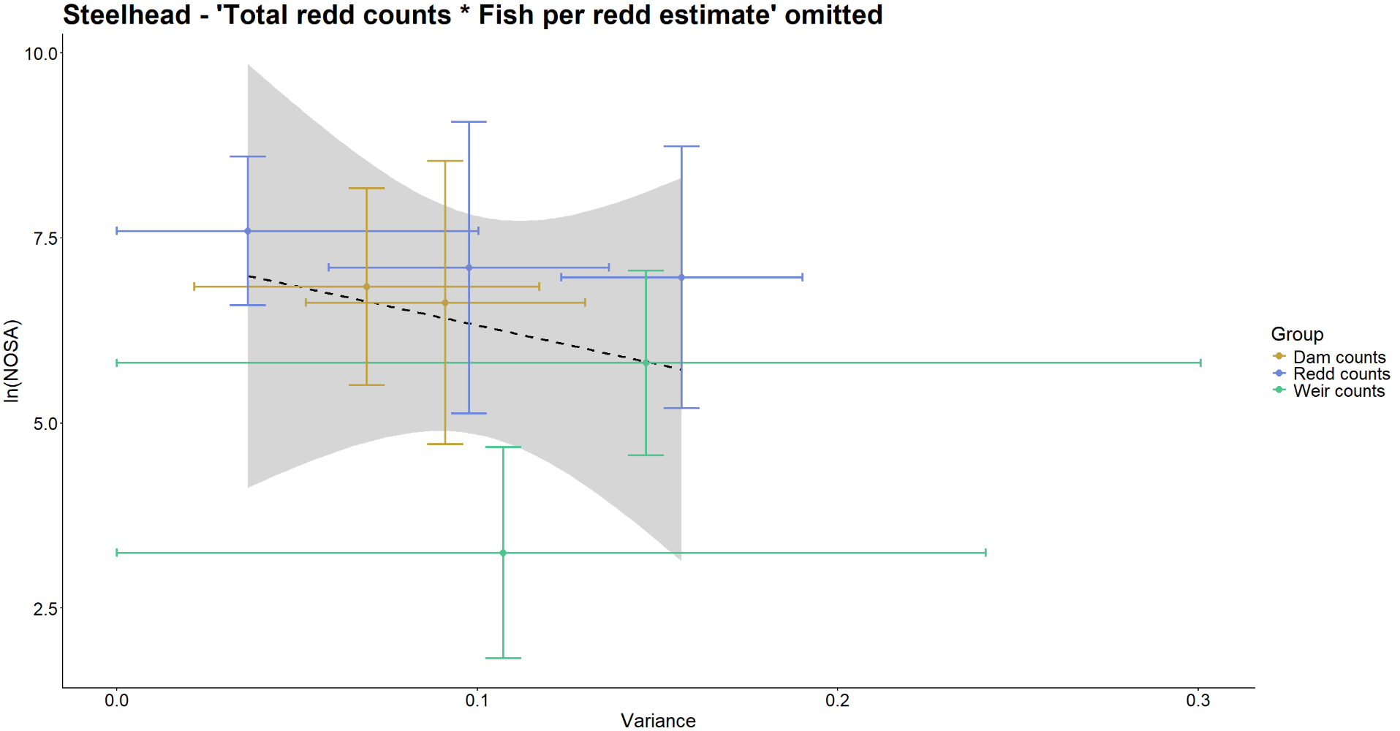 Figure B14: Relationship between variance associated with Steelhead survey methods and population sizes being surveyed. ‘Total redd counts * Fish per redd estimate’ is omitted as an outlier.
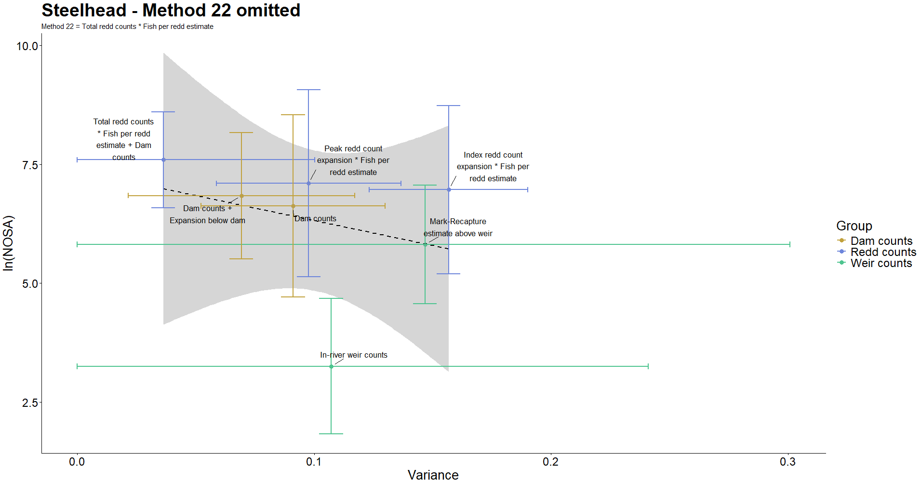 Figure B15: Relationship between variance associated with Steelhead survey methods and population sizes being surveyed. ‘Total redd counts * Fish per redd estimate’ is omitted as an outlier.

