Results
AICc comparisons find that, for all three species, best fit models include a u vector set to zero and a Q matrix specified to allow all populations to share an identical variance term and all pairs of states to share an identical covariance term. Recall also that, because MARSS models are unable to estimate bias parameters without a reference method, the bias results described in this section are estimated relative to the ‘Dam Counts’ method. This method is chosen for two reasons: 1) ‘Dam Counts’ have been found to be generally accurate and unbiased, and 2) ‘Dam Counts’ is employed in surveys for all three species in this study (Parsons and Skalski 2010). Throughout this section ‘Dam Counts’ will be treated as unbiased, although it must be noted that these results are relative and not absolute. The method with the strongest positive directional bias for a given species would be the same regardless of reference method chosen, and model fit would be unchanged.
In log space, most survey methods analyzed (14 out of 27) are not found to be directionally biased by more than 0.5, and 21 of 27 methods are not found to be directionally biased by more than 1. Similarly the variances associated with survey methods are found to be less than 0.5 in 22 of 28 methods analyzed (Table 1). This generally high level of accuracy speaks to the expertise of the fisheries biologists and technicians who have designed, refined, and regularly implement these survey methods. However, while these numbers are small, it must be remembered that they represent terms being linearly added or subtracted from log-transformed counts, meaning an offset of 0.5 scales in linear space depending on where in log space this offset is taking place. For example, if a

Table 1: Variance and relative bias associated with various observation processes (survey methods), estimated separately by species. Directional bias measured relative to ‘Dam Counts’ method for all species.
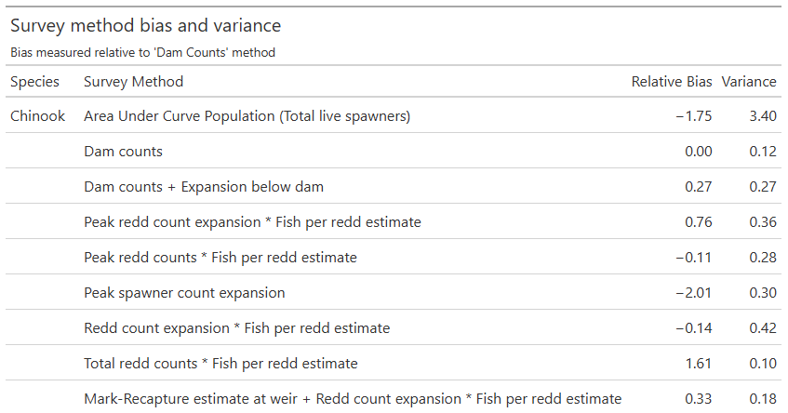
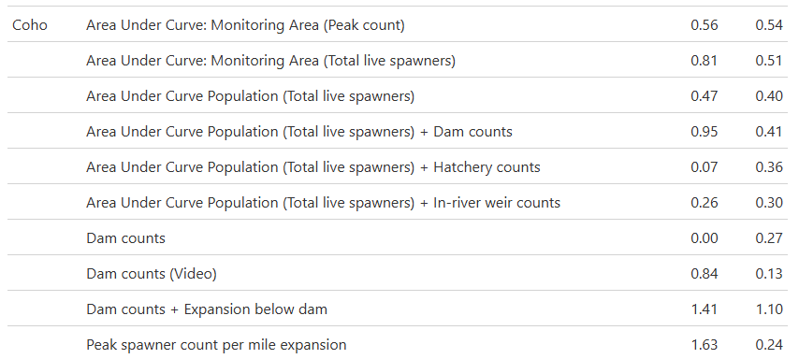
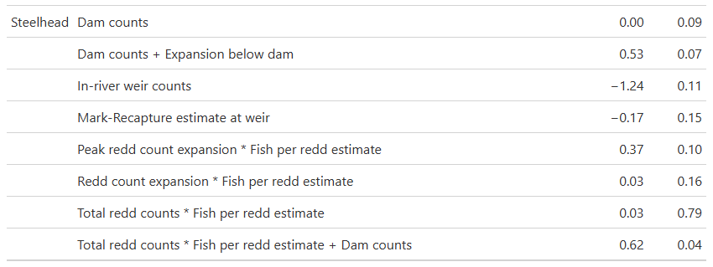

Chinook population surveyed is 1,000 fish (6.908 in log space), a log space offset of 0.5 would correspond to an additional 648 salmon, while the same offset applied to a population of 100 salmon would correspond to an additional 64 fish.

Chinook
Half of the Chinook survey methods analyzed in this study are biased by less than ±0.5 compared to the ‘Dam Counts’ method (Figure 4), and with the majority of observations occurring in populations between 100 and 1,000 fish these relatively small biases do not represent huge numbers of fish over or undercounted (Figure 21). ‘Area Under Curve:
Table 2: Frequency of Oregon Chinook annual survey methods by Evolutionarily Significant Unit (ESU), 1980-2024.
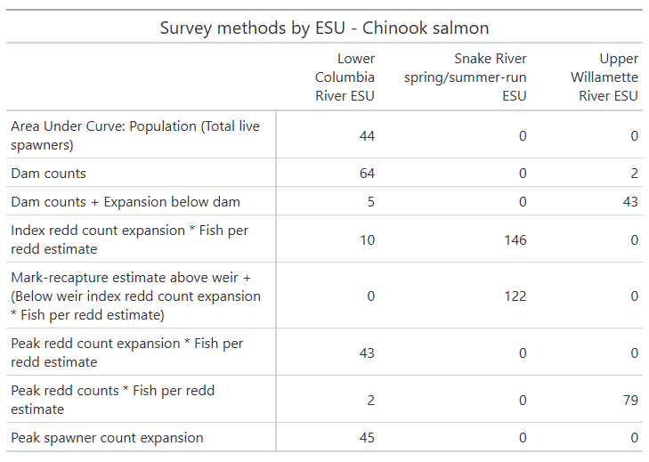
Population (Total live spawners)’ and ‘Peak spawner count expansion’ exhibit a tendency to undercount the underlying number of spawners, while the strongest positive bias is associated with the ‘Total redd counts * Fish per redd estimate’ method (Figure 4). The ‘Peak spawner count expansion’ method indeed exhibits the highest magnitude bias term associated with any survey method in this study (Table 1), a notable finding given that this method is almost exclusively applied to surveying populations of fewer than 100 individuals (Figure 21). The on-the-ground impact of these directional biases are seen most starkly in the Lower Columbia River ESU (Figure 5) due to the frequent employment of the ‘Area Under Curve: Population (Total live spawners)’ and ‘Peak spawner count expansion’ methods, which are not employed at all in other Chinook ESUs and are also both frequently employed in the monitoring of smaller populations (Table 2, Figure 21).
In terms of statistical precision (defined as σ⁻²), the ‘Area Under Curve: Population (Total live spawners)’ method is far less precise than every other method employed in Chinook surveys. Beyond this, the methods ‘Peak redd count expansion * Fish per redd estimate’, ‘Peak spawner count expansion’, ‘Peak redd counts * Fish per redd estimate’, and ‘Redd count expansion * Fish per redd estimate’ exhibit low levels of precision, though none are nearly as imprecise as the ‘Area Under Curve: Population (Total live spawners)’ method (Figure 6). Common to three of these methods are the use of fish per redd estimates, although the methods ‘Total redd counts * Fish per redd estimate’ and ‘Mark-Recapture estimate at weir + Redd count expansion * Fish per redd estimate’ likewise make use of fish per redd estimates in scaling their overall estimates but exhibit higher levels of precision. Two of the five least precise methods are frequently employed in the Lower Columbia River ESU (Table 2), meaning that not only does this ESU have a strong tendency towards biased population estimates, but also that those estimates are accompanied by a high degree of inherent uncertainty (Figure 7).
The majority of Chinook populations analyzed are not found to be heavily over- or undercounted, with most observed data points falling within a 95% confidence interval of the underlying state estimate across most populations (Figure 8). Once again, this general behavior reflects the care and expertise involved in Oregon’s salmon monitoring programs. However, there are some notable exceptions to this pattern. The exclusive use of the ‘Total redd counts * Fish per redd estimate’ method, shown to be the most upwardly biased Chinook survey method of any examined, has driven notable overcounts across all three John Day River populations, in which at no point during the study period does the observed time series cross the 95% confidence interval of the underlying state estimate. Similarly, exclusive reliance on the ‘Peak redd count expansion * Fish per redd estimate’ method, the second most upwardly biased Chinook survey method included in this study, has led to the Sandy River fall run also tending to be overcounted, though not to the same degree as the John Day populations (many years’ observations fall easily within the state estimate’s 95% confidence interval). The most undercounted populations in this study (Big Creek, Youngs Bay, Clatskanie River, and the Clackamas River fall run) are all measured using either the ‘Area Under Curve: Population (Total live spawners)’ or ‘Peak spawner count expansion’ method, not surprisingly the two most downwardly biased Chinook survey methods analyzed in this study. The Big Creek and Clatskanie River populations are of particular interest as they are two of the smallest populations surveyed, and these methods’

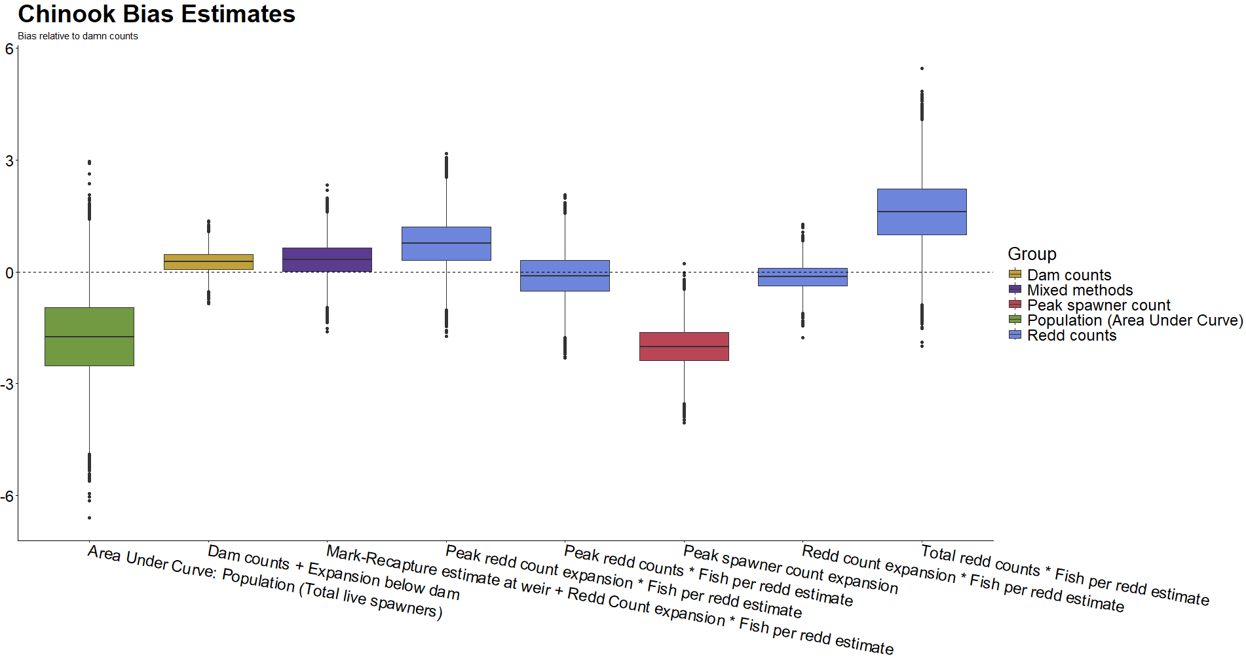 Figure 4: Directional bias in Chinook survey methods as measured relative to ‘Dam Counts’ method (not pictured). As a result, dashed line at zero does not relate to statistical confidence. Color groupings are non-scientific and intended only as reference.
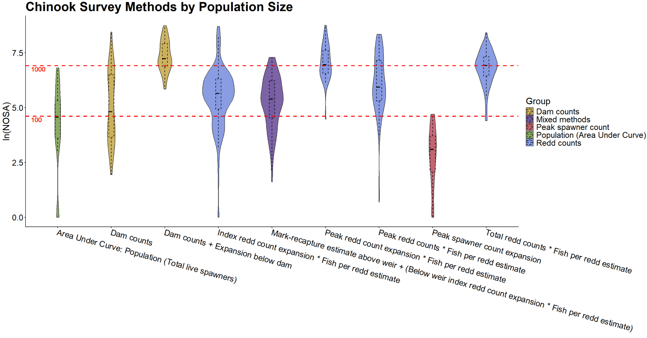 Figure 21: Distribution of Chinook survey method use relative to the size of the population being surveyed. Red dashed lines represent populations of one hundred and one thousand fish in linear space. 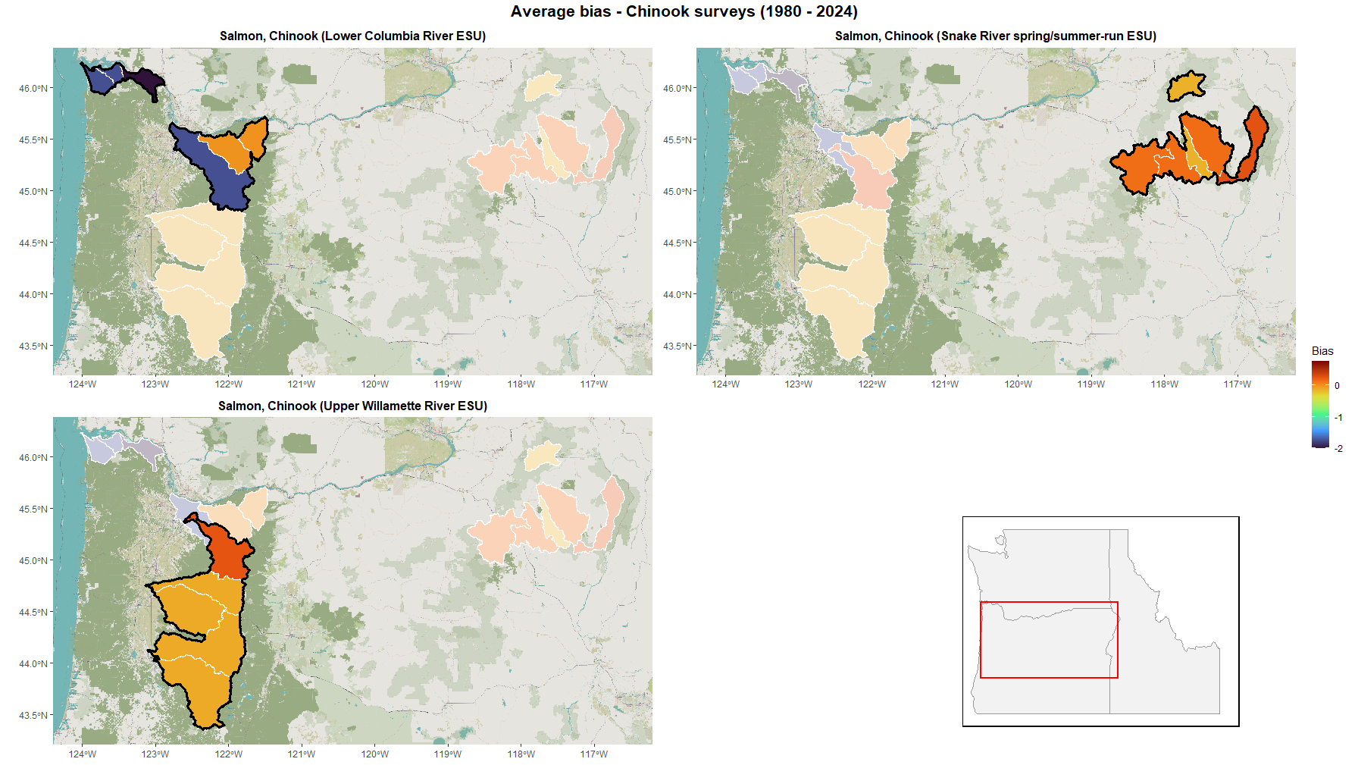 Figure 5: Average directional bias due to choice of survey methods across Oregon Chinook populations from 1980-2024. Survey method bias estimated relative to ‘Dam Counts’ method.
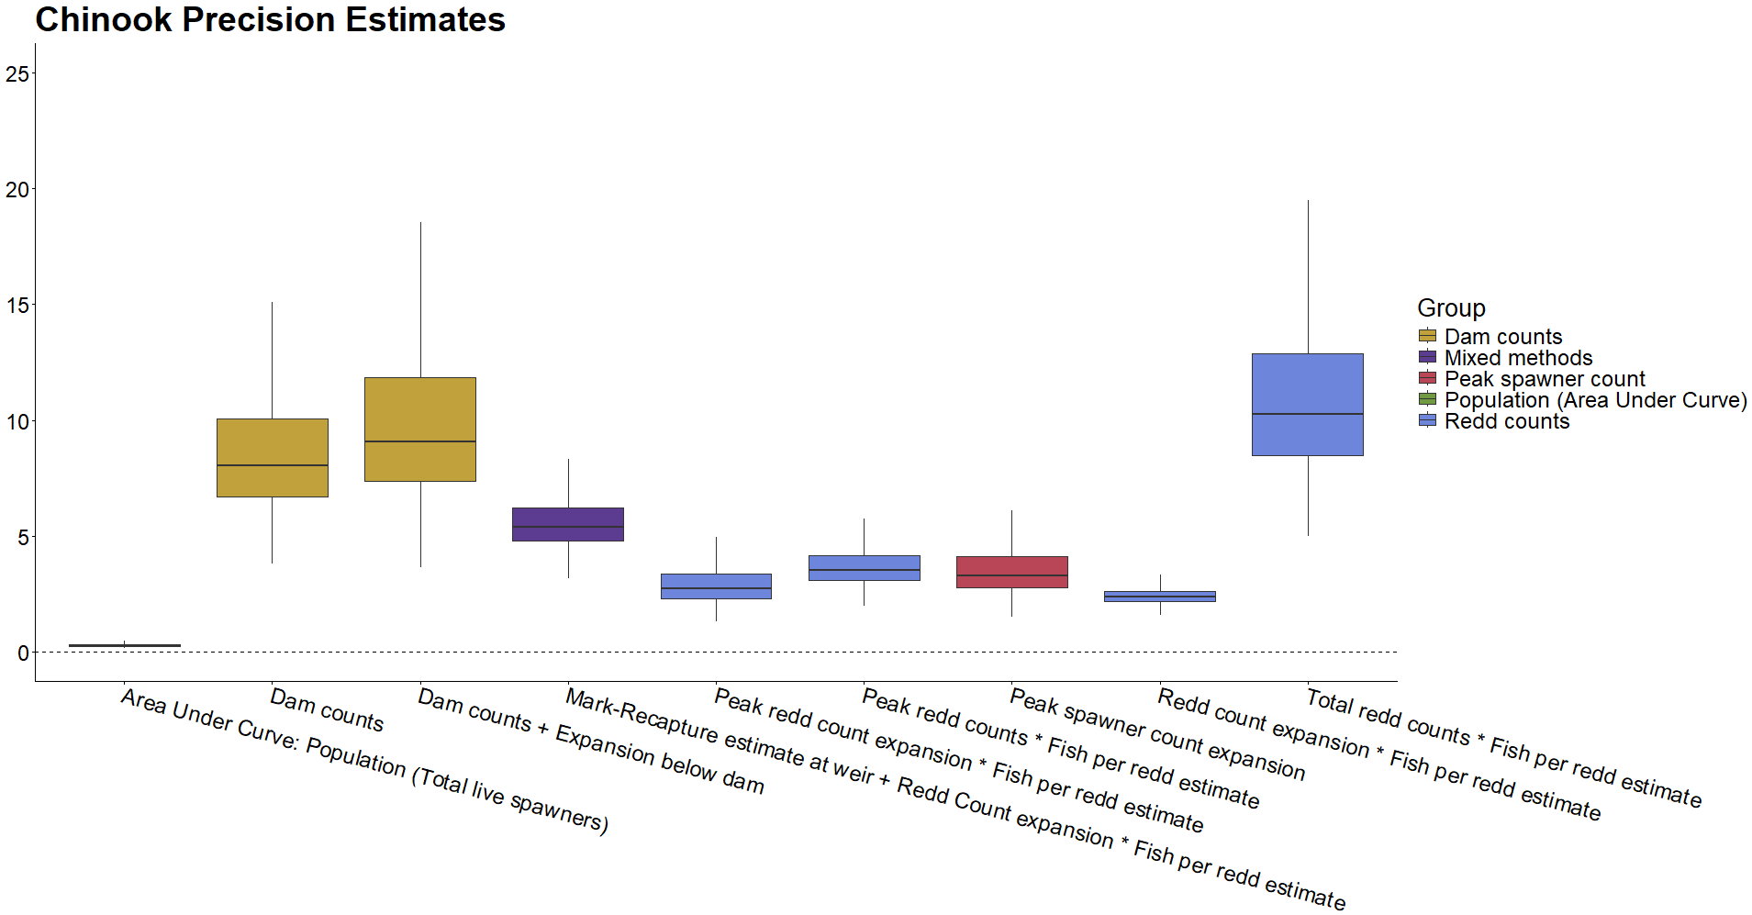 Figure 6: Precision (σ⁻²) in Chinook survey methods. Color groupings are non-scientific and intended only as reference.
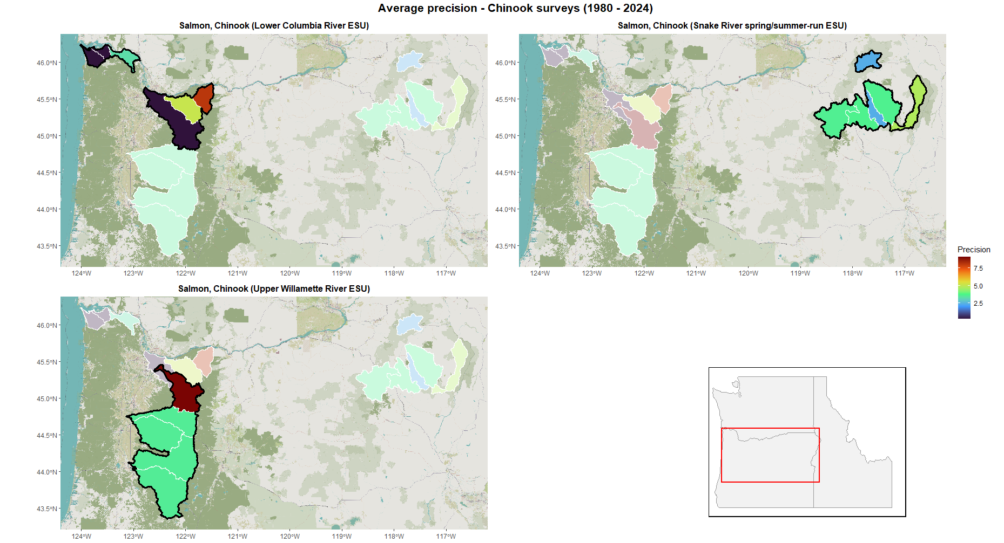 Figure 7: Average precision due to choice of survey methods across Oregon Chinook populations from 1980-2024. 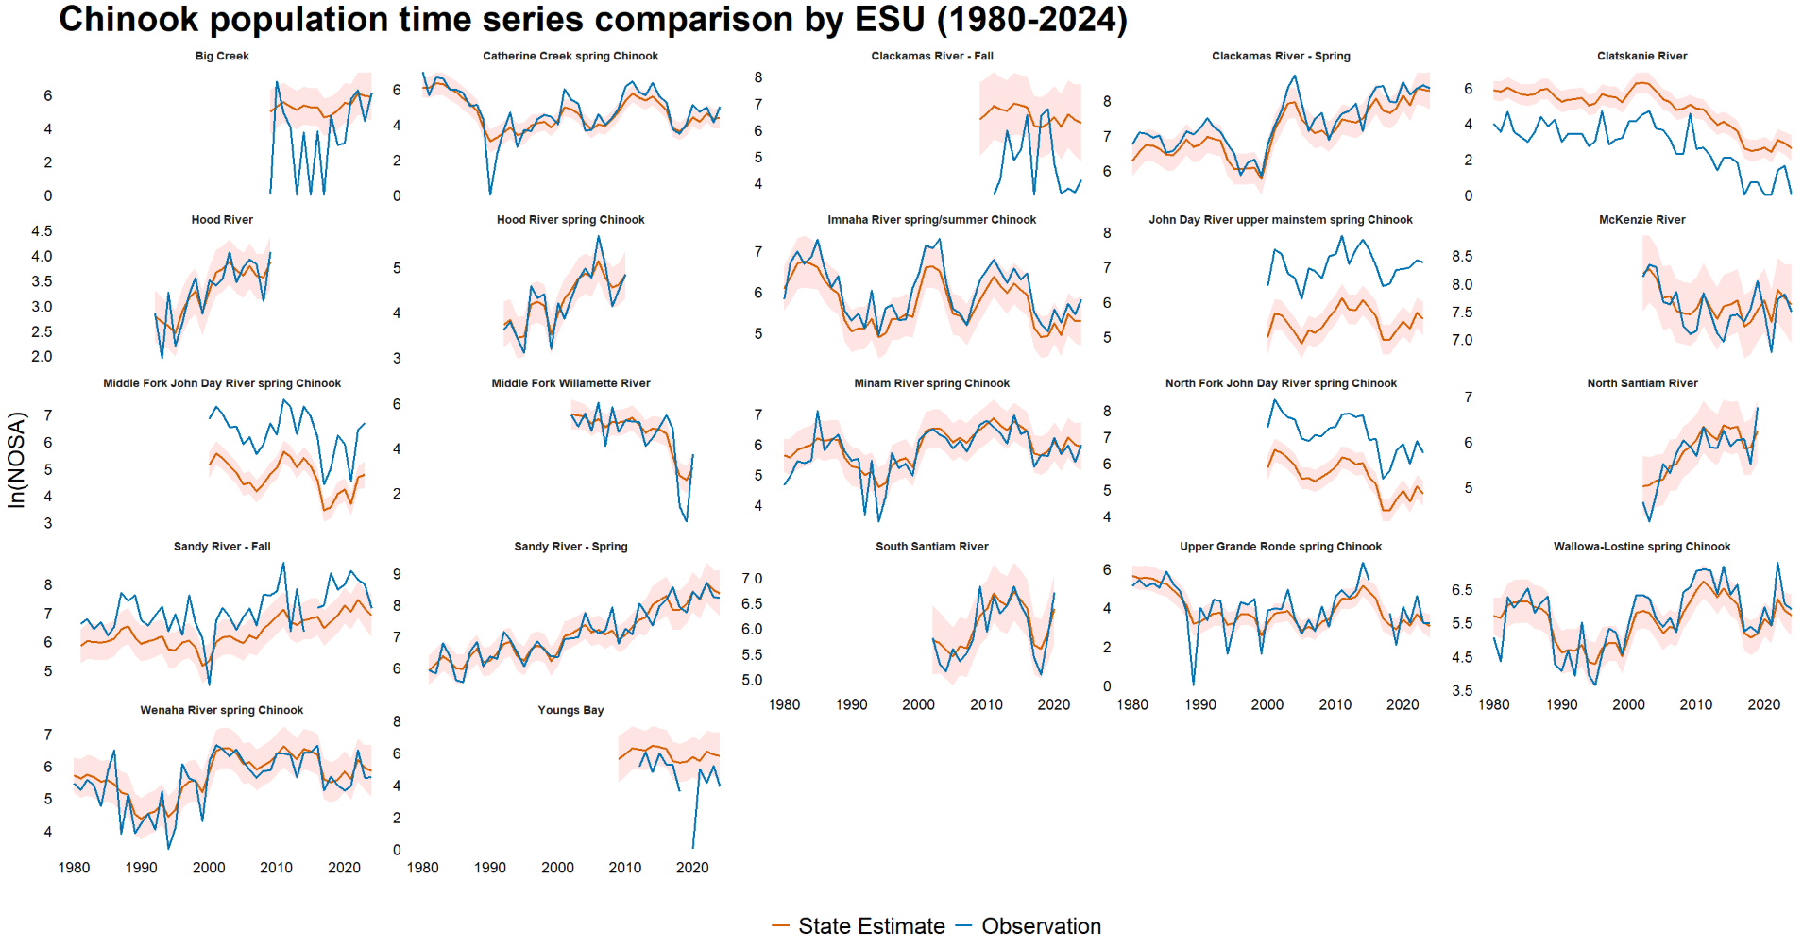Figure 8: Population level comparison of fitted abundance estimates (red) and observations (blue) of Oregon Chinook from 1980 – 2024.

tendencies to undercount fish implies that these small populations are in fact more numerous than the data suggests.

Coho
The methods used to survey coho are all found to have positive relative biases (as compared to the zero-value associated with the ‘Dam counts’ reference method), although bootstrapped parameter estimates are at least occasionally negative (beyond outliers) for most methods studied (Figure 10). No particular method vastly exceeds the rest in the magnitude of this upward bias, and neither is any method exclusively employed to survey populations of certain size (Figure 23). Although this behavior is not the most pronounced in ‘Area Under Curve’ survey methods, the tendency towards upward bias is especially worth noting in relation to these methods, as they are very frequently employed in coho monitoring, especially in the Oregon Coast ESU (Table 4). Coho populations in this study are often much larger than Chinook or steelhead populations, meaning that seemingly small positive bias terms can still translate to large numbers of nonexistent fish being counted (Figure 23). These tendencies towards overestimation are seen most starkly in the survey methods employed in the Oregon Coast ESU, but due to all survey methods being associated with some positive bias, some populations in the Lower Columbia River ESU likewise tend to be upwardly biased (Figure 11). Taken in aggregate however, the positive biases associated with surveys conducted within the Oregon Coast ESU could lead to the ESU-level coho abundance being more significantly overestimated, due to this ESU’s much larger number of constituent populations (21 populations in the Oregon Coast ESU compared to 6 in the Lower Columbia River ESU).
The methods employed to survey coho tend to be associated with much lower precision than those employed in Chinook surveys (Figure 12). This may be in part due to the late-year run timing of coho necessitating that surveys take place during periods of inclement weather
Table 4: Frequency of Oregon coho annual survey methods by Evolutionarily Significant Unit (ESU), 1980-2024.
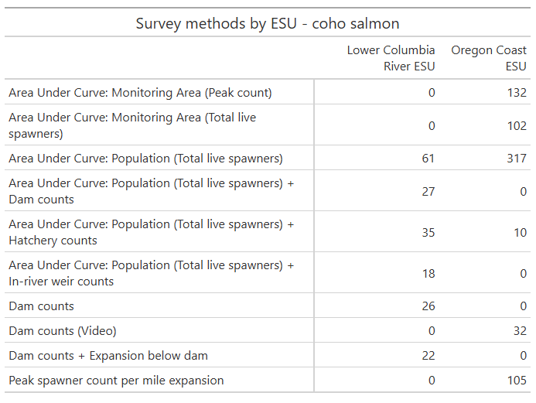
and high stream flows (National Marine Fisheries Service 2016). The ‘Dam counts + Expansion below dam’ method is found to be particularly imprecise compared to the other methods analyzed, although it should be noted that ‘Dam counts + Expansion below dam’ is also one of the least employed methods across both coho ESUs in this study, meaning its impact on the veracity of counts at the ESU level is likely negligible. Of greater interest is the somewhat low precision associated with certain ‘Area Under Curve’ methods – particularly ‘Area Under Curve: Monitoring Area (Peak count)’, ‘Area Under Curve: Monitoring Area (Total live spawners)’, and ‘Area Under Curve: Population (Total live spawners)’. These three methods together make up the majority of methods used to sample coho in this study, accounting for almost 80% of surveys conducted in the Oregon Coast ESU (Table 4). The predominance of these methods and their effects can be seen in the low precision associated with most populations in the Oregon Coast ESU (Figure 13). The Lower Columbia River ESU is generally more precisely surveyed but is still subject to high level of imprecision compared to the ESUs and DPSs of other species in this study.
A common pattern is seen when examining the population level differences between coho observations and underlying state estimates: in many populations, observations consistently hover above underlying state point estimates while dancing in and out of the 95% confidence intervals over the duration of the time series (Figure 14). This pattern is particularly prominent in populations which heavily rely on ‘Area Under Curve’ survey methods, such as (but not limited to) Beaver Creek, Coquille River, the Umpqua River populations, and Tillamook Bay. Beyond this general pattern, a few coho populations are more noticeably overcounted. Due to exclusive reliance on the exclusively using the ‘Peak spawner count per mile expansion’ survey method, the most upwardly biased of all coho survey methods analyzed, Siltcoos Lake, Tahkenitch Lake, and Tenmile Lake observations rarely cross their underlying state estimates’ 95% confidence intervals.

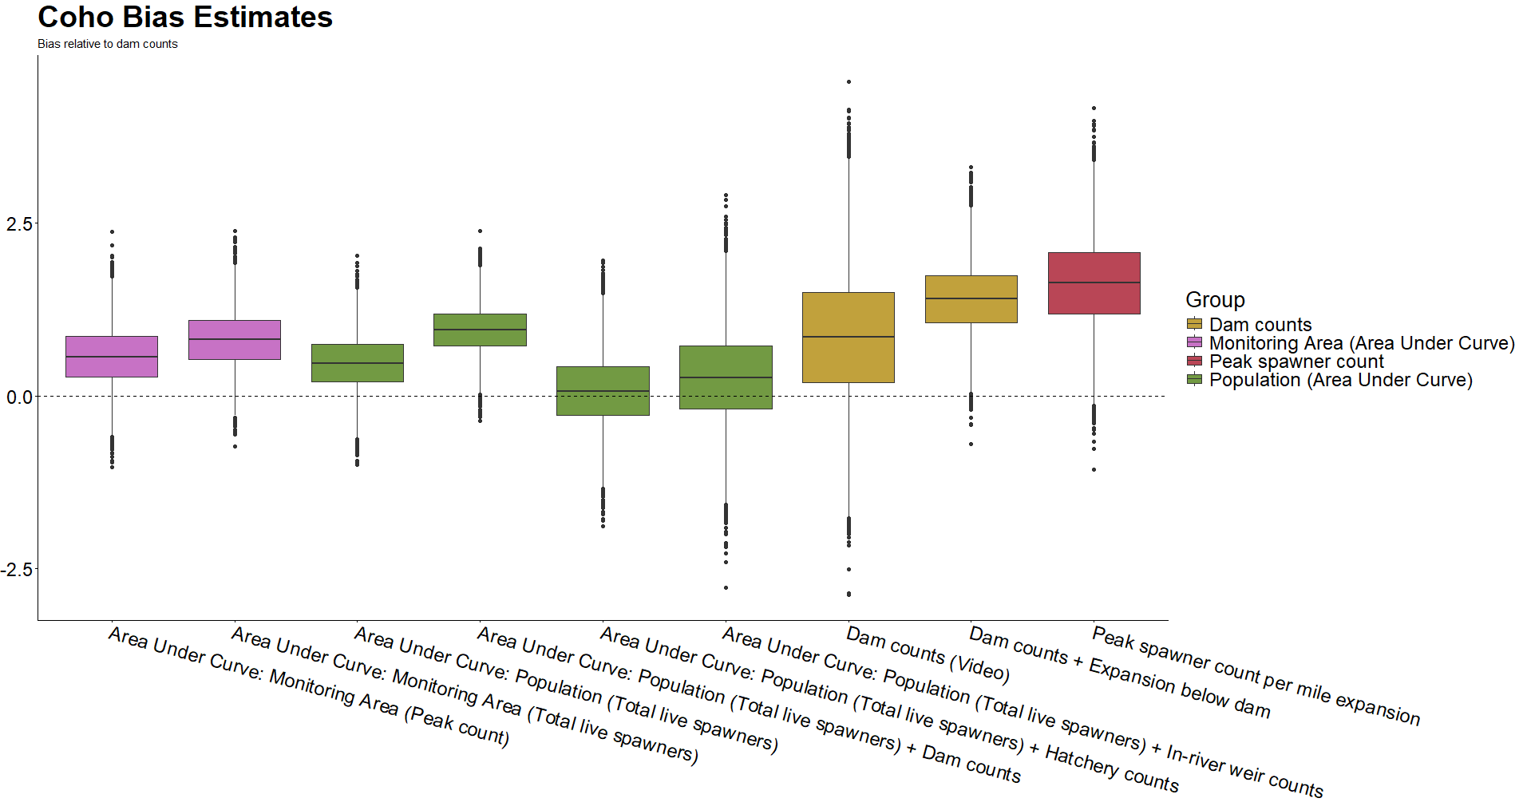 Figure 10: Directional bias in coho survey methods as measured relative to ‘Dam Counts’ method (not pictured). As a result, dashed line at zero does not relate to statistical confidence. Color groupings are non-scientific and intended only as reference.
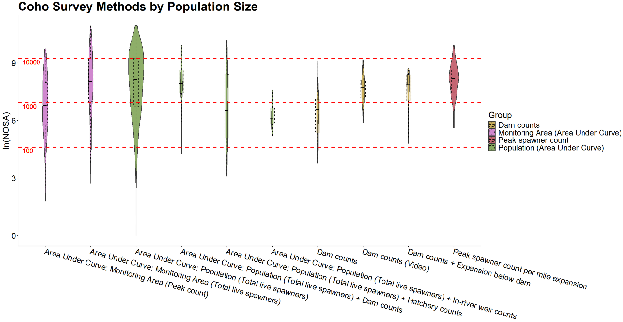 Figure 23: Distribution of coho survey method use relative to the size of the population being surveyed. Red dashed lines represent populations of one hundred, one thousand, and ten thousand fish in linear space.

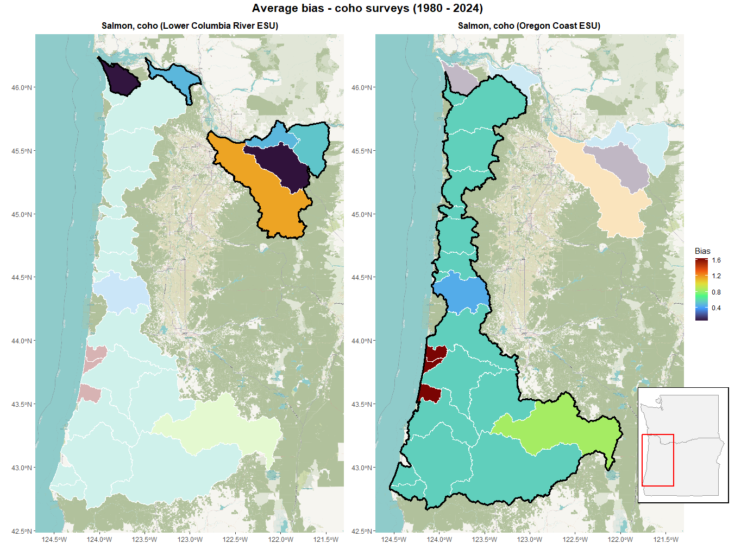
Figure 11: Average directional bias due to choice of survey methods across Oregon coho populations from 1980-2024. Survey method bias estimated relative to ‘Dam Counts’ method. Evolutionarily significant units (ESUs) outlined in black.
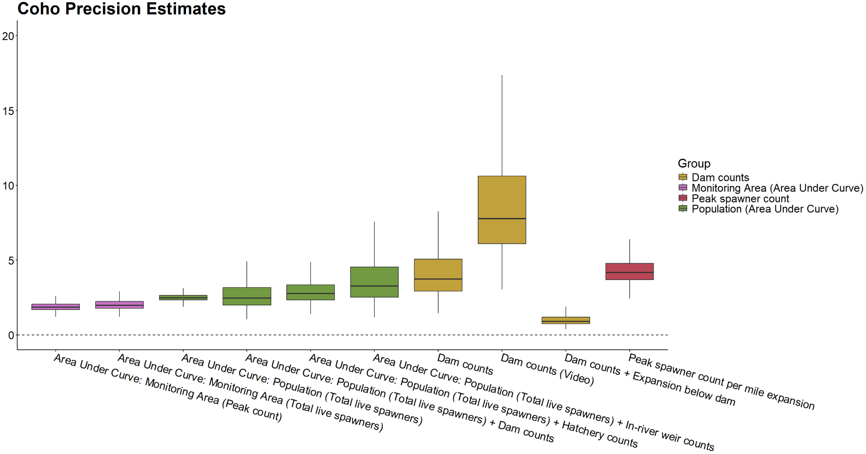 Figure 12: Precision (σ⁻²) in coho survey methods. Color groupings are non-scientific and intended only as reference.

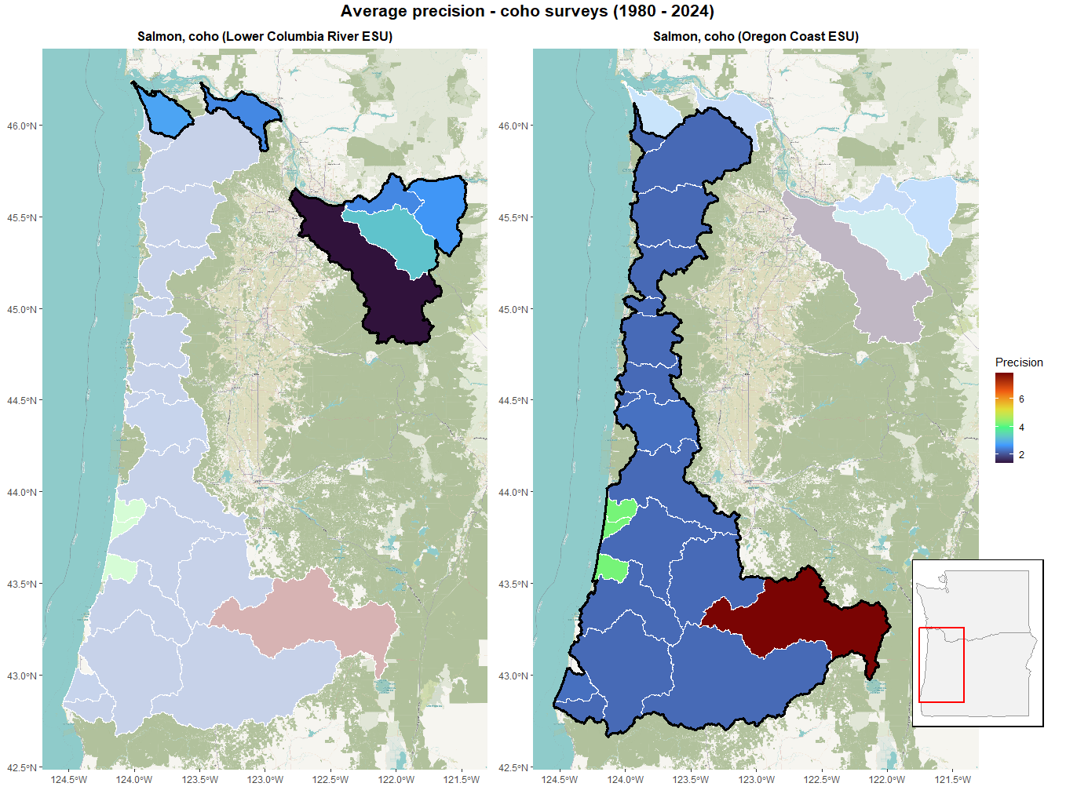
Figure 13: Average precision due to choice of survey methods across Oregon coho populations from 1980-2024. Evolutionarily significant units (ESUs) outlined in black.
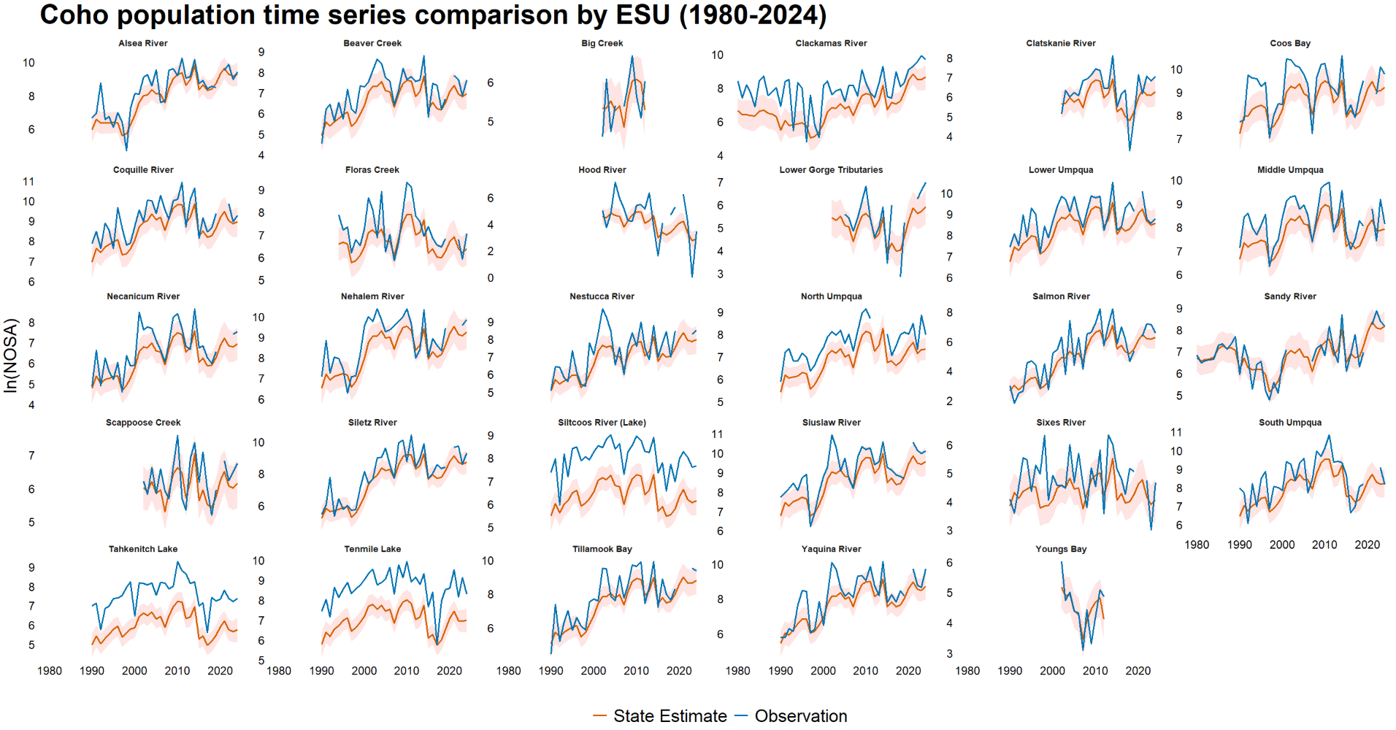Figure 14: Population level comparison of fitted abundance estimates (red) and observations (blue) of Oregon coho from 1980 – 2024.

Despite being measured by a variety of survey methods, Clackamas River observations also frequently exceed their underlying state’s 95% confidence interval. Recall that all coho survey methods analyzed in this study exhibit positive point estimates of bias parameters, which leads to very few instances where an observed value falls below the underlying state estimate for more than an occasional year.

Steelhead
With the exception on the ‘In-river weir counts’ method, the magnitude of bias associated with many steelhead survey methods (relative to the ‘Dam counts’ method) tends to be low (Table 1, Figure 16). The downward bias of the ‘In-river weir counts’ method, coupled with the fact that this method is almost exclusively used to survey populations of less than 100 fish, means that undercounts due to this method may not be enormous in terms of absolute numbers of fish (Figure 25). The two most positively biased methods are ‘Dam counts + Expansion below dam’ and ‘Total redd counts * Fish per redd estimate + Dam counts’, the latter of which is exclusively used to monitor populations of over 1,000 individuals. Of note is the most employed survey method for steelhead, ‘Redd count expansion * Fish per redd estimate’, which makes up roughly 52% of all DPS observations (Table 5). This frequently used method is not associated with a strong positive or negative relative bias, meaning average bias across most populations remains low, most especially in the Snake River Basin DPS and Middle Columbia River DPS, with the Snake River Basin DPS surveyed exclusively using this method (Figure 17). Among the four steelhead DPS, the Upper Willamette River DPS stands out due to its strong upward bias, as this DPS is exclusively surveyed using the ‘Peak redd count expansion * Fish per redd estimate’ method (Table 1, Figure 17).
Precision associated with steelhead survey methods is high compared with the estimates associated with Chinook and coho surveys. While the ‘Total redd counts * Fish
Table 5: Frequency of Oregon steelhead annual survey methods by Distinct Population Segment (DPS), 1980-2024. Note that, although the ‘In-river weir counts’ only appears in a DPS 3 times, this method was also employed in surveying populations outside of these DPSs, allowing for sufficient datapoints to estimate bias and variance terms.
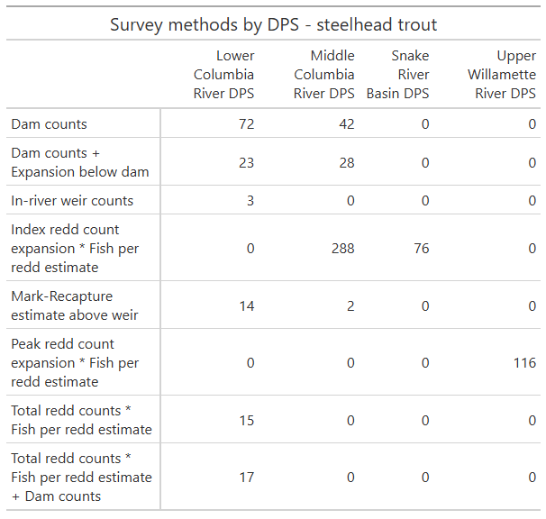

per redd estimate’ method stands out as being highly imprecise when compared to other steelhead survey methods, it is nonetheless quite accurate compared to the most imprecise methods for Chinook and coho (Figure 18). The reliance on singular survey methods across both the Snake River Basin DPS and Upper Willamette River DPS can be seen clearly on the landscape, where the Snake River Basin DPS’s constituent populations are consistently among the most imprecisely surveyed steelhead runs in this study (Figure 19).
Due to the relatively low absolute bias associated with the majority of steelhead survey methods, observations of steelhead populations tend to be closely associated with the underlying state estimates. The Walla Walla River is the only population that approaches the sort of drastic overcount described in some Chinook and coho populations wherein the observed abundances never or rarely cross the underlying state’s 95% confidence interval. Like many of the other populations in this study that have shown a consistent tendency towards over- or undercounting throughout the entirety of the time series, this behavior can be ascribed to Walla Walla River steelhead being counted exclusively using the ‘Dam counts + Expansion below dam’ method, shown to be the second most upwardly biased of all steelhead survey methods analyzed. The frequent employment of the ‘Peak redd count expansion * Fish per redd estimate’ method, the third most upwardly biased method employed in steelhead surveys, is likely responsible for some populations (the Calapooia River, Molalla River, and South Santiam River as examples) exhibiting similar behavior to the coho populations in which observations stay above underlying state point estimates while moving in and out of the states’ 95% confidence intervals.

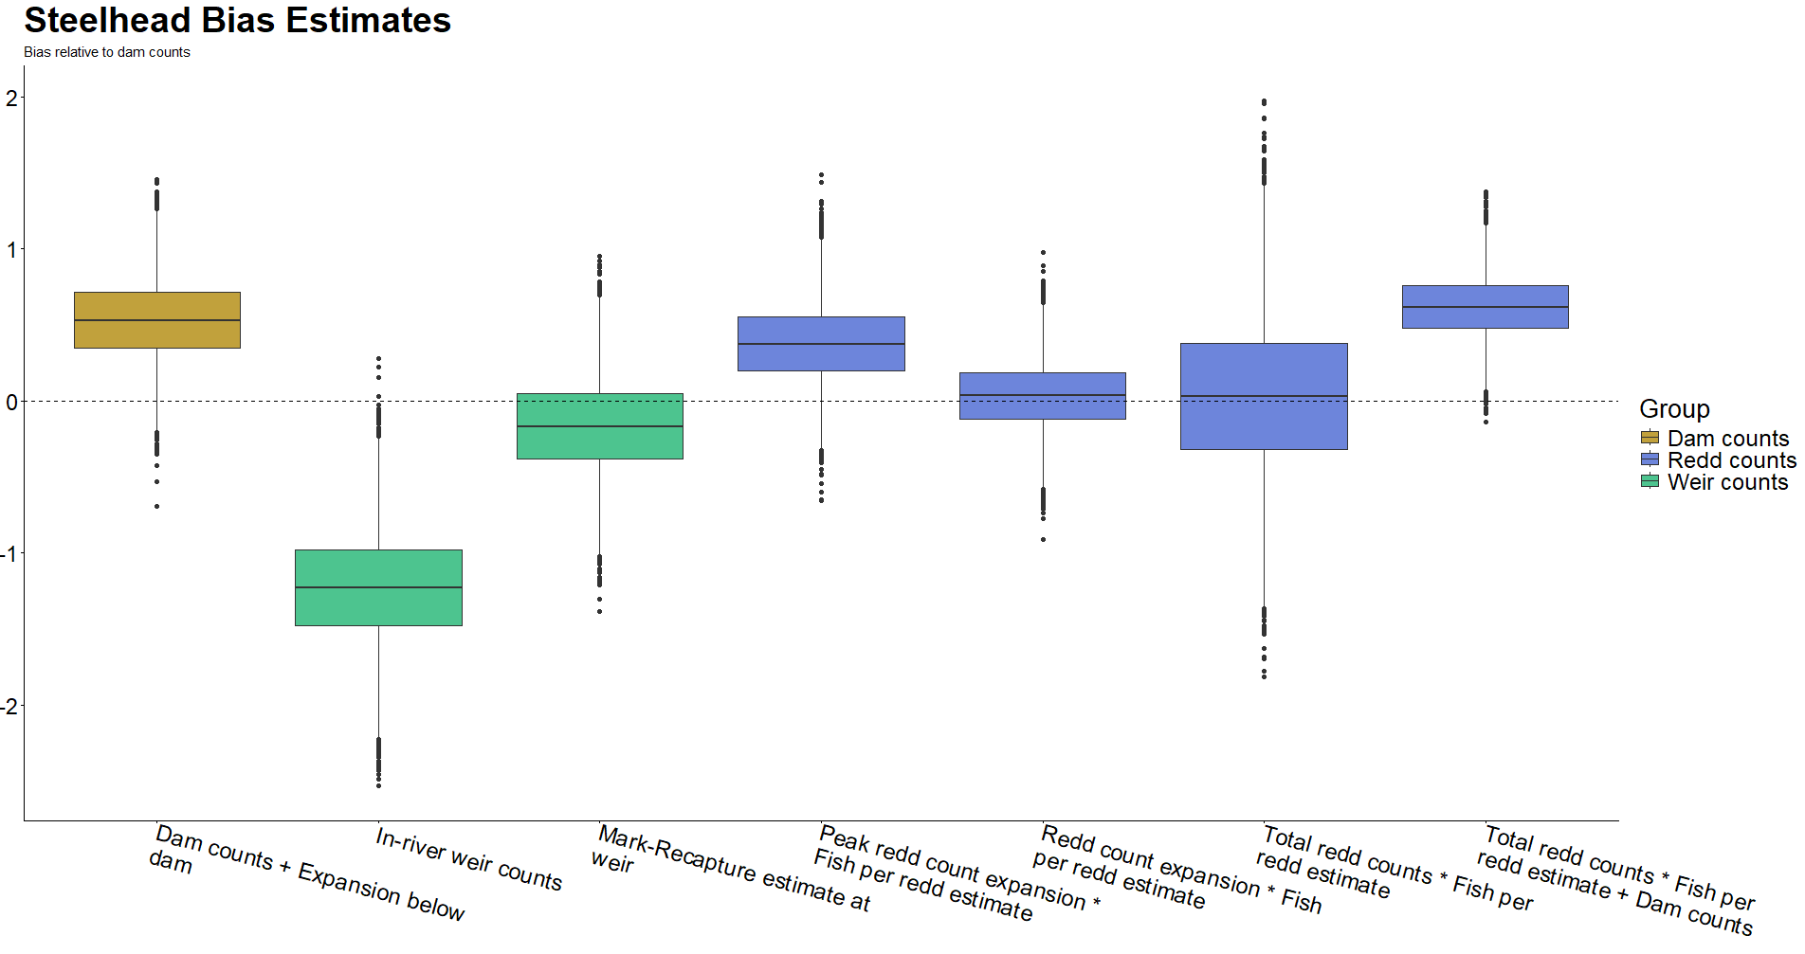 Figure 16: Directional bias in steelhead survey methods as measured relative to ‘Dam Counts’ method (not pictured). As a result, dashed line at zero does not relate to statistical confidence. Color groupings are non-scientific and intended only as reference. Figure 12: Observational variance in coho survey methods. Color groupings are non-scientific and intended only as reference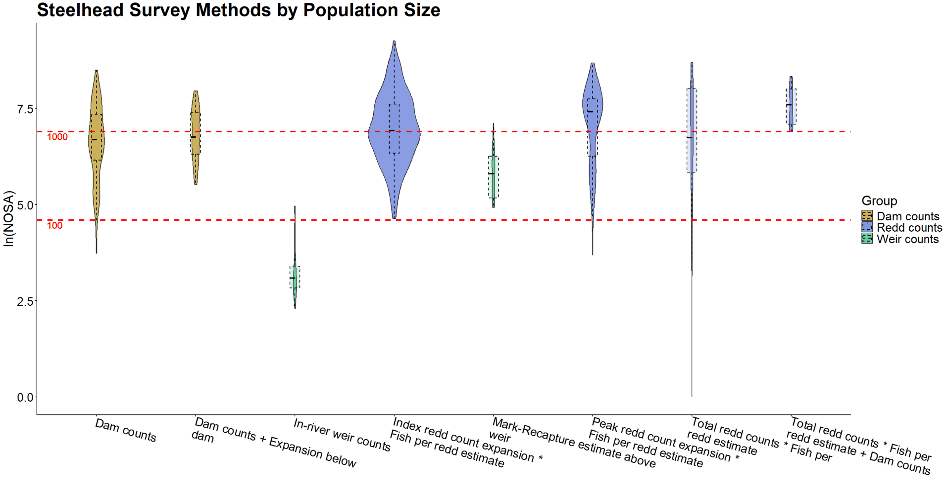 Figure 25: Distribution of steelhead survey method use relative to the size of the population being surveyed. Red dashed lines represent populations of one hundred and one thousand fish in linear space. 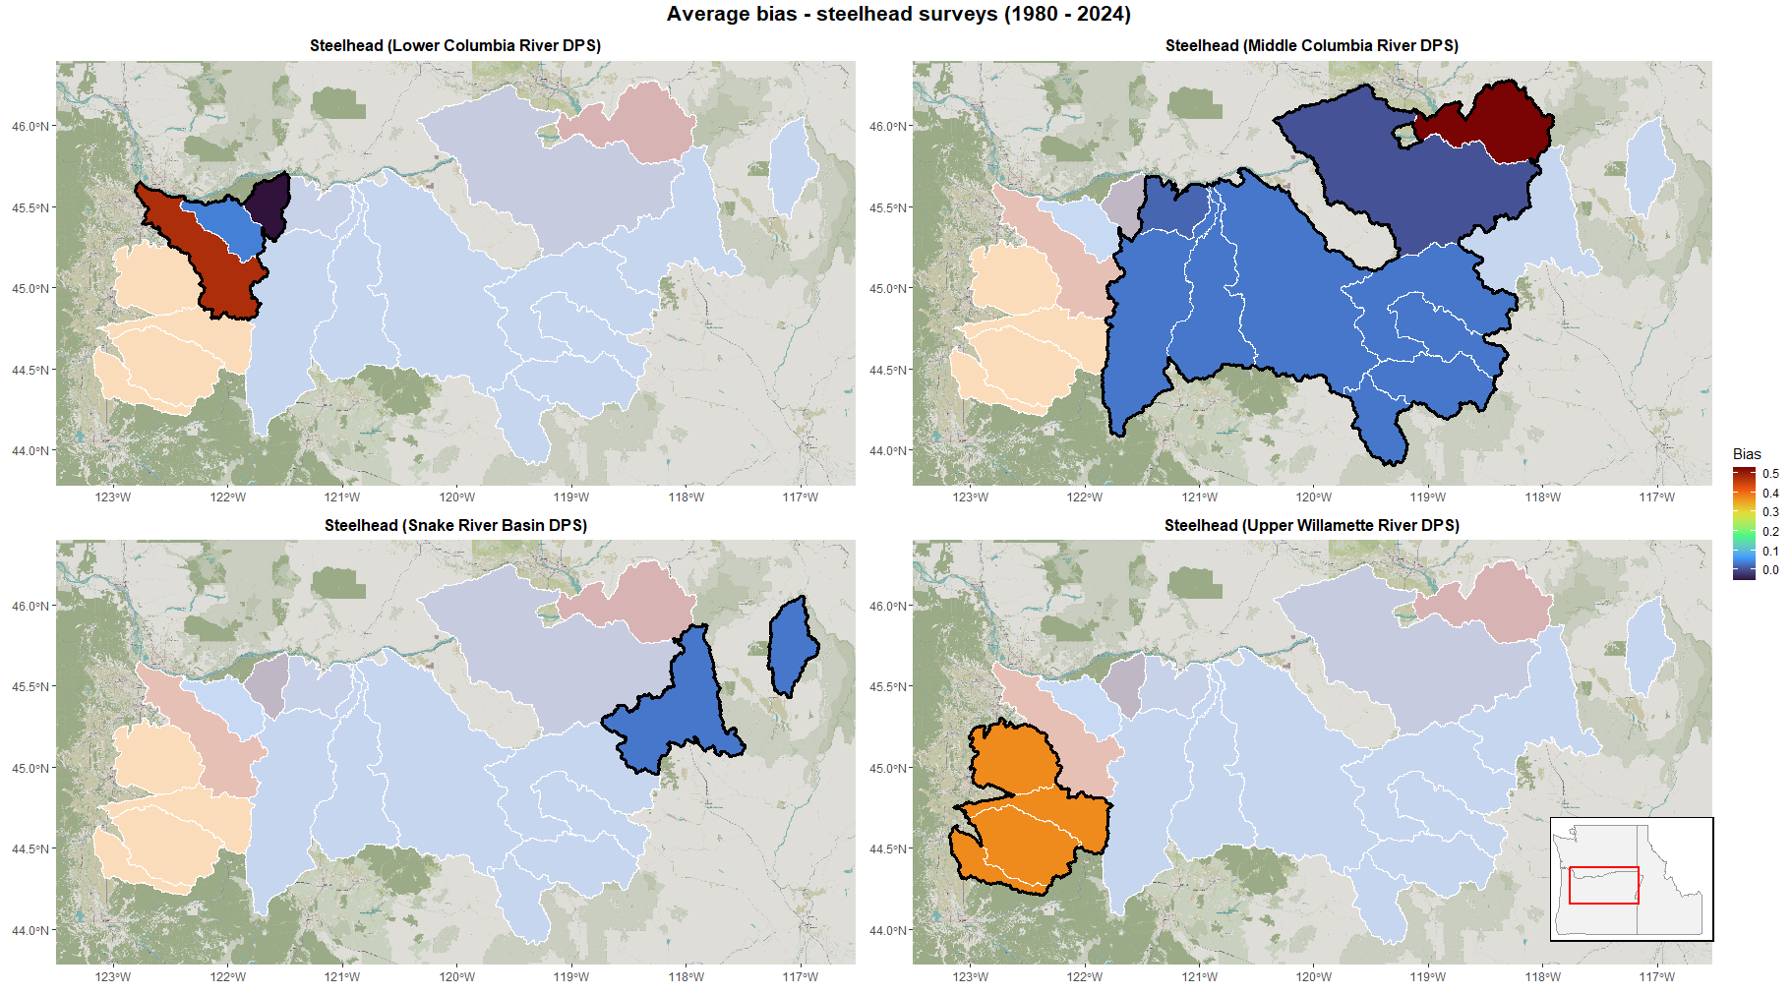 Figure 17: Average directional bias due to choice of survey methods across Oregon steelhead populations from 1980-2024. Survey method bias estimated relative to ‘Dam Counts’ method.
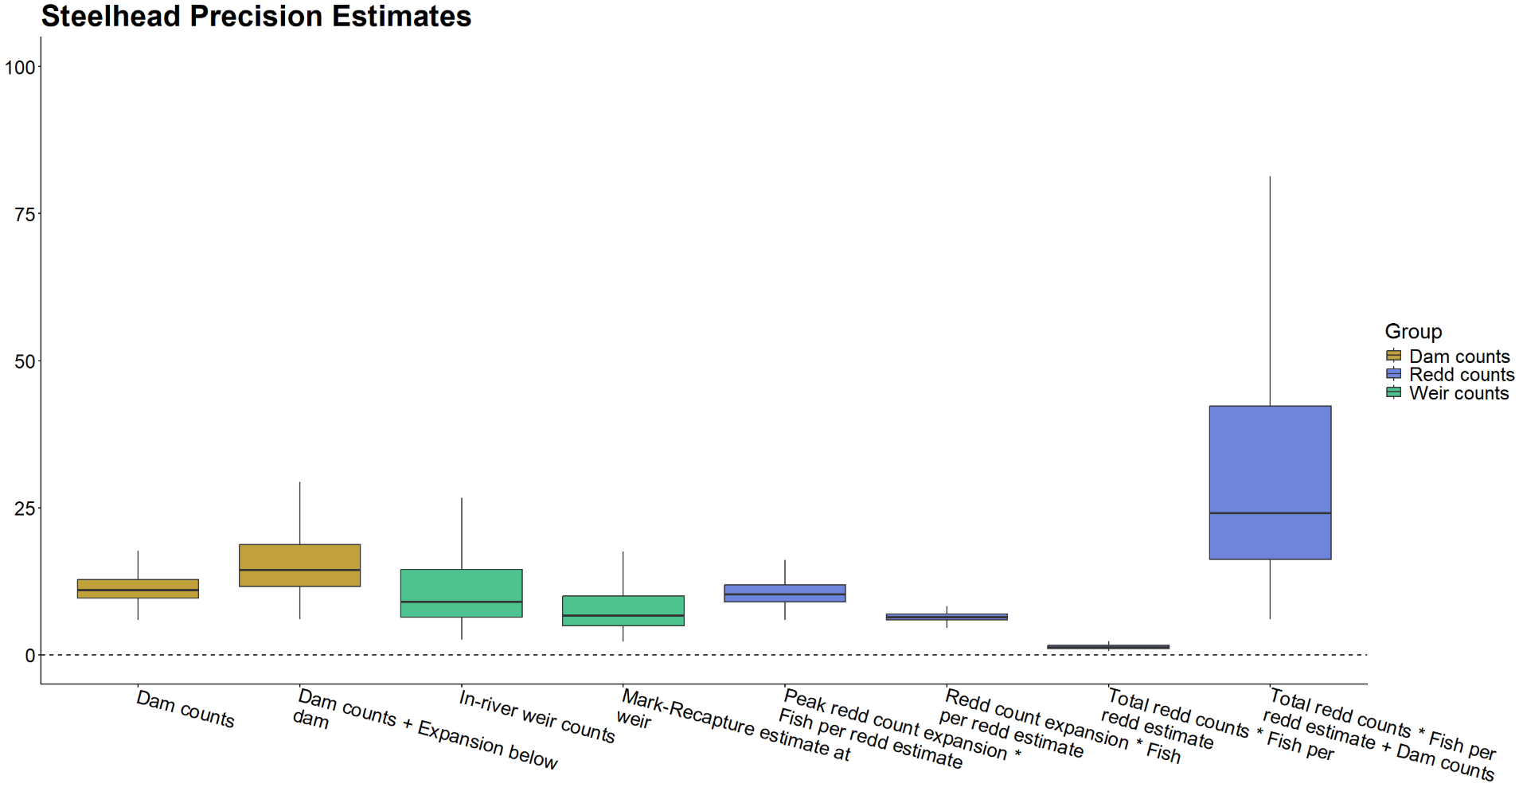 Figure 18: Precision (σ⁻²) in steelhead survey methods. Color groupings are non-scientific and intended only as reference.

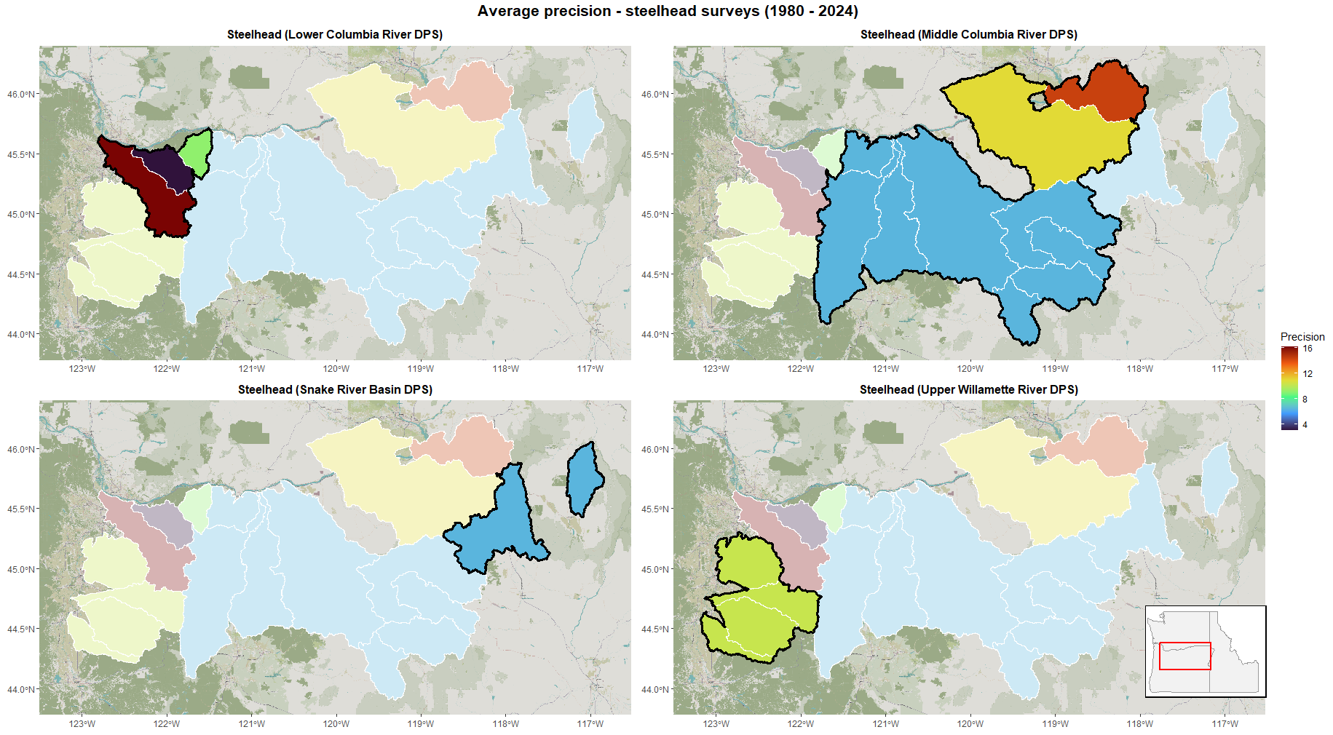Figure 19: Average precision due to choice of survey methods across Oregon steelhead populations from 1980-2024. Distinct population segments (DPSs) outlined in black.

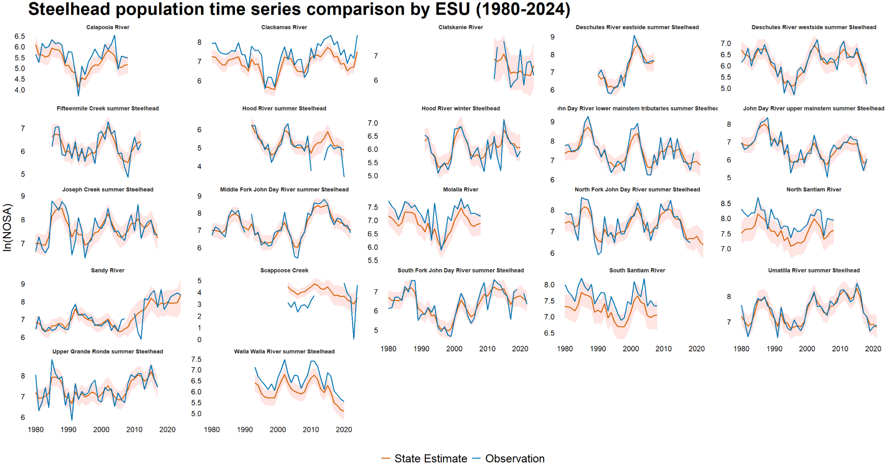Figure 20: Population level comparison of fitted abundance estimates (red) and survey observations (blue) of Oregon steelhead from 1980 – 2024. Youngs Bay omitted due to too few observations.

