Salmonid survey piece

Brian McGreal
Quantitative Ecology and Resource Management
University of Washington
Seattle, WA

Mark D. Scheuerell
U.S. Geological Survey, Washington Cooperative Fish and Wildlife Research Unit
School of Aquatic and Fishery Sciences
University of Washington
Seattle, WA

William K. Jaeger
Department of Applied Economics
Oregon State University
Corvallis, OR

(potentially)
Kasey Bliesner - ODFW
Jake Chambers - ODFW

Abstract
Fisheries management and conservation policies depend on surveys designed to estimate the abundance of target species over time. A variety of survey methods are employed for these purposes, each characterized by some level of precision and the potential for directional bias. While low levels of precision in survey methods lead to low confidence in point estimates of population abundance or forecasts, directional bias presents a more pernicious problem as it may lead to the mismanagement of imperiled species, invasive species, and commercially valuable populations, due to over- or under-estimation of their numbers. We estimated levels of precision and bias associated with 28 survey methods commonly used by the Oregon Department of Fish and Wildlife to estimate the abundance of 74 ESA-listed populations of Chinook (Oncorhynchus tshawytscha) and coho salmon (O. kisutch), and steelhead trout (O. mykiss), from 1980 to 2022. Using multivariate autoregressive state-space models (MARSS), we distinguish observation (sampling) error from process (environmental) error and estimate directional bias at the level of individual methods. We find that, while some survey methods are generally more precise than others (dam counts, weir counts, and redd counts are highly precise), the same survey methods can have very different levels of precision and biases when applied to different species. Additionally, we investigate the extent to which individual populations are subject to inherent imprecision and bias as a result of the survey methods historically employed in monitoring efforts.

Introduction
The conservation of salmon and trout for environmental, tribal, commercial, and recreational use is of tremendous importance to fish and wildlife agencies in the Pacific Northwest. Additionally, multiple Evolutionarily Significant Units (ESUs) comprising many salmonid populations are protected under the US Endangered Species Act of 1973 (National Oceanic and Atmospheric Administration 2025a). Since 1980, the state of Oregon alone has spent over $9 billion in the effort to protect and restore populations of steelhead trout (Oncorhynchus mykiss) and Pacific salmon (Oncorhynchus spp.) in the Columbia River Basin. However, the impacts of these restoration efforts remain difficult to quantify (Jaeger and Scheuerell 2023). To determine the value of investments like these, policymakers and fisheries managers need accurate assessments of the salmonid populations in question.
To manage harvest and assess the impact of conservation policy and interventions, various survey methods are employed to estimate the abundance of target species over time. Each method is characterized by an inherent level of precision and potentially some inherent directional bias as well (Parsons and Skalski 2010). Past studies have shown a positive relationship between the intensity of sampling efforts, and the precision of abundance estimates in both aquatic and terrestrial species (Walsh et al. 2001, Nuno et al. 2013, Annear et al. 2024). As such, managers must navigate the tradeoffs between more intensive sampling efforts and the level of precision they hope to achieve. While low levels of precision in survey methods lead to low confidence in point estimates of population abundance or forecasts, directional bias presents a more pernicious problem as it may lead to the mismanagement of imperiled species, invasive species, and commercially valuable populations, due to over- or under-estimation of their numbers (Tracey and Fleming 2022, Satterthwaite and Shelton 2023). Indeed, in the United States, decisions of whether to list or de-list species as endangered under the Endangered Species Act are based on abundance estimates that may be influenced by such bias (National Oceanic and Atmospheric Administration 2025b). It has been shown that when directional bias can be assessed, it may be corrected by combining multiple datasets using bias parameters to achieve more accurate measures of central tendency in abundance estimates (Polansky et al. 2023).
Spawning salmon and trout are surveyed in freshwater using methods that vary from visual inspection of known spawning grounds to counts of salmon migrating up stream at fixed points to inferential methods estimating total escapement in a stream system based on periodic counts of spawners (Knudsen 2000). Survey methods conducted at terminal spawning grounds include foot surveys of live fish, carcass counts, and visual inspection of salmonid nests known as redds (Johnson et al. 2007, Oregon Department of Fish and Wildlife 2024a). Within streams, adult fish may be captured and counted at weirs before being released to continue their upstream migration (Anderson et al. 2015). Another approach involves capturing salmonids as juveniles and fitting them with small passive integrated transponders (PIT-tags). This enables tagged fish to be electronically counted as adults years later, as the return to their natal spawning grounds takes them past sensor arrays (Lamb et al. 2024). In more remote localities, aerial surveys are favored with fish being counted from either helicopter or fixed-wing aircraft, trading precision for the ability to survey sites which are otherwise very difficult to access (Walker 2015, Copeland et al. 2019). Finally, these methods and more may be included in the estimation of total escapement through a variety of area-under-the-curve and peak spawner count estimation methods (English et al. 1992, Parken et al. 2003, Millar and Jordan 2013). Given this variety of survey methods dependent on various technology and statistical techniques, each method will be characterized by some degree of imprecision, and perhaps some intrinsic tendency to over- or under-estimate spawning salmonids.
My research seeks to measure the levels of precision and relative bias accompanying various survey methods by comparing observations from 73 populations of Chinook (O. tshawytscha) and coho salmon (O. kisutch) and steelhead trout throughout Oregon, most of which each belong to an ESU (or in the case of steelhead trout, Distinct Population Segment or DPS) listed as threatened under the Endangered Species Act. These surveys were conducted by biologists from the Oregon Department of Fish and Wildlife (ODFW) from 1980 to 2024, using 31 distinct survey methods. The precision inherent to a survey method (and the associated variance of estimates derived from these surveys) directly impacts the ability to detect changes throughout time, as large confidence intervals may obscure shifting abundance regimes (Vallecillo et al. 2021). This work will also seek to determine whether directional bias exists in some survey methods, although bias estimates will necessarily be defined relative to other survey methods, as “true” censuses of the underlying salmonid populations do not exist. A secondary objective of this research is to identify which and to what extent ESU/DPSs in the study area have been chronically under- or over-estimated due to the survey methods employed in monitoring them, and whether some common characteristics of these populations can be associated with the survey methods chosen.

Methods
Data
We used an extensive dataset that includes annual observations of natural-origin spawner abundance (NOSA) covering 74 populations of Chinook and coho salmon and steelhead trout throughout Oregon from 1980 to 2024. Crucially, each observation also includes the method by which the abundance survey was conducted. Data have been collected through 31 unique survey methods (fully enumerated in the attached appendix) and contain 2,396 individual observations with recorded NOSA values. 848 observations missing NOSA values almost entirely related to years in which no survey was conducted were dropped (15 of these dropped observations confoundingly include a survey method along with a null value). Survey methods which appear only very rarely in the data (less than ten occurrences for a given species) were also dropped due to a lack of sufficient sample size.
While trends are difficult to observe visually (Figure 1), simple linear regressions evaluating the effect of time on the natural log of abundance describe 34 (half) of the surveyed salmonid populations as having no statistically significant change across the study period. Of the remaining 34 populations, 23 exhibit a statistically significant increase in abundance, while the other 11 show evidence of decline. Across the landscape it can be seen that shifts in average populations sizes between the first and last decades recorded in the study period are not necessarily typically spatially correlated (coho on the northern Oregon coast being a notable exception), and that the majority of populations have increased or decreased by less than 50% in this timeframe (Figure 2).
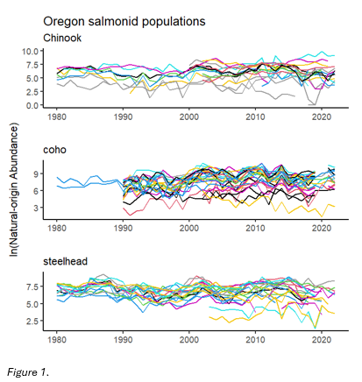
Of course, the accuracy of the estimated trends described above are dependent on the accuracy of the observed data, itself a product of the survey methods employed. The frequency with which survey methods are employed is not uniform across the study period (Figure 3).
Figure 1: Changes in abundance of individual salmonid populations from 1980 to 2022. Note that not all populations are represented throughout the entirety of the study period.

While some methods such as redd counts have been widely used throughout the study period, other methods have seen drastic changes in usage. If different survey methods indeed exhibit varying levels of precision and/or inherent directional bias, the statistical significance estimated by simple regression models must be questioned.
Because my goal is to isolate variance and bias in different survey methods, it is vital to distinguish variability in observations due to survey methods from variation in the natural state of salmonid populations. Multivariate autoregressive state space (MARSS) models are well
suited for this purpose, as they can mathematically distinguish observation error from process/state error and assign separate variance parameters to each. Recall that the generic MARSS model formulation and a description of all model terms is described in Chapter 1 of this dissertation.
There exists the likelihood that some survey methods are endogenously related to the abundances they seek to estimate. For example, dam counts require that a dam be present, a feature which has been shown to have adverse impacts on salmonid populations (Levin and Tolimieri 2001, Pess et al. 2008). In theory, MARSS models should be able to statistically account for this potential endogeneity by mathematically partitioning the variance and bias originating due to the survey method (i.e., the accuracy of dam counts) from the variance and bias inherent in the underlying process being observed (i.e., natural fluctuations in a population’s abundance), especially given multiple populations being surveyed via the same method (See and Holmes 2015). To ensure that potential endogenous relationships between populations and methods will not impact the results of this work, I conduct robustness checks using simulated data to ensure that the models employed are indeed able to capably distinguish process error from observation error in such cases.

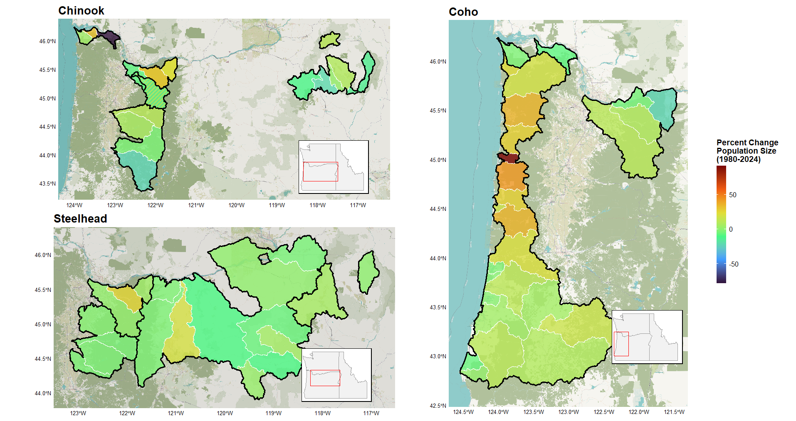
Figure 2: Percent change in average population size between the periods 1980-1989 and 2015-2024.Population outlines in white with ESU borders in black. Majority of populations do not increase by more or less than 50% over the course of the study period. In Chinook panel shared population, solid color = Lower Columbia ESU | striped color = Upper Willamette ESU
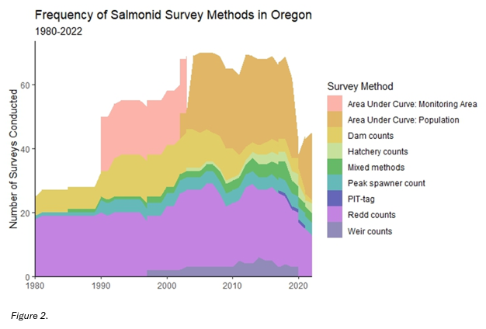
Figure 3: Groups of survey methods and the frequency of their employment from 1980 to 2022. The nine groups displayed in the figure are bins containing each of the 31 survey methods described in the data. These bins are non-scientific and do not reflect designations established by ODFW or any other party, and are instead intended strictly as an aid for visualizing these data.

Because of their differing life histories, I will model all three species salmonid species separately, using three data subsets respectively containing 22 Chinook populations, 29 coho populations, and 23 steelhead populations. Each observation contains four crucial pieces of information: 1) an estimate of natural-origin spawner abundance (denoted mathematically from here on as y), 2) the population of interest (denoted with the subscript p), 3) the survey method used (denoted with the subscript s), and 4) the year of observation (denoted with the subscript t).
Applying a MARSS model structure to the analysis described above involves determining how best to structure spawner abundance data (y_{p,s,t}) and specify model parameters to isolate precision and bias in salmonid survey methods. Specifically, we arrange y_{t} such that each row relates to observations of population p by survey method s. Z is specified such that each population as identified in the data will correspond to a distinct underlying natural state. By specifying each population as an underlying state, the model will be able to assess variation in the natural state of the population as separate from variation in counts arising due to the survey method employed. The vector a contains a unique bias term for each survey method, irrespective of population. Crucially, one method will be selected as a reference against which bias associated with other methods will be measured, meaning that bias estimates discussed throughout this study are not absolute but relative to this reference. For this chosen reference method, a_{s} is set equal to zero. Were another reference method to be chosen, model fit would not be changed, but relative bias terms would shift to reflect this change. The matrix R is specified in a similar manner, with a unique term for each method placed in the corresponding places along R‘s diagonal. Again, this is irrespective of population to capture the variation inherent in each survey method.
Below is an example of the observation equation written out in matrix form. In this example, two populations of salmonid have been surveyed with a total of five survey methods. As indicated by the y term subscripts, population one has been surveyed with methods one through four and population two with methods one, four, and five. Z is specified as two columns relating to the two populations which here are considered underlying states (x₁ and x₂). Survey method one has been selected as the reference method against which other methods’ directional bias will be measured. Therefore, in vector a, those rows which correspond to an observation taken with method one are set equal to zero, while all other methods are represented by an a parameter which repeats as often as the method appears. Finally, R is specified so that each survey method is represented by an r parameter, which again repeats as often as the method appears, to capture the variance inherent to each.
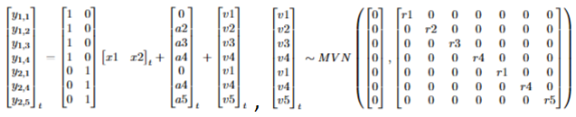
The process/state equation is more straightforward. It is constructed to be as parsimonious as possible to essentially act as a receptacle for the natural variance in annual salmonid spawner returns. B is specified as an identity matrix. Whether the vector u is set to zero or allowed to estimate a trend in each population’s growth will depend on model fit. The terms along the diagonal of Q will also be specified as unequal to allow for differences in abundance dynamics based on population, although other specifications (equal population variances and allowing for equal variance and equal covariance terms) will also be evaluated. Below is an example of the process/state equation written out in matrix form.
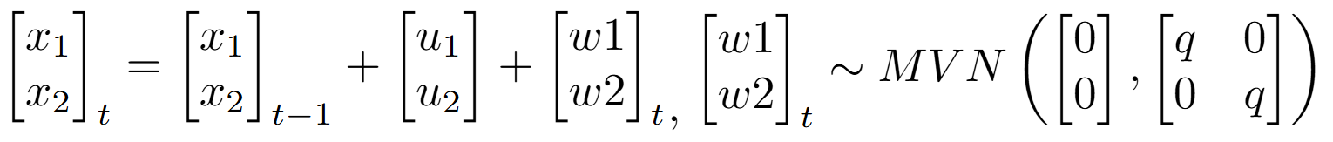
The various specifications of u and Q will be evaluated for best fit based on AICc, as this criterion is better suited than AIC for balancing fit with the many parameters MARSS models must estimate.
With these estimates in hand, the data presented in Figure 1 will then be adjusted to account for bias resulting from survey methods used to assess whether populations are indeed behaving in the way the figure portrays, and whether ESU/DPSs are being chronically over or undercounted. Next steps will involve the evaluation of mixed survey method approaches commonly seen in the data. Many of the abundance estimates reported are derived from the combination of more than one survey method (see attached Appendix A). For example, Scappoose Creek winter steelhead are each year variously surveyed through either in-river weir counts, total redd counts * fish per redd estimate, or the combination of the two. This research will evaluate whether imprecision and/or directional bias produced by combining survey methods (such as those described above) is amplified or dampened compared to those associated with each constituent part. This work will also consider the efficiency of the same survey method in estimating populations that differ by orders of magnitude, as it is not hard to imagine the accuracy of a given method differing considerably when the number of fish present differ substantially.
Results
The following section describes bias and precision estimates associated with various salmonid survey methods and their impact on abundance estimates by species (Table 1). Because MARSS models are unable to estimate bias parameters without a reference method, the bias results described in this section are estimated relative to the ‘Dam Counts’ method. This method is chosen for two reasons: 1) ‘Dam Counts’ have been found to be generally accurate and unbiased, and 2) ‘Dam Counts’ is employed in surveys for all three species in this study (Parsons and Skalski 2010). Throughout this section ‘Dam Counts’ will be treated as unbiased, although it must be noted that these results are relative and not absolute. The method with the strongest positive directional bias for a given species would be the same regardless of reference method chosen, and model fit would be unchanged.

Chinook
Most Chinook survey methods employed are not dramatically biased compared to the ‘Dam Counts’ method. ‘Area Under Curve: Population (Total live spawners)’ and ‘Peak spawner count expansion’ exhibit a tendency to undercount the underlying number of spawners, while the strongest positive bias is associated with the ‘Total redd counts * Fish per redd estimate’ method (Figure 4). The ‘Peak spawner count expansion’ method indeed exhibits the highest magnitude bias term associated with any survey method in this study (Table 1). The on-the-ground impact of these directional biases are seen most starkly in the Lower Columbia River ESU (Figure 5) due to the frequent employment of the ‘Area Under Curve: Population (Total live
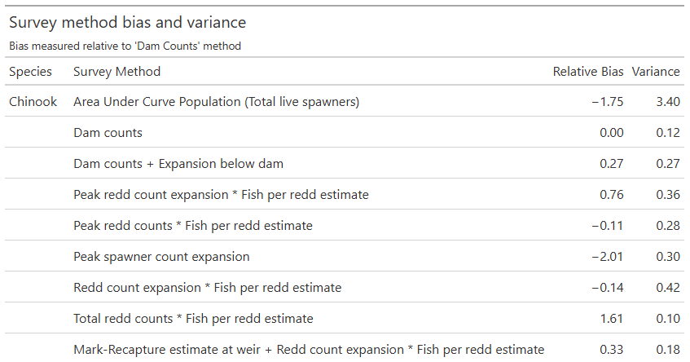
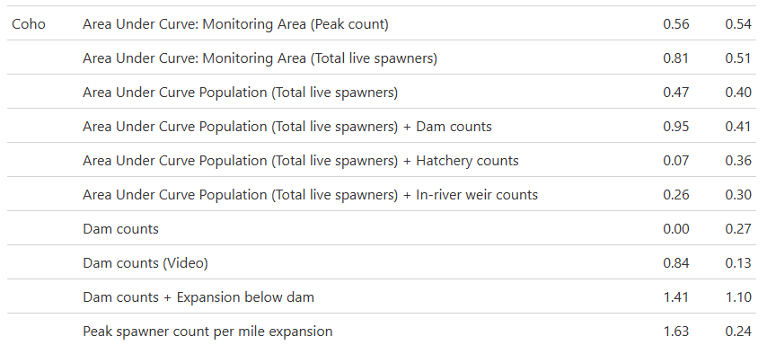
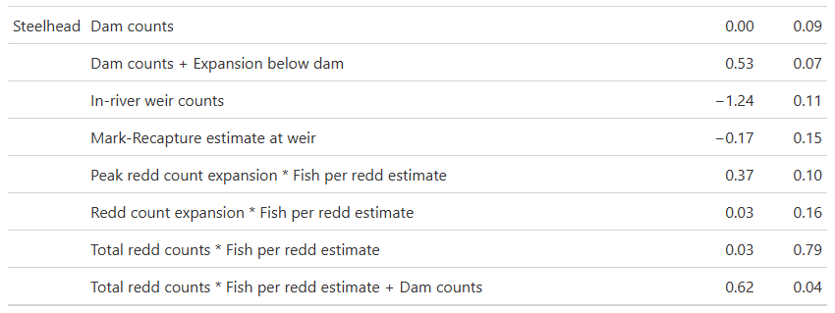
Table 1: Variance and relative bias associated with various observation processes (survey methods), estimated separately by species. Directional bias measured relative to ‘Dam Counts’ method for all species.
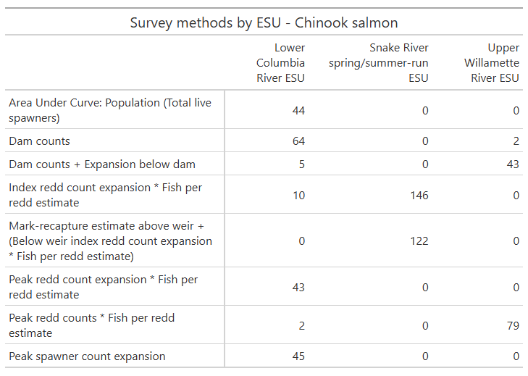
Table 2: Frequency of Oregon Chinook annual survey methods by Evolutionarily Significant Unit (ESU), 1980-2024.

spawners)’ and ‘Peak spawner count expansion’ methods (methods not employed at all in other Chinook ESUs (Table 2).
In terms of statistical variance, the ‘Area Under Curve: Population (Total live spawners)’ method dwarfs every other method employed in Chinook surveys. Beyond this, the methods ‘Peak redd count expansion * Fish per redd estimate’, ‘Peak spawner count expansion’, and ‘Redd count expansion * Fish per redd estimate’ exhibit lower precision than the other methods analyzed, though none are nearly as imprecise as the ‘Area Under Curve: Population (Total live spawners)’ method (Figure 6). Two of these three methods are frequently employed in the Lower Columbia River ESU (Table 2), meaning that not only does this ESU have the strongest tendency towards biased population estimates, but also that those estimates are accompanied by a high degree of inherent uncertainty. Meanwhile, the Upper Willamette River ESU is the most precisely surveyed of the three due to its heavy reliance on the ‘Dam counts + Expansion below dam’ and ‘Peak redd counts * Fish per redd estimate’ survey method, both of which are found to be more precise (Figure 7).
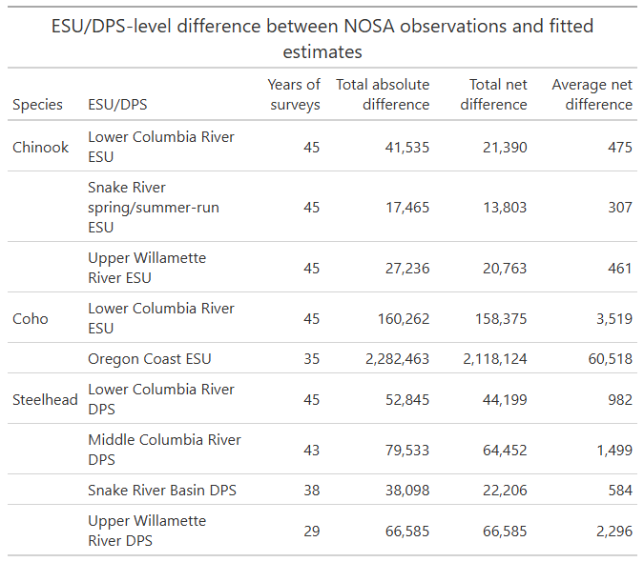 Table 3: ESU/DPS-level difference between observations and estimates across study period (1980-2024). Positive value indicates aggregate overcounts due to survey methods employed.

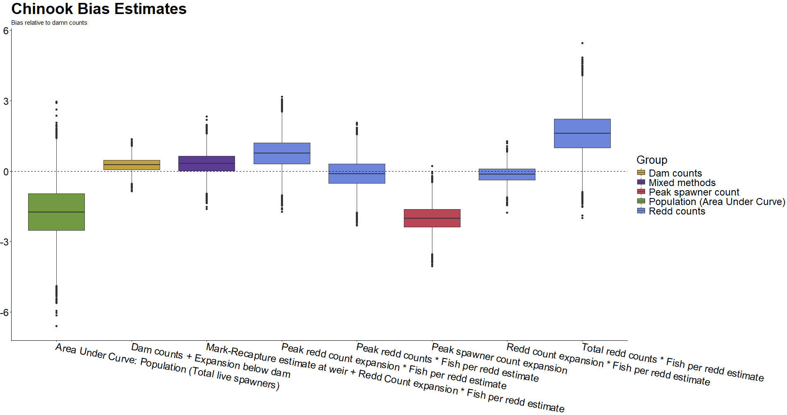 Figure 4: Directional bias in Chinook salmon survey methods as measured relative to ‘Dam Counts’ method (not pictured). As a result, dashed line at zero does not relate to statistical confidence. Color groupings are non-scientific and intended only as reference.
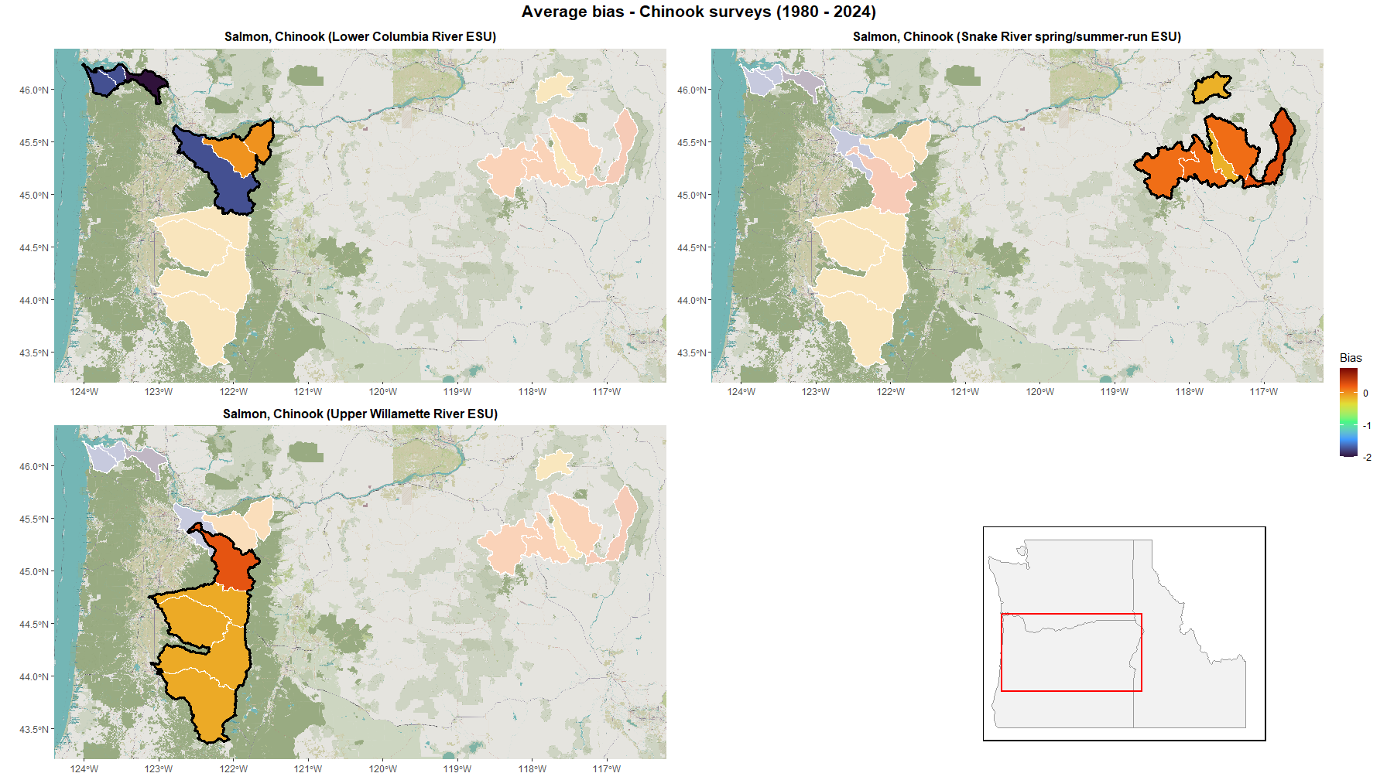 Figure 5: Average directional bias due to choice of survey methods across Oregon Chinook salmon populations from 1980-2024. Survey method bias estimated relative to ‘Dam Counts’ method.
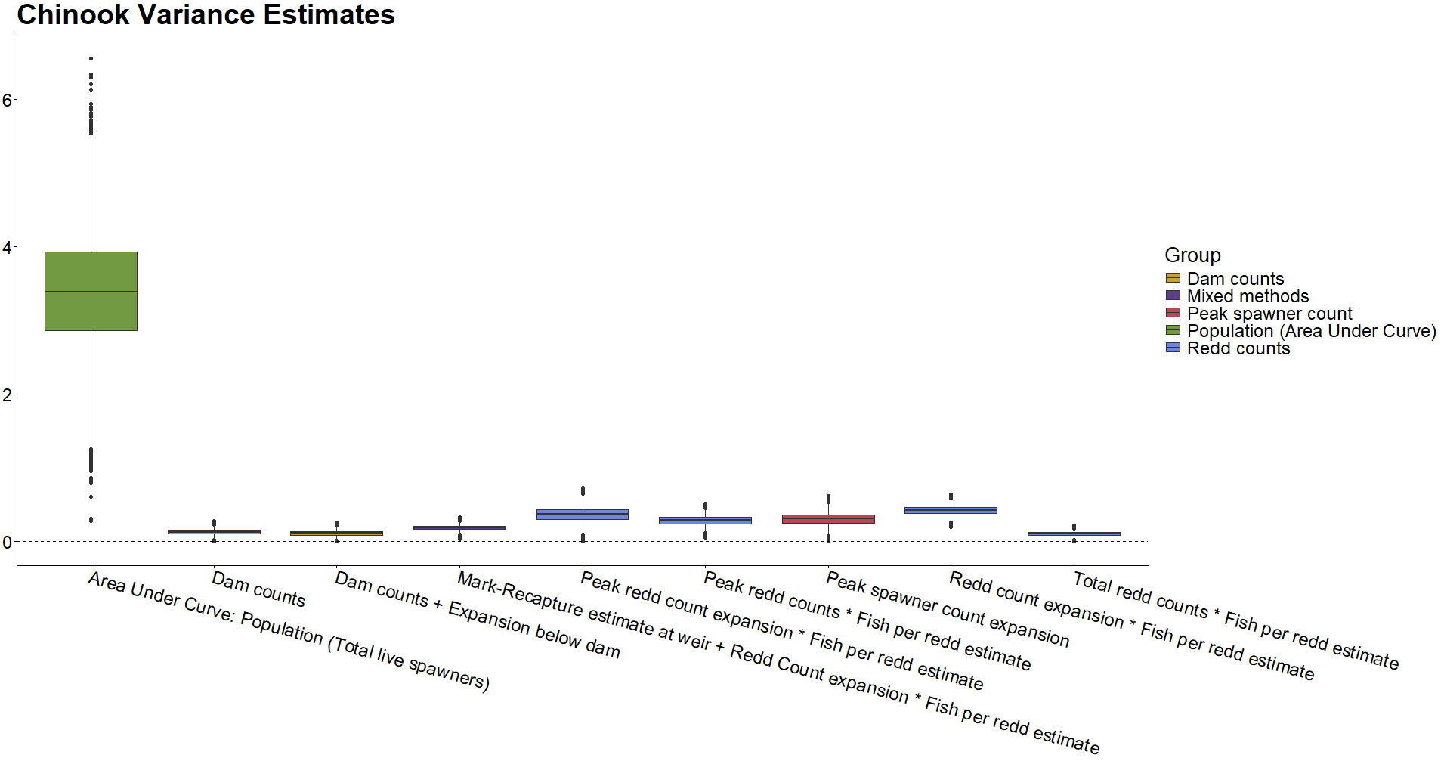 Figure 6: Observational variance in Chinook salmon survey methods. Color groupings are non-scientific and intended only as reference.
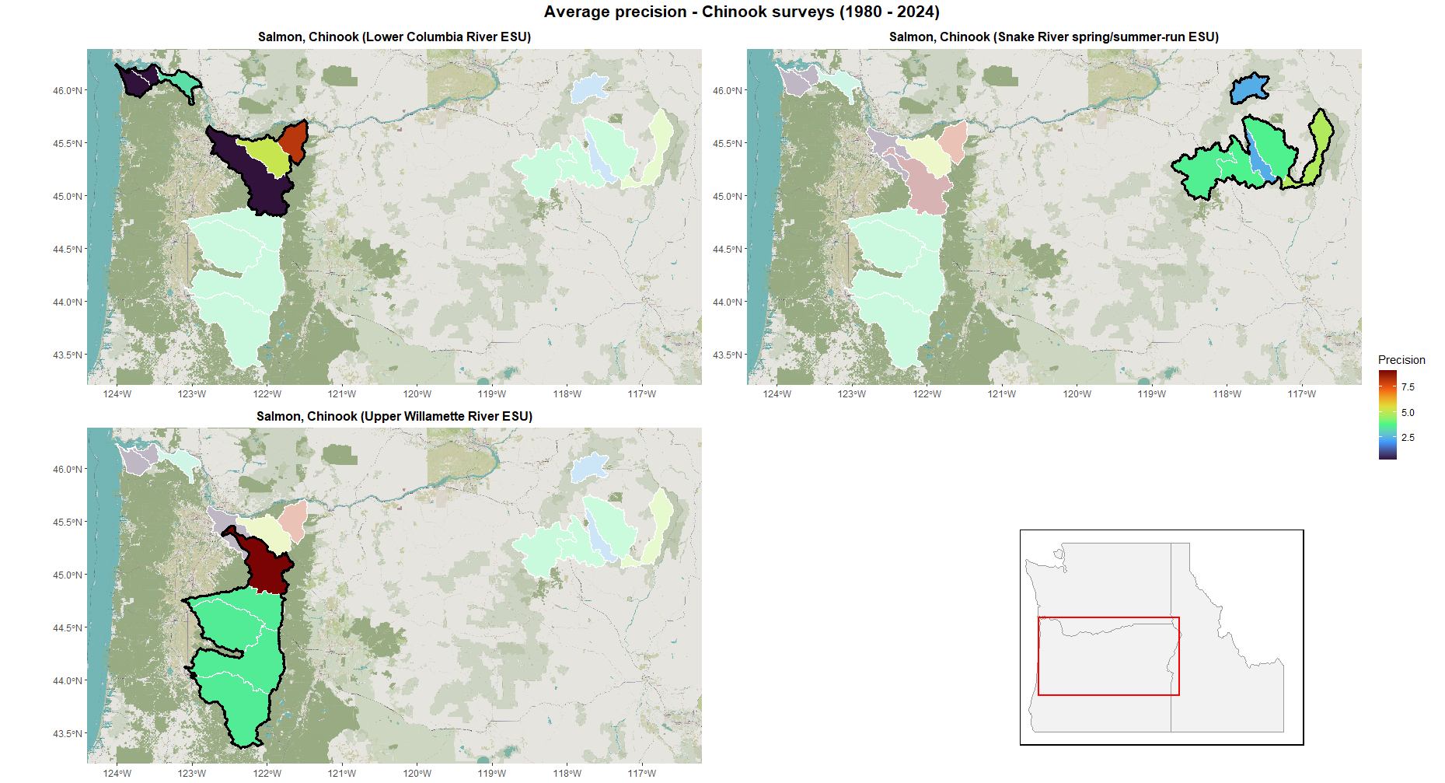 Figure 7: Average precision due to choice of survey methods across Oregon Chinook salmon populations from 1980-2024.
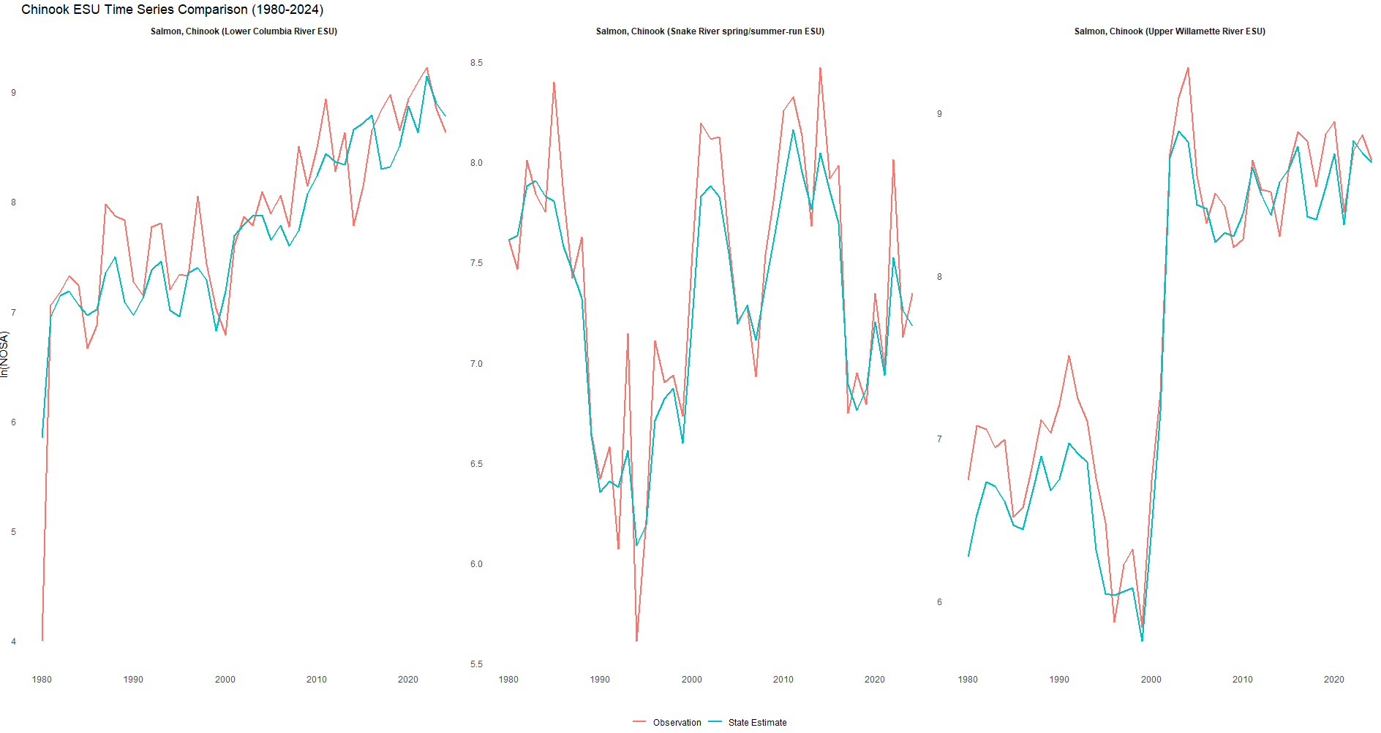 Figure 8: Evolutionarily Significant Unit level comparison of fitted abundance estimates (red) and observations (blue) of Oregon Chinook salmon from 1980 – 2024.
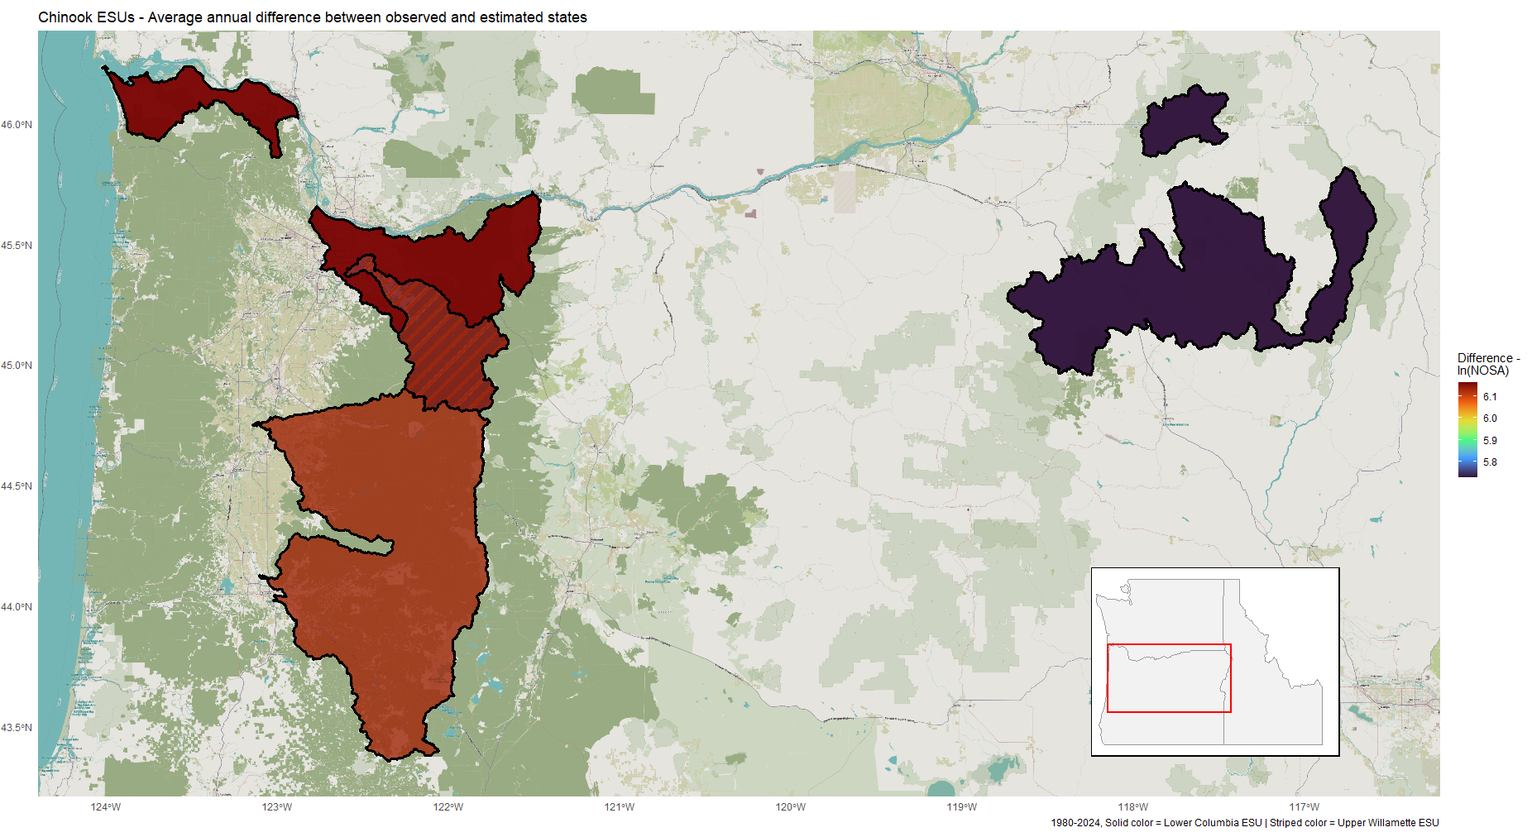 Figure 9: Evolutionarily significant unit level average difference between survey observations and fitted abundance estimates of Oregon Chinook salmon from 1980 – 2024. A positive value indicates an overcount due to survey methods employed, while a negative value indicates an undercount.
Of the three Chinook ESUs, the Lower Columbia River ESU and Upper Willamette River ESU have similar disparities between aggregate survey observations and the fitted states of the underlying populations. Contrary to what one might expect from the bias terms associated with many of its constituent populations, survey observations in the Lower Columbia River ESU overestimate spawner abundance by a wide margin (Figure 8). This is due to the ESU’s two largest populations (‘Sandy River – spring’ and ‘Sandy River - late fall’) being consistently surveyed using the ‘Peak redd count expansion * Fish per redd estimate’ or ‘Dam counts’ methods, which are associated with a positive relative bias and no relative bias respectively (recall that ‘Dam counts’ was chosen as the reference method in these models). The Snake River spring/summer-run ESU likewise displays tendencies to overestimate spawner abundance due to the choice of survey method, although not to the same degree as the other two Chinook ESUs (Figure 8 & 9). While the disparity is not as great, this is tendency to overestimate spawner abundance is potentially of greatest concern in the Snake River spring/summer-run ESU, given that it less populous than the other two Chinook ESUs included in this study (Figure 8). With all this in mind, it is encouraging that the three Chinook ESUs display the lowest annual difference between survey observations and fitted spawner estimates of all the ESU/DPSs included in this study (Table 3).

Coho
The methods used to survey coho display relative biases are all positively biased relative to the zero-value associated with the ‘Dam counts’ reference method (Figure 10). Although this behavior is not the most pronounced in ‘Area Under Curve’ survey methods, these tendancies are especially worth noting in relation to these methods, as they are very frequently employed in coho monitoring, especially in the Oregon Coast ESU (Table 4). These tendencies towards overestimation are seen most starkly in the survey methods employed in the Oregon Coast ESU, but due to all survey methods being associated with some positive bias, some populations in the Lower Columbia River ESU likewise tend to be upwardly biased (Figure 11). Taken in aggregate however, the positive biases associated with surveys conducted in the Oregon Coast ESU could lead to the ESU-level coho abundance being more significantly overestimated, due
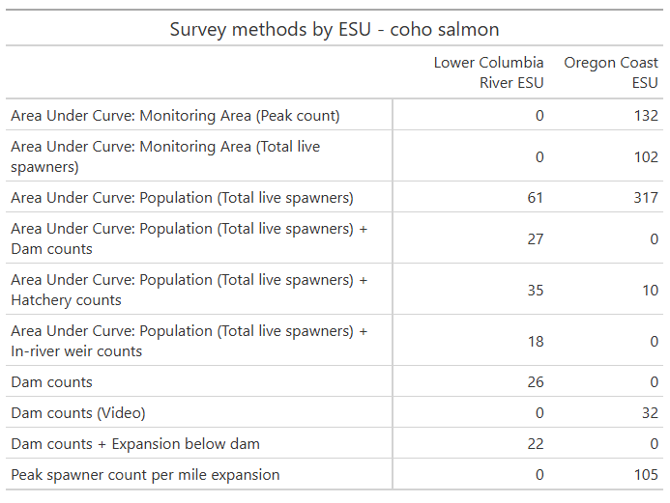
Table 4: Frequency of Oregon coho annual survey methods by Evolutionarily Significant Unit (ESU), 1980-2024.

to this ESU’s much larger number of constituent populations (21 populations in the Oregon Coast ESU compared to 6 in the Lower Columbia River ESU).
The methods employed to survey coho tend to be associated with much higher statistical variance than those employed in Chinook surveys (Figure 12). This may be in part due to the late-year run timing of coho salmon being associated with higher flows (National Marine Fisheries Service 2016). The ‘Dam counts + Expansion below dam’ method seems to be particularly imprecise, although bootstrapped parameter estimates do not allow this to be said with high confidence. It should be noted that ‘Dam counts + Expansion below dam’ is also one of the least employed methods across both coho ESUs in this study, meaning its impact on the veracity of counts at the ESU level is likely negligible. Of greater interest are the somewhat high variance terms associated with certain ‘Area Under Curve’ methods – particularly ‘Area Under Curve: Monitoring Area (Peak count)’, ‘Area Under Curve: Monitoring Area (Total live spawners)’, and ‘Area Under Curve: Population (Total live spawners)’. These three methods together make up the vast majority of methods used to sample coho in this study, accounting for almost 80% of surveys conducted in the Oregon Coast ESU (Table 4). The predominance of these methods and their effects can be seen in the low precision associated with most populations in the Oregon Coast ESU (Figure 13). The Lower Columbia River ESU is generally more precisely surveyed, but is still subject to high level of imprecision compared to the ESUs and DPSs of other species in this study.
Despite no relative bias term’s magnitude greatly exceeding zero, the frequent employment of ‘Area Under Curve’ methods across the two coho ESUs leads to escapement surveys overestimating the number of natural origin spawning salmon to a great degree (Figure

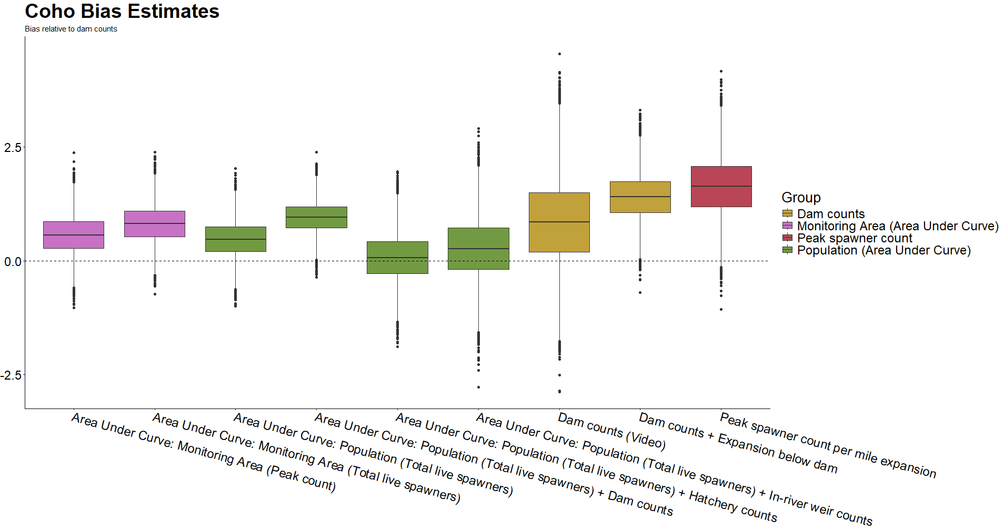 Figure 10: Directional bias in coho salmon survey methods as measured relative to ‘Dam Counts’ method (not pictured). As a result, dashed line at zero does not relate to statistical confidence. Color groupings are non-scientific.
and intended only as reference. 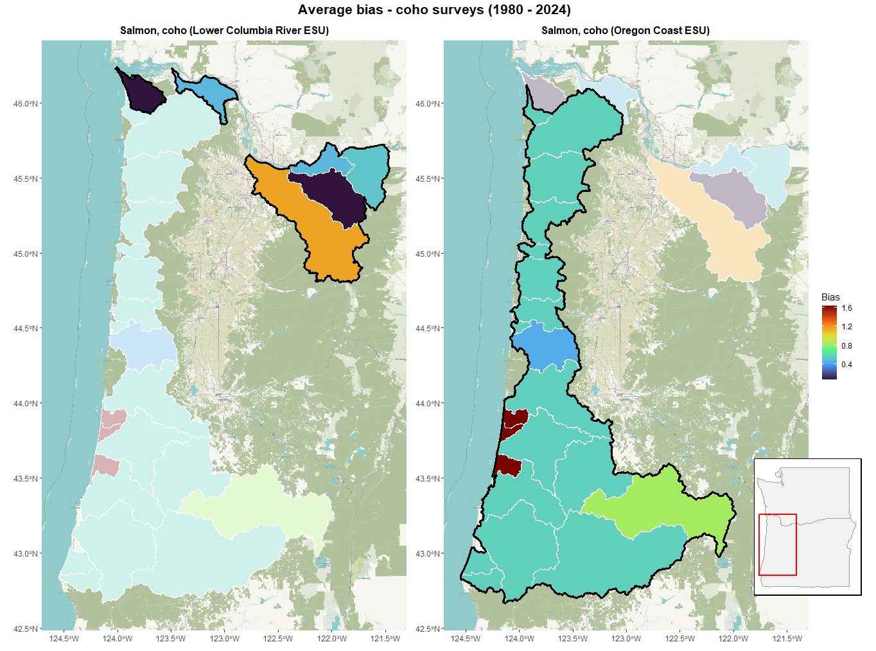
Figure 11: Average directional bias due to choice of survey methods across Oregon coho salmon populations from 1980-2024. Survey method bias estimated relative to ‘Dam Counts’ method. Evolutionarily significant units (ESUs) outlined in black.
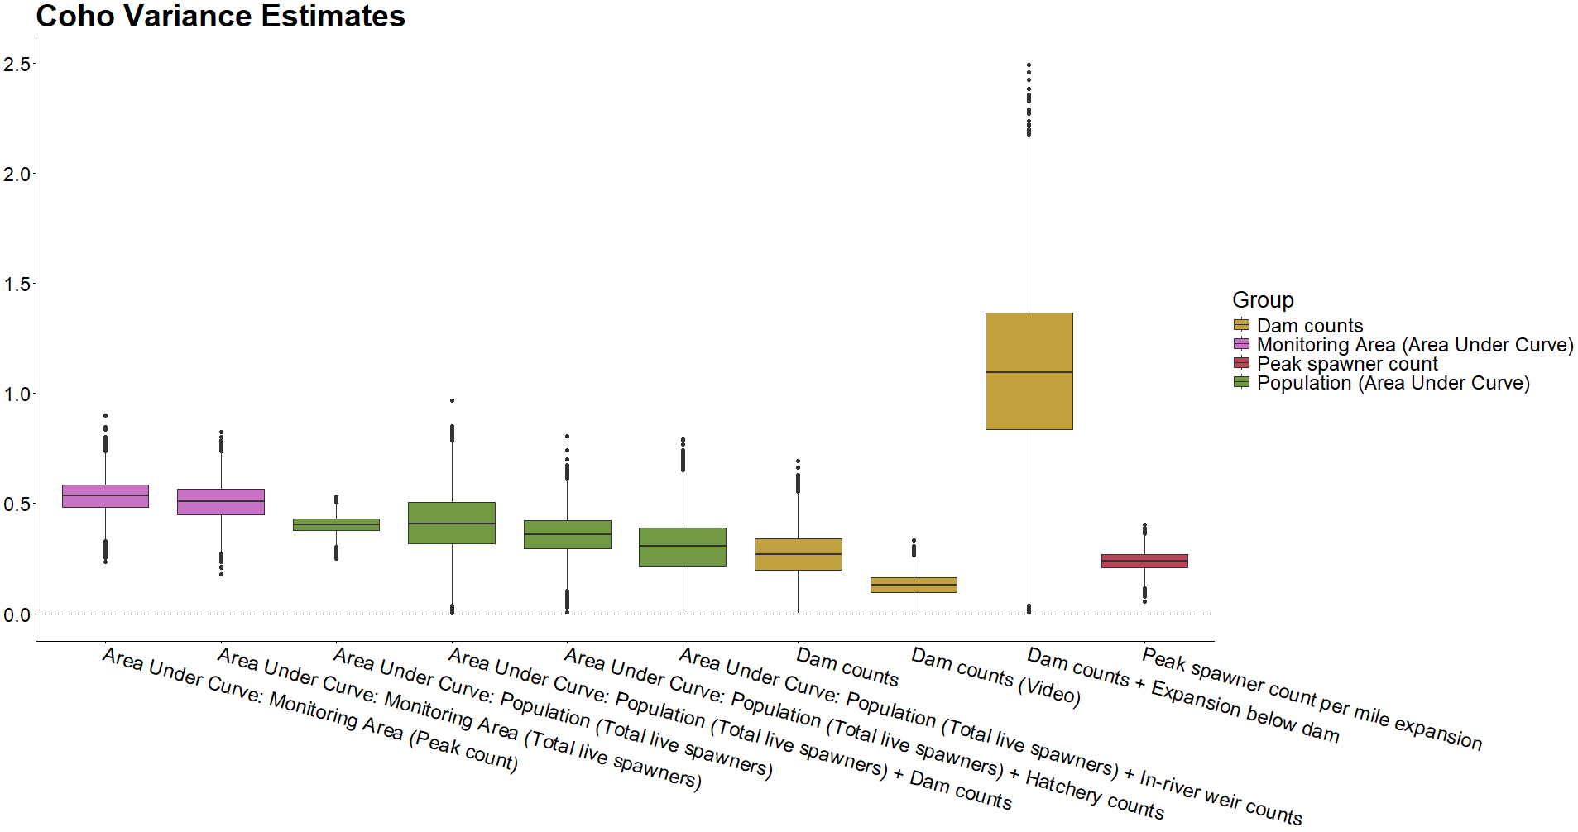 Figure 12: Observational variance in coho salmon survey methods. Color groupings are non-scientific and intended only as reference.

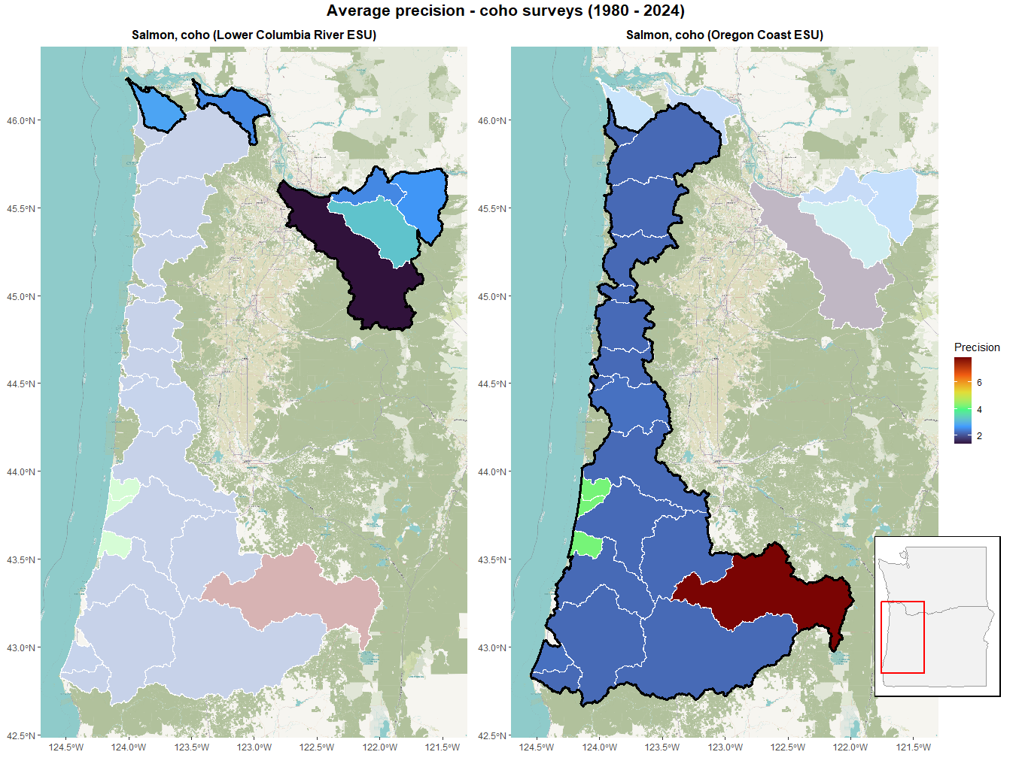
Figure 13: Average precision due to choice of survey methods across Oregon coho salmon populations from 1980-2024. Evolutionarily significant units (ESUs) outlined in black.
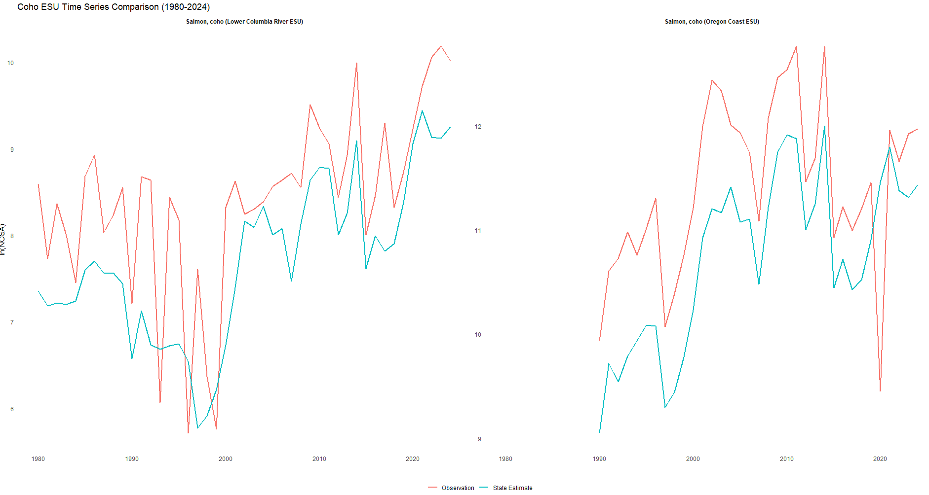 Figure 14: Evolutionarily Significant Unit level comparison of fitted abundance estimates (red) and observations (blue) of Oregon coho salmon from 1980 – 2024.
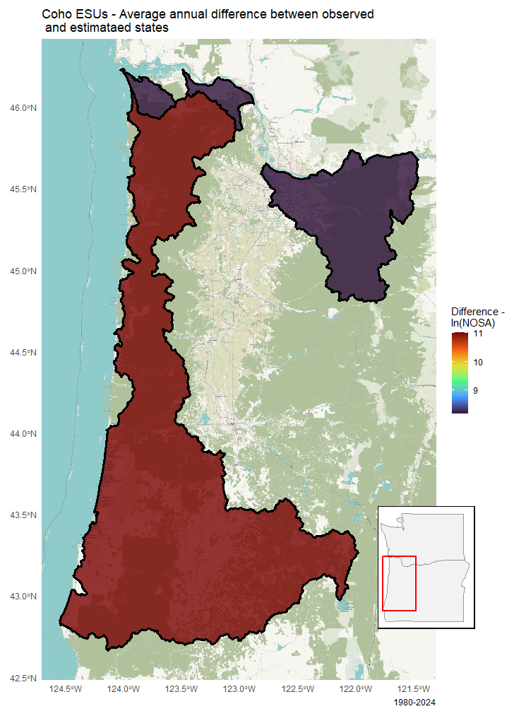
Figure 15: Evolutionarily significant unit level average difference between survey observations and fitted abundance estimates of Oregon coho salmon from 1980 – 2024. A positive value indicates an overcount due to survey methods employed, while a negative value indicates an undercount.
14, Table 3). This most acutely seen in the Oregon Coast ESU, where the heavy reliance on the ‘Area Under Curve: Population (Total live spawners)’ method in particular, along with the number of populations making up the ESU, combine to increase the amount by which this ESU is overcounted despite the absolute relative bias of this method not being close to the highest found in this study (Figure 15). As a result of these factors, the Oregon Coast ESU is the most overcounted ESU/DPS throughout the study period, while the Lower Columbia River ESU is the third most overcounted (Table 3).

Steelhead
With the exception on the ‘In-river weir counts’ method, the magnitude of bias associated with many steelhead trout survey methods (relative to the ‘Dam counts’ method) tends to be fairly low (Table 1, Figure 16). The two most positively biased methods are ‘Dam counts + Expansion below dam’ and ‘Total redd counts * Fish per redd estimate + Dam counts’, while the ‘In-river weir counts’ method shows strong negative relative bias. Also of note is the most commonly employed survey method for steelhead trout, ‘Redd count expansion * Fish per redd estimate’, which makes up roughly 52% of all DPS observations (Table 5). This frequently used method is not associated with a strong positive or negative relative bias, meaning average bias across most populations remains relatively low, most especially in the Snake River Basin DPS and Middle Columbia River DPS, with the Snake River Basin DPS surveyed exclusively using this method (Table 1, Figure 17). Among the four steelhead trout DPS, the Upper Willamette River DPS stands out due its strong upward bias, due to this DPS likewise being exclusively surveyed using the ‘Peak redd count expansion * Fish per redd estimate’ method (Table 1, Figure 17).

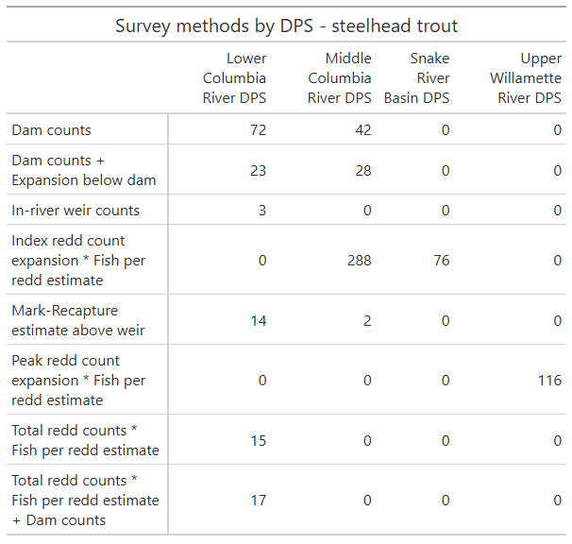 Table 5: Frequency of Oregon steelhead annual survey methods by Distinct Population Segment (DPS), 1980-2024. Note that, although the ‘In-river weir counts’ only appears in a DPS 3 times, this method was also employed in surveying populations outside of these DPSs, allowing for sufficient datapoints to estimate bias and variance terms.

Observation variance associated with steelhead survey methods is generally low compared with those estimates associated with Chinook and coho surveys. While the ‘Total redd counts * Fish per redd estimate’ method stands out as being highly imprecise when compared to other steelhead survey methods, it is nonetheless quite accurate compared to the most imprecise methods for Chinook and coho (Table 1, Figure 18).
Due to the relatively low absolute bias associated with the majority of steelhead survey methods, three out of four steelhead DPSs are not drastically over or undercounted, with the Upper Willamette River DPS being the exception (Table 3, Figure 20). While the Middle Columbia River DPS steelhead spawner abundance has been overestimated more significantly throughout the study period than the Lower Columbia River DPS and Snake River Basin DPS, the average annual overcount of spawners is far less than both coho ESUs. It should be noted however that all steelhead DPSs are annually overcounted to a greater extent than the worst Chinook ESU in this regard. The outlier in all this is the Upper Willamette River DPS (Figure 21). Due to its exclusive reliance on the ‘Peak redd count expansion * Fish per redd estimate’ survey method and its positive bias. Surveys of this DPS’s populations significantly overcount what this study estimates to be the true number of spawners in this DPS, to an extent only exceeded annually by coho surveys in the Oregon Coast ESU.

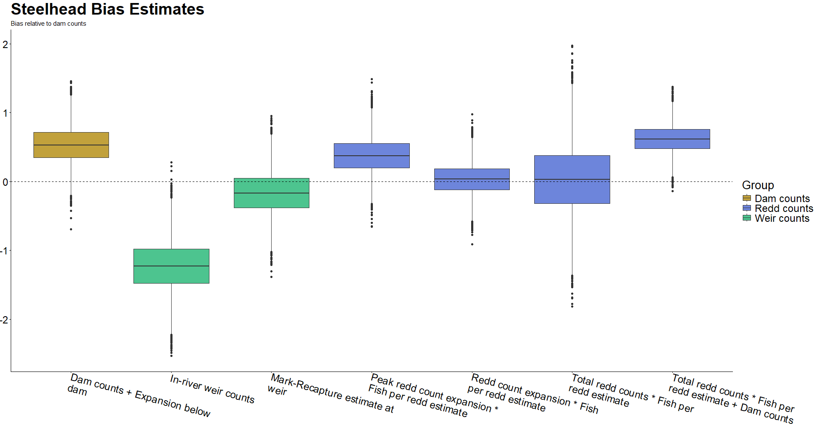 Figure 16: Directional bias in steelhead trout survey methods as measured relative to ‘Dam Counts’ method (not pictured). As a result, dashed line at zero does not relate to statistical confidence. Color groupings are non-scientific and intended only as reference. Figure 12: Observational variance in coho salmon survey methods. Color groupings are non-scientific and intended only as reference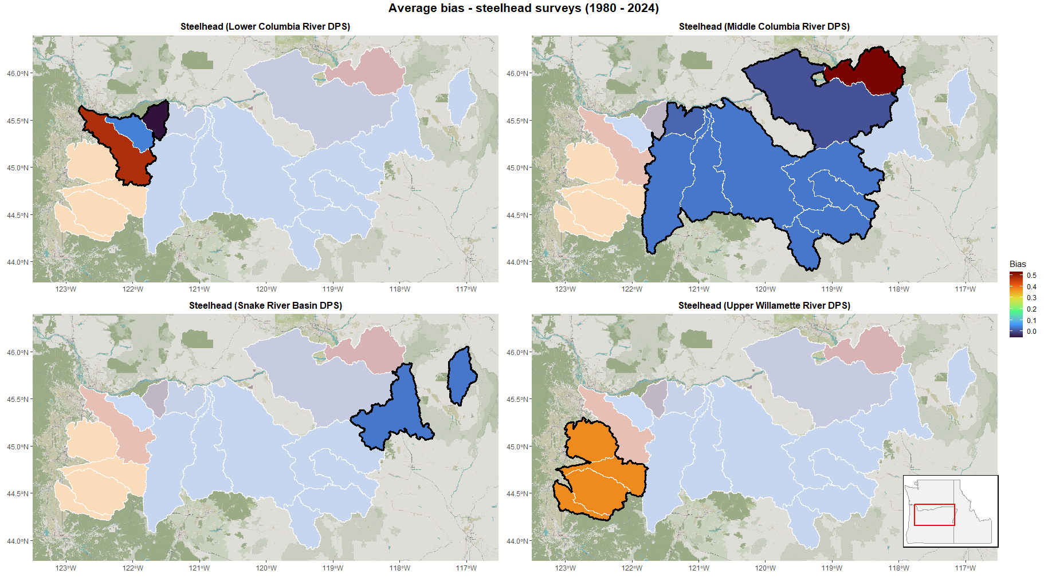 Figure 17: Average directional bias due to choice of survey methods across Oregon steelhead trout populations from 1980-2024. Survey method bias estimated relative to ‘Dam Counts’ method.
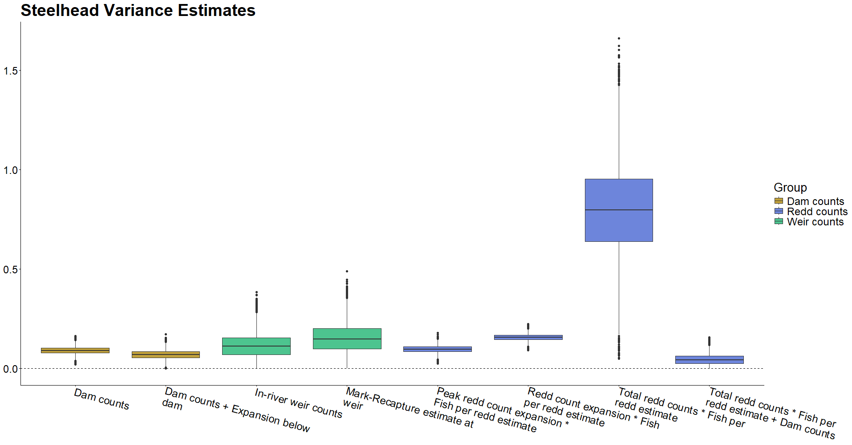 Figure 18: Observational variance in steelhead trout survey methods. Color groupings are non-scientific and intended only as reference.

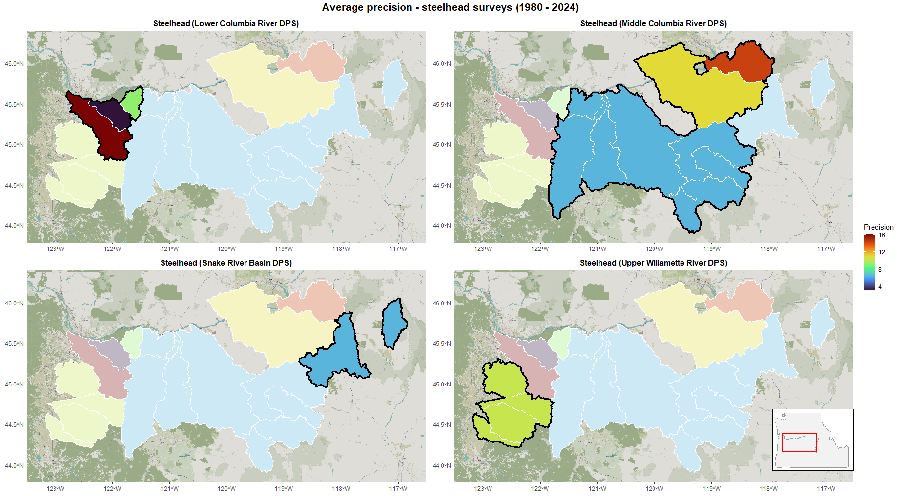 Figure 19: Average precision due to choice of survey methods across Oregon steelhead trout populations from 1980-2024. Distinct population segments (DPSs) outlined in black.

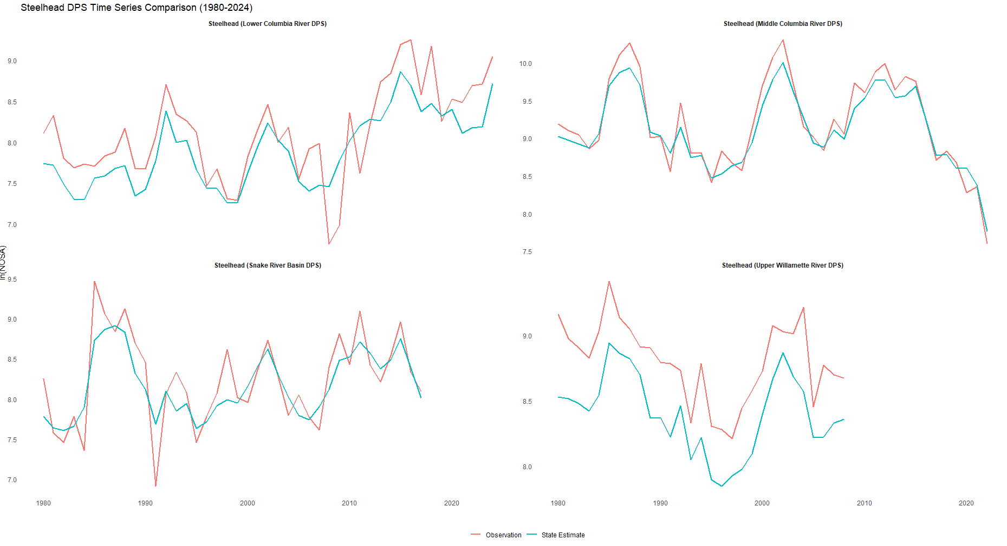 Figure 20: Distinct Population Segment level comparison of fitted abundance estimates (red) and observations (blue) of Oregon steelhead trout from 1980 – 2024.

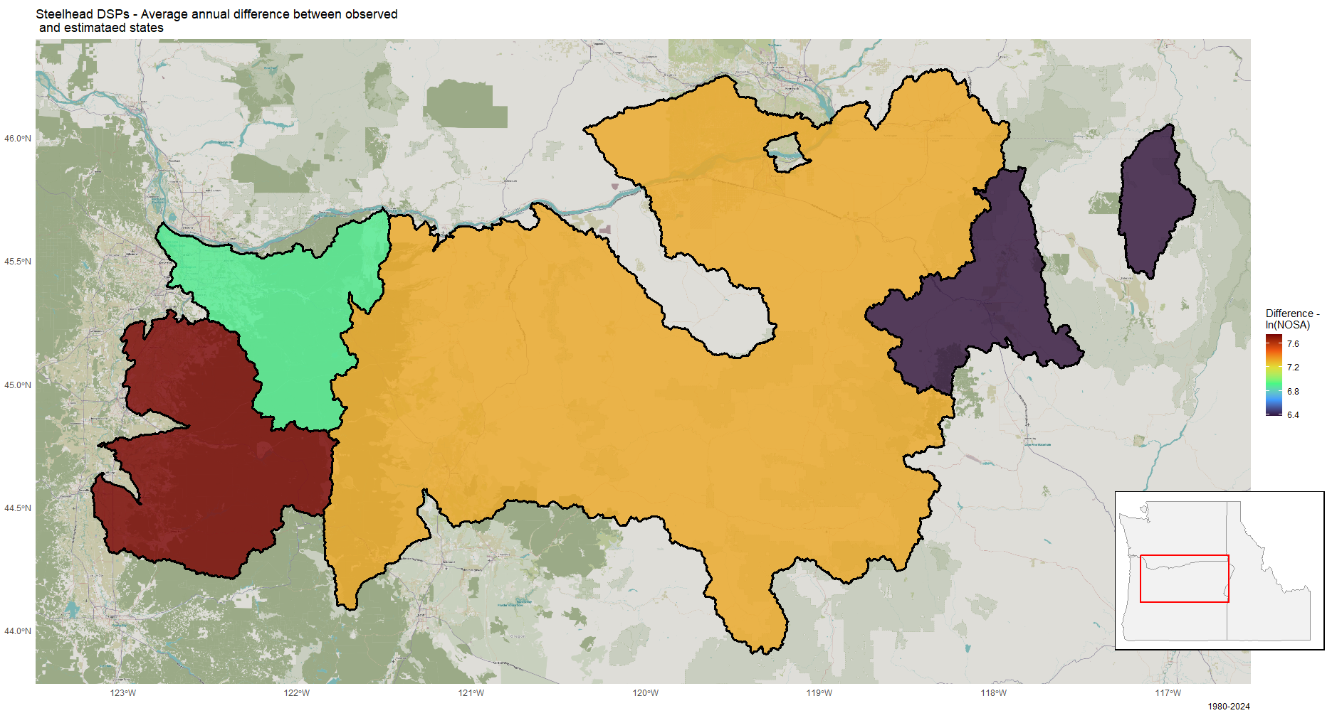
Figure 21: Distinct population segment level average difference between survey observations and fitted abundance estimates of Oregon steelhead trout from 1980 – 2024. A positive value indicates an overcount due to survey methods employed, while a negative value indicates an undercount.

Robustness checks
The validity of the results described in this study are premised on MARSS models’ ability to statistically parse variability inherent to the observation processes from variability in the underlying populations, even when the two are endogenously related. To evaluate this ability, synthetic datasets were constructed in which populations’ initial abundance are drawn from distributions relating to ‘small’, ‘medium’, and ‘large, and a randomized subset of survey methods are only applicable to either ‘small’ or ‘large’ populations. MARSS models are then fit using these datasets and bootstrapped confidence intervals are established around the parameter estimates of interest – variance terms related to survey method. Because the true variance terms are known, it is trivial to determine what percentage of true variance terms fall within these bootstrapped confidence intervals. This process of creating a randomized synthetic dataset, fitting MARSS models, and comparing bootstrapped confidence intervals to the true parameters, is repeated 100 times to ensure complete confidence in these models’ capabilities.

Discussion
Every ESU and DPS included in the study data is overcounted to one degree or another, meaning that in each case the suite of survey methods employed across the constituent populations combines to push the observed abundance above what MARSS models estimate the true underlying abundance levels to be. It is also clear that the same survey method can have drastically different behavior across species. We see that, due to the survey methods employed specifically within the Oregon Coast ESU, coho salmon ESUs are the most heavily overcounted of all species in this study. DPS-level steelhead trout abundance is not typically severely overestimated, but in the case of the Upper Willamette River DPS, exclusive reliance on one survey method has undermined this trend.
The finding that all ESUs and DPSs included in this study have been overcounted due to survey bias is extremely compelling. Significant efforts and expenditures have been made in Oregon towards the restoration and recovery of these fish, and chronic overcounting at the level at which conservation status is determined paints an unrealistically optimistic picture of these efforts’ return on investment (U.S. Fish and Wildlife Service 1989 – 2022, Moore et al. 2022, Jaeger and Scheuerell 2023). Overcounting itself isn’t inherently an issue, as any survey method will be associated with some inherent directional bias and observation error (Parsons and Skalski 2010). If fisheries biologists and managers have at least a rough idea of bias tendencies of the survey methods being employed and are able to adjust abundance estimates accordingly (the same applies to undercounting, although that doesn’t occur in this study). These sorts of adjustments for statistical bias in survey methods are commonplace in the ecology literature (Pearse et al. 2008, Conn et al. 2013, Dorazio 2014, Fithian et al. 2015).
Generally speaking, most survey methods examined in this study were not strongly biased and did not have particularly low precision across most species. While some exceptions exist (and will be discussed in finer detail shortly), on the whole speaks this to the expertise of the fisheries biologists and technicians who have designed, refined, and regularly implement these survey methods. Due to their accuracy, these “well behaved” methods do not necessitate prolonged discussion, so it is worth acknowledging that the majority of survey methods examined are generally sound. One exception to this is the ‘Area Under Curve: Population (Total live spawners)’ method, which is of particular interest dure to its radically different behavior between species. When applied to surveying Chinook salmon, this method is far and away the least precise of all methods analyzed, and is additionally fairly strongly negatively biased. However, when applied to coho, this method is still somewhat imprecise but not even the most imprecise survey method for the species, while its relative bias is middle of the pack among coho survey methods (Table 1). This illustrates a need for practitioners to have deep understanding of both the survey methods being applied and the target species. Likely there are no bad tools, just tools that are better or worse fits for the job at hand.
The high level of precision associated with steelhead trout survey methods is also noteworthy. This may be due to the large number of methods associated with counts at dams and weirs employed in steelhead surveys (Table 2). Of course, it is not practicable to implement these measures for all populations (in the case of a dam count this is particularly self-evident), but this does provide compelling evidence that these methods should be employed when possible. The relatively low variance associated with the Chinook survey methods ‘Dam counts’ and ‘Dam counts + Expansion below dam’ would seem to corroborate this. It should however be noted that the method ‘Dam counts + Expansion below dam’, which is highly precise for Chinook and steelhead surveys, is fairly imprecise when applied to surveying coho, once again reinforcing the ‘right tool for the job’ takeaway from the previous paragraph.
In many cases the methods employed by fisheries biologists and technicians are chosen due to factors beyond the scope of this study. Among the factors driving these decisions are the species, size, and run timing of the population being surveyed, the physical characteristics of the waterbody and stream network in which the population resides, and the number of labor-hours required to effectively survey a specific population using a particular method over another (Parsons and Skalski 2010, Washington Department of Fish and Wildlife 2018, Oregon Department of Fish and Wildlife 2024b). The best method for surveying any population is the one that biologists are able to implement efficiently and repeatedly in the effort to ensure continuous monitoring of imperiled populations, with statistical adjustments able to be applied if necessary once data have been collected.
Moving on to the discussion of the effects of these methods observed at the level of conservation decision making, the most notable discussion points are the coho salmon ESUs and the Upper Willamette River DPS for steelhead trout. The two coho ESUs are among the most overcounted in this study, with only the aforementioned Upper Willamette River DPS being as heavily overcounted annually (Table 3). The coho salmon Oregon Coast ESU is estimated to be overcounted by over 60,000 fish each year. This finding is perhaps not entirely surprising, as the Oregon Coast ESU is made up of by far the most constituent populations of any ESU or DPS in this study. Surveys of this ESU are heavily reliant on Area Under Curve estimation, with three methods in particular (‘Area Under Curve: Monitoring Area (Peak count)’, ‘Area Under Curve: Monitoring Area (Total live spawners)’, and ‘Area Under Curve: Population (Total live spawners)’) accounting for almost 80% of observations (Table 4). While none of these methods are the most heavily biased of those used to survey coho in this study, the aggregation of so many populations being monitored using slightly directionally biased survey methods adds up to a significant overestimation of coho abundance along the Oregon coast.
The steelhead trout Upper Willamette River DPS tells a similar story albeit more pronounced story of reliance on a small number survey methods driving overestimation of abundance levels. In this case that small number is one, as populations within this DPS are exclusively sampled using the ‘Peak redd count expansion * Fish per redd estimate’ method. As in the case of the Oregon coast coho, this is not most positively biased among those steelhead survey methods analyzed, but since no other method is in use, whatever properties of bias and precision are inherent to this method will be directly reflected in the DPS’s spawner counts.
Understanding levels of precision in salmonid survey methods will enable fisheries managers to better understand the reliability of abundance estimates upon which they must make decisions. Understanding directional bias in these survey methods will help policymakers to more accurately determine the long-term cost-effectiveness of conservation efforts. As noted, decisions to list and de-list species under the US Endangered Species Act rely on population surveys of the sort this work is interrogating. Low precision in survey methods may lead to undetected shifts in population regimes, while consistent directional bias could lead to over- or under-estimation of target populations. Understanding how combining more than one method may influence the accuracy of abundance estimates will be of great use to fisheries biologists tasked with developing survey plans. Understanding these survey methods’ levels of precision and directional bias relative to each method’s implementation cost will further help fisheries managers in programming future salmonid survey efforts.
Acknowledgements

Acknowledgements related to this project. This should not be double spaced. I guess I should thank the rest of the committee if they aren’t going to be authors on this. Maybe Genoa Salami too?

References
Anderson, J. T., J. E. Merz, C. B. Watry, and M. K. Saiki. 2015. Comparison of selected population characteristics of adult Chinook salmon during upstream passage through a resistance board weir and during salmon carcass surveys. California Fish and Game 101(1): 24-39.
Annear, A. R., M. A. Simonson, P. M. Dixon, and M. J. Weber. 2024. Effects of sampling effort and data sources on precision of common carp and bigmouth buffalo population estimates. Fisheries Research 279: 12 pp.
Conn, P. B., B. T. McClintock, M. F. Cameron, D. S. Johnson, E. E. Moreland, and P. L. Boveng. 2013. Accommodating species identification errors in transect surveys. Ecology 94(11): 2607-2618.
Copeland, T., W. C. Schrader, B. Barnett, M. T. Davison, K. A. Apperson, M. Belnap, E. Brown, and E. A. Felts. 2019. Idaho Chinook Salmon Spawning Ground Surveys: Protocol and Historic Trends. Idaho Department of Fish and Game, Annual Report 19-16, 109pp.
Dorazio, R. M. 2014. Accounting for imperfect detection and survey bias in statistical analysis of presence-only data. Global Ecology and Biogeography 23(12): 1472-1484.
English, K. K., R. C. Bocking, and J. R. Irvine. 1992. A Robust Procedure for Estimating Salmon Escapement based on the Area-Under-the-Curve Method. Canadian Journal of Fisheries and Aquatic Sciences 49(10): 1982-1989.
Fithian, W., J. Elith, T. Hastie, and D. A. Keith. 2015. Bias correction in species distribution models: pooling survey and collection data for multiple species. Methods in Ecology and Evolution 6(4): 424-438.
Jaeger, W. K. and M. D. Scheuerell. 2023. Return(s) on investment: Restoration spending in the Columbia River Basin and increased abundance of salmon and steelhead. PLoS ONE 18(7): 21 pp.
Johnson, D. H., B. M. Shrier, J. S. O’Neal, J. A. Knutzen, X. Augerot, T. A. O’Neill, and T. N. Pearsons. 2007. Salmon Field Protocols Handbook – Techniques for Assessing Status and Trends in Salmon and Trout Populations. American Fisheries Society in Association with State of the Salmon, 490 pp.
Knudsen, E. E. 2000. Managing Pacific Salmon Escapements: The Gaps Between Theory and Reality. In E. E. Knudsen, Steward, C. R., MacDonald, D. D., Williams, J. E., Reiser, D. W. Sustainable Fisheries Managemnt – Pacific Salmon, 237-272. Lewis Publishers.
Lamb, J. J., B. P. Sandford, S. G. Smith, and G. A. Axel. 2024. Comparing standard- and reduced-size passive integrated transponder (PIT) tags for monitoring juvenile wild spring Chinook salmon. Transactions of the American Fisheries Society 153(4): 505-521.
Levin, P. S. and N. Tolimieri. 2001. Differences in the impacts of dams on the dynamics of salmon populations. Animal Conservation forum 4(4): 291-299.
Millar, R. B. and C. E. Jordan. 2013. A simple variance estimator for the trapezoidal area-under-the-curve estimator of the spawner abundance of Pacific salmon. Canadian Journal of Fisheries and Aquatic Sciences 70(8): 1231-1239.
Moore, F. C., A. Stokes, M. N. Conte, and X. Dong. 2022. Noah’s Ark in a Warming World: Climate Change, Biodiversity Loss, and Public Adaptation Costs in the United States. Journal of the Association of Environmental and Resource Economists 9(5): 981-1015.
National Marine Fisheries Service. 2016. Recovery Plan for Oregon Coast Coho Salmon Evolutionarily Significant Unit. National Marine Fisheries Service, 230pp.
National Oceanic and Atmospheric Administration. 2025a. Pacific Salmon and Steelhead: ESA Protected Species. Available at: https://www.fisheries.noaa.gov/species/pacific-salmon-and-steelhead/esa-protected-species (accessed May 18, 2025).
National Oceanic and Atmospheric Administration. 2025b. Listing Species Under the Endangered Species Act. Available at: https://www.fisheries.noaa.gov/national/endangered-species-conservation/listing-species-under-endangered-species-act (accessed May 27, 2025).
Nuno, A., N. Bunnefeld, and E. J. Milner-Gulland. 2013. Matching observations and reality: using simulation models to improve monitoring under uncertainty in the Serengeti. Journal of Applied Ecology 50(2): 488-498.
Oregon Department of Fish and Wildlife Coastal Chinook Research and Monitoring Program. 2024a. Field Method for Salmon Spawning Ground Surveys. 22pp.
Oregon Department of Fish and Wildlife Oregon Adult Salmonid Inventory and Sampling (Oasis) Project. 2024b. Coho Spawning Survey Procedures Manual. 99pp.
Parken, C. K., R. E. Bailey, and J. R. Irvine. 2003. Incorporating Uncertainty into Area-under-the-Curve and Peak Count Salmon Escapement Estimation. North American Journal of Fisheries Management 23(1): 78-90.
Parsons, A. L., and J. R. Skalski. 2010. Quantitative Assessment of Salmonid Escapement Techniques. Reviews in Fisheries Science 18(4): 301-314.
Pearse, A. T., P. D. Gerard, S. J. Dinsmore, R. M. Kaminski, and K. J. Reinecke. 2008. Estimation and Correction of Visibility Bias in Aerial Surveys of Wintering Ducks. The Journal of Wildlife Management 72(3): 808-813.
Pess, G. R., M. L. McHenry, T. J. Beechie, and J. Davies. 2008. Biological Impacts of the Elwha River Damns and Potential Salmonid Responses to Dam Removal. Northwest Science 82(sp1): 72-90.
Polansky, L., L. Mitchell, and K. B. Newman. 2023. Combining multiple data sources with different biases in state-space models for population dynamics. Ecology and Evolution 13(6): 12 pp.
Satterthwaite, W. H. and A. O. Shelton. 2023. Methods for assessing and responding to bias and uncertainty in US West Coast salmon abundance forecasts. Fisheries Research 257: 14 pp.
See, K. E. and E. E. Holmes. 2015. Reducing bias and improving precision in species extinction forecasts. Ecological Applications 25(4): 1157-1165.
Tracey, J. P. and Fleming, P. J. S. 2023. Recounting bias can affect abundance estimates from intensive helicopter surveys of feral goats. Wildlife Research 50(5): 389-397.
U.S. Fish and Wildlife Service. 1989 – 2022. Endangered and Threatened Species Expenditures Reports. Available at: https://www.fws.gov/library/collections/endangered-and-threatened-species-expenditures-reports (accessed August 3, 2026).
Vallecillo, D., M. Gauthier-Clerc, M. Guillemain, M. Vittecoq, P. Vandewalle, B. Roche, and J. Champagnon. 2021. Reliability of animal counts and implications for the interpretation of trends. Ecology and Evolution 11(5): 2249-2260.
Walker, S. 2015. Aerial Surveying for Salmon in Alaska. Alaska Fish and Wildlife News.
Walsh, P. D., L. J. T. White, C. Mbina, D. Idiata, Y. Mihindou, F. Maisels, and M. Thibault. 2001. Estimates of forest elephant abundance: projecting the relationship between precision and effort. Journal of Applied Ecology 38(1): 217-228.
Washington Department of Fish and Wildlife. 2018. Spawner Abundance and Distribution of Salmon and Steelhead in the Upper Chehalis River, 2017-2018. 49pp.

Appendix A – All survey methods included in data, including those with too few observations to estimate bias and variance
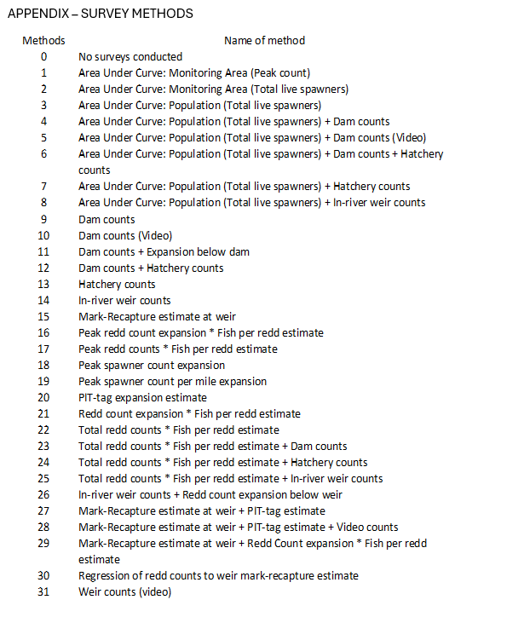

Appendix B – Species-level time series comparisons by population

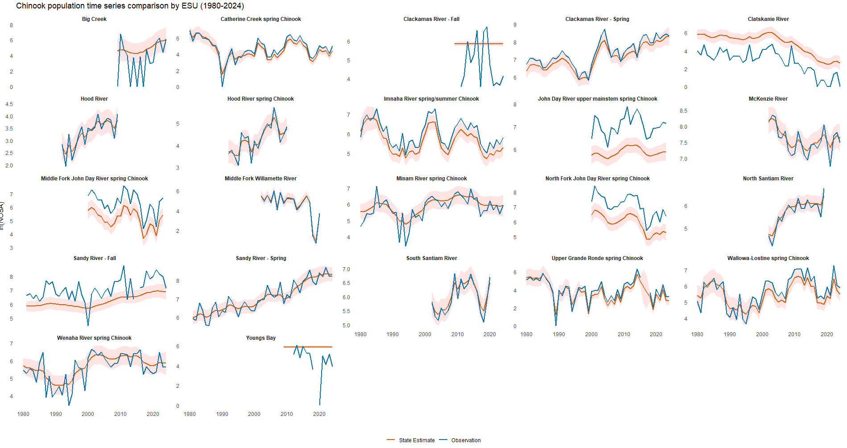Figure X(a): Population level comparison of fitted abundance estimates (red) and observations (blue) of Oregon Chinook salmon from 1980 – 2024.

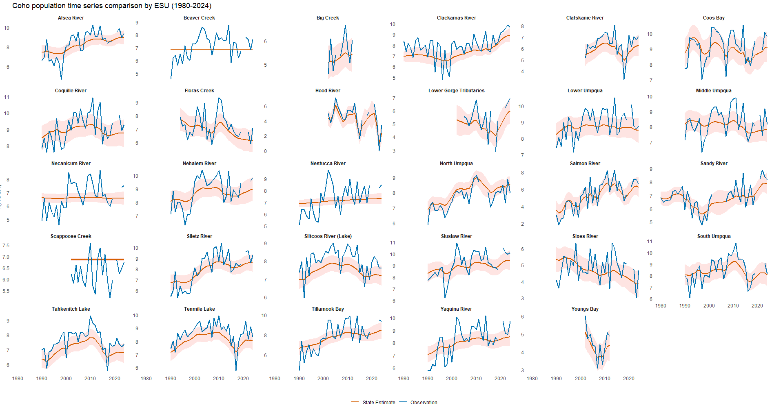Figure X(b): Population level comparison of fitted abundance estimates (red) and observations (blue) of Oregon coho salmon from 1980 – 2024.

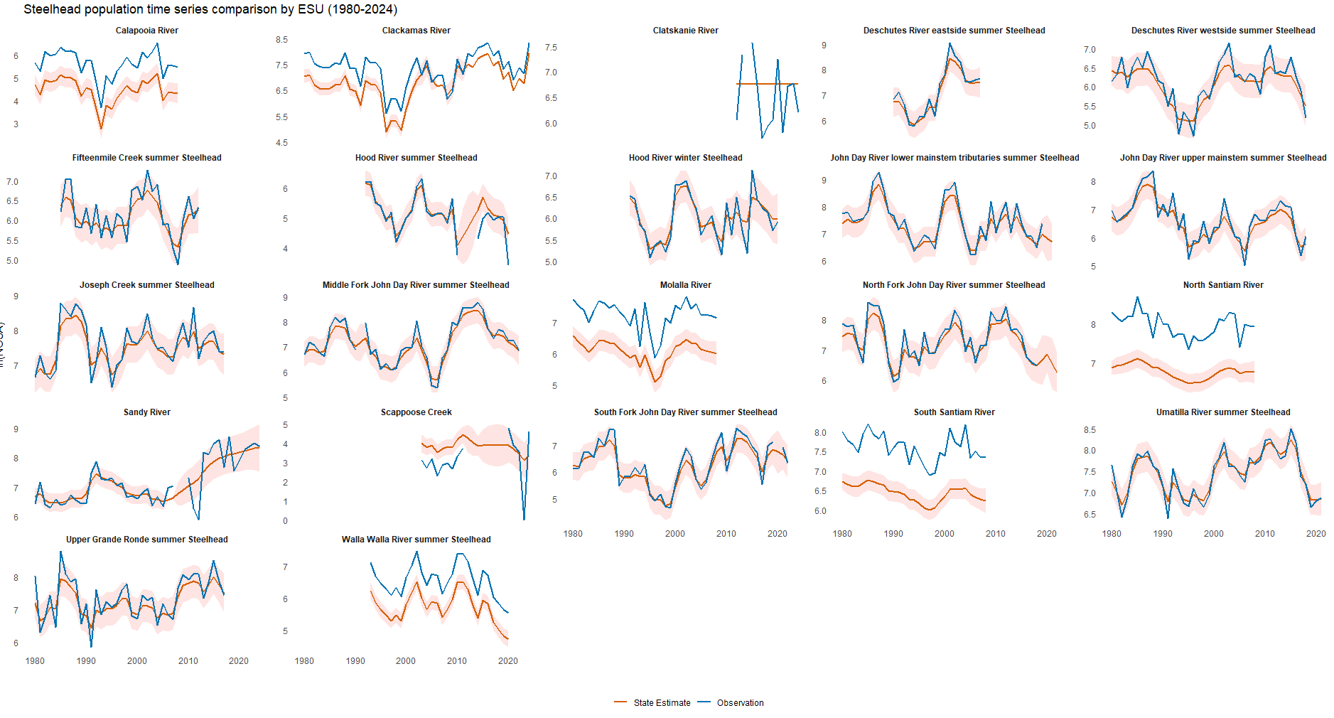Figure X(c): Population level comparison of fitted abundance estimates (red) and survey observations (blue) of Oregon steelhead trout from 1980 – 2024.

