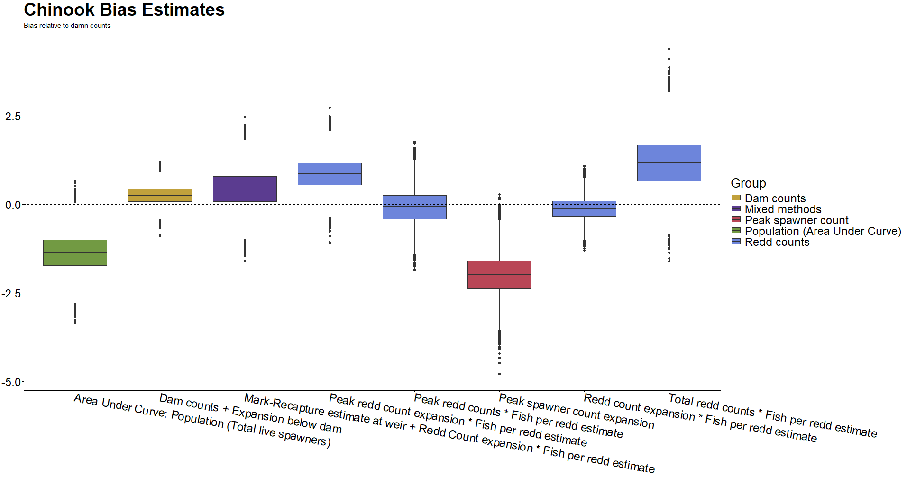Figure U(a): Directional bias in Chinook salmon survey methods as measured relative to ‘Dam Counts’ method (not pictured). Color groupings are non-scientific and intended only as reference. 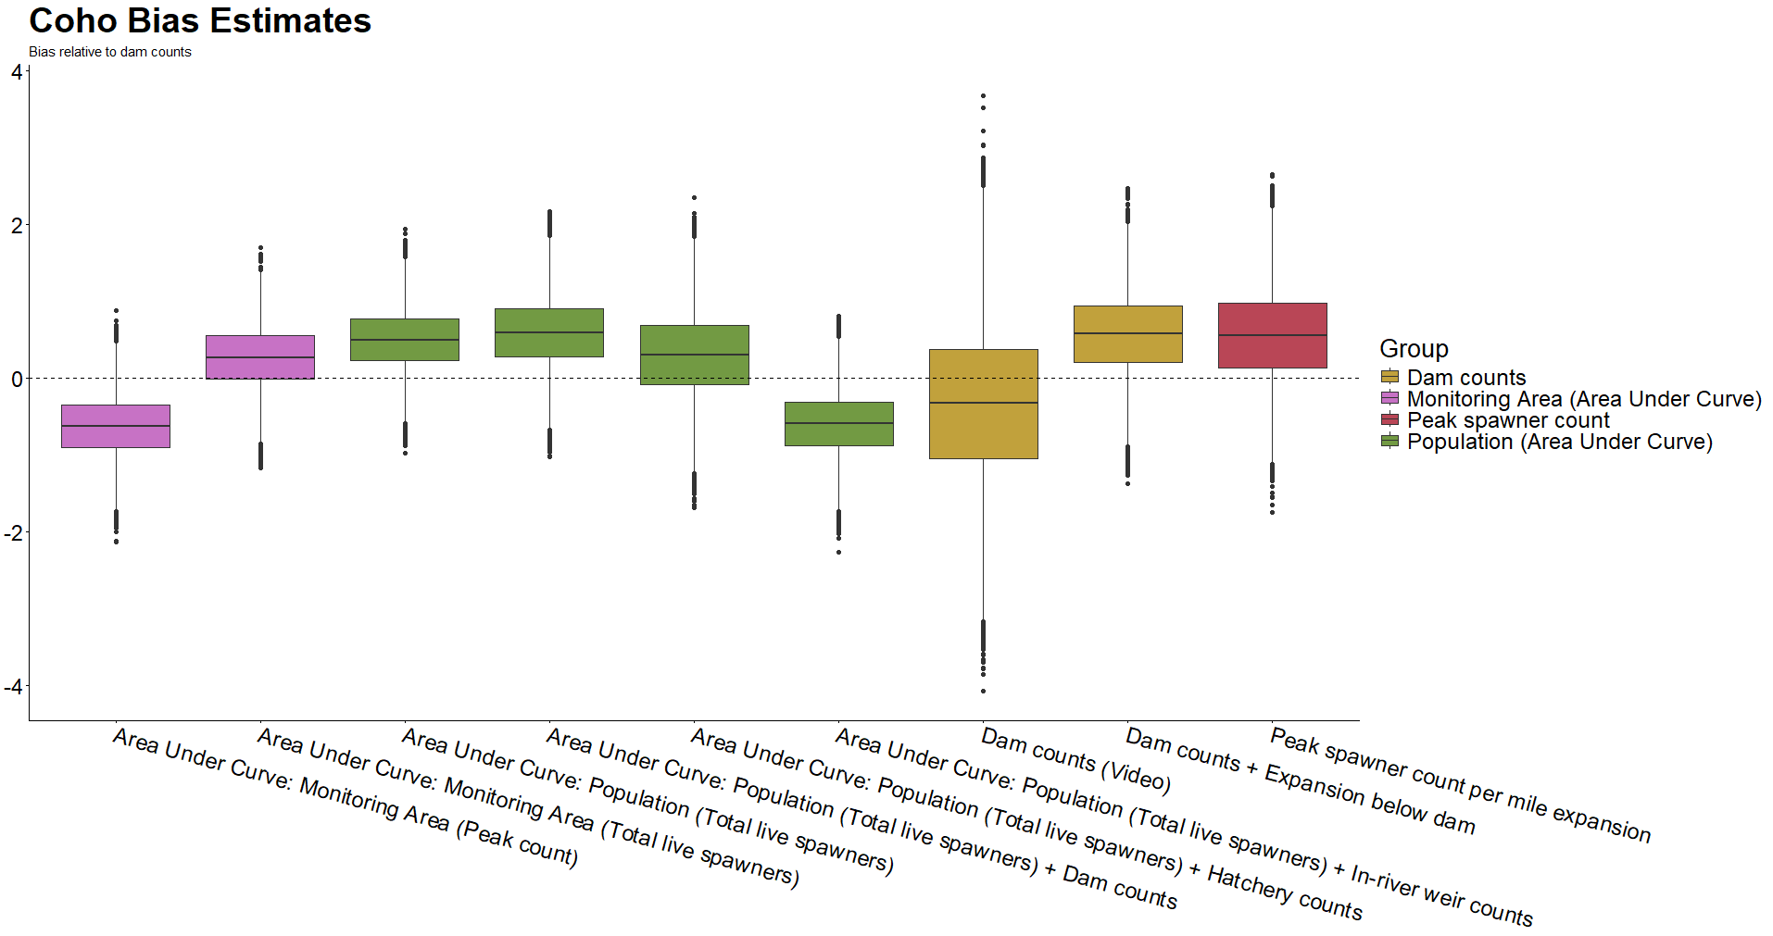Figure U(b): Directional bias in coho salmon survey methods as measured relative to ‘Dam Counts’ method (not pictured). Color groupings are non-scientific and intended only as reference. 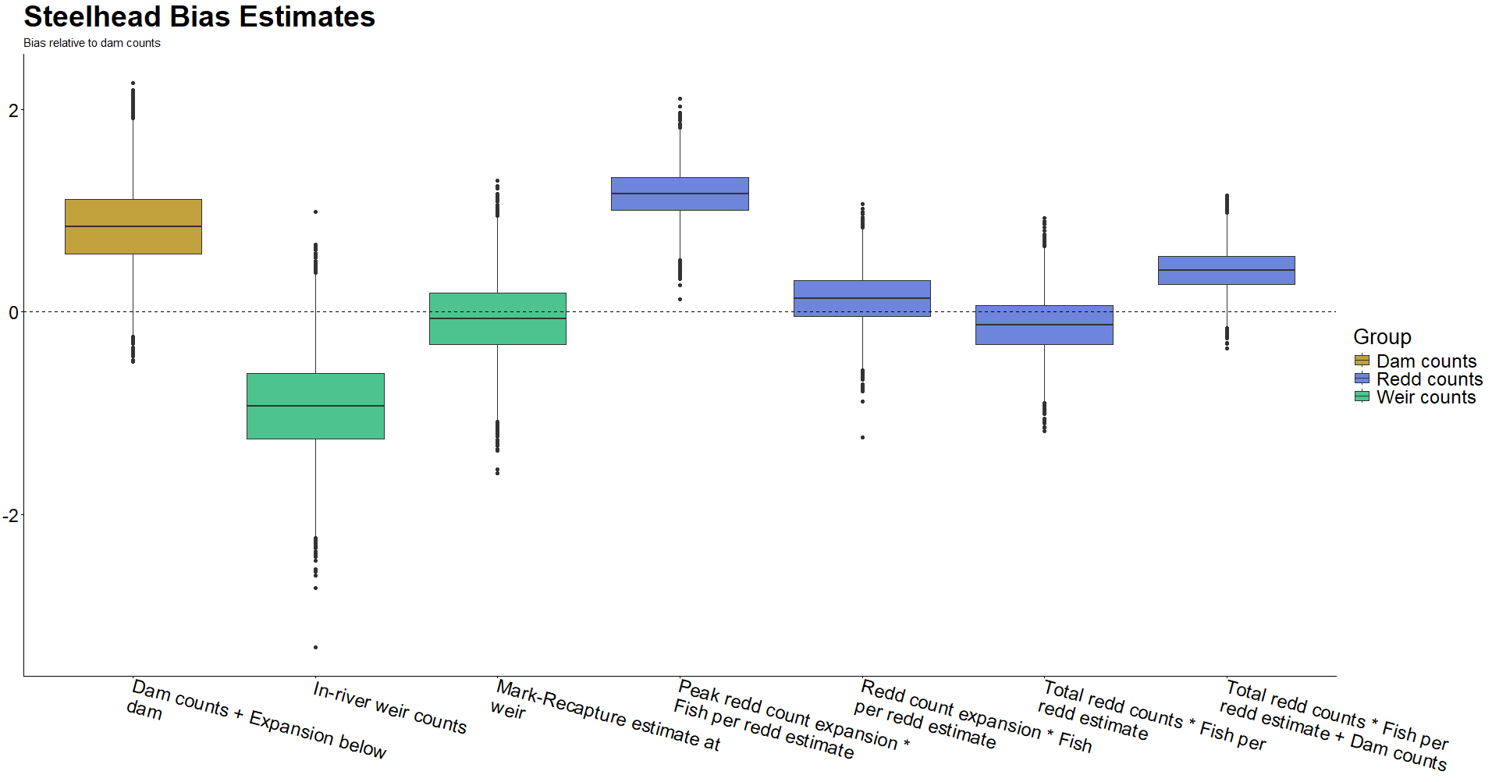Figure U(c): Directional bias in steelhead trout survey methods as measured relative to ‘Dam Counts’ method (not pictured). Color groupings are non-scientific and intended only as reference. 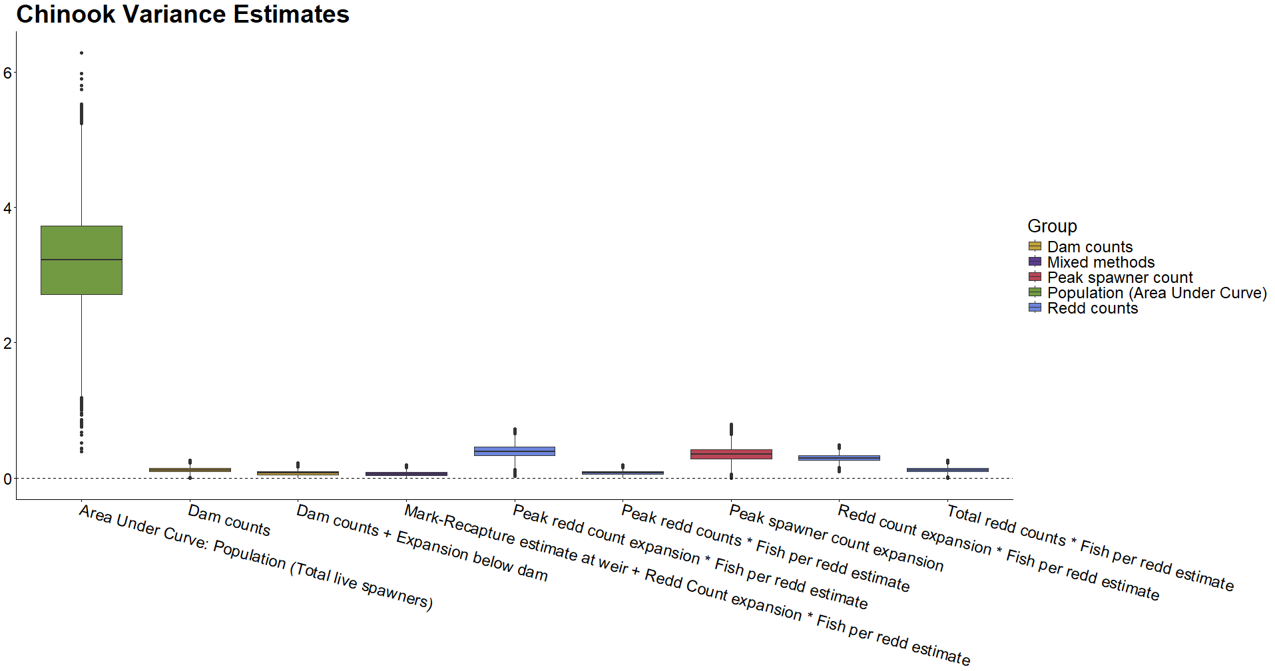Figure V(a): Observational variance in Chinook salmon survey methods. Color groupings are non-scientific and intended only as reference.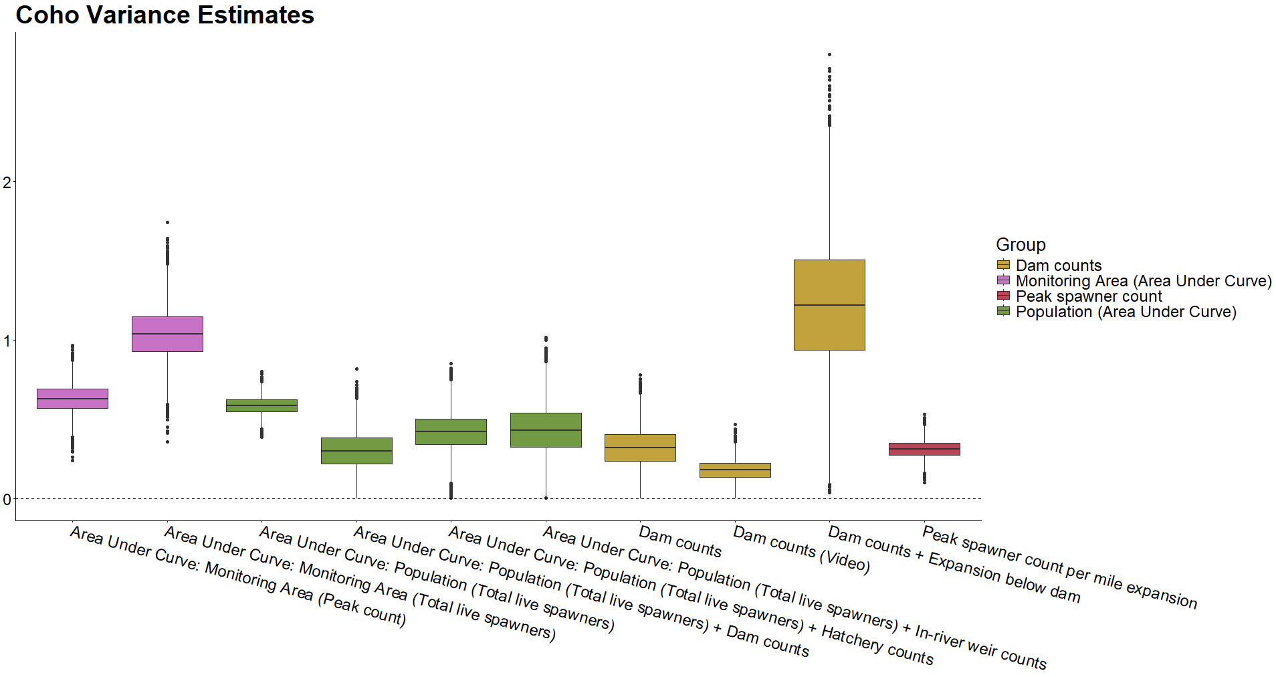Figure V(b): Observational variance in coho salmon survey methods. Color groupings are non-scientific and intended only as reference.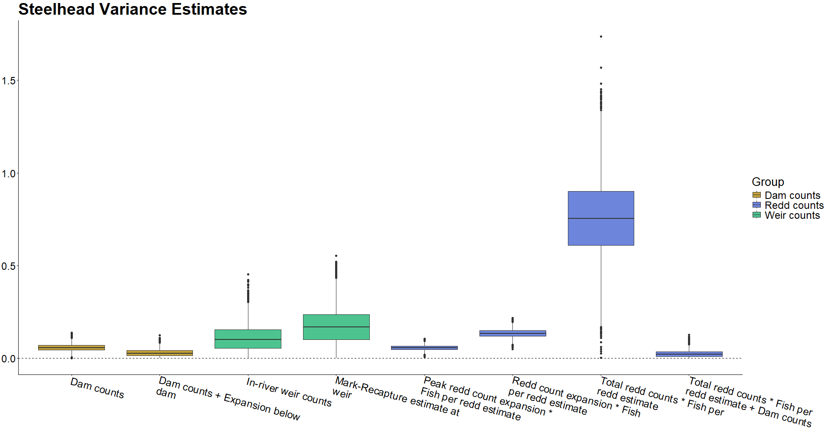Figure V(c): Observational variance in steelhead trout survey methods. Color groupings are non-scientific and intended only as reference.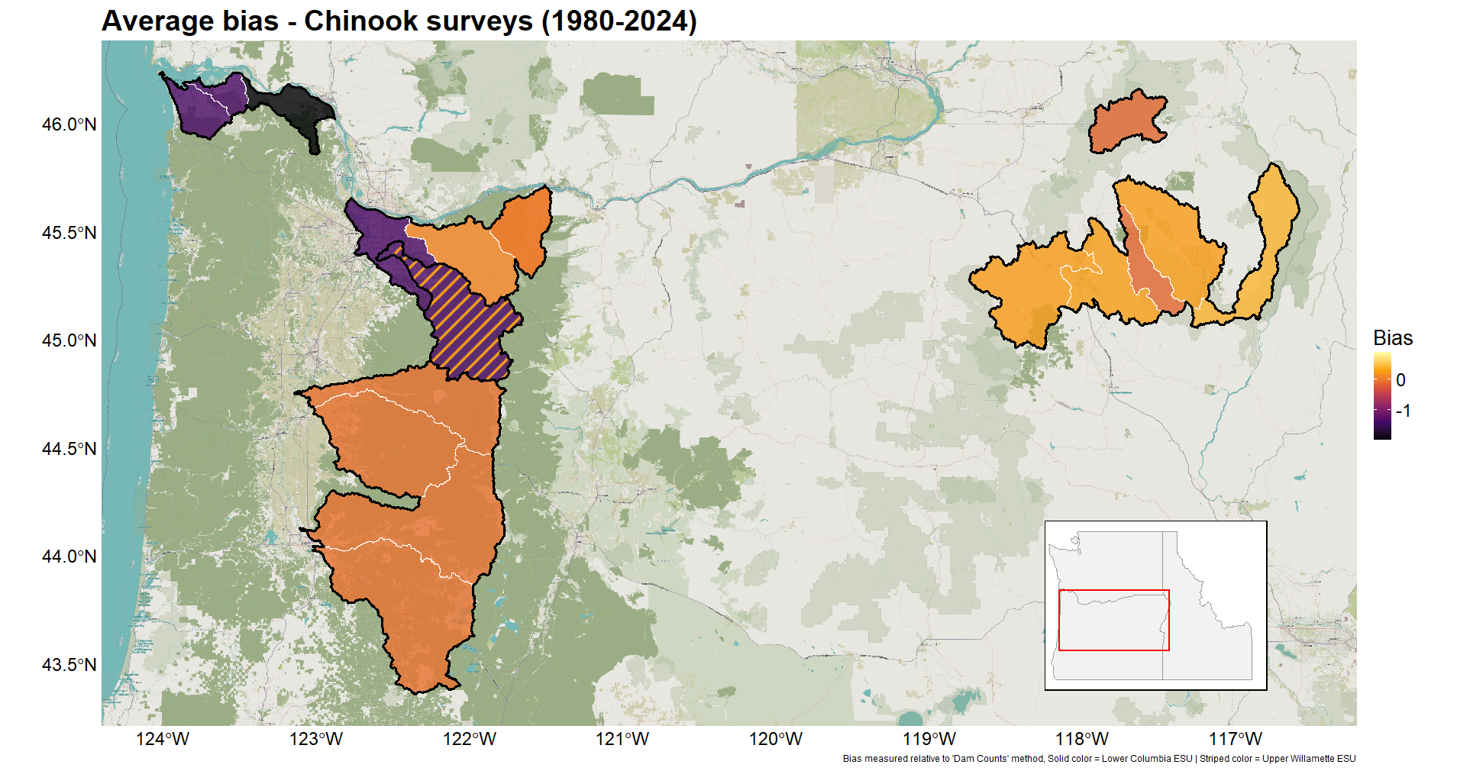Figure W(a): Average directional bias due to choice of survey methods across Oregon Chinook salmon populations from 1980-2024. Survey method bias estimated relative to ‘Dam Counts’ method. Evolutionarily significant units (ESUs) outlined in black. Multicolored area contains populations belonging to multiple ESUs: solid color = ‘Salmon, Chinook (Lower Columbia River ESU) Clackamas River – fall’, striped color = ‘Salmon, Chinook (Upper Willamette River ESU) Clackamas River – spring’.
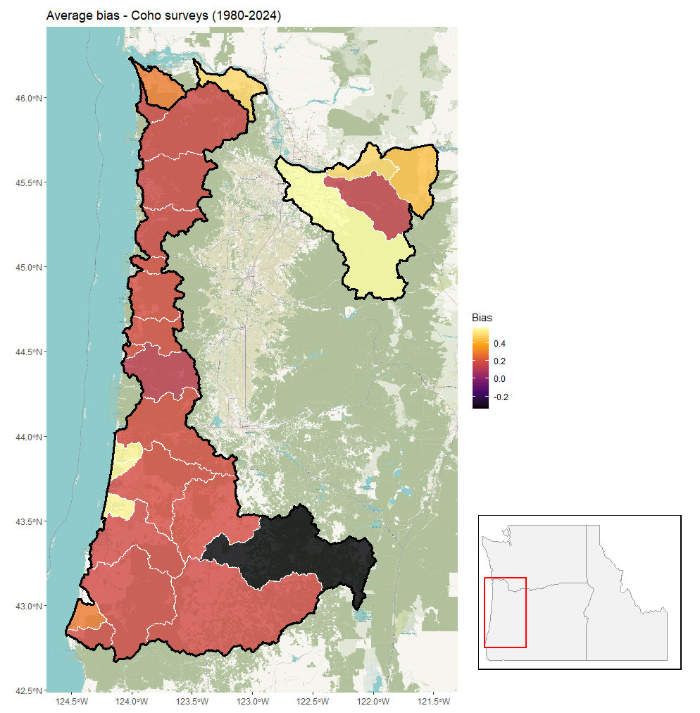
Figure W(b): Average directional bias due to choice of survey methods across Oregon coho salmon populations from 1980-2024. Survey method bias estimated relative to ‘Dam Counts’ method. Evolutionarily significant units (ESUs) outlined in black.

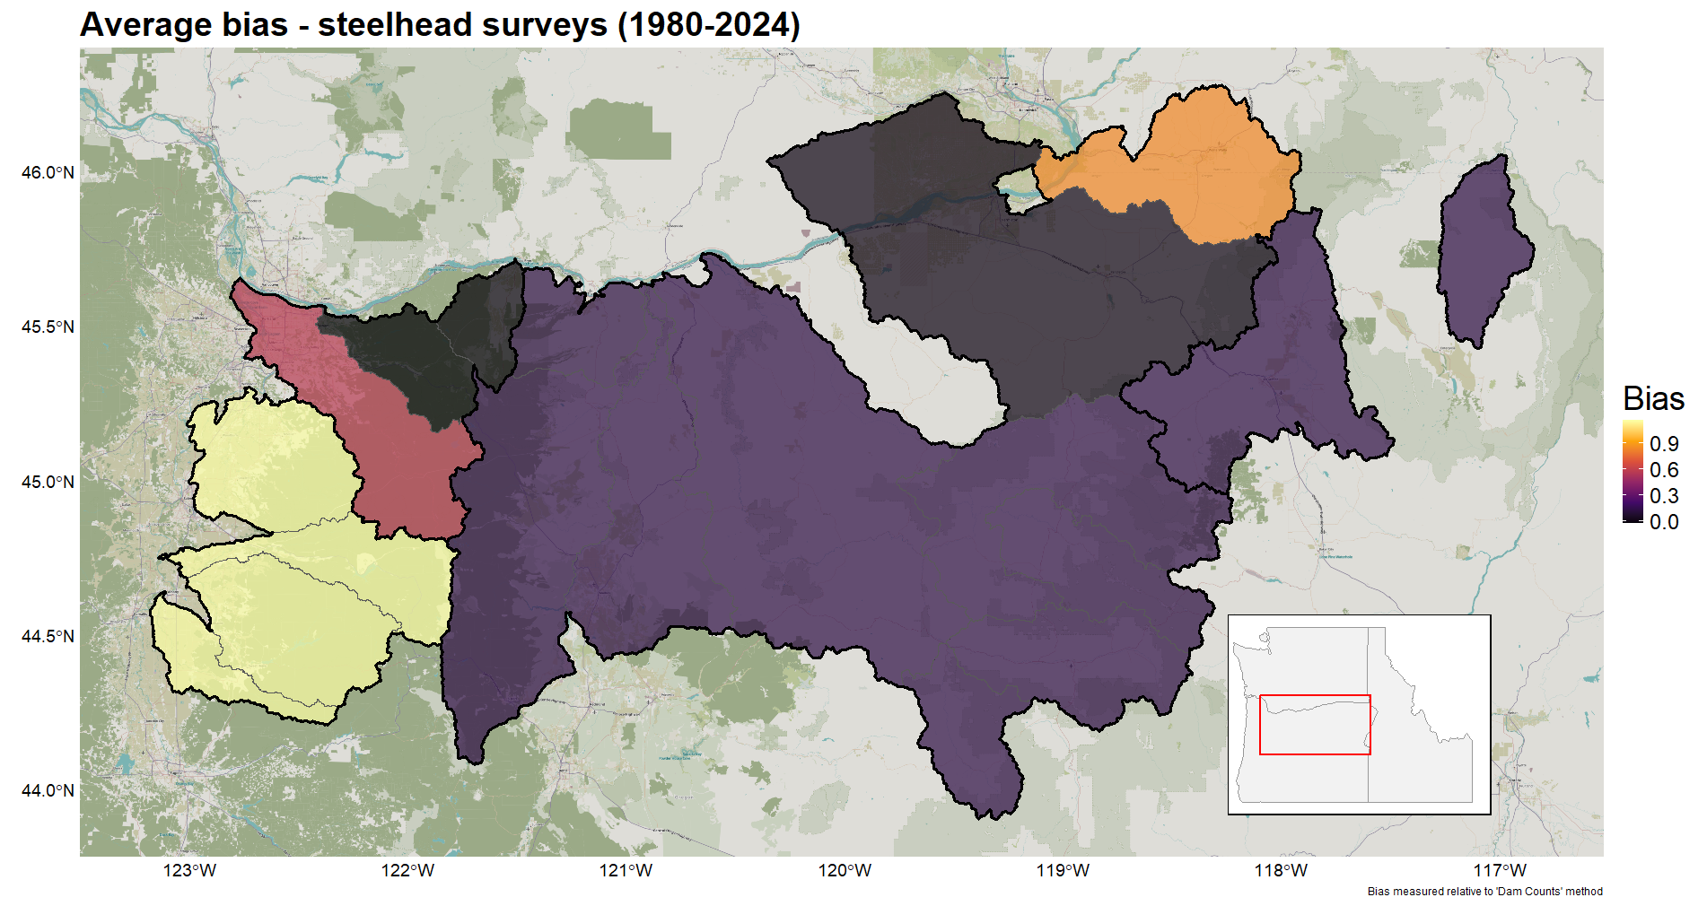Figure W(c): Average directional bias due to choice of survey methods across Oregon steelhead trout populations from 1980-2024. Survey method bias estimated relative to ‘Dam Counts’ method. Evolutionarily significant units (ESUs) outlined in black.

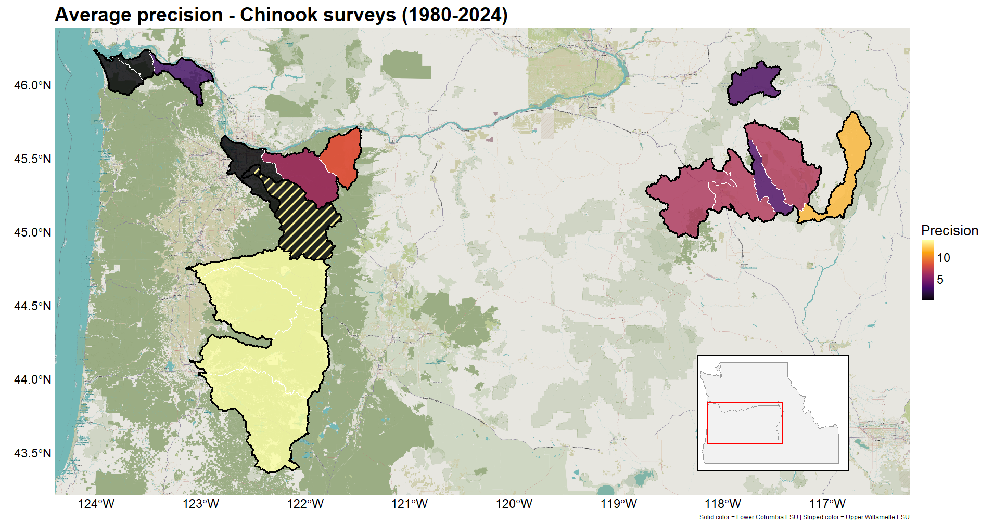 Figure Z(a): Average precision due to choice of survey methods across Oregon Chinook salmon populations from 1980-2024. Evolutionarily significant units (ESUs) outlined in black. Multicolored area contains populations belonging to multiple ESUs: solid color = ‘Salmon, Chinook (Lower Columbia River ESU) Clackamas River – fall’, striped color = ‘Salmon, Chinook (Upper Willamette River ESU) Clackamas River – spring’.

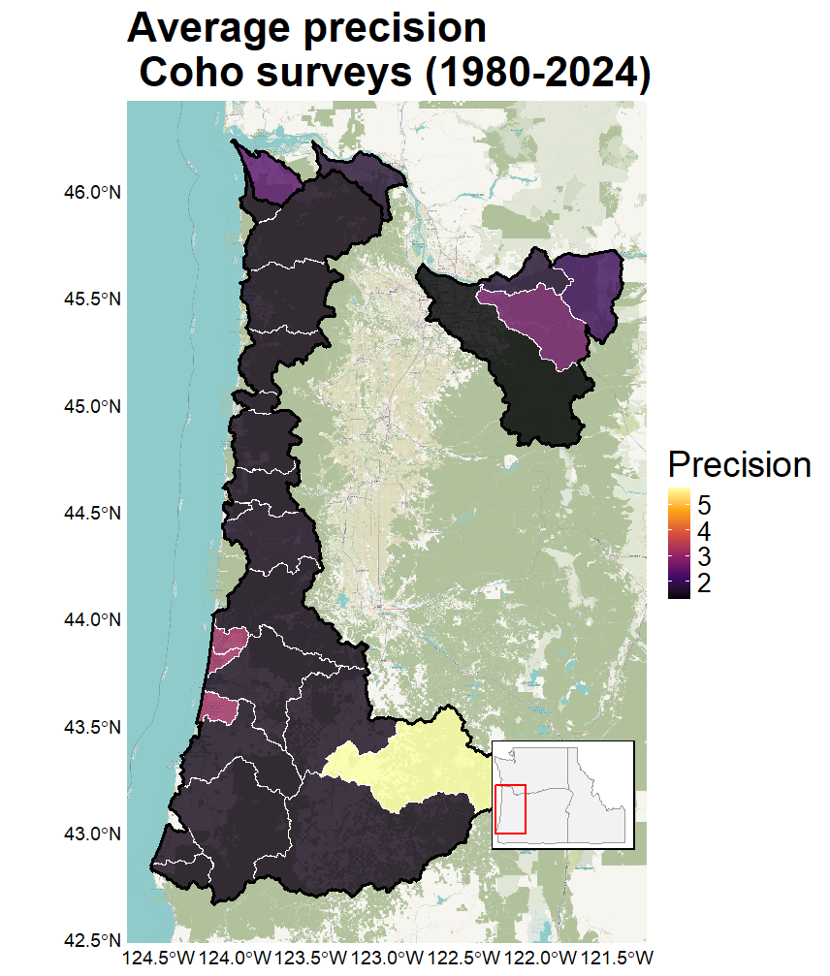
Figure Z(b): Average precision due to choice of survey methods across Oregon coho salmon populations from 1980-2024. Evolutionarily significant units (ESUs) outlined in black.

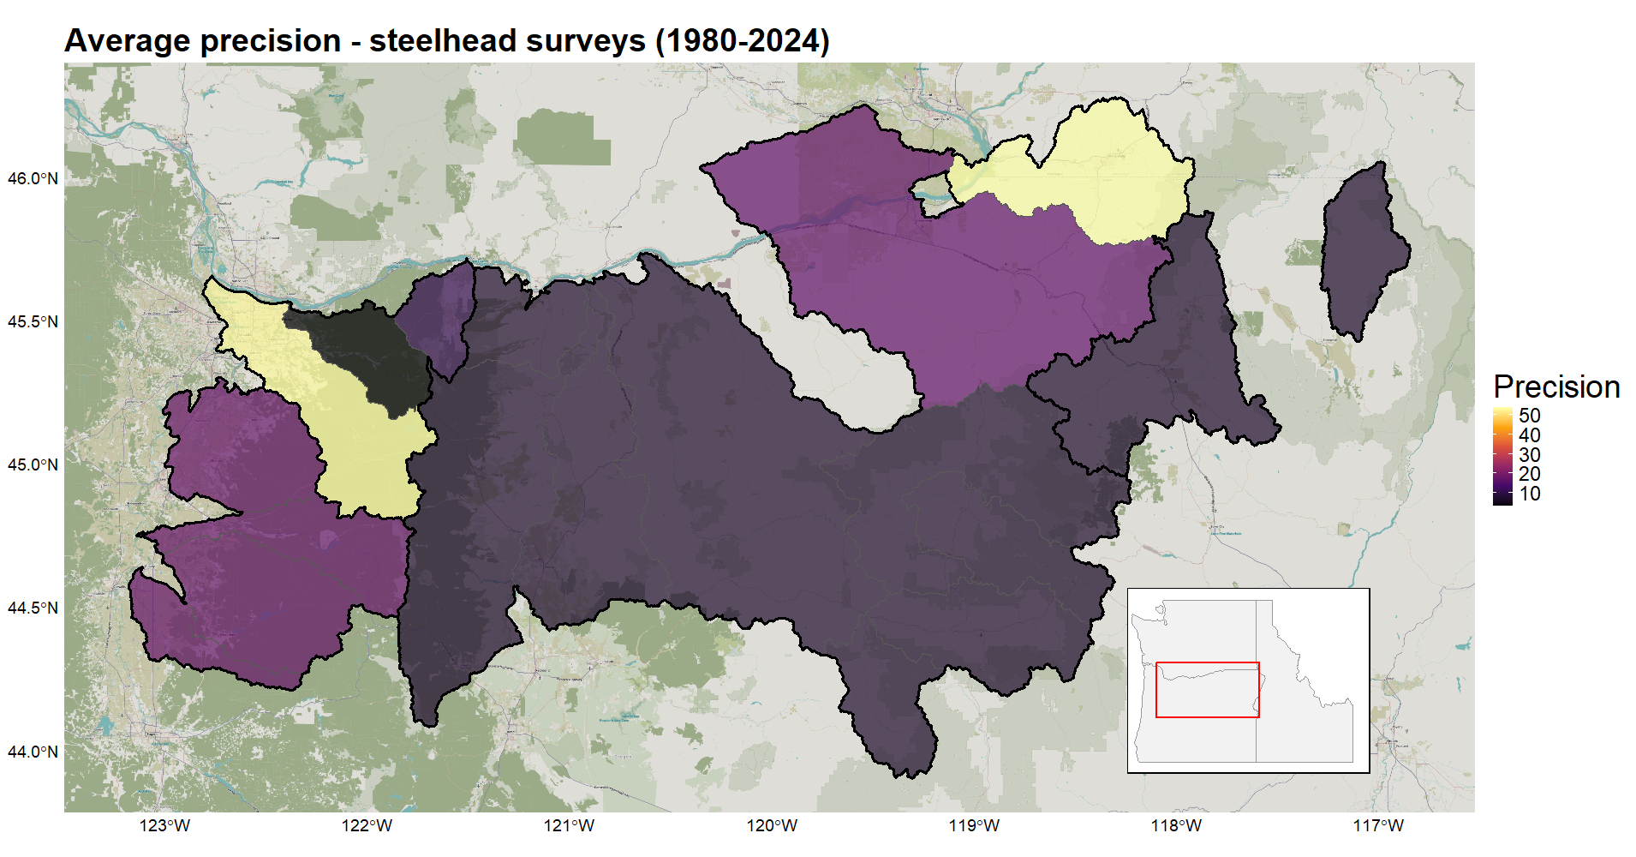Figure Z(c): Average precision due to choice of survey methods across Oregon steelhead trout populations from 1980-2024. Evolutionarily significant units (ESUs) outlined in black.

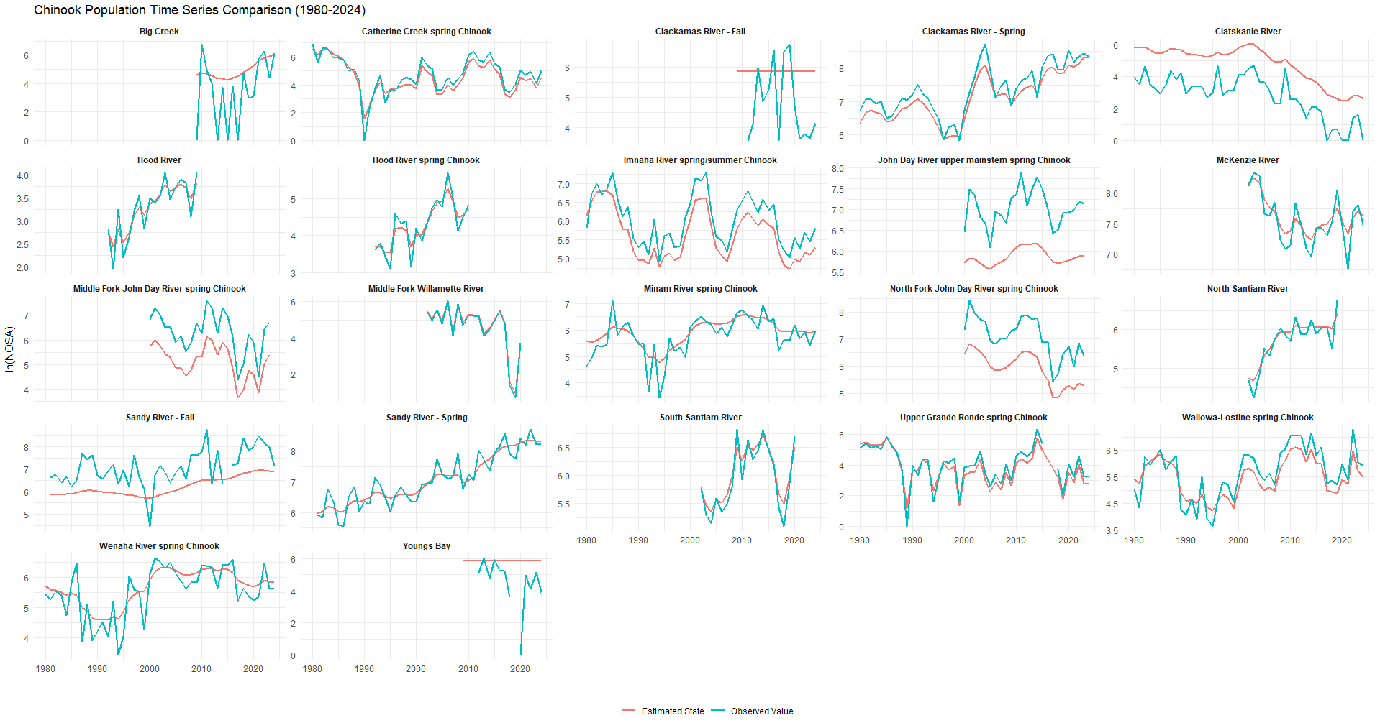
Figure X(a): Population level comparison of

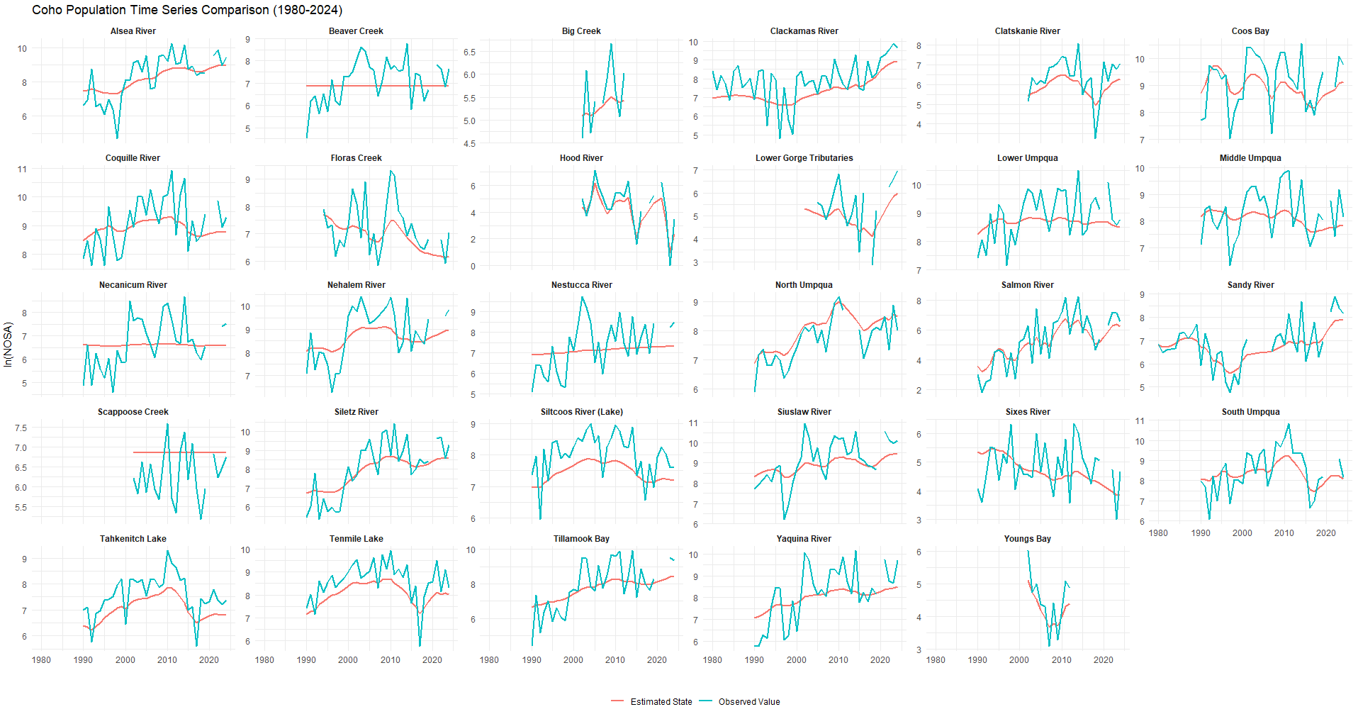
Figure X(b):
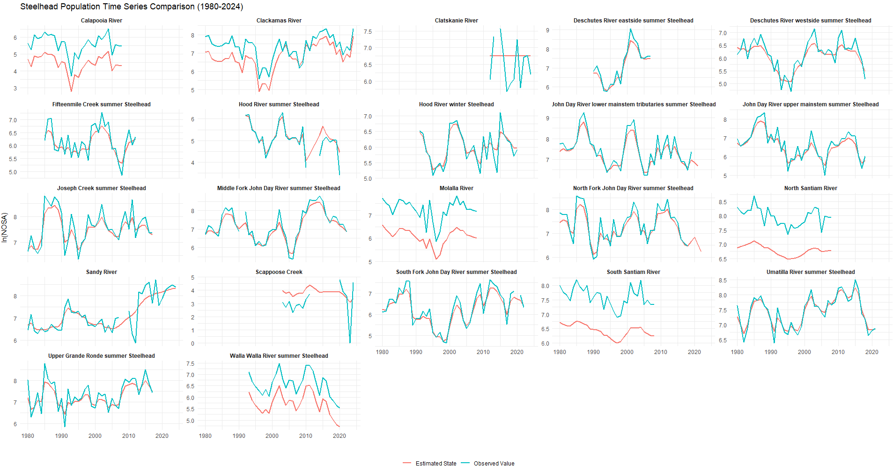Figure X(c):
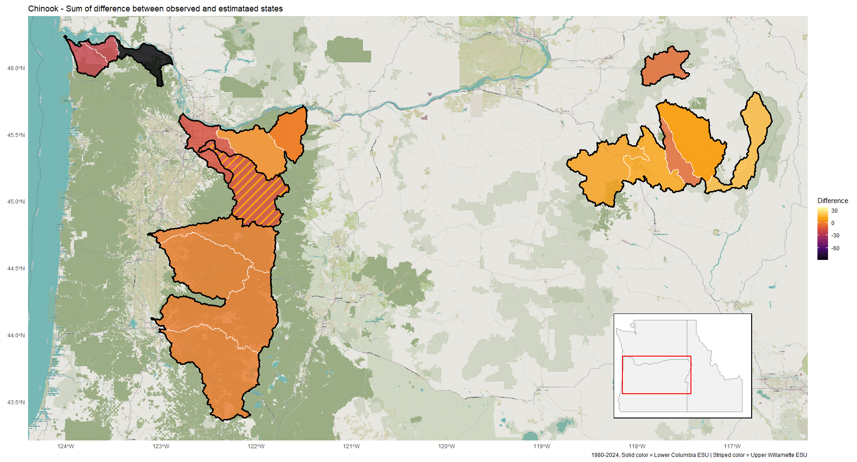Figure Y(a):

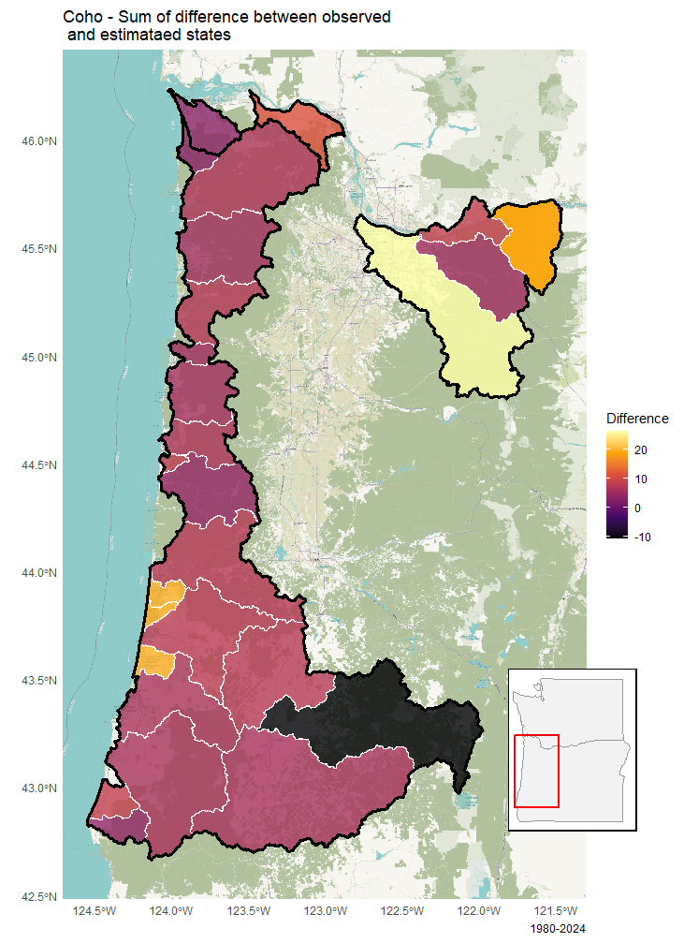
Figure Y(b):

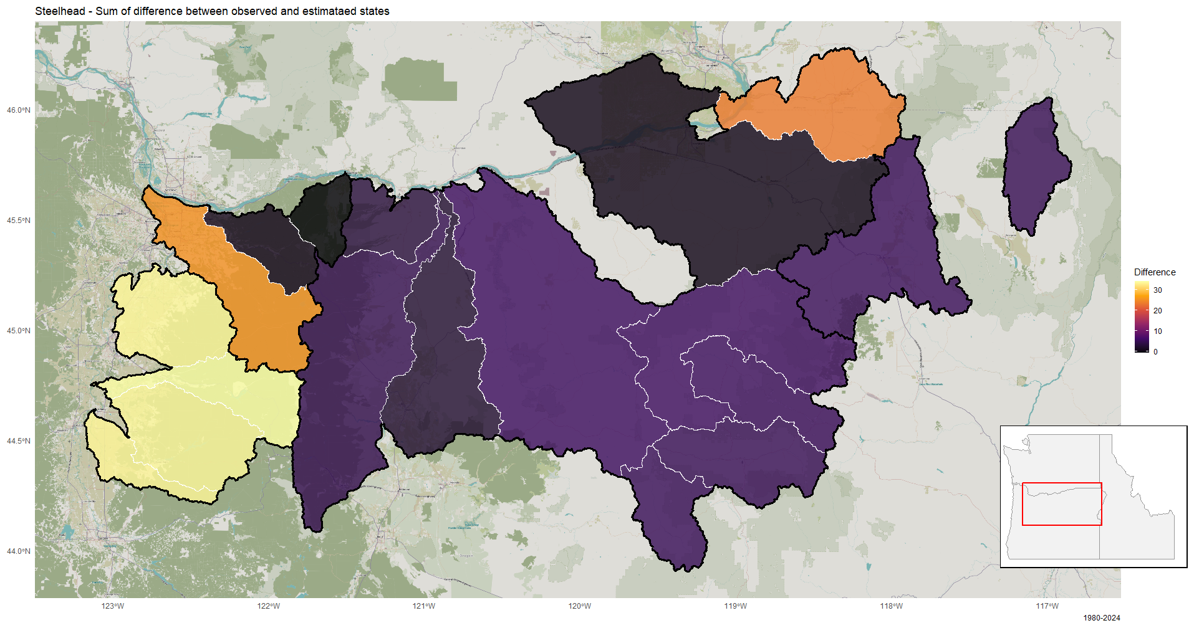
Figure Y(c):

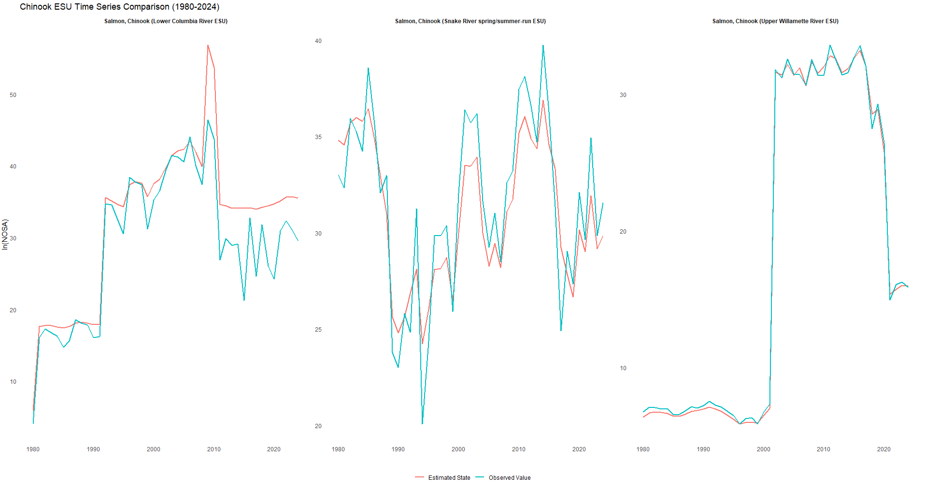Figure T(a):

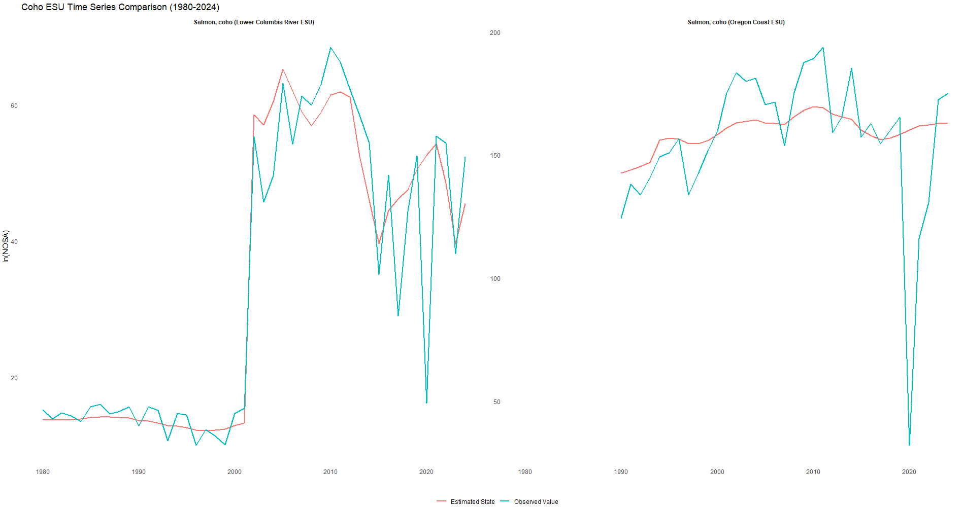Figure T(b): 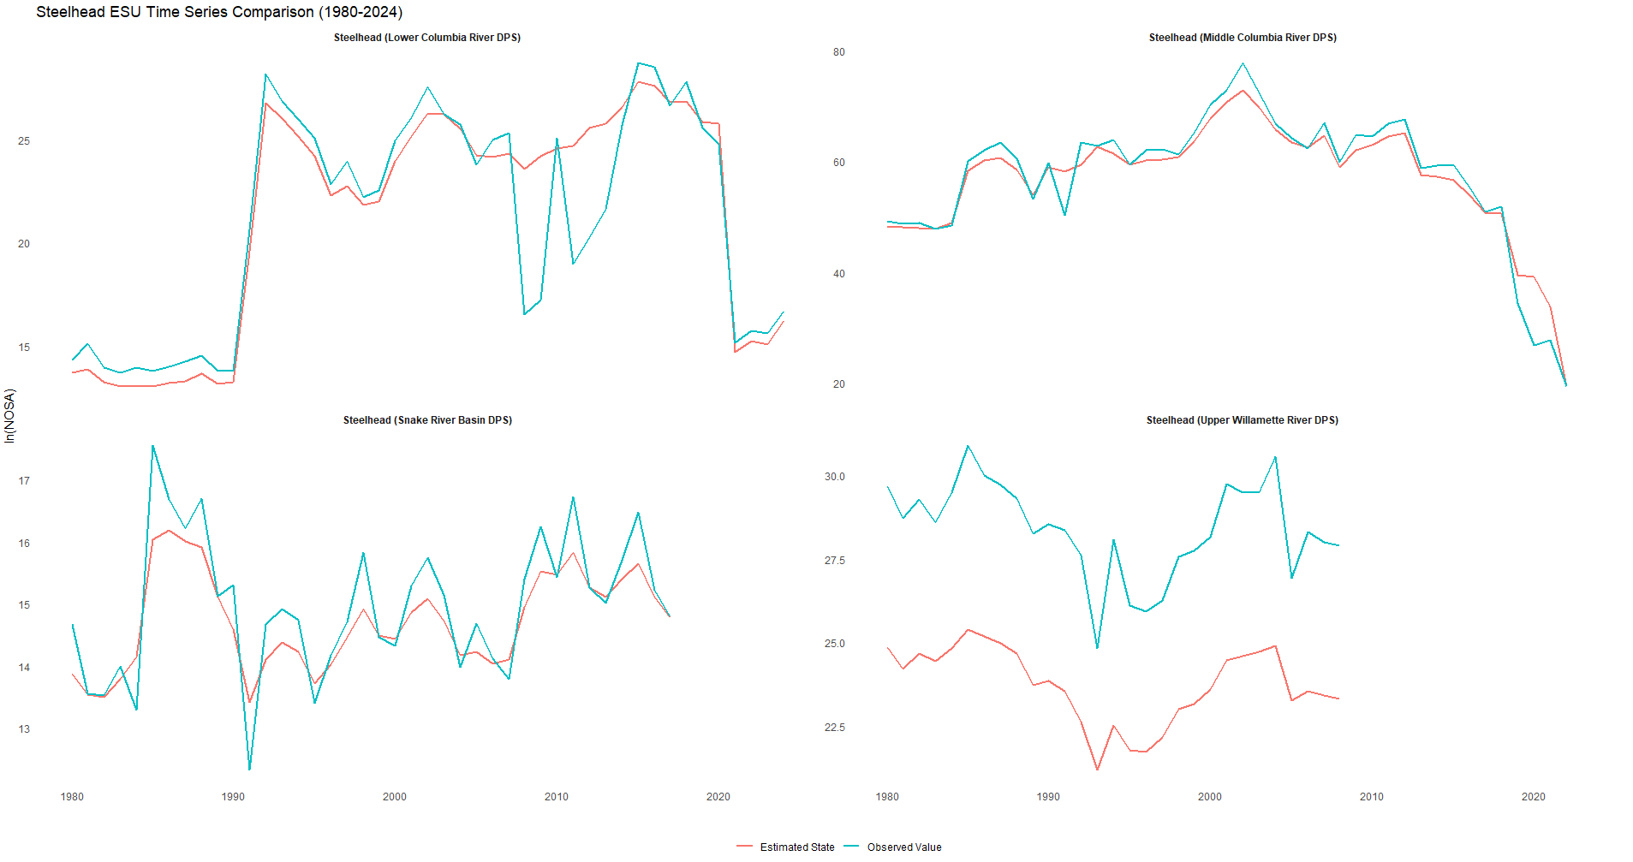Figure T(c):
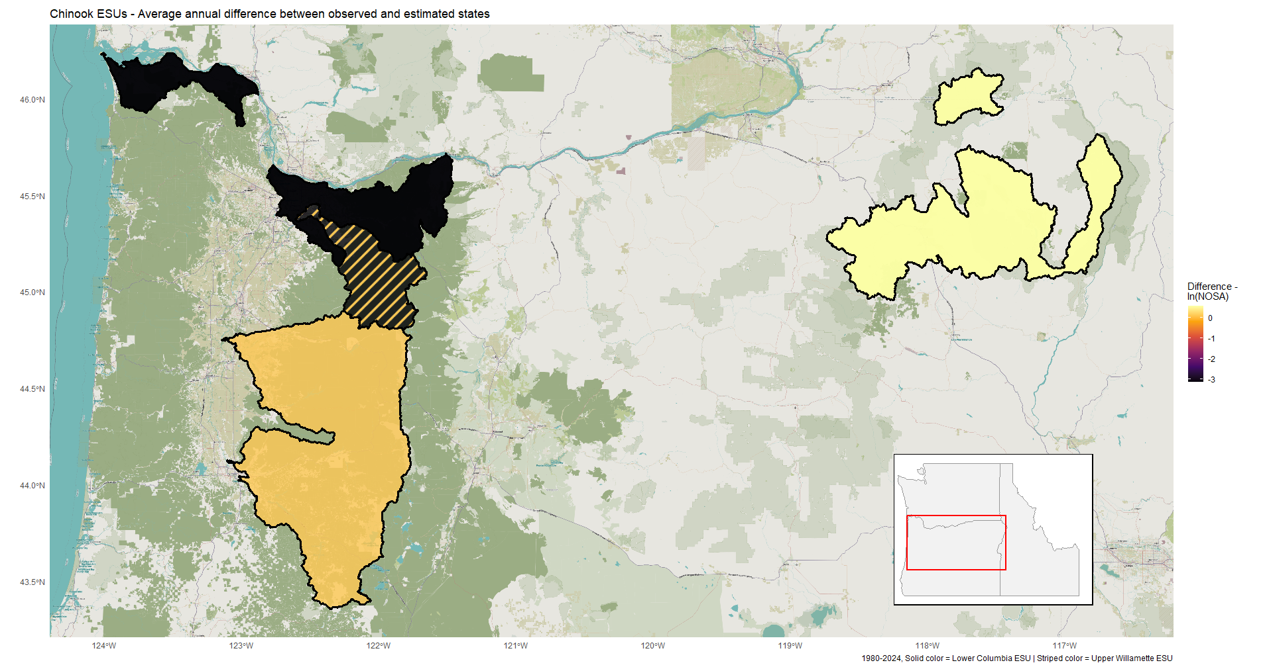 Figure S(a):

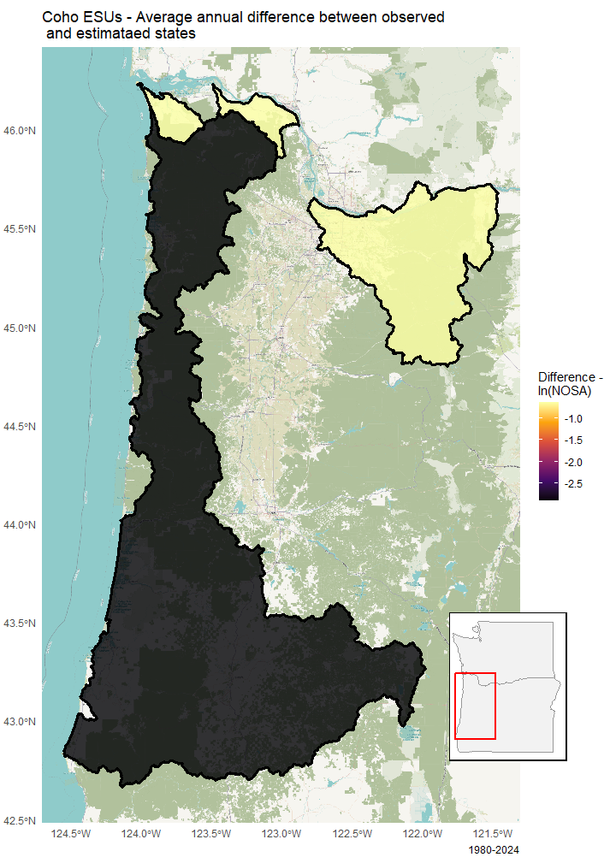
Figure S(b):

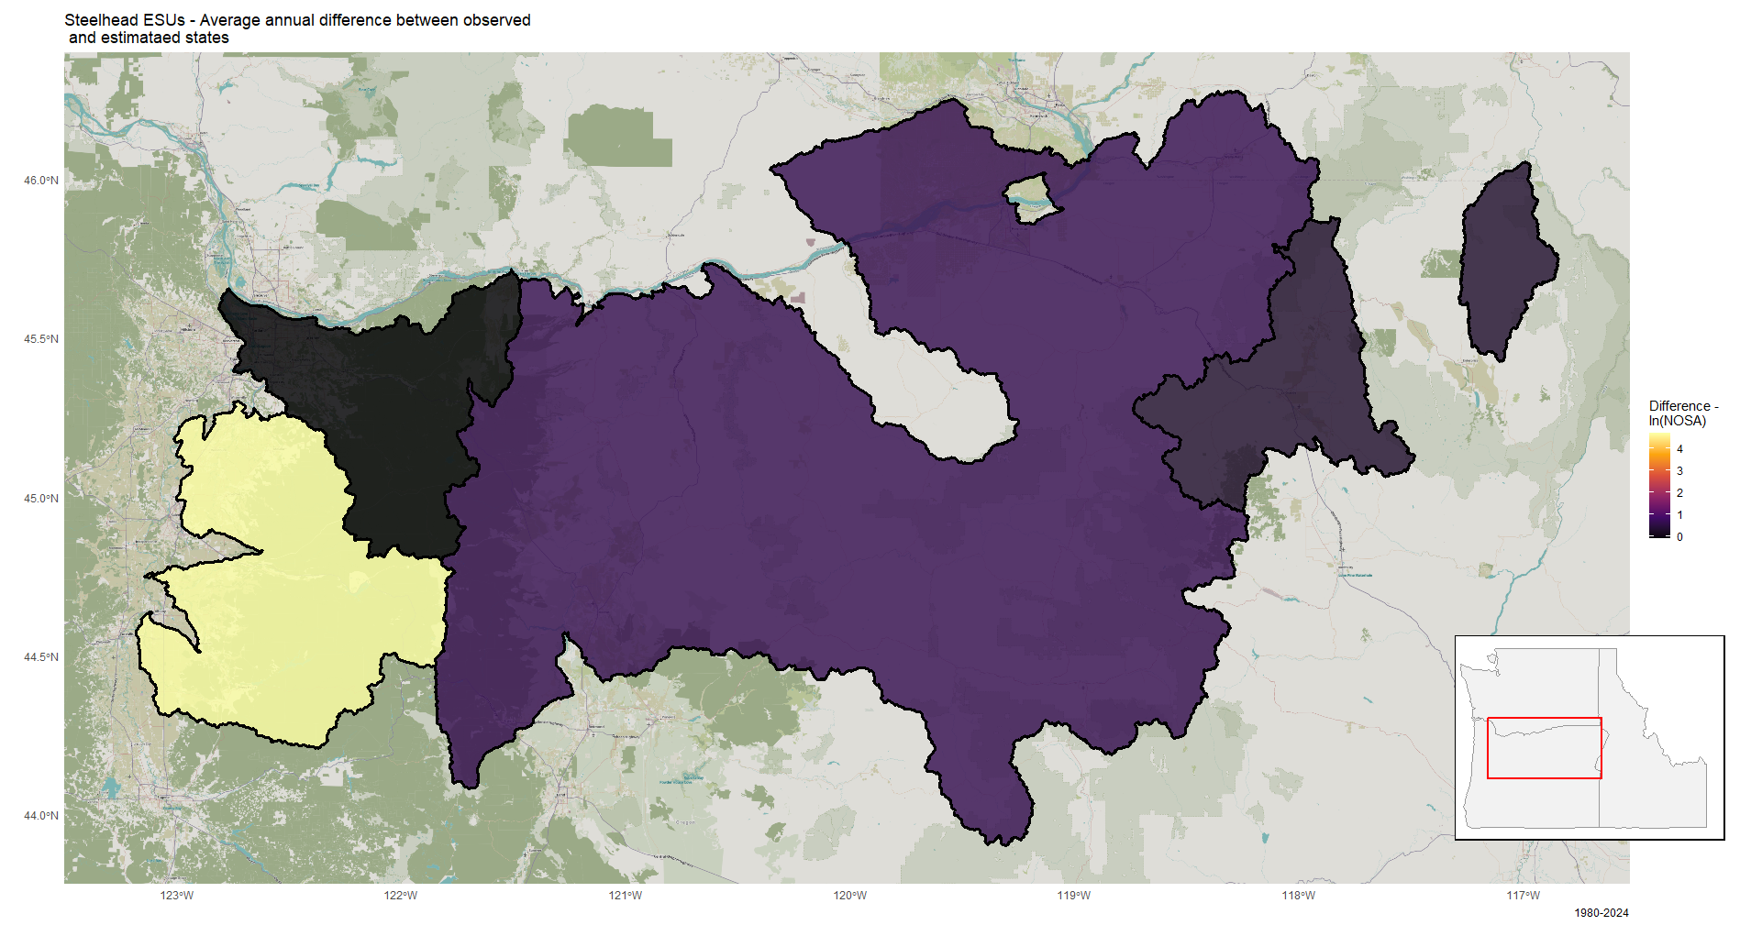
Figure S(c):

