Salmonid survey piece

Brian McGreal
Quantitative Ecology and Resource Management
University of Washington
Seattle, WA

Mark D. Scheuerell
U.S. Geological Survey, Washington Cooperative Fish and Wildlife Research Unit
School of Aquatic and Fishery Sciences
University of Washington
Seattle, WA

William K. Jaeger
Department of Applied Economics
Oregon State University
Corvallis, OR

(potentially)
Kasey Bliesner - ODFW
Jake Chambers - ODFW

Abstract
Fisheries management and conservation policies depend on surveys designed to estimate the abundance of target species over time. A variety of survey methods are employed for these purposes, each characterized by some level of precision and the potential for directional bias. While low levels of precision in survey methods lead to low confidence in point estimates of population abundance or forecasts, directional bias presents a more pernicious problem as it may lead to the mismanagement of imperiled species, invasive species, and commercially valuable populations, due to over- or under-estimation of their numbers. I estimated levels of precision and bias associated with 27 survey methods commonly used by the Oregon Department of Fish and Wildlife to estimate the abundance of 74 ESA-listed populations of Chinook (Oncorhynchus tshawytscha) and coho salmon (O. kisutch), and steelhead trout (O. mykiss), from 1980 to 2022. Using multivariate autoregressive state-space models (MARSS), I distinguish observation (sampling) error from process (environmental) error and estimate directional bias at the level of individual methods. I find that, while some survey methods are generally more precise than others, the same survey methods can have very different levels of precision and biases when applied to different species. Species level patterns are also present, with coho survey methods being the least precise of those examined, Chinook methods the most biased, and steelhead trout methods being generally the most accurate.

Introduction
Ecological monitoring, in which intermittent surveillance of one or more ecological measures of interest is undertaken, is widely regarded as an essential pillar of conservation science and management (Goldsmith 1991, Nichols and Williams 2006, Lindenmayer and Likens 2010). Monitoring programs differ in goals and scope but typically involve recurring collection of data to inform some combination of science, management, and policy (Lindenmayer and Likens 2010). Surveys are the essential “on-the-ground” data-gathering efforts which make up monitoring programs, and which take a wide variety of forms in ecology depending on the species/systems of interest and the objectives of the monitoring program, as well as the costs of monitoring efforts and managers wanting to ensure the most efficient use of resources available (Goldsmith 1991, Caughlan and Oakley 2001, Field et al. 2005, Wintle et al. 2010, Hanson et al. 2023). Data collected through survey efforts are often used to construct estimates of population-level characteristics, introducing statistical uncertainty. Survey methods are additionally subject to observation inaccuracy (i.e. missed individuals, individuals double-counted, non-existent individuals recorded) resulting from the form of the method employed (Tyre et al. 2003, Elphick 2008). Bias and precision related to survey methods have been studied across multiple ecological niches, underscoring the value in identifying these characteristics (Leujak and Ormond 2007, Hone 2008, Parsons and Skalski 2010, Morrison 2016). An imprecise survey method can still be of use depending on the application, but it is crucial that scientists and wildlife managers understand the ways in which a method or suite of methods is inaccurate when evaluating data collected and drawing conclusions. Getting the best out of such a survey method requires estimates of the method’s precision and potential bias to allow for adjustments relative to some predetermined standard of accuracy.
Pacific salmon (Oncorhynchus spp.) have long been the subject of monitoring programs in North America. Many populations of pacific salmon are ESA listed, beyond which the conservation of these species for environmental, tribal, commercial, and recreational use is of tremendous importance to fish and wildlife agencies in the Pacific Northwest (Wolf and O’Neal 2010, Levi et al. 2018, Jaeger and Scheuerell 2023, National Oceanic and Atmospheric Administration 2025b, Price and Moore 2026). While these motivating factors can be said of all salmonid population in the Pacific northwest, multiple salmon and trout Evolutionarily Significant Units (or ESUs - groupings composed of many salmonid populations) are protected under the US Endangered Species Act of 1973, further compelling the need for sustained monitoring (National Oceanic and Atmospheric Administration 2025a). Since 1980, the state of Oregon alone has spent over $9 billion in the effort to protect and restore populations of steelhead trout (Oncorhynchus mykiss) and Pacific salmon in the Columbia River Basin. However, the impacts of these restoration efforts remain difficult to quantify (Jaeger and Scheuerell 2023). While some amount of uncertainty will always exist, understanding the value of conservation investments relies on understanding the accuracy of salmonid population assessments.
To manage harvest and assess the impact of conservation policy and interventions, various survey methods are employed to estimate the abundance of target species over time. Each method is characterized by an inherent level of precision and potentially some inherent directional bias as well (Parsons and Skalski 2010). Past studies have shown a positive relationship between the intensity of sampling efforts, and the precision of abundance estimates in both aquatic and terrestrial species (Walsh et al. 2001, Nuno et al. 2013, Annear et al. 2024). As such, managers must navigate the tradeoffs between more intensive sampling efforts and the level of precision they hope to achieve. While low levels of precision in survey methods lead to low confidence in point estimates of population abundance or forecasts, directional bias presents a more pernicious problem as it may lead to the mismanagement of imperiled species, invasive species, and commercially valuable populations (Tracey and Fleming 2022, Satterthwaite and Shelton 2023). Over-estimation of a species of interest lends itself to potential overharvesting, while under-estimation may lead to lost revenue due to harvest restrictions, and either of these outcomes could result in the suboptimal allocation of conservation (Elphick 2008, Parsons and Skalski 2010, Katzner et al. 2011). Indeed, in the United States, decisions of whether to list or de-list species as endangered under the Endangered Species Act are based on abundance estimates that may be influenced by such bias (National Oceanic and Atmospheric Administration 2025b, U.S. Fish and Wildlife Service 2026). When directional bias can be assessed and corrected for, we can achieve more accurate abundance estimates (Polansky et al. 2023).
Spawning salmon and trout are surveyed in freshwater using methods that vary from visual inspection of known spawning grounds to counts of salmon migrating up stream at fixed points to inferential methods estimating total escapement in a stream system based on periodic counts of spawners (Knudsen 2000). Survey methods conducted at terminal spawning grounds include foot surveys of live fish, carcass counts, and visual inspection of salmonid nests known as redds (Johnson et al. 2007, Oregon Department of Fish and Wildlife 2024a). Within streams, adult fish may be captured and counted at weirs before being released to continue their upstream migration (Anderson et al. 2015). Another approach involves capturing salmonids as juveniles and fitting them with small passive integrated transponders (PIT-tags). This enables tagged fish to be electronically counted as adults years later, as the return to their natal spawning grounds takes them past sensor arrays (Lamb et al. 2024). In more remote localities, aerial surveys are favored with fish being counted from either helicopter or fixed-wing aircraft, trading precision for the ability to survey sites which are otherwise very difficult to access (Walker 2015, Copeland et al. 2019). Finally, these methods and more may be included in the estimation of total escapement through a variety of area-under-the-curve and peak spawner count estimation methods (English et al. 1992, Parken et al. 2003, Millar and Jordan 2013). Given this variety of survey methods dependent on various technology and statistical techniques, each method will be characterized by some degree of imprecision, and perhaps some intrinsic tendency to over- or under-estimate spawning salmonids.
My research seeks to measure the levels of precision and relative bias accompanying various survey methods by comparing observations from 74 populations of Chinook (O. tshawytscha) and coho salmon (O. kisutch) and steelhead throughout Oregon, most of which each belong to an ESU (or in the case of steelhead, Distinct Population Segment or DPS) listed as threatened under the Endangered Species Act. These surveys were conducted by biologists from the Oregon Department of Fish and Wildlife (ODFW) from 1980 to 2024, using 31 distinct survey methods. The precision inherent to a survey method (and the associated variance of estimates derived from these surveys) directly impacts the ability to detect changes throughout time, as large confidence intervals may obscure shifting abundance regimes (Vallecillo et al. 2021). I also seek to determine whether non-zero directional bias exists in some survey methods, although bias estimates will necessarily be defined relative to other survey methods, as “true” censuses of the underlying salmonid populations do not exist. While most survey methods analyzed in this study do not show significant directional bias, some exceptions to this pattern warrant closer scrutiny. A secondary objective of this research is to identify which and to what extent ESU/DPSs in the study area have been chronically under- or over-estimated due to the survey methods employed in monitoring them, with over-estimation being of particular concern.

Methods
Data
I used an extensive dataset that includes annual observations of natural-origin spawner abundance (NOSA) covering 74 populations of Chinook, coho, and steelhead throughout Oregon from 1980 to 2024. Crucially, each observation also includes the method by which the abundance survey was conducted. Data have been collected through 31 unique survey methods (fully enumerated in the attached appendix) and contain 2,396 individual observations with recorded NOSA values. Eight hundred and forty eight observations missing NOSA values almost entirely related to years in which no survey was conducted were dropped. Survey methods which appear only very rarely in the data (less than ten occurrences for a given species) were also dropped due to a lack of sufficient sample size.
Across the landscape it can be seen that shifts in average populations sizes between the first and last decades recorded in the study period are not necessarily typically spatially correlated (coho on the northern Oregon coast being a notable exception), and that the majority of populations have increased or decreased by less than 50% in this timeframe (Figure 2). Of course, the accuracy of the trends described above are dependent on the accuracy of the observed data, itself a product of the survey methods employed. The frequency with which survey methods are employed is not uniform across the study period (Figure 3). While some methods such as redd counts have been widely used throughout the study period, other methods have seen drastic changes in usage. If different survey methods indeed exhibit varying levels of precision and/or inherent directional bias, then changes in population overtime may be less accurate than initially assumed. Assessing both the accuracy of these methods and the unbiased underlying trends in abundance requires an approach capable of distinguishing between the two.

MARSS Models
Because my goal is to isolate variance and bias in different survey methods, it is vital to distinguish variability in observations due to survey methods from variation in the natural state of salmonid populations. Multivariate autoregressive state space (MARSS) models are well
suited for this purpose, as they can mathematically distinguish observation error from process/state error and assign separate variance parameters to each. This is accomplished through a model structure with two components: a process equation which models one or more true but unobserved states, and an observation equation which models the relationship
between these unobserved states and the observed data and captures error resulting from imperfect detection. The observation equation is formulated as follows:
y_{t} = Zx_{t} + a + v_{t}, where v_{t}∼MVN(0,R)
In the above, observed data in each period (y_{t}) are used to estimate the underlying state of a system of interest (x_{t}). Z is a matrix of zeroes and ones designed to indicate which time series observations will inform which underlying states in the process equation. The vector a allows for the existence of some degree of offset between the observed data and the underlying state process to be captured, and while variation in observation error captured by the diagonal elements in R.
The observation equation is linked to the autoregressive process equation through the estimates of underlying states (x_{t}). The process equation connects time steps in state processes
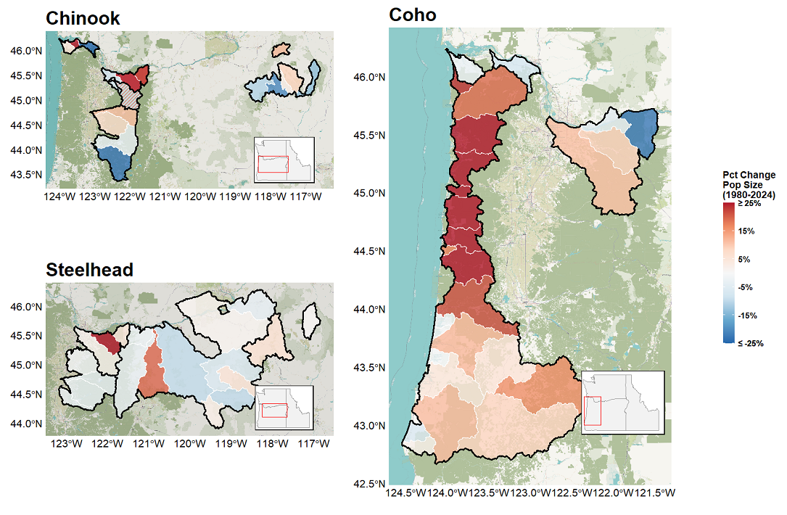
Figure 2: Percent change in average population size between the periods 1980-1989 and 2015-2024.Population outlines in white with ESU borders in black. Majority of populations do not increase by more or less than 50% over the course of the study period. In Chinook panel shared population, solid color = Lower Columbia ESU | striped color = Upper Willamette ESU
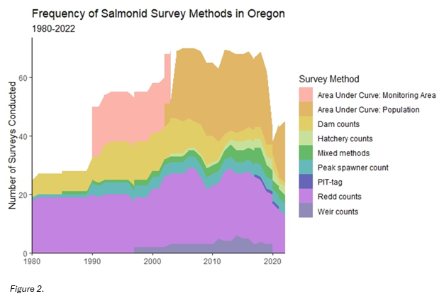
Figure 3: Groups of survey methods and the frequency of their employment from 1980 to 2022. The nine groups displayed in the figure are bins containing each of the 31 survey methods described in the data. These bins are non-scientific and do not reflect designations established by ODFW or any other party, and are instead intended strictly as an aid for visualizing these data.

by estimating terms for both x_{t} (in conjunction with the observation equation) and x_{t−1}. The process equation is formulated as follows:
x_{t} = Bx_{t−1} + u + w_{t}, where w_{t}∼MVN(0,Q)
Here, B defines the interaction between state estimates through time (i.e., x_{t} and x_{t−1}). If B is specified as an identity matrix, u then represents trends in the underlying state(s), otherwise B and u together determine the underlying mean and how quickly the time series would return to the mean following some perturbation. The variance of process errors as well as the (possible) covariance between them is defined by Q.
MARSS models are very useful when parsing long running time series data collected using varying survey methods, where inherent features of those methods could potentially bias the observations being made. Furthermore, MARSS models allow for gaps in the observed time series while retaining the ability to make inferences about the underlying state (Holmes et al. 2012, Scheuerell et al. 2015). It is important to note that these models require that observed time series data (y_{t}) be log-transformed before it can be parsed.
Because of their differing life histories, I modeled all three species salmonid species separately, using three data subsets respectively containing 22 Chinook populations, 29 coho populations, and 23 steelhead populations. Each observation contains four crucial pieces of information: 1) an estimate of natural-origin spawner abundance (denoted mathematically from here on as y), 2) the population of interest (denoted with the subscript p), 3) the survey method used (denoted with the subscript s), and 4) the year of observation (denoted with the subscript t).
Applying a MARSS model structure to the analysis described above involves determining how best to structure spawner abundance data (y_{p,s,t}) and specify model parameters to isolate precision and bias in salmonid survey methods. To distinguish inaccuracy resulting from survey methods from naturally occurring variation in the populations being surveyed, y_{t} is structured such that each row relates to a unique combination of population p and survey method employed. Z is then specified to relate multiple rows in y_{t} to their given underlying populations, which make up x_{t}. By specifying each population as an underlying state, these models assess variation in the natural state of the population separately from variation in counts arising due to inaccuracy of the survey method employed. The vector a contains a unique bias term for each survey method, irrespective of population. The matrix R is specified in a similar manner, with a unique term for each method placed in the corresponding places along R‘s diagonal. Again, this is irrespective of population to capture the variation inherent in each survey method.
Below is an example of the observation equation written out in matrix form. In this example, two populations of salmonid have been surveyed with a total of five survey methods. As indicated by the y term subscripts, population one has been surveyed with methods one through four and population two with methods one, four, and five. Z is specified as two columns relating to the two populations which here are considered underlying states (x₁ and x₂). Vector a is specified so that each survey method is represented by an a parameter which repeats as often as the method appears. Finally, R is specified likewise, with diagonal elements corresponding to the survey method employed in each observation, in order to capture these methods’ inherent variance.
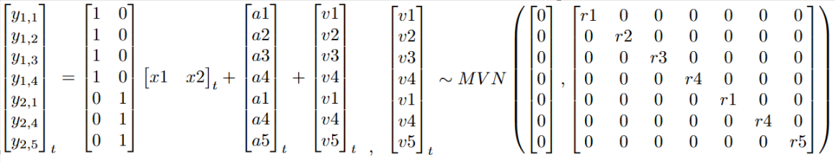
The process/state equation is more straightforward. It is constructed to be as parsimonious as possible to essentially act as a receptacle for the natural variance in annual salmonid spawner returns. B is specified as an identity matrix. Whether the vector u is set to zero or allowed to estimate a trend in each population’s growth will depend on model fit. The terms along the diagonal of Q will also be specified as equal to describe members of the same species and cohort facing similar pressures both at sea and during their homeward migration, although other specifications (unequal population variances and allowing for equal variance and equal covariance terms) will also be evaluated. Below is an example of the process/state equation written out in matrix form.
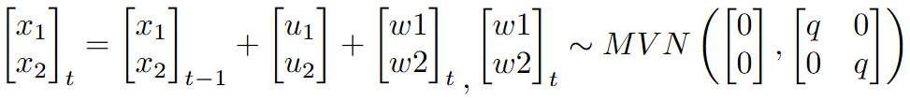
The various specifications of u and Q described above were evaluated for best fit based on AICc, as this criterion is better suited than AIC for balancing fit with the many parameters MARSS models must estimate. AICc comparisons find that, for all three species, best fit models include a u vector set to zero and a Q matrix specified to allow all populations to share an identical variance term and all pairs of states to share an identical covariance term.
The estimates x_{t} are definitionally adjusted to account for bias resulting from the survey methods employed in making observations. These estimates then may be used to assess population-level differences in observations and the underlying natural states being observed, and whether populations are being chronically over or undercounted, as well as the extent to which variability of observation error may be obscuring trends or shifts in the abundance of the population in question.

Robustness checks
There exists the likelihood that some survey methods are endogenously related to the abundances they seek to estimate. For example, dam counts require that a dam be present, a feature which has been shown to have adverse impacts on salmonid populations (Levin and Tolimieri 2001, Pess et al. 2008). In theory, MARSS models should be able to statistically account for this potential endogeneity by mathematically partitioning the variance and bias originating due to the survey method (i.e., the accuracy of dam counts) from the variance and bias inherent in the underlying process being observed (i.e., natural fluctuations in a population’s abundance), especially given multiple populations being surveyed via the same method (Lindén and Knape 2009, See and Holmes 2015). To ensure that potential endogenous relationships between populations and methods will not impact the results of this work, I conduct robustness checks using simulated data to ensure that the models employed are indeed able to capably distinguish process error from observation error in such cases.
To evaluate MARSS models’ ability to statistically parse variability inherent to the observation processes from variability in the underlying populations, even when the two are endogenously related, I constructed synthetic datasets in which populations’ initial abundance were drawn from distributions relating to ‘small’, ‘medium’, and ‘large, and a randomized subset of survey methods are only applicable to either ‘small’ or ‘large’ populations. MARSS models are then fit using these datasets and bootstrapped confidence intervals are established around the parameter estimates of interest – variance terms related to survey method. Because the true variance terms are known, it is trivial to determine what percentage of true variance terms fall within these bootstrapped confidence intervals. The accuracy of these estimates are then compared to the accuracy of models fit using synthetic data in which no endogeneity is present (i.e., no method is exclusively linked to ‘large’ or ‘small’ populations). This process of creating randomized synthetic datasets, fitting MARSS models, and comparing bootstrapped confidence intervals to the true parameters, is repeated 100 times to provide complete assurance of these models’ abilities to distinguish process error from observation error, even given endogenous relationships between populations and survey methods.
INITIAL RESULTS DON’T INDICATE ANY HUGE DISPARITY BETWEEN ACCURACY OF PARAMETER ESTIAMTES TRAINED ON THESE DIFFERING DATASETS
Results
Most of the survey methods analyzed in this study were found to be precise and not strongly biased. This is not surprising, as these approaches have been designed, refined, implemented, and revised by capable ecologists, biologists, and statisticians whose professional interests lie in making these methods as accurate as possible. Due to their accuracy, these “well behaved” methods do not necessitate prolonged discussion, and so most of this section will be devoted to discussing those survey methods which break from this general pattern. As such, it is worth acknowledging first and foremost that the majority of survey methods examined are generally sound.
Here it is also important to recall that MARSS models require that observed time series data (y_{t}) be log-transformed, and as a result, the bias and precision terms estimated are likewise estimated on a logarithmic scale. In log space, most survey methods analyzed (18 out of 27) are not found to be directionally biased by more than 0.5, and 22 of 27 methods are found to be directionally biased by less than 1. Similarly the variances associated with survey methods are found to be less than 0.5 in 22 of 28 methods analyzed (Table 1). While these numbers are small, it must be remembered that they represent terms being linearly added or subtracted from log-transformed counts, meaning an offset of 0.5 scales in linear space depending on where in log space this offset is taking place. For example, if a Chinook population surveyed is 1,000 fish (6.908 in log space), a log space offset of 0.5 would correspond to an additional 648 salmon, while the same offset applied to a population of 100 salmon would correspond to an additional 64 fish. Perhaps a more comprehensive way to hold this idea in mind is to consider
Table 1: Precision, variance, and bias associated with various observation processes (survey methods), estimated separately by species. Precision is defined as the inverse of variance (σ⁻²).
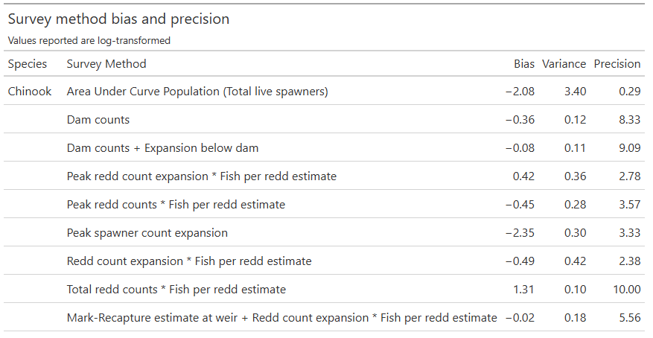
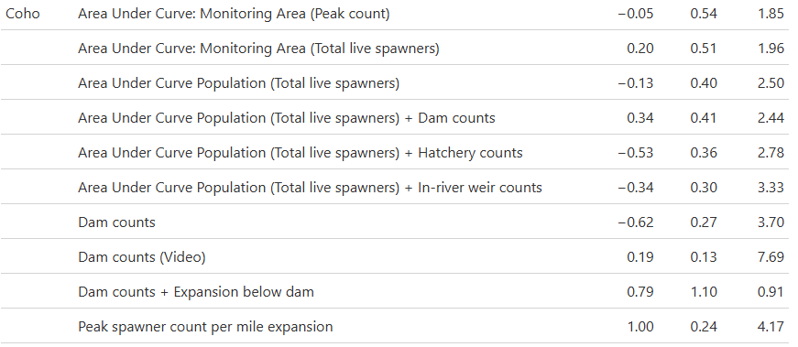
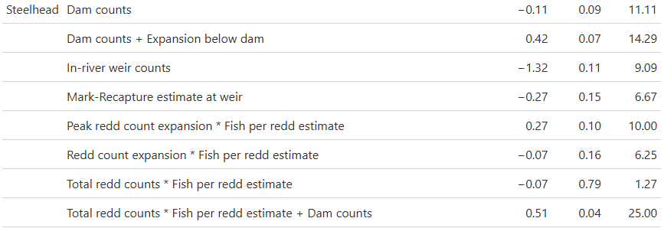

that an increase of 0.5 in log space represents a linear increase of approximately 64.87%, and that this relationship does not scale linearly (an increase of 1 in log space corresponds to a linear increase of 171.8%).

Chinook
Two thirds of the Chinook survey methods analyzed in this study are biased by less than ±0.5 compared to the ‘Dam Counts’ method (Figure 4), and with the majority of observations occurring in populations between 100 and 1,000 fish these relatively small biases do not represent huge numbers of fish over or undercounted (Figure 21). ‘Area Under Curve: Population (Total live spawners)’ and ‘Peak spawner count expansion’ exhibit strong tendencies
Table 2: Frequency of Oregon Chinook annual survey methods by Evolutionarily Significant Unit (ESU), 1980-2024.
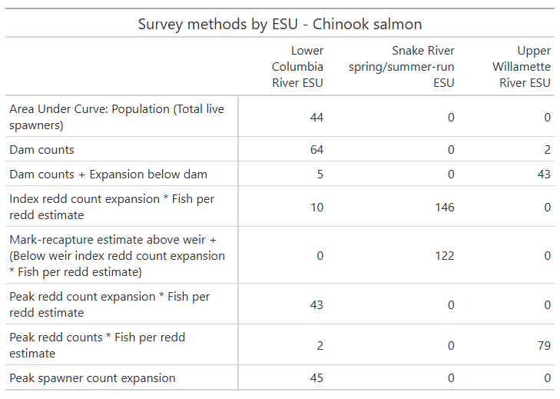
to undercount the true number of spawners, while the strongest positive bias is associated with the ‘Total redd counts * Fish per redd estimate’ method (Figure 4). The ‘Peak spawner count expansion’ method indeed exhibits the highest magnitude bias term associated with any survey method in this study (Table 1), a notable finding given that this method is almost exclusively applied to surveying populations of fewer than 100 individuals (Figure 21). The on-the-ground impact of these directional biases result in the majority of Chinook populations being slightly overcounted, due to the frequent employment of methods with some small downward bias, most often the methods ‘Redd count expansion * Fish per redd estimate’, ‘Mark-Recapture estimate at weir + Redd Count expansion * Fish per redd estimate’, and ‘Peak redd counts * Fish per redd estimate’ (Figure 5, Table 2). However, this tendency towards overcounting is seen most starkly in the Lower Columbia River ESU due to the frequent employment of the ‘Area Under Curve: Population (Total live spawners)’ and ‘Peak spawner count expansion’ methods, which are not employed at all in other Chinook ESUs and are also both frequently employed in the monitoring of smaller populations (Figure 5, Table 2, Figure 21).
In terms of statistical precision (defined as σ⁻²), the ‘Area Under Curve: Population (Total live spawners)’ method is far less precise than every other method employed in Chinook surveys. Beyond this, the methods ‘Peak redd count expansion * Fish per redd estimate’, ‘Peak spawner count expansion’, ‘Peak redd counts * Fish per redd estimate’, and ‘Redd count expansion * Fish per redd estimate’ exhibit low levels of precision, though none are nearly as imprecise as the ‘Area Under Curve: Population (Total live spawners)’ method (Figure 6). Common to three of these methods are the use of fish per redd estimates, although the methods ‘Total redd counts * Fish per redd estimate’ and ‘Mark-Recapture estimate at weir + Redd count expansion * Fish per redd estimate’ likewise make use of fish per redd estimates in scaling their overall estimates but exhibit higher levels of precision. Two of the five least precise methods are frequently employed in the Lower Columbia River ESU (Table 2), meaning that not only does this ESU have a strong tendency towards biased population estimates, but also that those estimates are accompanied by a high degree of inherent uncertainty (Figure 7).
Most Chinook populations analyzed are not found to be heavily over- or undercounted, with the majority of observed data points (58.49%) falling within a 95% confidence interval of the underlying state estimate across most populations (Figure 8). While Chinook are the least accurately surveyed species included in this study, the fact that almost 60% of observations fall within these confidence intervals reflects the care and expertise involved in Oregon’s salmon monitoring programs. However, there are some notable exceptions to this pattern. The exclusive use of the ‘Total redd counts * Fish per redd estimate’ method, shown to be the most upwardly biased Chinook survey method of any examined, has driven notable overcounts across all three John Day River populations, in which at no point during the study period does the observed time series cross the 95% confidence interval of the underlying state estimate. The most undercounted populations in this study (Big Creek, Youngs Bay, Clatskanie River, and the Clackamas River fall run) are all measured using either the ‘Area Under Curve: Population (Total live spawners)’ or ‘Peak spawner count expansion’ method, not surprisingly the two most downwardly biased survey methods analyzed for any species in this study. The Big Creek and Clatskanie River populations are of particular interest as they are two of the smallest populations surveyed, and these methods’ tendencies to undercount fish implies that these small populations are in fact more numerous than the data suggests.

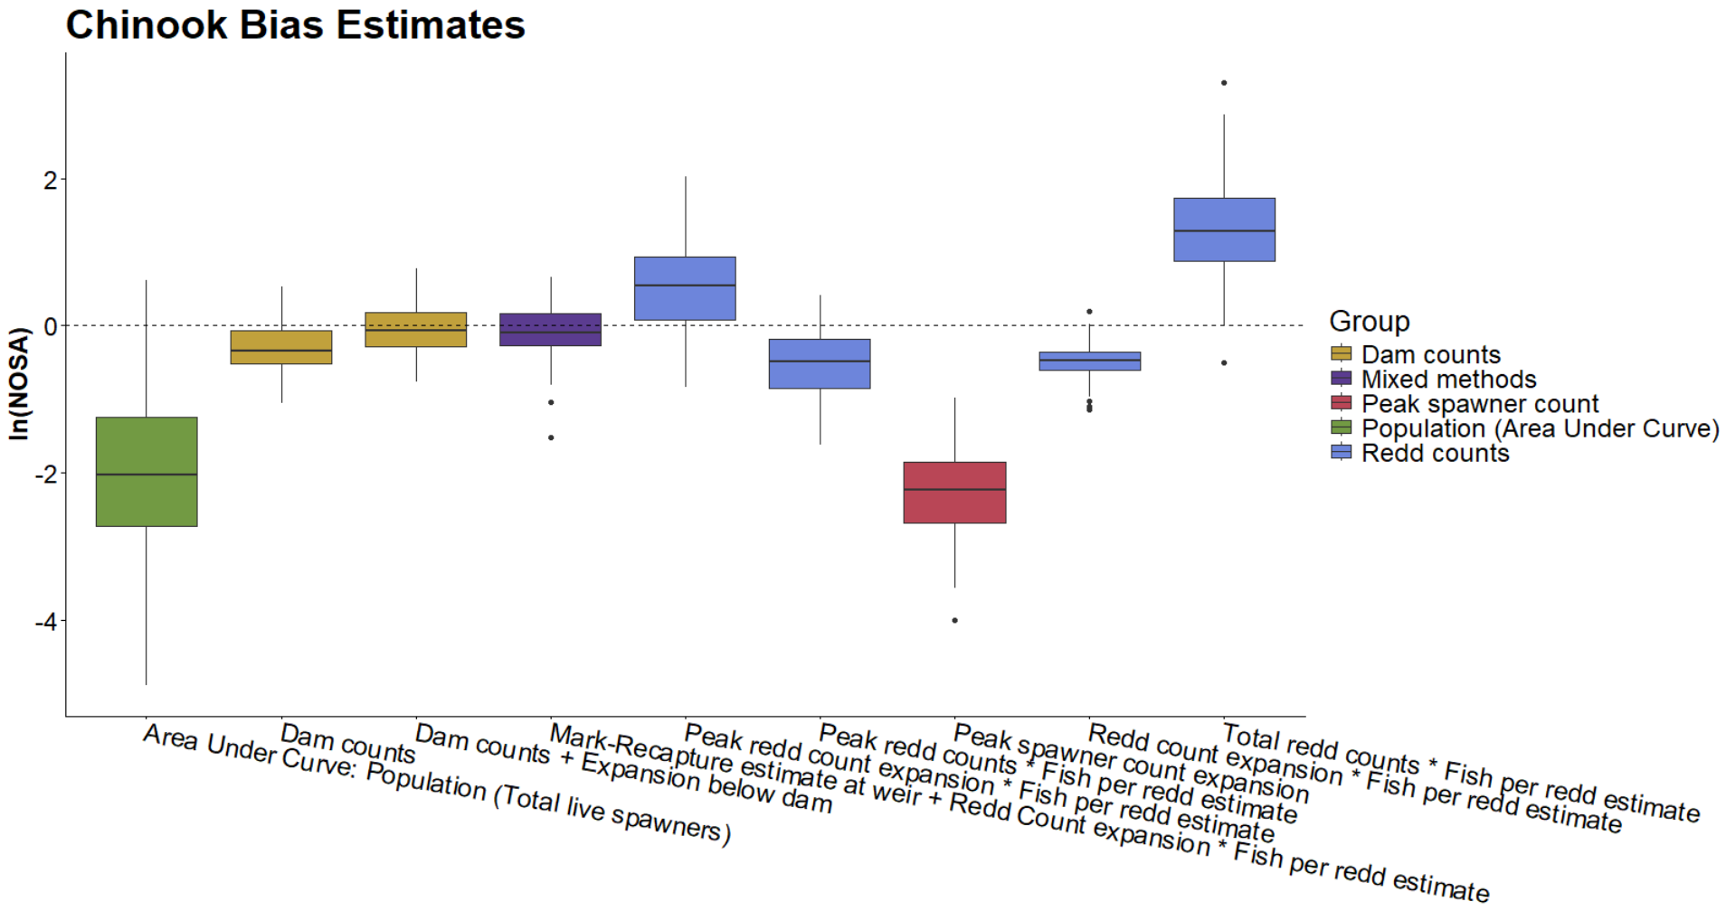 Figure 4: Bootstrapped parameter estimates of directional bias in Chinook survey methods (n=100). Color groupings are non-scientific and intended only as reference.
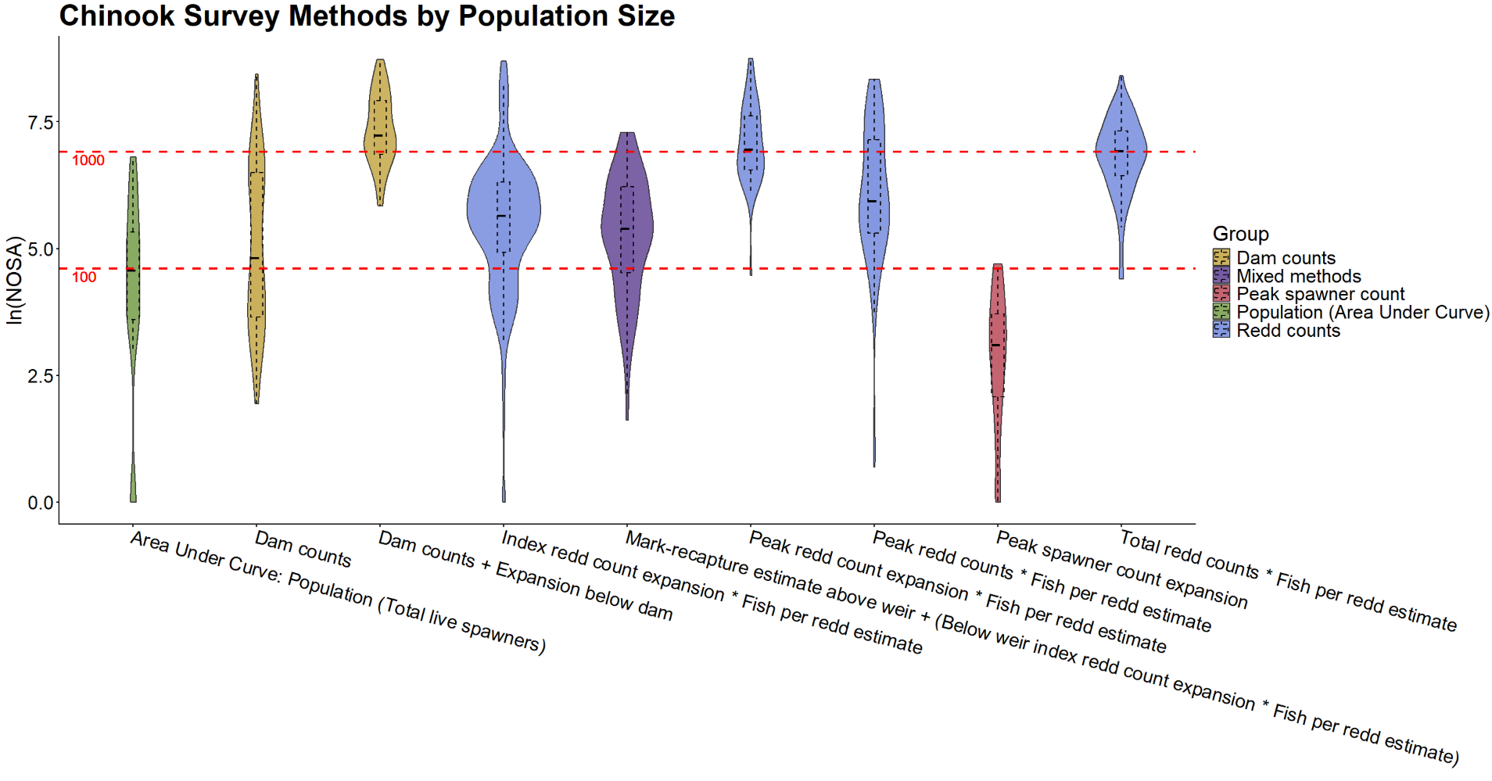 Figure 21: Distribution of Chinook survey method use relative to the size of the population being surveyed. Red dashed lines represent populations of one hundred and one thousand fish in linear space. 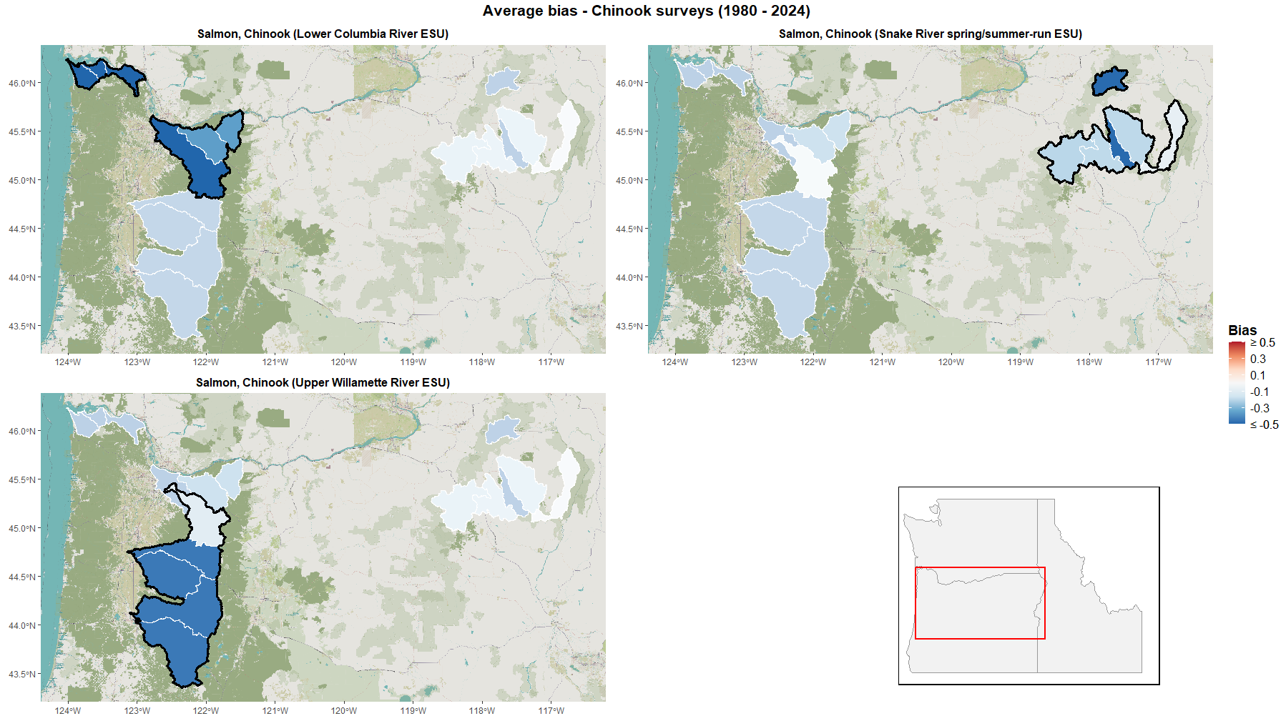 Figure 5: Average directional bias in population-level observations resulting from choice of survey methods across Oregon Chinook populations from 1980-2024.
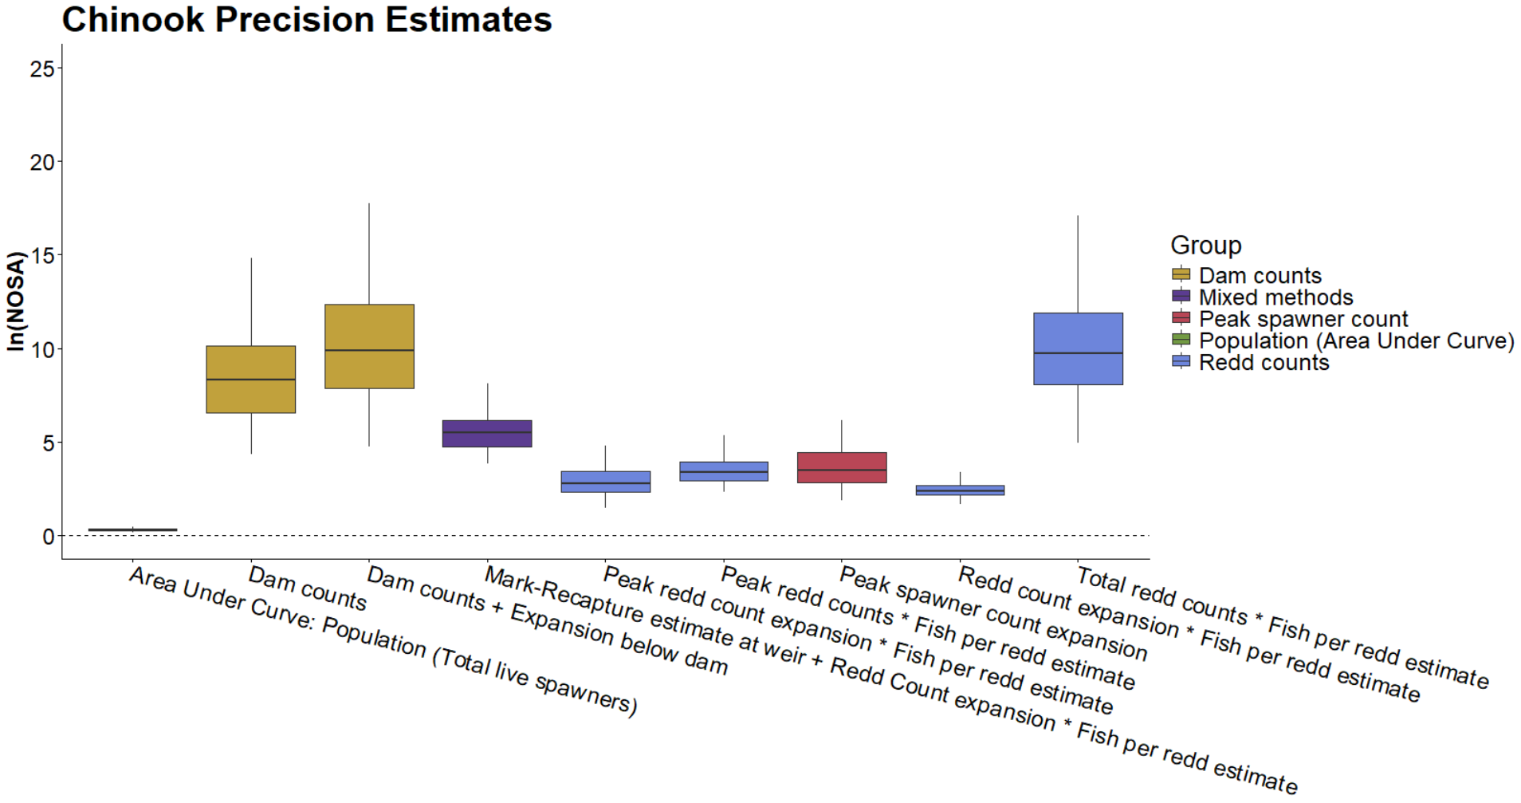 Figure 6: Bootstrapped parameter estimates of precision (σ⁻²) in Chinook survey methods (n=100). Color groupings are non-scientific and intended only as reference.
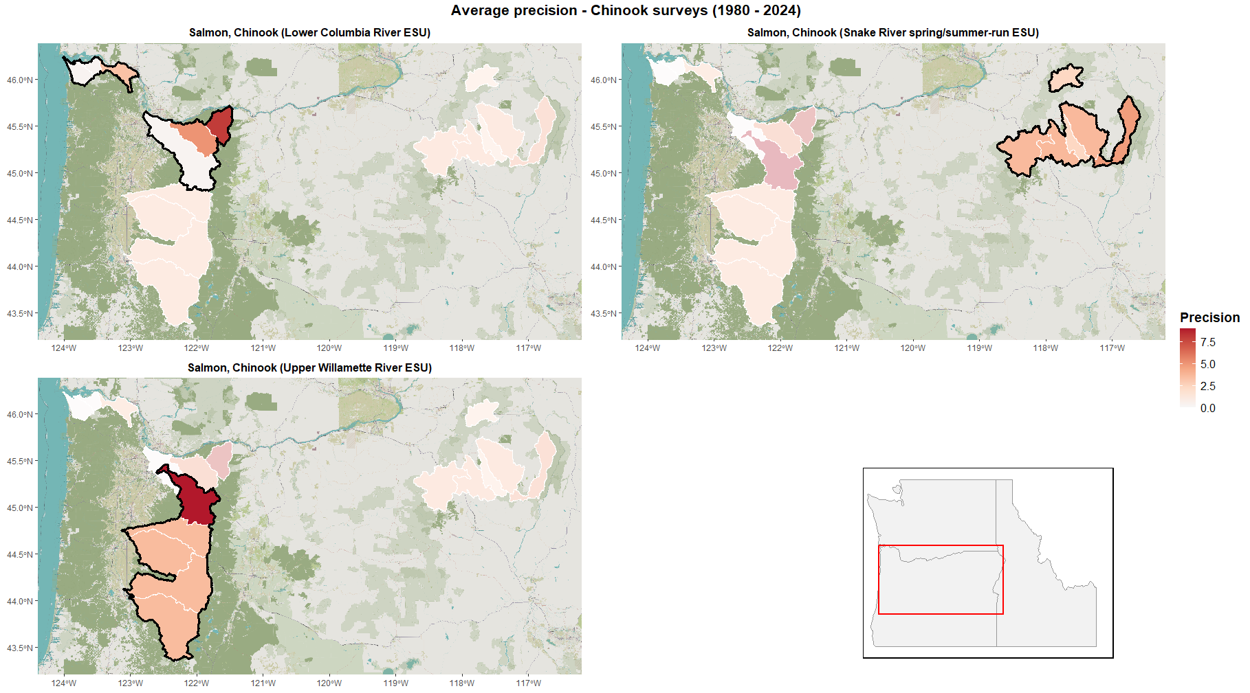 Figure 7: Average precision due to choice of survey methods across Oregon Chinook populations from 1980-2024.
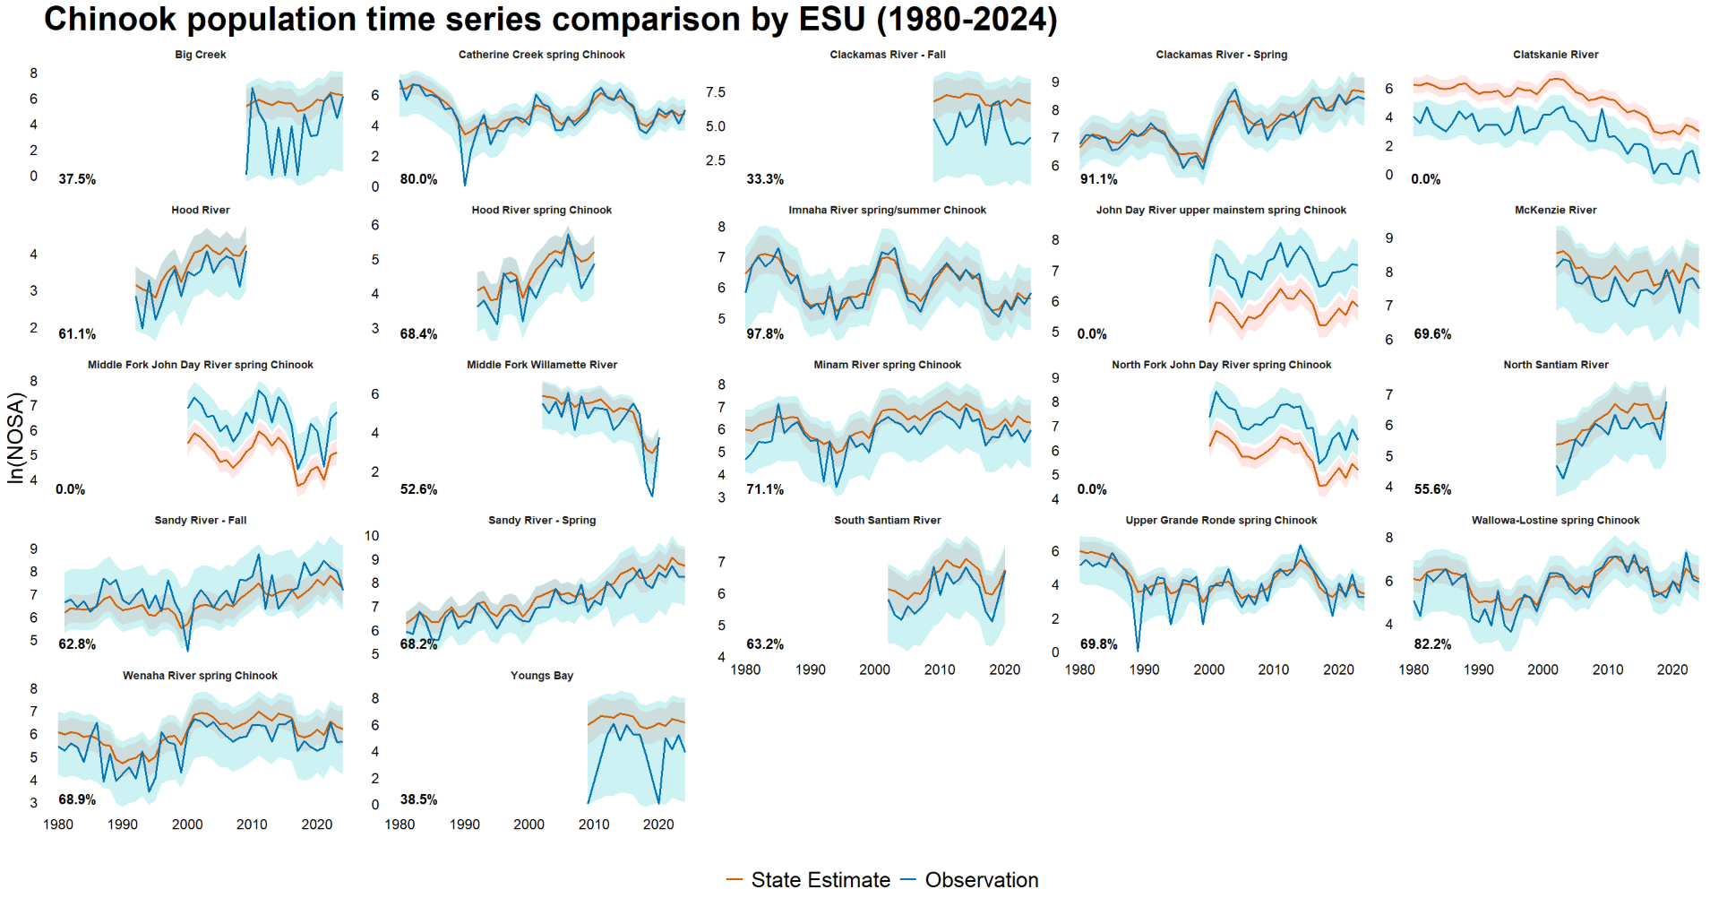Figure 8: Population level comparison of fitted abundance estimates (red) and survey observations (blue) with 95% confidence intervals of Oregon Chinook from 1980 – 2024. Percentages in bottom left corner reflect the number of years in which the observed value falls within the state estimate’s 95% confidence interval. Overall, 58.49% of values recorded in Chinook surveys fall within their respective population estimate’s 95% confidence interval.
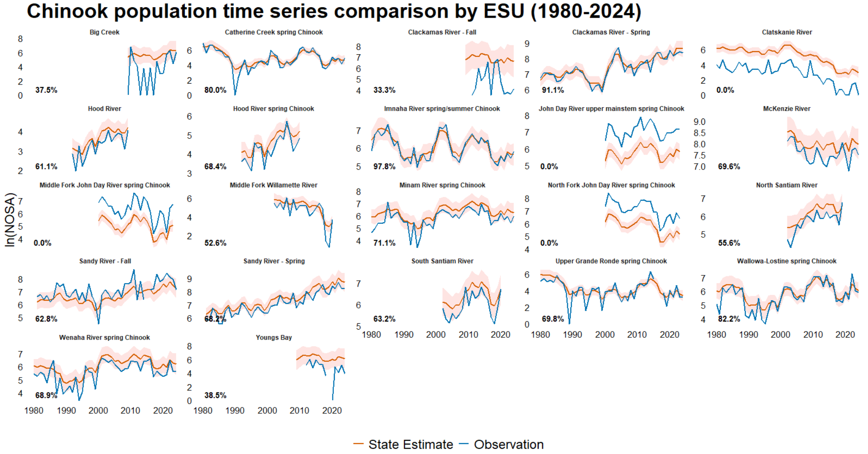Figure 8: Population level comparison of fitted abundance estimates with 95% confidence intervals (red) and survey observations (blue) of Oregon Chinook from 1980 – 2024. Percentages in bottom left corner reflect the number of years in which the observed value falls within the state estimate’s 95% confidence interval. Overall, 58.49% of values recorded in Chinook surveys fall within their respective population estimate’s 95% confidence interval.

Coho
The methods used to survey coho are all found to have relatively small bias terms compared to the other species included in this study, with no coho survey method exhibiting a bias term of magnitude greater than 1, and the largest difference between the bias inherent to any two methods being 1.62 (Figure 10, Table 1). Additionally, no method is exclusively employed to survey populations of certain size (Figure 23). ‘Area Under Curve’ methods are shown to be the least biased of all coho survey methods, a noteworthy finding as these methods are very frequently employed in coho monitoring, especially in the Oregon Coast ESU (Table 4). It must be noted however that coho populations in this study are often much larger than Chinook or steelhead populations, meaning that smaller bias terms can still translate to large numbers of fish being over- or undercounted (Figure 23). Populations within the Lower Columbia River ESU exhibit tendencies towards over- underestimation which are more dramatic than the majority seen in the Oregon Coast ESU, due to the latter’s heavy use of the ‘Area Under Curve’ monitoring methods described above (Figure 11). Taken in aggregate, the small negative biases associated with many population within the Oregon Coast ESU could lead to the ESU-level coho abundance being more significantly underestimated, due to this ESU’s much larger number of constituent populations (21 populations in the Oregon Coast ESU compared to 6 in the Lower Columbia River ESU).
The methods employed to survey coho tend to be associated with much lower precision than those employed in Chinook surveys (Figure 12). This may be in part due to the late-year run timing of coho necessitating that surveys take place during periods of inclement weather and high stream flows (National Marine Fisheries Service 2016). The ‘Dam counts + Expansion
Table 4: Frequency of Oregon coho annual survey methods by Evolutionarily Significant Unit (ESU), 1980-2024.
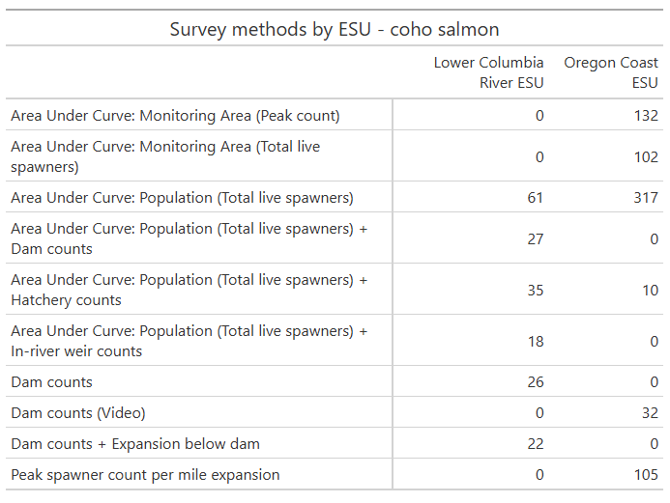
below dam’ method is found to be particularly imprecise compared to the other methods analyzed, although it should be noted that ‘Dam counts + Expansion below dam’ is also one of the least employed methods across both coho ESUs in this study, meaning its impact on the veracity of counts at the ESU level is likely negligible. Of greater interest is the low precision associated with certain ‘Area Under Curve’ methods – particularly ‘Area Under Curve: Monitoring Area (Peak count)’, ‘Area Under Curve: Monitoring Area (Total live spawners)’, and ‘Area Under Curve: Population (Total live spawners)’. These three methods together make up the majority of methods used to sample coho in this study, accounting for almost 80% of surveys conducted in the Oregon Coast ESU (Table 4). The predominance of these methods and their effects can be seen in the low precision associated with most populations in the Oregon Coast ESU (Figure 13). The Lower Columbia River ESU is generally more precisely surveyed but is still subject to high level of imprecision compared to the ESUs and DPSs of other species in this study.
Population level differences between coho observations and underlying state estimates are less pronounced than those seen across Chinook populations, with observations falling within the underlying states’ 95% confidence intervals 63.02% of the time, but also with no populations’ observations falling completely outside said intervals (as was the case for Chinook in the Clatskanie River and all three John Day River populations) (Figure 14). Nineteen of twenty-six coho populations are recorded more accurately than the 63.02% average for the species, likely due to the heavy reliance on ‘Area Under Curve’ survey methods with relatively small bias terms. Beyond this general pattern, a few coho populations are noticeably overcounted. Due to exclusive reliance on the exclusively using the ‘Peak spawner count per mile expansion’ survey method, the most upwardly biased of all coho survey methods analyzed, Siltcoos River, Tahkenitch Lake, and Tenmile Lake observations rarely cross their underlying state estimates’ 95% confidence intervals. The tendency of Sandy River and Scappoose Creek coho observations to underestimate their underlying states results from these populations frequently being measured using the ‘Dam counts’ and ‘Area Under Curve: Population (Total live spawners) + In-river weir counts’ methods, two of the most downward biased among all coho survey methods.

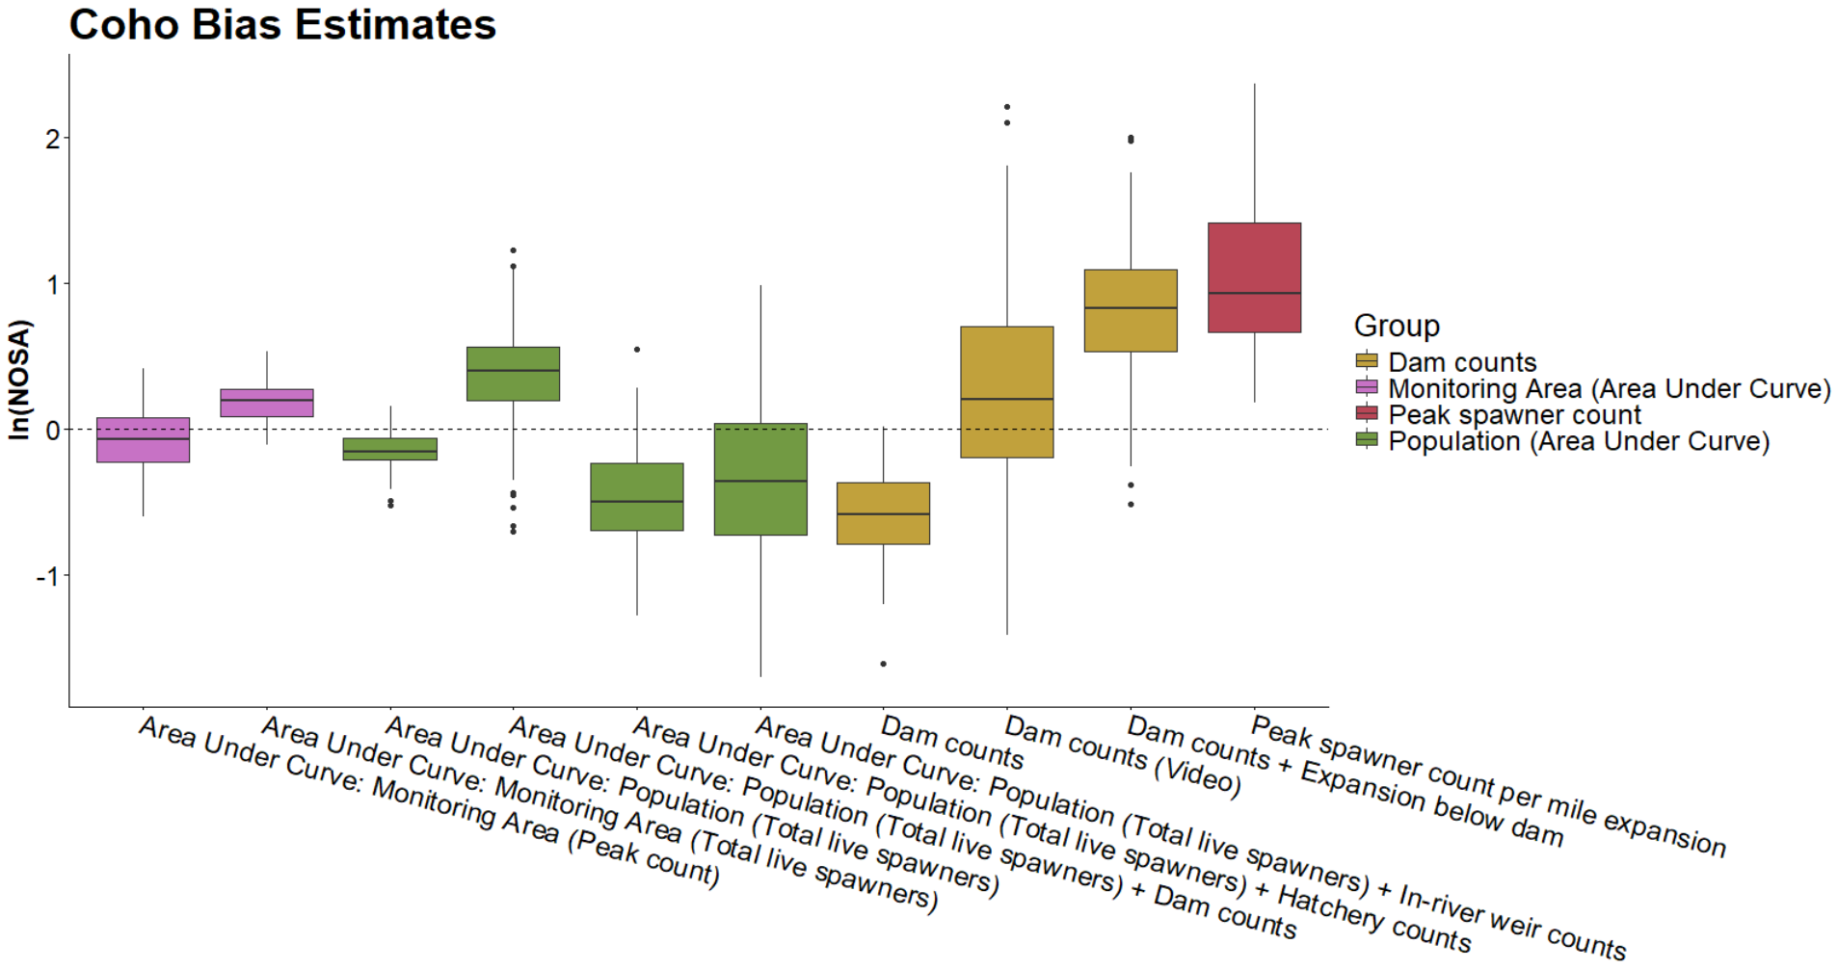 Figure 10: Bootstrapped parameter estimates of directional bias in coho survey methods (n=100). Color groupings are non-scientific and intended only as reference.
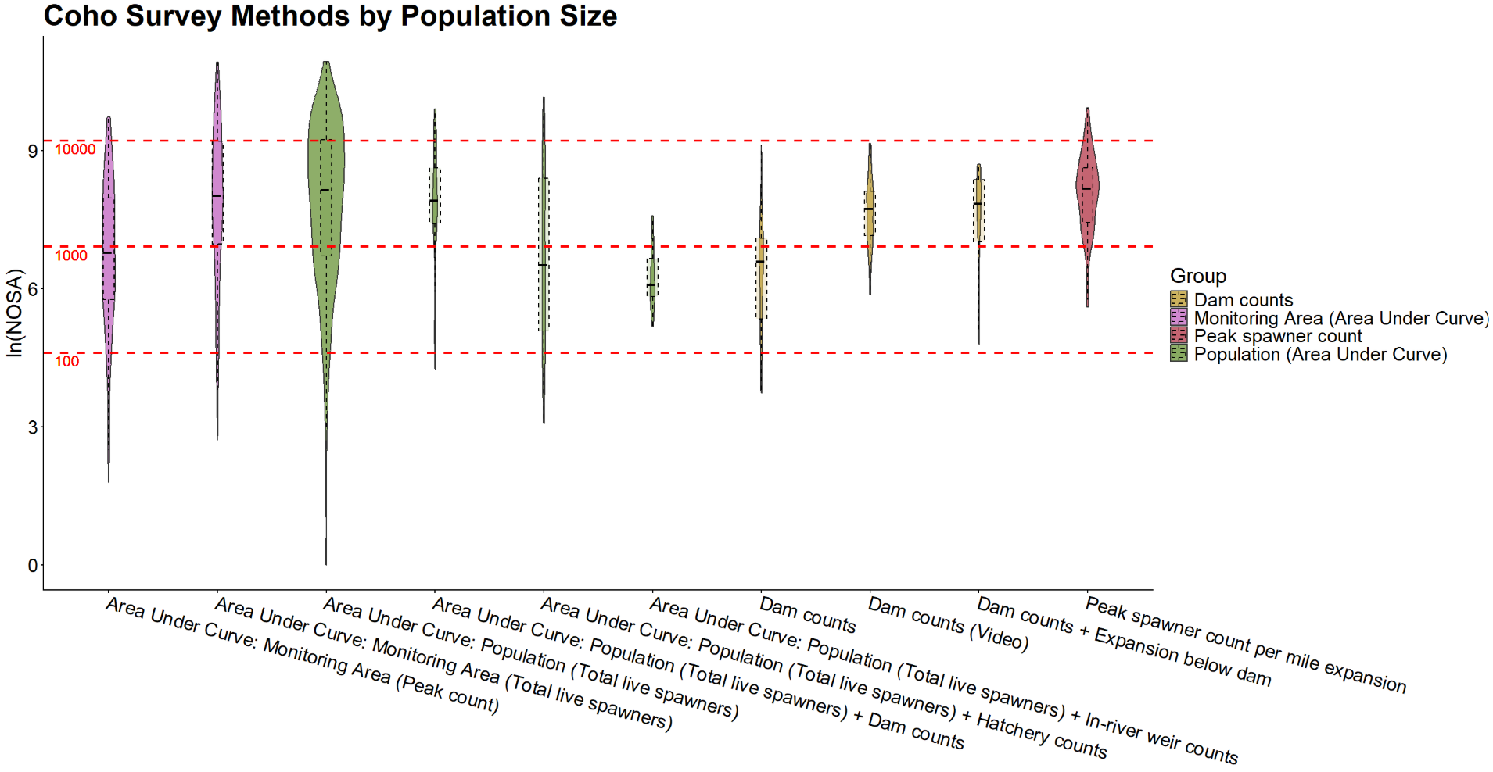 Figure 23: Distribution of coho survey method use relative to the size of the population being surveyed. Red dashed lines represent populations of one hundred, one thousand, and ten thousand fish in linear space.

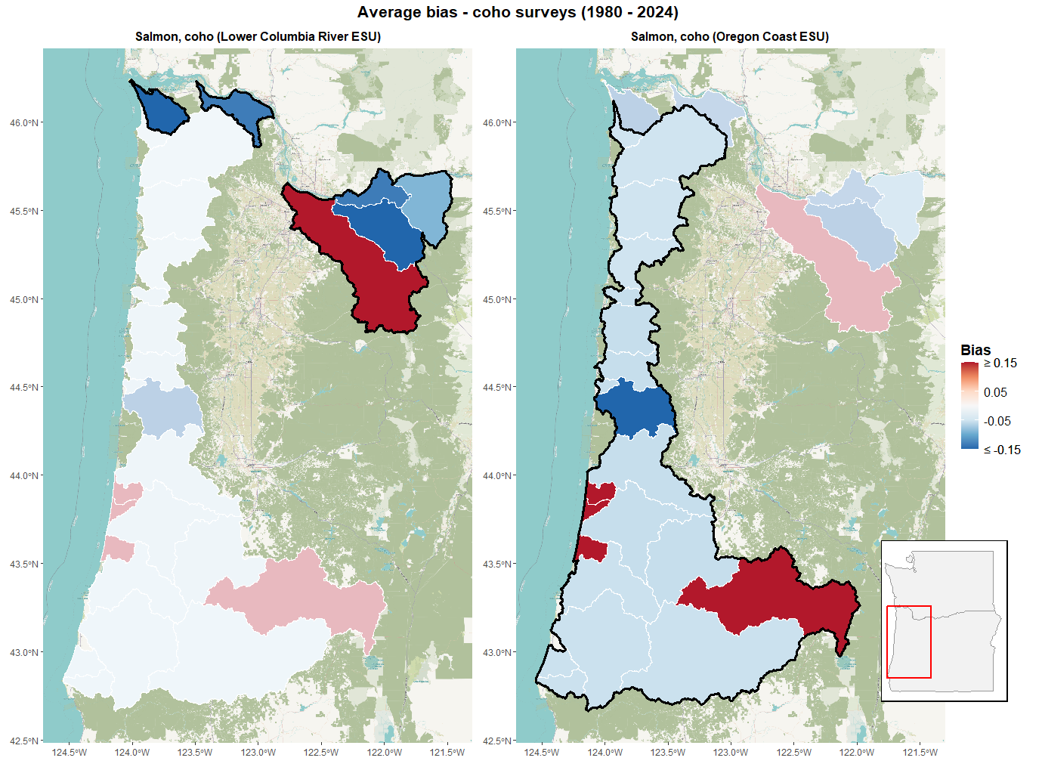
Figure 11: Average directional bias in population-level observations resulting from choice of survey methods across Oregon coho populations from 1980-2024.
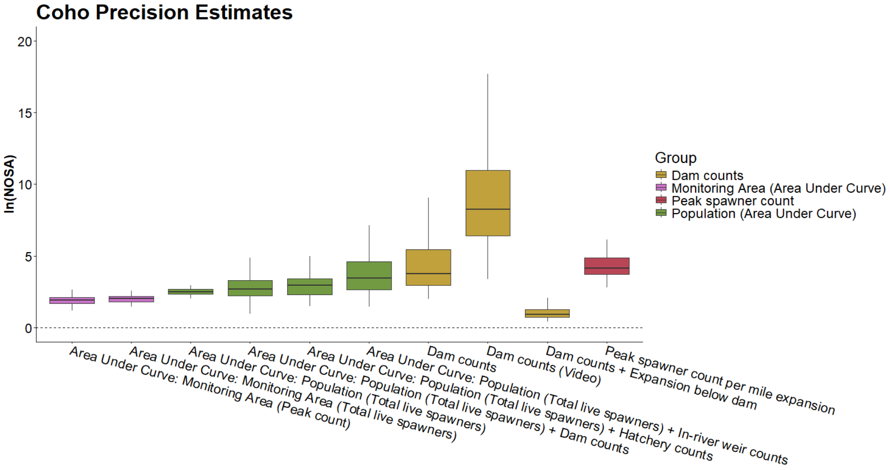 Figure 12: Bootstrapped parameter estimates of precision (σ⁻²) in coho survey methods (n=100). Color groupings are non-scientific and intended only as reference.

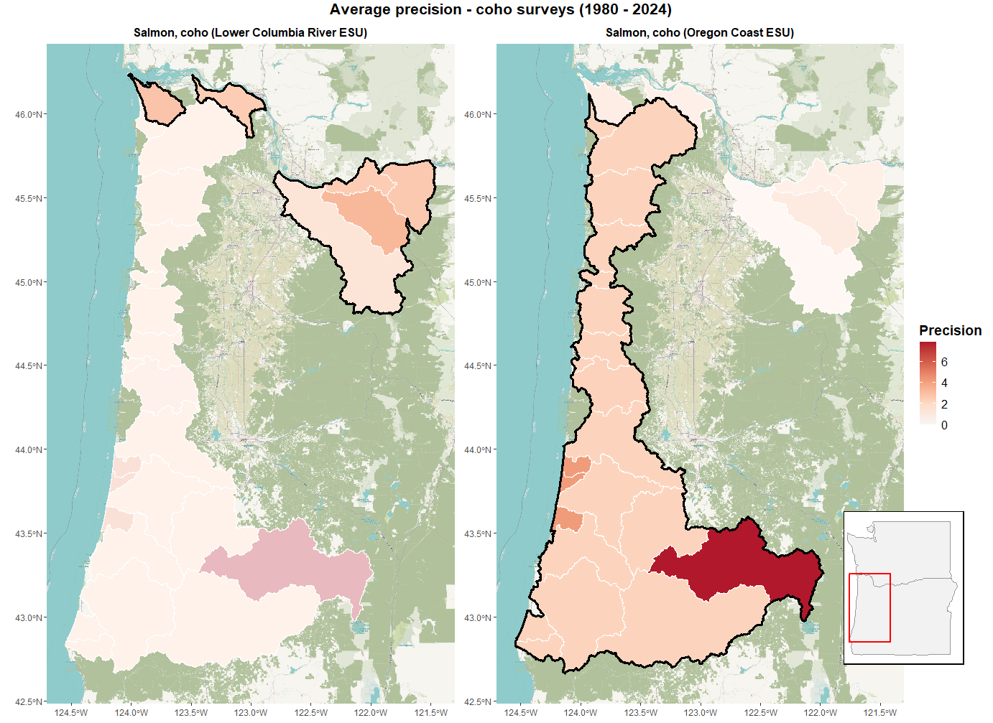
Figure 13: Average precision due to choice of survey methods across Oregon coho populations from 1980-2024.
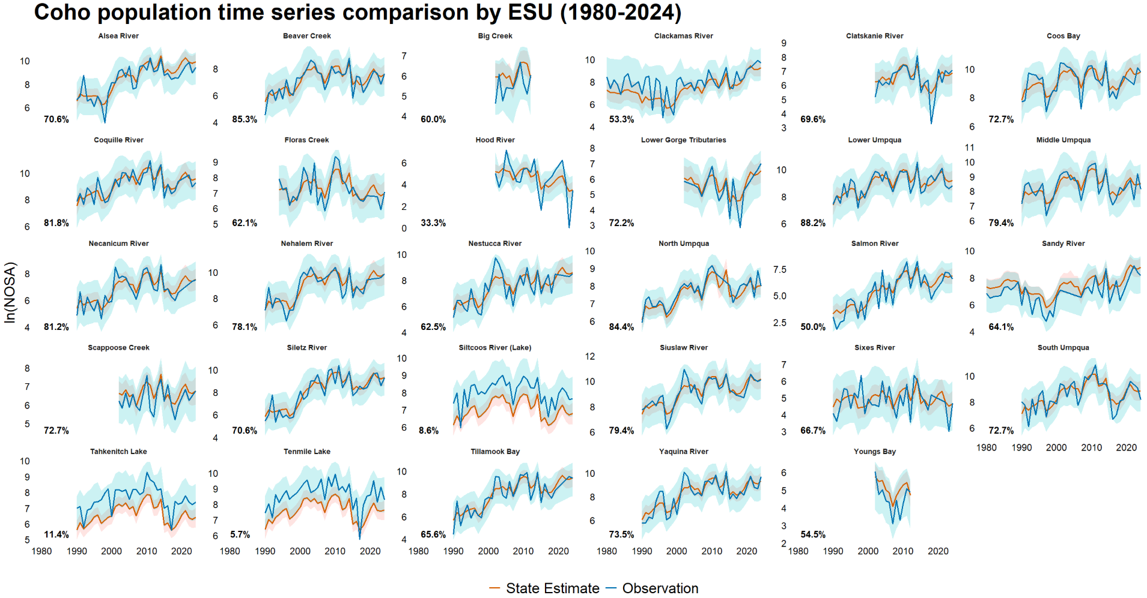Figure 14: Population level comparison of fitted abundance estimates (red) and survey observations (blue) with 95% confidence intervals of Oregon coho from 1980 – 2024. Percentages in bottom left corner reflect the number of years in which the observed value falls within the state estimate’s 95% confidence interval. Overall, 63.02% of values recorded in coho surveys fall within their respective population estimate’s 95% confidence interval. 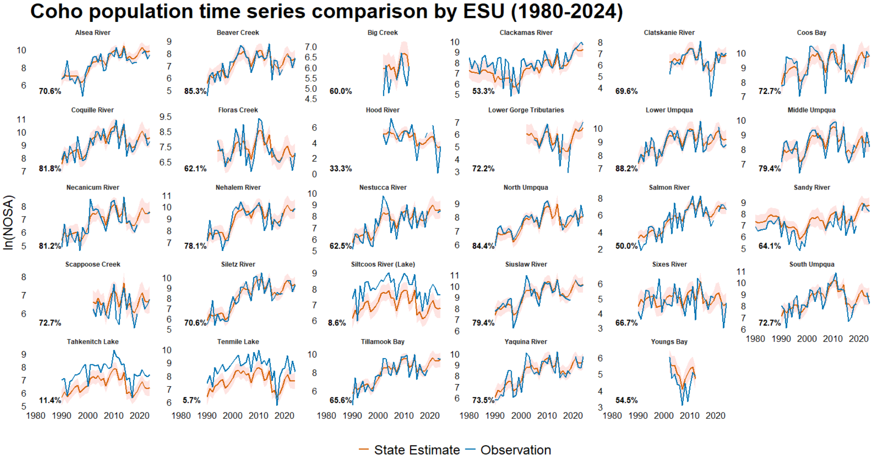Figure 14: Population level comparison of fitted abundance estimates with 95% confidence intervals (red) and survey observations (blue) of Oregon coho from 1980 – 2024. Percentages in bottom left corner reflect the number of years in which the observed value falls within the state estimate’s 95% confidence interval. Overall, 63.02% of values recorded in coho surveys fall within their respective population estimate’s 95% confidence interval.
Steelhead
With the exception on the ‘In-river weir counts’ method, the magnitude of bias associated with many steelhead survey methods tends to be low (0.51 or less for all other methods) (Table 1, Figure 16). The downward bias of the ‘In-river weir counts’ method, coupled with the fact that this method is almost exclusively used to survey populations of less than 100 fish, means that undercounts due to this method may not be enormous in terms of absolute numbers of fish, but that the percentage of fish not being counted in these populations is quite high (Figure 25). The two most positively biased methods are ‘Dam counts + Expansion below dam’ and ‘Total redd counts * Fish per redd estimate + Dam counts’, the latter of which is exclusively used to monitor populations of over 1,000 individuals. Of note is the most employed survey method for steelhead, ‘Redd count expansion * Fish per redd estimate’, which makes up roughly 52% of all DPS observations (Table 5). This frequently used method is not associated with a strong positive or negative relative bias, meaning average bias across most populations remains low, most especially in the Snake River Basin DPS and Middle Columbia River DPS (the Snake River Basin DPS is surveyed exclusively using this method) (Figure 17). Among the four steelhead DPS, the Upper Willamette River DPS stands out due to its strong upward bias, as this DPS is exclusively surveyed using the ‘Peak redd count expansion * Fish per redd estimate’ method (Table 1, Figure 17).
Precision associated with steelhead survey methods is high compared with the estimates associated with Chinook and coho surveys. While the ‘Total redd counts * Fish per redd estimate’ method stands out as being highly imprecise when compared to other steelhead survey methods, it is nonetheless quite accurate compared to the most imprecise methods for
Table 5: Frequency of Oregon steelhead annual survey methods by Distinct Population Segment (DPS), 1980-2024. Note that, although the ‘In-river weir counts’ only appears in a DPS 3 times, this method was also employed in surveying populations outside of these DPSs, allowing for sufficient datapoints to estimate bias and variance terms.
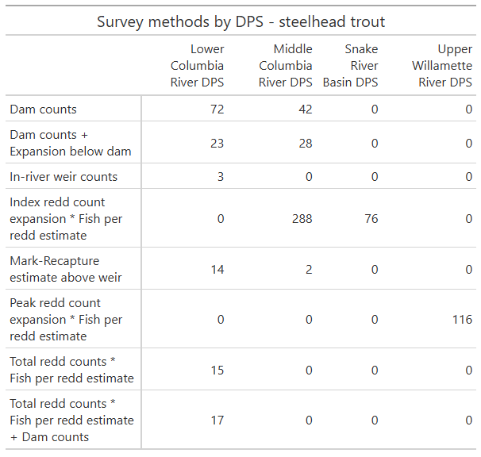

Chinook and coho (Figure 18). The reliance on singular survey methods across both the Snake River Basin DPS and Upper Willamette River DPS can be seen clearly on the landscape, where the Snake River Basin DPS’s constituent populations are consistently among the most imprecisely surveyed steelhead runs in this study (Figure 19).
Due to the relatively low magnitude of bias associated with the majority of steelhead survey methods, observations of steelhead populations tend to be closely associated with the underlying state estimates (Figure 25). The Clackamas River, Walla Walla River, and Scappoose Creek are the only populations that approach the sort of drastic under or overcounting seen frequently in Chinook populations, wherein the observed abundances never or rarely cross the underlying state’s 95% confidence interval. Like many of the other populations in this study that have shown a consistent tendency towards over- or undercounting throughout the entirety of the time series, this behavior can be ascribed to Walla Walla River steelhead being counted exclusively using the ‘Dam counts + Expansion below dam’ method, shown to be the second most upwardly biased of all steelhead survey methods analyzed, while Scappoose Creek steelhead in the early 2000s were consistently surveyed using the ‘In-river weir counts’ method, the most downwardly biased employed in steelhead monitoring. Reliance on the ‘Peak redd count expansion * Fish per redd estimate’ method, the third most upwardly biased method employed in steelhead surveys, is likely responsible for Clackamas River steelhead exhibiting behavior in which observations stay above underlying state point estimates while moving in and out of the states’ 95% confidence intervals. Due to frequent employment of the same method, this behavior is also seen in the Calapooia River, Molalla River, and South Santiam River populations, although their observed abundances do not exceed the underlying states’ 95% confidence intervals nearly as frequently.
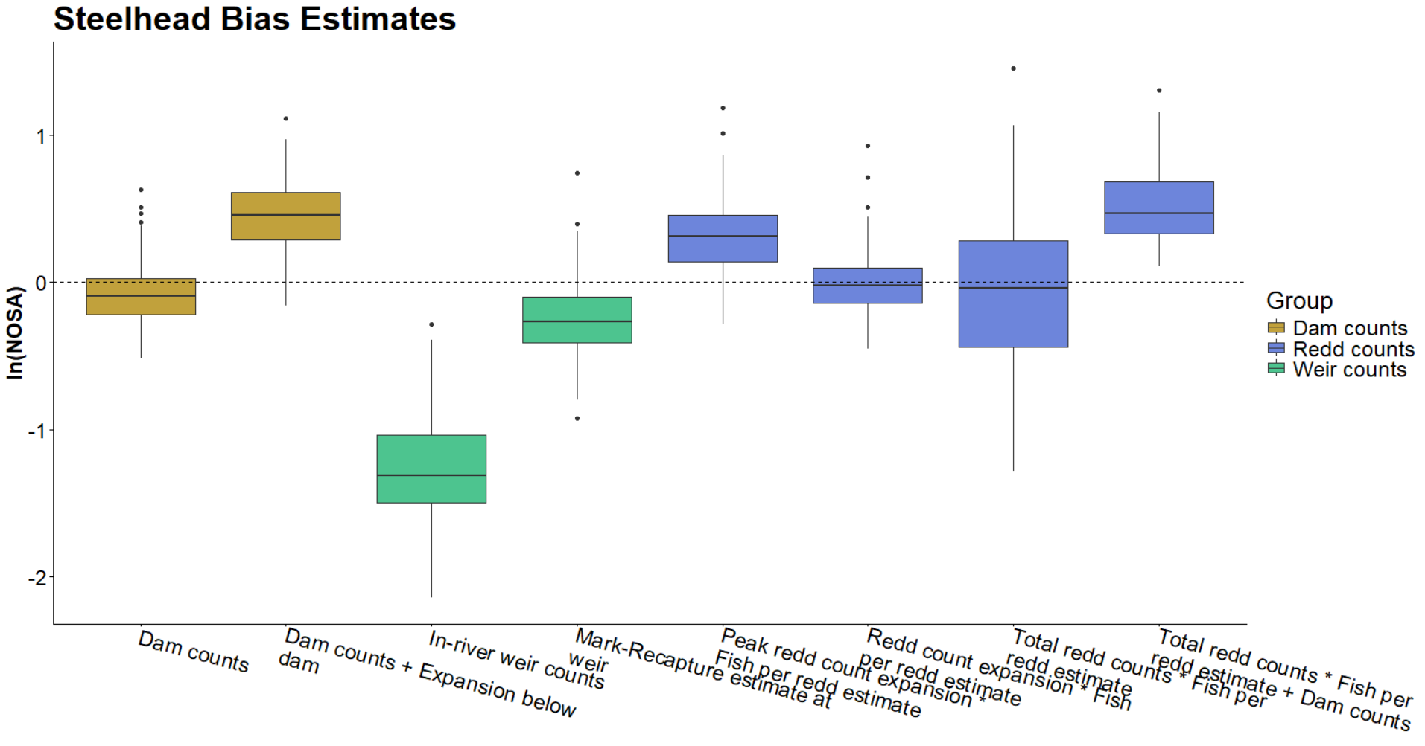 Figure 16: Bootstrapped parameter estimates of directional bias in steelhead survey methods (n=100). Color groupings are non-scientific and intended only as reference. 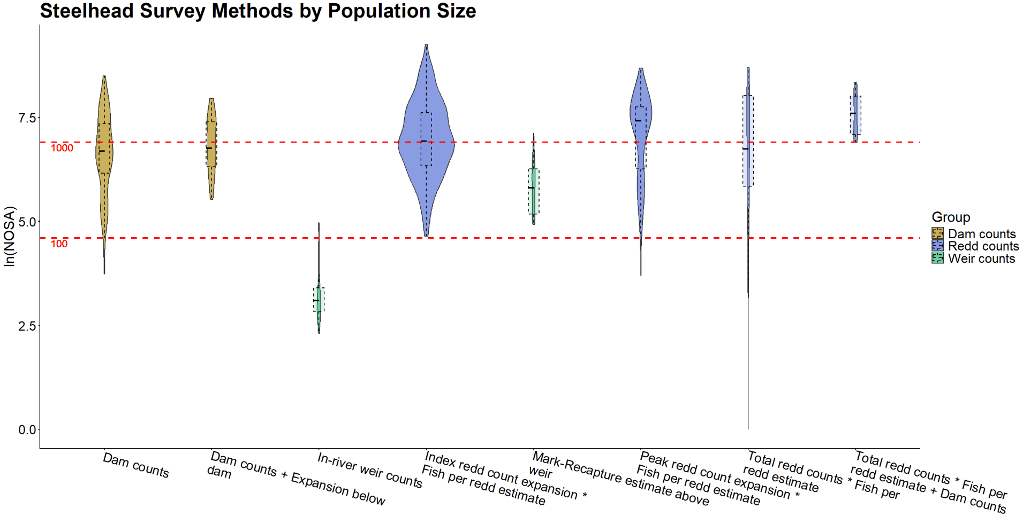 Figure 25: Distribution of steelhead survey method use relative to the size of the population being surveyed. Red dashed lines represent populations of one hundred and one thousand fish in linear space. 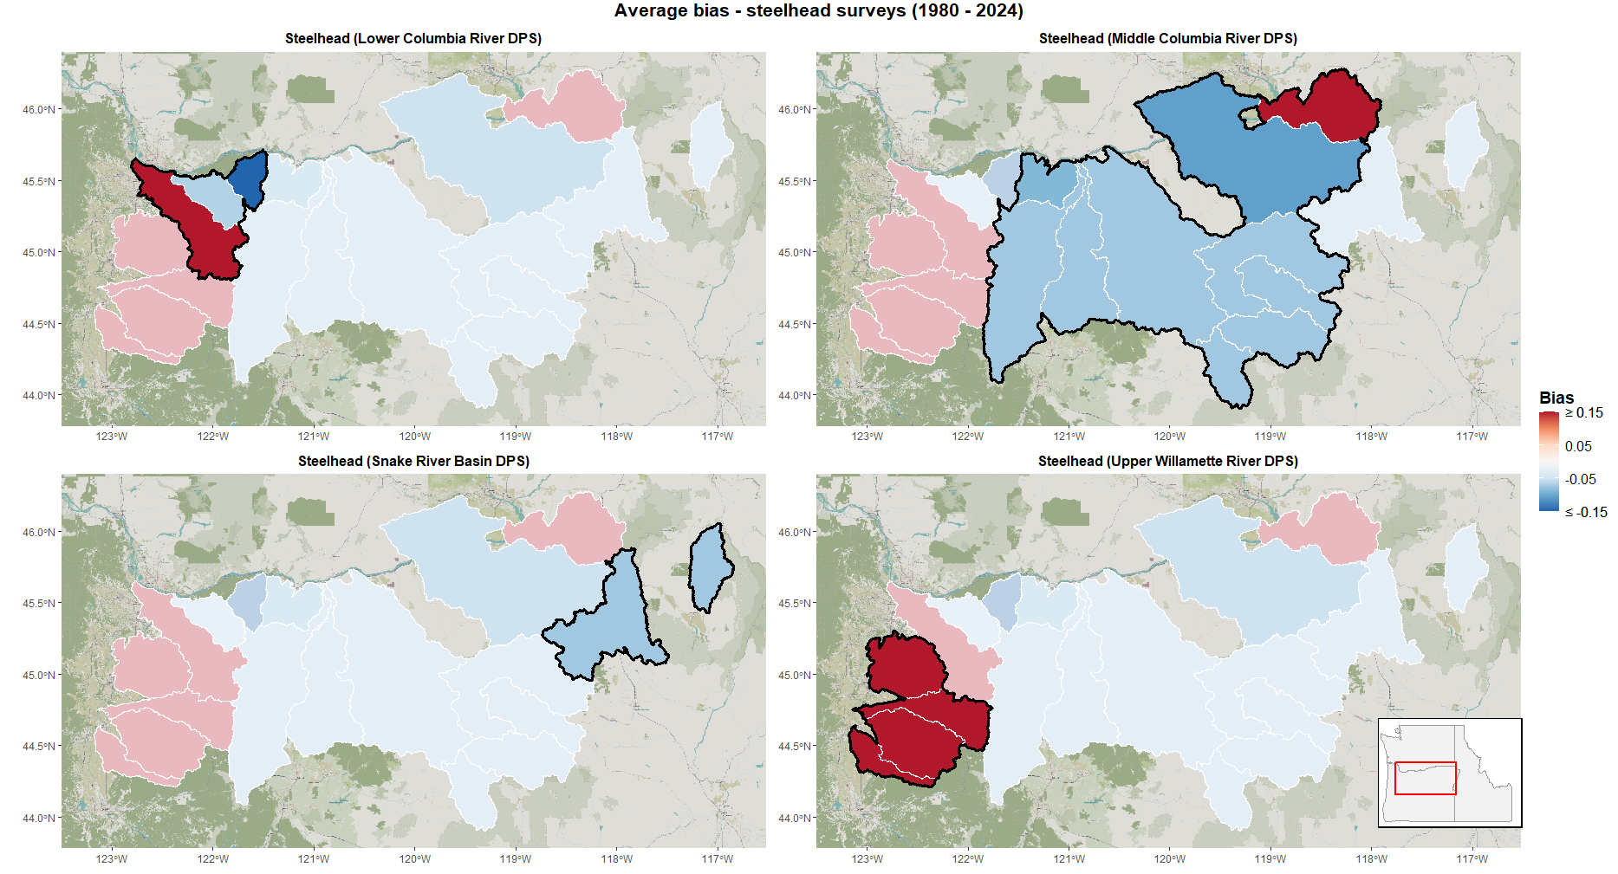 Figure 17: Average directional bias due to choice of survey methods across Oregon steelhead populations from 1980-2024.
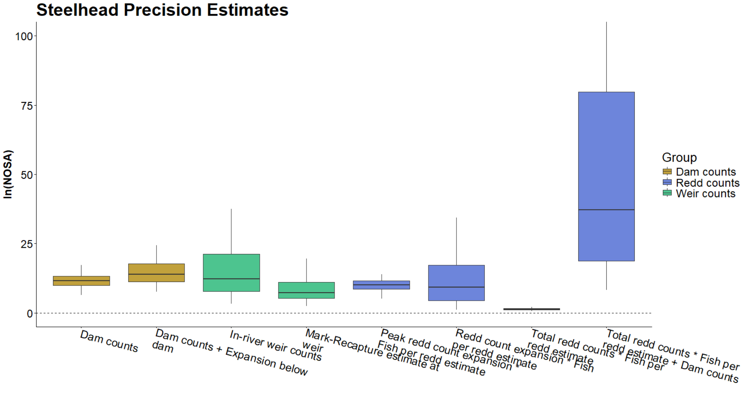 Figure 18: Bootstrapped parameter estimates of precision (σ⁻²) in steelhead survey methods (n=100). Color groupings are non-scientific and intended only as reference.

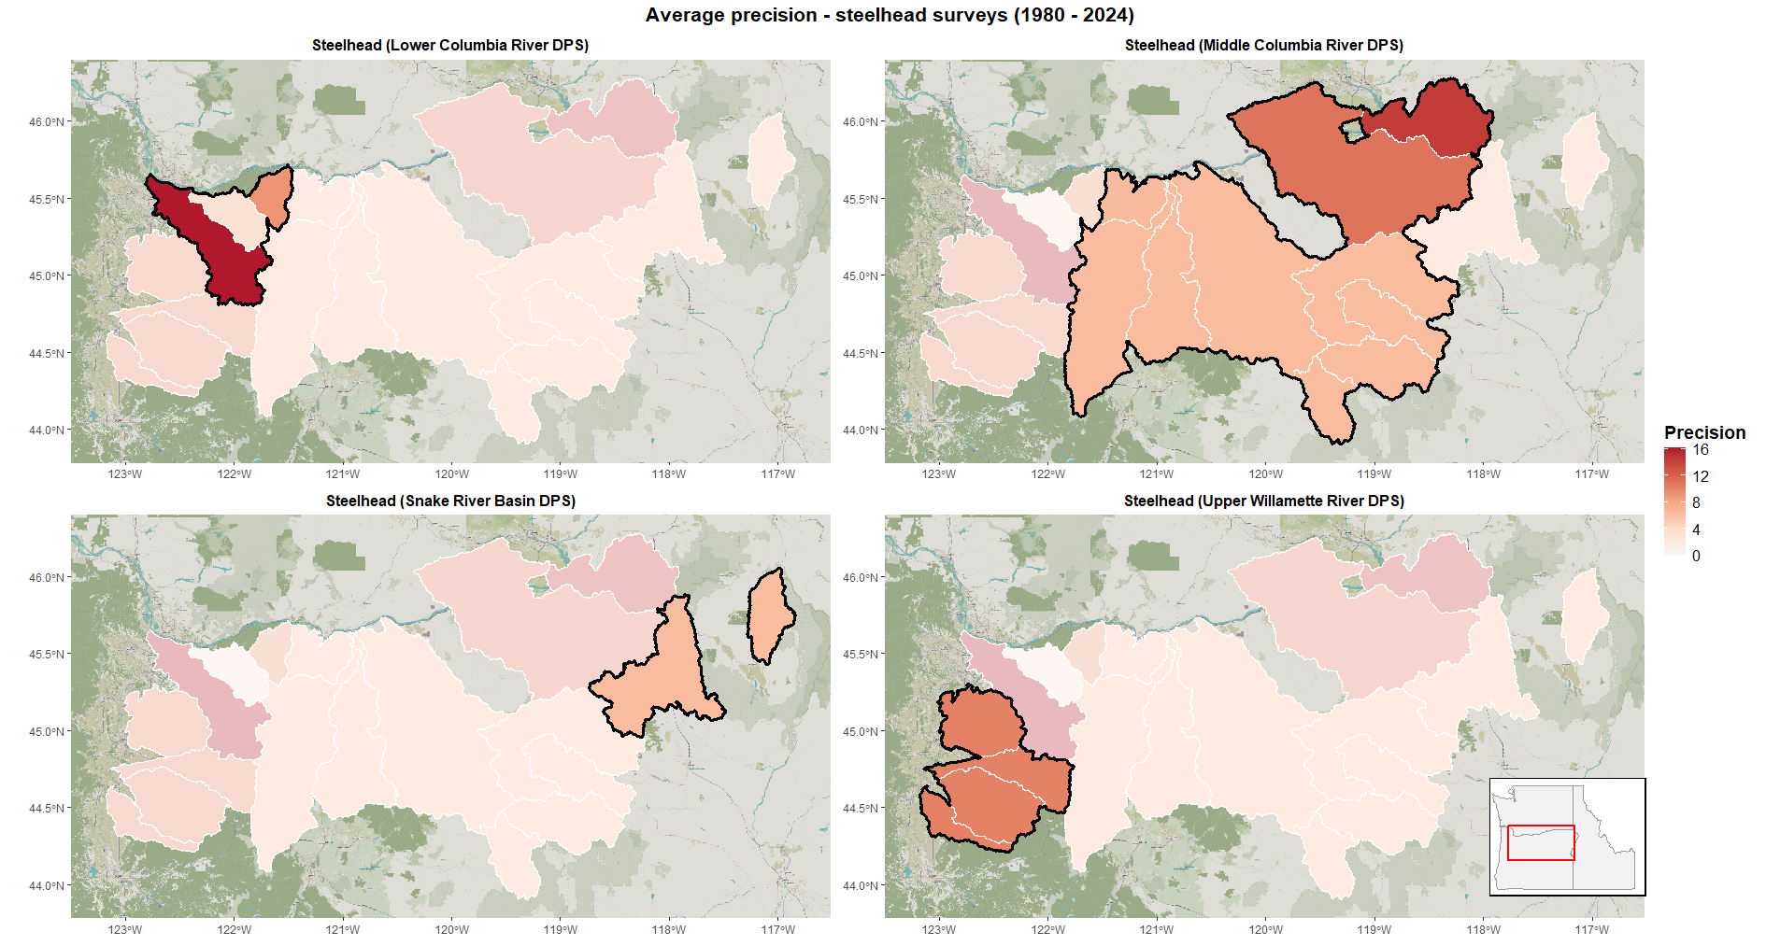 Figure 19: Average precision due to choice of survey methods across Oregon steelhead populations from 1980-2024. Distinct population segments (DPSs) outlined in black.
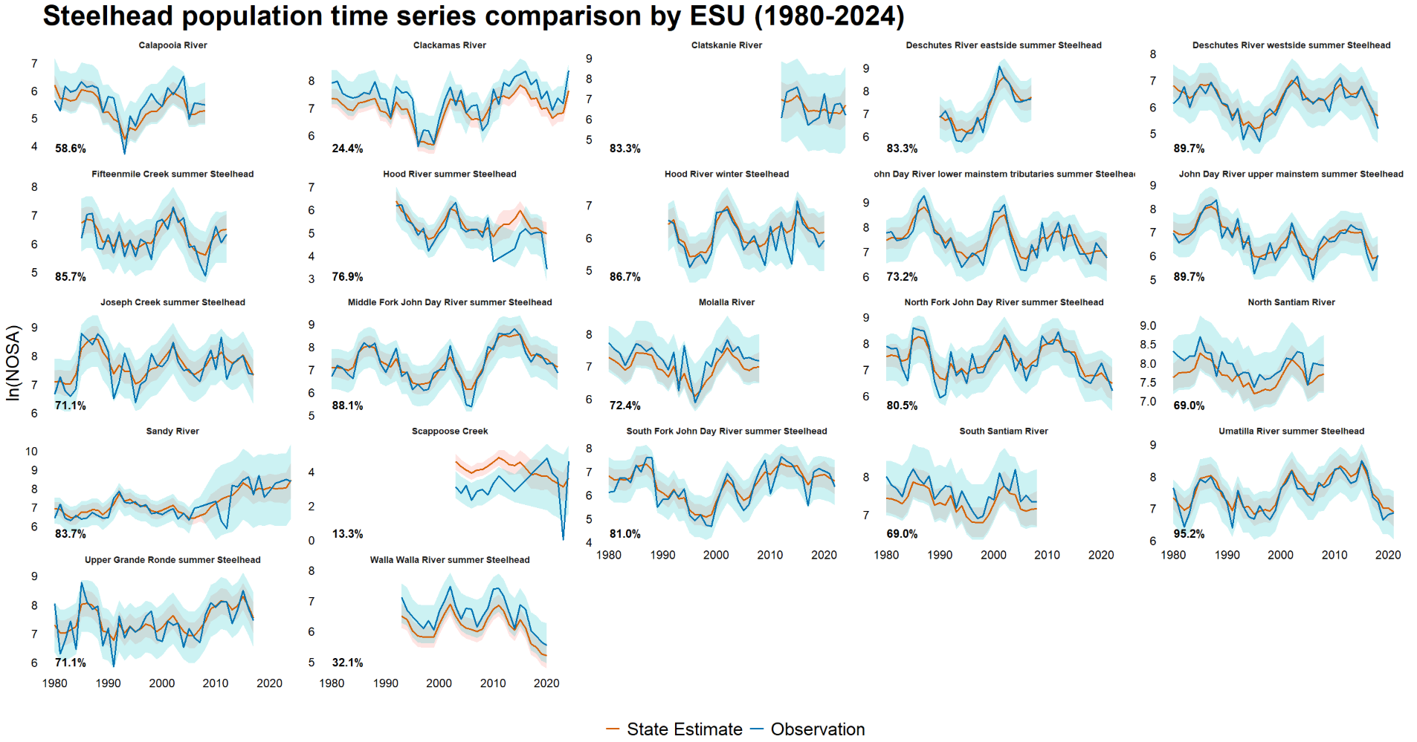Figure 20: Population level comparison of fitted abundance estimates (red) and survey observations (blue) with 95% confidence intervals of Oregon steelhead from 1980 – 2024. Youngs Bay omitted due to too few observations. Percentages in bottom left corner reflect the number of years in which the observed value falls within the state estimate’s 95% confidence interval. Overall, 73.17% of values recorded in steelhead surveys fall within their respective population estimate’s 95% confidence interval. 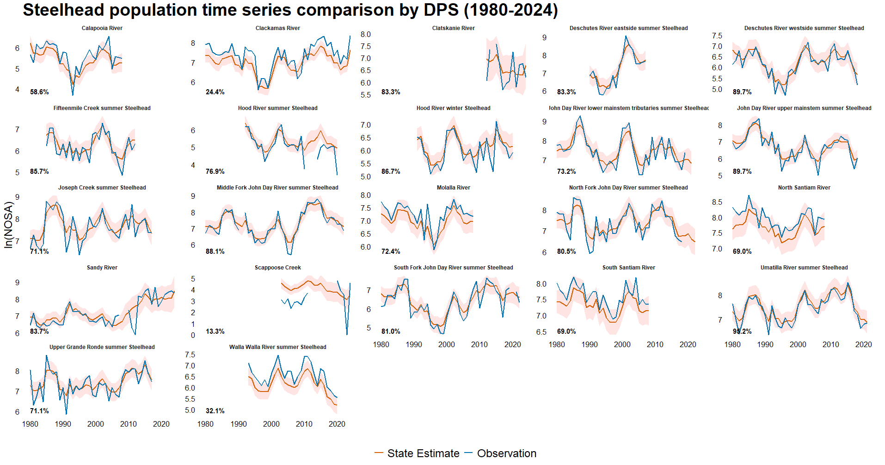 Figure 20: Population level comparison of fitted abundance estimates with 95% confidence intervals (red) and survey observations (blue) of Oregon steelhead from 1980 – 2024. Youngs Bay omitted due to too few observations. Percentages in bottom left corner reflect the number of years in which the observed value falls within the state estimate’s 95% confidence interval. Overall, 73.17% of values recorded in steelhead surveys fall within their respective population estimate’s 95% confidence interval.

Discussion
Significant efforts and expenditures have been made in Oregon towards the restoration and recovery of salmonids (U.S. Fish and Wildlife Service 1989 – 2022, Moore et al. 2022, Jaeger and Scheuerell 2023). In conjunction with these efforts both in Oregon and elsewhere, significant work has been and will continue to be done to evaluate the impact of conservation actions on salmonid populations (Justice et al. 2023, Fisheries and Oceans Canada 2025, Sobocinski et al. 2025). These efforts may be confounded due to imperfection of information resulting from statistical artifacts inherent to various salmonid monitoring techniques. As such, understanding levels of precision in salmonid survey methods will enable fisheries managers to better understand the reliability of abundance estimates upon which they must make decisions, while identifying directional bias in these survey methods will allow for more accurate determinations of the cost-effectiveness of conservation efforts. Low precision in survey methods may lead to undetected shifts in population regimes, while consistent directional bias could lead to over- or under-estimation of target populations.
It is evident that high level patterns in survey method accuracy (bias and precision) occur at the level of species. The majority of Chinook survey methods are not heavily directionally biased, but the most extreme survey method biases found by this study occur in the monitoring of this species (‘Area Under Curve: Population (Total live spawners)’ and ‘Peak spawner count expansion’). Similarly, most methods employed to survey Chinook are highly precise, but the ‘Area Under Curve: Population (Total live spawners)’ applied to Chinook populations is the least precise of any method analyzed in this study. Similar to Chinook, coho survey methods exhibit a tendency towards neutral bias, with a couple of notable exceptions (specifically ‘Peak spawner count per mile expansion’ and ‘Dam counts + Expansion below dam’). Significant over- and undercounting occurs for populations where for whatever reason biologists must rely on these methods for long stretches of time. Coho survey methods are generally the least precise among the three species included in this study. This is perhaps due to the timing of coho migration or the generally larger sizes of coho populations relative to the other species in this work. Meanwhile, steelhead are generally the most accurately assessed species in this study, both in terms of bias and precision.
I find Chinook populations to be the least accurately counted in this study, with 58.49% of observations falling within the underlying state estimate’s 95% confidence interval. As mentioned in the results section, the fact that the least accurately assessed species falls within these intervals almost 60% of the time is encouraging and speaks to the effectiveness of Oregon’s salmonid monitoring efforts. Coho populations are observed within the underlying state estimate’s 95% confidence interval 63.02% of the time. While this is an improvement over Chinook accuracy, it is important to remember that coho have the largest populations of any of the three species included in this study, meaning biases in log space very often represent larger numbers of fish than they would for the other species analyzed. Not surprisingly, I find that steelhead are the most accurately surveyed species in this study (73.17%), with only 3 of 22 populations falling below 50% accuracy.
Throughout this study there are fifteen populations in which less than 50% of the observed time series falls outside the underlying state estimate’s 95% confidence interval due to bias inherent to the survey method or methods employed. Of these fifteen, nine are instances in which the population has been overcounted, four in which the population has been undercounted, and two in which the observed time series regularly falls both above and below the associated state’s confidence interval. In the context of conservation efforts, overcounts (in which biologists record the presence of fish that don’t actually exist, usually due to double counting) can give the appearance that populations do not require conservation actions or that interventions are having a greater impact than is actually the case (Strickfaden et al. 2019, Ford et al. 2021). On the other hand, undercounts (in which extant individuals are not recorded) present a more pernicious problem, as they may lead to the effectiveness of an intervention going unrecognized (Kéry and Schmidt 2008). Despite these potential outcomes, over- or undercounting isn’t inherently an issue. Any survey method is associated with some inherent directional bias and observation error, and if fisheries biologists and managers have at least a rough idea of bias tendencies of the survey methods being employed, they are able to adjust abundance estimates accordingly (Parsons and Skalski 2010). These sorts of adjustments for statistical bias in survey methods are commonplace in the ecology literature (Pearse et al. 2008, Conn et al. 2013, Dorazio 2014, Fithian et al. 2015).
Because seven of nine Chinook survey methods analyzed exhibit a negative bias term, these populations are the most likely to be undercounted among the three species included in this study. While these undercounts are seen prominently throughout the study area, they are perhaps most notable among the lower Columbia populations, which are frequently assessed using the two most downwardly biased Chinook survey methods. One of these methods (‘Area Under Curve: Population (Total live spawners)’) is also the least precise of any method analyzed in this study, meaning that not only are these populations very likely to be undercounted, but also that the observed time series are not likely to mirror trends in these populations’ underlying state. The combination of strong bias and low precision can combine to increase the likelihood of both the misallocation of management resources and the misunderstanding of the effect of conservation efforts. This contrasts with the John Day River Chinook populations, which are surveyed exclusively using the ‘Total redd counts * Fish per redd estimate’ method. This method is upwardly biased, leading to overcounts of these populations, but because it is the most precise of Chinook survey methods, trends in these populations’ abundance are captured quite well by the observed time series, meaning the effect of some conservation action can still be seen in the survey data, even if the abundances observed are higher than the true values.
Coho survey methods are generally the least precise of any species in this study. While the relatively low bias terms associated with most of these methods keep the point observed time series within the underlying state estimate’s 95% confidence interval, this lack of precision leads to more dramatic year-to-year oscillations around the underlying state than those seen in Chinook or steelhead populations. This does not present a tremendous problem when considering the entire time series but could present an issue when attempting to examine the impact of some conservation action in the near term.
Broadly speaking, steelhead survey methods are the most accurate of the three species analyzed in this study, both in terms of bias and precision, although exceptions do exist and are evident in certain populations. Upper Willamette River populations are surveyed exclusively using the ‘Peak redd count expansion * Fish per redd estimate’ method, the upward bias of which results in these populations’ observed time series consistently falling above the underlying state estimates. The least precise steelhead survey method (‘Total redd counts * Fish per redd estimate’) is employed in three populations: Clatskanie River, Sandy River, and Scappoose Creek. Similar to the low precision coho survey methods discussed above, the implementation of this method leads to the observed time series dramatic oscillating around the underlying state estimate.
The same survey method can have drastically different behavior across species. The ‘Area Under Curve: Population (Total live spawners)’ method is strongly negatively biased and the least precise of all methods analyzed when applied to surveying Chinook populations, yet is only slightly biased and ten times more precise when applied to coho (Table 1). Meanwhile the ‘Dam counts’ method, the only survey method employed across all three species, is significantly less precise when applied to coho populations compared to both steelhead and Chinook. While the ‘Dam counts’ method performs similarly across steelhead and Chinook, the behavior of the ‘Total redd counts * Fish per redd estimate’ method diverges wildly between these two species. When applied to surveying steelhead populations this method shows very little directional bias but is notably extremely imprecise for that species, whereas the same method is the most precise of all Chinook survey methods but is also the most upwardly biased. These divergent behaviors illustrate the need for practitioners to have deep understanding of both the survey methods being applied and the target species. It appears, in this study anyway, that there is no such thing as a bad tool, but that certain tools are much better or much worse fits for the job at hand.
In many cases the methods employed by fisheries biologists and technicians are chosen due to factors beyond the scope of this study. Among the factors driving these decisions are the species, size, and run timing of the population being surveyed, the physical characteristics of the waterbody and stream network in which the population resides, and the number of labor-hours required to effectively survey a specific population using a particular method over another (Parsons and Skalski 2010, Washington Department of Fish and Wildlife 2018, Oregon Department of Fish and Wildlife 2024b). The best method for surveying any population is the one that biologists are able to implement efficiently and repeatedly in the effort to ensure continuous monitoring of imperiled populations, with statistical adjustments able to be applied if necessary once data have been collected.

Acknowledgements

Acknowledgements related to this project. This should not be double spaced. I guess I should thank the rest of the committee if they aren’t going to be authors on this. Maybe Genoa Salami too?

References
Anderson, J. T., J. E. Merz, C. B. Watry, and M. K. Saiki. 2015. Comparison of selected population characteristics of adult Chinook salmon during upstream passage through a resistance board weir and during salmon carcass surveys. California Fish and Game 101(1): 24-39.
Annear, A. R., M. A. Simonson, P. M. Dixon, and M. J. Weber. 2024. Effects of sampling effort and data sources on precision of common carp and bigmouth buffalo population estimates. Fisheries Research 279: 12 pp.
Caughlan, L. and K. L. Oakley. 2001. Cost considerations for long-term ecological monitoring. Ecological Indicators 1(2): 123-134.
Conn, P. B., B. T. McClintock, M. F. Cameron, D. S. Johnson, E. E. Moreland, and P. L. Boveng. 2013. Accommodating species identification errors in transect surveys. Ecology 94(11): 2607-2618.
Copeland, T., W. C. Schrader, B. Barnett, M. T. Davison, K. A. Apperson, M. Belnap, E. Brown, and E. A. Felts. 2019. Idaho Chinook Salmon Spawning Ground Surveys: Protocol and Historic Trends. Idaho Department of Fish and Game, Annual Report 19-16, 109pp.
Dorazio, R. M. 2014. Accounting for imperfect detection and survey bias in statistical analysis of presence-only data. Global Ecology and Biogeography 23(12): 1472-1484.
Elphick, C. S. 2008. How you count counts: the importance of methods research in applied ecology. Journal of Applied Ecology 45(5): 1313-1320.
English, K. K., R. C. Bocking, and J. R. Irvine. 1992. A Robust Procedure for Estimating Salmon Escapement based on the Area-Under-the-Curve Method. Canadian Journal of Fisheries and Aquatic Sciences 49(10): 1982-1989.
Field, S. A., A. J. Tyre, and H. P. Possingham. 2005. Optimizing Allocation of Monitoring Effort Under Economic and Observational Constraints. The Journal of Wildlife Management 69(2): 473-482.
Fisheries and Oceans Canada. 2025. Evaluation of the Pacific Salmon Strategy Initiative. Available at: https://waves-vagues.dfo-mpo.gc.ca/library-bibliotheque/41286133.pdf (accessed October 6, 2025).
Fithian, W., J. Elith, T. Hastie, and D. A. Keith. 2015. Bias correction in species distribution models: pooling survey and collection data for multiple species. Methods in Ecology and Evolution 6(4): 424-438.
Ford, A. T., A. H. Ali, S. R. Colla, S. J. Cooke, C. T. Lamb, J. Pittman, D. S. Shiffman, and N. J. Singh. Understanding and avoiding misplaced efforts in conservation. Facets 6(1): 252-271.
Goldsmith, F. B. (Ed.). 1991. Monitoring for Conservation and Ecology. Springer-Science+Business Media, B.V. 275 pp.
Hanson, J. O., J. L. McCune, I. Chadès, C. A. Proctor, E. J. Hudgins, and J. R. Bennett. 2023. Optimizing ecological surveys for conservation. Journal of Applied Ecology 60(1): 41-51.
Holmes, E. E., E. J. Ward, and K. Wills. 2012. MARSS: Multivariate Autoregressive State-space Models for Analyzing Time-series Data. The R Journal 4(1): 11-19.
Hone, J. 2008. On bias, precision and accuracy in wildlife aerial surveys. Wildlife Research 35(4): 253-257.
Jaeger, W. K. and M. D. Scheuerell. 2023. Return(s) on investment: Restoration spending in the Columbia River Basin and increased abundance of salmon and steelhead. PLoS ONE 18(7): 21 pp.
Johnson, D. H., B. M. Shrier, J. S. O’Neal, J. A. Knutzen, X. Augerot, T. A. O’Neill, and T. N. Pearsons. 2007. Salmon Field Protocols Handbook – Techniques for Assessing Status and Trends in Salmon and Trout Populations. American Fisheries Society in Association with State of the Salmon, 490 pp.
Justice, C., M. Kaylor, A. Ringelman, B. Staton, M. Wolf, and D. Graves. 2023. Evaluating Salmonid and Stream Ecosystem Response to Conservation Measures and Environmental Stressors in the Columbia River Basin: Annual Report 2024. Columbia River Inter-Tribal Fish Commission. 290 pp.
Katzner, T. E., J. A. R. Ivy, E. A. Bragin, E. J. Milner-Gulland, and J. A. DeWoody. 2011. Conservation implications of inaccurate estimation of cryptic population size. Animal Conservation 14(4): 328-332.
Kéry, M. and B. R. Schmidt. 2008. Imperfect detection and its consequences for monitoring for conservation. Community Ecology 9(2): 207-216.
Knudsen, E. E. 2000. Managing Pacific Salmon Escapements: The Gaps Between Theory and Reality. In E. E. Knudsen, Steward, C. R., MacDonald, D. D., Williams, J. E., Reiser, D. W. Sustainable Fisheries Managemnt – Pacific Salmon, 237-272. Lewis Publishers.
Lamb, J. J., B. P. Sandford, S. G. Smith, and G. A. Axel. 2024. Comparing standard- and reduced-size passive integrated transponder (PIT) tags for monitoring juvenile wild spring Chinook salmon. Transactions of the American Fisheries Society 153(4): 505-521.
Leujak, W. and R. F. G. Ormond. 2007. Comparative accuracy and efficiency of six coral community survey methods. Journal of Experimental Marine Biology and Ecology 351(1): 168-187.
Levi, T., J. M. Allen, D. Bell, J. Joyce, J. R. Russell, D. A. Tallmon, S. C. Vulstek, C. Yang, and D. W. Yu. 2018. Environmental DNA for the enumeration and management of Pacific salmon. Molecular Ecology Resources 19(3): 597-608.
Levin, P. S. and N. Tolimieri. 2001. Differences in the impacts of dams on the dynamics of salmon populations. Animal Conservation forum 4(4): 291-299.
Lindén, A. and J. Knape. 2009. Estimating environmental effects on population dynamics: consequences of observation error. Oikos 118(5): 675-680.
Lindenmayer, D. B. and G. E. Likens. 2010. The science and application of ecological monitoring. Biological Conservation 143(6): 1317-1328.
Millar, R. B. and C. E. Jordan. 2013. A simple variance estimator for the trapezoidal area-under-the-curve estimator of the spawner abundance of Pacific salmon. Canadian Journal of Fisheries and Aquatic Sciences 70(8): 1231-1239.
Moore, F. C., A. Stokes, M. N. Conte, and X. Dong. 2022. Noah’s Ark in a Warming World: Climate Change, Biodiversity Loss, and Public Adaptation Costs in the United States. Journal of the Association of Environmental and Resource Economists 9(5): 981-1015.
Morrison, L. W. 2016. Observation error in vegetation surveys: a review. Journal of Plant Ecology 9(4): 367-379.
National Marine Fisheries Service. 2016. Recovery Plan for Oregon Coast Coho Salmon Evolutionarily Significant Unit. National Marine Fisheries Service, 230pp.
National Oceanic and Atmospheric Administration. 2025a. Pacific Salmon and Steelhead: ESA Protected Species. Available at: https://www.fisheries.noaa.gov/species/pacific-salmon-and-steelhead/esa-protected-species (accessed May 18, 2025).
National Oceanic and Atmospheric Administration. 2025b. Listing Species Under the Endangered Species Act. Available at: https://www.fisheries.noaa.gov/national/endangered-species-conservation/listing-species-under-endangered-species-act (accessed May 27, 2025).
Nichols, J. D. and B. K. Williams. 2006. Monitoring for conservation. Trends in Ecology & Evolution 21(12): 668-673.
Nuno, A., N. Bunnefeld, and E. J. Milner-Gulland. 2013. Matching observations and reality: using simulation models to improve monitoring under uncertainty in the Serengeti. Journal of Applied Ecology 50(2): 488-498.
Oregon Department of Fish and Wildlife Coastal Chinook Research and Monitoring Program. 2024a. Field Method for Salmon Spawning Ground Surveys. 22pp.
Oregon Department of Fish and Wildlife Oregon Adult Salmonid Inventory and Sampling (Oasis) Project. 2024b. Coho Spawning Survey Procedures Manual. 99pp.
Parken, C. K., R. E. Bailey, and J. R. Irvine. 2003. Incorporating Uncertainty into Area-under-the-Curve and Peak Count Salmon Escapement Estimation. North American Journal of Fisheries Management 23(1): 78-90.
Parsons, A. L., and J. R. Skalski. 2010. Quantitative Assessment of Salmonid Escapement Techniques. Reviews in Fisheries Science 18(4): 301-314.
Pearse, A. T., P. D. Gerard, S. J. Dinsmore, R. M. Kaminski, and K. J. Reinecke. 2008. Estimation and Correction of Visibility Bias in Aerial Surveys of Wintering Ducks. The Journal of Wildlife Management 72(3): 808-813.
Pess, G. R., M. L. McHenry, T. J. Beechie, and J. Davies. 2008. Biological Impacts of the Elwha River Damns and Potential Salmonid Responses to Dam Removal. Northwest Science 82(sp1): 72-90.
Polansky, L., L. Mitchell, and K. B. Newman. 2023. Combining multiple data sources with different biases in state-space models for population dynamics. Ecology and Evolution 13(6): 12 pp.
Price, M. H. H. and J. W. Moore. 2026. From policy to practice: declines in monitoring and Pacific salmon conservation in Canada. Canadian Journal of Fisheries and Aquatic Sciences 83: 11 pp.
Satterthwaite, W. H. and A. O. Shelton. 2023. Methods for assessing and responding to bias and uncertainty in US West Coast salmon abundance forecasts. Fisheries Research 257: 14 pp.
Scheuerell, M. D., E. R. Buhle, B. X. Semmens, M. J. Ford, T. Cooney, and R. W. Carmichael. 2015. Analyzing large-scale conservation interventions with Bayesian hierarchical models: a case study of supplementing threatened Pacific salmon. Ecology and Evolution 5(10): 2115-2125.
See, K. E. and E. E. Holmes. 2015. Reducing bias and improving precision in species extinction forecasts. Ecological Applications 25(4): 1157-1165.
Sobocinski, K. L., M. LeMoine, J. W. Chamberlin, L. Conway-Cranos, A. Del Rio, H. L. Diefenderder, C. M. Greene, J. Hall, G. E. Johnson, R. M. Thorn, and E. Trujillo. 2025. Assessing the cumulative effects of nearshore habitat restoration actions for multiple populations of juvenile salmon in Whidbey Basin, Washington: foundation and approach for synthesis and evaluation. Frontiers in Marine Science 12: 19 pp.
Strickfaden, K. M., D. A. Fagre, J. D. Golding, A. H. Harrington, K. M. Reintsma, J. D. Tack, and V. J. Dreitz. 2019. Dependent double-observer method reduces false-positive errors in auditory avian survey data. Ecological Applications 30(2): 9 pp.
Tracey, J. P. and P. J. S. Fleming. 2023. Recounting bias can affect abundance estimates from intensive helicopter surveys of feral goats. Wildlife Research 50(5): 389-397.
Tyre, A. J., B. Tenhumberg, S. A. Field, D. Niejalke, K. Parris, and H. P. Possingham. 2003. Improving Precision and Reducing Bias in Biological Surveys: Estimating False-Negative Error Rates. Ecological Applications 13(6): 1790-1801.
U.S. Fish and Wildlife Service. 1989 – 2022. Endangered and Threatened Species Expenditures Reports. Available at: https://www.fws.gov/library/collections/endangered-and-threatened-species-expenditures-reports (accessed August 3, 2026).
U.S. Fish and Wildlife Service. 2026. Listed Animals. Available at: https://ecos.fws.gov/ecp0/reports/ad-hoc-species-report?kingdom=V&kingdom=I&status=E&status=T&status=EmE&status=EmT&status=EXPE&status=EXPN&status=SAE&status=SAT&mapstatus=3&fcrithab=on&fstatus=on&fspecrule=on&finvpop=on&fgroup=on&header=Listed+Animals (accessed September 2, 2026).
Vallecillo, D., M. Gauthier-Clerc, M. Guillemain, M. Vittecoq, P. Vandewalle, B. Roche, and J. Champagnon. 2021. Reliability of animal counts and implications for the interpretation of trends. Ecology and Evolution 11(5): 2249-2260.
Walker, S. 2015. Aerial Surveying for Salmon in Alaska. Alaska Fish and Wildlife News.
Walsh, P. D., L. J. T. White, C. Mbina, D. Idiata, Y. Mihindou, F. Maisels, and M. Thibault. 2001. Estimates of forest elephant abundance: projecting the relationship between precision and effort. Journal of Applied Ecology 38(1): 217-228.
Washington Department of Fish and Wildlife. 2018. Spawner Abundance and Distribution of Salmon and Steelhead in the Upper Chehalis River, 2017-2018. 49pp.
Wintle, B. A., M. C. Runge, and S. A. Bekessy. 2010. Allocating monitoring effort in the face of unknown unknowns. Ecology Letters 13(11): 1325-1337.
Wolf, K. and J. O’Neal (Eds.). Tagging, Telemetry, and Marking Measures for Monitoring fish Populations: A compendium of new and recent science for use in informing technique and decision modalities. Pacific Northwest Aquatic Monitoring Partnership – Special Publication. 204 pp.

Appendix A – All survey methods included in data, including those with too few observations to estimate bias and variance
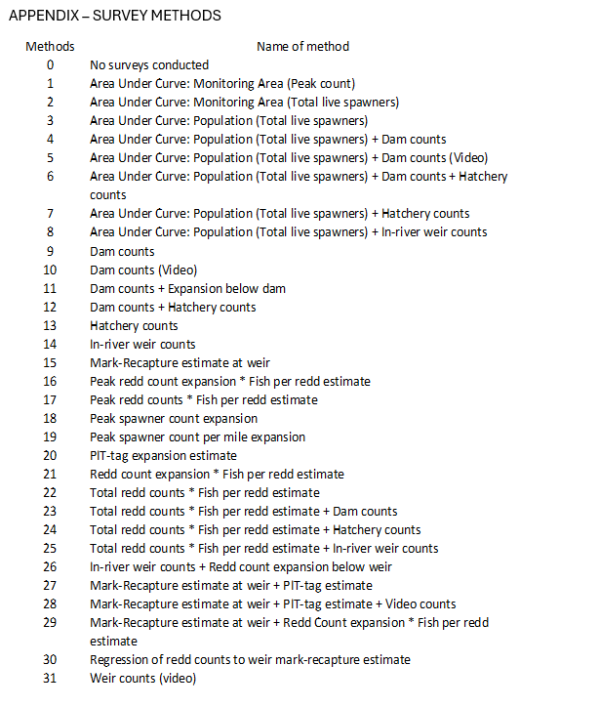

Appendix B – Additional Figures
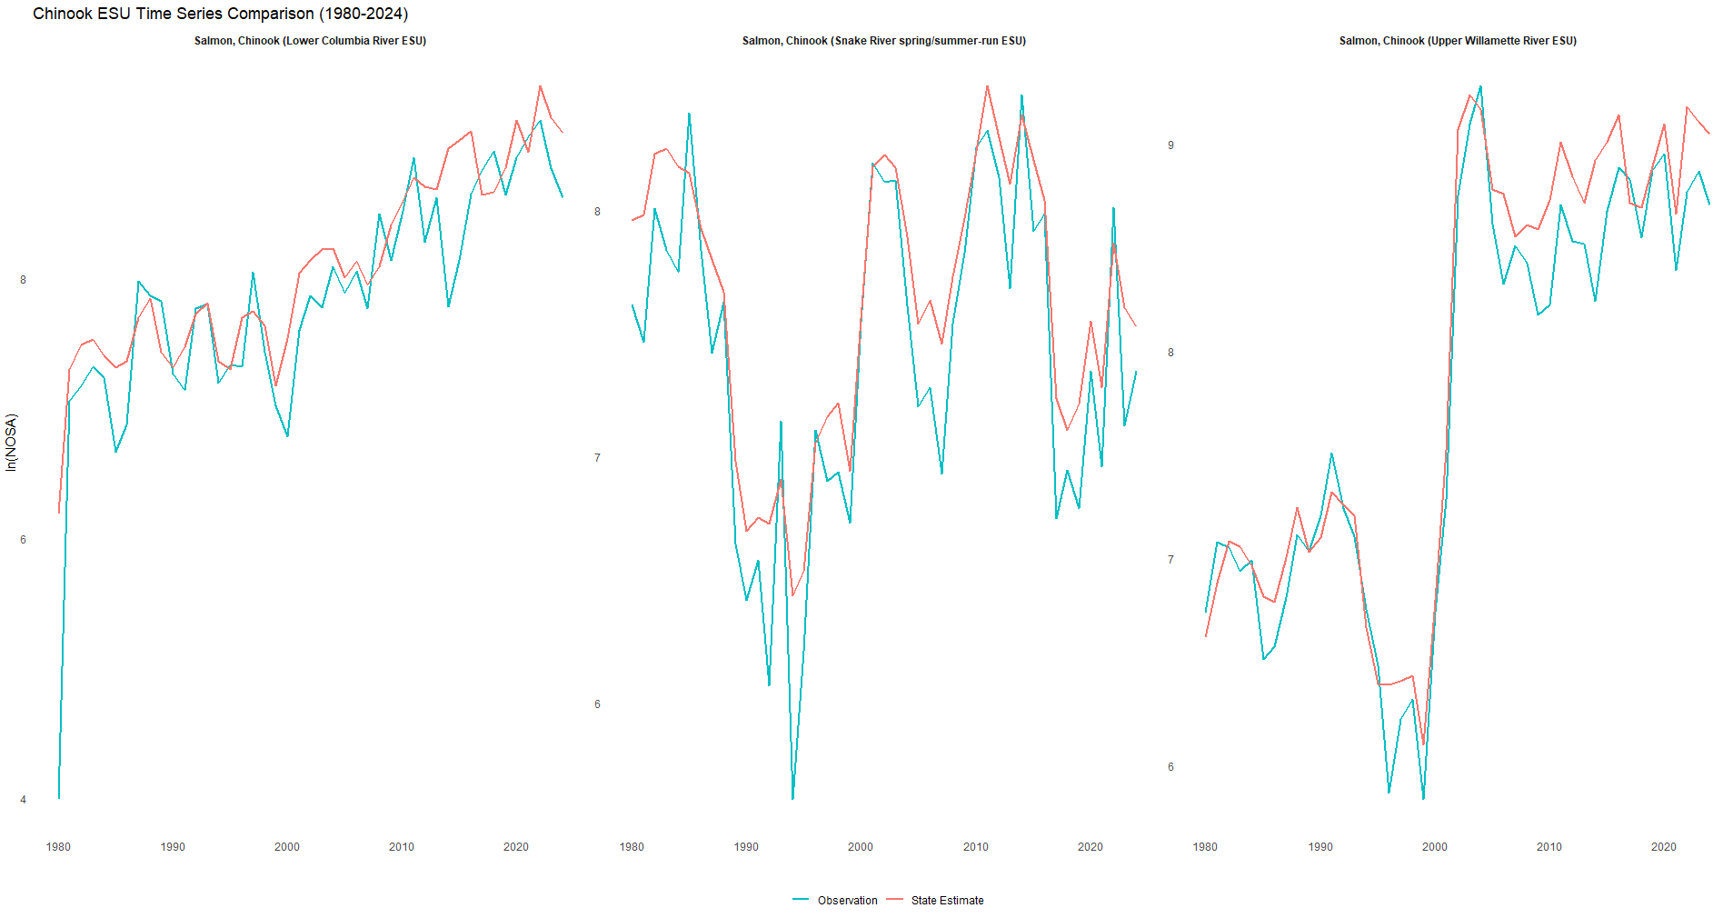 Figure B1: Evolutionarily Significant Unit level comparison of fitted abundance estimates (red) and observations (blue) of Oregon Chinook from 1980 – 2024.
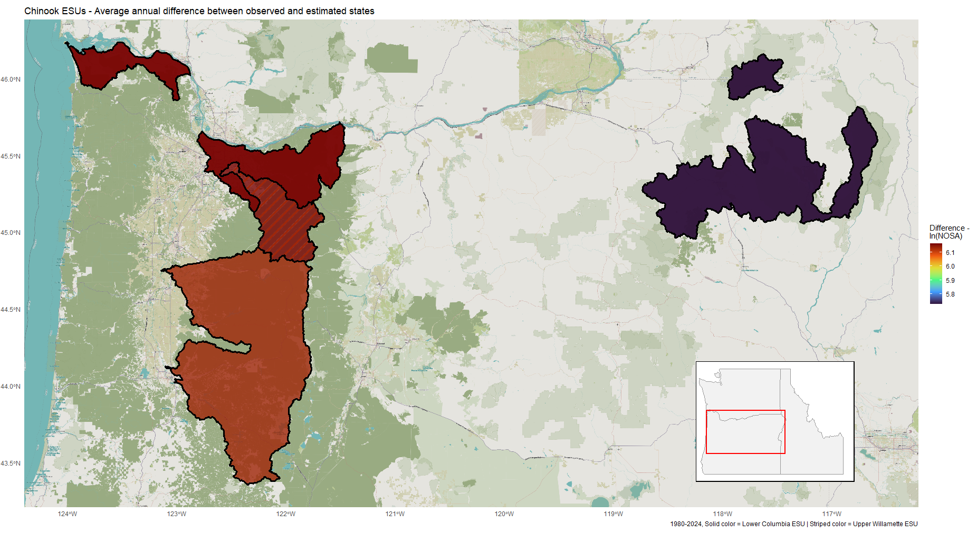 Figure B2: Evolutionarily significant unit level average difference between survey observations and fitted abundance estimates of Oregon Chinook from 1980 – 2024. A positive value indicates an overcount due to survey methods employed, while a negative value indicates an undercount. 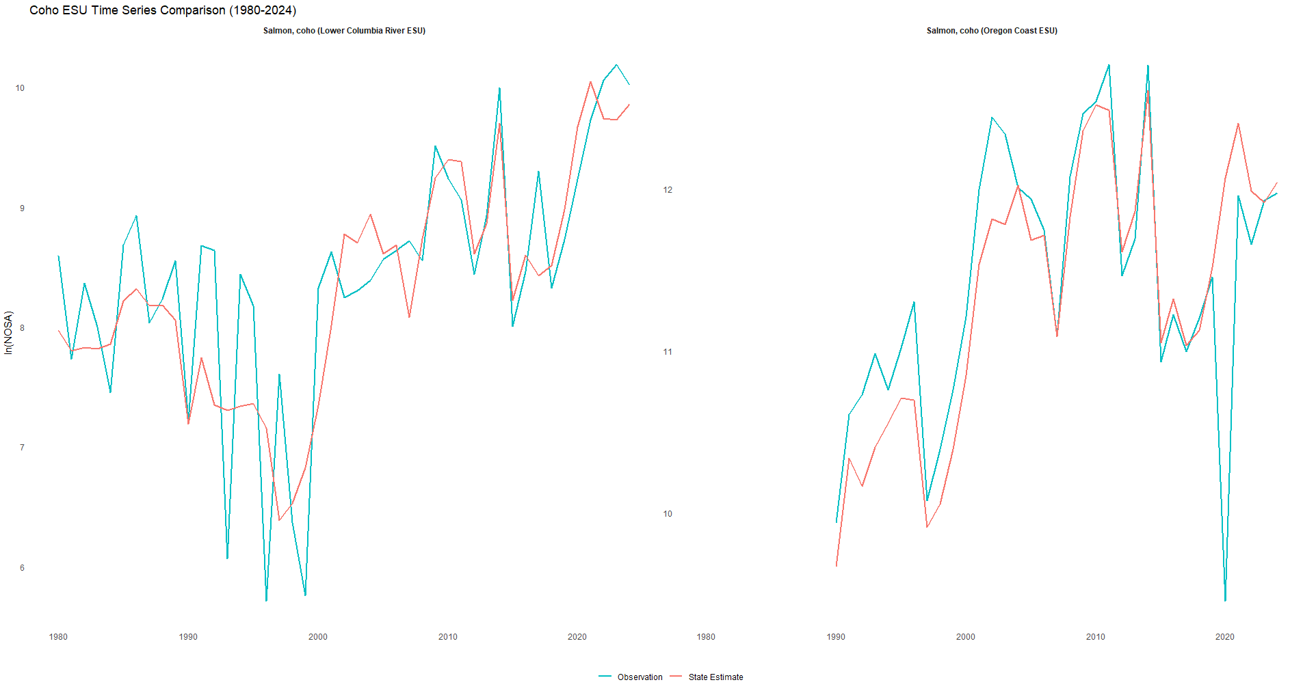 Figure B3: Evolutionarily Significant Unit level comparison of fitted abundance estimates (red) and observations (blue) of Oregon coho from 1980 – 2024.
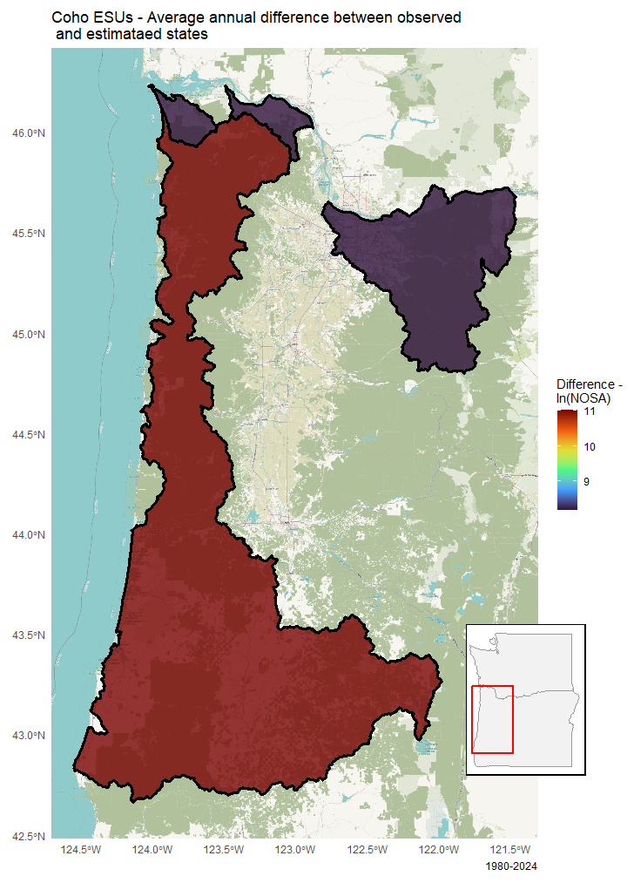
Figure B4: Evolutionarily significant unit level average difference between survey observations and fitted abundance estimates of Oregon coho from 1980 – 2024. A positive value indicates an overcount due to survey methods employed, while a negative value indicates an undercount.
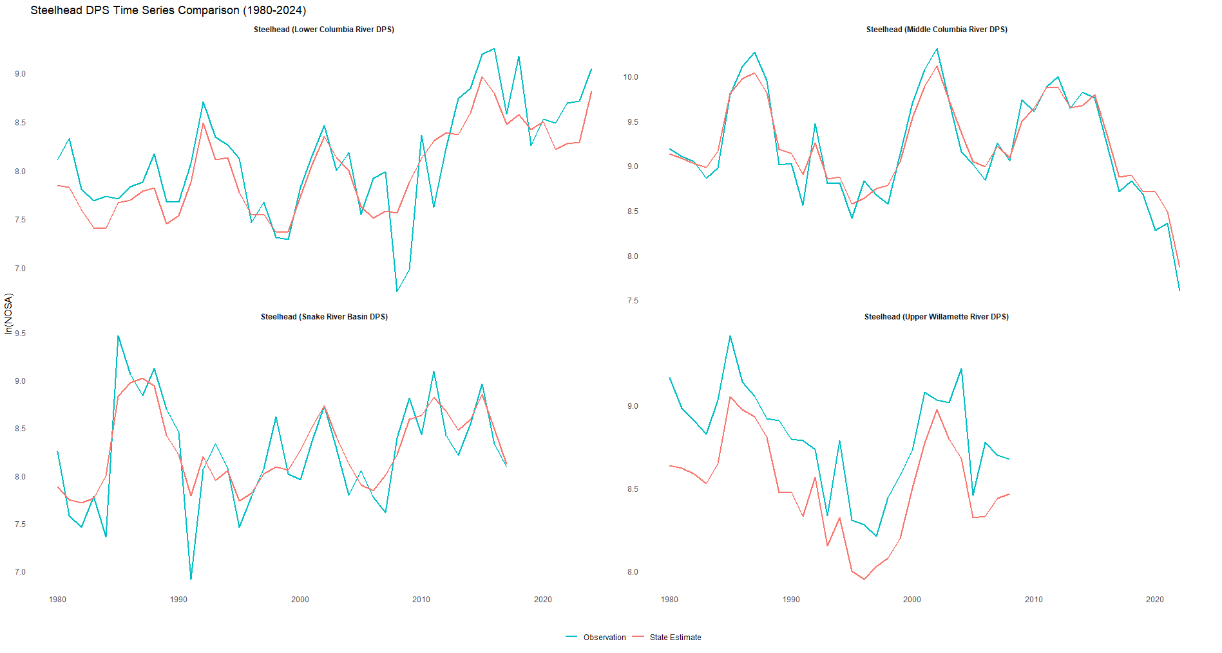 Figure B5: Distinct Population Segment level comparison of fitted abundance estimates (red) and observations (blue) of Oregon steelhead from 1980 – 2024.

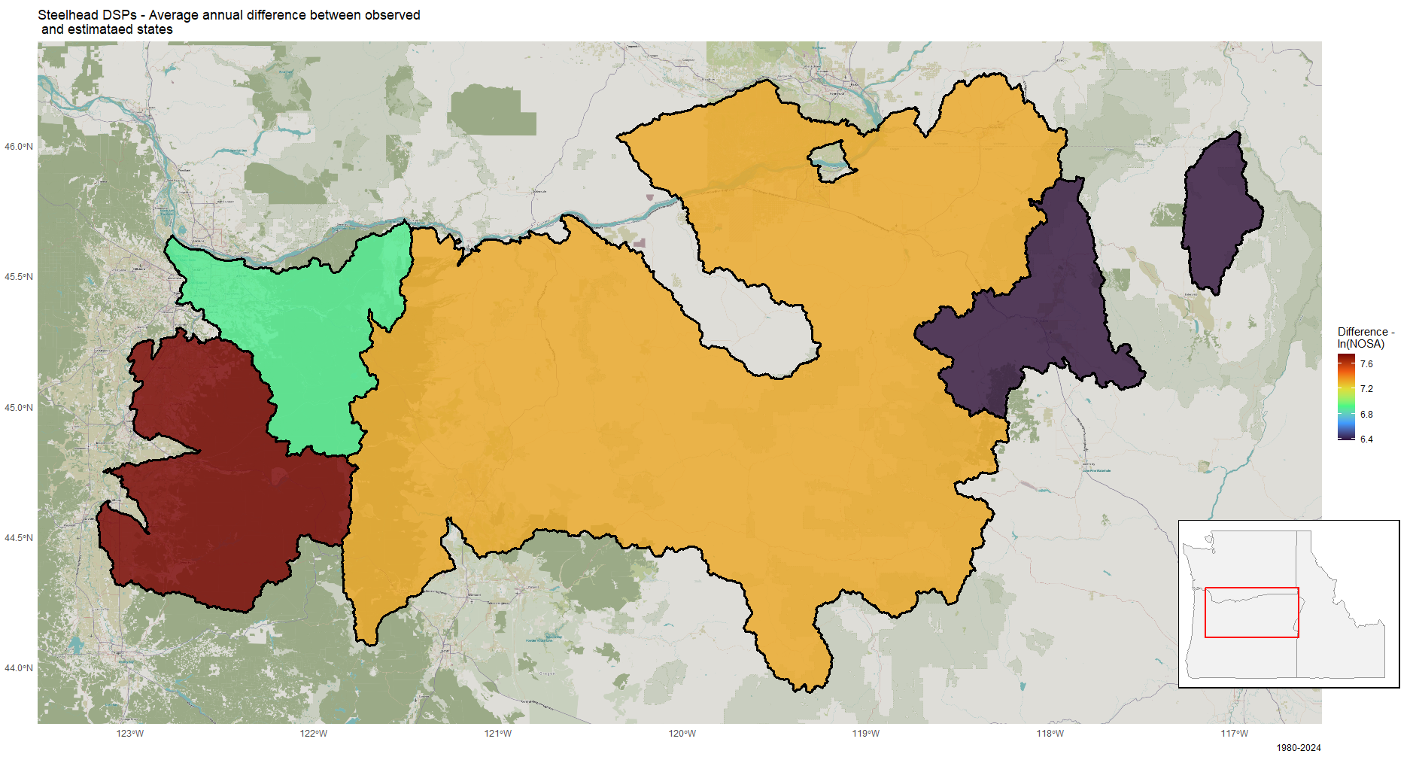
Figure B6: Distinct population segment level average difference between survey observations and fitted abundance estimates of Oregon steelhead from 1980 – 2024. A positive value indicates an overcount due to survey methods employed, while a negative value indicates an undercount.
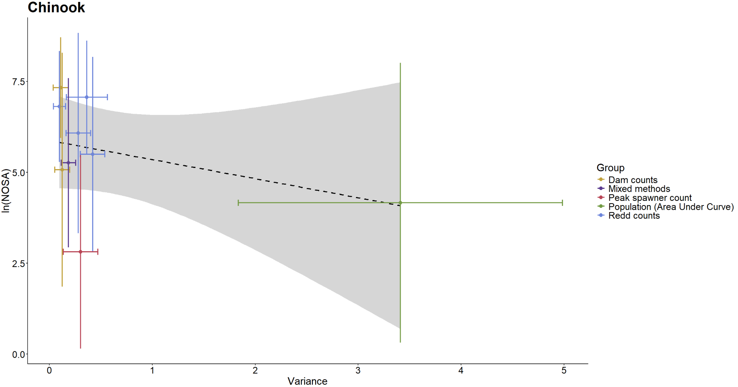 Figure B7: Relationship between variance associated with Chinook survey methods and population sizes being surveyed.
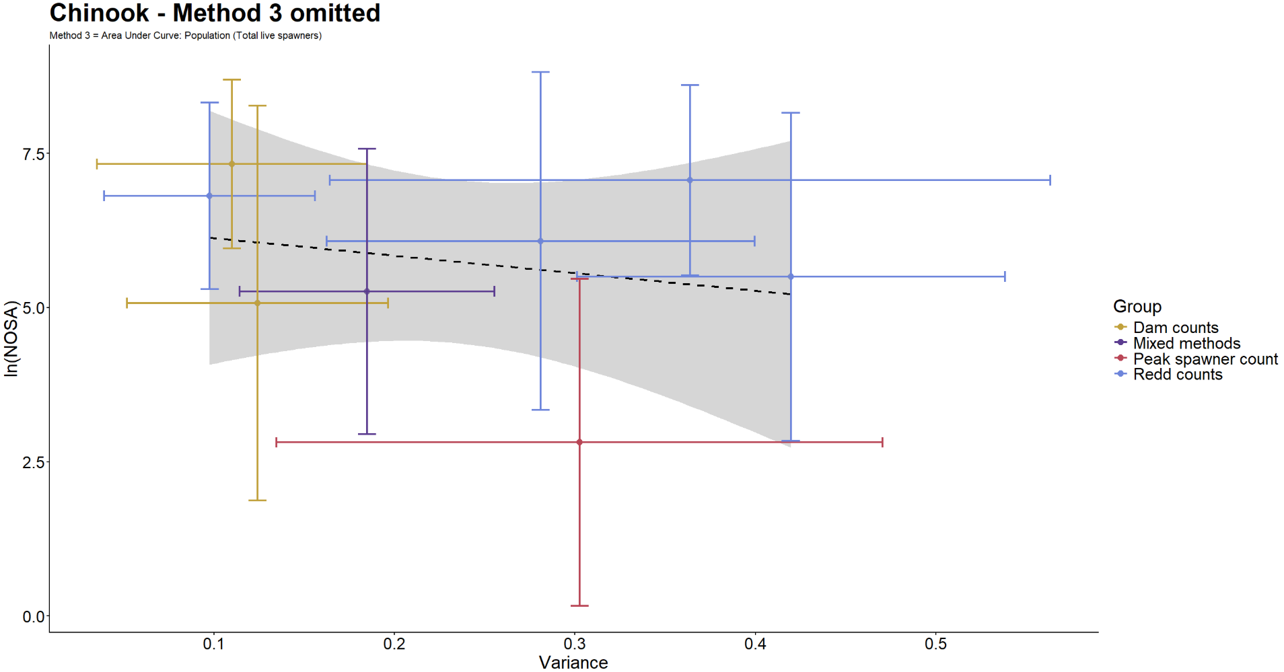 Figure B8: Relationship between variance associated with Chinook survey methods and population sizes being surveyed. ‘Area Under Curve: Population (Total live spawners) is omitted as an outlier.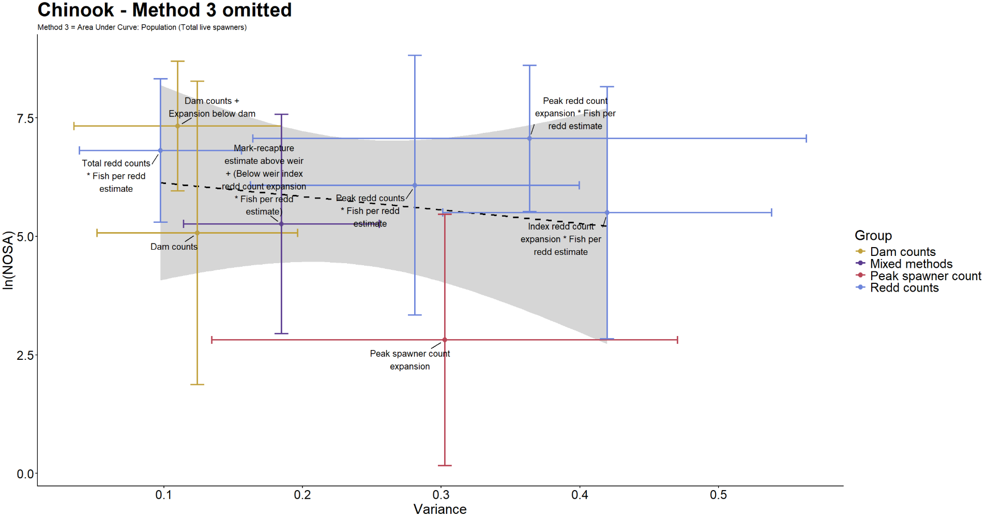 Figure B9: Relationship between variance associated with Chinook survey methods and population sizes being surveyed. ‘Area Under Curve: Population (Total live spawners) is omitted as an outlier. 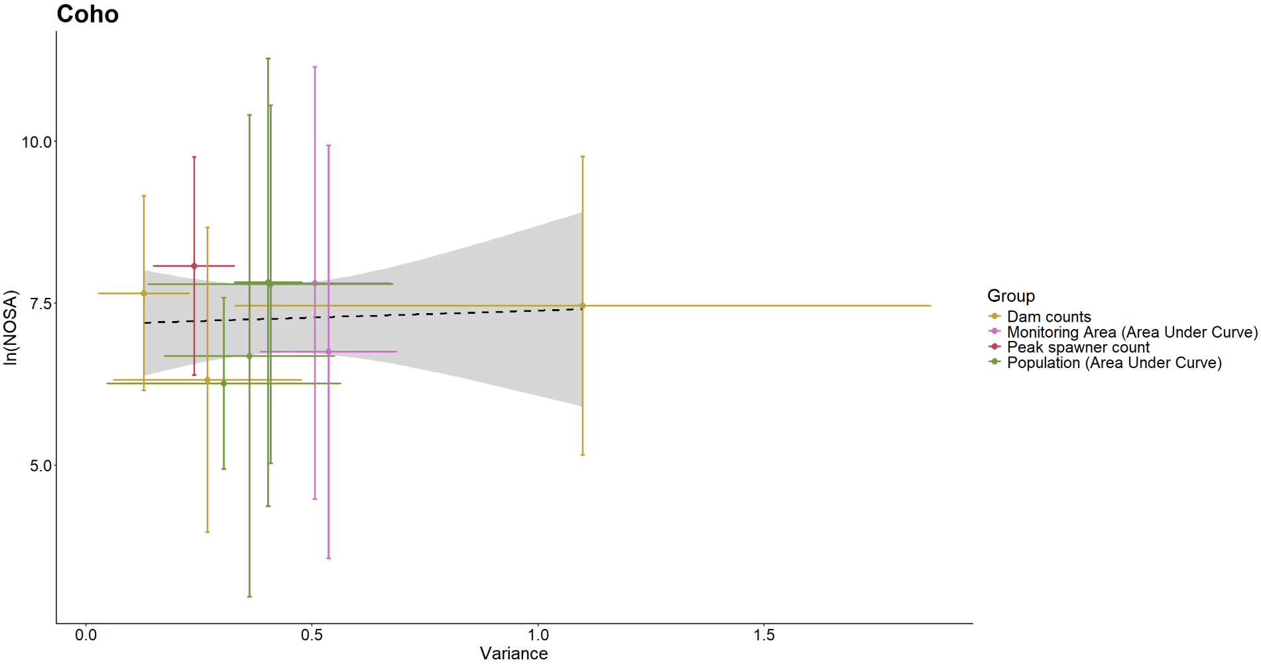 Figure B10: Relationship between variance associated with coho survey methods and population sizes being surveyed.
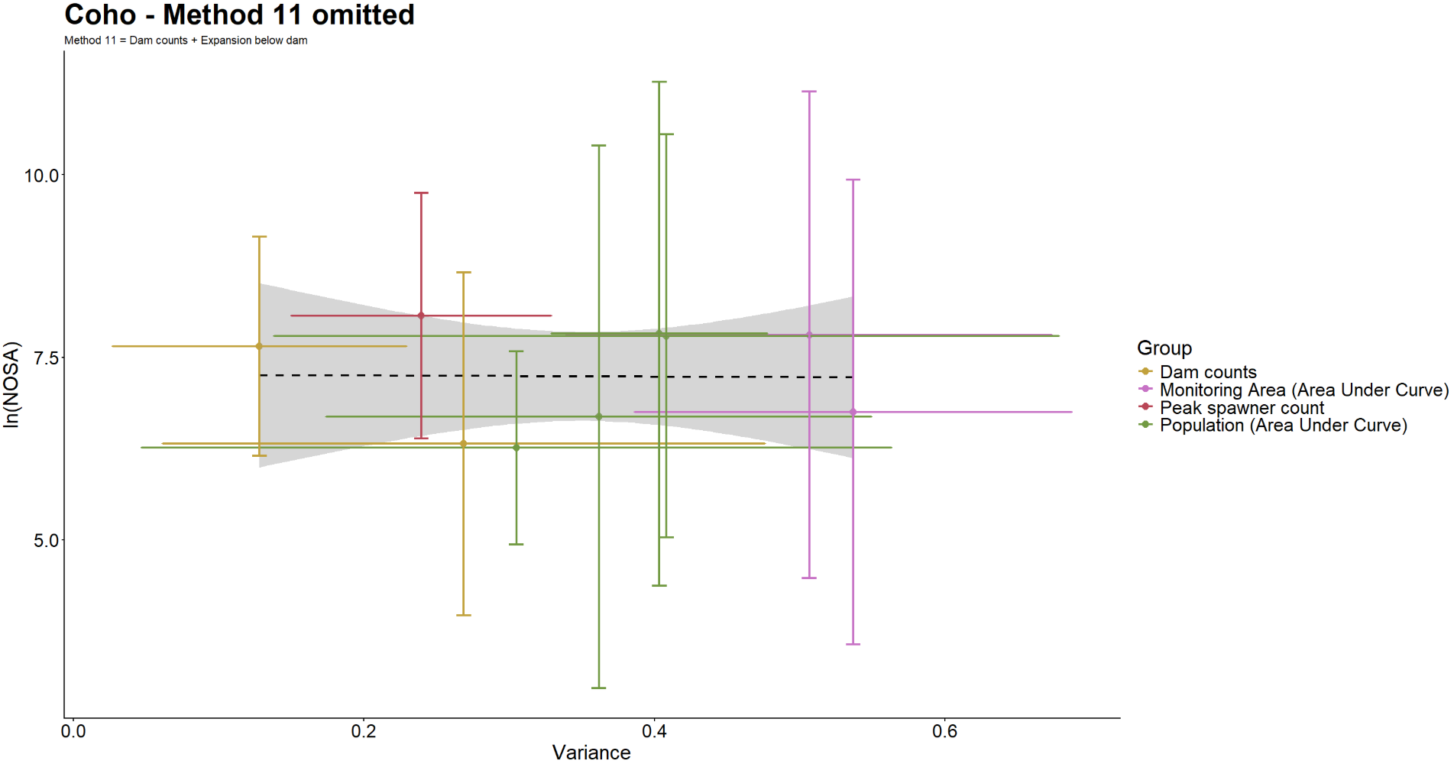 Figure B11: Relationship between variance associated with coho survey methods and population sizes being surveyed. ‘Dam counts + Expansion below dam’ is omitted as an outlier.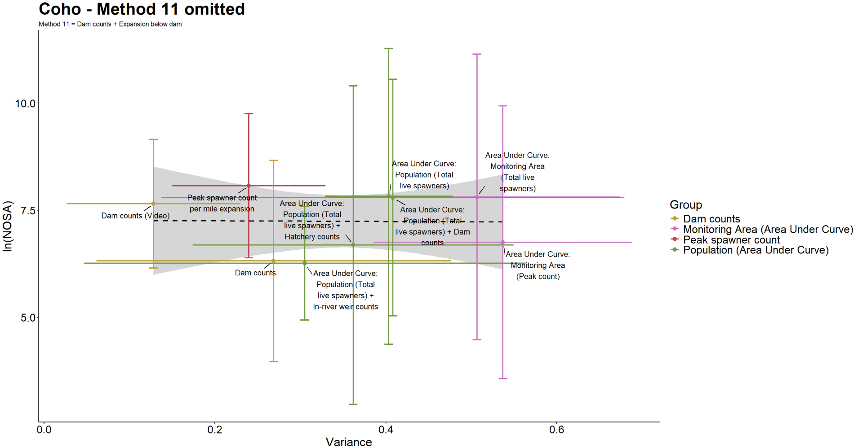 Figure B12: Relationship between variance associated with coho survey methods and population sizes being surveyed. ‘Dam counts + Expansion below dam’ is omitted as an outlier. 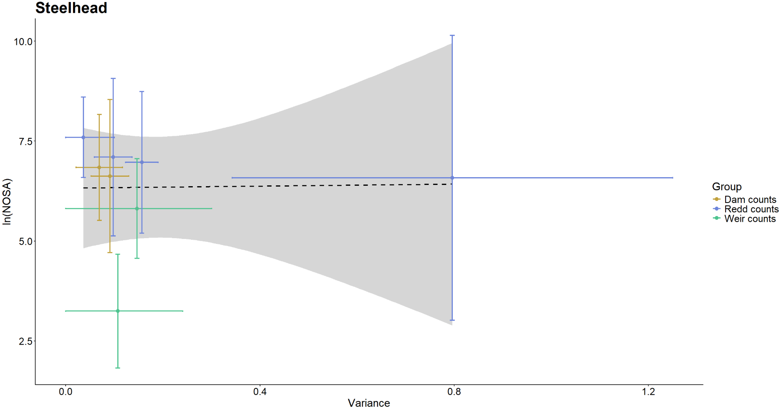 Figure B13: Relationship between variance associated with Steelhead survey methods and population sizes being surveyed. 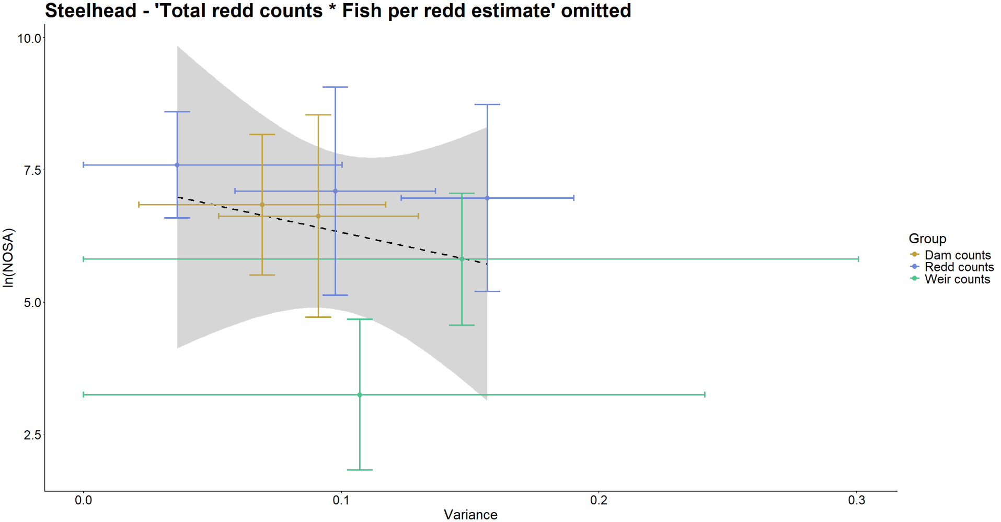 Figure B14: Relationship between variance associated with Steelhead survey methods and population sizes being surveyed. ‘Total redd counts * Fish per redd estimate’ is omitted as an outlier.
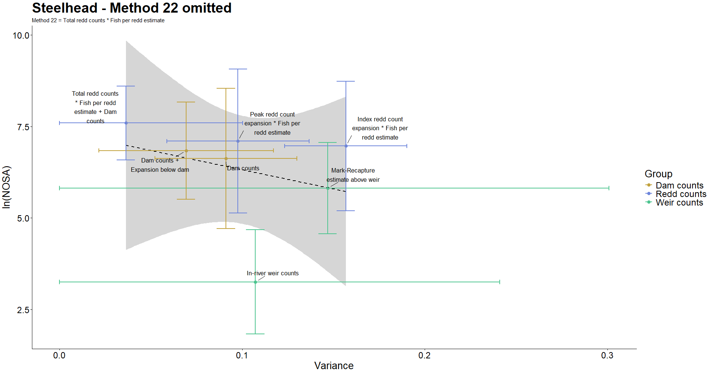 Figure B15: Relationship between variance associated with Steelhead survey methods and population sizes being surveyed. ‘Total redd counts * Fish per redd estimate’ is omitted as an outlier.

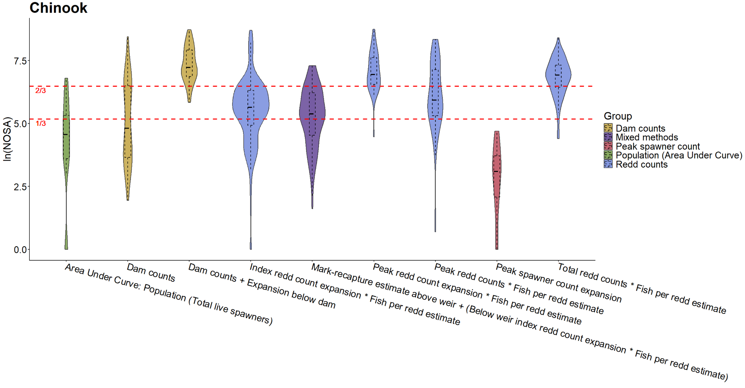Figure B16: Distribution of steelhead survey method use relative to the size of the population being surveyed. Red dashed lines represent the first and second thirds of all populations surveyed across study period. 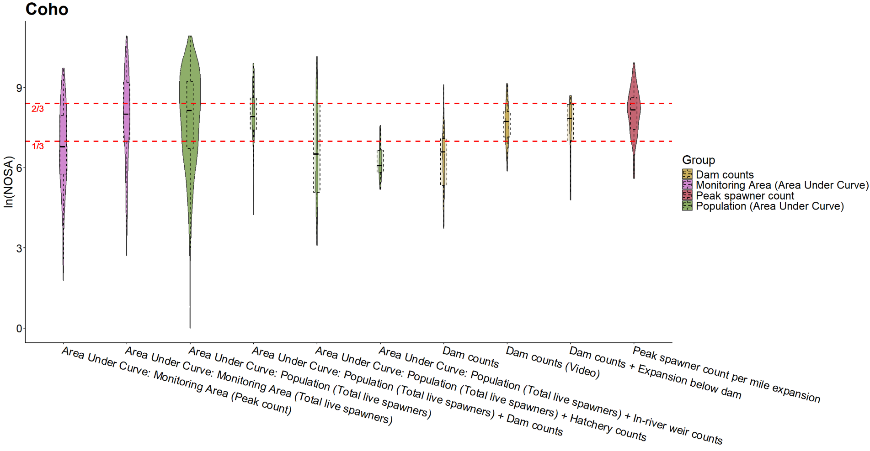 Figure B17: Distribution of steelhead survey method use relative to the size of the population being surveyed. Red dashed lines represent the first and second thirds of all populations surveyed across study period.
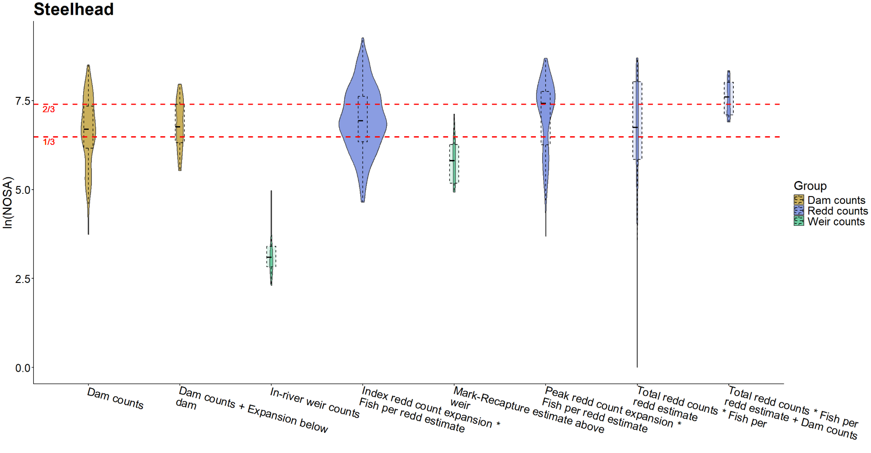Figure B18: Distribution of steelhead survey method use relative to the size of the population being surveyed. Red dashed lines represent the first and second thirds of all populations surveyed across study period.

