Salmonid survey piece

Brian McGreal
Quantitative Ecology and Resource Management
University of Washington
Seattle, WA

Mark D. Scheuerell
U.S. Geological Survey, Washington Cooperative Fish and Wildlife Research Unit
School of Aquatic and Fishery Sciences
University of Washington
Seattle, WA

William K. Jaeger
Department of Applied Economics
Oregon State University
Corvallis, OR

(potentially)
Kasey Bliesner - ODFW
Jake Chambers - ODFW

Introduction
Ecological monitoring, in which intermittent surveillance of one or more ecological measures of interest is undertaken, is widely regarded as an essential pillar of conservation science and management (Goldsmith 1991, Nichols and Williams 2006, Lindenmayer and Likens 2010). Monitoring programs differ in goals and scope but typically involve recurring collection of data to inform some combination of science, management, and policy (Lindenmayer and Likens 2010). Surveys are the essential “on-the-ground” data-gathering efforts which make up monitoring programs, and which take a wide variety of forms in ecology depending on the species/systems of interest and the objectives of the monitoring program, as well as the costs of monitoring efforts and managers wanting to ensure the most efficient use of resources available (Goldsmith 1991, Caughlan and Oakley 2001, Field et al. 2005, Wintle et al. 2010, Hanson et al. 2023). Data collected through survey efforts are often used to construct estimates of population-level characteristics, introducing statistical uncertainty. Survey methods are additionally subject to observation inaccuracy (i.e. missed individuals, individuals double-counted, non-existent individuals recorded) resulting from the form of the method employed (Tyre et al. 2003, Elphick 2008). Bias and precision related to survey methods have been studied across multiple ecological niches, underscoring the value in identifying these characteristics (Leujak and Ormond 2007, Hone 2008, Parsons and Skalski 2010, Morrison 2016). An imprecise survey method can still be of use depending on the application, but it is crucial that scientists and wildlife managers understand the ways in which a method or suite of methods is imprecise when evaluating data collected and drawing conclusions.
Pacific salmon (Oncorhynchus spp.) and steelhead trout (Oncorhynchus mykiss) have long been the subject of monitoring programs in North America, as the conservation of these species for environmental, tribal, commercial, and recreational use is of tremendous importance to fish and wildlife agencies in the Pacific Northwest (Wolf and O’Neal 2010, Levi et al. 2018, Jaeger and Scheuerell 2023, Price and Moore 2026). While these motivating factors can be said of all salmonid population in the Pacific northwest, multiple salmon and trout Evolutionarily Significant Units (ESUs) (groupings composed of many salmonid populations) are protected under the US Endangered Species Act of 1973, further compelling the need for sustained monitoring (National Oceanic and Atmospheric Administration 2025a). Since 1980, the state of Oregon alone has spent over $9 billion in the effort to protect and restore populations of steelhead trout (Oncorhynchus mykiss) and Pacific salmon in the Columbia River Basin. However, the impacts of these restoration efforts remain difficult to quantify (Jaeger and Scheuerell 2023). While some amount of uncertainty will always exist, understanding the value of conservation investments relies on understanding the accuracy of salmonid population assessments.
To manage harvest and assess the impact of conservation policy and interventions, various survey methods are employed to estimate the abundance of target species over time. Each method is characterized by an inherent level of precision and potentially some inherent directional bias as well (Parsons and Skalski 2010). Past studies have shown a positive relationship between the intensity of sampling efforts, and the precision of abundance estimates in both aquatic and terrestrial species (Walsh et al. 2001, Nuno et al. 2013, Annear et al. 2024). As such, managers must navigate the tradeoffs between more intensive sampling efforts and the level of precision they hope to achieve. While low levels of precision in survey methods lead to low confidence in point estimates of population abundance or forecasts, directional bias presents a more pernicious problem as it may lead to the mismanagement of imperiled species, invasive species, and commercially valuable populations (Tracey and Fleming 2022, Satterthwaite and Shelton 2023). Over-estimation of a species of interest lends itself to potential overharvesting, while under-estimation may lead to lost revenue due to harvest restrictions, and either of these outcomes could result in the suboptimal allocation of conservation (Elphick 2008, Parsons and Skalski 2010, Katzner et al. 2011). Indeed, in the United States, decisions of whether to list or de-list species as endangered under the Endangered Species Act are based on abundance estimates that may be influenced by such bias (National Oceanic and Atmospheric Administration 2025b, U.S. Fish and Wildlife Service 2026). It has been shown that when directional bias can be assessed, it may be corrected if the offset is known in order to achieve more accurate abundance estimates (Polansky et al. 2023).
Spawning salmon and trout are surveyed in freshwater using methods that vary from visual inspection of known spawning grounds to counts of salmon migrating up stream at fixed points to inferential methods estimating total escapement in a stream system based on periodic counts of spawners (Knudsen 2000). Survey methods conducted at terminal spawning grounds include foot surveys of live fish, carcass counts, and visual inspection of salmonid nests known as redds (Johnson et al. 2007, Oregon Department of Fish and Wildlife 2024a). Within streams, adult fish may be captured and counted at weirs before being released to continue their upstream migration (Anderson et al. 2015). Another approach involves capturing salmonids as juveniles and fitting them with small passive integrated transponders (PIT-tags). This enables tagged fish to be electronically counted as adults years later, as the return to their natal spawning grounds takes them past sensor arrays (Lamb et al. 2024). In more remote localities, aerial surveys are favored with fish being counted from either helicopter or fixed-wing aircraft, trading precision for the ability to survey sites which are otherwise very difficult to access (Walker 2015, Copeland et al. 2019). Finally, these methods and more may be included in the estimation of total escapement through a variety of area-under-the-curve and peak spawner count estimation methods (English et al. 1992, Parken et al. 2003, Millar and Jordan 2013). Given this variety of survey methods dependent on various technology and statistical techniques, each method will be characterized by some degree of imprecision, and perhaps some intrinsic tendency to over- or under-estimate spawning salmonids.
My research seeks to measure the levels of precision and relative bias accompanying various survey methods by comparing observations from 74 populations of Chinook (O. tshawytscha) and coho salmon (O. kisutch) and steelhead throughout Oregon, most of which each belong to an ESU (or in the case of steelhead, Distinct Population Segment or DPS) listed as threatened under the Endangered Species Act. These surveys were conducted by biologists from the Oregon Department of Fish and Wildlife (ODFW) from 1980 to 2024, using 31 distinct survey methods. The precision inherent to a survey method (and the associated variance of estimates derived from these surveys) directly impacts the ability to detect changes throughout time, as large confidence intervals may obscure shifting abundance regimes (Vallecillo et al. 2021). This work will also seek to determine whether non-zero directional bias exists in some survey methods, although bias estimates will necessarily be defined relative to other survey methods, as “true” censuses of the underlying salmonid populations do not exist. While most survey methods analyzed in this study do not show significant directional bias, some exceptions to this pattern warrant closer scrutiny. A secondary objective of this research is to identify which and to what extent ESU/DPSs in the study area have been chronically under- or over-estimated due to the survey methods employed in monitoring them, with over-estimation being of particular concern.

Methods
Data
I used an extensive dataset that includes annual observations of natural-origin spawner abundance (NOSA) covering 74 populations of Chinook, coho, and steelhead throughout Oregon from 1980 to 2024. Crucially, each observation also includes the method by which the abundance survey was conducted. Data have been collected through 31 unique survey methods (fully enumerated in the attached appendix) and contain 2,396 individual observations with recorded NOSA values. Eight hundred and forty eight observations missing NOSA values almost entirely related to years in which no survey was conducted were dropped. Survey methods which appear only very rarely in the data (less than ten occurrences for a given species) were also dropped due to a lack of sufficient sample size.
Across the landscape it can be seen that shifts in average populations sizes between the first and last decades recorded in the study period are not necessarily typically spatially correlated (coho on the northern Oregon coast being a notable exception), and that the majority of populations have increased or decreased by less than 50% in this timeframe (Figure 2). Of course, the accuracy of the trends described above are dependent on the accuracy of the observed data, itself a product of the survey methods employed. The frequency with which survey methods are employed is not uniform across the study period (Figure 3). While some methods such as redd counts have been widely used throughout the study period, other methods have seen drastic changes in usage. If different survey methods indeed exhibit varying levels of precision and/or inherent directional bias, then changes in population overtime may be less accurate than initially assumed. Assessing both the accuracy of these methods and the unbiased underlying trends in abundance requires an approach capable of distinguishing between the two.

MARSS Models
Because my goal is to isolate variance and bias in different survey methods, it is vital to distinguish variability in observations due to survey methods from variation in the natural state of salmonid populations. Multivariate autoregressive state space (MARSS) models are well
suited for this purpose, as they can mathematically distinguish observation error from process/state error and assign separate variance parameters to each. This is accomplished through a model structure with two components: a process equation which models one or more true but unobserved states, and an observation equation which models the relationship
between these unobserved states and the observed data and captures error resulting from imperfect detection. The observation equation is generically formulated as follows:
y_{t} = Zx_{t} + a + Dd_{t,} + v_{t}, where v_{t}∼MVN(0,R)
In the above, observed data in each period (y_{t}) are used to estimate the underlying state of a system of interest (x_{t}). Z is a matrix of zeroes and ones designed to indicate which time series
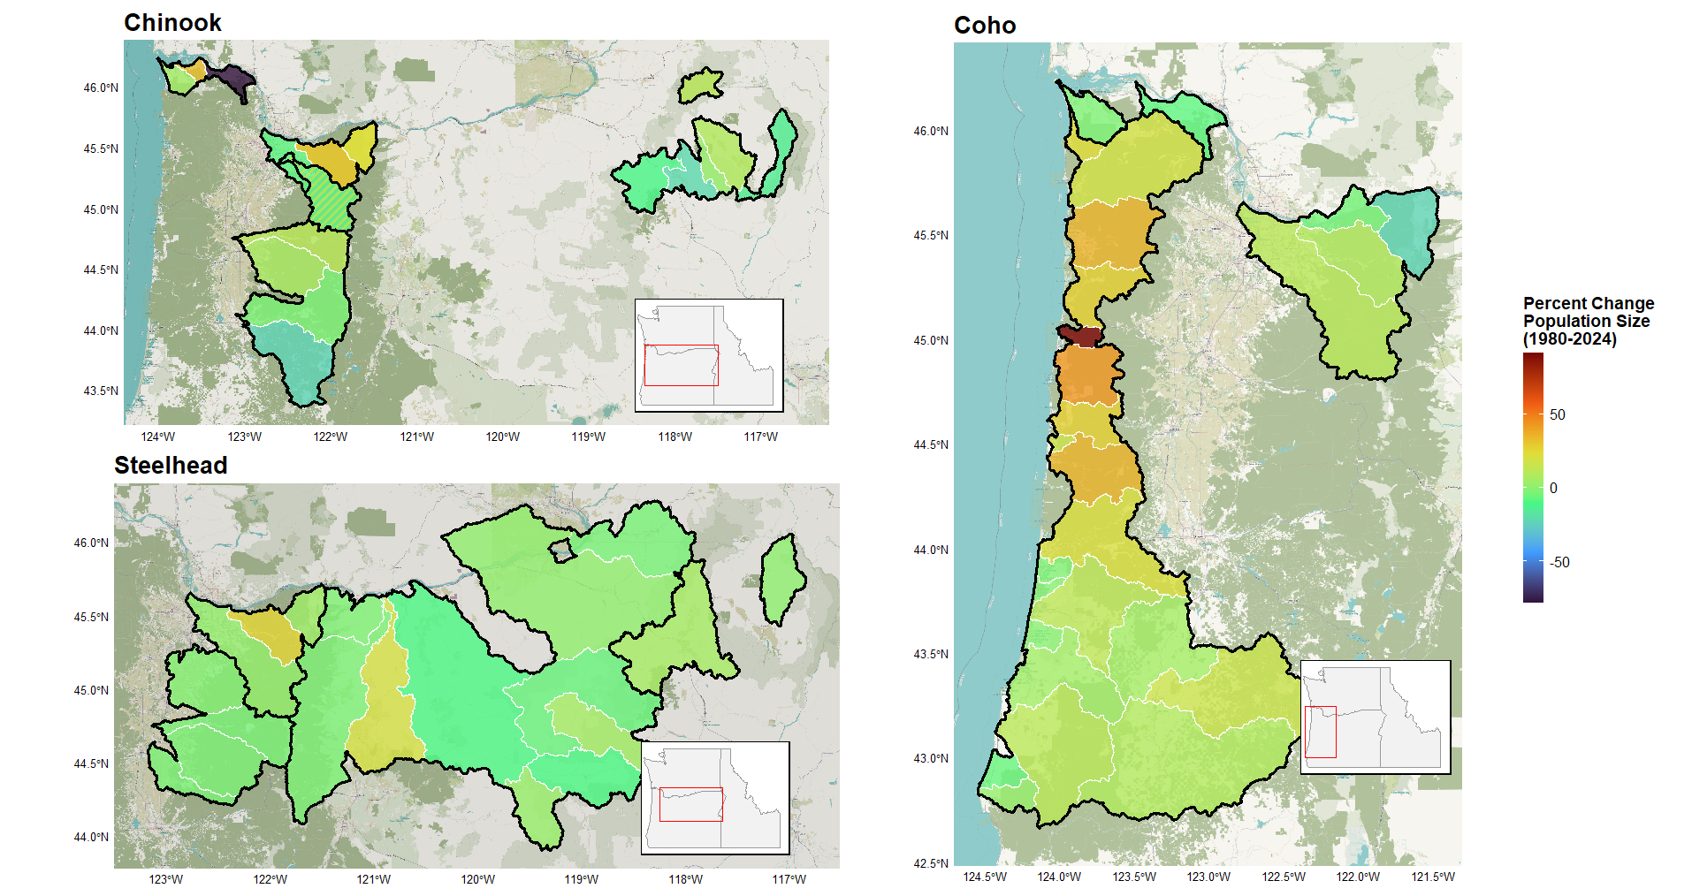
Figure 2: Percent change in average population size between the periods 1980-1989 and 2015-2024.Population outlines in white with ESU borders in black. Majority of populations do not increase by more or less than 50% over the course of the study period. In Chinook panel shared population, solid color = Lower Columbia ESU | striped color = Upper Willamette ESU
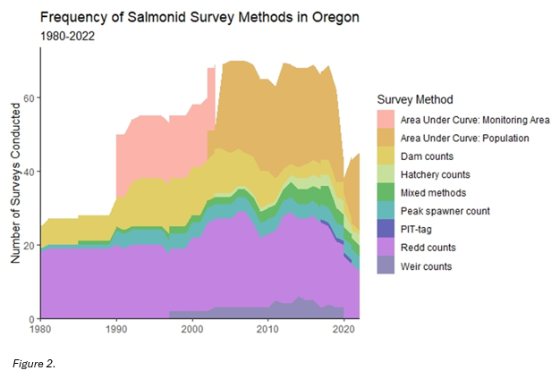
Figure 3: Groups of survey methods and the frequency of their employment from 1980 to 2022. The nine groups displayed in the figure are bins containing each of the 31 survey methods described in the data. These bins are non-scientific and do not reflect designations established by ODFW or any other party, and are instead intended strictly as an aid for visualizing these data.

observations will inform which underlying states in the process equation. The vector a allows for the existence of some degree of offset between the observed data and the underlying state process to be captured, and while variation in observation error captured by the diagonal elements in R. The vector d_{t} represents covariate data related to the sampling procedure, with D capturing the effect of these covariates.
The observation equation is linked to the autoregressive process equation through the estimates of underlying states (x_{t}). The process equation connects time steps in state processes by estimating terms for both x_{t} (in conjunction with the observation equation) and x_{t−1}. The process equation is formulated as follows:
x_{t} = Bx_{t−1} + u + Cc_{t} + w_{t}, where w_{t}∼MVN(0,Q)
Here, B defines the interaction between state estimates through time (i.e., x_{t} and x_{t−1}). If B is specified as an identity matrix, u then represents trends in the underlying state(s), otherwise B and u together determine the underlying mean and how quickly the time series would return to the mean following some perturbation. The variance of process errors as well as the (possible) covariance between them is defined by Q. Finally, c_{t} and C respectively represent covariate data related to the state process and the effect of said covariates.
MARSS models are very useful when parsing long running time series data collected using varying survey methods, where inherent features of those methods could potentially bias the observations being made. Furthermore, MARSS models allow for gaps in the observed time series while retaining the ability to make inferences about the underlying state (Holmes et al. 2012, Scheuerell et al. 2015).
Because of their differing life histories, I modeled all three species salmonid species separately, using three data subsets respectively containing 22 Chinook populations, 29 coho populations, and 23 steelhead populations. Each observation contains four crucial pieces of information: 1) an estimate of natural-origin spawner abundance (denoted mathematically from here on as y), 2) the population of interest (denoted with the subscript p), 3) the survey method used (denoted with the subscript s), and 4) the year of observation (denoted with the subscript t).
Applying a MARSS model structure to the analysis described above involves determining how best to structure spawner abundance data (y_{p,s,t}) and specify model parameters to isolate precision and bias in salmonid survey methods. To distinguish inaccuracy resulting from survey methods from naturally occurring variation in the populations being surveyed, y_{t} is structured such that each row relates to a unique combination of population p and survey method employed. Z is then specified to relate multiple rows in y_{t} to their given underlying populations, which make up x_{t}. By specifying each population as an underlying state, these models are able to assess variation in the natural state of the population separately from variation in counts arising due to inaccuracy of the survey method employed. The vector a contains a unique bias term for each survey method, irrespective of population. Crucially, one method will be selected as a reference against which bias associated with other methods will be measured, meaning that bias estimates discussed throughout this study are not absolute but relative to this reference. For this chosen reference method, a_{s} is set equal to zero. Were another reference method to be chosen, model fit would not be changed, but relative bias terms would shift to reflect this change. The matrix R is specified in a similar manner, with a unique term for each method placed in the corresponding places along R‘s diagonal. Again, this is irrespective of population to capture the variation inherent in each survey method.
Below is an example of the observation equation written out in matrix form. In this example, two populations of salmonid have been surveyed with a total of five survey methods. As indicated by the y term subscripts, population one has been surveyed with methods one through four and population two with methods one, four, and five. Z is specified as two columns relating to the two populations which here are considered underlying states (x₁ and x₂). Survey method one has been selected as the reference method against which other methods’ directional bias will be measured. Therefore, in vector a, those rows which correspond to an observation taken with method one are set equal to zero, while all other methods are represented by an a parameter which repeats as often as the method appears. Finally, R is specified so that each survey method is represented by an r parameter, which again repeats as often as the method appears, to capture the variance inherent to each.
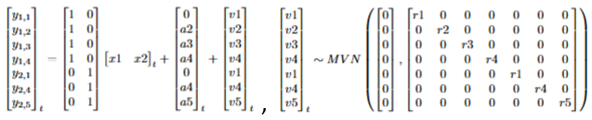
The process/state equation is more straightforward. It is constructed to be as parsimonious as possible to essentially act as a receptacle for the natural variance in annual salmonid spawner returns. B is specified as an identity matrix. Whether the vector u is set to zero or allowed to estimate a trend in each population’s growth will depend on model fit. The terms along the diagonal of Q will also be specified as unequal to allow for differences in abundance dynamics based on population, although other specifications (equal population variances and allowing for equal variance and equal covariance terms) will also be evaluated. Below is an example of the process/state equation written out in matrix form.
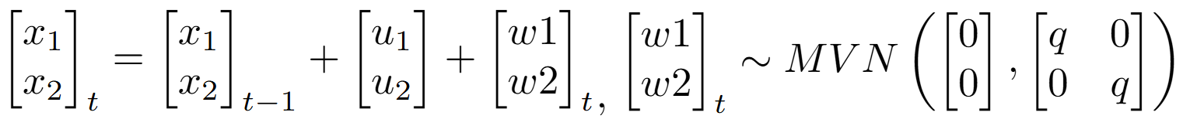
The various specifications of u and Q will be evaluated for best fit based on AICc, as this criterion is better suited than AIC for balancing fit with the many parameters MARSS models must estimate.
These x_{t} estimates are definitionally adjusted to account for bias resulting from the survey methods employed in making observations. These estimates then may be used to assess population-level differences in observations and the underlying natural states being observed, and whether ESU/DPSs are being chronically over or undercounted. This work additionally considers the efficiency of the same survey method in estimating populations that differ by orders of magnitude, as it is not hard to imagine the accuracy of a given method differing considerably when the number of fish present differ substantially. Finally, many of the abundance estimates reported are derived from the combination of more than one survey method (see attached Appendix A). For example, Scappoose Creek winter steelhead are each year variously surveyed through either in-river weir counts, total redd counts * fish per redd estimate, or the combination of the two. This work evaluate these mixed survey method approaches commonly seen in the data to assess whether imprecision and/or directional bias produced by combining survey methods is amplified or dampened compared to those associated with each constituent part.

Robustness checks
There exists the likelihood that some survey methods are endogenously related to the abundances they seek to estimate. For example, dam counts require that a dam be present, a feature which has been shown to have adverse impacts on salmonid populations (Levin and Tolimieri 2001, Pess et al. 2008). In theory, MARSS models should be able to statistically account for this potential endogeneity by mathematically partitioning the variance and bias originating due to the survey method (i.e., the accuracy of dam counts) from the variance and bias inherent in the underlying process being observed (i.e., natural fluctuations in a population’s abundance), especially given multiple populations being surveyed via the same method (Lindén and Knape 2009, See and Holmes 2015). To ensure that potential endogenous relationships between populations and methods will not impact the results of this work, I conduct robustness checks using simulated data to ensure that the models employed are indeed able to capably distinguish process error from observation error in such cases.
To evaluate MARSS models’ ability to statistically parse variability inherent to the observation processes from variability in the underlying populations, even when the two are endogenously related, I constructed synthetic datasets in which populations’ initial abundance were drawn from distributions relating to ‘small’, ‘medium’, and ‘large, and a randomized subset of survey methods are only applicable to either ‘small’ or ‘large’ populations. MARSS models are then fit using these datasets and bootstrapped confidence intervals are established around the parameter estimates of interest – variance terms related to survey method. Because the true variance terms are known, it is trivial to determine what percentage of true variance terms fall within these bootstrapped confidence intervals. The accuracy of these estimates are then compared to the accuracy of models fit using synthetic data in which no endogeneity is present (i.e., no method is exclusively linked to ‘large’ or ‘small’ populations). This process of creating randomized synthetic datasets, fitting MARSS models, and comparing bootstrapped confidence intervals to the true parameters, is repeated 100 times to provide complete assurance of these models’ abilities to distinguish process error from observation error, even given endogenous relationships between populations and survey methods.
INITIAL RESULTS DON’T INDICATE ANY HUGE DISPARITY BETWEEN ACCURACY OF PARAMETER ESTIAMTES TRAINED ON THESE DIFFERING DATASETS

