PROJECT PROPOSAL

My research project seeks to examine the efficiency of various salmonid survey methods employed by the Oregon Department of Fish and Wildlife. My intention is to evaluate 31 survey methods to determine their precision and potentially identify any directional bias.

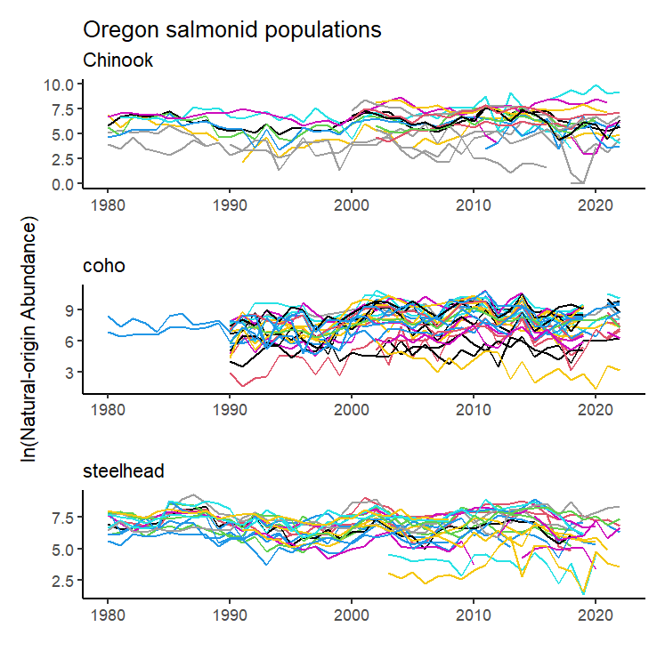Data includes annual observations of “natural-origin salmon and steelhead abundance” or NOSA, covering 69 populations of Chinook and coho salmon and steelhead trout throughout Oregon from 1980 to 2022. Crucially, each observation also includes a variable indicating the method by which the abundance survey was conducted. Data has been collected through 31 unique survey methods. The data contains 2,924 individual observations, of which 848 are missing NOSA values which almost entirely relate to years in which no survey was conducted (15 observations confoundingly include a survey method along with a null value). Figure 1 illustrates changes in abundance of individual salmonid populations throughout the study period.

*Figure 1.*

The frequency with which survey methods are employed is not uniform across the study period. Figure two illustrates groups of survey methods and the frequency of their employment from 1980 to 2022. The nine groups displayed in the figure are bins containing each of the 31 survey methods described in the data. While some methods such as (redd counts) have been widely used throughout the study period, other methods have seen drastic changes in usage.

I intend to analyze this data by fitting MARSS models and comparing estimates of variation related to different survey methods. Specification of these models will require careful consideration to capture the precision of each survey method, as the individual time series (each related to a particular population of salmonids) are typically composed of observations drawn from multiple survey methods. I *think* this will likely take the form of careful construction of the MARSS model’s **R** matrix to isolate the behaviors of various 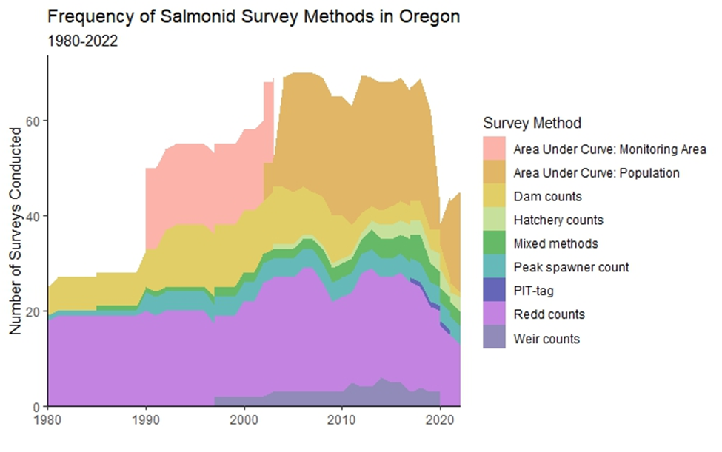sampling methods.

*Figure 2.*

DRAFT INTRODUCTION

The conservation of salmon and trout for environmental, tribal, commercial, and recreational use is of tremendous importance to state-level fish and wildlife agencies in the pacific northwest. Oregon alone has, since 1980, spent over $9 billion in the effort to protect and restore populations of steelhead trout and salmon. To determine the value of investments like these, policymakers and fisheries managers need accurate assessments of the populations in question. To this end various survey methods may be employed, with each method accompanied by some cost and presumably characterized by an inherent level of precision.

This study seeks to measure the levels of precision accompanying various survey methods by comparing observations from 69 populations of Chinook and coho salmon and steelhead trout throughout Oregon, taken from 1980 to 2022. Additionally, this work seeks to determine whether directional bias exists in some survey methods, although any estimates of bias will likely be relative to other survey methods, as “true” censuses of the underlying salmonid populations do not exist. The intention of this research is to map the value of information, such that managers can better determine achievable levels of precision given some budget, or inversely the cost of some minimum level of precision in their estimates.