Appraisal

Objective Analysis

| **Objective** | **Success or Failure** | **Comment** |
| --- | --- | --- |
| 1 | Success | The system is able to parse CSV map files, where each file is an individual building or floor. Distances are calculated by recursively traversing each map file, and store in the ‘distance’ table in the database. Once the distances are calculated, the map is no longer referenced, therefore allowing the Java Runtime Environment’s garbage collector. |
| 2 | Success | By clicking on the import button, the user is able to select a CSV to load for a single data type. A single file can only contain data for a single data type, and the user must import the data in the correct order to allow for foreign key constraints to be forfilled. |
| 3 | Success | All data stored in the database is shown in multiple tables in the user interface. The user is able to insert a single entry, import from a CSV file, remove a single entry or remove all entries, at runtime. |
| 4 | Success | The lesson table represents the timetable, which can have entries added to it either with or without a member of staff or classroom. The timetabling section of the system is able to avoid lessons which are already fully timetabled. |
| 5 | Success | The location of the top map and other map files are specified when the user requests for the classrooms and buildings to be loaded. But, the user cannot change the format of the files which are imported. This can only by changed the implementation of the data access objects’ loadFile method. |

User Feedback

In order to get the best user feedback, I sent the user a ZIP file containing the installer and a copy of the user manual. This will allow me to be able to obtain better feedback than me showing the user what the system is able to do, as I know how the system flows. Also, this allows me to assess the quality of the user manual when given to a user with no experience with the system. The following is a copy of the email sent by my user in response to the timetabler.

Dear Stuart,

First, I would like to thank you for the creating the timetabler program. The program has a simple, easy to follow design, which is much better than the current system. Although, the single window design is nice, but it would be nice if I could see more the data at one time, so for example, spiting the tables into individual windows, and having a central window to open each window from, or being able to zoom in and out, so I can see more of each table, as most were larger than the screen.

The tables are well laid out, but I was not expecting to have to remember ‘ID’s or have to frequently switch between tables to see what the ‘ID’s referenced. It would have been better if data, such as names, where used instead of ‘ID’s in other tables as it would be easer to read the data in the tables. The import from file is very useful and intuitive to use, but again, it would have been better to not have to use ‘ID’s for referencing other data, like how the maps store subjects. The lesson data could have had an import button, like the rest of the data, as this would have sped up data entry.

Installing the program was quick and simple, thanks to the installer provided. By following, the given manual, I was able to install and understand the program without any trouble. But, the manual could have done with more information on how to deal with errors. The listed errors were not in enough detail, and the information given in the error window did not always specify how to solve the issue.

The timetabling was able to complete its task efficiently and effectively with the data it was given, but I would have liked to have been able to specify year group restriction on the classrooms, as only sixth form students should be able to be taught in the sixth form block for example.

To summerise, the timetabler program is a better solution to the current system, but needs a few improvements before I can use it to completely replace the current system.

Yours sincerely

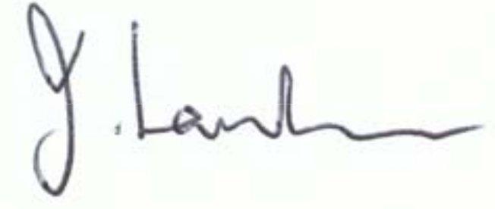

Mrs J Lansdown

Head of Sixth From

Assistant Head Teacher

Feedback Analysis

The feedback given is very constructive, as it shows how the user knows where there are shortfalls in the systems user-system interaction design. It shows how I have just met all the objectives, but have left out functionality which the user appeared to assume would have been included. Other suggestions, such as not having the tables use IDs, but use names should have been the design of the tables, but I struggled to find an efficient solution in the time I allocated to the design of the user interface tables. After reading through the possible errors which can be thrown, I feel the errors are either self-explanatory or have enough information to help solve the issue, but this appears to not be the case, and the should have all had possible solutions, rather than relying on the user to decipher the error messages. From the beginning of the user interface design, I wanted to try and implement the interface in a single window, as I felt the current system utilised an excess of windows in its design. The user appears to have a similar opinion, but felt I took this design to the extreme of minimal windows, and should have included more windows.

Extensions

Based on the user feedback, I would allow the user to ‘pop out’ a table into a new window, remove the extensive use of IDs in the user interface’s tables and allow the user to restrict the year groups which can be taught in a classroom. To implement the ‘pop out’ table functionality, I would have to design a new abstract table window, which is given the data to be displayed, forms a table from it and updates the table in the main section of the interface upon closing the window. In order to reduce the IDs displayed in the interface, I would have to find a way to store the ID data in a hidden element in the table, without changing the layout of the table, and retrieve the IDs when adjusting the data. I would have to add a new ‘possible year group’ field to the classroom table, allow the user to modify it and view it in the user interface, and change the timetabler to include this information when timetabling classrooms.