Testing

Test Series 1

| Test | Description | Test Data | Expected Result | Pass or Fail | Evidence Reference |
| --- | --- | --- | --- | --- | --- |
| 1 | Add subject | Typical:  Maths | Adds new subject to table | Pass | 1 |
| Erroneous:  (Blank) | Asks user to specify a name and keep dialogue open | Pass | 2 |
| Extreme:  Design and Technology | Stops the user from typing more than 20 characters | Pass | 3 |
| 2 | Add Staff Member | Typical:  Mr Smith  Maths  20 Hours | Adds new staff member to the table | Pass | 4 |
| Erroneous:  Mr Smith  Maths  -1 Hours | Asks the user to specify a valid unsigned integer and keeps the dialogue open | Pass | 5 |
| Extreme:  Verylongpaddednametofillspace  Maths  20 Hours | Stops the user from typing any more than 20 characters | Pass | 6 |

| Test | Description | Test Data | Expected Result | Pass or Fail | Evidence Reference |
| --- | --- | --- | --- | --- | --- |
| 3 | Add Year Group | Typical:  Year 7 | Adds new year group | Fail | 7 |
| Erroneous:  (Blank) | Asks the user for a name and keeps the dialogue open | Pass | 8 |
| Boundary:  Year 65430 | Does not let the user type more than 8 characters | Pass | 9 |
| 4 | Add Class | Typical:  Set 1  Maths  Year 7 | Adds a new class to the table | Pass | 10 |
| Erroneous:  (Blank)  (Blank)  (Blank) | Prompt the user to select data to add to the table | Pass | 11 |
| 5 | Add Lesson | Typical:  Monday 9:30  Set 1 Maths Year 7  (Blank)  (Blank) | Adds a new lesson to the table with -1 in the classroom and staff columns | Pass | 12 |
| Erroneous:  Monday 9:30  (Blank)  (Blank)  (Blank) | Prompt the user to select data to add to the table | Pass | 13 |

1.

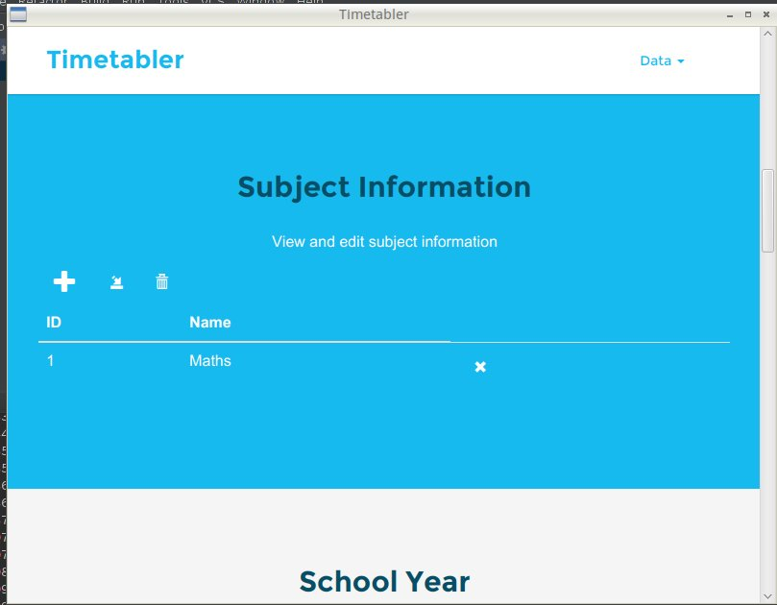2.

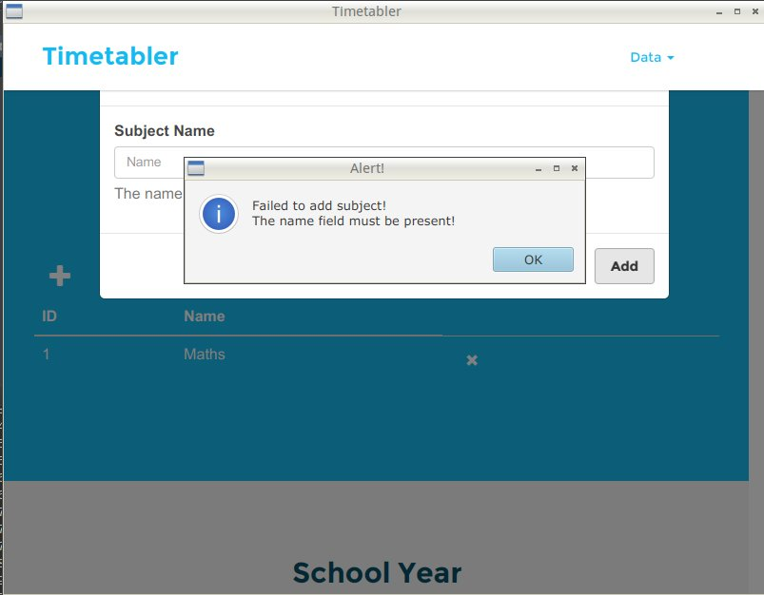

3.

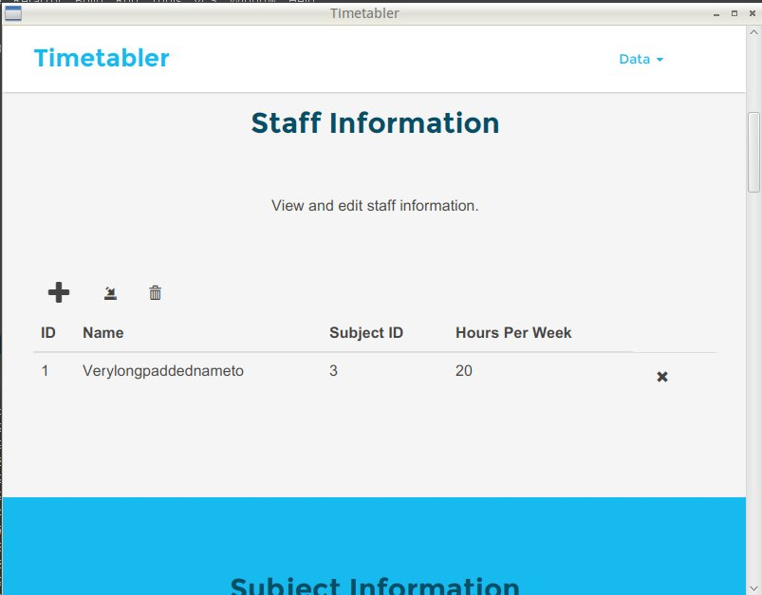

4.



5.

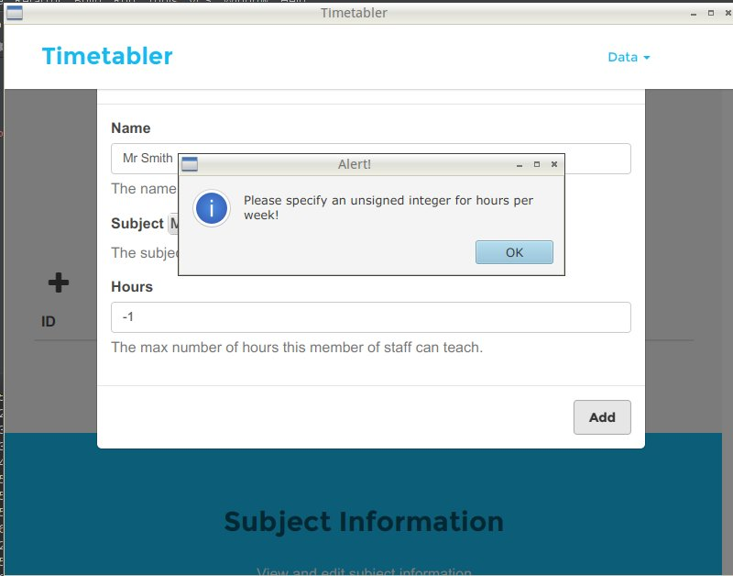

6.



7.

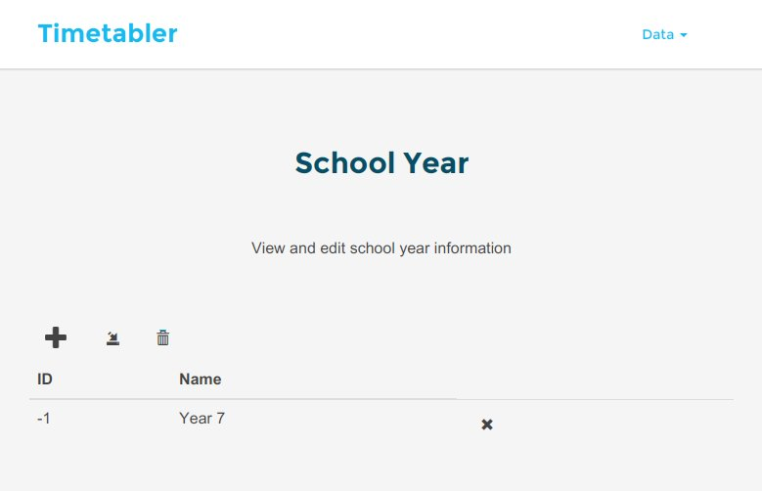

8.

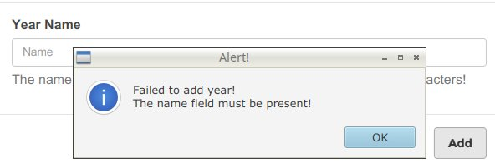

9.

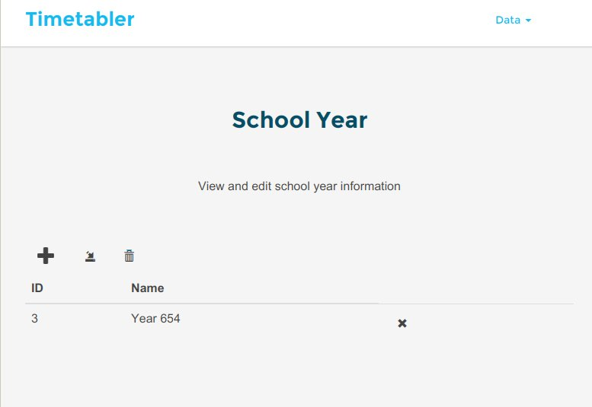

10.

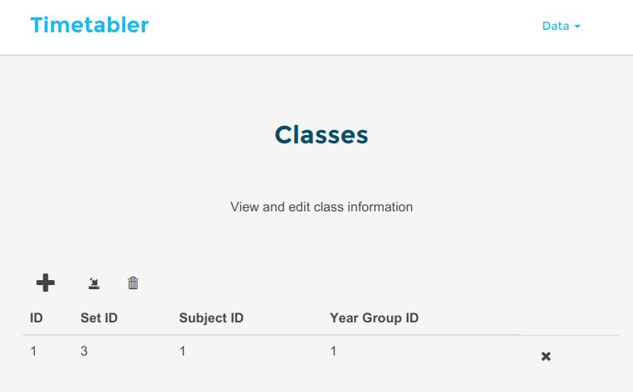

11.

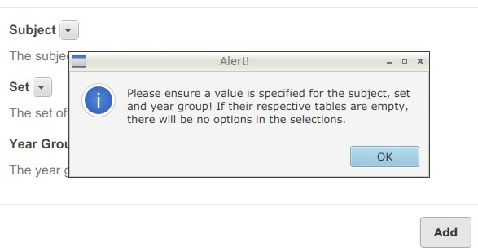12.

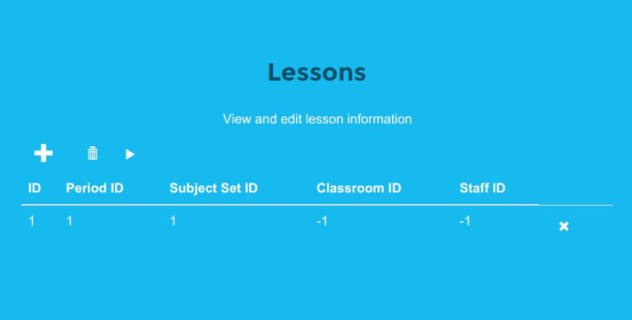

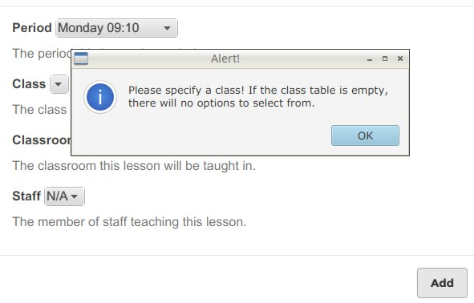13.