**User Manual**

Introduction

This timetabling program is designed to be used in conjunction with any other timetabling software, in order to create a timetable which includes the distance for members of staff in the timetabling process. It takes information about the layout of the school, lessons taught at the school, and the members of staff teaching at the school, stores the information and produces a timetable from the information. All information stored by the program is only accessible through the program and is protected using a password.

In order for the program to run successfully on your system, it must meet all the following requirements:

* Running a compatible operating system
  + Windows Vista or newer, 32 or 64 bit
  + Linux, 32 or 64 bit
* Have the latest version of the Java Runtime Environment installed
  + At the time of writing this is JRE 1.8

Installation

To install the system, follow the following steps:

1. Insert the installation media, this can be a disk to USB stick
2. If the installation media was a USB stick or you are not running Windows, skip this step
   1. Select the recommended option from the ‘*AutoPlay*’ popup
   2. Go to step 4, unless there was no ‘*AutoPlay*’ popup, where you should continue to step 3
3. Navigate to the installation media using ‘*My Computer*’, ‘*Computer*’ or your file explorer
   1. Run ‘*Installer.jar*’, ‘*Installer.bat*’ or ‘*Installer.sh*’
   2. Go to step 4
4. You should now have a window with ‘*Install Path*’ and ‘*Password*’ text fields
5. Specify an install path, either by typing into the text field or using the ‘*Browse*’ button
   1. This can be anywhere on your system, but is recommended to be

‘*C:/Program Files/Timetabler*’ if you are running Windows

* 1. For Linux, it is recommended to be installed to ‘*/opt/timetabler/*’

1. Specify a password for the system, this cannot be changed after the installation
2. Finally, press the ‘*Install*’ button and wait for the program to be installed

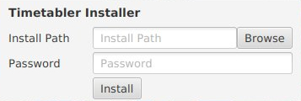

Opens a Directory Chooser

Starts installing the timetabler

Navigation

The system can be navigated in two ways: scrolling or the navigation bar. Since the whole program exists within a single window, one can access any part of the system just by scrolling to it. Also, at the top of the window, as shown, there is a navigation bar. This bar contains shortcuts to each section of the window as shown. By clicking on one of the options, the window will automatically scroll to the correct place.

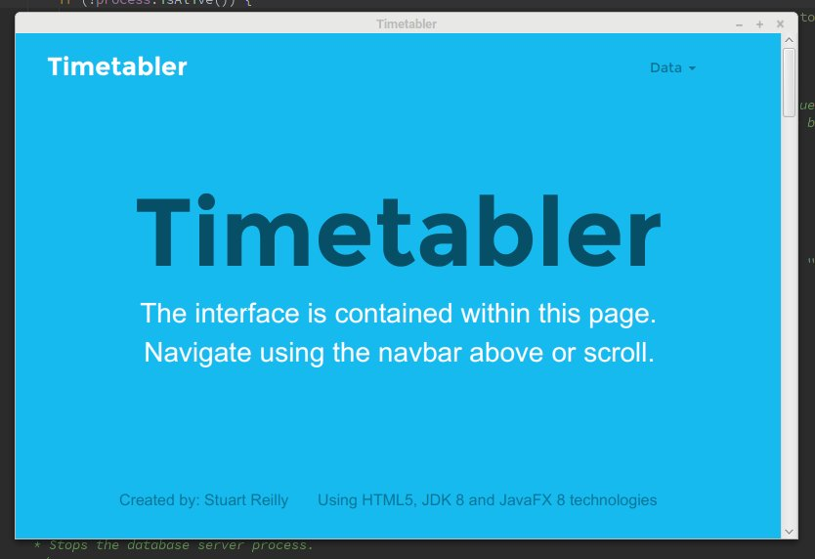

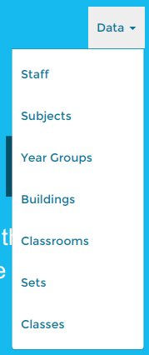

Clicking on dropdown opens this menu

Data Entry

The system requires data to be entered before any timetabling can begin. This data will be: staff data, subject data, set data, year group data, class data, lesson data and the layout of the school. In the system, lesson is a class with a classroom to be taught in, a member of staff to teach the class and period of time for the class to be taught in. The layout data will be entered only through importing map files, but all other data can be entered through the on screen wizard or from files. All the file format will be defined later in the manual.

Staff Data

Each member of staff stored by the system will be displayed in the table below. Therefore each member of staff must be defined with a name, subject and maximum hours per week. The table states ‘Subject ID’ rather than Subject, this is because the table shows the unique ID of the subject taught by the member of staff as this allows the system to access and process the staff data faster. Also, the structure of the file used to import staff data will also use ‘Subject ID’ as it allows the system to read the data faster and more accurately. To add a new member of staff, click the ‘+’ icon to open the ‘Add Staff’ wizard.

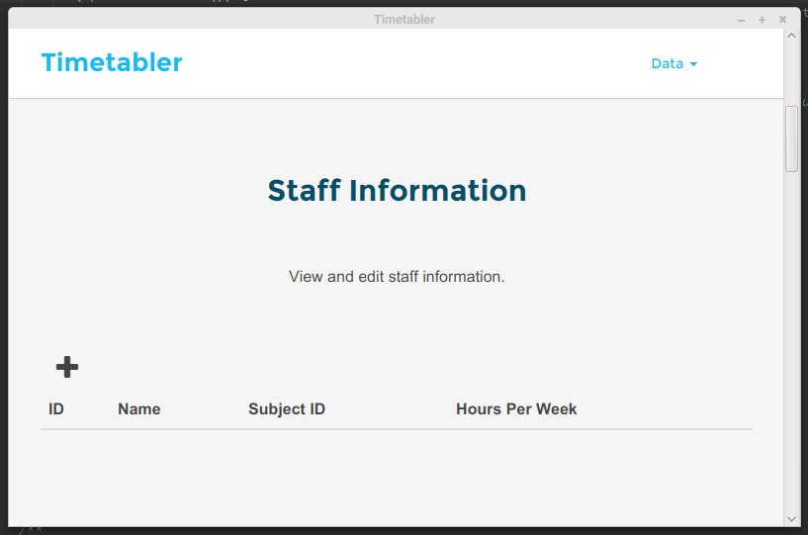

Navigation bar

Table containg the staff members

Opens the ‘Add Staff’ wizard

This is the ‘Add Staff’ wizard. This allows for a simple way to add a single member of staff to the system. The wizard allows for the selection of subjects by name for the subjects already added to the system.