**Timetabler**

**User Manual**

**Stuart Reilly**

**4113**

**17407**

**Contents**

* **Introduction – page 3**
* **Installation – page 3**
* **Starting -page 4**
* **Login – page 4**
* **Navigation – page 5**
* **Data Entry - page 5 – 12**
  + **Staff Data – page 6**
  + **Subject Data – page 7**
  + **Year Data – page 8**
  + **Building and Classroom Data – page 9**
  + **Set Data – page 10**
  + **Class Data – page 11**
  + **Lesson Data – page 12**
* **Errors – page 13**

Introduction

This timetabling program is designed to be used in conjunction with any other timetabling software, in order to create a timetable which includes the distance for members of staff in the timetabling process. It takes information about the layout of the school, lessons taught at the school, and the members of staff teaching at the school, stores the information and produces a timetable from the information. All information stored by the program is only accessible through the program and is protected using a password.

In order for the program to run successfully on your system, it must meet all the following requirements:

* Running a compatible operating system
  + Windows Vista or newer, 32 or 64 bit
  + Linux, 32 or 64 bit
* Have the latest version of the Java Runtime Environment installed
  + At the time of writing this is JRE 1.8

Installation

To install the system, follow the following steps:

1. Insert the installation media, this can be a disk to USB stick
2. If the installation media was a USB stick or you are not running Windows, skip this step
   1. Select the recommended option from the ‘*AutoPlay*’ popup
   2. Go to step 4, unless there was no ‘*AutoPlay*’ popup, where you should continue to step 3
3. Navigate to the installation media using ‘*My Computer*’, ‘*Computer*’ or your file explorer
   1. Run ‘*Installer.jar*’, ‘*Installer.bat*’ or ‘*Installer.sh*’
   2. Go to step 4
4. You should now have a window with ‘*Install Path*’ and ‘*Password*’ text fields
5. Specify an install path, either by typing into the text field or using the ‘*Browse*’ button
   1. This can be anywhere on your system, but is recommended to be

‘*C:/Program Files/Timetabler*’ if you are running Windows

* 1. For Linux, it is recommended to be installed to ‘*/opt/timetabler/*’

1. Specify a password for the system, this cannot be changed after the installation
2. Finally, press the ‘*Install*’ button and wait for the program to be installed

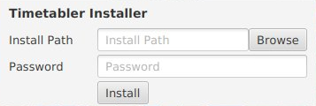

Opens folder chooser for install path

Starts installing the timetabler

Starting

The program should be able ran by clicking on the ‘Timetabler.jar’ file in the installation folder. This method does require Java to be configured as the default program for jar files and have Java’s path variable configured. Both of these requirements are for filled by the Java installer, but if it does not run by clicking on it, ensure Java is installed and run ‘Timetabler.bat’ or ‘Timeabler.sh’ if you are running Windows or Linux respectively.

Login

Upon opening the program, you will be greeted with a login window. The login window, shown below, requires you to enter the password specified when the program was installed. If you cannot provide the correct password, you will not be granted access to the program for data protection.

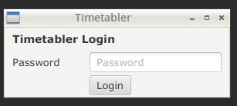

Authenticates password and continues if the password is correct

Enter the password given at installation

The password given at installation

Authenticates password and continues if the password is correct

Navigation

The system can be navigated in two ways: scrolling or the navigation bar. Since the whole program exists within a single window, one can access any part of the system just by scrolling to it. Also, at the top of the window, as shown, there is a navigation bar. This bar contains shortcuts to each section of the window as shown. By clicking on one of the options, the window will automatically scroll to the correct place.

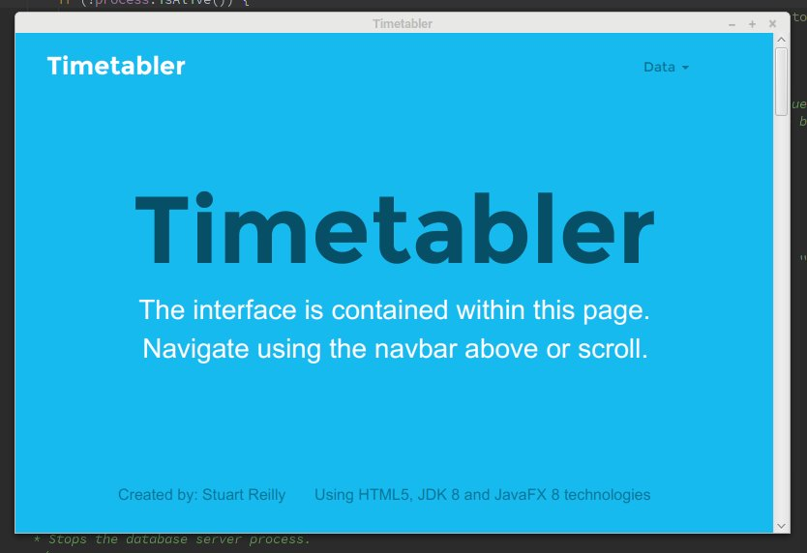

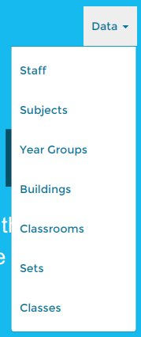

Clicking on dropdown opens this menu

Data Entry

Subject Data

Subject data consists only of the names of subjects. There are two ways to add new subjects: the new subject dialogue, or CSV file import. The new subject dialogue allows for an easy, intuitive method to add a single subject, by providing a simple data entry screen and having a better error report upon entering invalid data.

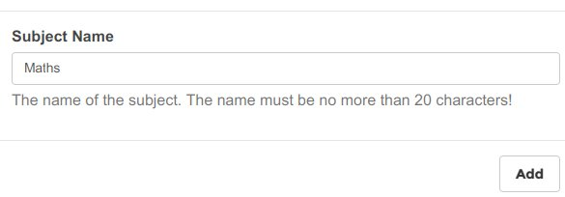This is an example of how to fill out the new subject dialogue. Type the name of the new subject in to the text box, which allows up to 20 characters, then click the ‘Add’ button to add the new subject. If you wish to cancel, click of the dialogue to cancel the addition.

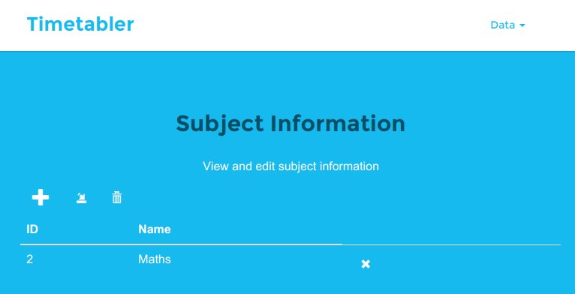

Once the subject is added, the subject table will look similar to this.

The ID column represents the unique ID of the subject, which is used to identify the subject in other tables. Each row will have a ‘X’ button, which removes the subject in the row the button is on. The buttons above the table are in order: ‘add subject’, import from CSV, remove all. The ‘add subject’ button opens the ‘add subject’ dialogue. The import from CSV opens a file chooser window for you to select the CSV file to be imported. The remove all button removes all subjects known to the timetabler. Once a subject has been added, it will become available for the other data which requires a subject.

The CSV file must be in the format, where each line is an individual subject in the form ‘*id*,*name*’ or ‘*name*’. The former being used when you want to specify the id of the subject being added, and the latter for when the timetabler should determine the ID of the subject.

Year Group Data

Year group data consists only of the names of year groups. There are two ways to add new year groups: the new year group dialogue, or CSV file import. The new year group dialogue allows for an easy, intuitive method to add a single year group, by providing a simple data entry screen and having a better error report upon entering invalid data.

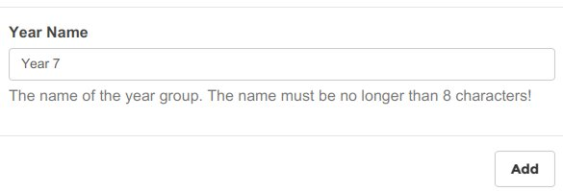This is an example of how to fill out the new year group dialogue. Type the name of the new year group in to the text box, which allows up to 20 characters, then click the ‘Add’ button to add the new year group. If you wish to cancel, click of the dialogue to cancel the addition.

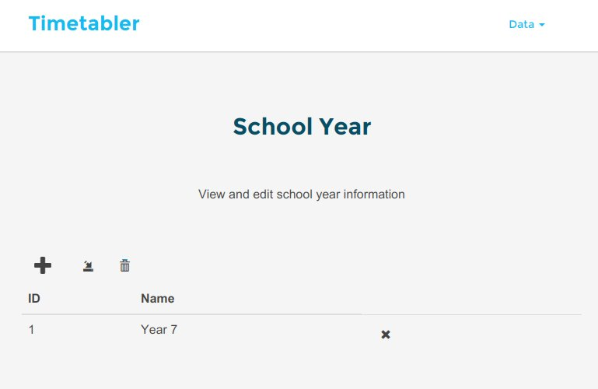

Once the year group is added, the year group table will look similar to this.

The ID column represents the unique ID of the year group, which is used to identify the year group in other tables. Each row will have a ‘X’ button, which removes the year group in the row the button is on. The buttons above the table are in order: ‘add year group’, import from CSV, remove all. The ‘add year group’ button opens the ‘add year group’ dialogue. The import from CSV opens a file chooser window for you to select the CSV file to be imported. The remove all button removes all year groups known to the timetabler. Once a year group has been added, it will become available for the other data which requires a year group.

The CSV file must be in the format, where each line is an individual year group in the form ‘*id*,*name*’ or ‘*name*’. The former being used when you want to specify the id of the year group being added, and the latter for when the timetabler should determine the ID of the year group.

Set Data

Set data consists only of the names of sets. There are two ways to add new sets: the new set dialogue, or CSV file import. The new set dialogue allows for an easy, intuitive method to add a single set, by providing a simple data entry screen and having a better error report upon entering invalid data.

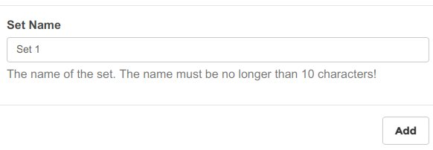This is an example of how to fill out the new set dialogue. Type the name of the new set in to the text box, which allows up to 20 characters, then click the ‘Add’ button to add the new set. If you wish to cancel, click of the dialogue to cancel the addition.

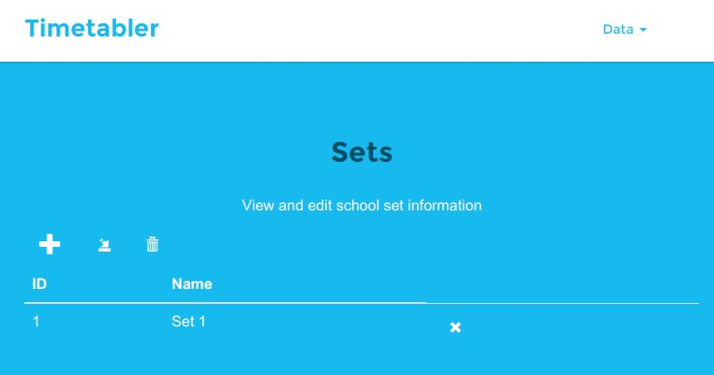

Once the set is added, the set table will look similar to this.

The ID column represents the unique ID of the set, which is used to identify the set in other tables. Each row will have a ‘X’ button, which removes the set in the row the button is on. The buttons above the table are in order: ‘add set’, import from CSV, remove all. The ‘add set’ button opens the ‘add set’ dialogue. The import from CSV opens a file chooser window for you to select the CSV file to be imported. The remove all button removes all sets known to the timetabler. Once a set has been added, it will become available for the other data which requires a set.

The CSV file must be in the format, where each line is an individual set in the form ‘*id*,*name*’ or ‘*name*’. The former being used when you want to specify the id of the set being added, and the latter for when the timetabler should determine the ID of the set.

Staff Data

Staff data consists of the name of the staff member, the subject they teach and the maximum number of hours the member of staff can teach in one week. There are two ways to add a new member of staff into the timetabler: ‘Add Staff’ dialogue, CSV file import. The ‘Add Staff’ dialogue allows for an easy, intuitive method to add a single member of staff, by providing a simple data entry screen and having a better error report upon entering invalid data. Since staff data relies on subject data, in order to add a new staff member, you must add their subject into the timetabler before they can be added.

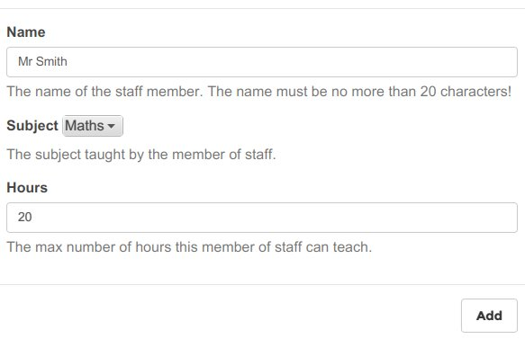This is an example of how to fill out the ‘Add Staff’ dialogue. By clicking the ‘Add’ button, a new member of staff will be added with the information given in the dialogue. The name must be less than 20 characters, so the text box will not let you type any more than 20 characters. The subject the member of staff teaches is selected from the drop down menu, which contains the subjects already added to the timetabler. The maximum number of hours can be any size, but if it exceeds the number of hours in a week, the timetabler will timetable them to teach in every available period. If you wish to cancel adding the member of staff, click off the dialogue.

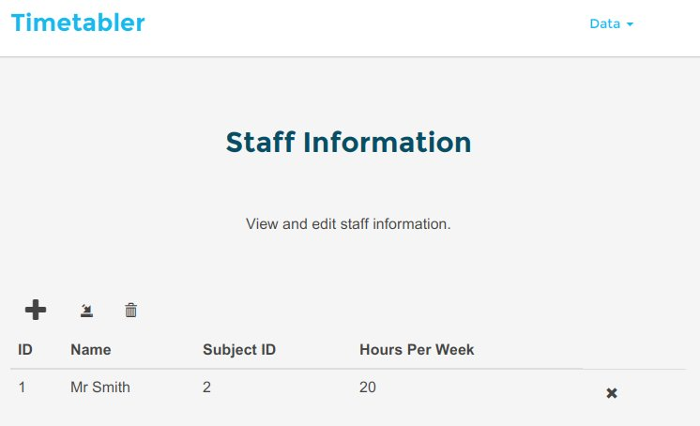

Once the member of staff is added, the staff table should look similar to this. The ID column is the unique ID of the member of staff, which is used to identify the staff member in other tables. The subject ID column is the ID of the subject taught by the member of staff. Each row will have a ‘X’ button, which removes the member of staff in the row the button is on. The buttons above the table are in order: ‘Add staff’, import from CSV, remove all. The ‘Add staff’ button opens the ‘Add staff’ dialogue. The import from CSV opens a file chooser window for you to select the CSV file to be imported. The remove all button removes all members of staff known to the timetabler. Once a member of staff has been added, it will become available for the other data which requires a set.

The CSV file must be in the format, where each line is an individual set in the form ‘*id*,*name,subjectId*,*hours*’ or ‘*name,subjectId,hours*’. The former being used when you want to specify the id of the member of staff being added, and the latter for when the timetabler should determine the ID of the member of staff.

Class Data

Class data consists of a set to be taught, a year group to be taught and a subject to be taught. There are two ways to add a new class into the timetabler: ‘Add Class’ dialogue, CSV file import. The ‘Add Class’ dialogue allows for an easy, intuitive method to add a single class, by providing a simple data entry screen and having a better error report upon entering invalid data. Since class data relies on set, year group and subject data, you must add the required sets, year groups and subjects before the classes can be added.

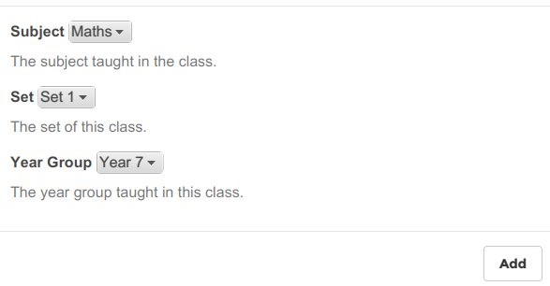This is an example of how to fill out the ‘Add Class’ dialogue. By clicking the ‘Add’ button, a class with the given data will be added to the timetabler. Each drop down menu is filled with the data from their corresponding tables. For example, the Subject drop down is filled with the subjects in the subject table. If any of the drop downs are empty, their table is also empty and needs filling before classes can be added.

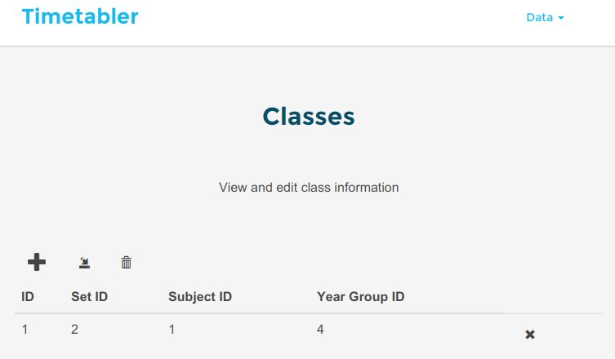Once the class is added, the class table should look similar to this. The set ID is the ID of the set taught in this class. The subject ID is the ID of the subject taught in this class. The year group ID is the ID of the year group taught in this class. Each row will have a ‘X’ button, which removes the class in the row the button is on. The buttons above the table are in order: ‘Add Class’, import from CSV, remove all. The ‘Add Class’ button opens the ‘Add Class’ dialogue. The import from CSV opens a file chooser window for you to select the CSV file to be imported. The remove all button removes all classes known to the timetabler. Once a member of staff has been added, it will become available for the other data which requires a set.

The CSV file must be in the format, where each line is an individual set in the form ‘*id,subjectId,setId*,*yearId*’ or ‘*subjectId,setId,yearId*’. The former being used when you want to specify the id of the class being added, and the latter for when the timetabler should determine the ID of the class. If any IDs given do not reference any entries in their respective data tables, the timetabler will ignore it, but tell you which lines were ignored.

Building and Classroom Data

Building and classroom data is loaded from a collection of map files. By clicking the import button on either the building or classroom section, you will be asked to first specify the file which is the highest level map. Then you will be asked to specify the folder containing the other map files, which can contain the top map file. In each map file, there are the following possible cells:

|  |  |
| --- | --- |
| **Cell Type** | **Content of cell** |
| Path | 0 |
| Building | Name of building’s map file without .csv |
| Classroom | C-*Name*-*Subject Name* |
| Wall | Empty |

All the classrooms which can teach a single subject, must all be located in the same map file.

Once the maps are selected, a pop up window will open to keep you informed about what the timetabler is boing, and inform you of errors. Once the maps are fully loaded, the tables should look something like this:

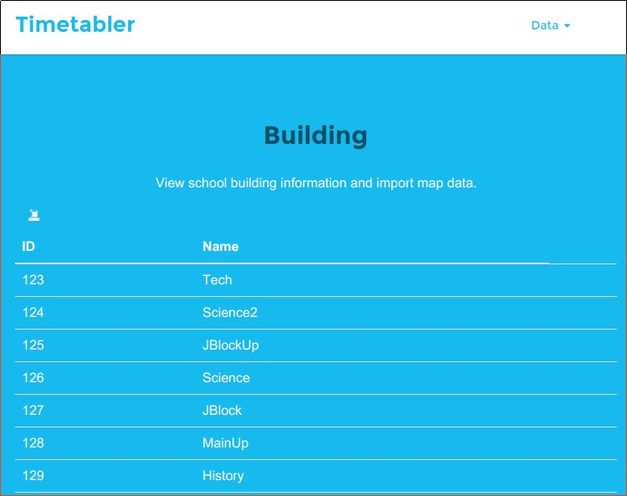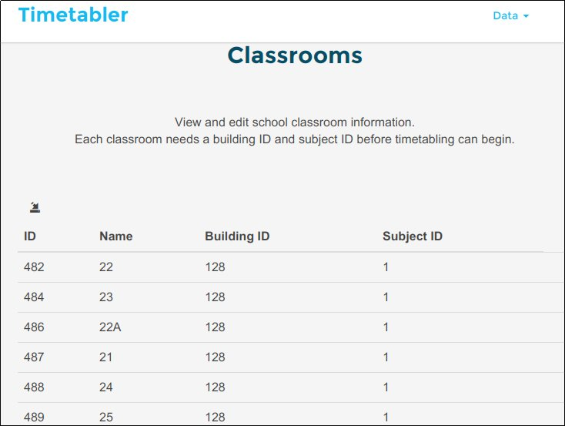

The ID on both tables is the unique ID for the individual building or classroom, which is used to refer to the building or classroom in other tables. These IDs may have gaps or be large, this is normal as the timetabler is just ensuring IDs are kept unique. The building ID column in the classroom table is the ID of the building the classroom is in. The subject ID column in the classrooms table is the ID of the subject taught in the classroom.

Lesson Data

Lesson data consists of a period for the lesson to occur in, a class to be taught in the lesson, a member of staff to teach the lesson and a classroom for the lesson to be taught in. When adding lesson data, the member of staff and classroom is not required as the timetabler will generate that data when timetabling lessons. To add a new lesson, click the ‘+’ button to open the ‘Add Lesson’ dialogue.

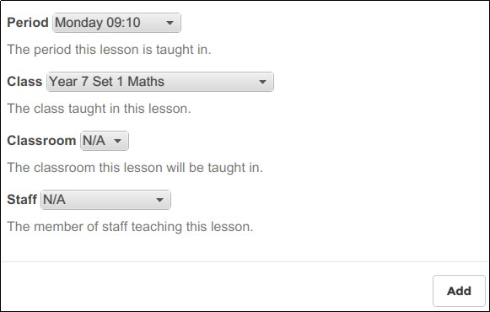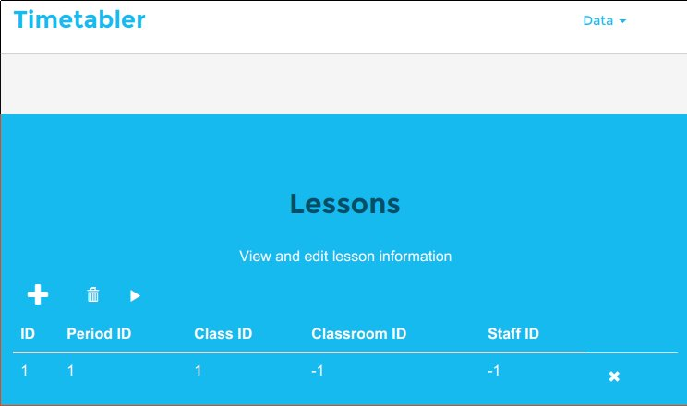This is an example of how to fill out the ‘Add Lesson’ dialogue. Currently, periods cannot be changed, added or removed from the timetabler. The class, classroom and staff dropdown are filled with the entries from their respective tables. If they are empty, fill the tables before continuing to add classes. If you select ‘N/A’ for classroom or staff, the timetabler will treat the new lesson as one which needs to be timetabled.

Once the lesson is added, the table will look similar to this. The ID column is the unique ID of the lesson. The period ID is the unique ID of the period the lesson is taught in. The class ID column is the ID of the class taught in the lesson. The classroom ID column is the ID of the classroom in which the lesson is taught in, which is -1 if there is no classroom currently. The staff ID column is the ID of the member of staff who teaches the lesson, which is -1 if there is no member of staff currently. Each row has a ‘X’ button which removes the lesson in the row the button is on. Across the top of the table are the following buttons: the ‘Add Lesson’ button, which opens the ‘Add Lesson’ dialogue; the remove all button, which removes all the lessons currently known to the timetabler; the timetable button, which starts the timetabling process. Clicking the timetable button starts the timetabler’s timetable process which maps the lessons to classrooms and members of staff, while finding the most optimal combination to reduce the distance travelled by members of staff.

Errors

Generally, the timetabler will only have an error if it given invalid data, missing data (map loader not having subjects) or something really bad happened.

DataConnectionException

This only occurs if the timetabler cannot connect to its data store, which should happen rarely. But, if it does, the timetabler will close itself once you close the window, then just reopen the timetabler. If the same error happens, contact your system administrator and give them the contents of the log folder located at *installFolder*/log.

DataUpdateException or DataAccessException

This occurs if the timetabler is unable to either access or update the data. Each time they occur, they have a different reason, but read the info given in the error window. If it seems useful, act on, for example, a DataUpdateException can occur if the file being imported contain invalid data. Otherwise, try again, and if it keeps occuring, contact your system administrator and give them the contents of the log folder located at *installFolder*/log.

IOException

This occurs if the timetabler cannot work with a file, such as, it cannot read the configuration file, or cannot read the file it has been tasked to import. The error window will contain useful information for this type of information, such as, this user need read permissions. If it occurs when you try to import files, generally the system administrator does not need contacting as the error is to do with the file you chose. Otherwise, if it about a more important file such as the configuration file, contact your system administrator and given them the contents of the log folder located at *installFolder*/log.