Algoid – learning programming made simple and funny !

Two years ago, my 10 years old son asked me: « Daddy, what is your job ? ». Then I replied that I make computer programs and give to computer some working tasks. I don't have to wait long the second question: « Ok ! but how do you tell to computer that it has to do ? How a program works ? ».
Then I decied to write Algoid to teach him what computer programming is and how to do this.
First, Algoid was designed to run on Android platform but recently I discovered the Raspberry PI ; this low cost credit card computed was exactly designed for education.

What is AlgoIDE ? So AlgoIDE is a developpment environnment, with its IDE and its own language (AL) designed together to simplify the understanding of programming !

Principle
The language AL was developped with three ideas in mind :
First – It's apprenticeship should be as progressive and memorizable as possible.
For this proof, try to explain a kid how the « for » loop is running ? You should encounter some difficulties like having to explain before what a variable, a condition, a boolean expression, an incrementation... are. all of that to explain a simple loop !
Further, its syntax was designed to be as easy to memorize as possible. All it's structure statements are written the same way (variables, function, array, object ...)
Second – It's syntax should be as close as possible to the industrials standards.
Because learning a language represents a large amount of time and a lot of educational languages have a too great gap with the « real » languages. The day the kid wants to go for Java, Python or C++ (why not) he have to learn again another syntax and another programming reflexes.
Third – It semantic should not be limited to one or two paradigms.
When I was young, I was very frustrated by the Basic language. After having understood how imperative statements works and procedures, I was limited to them. If I wanted to go further, I had to learn another language, another syntax and waste a lot of time.

All things considered, AlgoIDE tries to simplify the programming and its understanding.
My first Idea was to create a step by step execution mode. With two clicks, the execution slows down and highlight appears in the source code on the line executed.
It becomes possible to control the execution flow with debugging mode. We will see further how it works.
AlgoIDE has the ability to view the used variables on its scope viewer and has its own logger.

Algoid quick tour.
AlgoIDE is available on the Pi Store at the following address: http://store.raspberrypi.com/projects/algoid
Note : It is also available on the play store for Android : https://play.google.com/store/apps/details?id=fr.cyann.algoid
And all platforms wich run Java (tm) : http://download.algoid.net

Install it on your Pi and launch it. Click on the play button and the demo script will run.

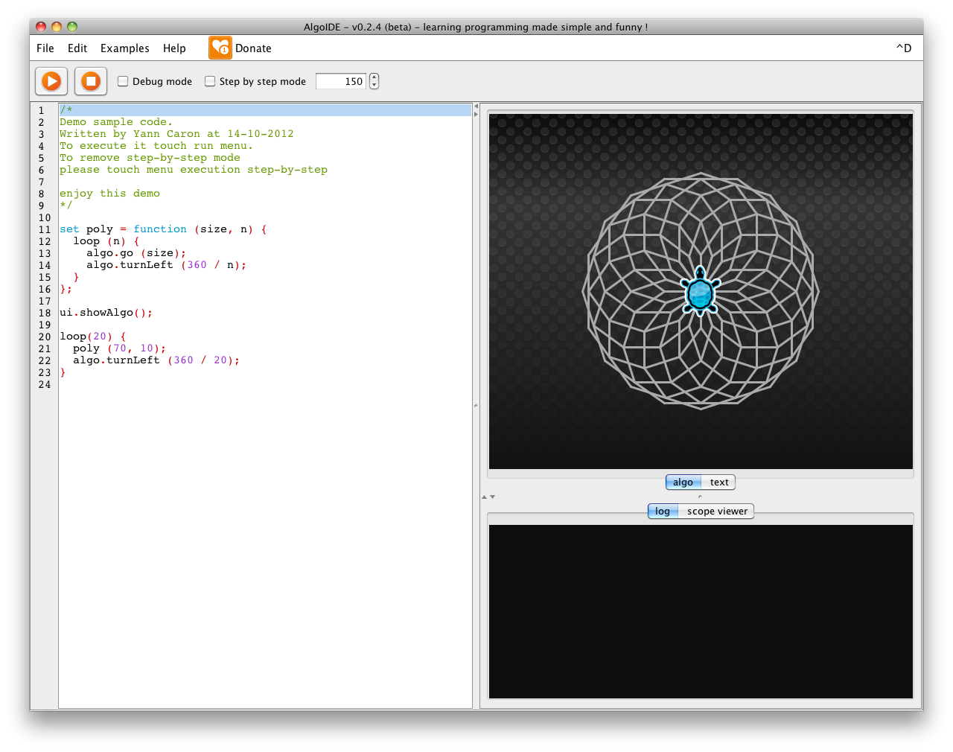
Program show a function named poly and a loop that draws a rose window.
Note that the function declaration is really special :

set poly = function (size, n) {
}

In AL, everything is an expression and then are declared like that.

set size = 7 ;
set o = object () {
} ;

Then, check the step by step box and run again.
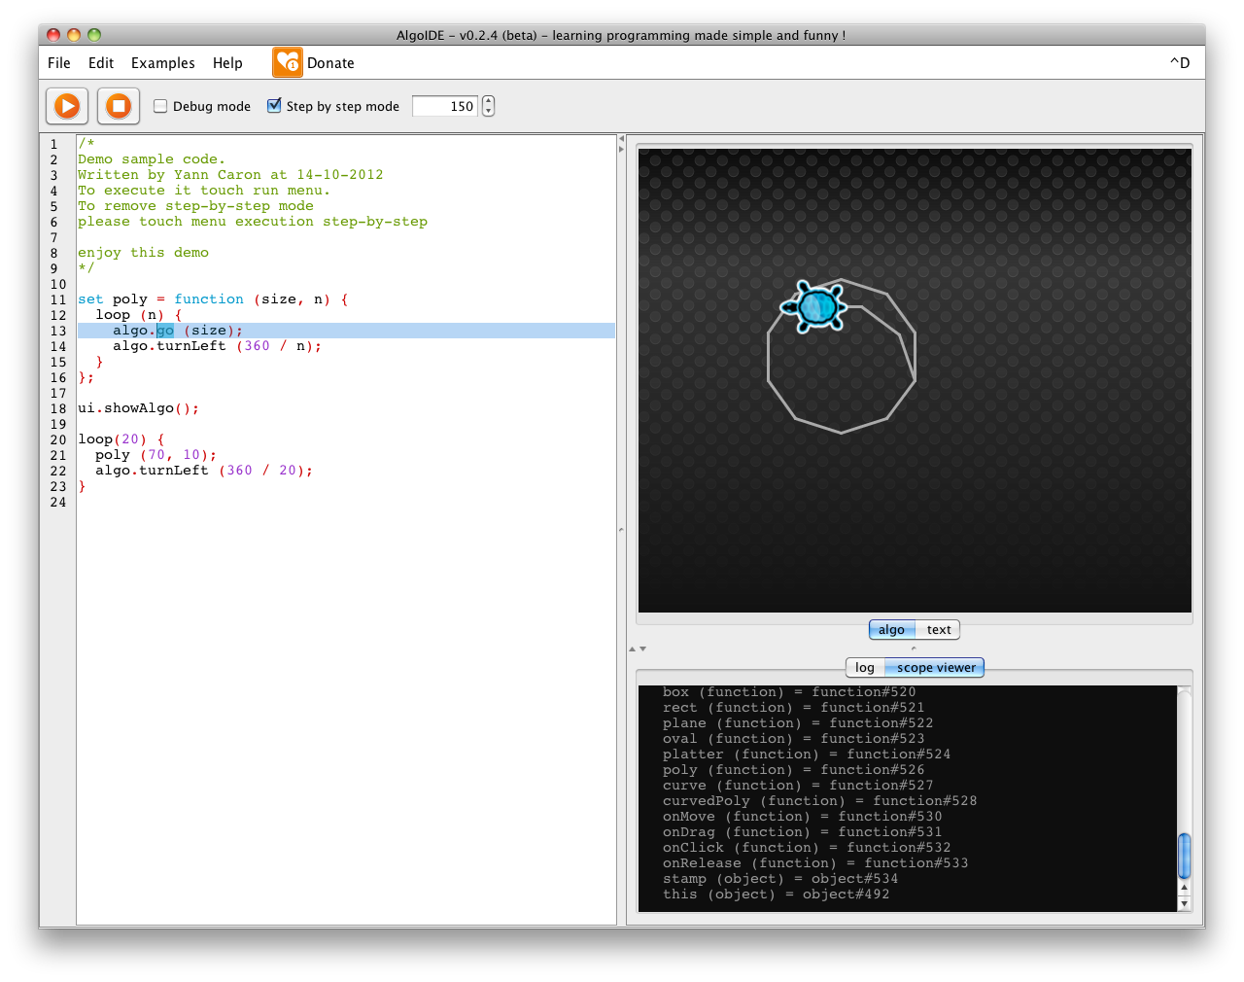

Then it become possible to understand where the programm is at the moment it do something.
The field number at the right of the check box gives the ability to tweak the step by step mode speed.

Now, uncheck step by step mode, check the debug mode and by clicking the source code margin, add a new breakpoint.
Run the program.
Some new buttons appears. In order, run to the next breakpoint, run to the next line and run to the next token.
The Algoid debugger considers each token like object path and expression calculation. Perfect to understand the precedence order for example.

Play with the three new buttons.
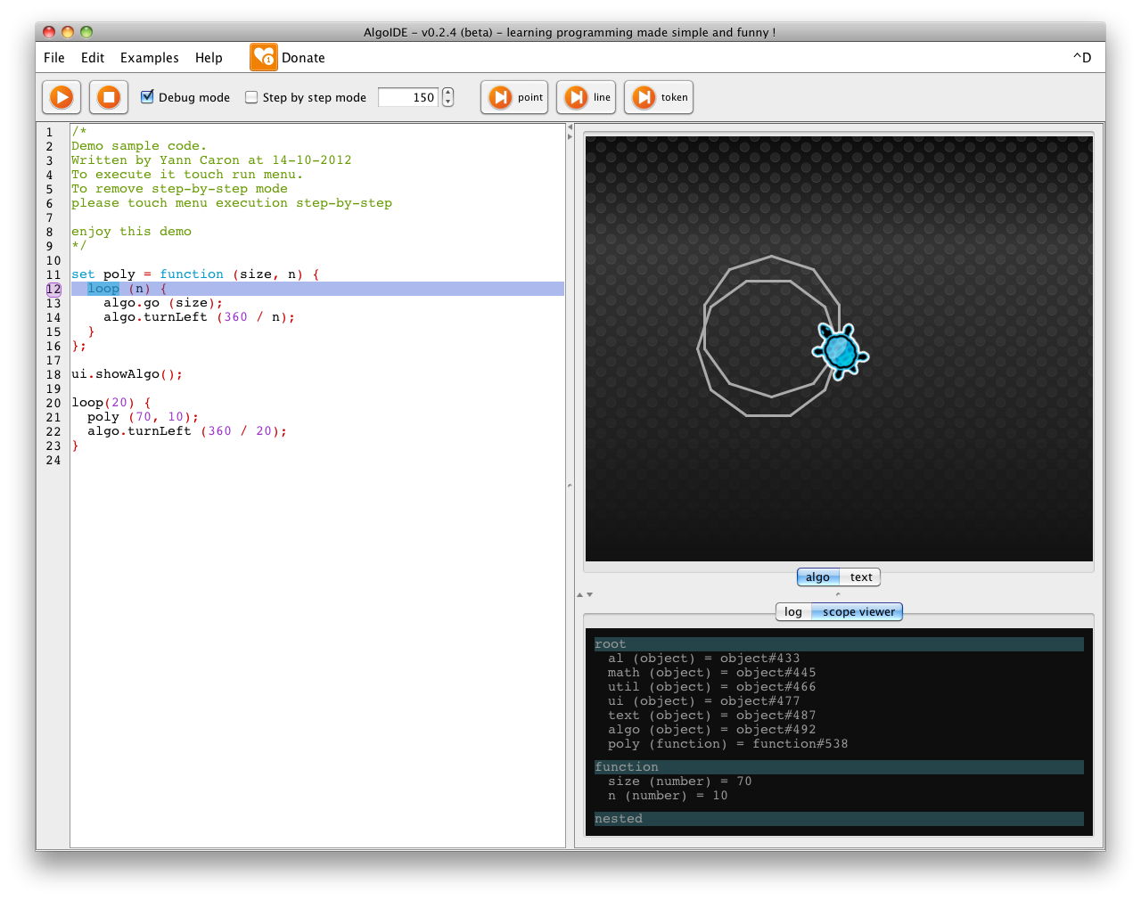
You can observe the Scope viewer window that indicate the current variables and their values.
In this case, values does not changes, but each time a variable value has changed, the window show it.

For example debug the koch fractal program (menu examples / fractal / koch fractal.al) and observe scope viewer on each iteration.
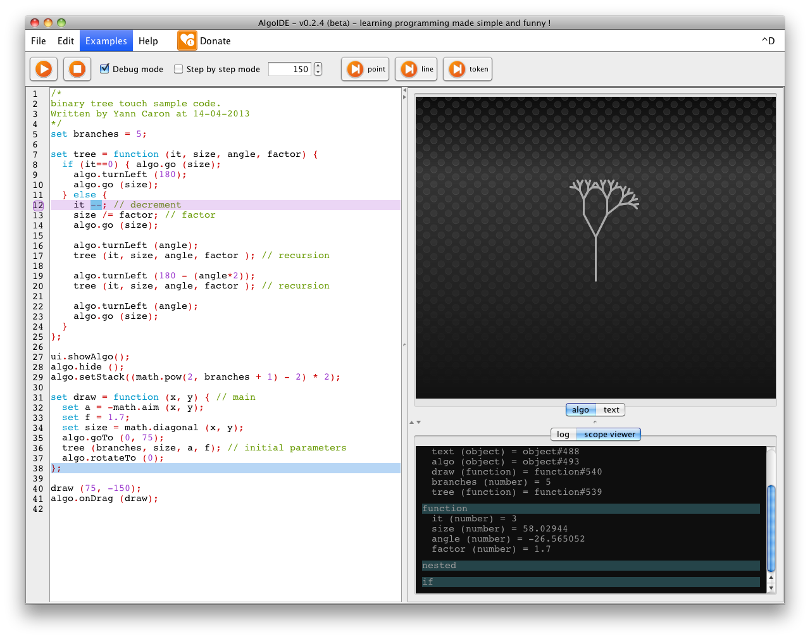

Documentation
To learn a language and how to program, the most important thing is documentation and experience sharing.
The www.algoid.net web site contains a complete language reference section and a tutorial list continously updated.
Tutorials contains a lots of examples and progressives exercices to understand each language statements and function.

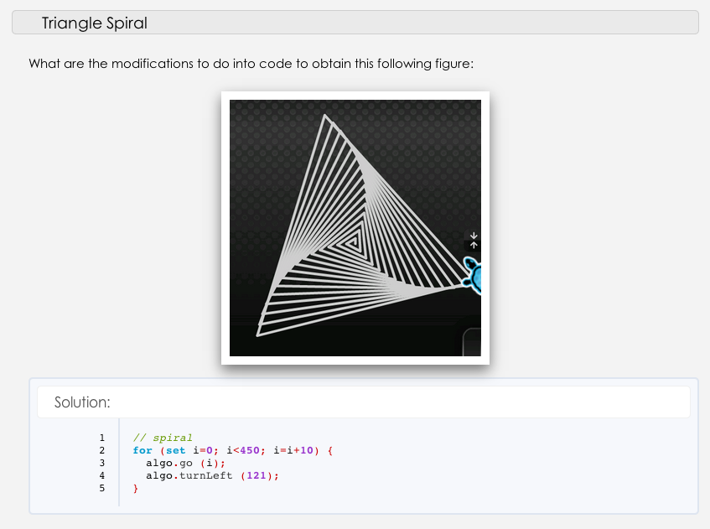
Algoid is also a community federated by the forum : http://forum.algoid.net
It contains a lots of discussion, problem solutions and mini-tutorials.
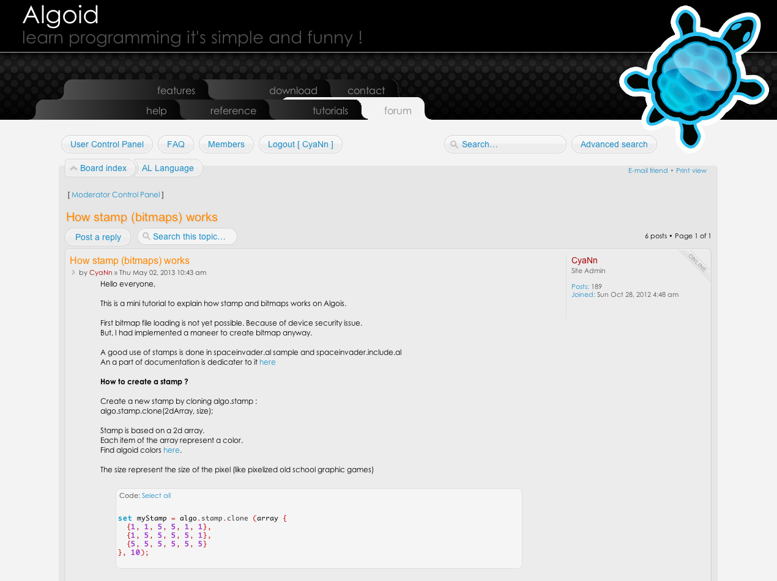
Another way to learn programming with another peoples !
Actually some members have create a team to develop the snack game on Algoid. When programs are interesting, they are compiled into the next application release and then, profit to anothers.
Everything in Algoid environment is based on the source code and knowledge sharing.

Teaching
Algoid is also designed for teacher.
Obviously, as Algoid is a free tool, every help is greatly appreciated for tutorial writing, documentation corrections etc...

Algoid, gives also the ability to teachers to write their own apprenticeship plugins. A tutorial and an article about how to do that are currently written.
To write a plugin in Algoid it is very simple. Teacher needs to have some basic java and swing developpment knowledge.
Plugin developpment is divided in two steps :
- developp the library with objects and functions needed for the course.
- if necessary, developp a new java panel (view) and binding it with library.
A complete range of tools are available to interact with AL language, existing library, adding some method to existing types, creating events and behaviours etc.

The tutorial will provide a complete netbeans project starter and documentation.
This is an example of the library developpment :
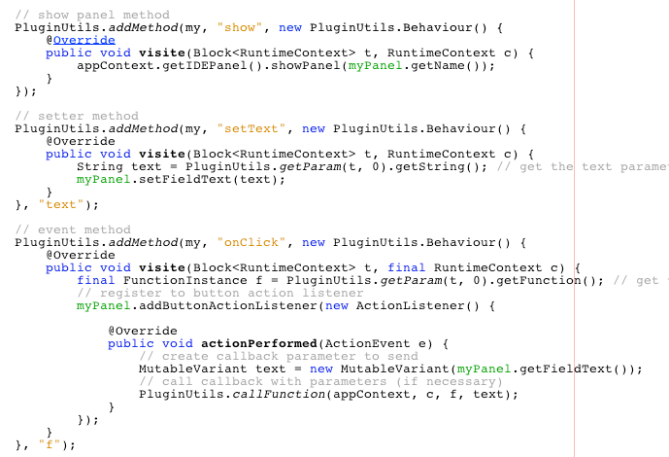

And the example panel.
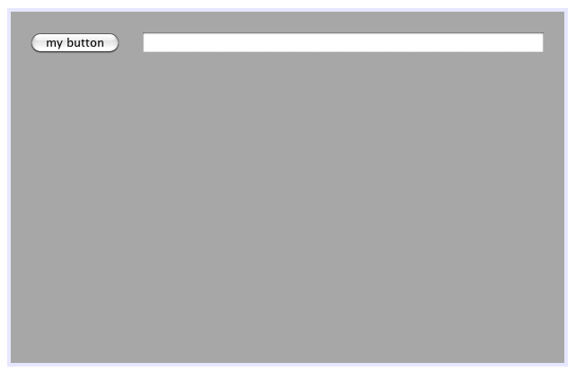
Then just copy the plugin.jar file in the Algoid/plugin folder and that's it.

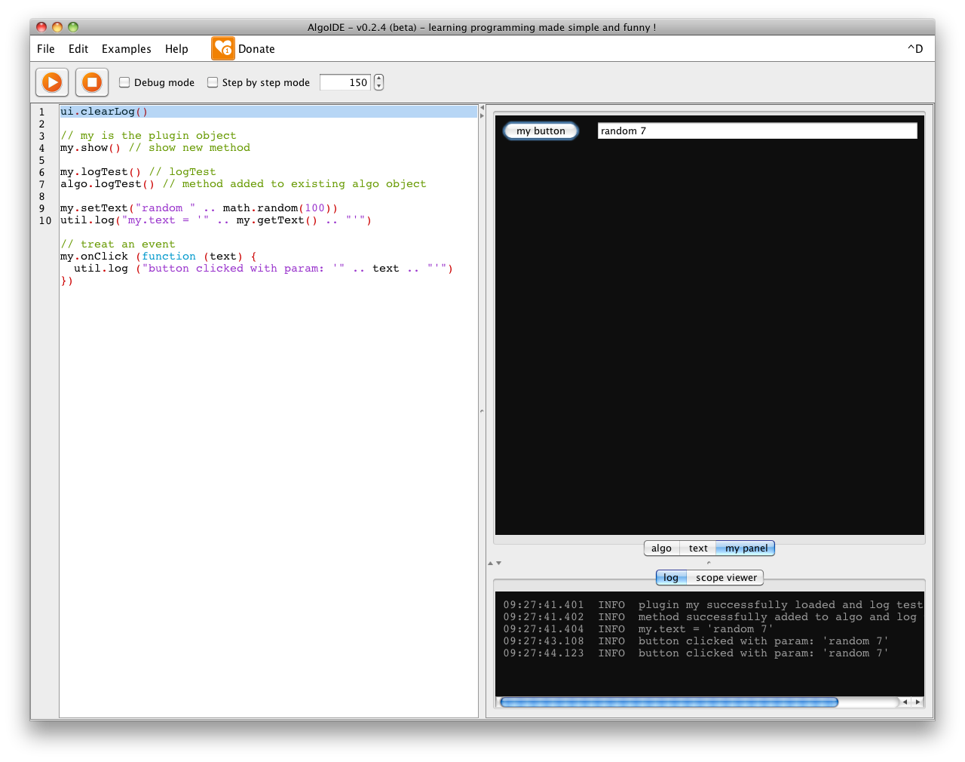
Simple, isn't it ?
With this feature, a lots of improvements can be added to Algoid, like GPIO communications, Mindstorm (tm) commands, true 2d game engine (planned of future developpment), mathematical function experimentation etc. etc.
Everything you want to teach or command with this powerfull scripting language !

Video game developpment
One principle of Algoid is to be funny. Because when it is funny, learning become a pleasure.
And what is more pleasant than creating your own game. That's why simplified approch of game developpement is available when turtle is hidded.
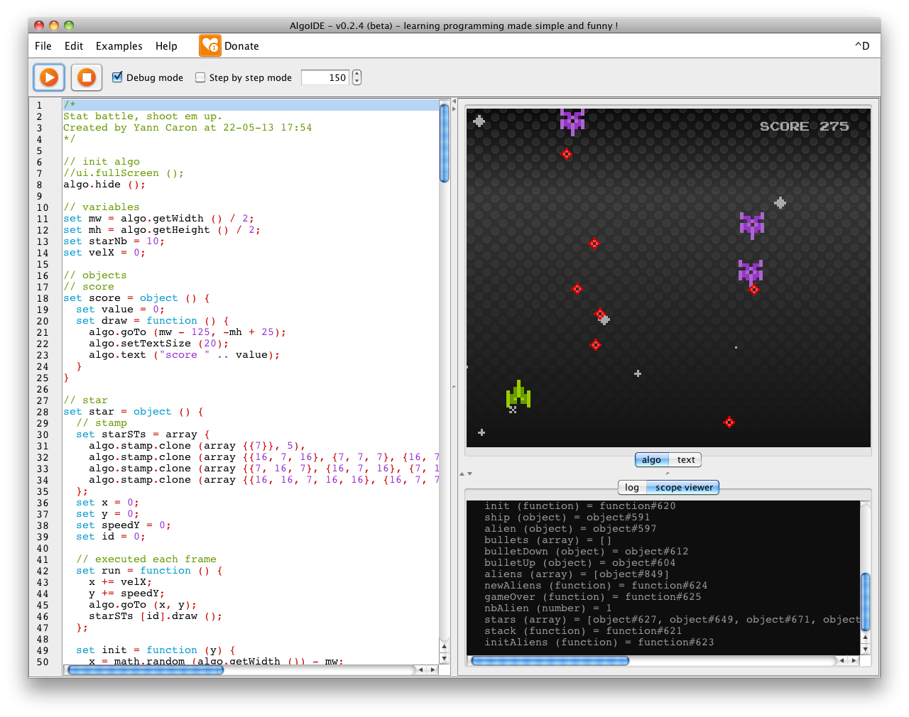
The game above contains only 300 lines of source code and these lines contains the ships drawing. Logic of the game and object architecture could be done in 200 lines only !

Tutorials
To illustrate the simplicity of Algoid developpment, let's follow this little tutorial.
We will see how to create the ship animation, then we will look through some AL features, like typing, stamps and events.
First, we will hide the turtle, create the ship and draw it.

algo.hide() ;

// ship
set ship = object () {

// define its position
set x = 0 ;
set y = 150 ;

// draw the ship
set stamp = algo.stamp.clone (
array {
{-1, -1, -1, 10, -1, -1, -1},
{-1, -1, -1, 10, -1, -1, -1},
{-1, -1, 02, 10, 02, -1, -1},
{10, -1, 02, 10, 02, -1, 10},
{10, 02, 02, 10, 02, 02, 10},
{10, 02, 10, -1, 10, 02, 10},
{10, 02, 02, -1, 02, 02, 10},
{10, -1, -1, -1, -1, -1, 10},
}, 7
);

// draw it
set draw = function () {
algo.goTo (x, y);
stamp.draw ();
} ;
};

First, note how objects are defined :
set ship = object () {} ;
Yes ! In AL everything is an expression. An object is exactly defined like a number or a string.
It become extremely simple to remind how an object / function / array are declared.... like every others expressions :

set [name] = [something] ;

In the case of object, parenthesis are used for inheritance and {} are used for members.
After all, objects have some composite states. Then, to define members, all you need is to define another expressions into the object like this :

set o = object () {
set attribute = 7 ;
set method = function () {
// do something
} ;

set nested = object () {
set method = function () {
} ;
} :
};

Note : The semi-colon are optionals.
We can appreciate how it is simple in AL to declare something.... And even nested objects !

Note : In AL, objects are directly created with their instance. An object can be used imediatelly after creation. If some more object of this class are needed, it is possible to clone the initial object.

Now, we will observe how a stamp is created.
It works by clonning (creating a new instance of an existing object) of the algo.stamp object.

It begins like any other thing by a « set »

set stamp = algo.stamp.clone () ;

Stamp is consituted by two data : the 2d array of colors and the size of a pixel.
In AL, array are declared by array keyword.

set a = array {1, 2, 3, 4} ;

The nested array does not need a keyword anymore.

set a = array {1, {2, {3, 4}}, 5, {6, 7}}

This example represents a tree.

It demonstrates how data structures are simple to be defined in AL.

Note : AL is functionnal and use the power of map / filter / reduce like Python (named in AL : each and filter)

Obviously, numbers can be replaced by function or why not objects, and array of functions etc. etc...
Imagine the capabilities of this kind of flexibility.

Now we observe the draw method.
It is constituted by only two calls :
- algo.goTo that five current position (if turtle was shown, she takes the given coordonates)
- stamp.draw() ;

That draws the stamp at the current position.

If we draw the stamp another time in another position, Algoid will draw the ship another time and then two stamps will appears in the screen.
To create an animation, we will limitate the number of simultaneous stamp in the screen.

algo.setStack (1) ; // only one stamp in the graphic stack

Then, now we will animate our object with an event:

util.pulse (function () {
ship.draw();
}, 40);

AL is also a complete functional language. Function can be passed as parameter and returned as result (First class function). Events are based on callback mechanism. Function are passed in parameter and are called when necessary. Here, every 40 milli seconds

Until now, nothing moves. To show any animation, let us modify the position each time like this :

util.pulse (function () {
ship.y--; // modify position each animation frame
ship.draw();
}, 40);

Now we will add the ability to move the ship according to the mouse position with the event algo.onMove().

algo.onMove (function (x, y) {
ship.x = x;
});

Note : the mouse coordinates are given in the x and y parameters of the callback function. Then it is possible de connect the ship x coordinate to the x mouse one.

That's it ! Now you are able to move a stamp in Algoid. The gap to create a complete game is not so great now. Observe the source code in example in the application. The steps are all the same :

- Define objects, their coordonates, their graphic stamp (s), their draw method etc.
- Hide the turtle
- Determin how many stamp are simultaneously drawn
- Create frame drawing with util.pulse
- Create behaviours with algo's events like onMove, onClick (or onTouch, onGravity and others sensors on android)

Conclusion
Algoid is a great tool to learn and to teach how to program.
It is a free software and aims to remain free. If you like it and want to contribute, you can help me to grow it resources, write some review or talk about it around you.
If you definitivelly love it, you can make a few donation. Everything is greatly appreciated and a simple word can motivate me in this huge amount of work (Algoid is the result of two years of developpement and it is just the beginning).

For further questions / suggestions / ideas, you can contact me at mailto://cyann74@gmail.com
Or why not in the http://forum.algoid.net

See you soon, and I hope you will be many to love Algoid ;-)

