Wyliodrin – Program Raspberry PI from the browser using a visual language or your favorite programming language

**Imagine making your own radio or creating disco lights using a Raspberry Pi, which you control from browser. Wyliodrin gives you this possibility. The user can write, modify and run programs in real time, no matter where the board is located.**

We all faced the hustle and bustle of building our first Raspberry Pi based devices: installing the software and repeatedly plug and unplug the board from the device until it finally does what is is supposed to. There is always the SSH connection option, but what if we don’t have the required permissions?

With Wyliodrin, you can install the Raspberry Pi directly on the remote controlled car you want to build and program it from your favourite browser. This way, programming becomes accessible, regardless of the board’s location, without the need to connect directly to it. The code is stored on the Cloud, so the user is no more dependent to a certain computer.

**Existing problems and Wyliodrin’s solution**

Wyliodrin enables the usage of embedded systems in education. For the beginners, the board’s setup and the limited number of programming languages available can be decisive factors in giving in.

Firstly, Wyliodrin allows the user to control the boards in real time.The only requirements are a computer, a browser and an Internet connection. The user does not have to install any software and he can even use a public computer.

Wyliodrin provides several programming languages, which make programming easier. The user can choose from multiple programing languages, such as Python, Javascript, Pascal, C, or even visual programming. This way, it is enough for one to have basic programming knowledge and he can use these kind of boards.

**How to use Wyliodrin**

Wyliodrin is currently available for the Raspberry Pi and the Intel Galileo. It will soon support Parallella and UDOO, boards still to enter the market. The programming is made by using the IDE on the official website www.wyliodrin.com, accessible from anywhere, on any device, independently of the location of the board. Moreover, all user’s data is stored on the Cloud.

The only setup needed is to download our SD Card image, and add a specific file to the SD Card. Press “Add new board” and follow the steps.

Let’s say we want to create our first project using Wyliodrin. We will make a LED blink.

Firstly we will access Wyliodrin's website, [www.wyliodrin.com](http://www.wyliodrin.com) (picture 1), where we can log in using one of our Facebook, GitHub or Gmail accounts. Now, we are on the projects’ page (picture 2), where we can create a project and add the board we want to develop on. Before doing that, we can make a virtual tour or we can study the tutorials from projects.wyliodrin.com/wiki.

For the electronics setup, we need the following objects:

* 1 breadboard
* 1 LED
* 1 resistor (220 Ohm)
* 2 jumper wires
* 1 development board
* the Raspberry Pi model B.

We have to wire the components, keeping in mind that each pin on the board acts like a software programmed power source. On Wyliodrin's tutorial about Raspberry Pi's pins we can see how to connect the components to the Raspberry Pi.The device needs to be connected to the internet using a wire or WIFI.

The next step is to implement the project, so we go back to the projects’ page. We select “Create new project” and we give it a name, a description and we choose a programming language: Visual Programming, Shell Script, C, C++, C#, Java, Javascript, Objective-C, Pascal, Perl, PHP or Python. We can add a Raspberry Pi board by selecting “Add new board”.

The “Main” file was implicitly created together with the project. There, we can write the code in the chosen programming language and then we will run it on the board. In photo 3 we have the code for making a led blink using C++. By choosing C++ -> LED Blink C++ when creating a new project, we can have and use the code provided by Wyliodrin. We only have to “Run” the program and to select the board in order to make LED blink. All this time, the board had no connection to the computer we wrote the program on.

For the beginners, who don’t master a programming language, they can add blocks by drag-and-drop and Wyliodrin will write the code for them. Visual Programming used by Wyliodrin is based on Google Blockly, a language like Scratch, but for electronics. Wyliodrin implemented pins, leds and buttons blocks, to let users run several applications.

To make a LED blink using the Raspberry Pi and the visual programming blocks Wyliodrin implemented, we used the blocks in picture 4. There can be seen the resulting code, which is in Python (picture 5).

**Future perspectives**

We work on implementing graphics, which will allow the users to monitor their boards in real-time. We also plan on introducing more blocks for the visual programming language.

We would like to ask you to provides feedback, that is very important for us. Of you would like new features or think that we should differently, please don’t hesitate.

You can read more about the project by accessing the website www.wyliodrin.com, on Facebook and Google Plus pages Wyliodrin and on the Twitter account @wyliodrin.

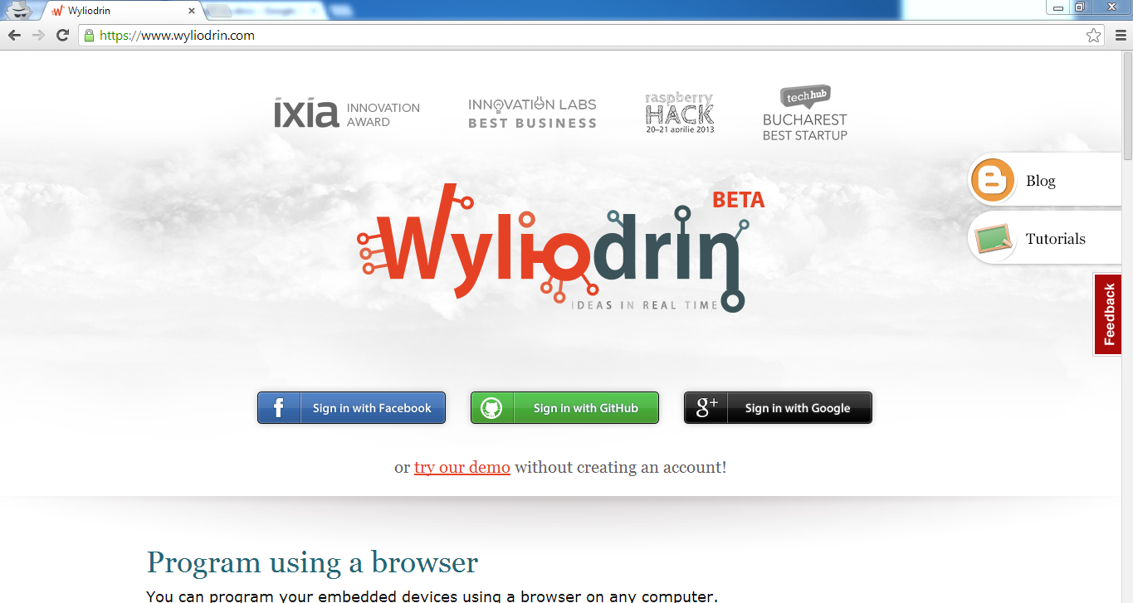

picture 1

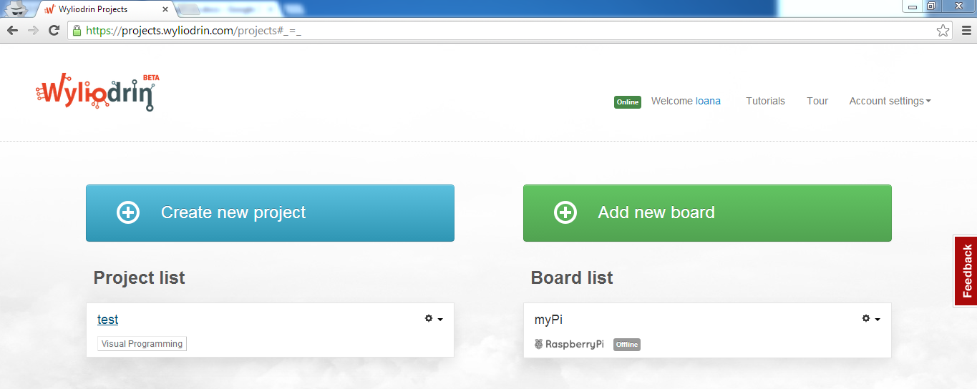

picture 2

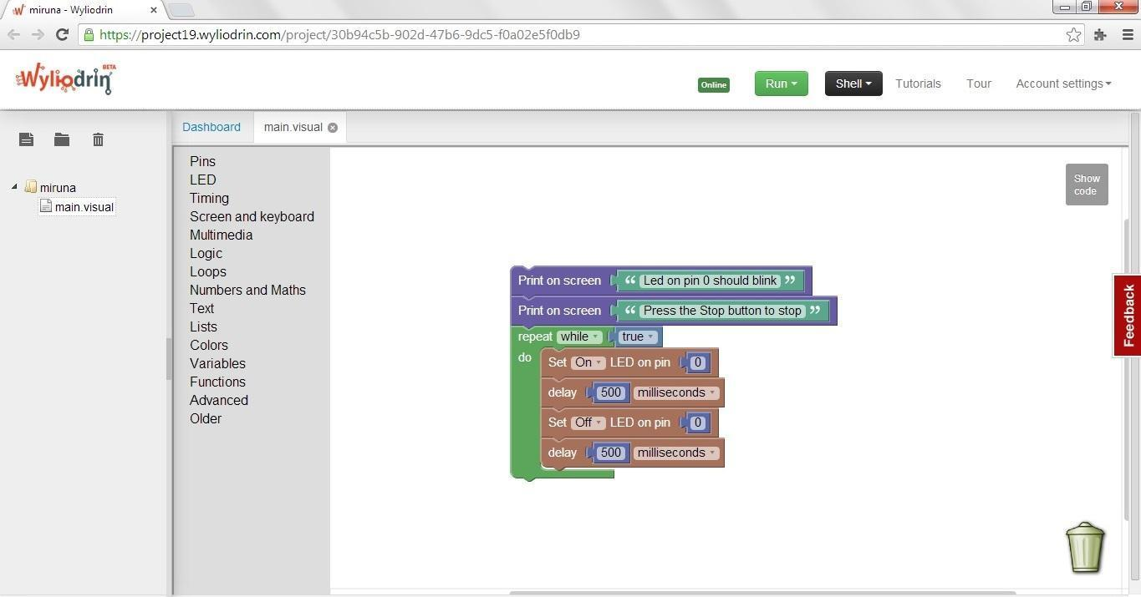

picture 4

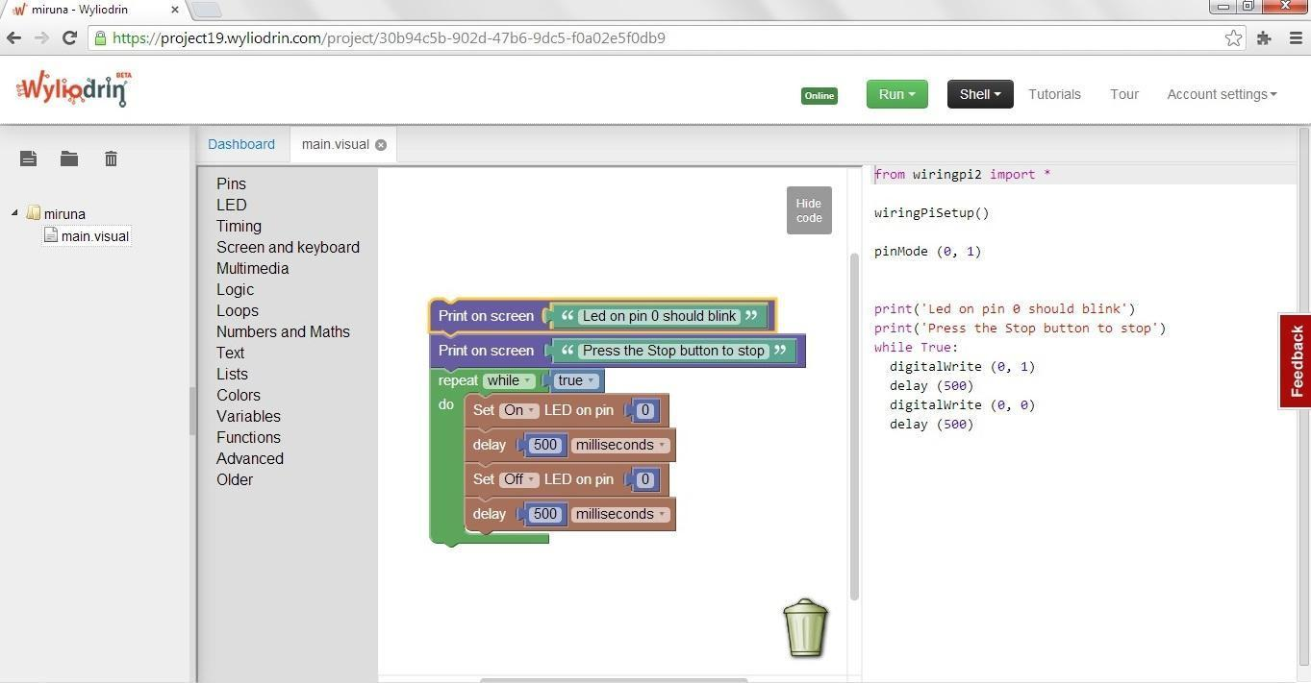

picture 5

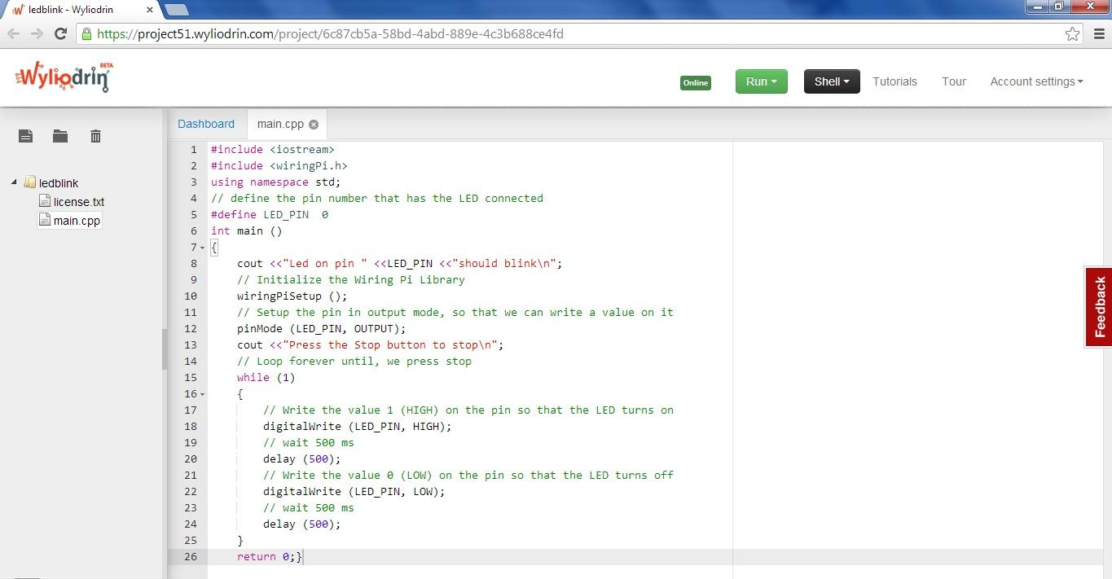

photo 3