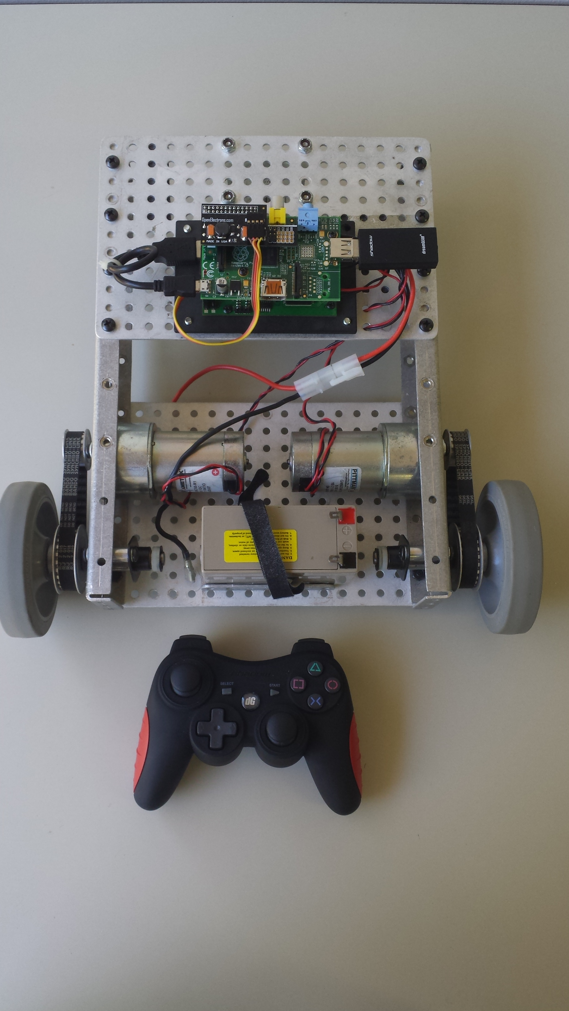
Picture of the finished robot
Coding a remote-controlled robot
The Raspberry Pi is amazing in the sense that it can be used to create programs for almost any purpose. I've seen people create media centers, cloud storage devices, weather stations, video game emulators and various other implementations of this little computer. However, I wanted to start off with something that didn't require lots of software maintenance and decided upon creating a remote-controlled robot. The hardware specifics of this robot will vary from user to user, therefore I want to focus more on the coding aspect of getting the robot to move. To run the motors, I used the PiDrive, which is a motor driver that allows you to control up to two high current motors with the use of a Raspberry Pi. When starting this program, it is important to import the following modules:
import pygame
import sys, os
from PiDrive import PiDrive
The pygame module is necessary to be able to create a joystick object, the sys module is necessary to be able to quit the program when prompted, and the os module is necessary to read the string environment.
The code for creating the joystick object is as follows:
try:
j = pygame.joystick.Joystick(0)
j.init()
print 'Enabled joystick: ' + j.get_name()
except pygame.error:
print 'no joystick found.'

A try-except block is recommended because it is important to be able to catch the exception of a pygame.error for debugging purposes.

When creating the code to actually move the robot, it is helpful to create a function for that purpose. The function is as follows:
def move(motor, speed):
direction = 1
if(speed <0):
direction = 0
speed = speed * -1
if speed > 100:
speed = 100
PiDrive.PiDrive_Run_Unlimited(motor, direction, speed)

When the direction is 0, the motor will run backwards, and when the direction is 1, the motor will run forwards. It was important to scale the speed to be no greater than 100 as the PiDrive ranges from 0-100. This function can now be called whenever prompted.

When starting on the main loop of the program, it is important to note that scaling for the axises is necessary. The get_axis function from pygame ranges -1 to 1 with 0 being centered, thus it is important to scale by 90 to be able to use the axis values for the speed parameter in the move function.

The main loop code is as follows:
while True:
pygame.event.get()
x1 = 90*j.get_axis(0)
y1 = 90*j.get_axis(1)
if j.get_button(1):
move(1,0)
move(2,0)
sys.exit(1)
lMotor = x1 + y1
rMotor = x1 - y1
move(1,lMotor)
move(2,-rMotor)

The get_button function is used primarily to quit the program once the user does not wish to run the robot any longer.

If you want to create your own robot similar to this, I've listed all of the electrical parts, motors, and other hardware that I've used for this project. I would also recommend checking out your local junkyard for any motors that you would like to use instead of buying them at first. My recommendation would be to look for window motors, or electric toy car motors. I decided to use the PiDrive because it is capable of supporting up to 300 Watts per motor and I only used motors that ran at 22 Watts each! There is definitely more headroom to use the PiDrive for more serious projects, if one wishes to.

What is the PiDrive:
Picture of the PiDrive
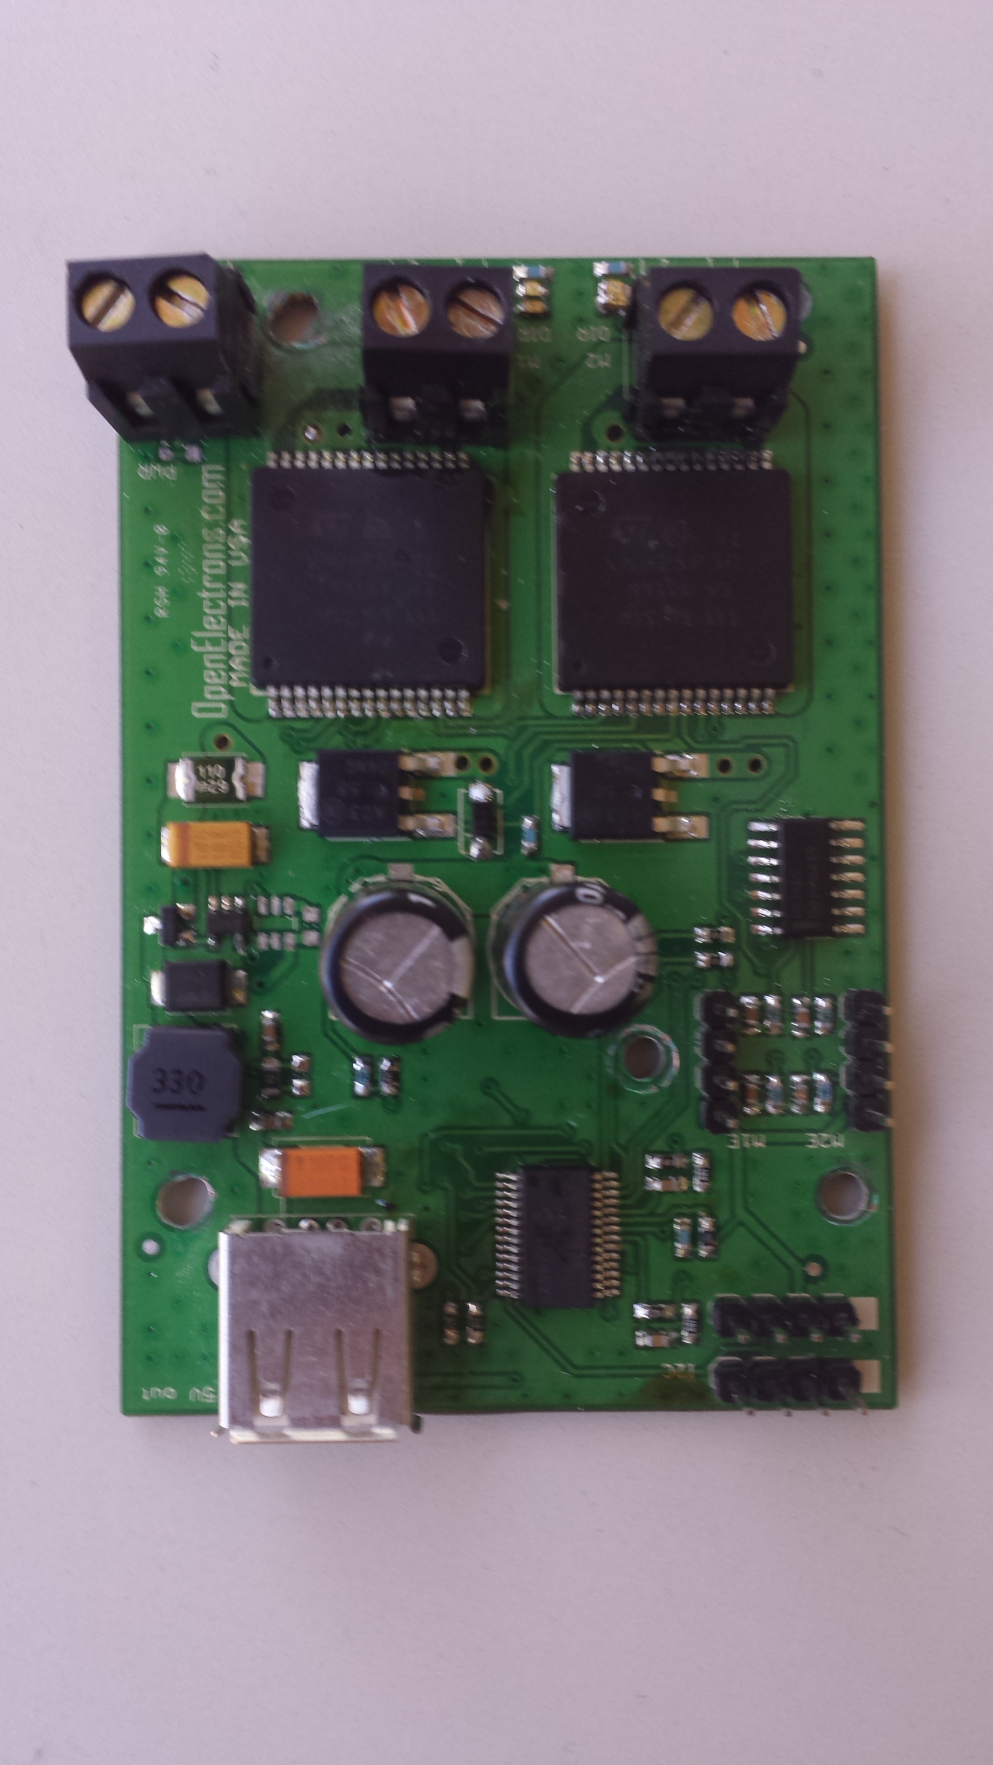
As stated above, the PiDrive allows you to control up to two high current motors with the use of a Raspberry Pi. The PiDrive can be connected to I2C Access Point board to either of the I2C header pins at the top right corner of the device. It is coded in the Python programming language and contains various different functions that allow you to run the motors in a variety of different ways. Two motors can be connected to PiDrive through two black connectors on the top left of the board labeled M1 and M2. It is also possible to program the PiDrive with the C programming language as well.
There are functions that allow you to run the motor in terms of degrees, seconds, and even for a certain number of rotations. It also supports rotary encoders as well. What's nice about the PiDrive is that it is capable of giving a 5V output which can be used to power the Raspberry Pi without using another power source.

References:
- Pi-Drive: http://www.openelectrons.com/pages/34
- Tempest TR1.3-12 Battery (12V): http://www.tempestbatteries.com/html/tr1.3-12.html
- Raspberry Pi
- DreamGrear Shadow USB wireless joystick: http://www.dreamgear.net/shadow-6-wireless-controller-for-ps3-1.html
- Two Pittman GM9234E765-R1 Motors: http://www.gearseds.com/files/PITTMAN_MOTOR_SPECS.pdf

