Arduino Piggyback on Raspberry Pi

Arduino is a perfect mindless slave. Give it a job and it performs the task endlessly without defaulting even for a nano second. On the other hand Raspberry Pi is a computer which has got a brain of it's own. It's task may falter as it may get busy doing some other jobs that moment. But imagine a situation where Arduino is doing the job and Raspberry Pi is supervising it – Superb !

All the limits of Raspberry Pi will be vanished in a moment and any sensor be it analog or digital , will be read , analyzed and processed by the Arduino-Raspi combi.

I must say it's a perfect world of robotism.

Frankly speaking we are actually reducing the powerful Arduino to a mere micro controller but it really helps. Lets see how.

GPIO-14 & 15 (physical pin no 8 & 10) are the UART Tx & Rx pin. The Rx , Tx pin of Arduino will just go into these GPIO 14 & 15 pins and the ground pin of Arduino will go to any one ground pins (physical pin no 6 / 9 /20) of Raspi.

Hey, don't do that now, your Raspberry Pi board will be damaged beyond repair. The voltage level of Arduino out pin is approximately 5 volt whereas that of Raspi is hardly 3 Volt. We need to reduce the Arduino IO volt to the matching voltage level of Raspi by the following circuit.
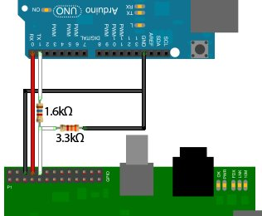

Fig-1

Only 3 wires to be connected with each other ,rest is the power supply which can be separate or common. The serial connection wires – Tx & Rx will be reversed with each other with a resistor network as shown in the pic on the Arduino Rx to Raspi Tx pins.

Fig-2
Arduino Pin | Raspi Pin
Tx | 10 (thru' resistor network as shown in pic)
Rx | 8 (direct)
Gnd | Any of 6 or 9 or 20 (direct)

Softwares: python , py-serial and any serial communication software like putty or minicom. I prefer minicon as it is very light and fast acting.

$sudo apt-get install python python-serial minicom
Now in order to use the Raspberry Pi’s serial port, we need to disable getty (the program that displays login screen). Locate the following line in file /etc/inittab

$sudo nano /etc/inittab
TO:23:respawn:/sbin/getty -L ttyAMA0 115200 vt100

and comment it out by adding a '#' in front of it.
#TO:23:respawn:/sbin/getty -L ttyAMA0 115200 vt100

Save it and exit. Now one more job is left , when Raspi boots it sends data to the serial ports. We need to stop it. Remove the following data from the /boot/cmdline.txt file.
$sudo nano /boot/cmdline.txt
console=ttyAMA0, 115200 kgdboc=ttyAMA0, 115220

Save and exit . Now everything to take into effect reboot your Raspi.

LM35 is a cheap analog temperature sensor available for RS:35 from the mail order shops in India. The LM35 temperature sensor produces an analog voltage directly proportional to
temperature with an output of 1 millivolt per 0.1°C (10 mV per degree).
The sketch converts the analogRead values into millivolts and divides this by 10 to get degrees.
The sensor accuracy is around 0.5°C with a range from -20 to 85 Deg Celsius.

The development board Arduino has got many varieties in the market. I bought Arduino Uno from the mail order firms for Rs:1250.

Connect the lm35 sensor with the Arduino as shown in the pic and then connect the USB cable with your computer and open the Arduino IDE and transfer the following sketch (Arduino program ) into the UNO board.
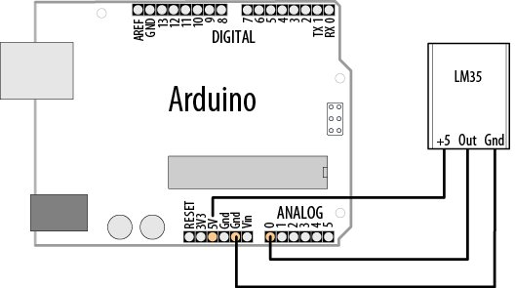
Fig-3

------ arduino-temp.pde ------------------
byte n = 0;
const int tpin=0;
void setup(){
Serial.begin (9600);
pinMode(tpin, INPUT);
}
void loop() {
int value=analogRead(tpin);
float mv=(value / 1024.0 )*5000;
float cel = mv / 10;
float far=(cel*9)/5 +32;
delay(1000);
if(Serial.available() ) {
n = Serial.read();
Serial.print ("character received:");
Serial.println(char(n));
Serial.println(n,DEC);
if(char(n)=='c') {
Serial.print(cel);
Serial.print(":Deg Celsius");
Serial.println("");
}
if (char(n)=='f') {
Serial.print(far);
Serial.print( ":Deg Farhenite");
Serial.println("");
}
else Serial.print("enter c or f for temperature");
delay(1000);
}
}

Run the sketch , open the serial window and write 'c' to get the Celsius and 'f' to get Fahrenheit temperature.

So far so good …...

Now our main intension of making Arduino piggy back on Raspberry Pi is on the way. Connect the wires between Arduino & Raspi as shown in Fig-2 & Fig-3. Put on the power supply of both the board.

Connect Raspi either thru' headless mode or in direct mode. I always prefer headless way and then run minicom.

$ ssh -Y pi@192.168.1.4
$ minicom -b 9600 -o -D /dev/ttyAMA0

As the serial console opens , enter 'c' to get Celsius temperature or 'f' to get Fahrenheit temperature. The minicom has a help window which opens by 'Contrl+a , z command. Open it and see for more detail.

Here's a python program to achieve the same output in a more cute way.
--- temp1.py ----
import serial
import time
ser = serial.Serial('/dev/ttyAMA0',9600,timeout=10)
ser.open()
#ser.write("c")
print 'Enter your commands below.\r\nInsert "exit" to leave the application.'
input=1
while 1 :
# get keyboard input
input = raw_input("Enter choice >> ")
# Python 3 users
# input = input(">> ")
if input == 'exit':
ser.close()
exit()
else:
ser.write(input)
out = ''
time.sleep(1)

while ser.inWaiting() > 0:
out += ser.read(1)
if out != '':
print "Enter choice >>" + out

Now having done that all the sensors that can be fitted with Arduino can be transferred to Raspberry Pi from the above method. Like analog sensors LM35 we did here. In the temp.py now and later in temp.php we can do all other process works with LM35 output.

On webiopi the serial monitor of Arduino can be viewed very nicely here.

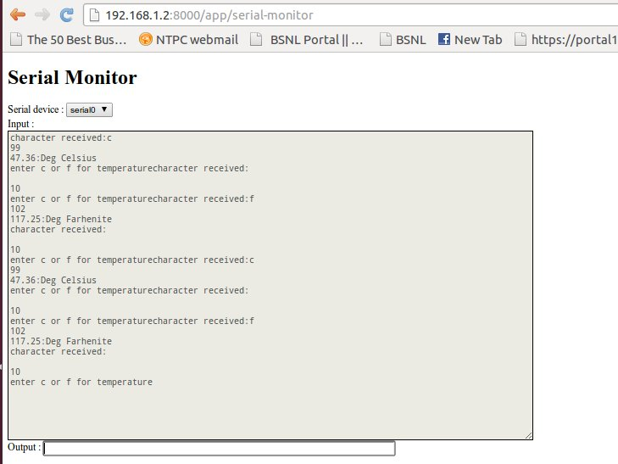
For this in the webiopi config file in [DEVICES] section just uncomment the following line.
$sudo nano /etc/webiopi/config

#serial0 = Serial device:ttyAMA0 baudrate:9600

Restart webiopi by
$sudo /etc/init.d/webiopi restart

Now go to the webiopi and then go to the serial monitor page and the above window will open. Supply the variable at the bottom output window and get the output in the top bigger window.

So nice !
That's all folks now !

S. Bera
Vindhyanagar

