Raspi controlling a dual H-Bridge

Here's more deep in robotics we are sliding into. We are going to control two traction motors of a typical robot. One traction will be to walk the robot forward and reverse direction while the other will be to make it's hand movements – front and back.

In total we will be controlling two core less DC motors in 7 possible combinations all from a stroke of buttons from an wifi connected laptop.

Walk motor-A : + direction
Walk motor-A : - direction
Walk motor-A : stop

Hands motor-B : + direction
Hands motor-B : - direction
Hands motor-B : stop

All motors (A & B) : stop

So in all we will be controlling these 7 possible conditions from Raspberry.

H bridge : Is an integral part of robotics for controlling the motor directions. Here's the internal schematic of an H bridge which is little over simplified for you.
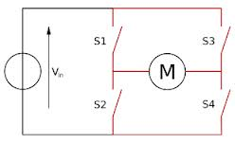

S1 | S2 | S3 | S4 | Motor Direction
1 | 0 | 0 | 1 | +
0 | 1 | 1 | 0 | -
S1 & S2 will never be 1 together
S3 & S4 will never be 1 together

A dual H bridge is two such sets together with additional facilities like enable / disable for speed control . Since our requirement is very small therefore, we have used a small powered dual H bridge pack – L293 . It is capable of supplying 600 MA current at 12 Volt . For a 2 amp current it is recommended to use L298 with suitable heat sink. It's nothing but a bigger and more powerful H bridge package.

Schematic Connections:
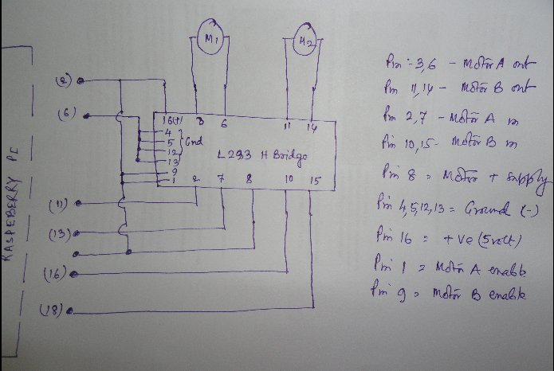
The pin no-8 of L293 is for motor power supply . Since we are using small 5 Volt core less motors, we directly couple this pin to the 5Volt onboard supply of Raspi. Pin-1 & 9 are used for enabling of Motor-A & B respectively. By supplying PWM pulse in these pins the speed also get controlled. But since we are not speed controlling here , we are directly coupling these two pins to +5Volt supply pin.

H-Bridge Connections:
For simplicity I've soldered it on a small piece of vero board and the relevant pins have been taken out for connecting with the the Raspi board. You can use a solder less breadboard for making those connections.

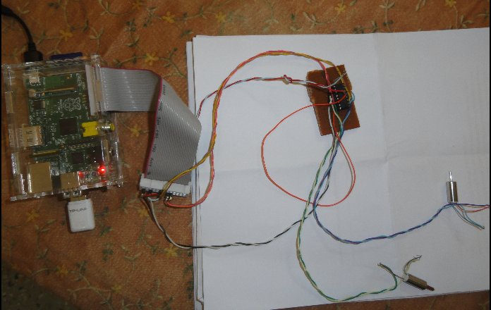
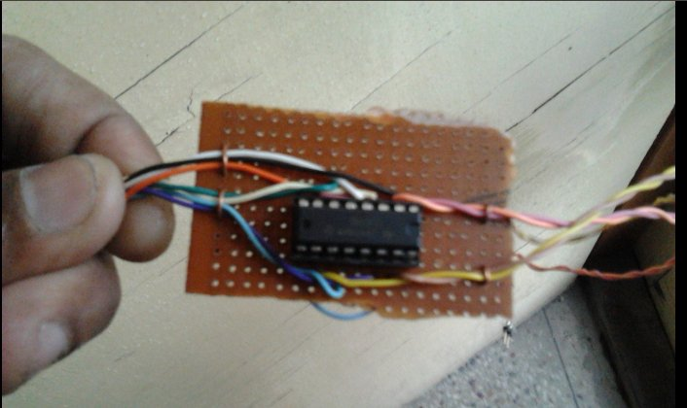
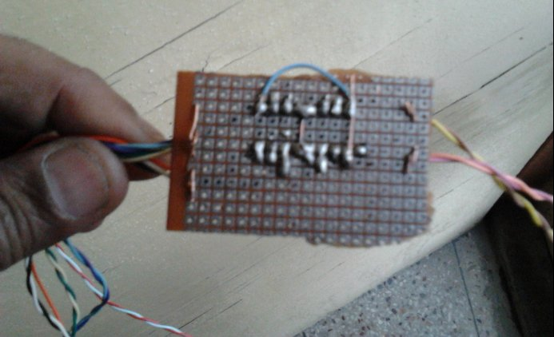

The Program: hbridge.php
#!/usr/bin/php
<?php
require_once('GPIO.php');
$gp17 = new GPIO(); // pin 11
$gp17->setup(17,"out");
$gp21 = new GPIO(); // pin 13
$gp21->setup(21,"out");
$gp23 = new GPIO(); // pin 16
$gp23->setup(23,"out");
$gp24 = new GPIO(); // pin 18
$gp24->setup(24,"out");

// reset all pins
$gp17->output(17,0);
$gp21->output(21,0);
$gp23->output(23,0);
$gp24->output(24,0);

$myc=0;
$mode=0;

while (true) {
begin:
printf( " Enter choice:");
$myc = fgets(STDIN);
printf( "You pressed:$myc\n");
if ($myc == 1) {
$mode = 1;
echo "Forward-1 motor on";
}
else if($myc ==11){
$mode=11;
echo "Forward-1 motor stop";
}

else if( $myc == 2) {
$mode =2;
echo "Reverse-1 motor on" ;
}

else if($myc == 21) {
$mode = 21;
echo "Reverse-1 motor stop";
}

else if ($myc == 3) {
$mode=3;
echo "Foroword-2 motor on";
}
else if ($myc == 31){
$mode =31;
echo " Forword-2 motor stop";
}

else if ($myc == 4){
$mode =4;
echo "Reverse-2 motor on";
}

else if($myc==41){
$mode=41;
echo "Reverse-2 motor stop";
}

else if($myc ==5){
$mode =5;
echo "All motors Stop";
}

else {
echo "Not a valid command";
goto begin;
}
// The subroutines
if($mode ==1){
$gp17->output(17,1);
$gp21->output(21,0);
}

if($mode==11){
$gp17->output(17,0);
$gp21->output(21,0);
}

if($mode==2){
$gp17->output(17,0);
$gp21->output(21,1);
}

if($mode==21){
$gp17->output(17,0);
$gp21->output(21,0);
}

if($mode==3){
$gp23->output(23,1);
$gp24->output(24,0);
}

if($mode==31){
$gp23->output(23,0);
$gp24->output(24,0);
}

if($mode==4){
$gp23->output(23,0);
$gp24->output(24,1);
}

if($mode==41){
$gp23->output(23,0);
$gp24->output(24,0);
}

if($mode==5){
$gp17->output(17,0);
$gp21->output(21,0);
$gp23->output(23,0);
$gp24->output(24,0);
}
}
?>

Note: 1,11, 2,21, 3,31, 4,41, 5 for each of these commands the motors will change it's behavior

Trial: Connect the Raspi board with a wireless hub, preferably your DSL wifi modem or hot spot of your sophisticated mobile phone. Connect your laptop with the wifi and now ssh into the Raspi from your laptop. Windows users can use putty (putty.exe) for ssh.

> ssh -l pi 192.168.1.4 (or the ip address of your Raspi)
supply the password when it asks.

Now cd to the directory where the hbridge.php is located and then
sudo php -f hbridge.php

[ now the real fun starts , control your robot with those commands, You can control as much as 8 motors with Raspi with the available GPIO pins, for more you have use a multiplexer circuit]

Good luck,

Bera
Vindhyanagar

