Raspi – Cam

Raspberry PI– Ever since this tiny credit card sized computer appeared in the market , it has caught the imagination of every electronic & computer hobbyist around the world. The powerful Linux operating system combined with it's 26 I/O pins can do many amazing things out of the box. One group at UK is trying to combine few thousands Raspi to think together thus creating the power of super computer while the fishpi.org group has already built the concept ship which will help the main ship to cross Atlantic ocean unmanned.

While the various enthusiast groups are working in pockets all over the world, the raspberrypi.org does maintain a forum where most of the questions are answered very lucidly. The several formats of Linux are available for installation on this tiny board. The most popular ones are -
archlinux
wheezy linux
qtonpi , fedora & xbmc

Out of this I prefer wheezy linux for it being the debian style where installation & tweaking is easier. The latest bundle “2012-09-18-wheezy-raspbian.zip” is available for download at the download page of raspberrypi.org. This bundle has several updation over it's immediate predecessor 2012-08-16-wheezy-raspbian.zip. The wireless adapter can be installed out of the box so is with the usb cameras.

The following article will describe step by step how to make a raspberry pi (model-B) an webcam server on wifi with bare minimum accessories.

Preparing the Raspi OS:
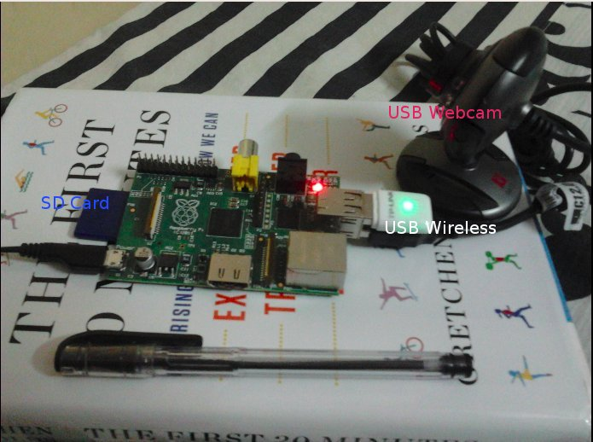
Unlike Windows, Linux is an operating system which can boot up & run when all it's I/O devices – monitor, keyboard , mouse etcs are removed thus making the camera operating on bare minimum from the board.

After downloading the zip file, extract the image in a suitable folder in a different computer and then insert a 2GB or bigger size SD card in the card reader slot or a card reader. At this stage before moving further determine beyond doubt what identity is given to the SD card by your computer – sda , sdb or sdc etc. Any mistake here will lead you to losing entire date of your computer hard disk.

Just after inserting the card issue an 'ls /dev/sd*' command at a terminal prompt and see what name it has been given to the card. Look for the highest order... sdc ,sdd etc.

bera@Acer-AOD255E:~$ ls /dev/sd*
/dev/sda /dev/sda2 /dev/sda4 /dev/sda6
/dev/sda1 /dev/sda3 /dev/sda5 /dev/sda7 /dev/sdb1 /dev/sdb2 /dev/sdc

[here my SD card has been identified as /dev/sdc]
To double ensure just unplug and re-plug the card few times and notice the changes.

Now go to the folder where you have extracted the “2012-09-18-wheezy-raspbian.img” file. This image file now need to be written on the SD card to make it the OS. At the terminal prompt, issue the following command . This will use dd - the powerful image creator program of Linux and transfer the image to the SD card.

bera@Acer-AOD255E:~/Desktop/Raspberry-PI/OS$sudo dd if=2012-09-18-wheezy-raspbian.img of=/dev/sdc bs=2M

[when it prompts for 'su' password. Supply it]

[In windows there are several graphical image creator programs like Nero burner which can be used in the similar fashion ]

The above command may take several minutes before finish. Look for the 'hdd lamp busy' indication. When the lamp is no more active then go to the desktop and 'safely remove' the SD card [ eg: right click on the SD card and then click on 'safely remove' the card]

Resurrecting the Raspi board:
The card is now ready for magic show on the Raspberry Pi computer. Insert it in the SD card slot of the board , connect a TV / Monitor thru' composite video cable [the AV cable] or the HDMI cable and switch on the power supply. The TV / monitor even on the right 'AV' channel may refuse to come up first time. Remove the power supply cord of Raspberry Pi board once (keeping the monitor power supply on) and then re-plug it. In most likelihood the monitor will come on live this time if not remove the SD card and prepare it again.

The login for the Raspi Wheezy linux is pi and the password is raspberry. Once entered ,the Raspi will open up the boring text screen. Enter the following command at the prompt to start the beautiful GUI.

startx

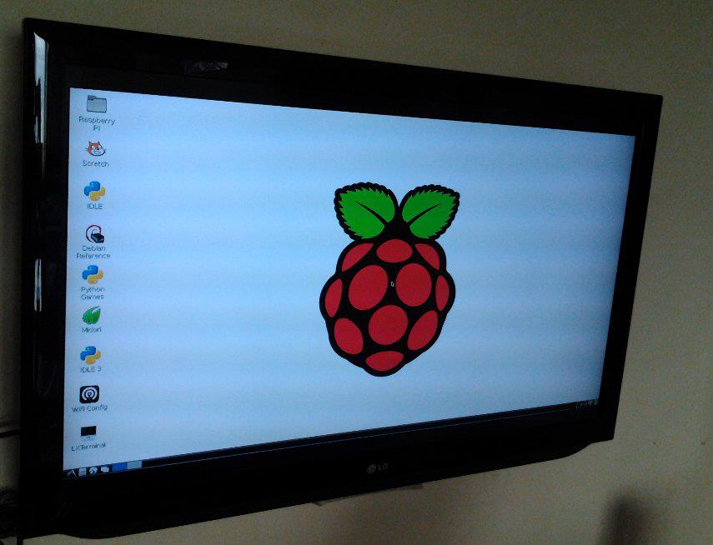
The real first image on my TV looks mesmerizing ! Now it's only dance forward with the Raspi board.

To make Raspi to open up the GUI screen every time it boots up all you have to do is change it in the raspi-config page. Do a 'sudo raspi-config' and then bring the cursor down on the 'automatic GUI boot up'. select – finish – reboot. You are done !

Connect the wireless adapter & the webcam to the usb slots. You may run short of USB ports now because the Raspi-B model has only two usb ports. So it's time now to do some walking to the nearest computer store and find out a powered USB hub. Grab one hub which has a small 5V power supply input to it (almost all have it now-a-days) . The store may not sell the power supply unit along with the hub but don't bother, any 5V cell phone charger (all Nokia chargers) will do for it.

So in the new set up now , power up the usb hub connect the wireless adapter, webcamera,keyboard , mouse and go to the desktop and double click the wirelesss module. Most of the present common wireless adapters are easily detected and installed on Raspi for other kind of models (which you might have got free from the retired neighbourly uncle.. ) you need to do some more hard work.

First the easy one: Go to the Raspi desktop and double click the 'wifi' icon. The LAN page will open up. Click the 'search' icon and all the list of the available wireless connections will be visible. [Rememebr wireless needs more power. Therefore, if the hub is not powered by a suitable 5V supply the Raspi may malfunction ]. Select your connection and then enter the IP values if required or leave it as it is for the DHCP mode and then select the authentication mode (mostly the WEP mode) from the pull-down menu and then enter the WEP key in the first blank space, finish and connect. The symbol will turn to 'connected' now.

[For connecting to mobile hot spot like cell phones the 'WPA2' psk type authentication is used. Select the same from the pull down menu]

pi@raspberrypi:/$ ping raspberrypi.org
If you get a handful and continuous ping response it means you're on line and connected. Else go back and try again.

Here is the hard one for seasoned people:
Enter the following command at the Raspi terminal.

pi@raspberrypi:/$ dmesg | grep ^usb

This command will furnish details of the kernel ring buffer of all the devices installed starting with the word usb. Look out for the word like '802.11' and the manufacturer name like 'realtek' , 'ralink' associated with it. It means the hardware is built on that chip and the poor Raspi needs the driver for it. Go back to your net connected computer and issue the following command.

bera@Acer-AOD255E:~/Desktop/Raspberry-PI/OS$sudo apt-cache search realtek

The command will give you details of the packages available for that manufacturer. Go to the manufacturer site and download the debian wireless package (eg: firmware-realtek.deb , firmware-ralink.deb etc) from their website. Copy this package in the /home/pi folder of the SD card and issue the following command at the Raspi.

pi@raspberrypi:/$ sudo apt-get install firmware-realtek.deb

This will install the right firmware on Raspi. Once the firmware is installed, disconnect the wireless adapter and reconnect it to the Raspi. This will restart the kernel search process for the right software driver. Next time once the Raspi is started and the wireless adapter is connected it will automatically load the right driver.

With the firmware installed, setting up the connection is pretty straight forward now. Go back to the Desktop and double click the 'wifi' icon and then follow the steps we followed in the previous examples.

Setting the webcam server:

ffmpg has got some issues on Raspi as a result of which the ffserver does not work easily. Some staunch Raspi supporter claim to tweak it to work but I find it very complicated and does not worth when more easy choices are available.

Apache2 server with webcam software makes our job very easy and elegant but before that to ensure the cam is working we have to install VLC software. VLC besides showing up webcam images can play all kinds of media files including *.flv files which in the earlier OS was not possible.

pi@raspberrypi:/$ sudo apt-get install vlc apache2 webcam

This will install all the 'wav' trio – webcam , apache2 & vlc media player. Go to the desktop , in the media section & click on VLC media player. Go to file – capture device and see if the camera images appearing or not. The VLC is smart enough to find your first camera at the /dev/video0 and the video driver as video4linux2 (if not ..then enter them from the pull-down menu) . The screen will take some time for the images to appear. The image may appear broken at many places but don't bother for it now.

Webcam software has no default configuration file to run with so we have to make one now. Nano is the most beautiful yet versatile text editor for debian Linux. It reminds me the erstwhile wordstar software which was the most talked about text software 25 years back.

Close the window and open a terminal to write the following commands.

pi@raspberrypi:/$ sudo nano /etc/webcam.conf

[ftp]
host = localhost
dir = /var/www
file = webcam.jpg
tmp = imageup.jpg
local = 1

[grub]
device = /dev/video0
width = 176
height = 144
delay = 5
quality = 75
trigger = 180

Save the file with contrl+O command . Exit nano by contl+x command. Like old wordstar all the relevant control commands are written below the nano window. So unlike 'vi' editor you don't have to remember all these nasty commands.

The webcam is a versatile software. It has the ability to continuously ftp the captured image to a different server where the main webpage may be host. But here in our case we have made the local = 1 ; means we will host it on the Raspi's apache server page (var/www directory) itself.
; delay = 0 means the cam will take pictures non stop . Though this means too much load on the tiny Raspi board ; a delay of 5 means taking one snap every 5 seconds seems more justified for the poor Raspi.

Close it and go back to the terminal window. Time now to check whether the apache web server is working or not. In the Raspi computer open a Midori browser page and enter the address as

http://localhost

The Apache will open up a page , telling the server is up and running only there is no content page available in the server. So far so good. Now we have to see whether the same page is available over wireless or not.

But before that we have to know the IP address of our Raspi board (mine is a DHCP by my wireless router ) .

Issue the following command at the terminal window.

pi@raspberrypi:/$ifconfig

This will give the detail of IP addresses of the wired as well as the wireless network of the Raspi board. Look out for the wlan configuration. I find the wlan IP address of my Raspi board as assigned by my router is 192.168.1.2 Therefore, I go back to my laptop and enter the the following address in the browser page.
http://192.168.1.2/

The same page opens up in my laptop. This confirms that the Apache is up and running on the Raspi board.

Starting the webcam for automatic capturing of images:
Open up a terminal window and enter the following command
pi@raspberrypi:/$sudo webcam /etc/webcam.conf &

The last '&' command means the process will execute background. Now go back to the remote laptop and issue the following address at the browser url.

[to stop webcam use command fg webcam]

http://192.168.1.2/webcam.jpg

The still image facing the camera will now appear on the top left corner of my laptop. This conforms the webcam is working. You may try to open the same page in the Midori browser on Raspi but it may take several minutes to open as most of it's resources are busy in handling the webcam images now.

But don't worry the page will open on the laptop quite comfortably. Change the direction of the camera and refresh the browser of your laptop and the image will change. Unless the browser window is refreshed the picture will not change – this is no fun ! So now we will create an automated page refresh in the Raspi itself.

Automated page refresh from the Raspi:
We will now use nano to create a simple html page in the /var/www directory of Raspi. /var/www is the apache document root directory. Whatever we write here will be available to view from outside.

pi@raspberrypi:/$ sudo nano /var/www/webcam.html

<html>
<head>
<META HTTP-EQUIV=”pragma” CONTENT=”no-cache”>
<META HTTP-EQUIV=”refresh” CONTENT=”0”>
</head>
<body>
<center>
<h2> My Raspi Webcam </h2>
<img src=”webcam.jpg” width=”320” height=”240”>
</center>
</body>
</html>

save it with cont+o and exit with cont+x. Now go to the laptop computer and open the following page. http://192.168.1.2/webcam.html

The image will be auto refreshing every second now. But this may be little irritating to the eyes so we may need to enter a delay factor here. In the webcam.html CONTENT=”0” can be made to CONTENT=”5” for a more soothing effect once in 5 seconds.

Now you can strip the Raspi board from the mouse , keyboard and the monitor and the webcam will still be working non stop such is the power of Raspi & Linux.

Complete automation:
Now how about an automated script ? Such that every time after boot up and even before login the Raspi will fire up the webcam command ! Wondering ? but that's very easy in Linux.

We will put the command in /etc/rc.local file and then every time on boot up the webcam will start. The necessity of monitor , keyboard and mouse can be completely get rid of from the Raspi board.

Open a shell script file - webcam.sh in /home/pi and then enter the following command.

pi@raspberrypi:/$ sudo nano /home/pi/webcam.sh
#! /bin/bash
webcam /etc/webcam.conf &

Save it and exit.
pi@raspberrypi:/$ sudo chmod +x /home/pi/webcam.sh // make it executable

Now in the /etc/rc.local file we will enter this line before 'exit 0' line like this.
pi@raspberrypi:/$ sudo nano /etc/rc.local
…..
…..
/home/pi/webcam.sh
exit 0

save it and exit.

Now strip off the keyboard , mouse and monitor from the Raspi and reboot it and then go to the laptop computer and open the page http://192.168.1.2/webcam.html. Look out for the time stamp at the bottom of the picture. It should change every 5 seconds. If so , congratulate yourself. You have just made the Raspi an automated bare minimum webcam server.

To keep the cost of Raspi board down to $35 ,manufacturer has not included an RTC (Real time Clock ) on the board. So every time on boot up the time goes back to an earlier date. However, you can change the date by the following command .
pi@raspberrypi:/$ sudo date –set='2012-10-06 23:30'

But when your Raspi board is running with no keyboard , mouse and monitor how to achieve that feat ? Simple thru' secure shell ! The ssh.. Before stripping the IO devices run the raspi-config command and then select the ssh option and set it on. Finish it and reboot.
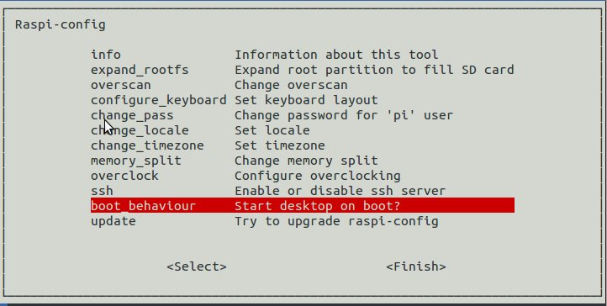
Now every time you reboot the Raspi you can log on to it on wifi from your laptop by the following command.

raspi-config page : for easy settings

pi@raspberrypi:/$ ssh -l pi 192.168.1.2
when asked for password supply 'raspberry' and you are onto it. Change the date & time by the above command and then check the webcam (which is already running now) time stamp on the http://192.168.1.2/webcam.html page.

It must be the current time now.

S. Bera
Mumbai

