Raspberry Pi – controlling 8 servo motors

Servos are controlled by varying width Pulse Width Modulated (PWM) signals. PWM with changing width from 1 ms to 1.5 micro seconds to 2 micro seconds will turn the servo from 0 degree to 90 degree and to 180 degree. By wiringpi we can have PWM only on one pin (i.e GPIO 18) and with a suitable program for varying width of PWM we can manager only one servo connected to that pin but with servvoblaster we can go overdrive and can control 8 servos – all at a time. Servoblaster is a kernel level hardware tweaking program for Raspberry Pi computer.

Servos & Pin numbers – at a glance
Servo Number | GPIO Number | Physical Pin Number
0 | 4 | 7
1 | 17 | 11
2 | 18 | 12
3 | 21 | 13
4 | 22 | 15
5 | 23 | 16
6 | 24 | 18
7 | 25 | 22

ServoBlaster is a kernel level driver for driving servos connected to Raspberry Pi. Installing it on your pure immaculate Raspi is a bit tricky. All the explanations are not available with me but once followed full , it works flawlessly.

OK here it goes:
assuming you have Devian Wheezy linux distribution on your Raspi because that's the most easy one.

$ sudo apt-get update // First do an updation
$ sudo apt-get upgrade // And do an upgradation
Reboot your Raspi for a fresh look.

$ sudo apt-get install gcc //C compiler for compilation with the kernel by servoblaster
$ sudo apt-get install git // Install git repository
$ git clone git://github.com/richardghirst/PiBits.git // Get the softwares from git
$ cd Pibits/ServoBlaster
$ sudo insmod servoblaster.ko //This put the servoblaster module on

$ sudo sed -n 's/ servoblaster//p' /proc/devices // This actually returns a process number , use that number here..
$ sudo mknod -m 0666 /dev/servoblaster c [put that number here] 0

example
$ sudo mknod -m 0666 /dev/servoblaster c 248 0

Once the last line is entered the servoblaster module is on now and the driver is loaded at the kernel level. Next time you reboot your Raspi you have to only

$ sudo home/pi/PiBits/ServoBlaster/servod
To start the already loaded driver.

For controlling the servos we will send direct commands to the driver from a shell prompt. Meanwhile the servod program tells about the PWM details.

$ sudo /home/pi/PiBits/ServoBlaster/servod
Using hardware: PWM
Number of servos: 8
Servo cycle time: 20000us
Pulse width units: 10us
Maximum width value: 249 (2490us)

Here's the shell commands for running different servos – all from a su terminal.

# echo 0=120 > /dev/servoblaster //start a servo at pin-7 with 1.2 ms delay
# echo 1=140 >/dev/servoblaster //start a servo at pin-11 with 1.4 ms delay
# echo 2=130 >/dev/servoblaster //start a servo at pin-12 with 1.3 ms delay
# echo 3=249 >/dev/servoblaster // start a servo at pin-13 with 2.49 ms delay
# echo 4=200 >/dev/servoblaster // starts a servo at pin no 15 with 2 ms delay.
[You can run upto 8 servos ]

When delay is 2.00 ms, it means it takes the servo to the 180 degree position approximately. Between 1ms and 249 ms different servos move differently. My servo moves almost 240 Degree rotation. You have to do some trial and error to find out the exact response of your servo.

Normally Servo has three wires Red – Black – Amber (or brown or white ). Red is for positive 5 volt or the voltage specified by your servo, Black is for Ground and the third wire is for signal. Please use separate power supply for the servos as servos draw good amount of power and if it is taken from the Raspi the surge of power flow into the Servos will make the Raspi to reboot.

Connect the servos like this...
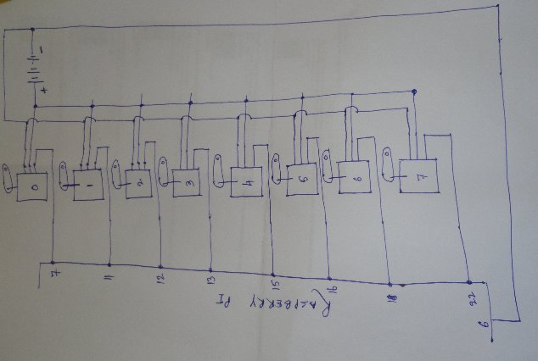
Look the 6th pin which is ground pin of Raspi is connected with the negative supply of the servo power supply. Whereas all other pins are connected with the signal wire of the servos.

Here's my prototype:
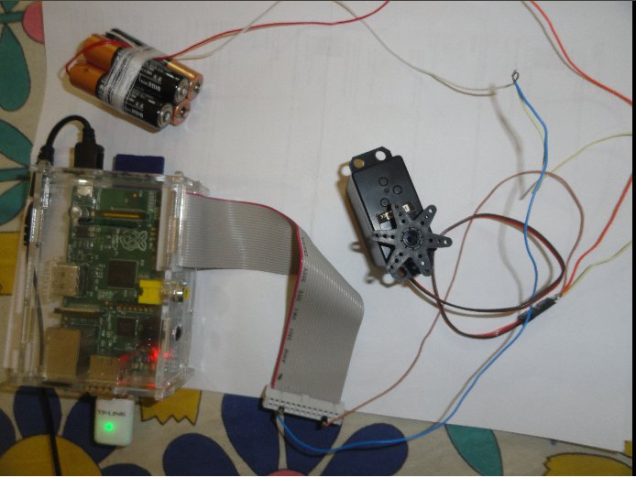
Here's the program to do a twist dance of the servo. Use nano to open a shell program.
#nano servo.sh and put the following lines into it. Save it by ctrl+o , exit by ctrl+x.

./servod // You can run it separately or here
for ((;; )) // this is an infinite loop
do
echo 7=0 >/dev/servoblaster
echo 7=17 >/dev/servoblaster
sleep 2
echo 7=200 >/dev/servoblaster
sleep 2
done

#chmod +x servo.sh // just make it executable
#./servo.sh
The servo will make a twist dance 0 to 180 degree non stop. The 0 command is for stopping the servo at the beginning else it vibrates continuously. Since the torque available at the shaft of servo is very good now by tying a few hard wires on the end disc, it can be made into a spider like animal which will be moving on long legs (180 degree left & right - look out in net and you will get many ideas). Press control+c to terminate the program.

The brush less motors too have 3 wires and they run on same principal. The varying width PWM signal (0 to 180 degree) to be applied on it's electronic speed controller's signal wire. At one position the motor takes start and then by increasing the angle it's speed increases to maximum and then it becomes zero again. You have to do a little trial and error here. My quadracopter motor takes start at 140 (7=140) position and then becomes maximum upto 200 (7=200) position. See it here..
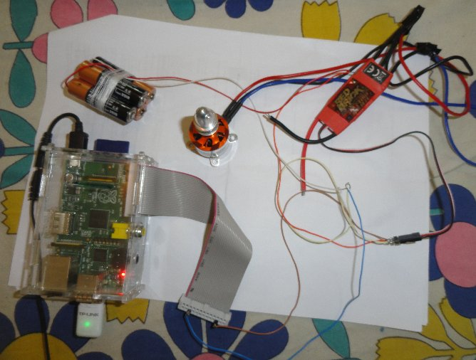
To achieve the maximum velocity of 35000 RPM the quadracopter motor requires 11.1 volt but here on a 4 alkaline cells the Raspi could comfortably drive the servo and control the motor while keeping the nano editor open on Raspi.

One distinct problem is observed with servoblaster – with servoblaster on (./servod running) the music playing gets severely distorted on Raspi.

Now, it's over to you to do further R&D on Raspi.

S. Bera
Vindhyanagar

