Creating Node.js Application

Step 1 - Import Required Module

We use the **require** directive to load the http module and store the returned HTTP instance into an http variable as follows −

var http = require("http");

Step 2 - Create Server

We use the created http instance and call **http.createServer()** method to create a server instance and then we bind it at port 8081 using the **listen** method associated with the server instance. Pass it a function with parameters request and response. Write the sample implementation to always return "Hello World".

http.createServer(function (request, response) {

// Send the HTTP header

// HTTP Status: 200 : OK

// Content Type: text/plain

response.writeHead(200, {'Content-Type': 'text/plain'});

// Send the response body as "Hello World"

response.end('Hello World\n');

}).listen(8081);

// Console will print the message

console.log('Server running at http://127.0.0.1:8081/');

The above code is enough to create an HTTP server which listens, i.e., waits for a request over 8081 port on the local machine.

Step 3 - Testing Request & Response

Let's put step 1 and 2 together in a file called **main.js** and start our HTTP server

var http = require("http");

http.createServer(function (request, response) {

// Send the HTTP header

// HTTP Status: 200 : OK

// Content Type: text/plain

response.writeHead(200, {'Content-Type': 'text/plain'});

// Send the response body as "Hello World"

response.end('Hello World\n');

}).listen(8081);

// Console will print the message

console.log('Server running at http://127.0.0.1:8081/');

Now execute the main.js to start the server as follows −

$ node main.js

Verify the Output. Server has started.

Server running at http://127.0.0.1:8081/

Make a Request to the Node.js Server

Open http://127.0.0.1:8081/ in any browser and observe the following result.

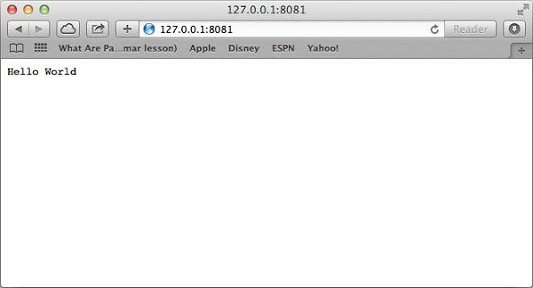

Congratulations, you have your first HTTP server up and running which is responding to all the HTTP requests at port 8081.