AWS WordPress Deployment using CloudFormation

1)Login to AWS
URL: https://console.aws.amazon.com
2)Choose the Correct Region
Region: N. Virginia (us-east-1)
3) Create Key Pair : Go to EC2 → Key Pairs → Create Key Pair ->Name: my-keypair-> it will Download the .pem file auto keep it safe place
4)Open CloudFormation
  - Search: CloudFormation
Create Stack: Build from Infrastructure Composer -.Create in Infrastructure composer ->Select .yaml -> Paste Code -> Validate ->Create Template -> Confirm and continue ->Next - > Enter Stack Name : aws-wordpress-cloudformation-project -> KeyPair -> Next -> Submit
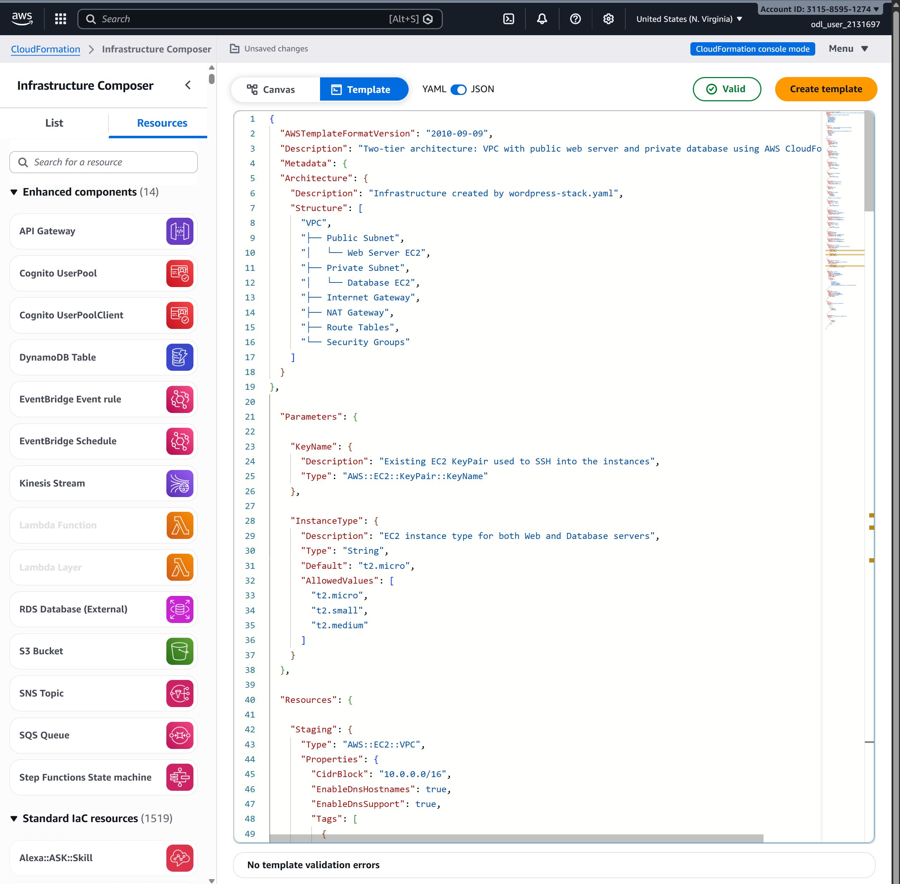
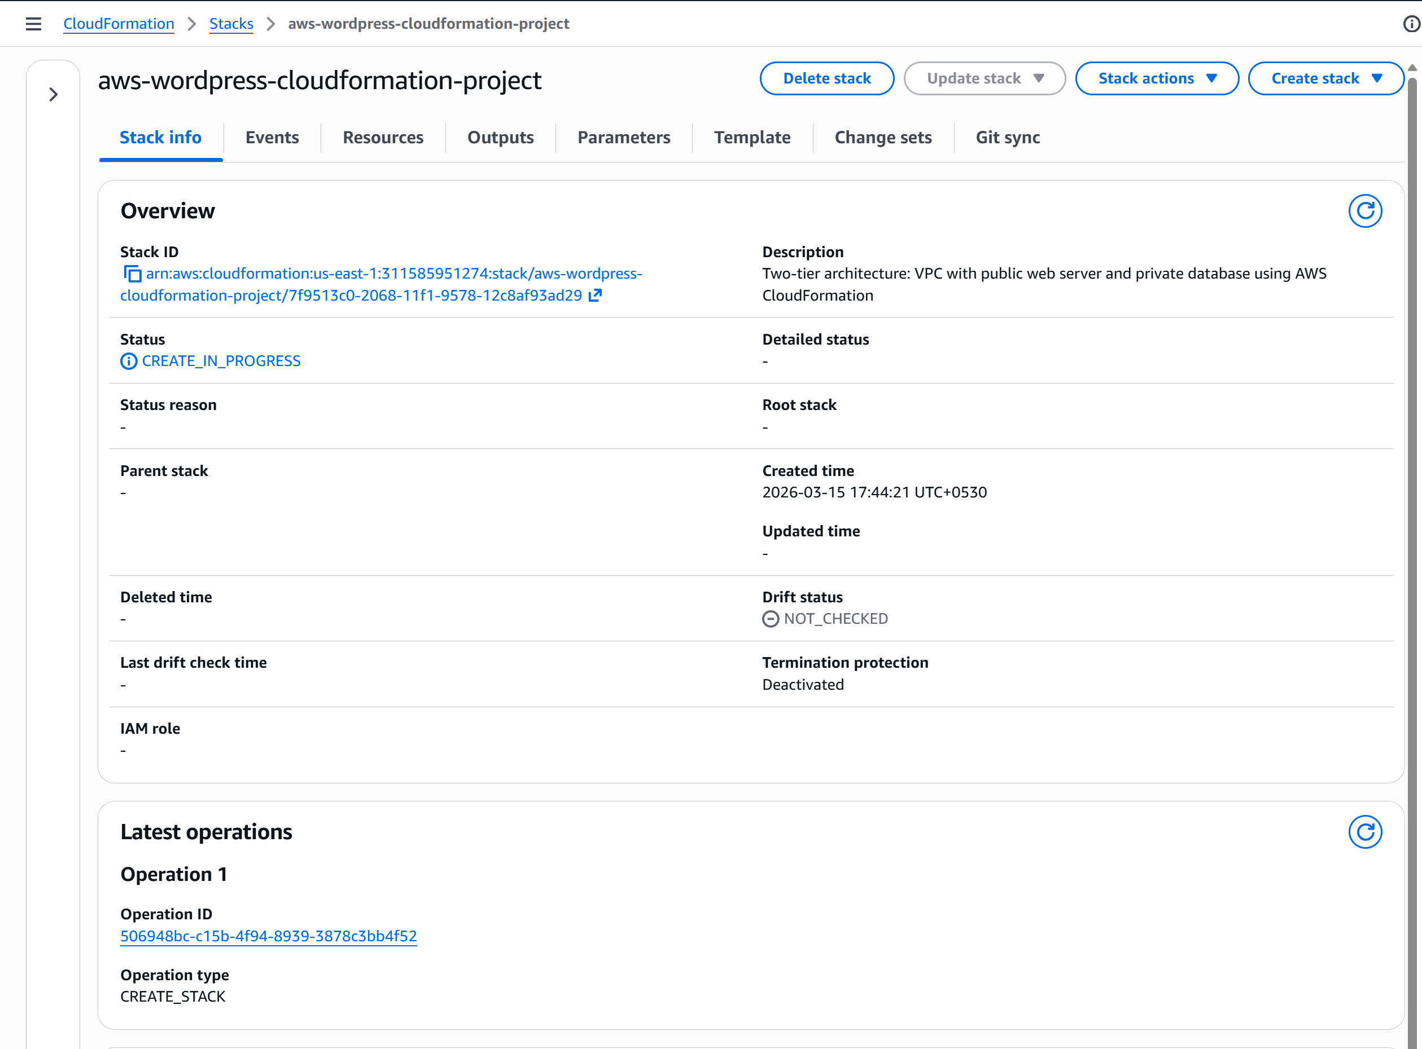
5) CloudFormation Deployment -> You will see status: CREATE_COMPLETE , after 3-4 mins CREATE_COMPLETE
Now CloudFormation will automatically create:
- VPC
- Subnets
- Internet Gateway
- NAT Gateway
- Route Tables
- Security Groups
- EC2 Web Server
- EC2 Database Server
6) Get Your Website URL
After deployment:
- Open your stack
- Click Outputs tab ->Eg : http://ec2-100-54-140-177.compute-1.amazonaws.com ->You will see : CloudFormation Web Server -> Congratulation !!!!!!!
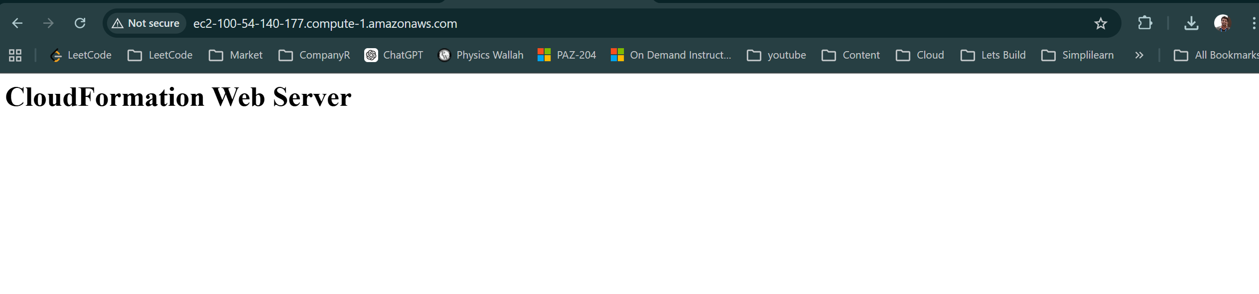
7) Verify Infrastructure
- EC2 -> Instances : 2 instances
  - webserver
  - database
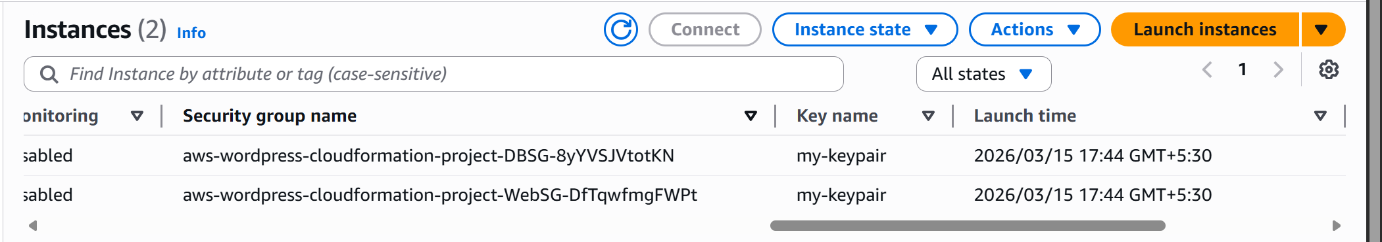

- Also check:
  - VPC
  - Subnets
  - Security Groups
  - NAT Gateway
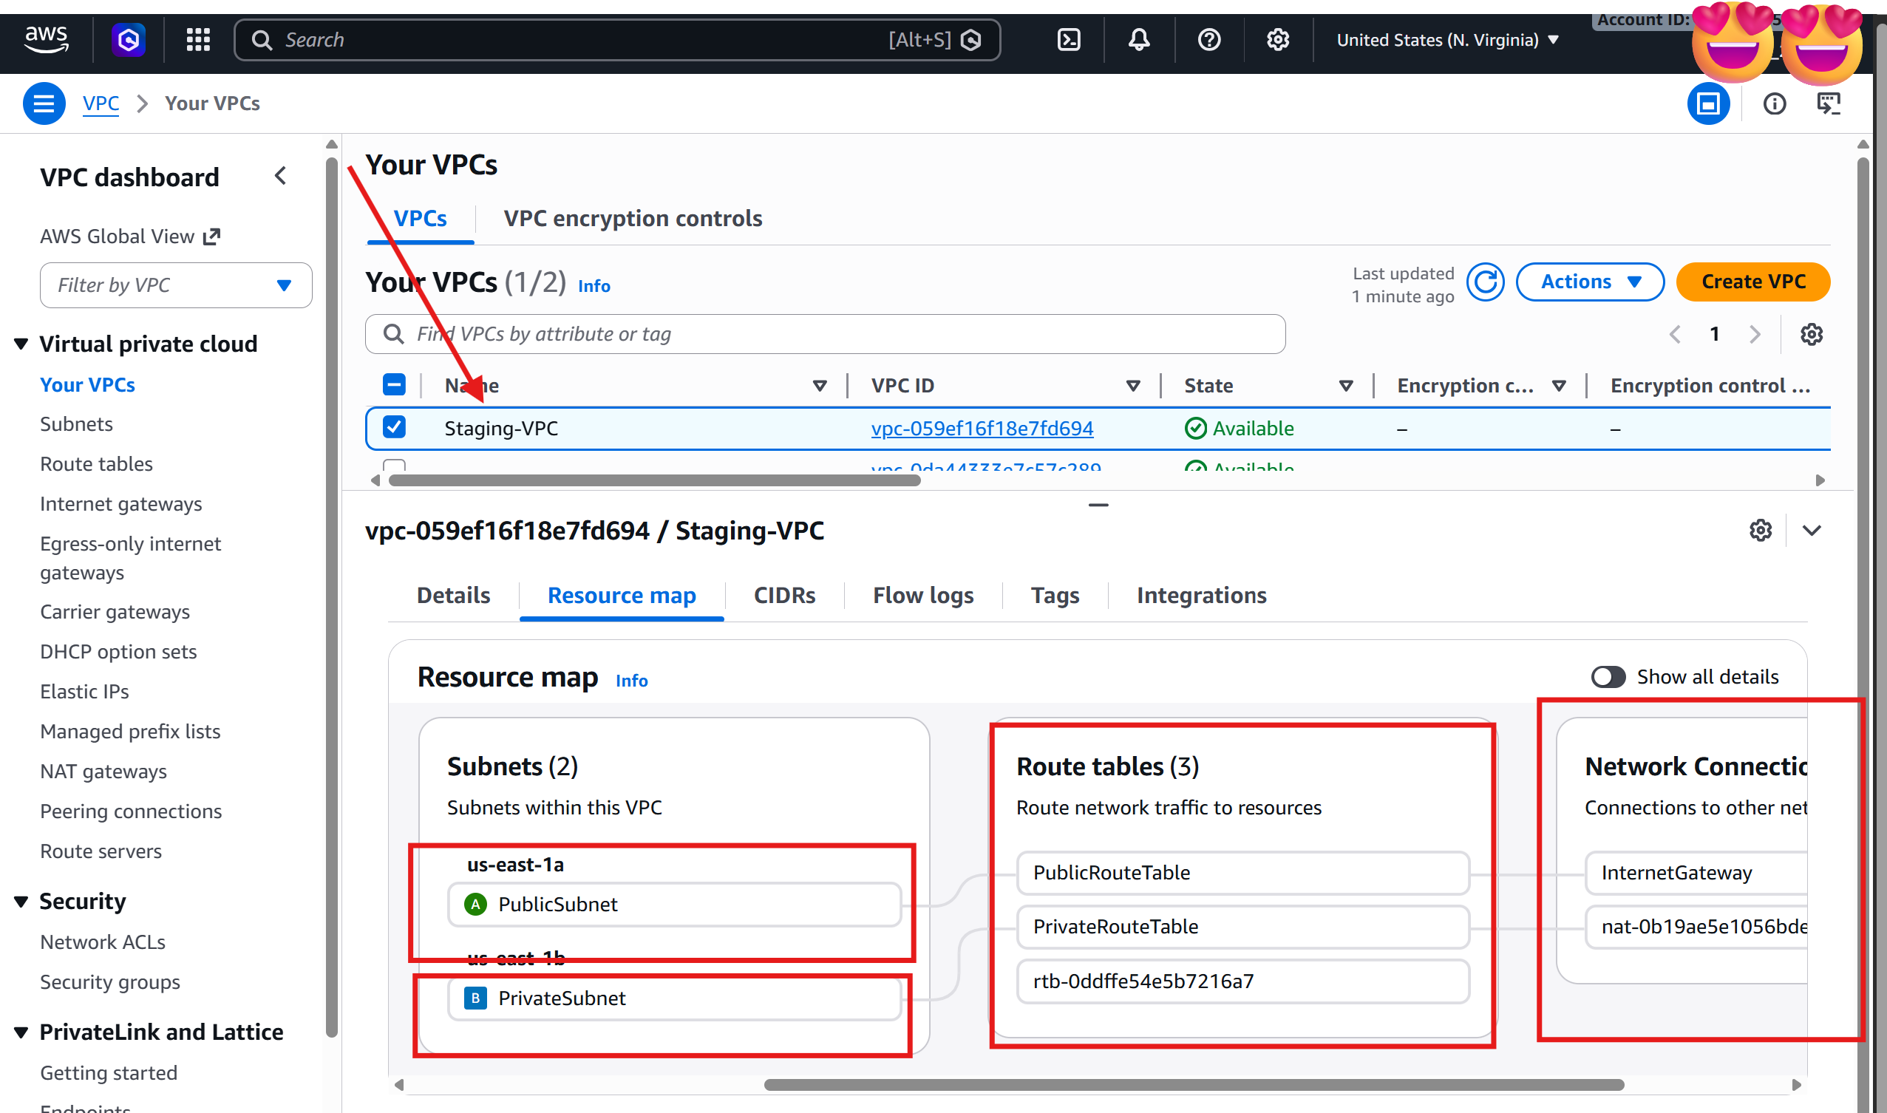
Everything was created automatically by CloudFormation.

Reference :
Subnet 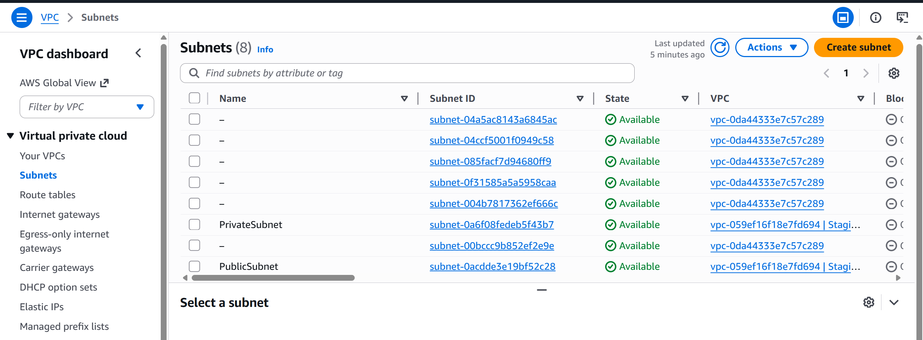
Route Table 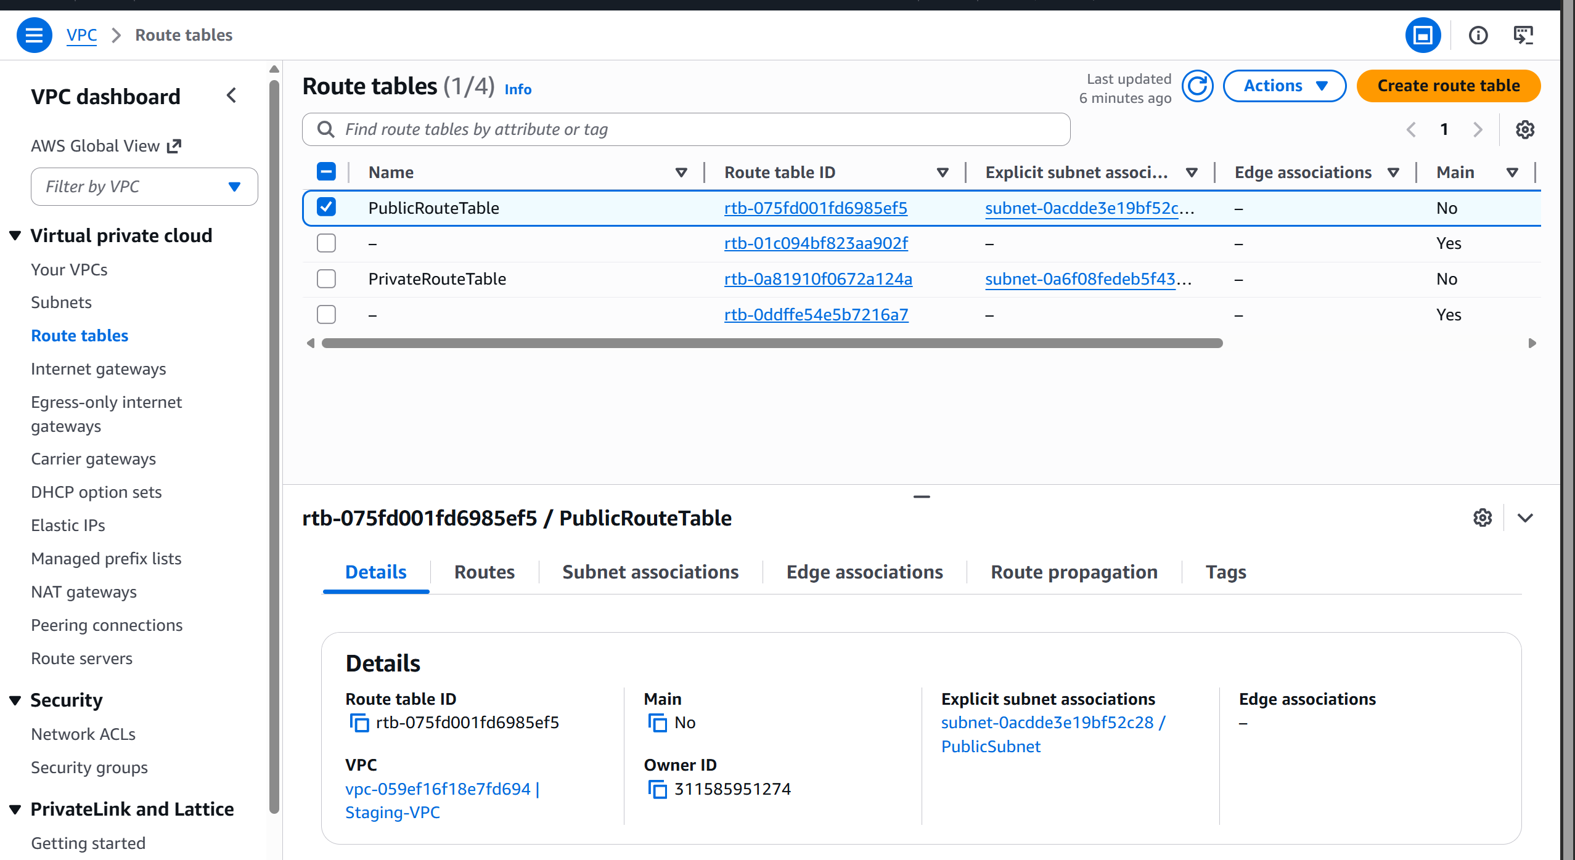
Internet Gateways
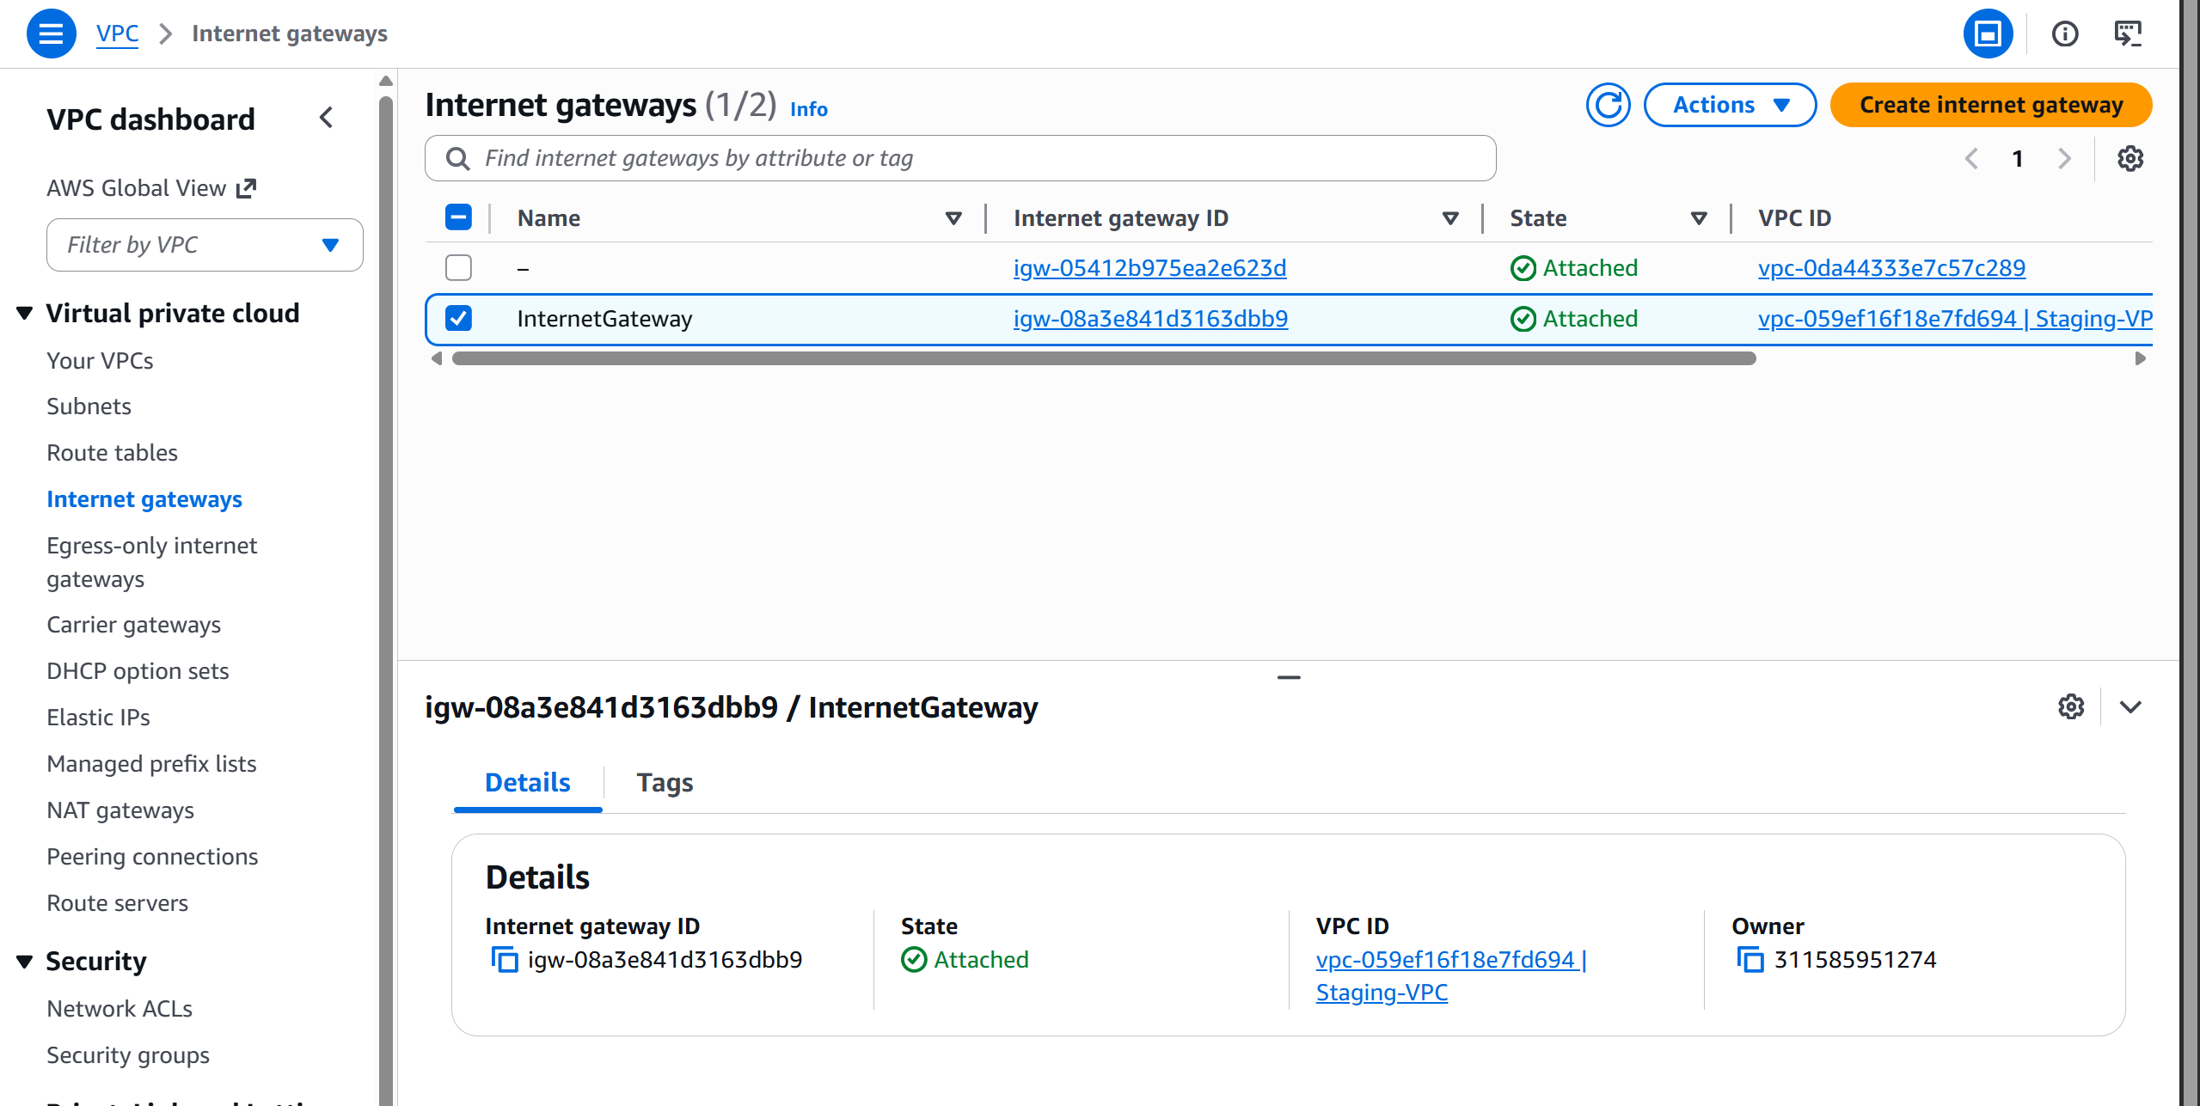

Elastic IP:
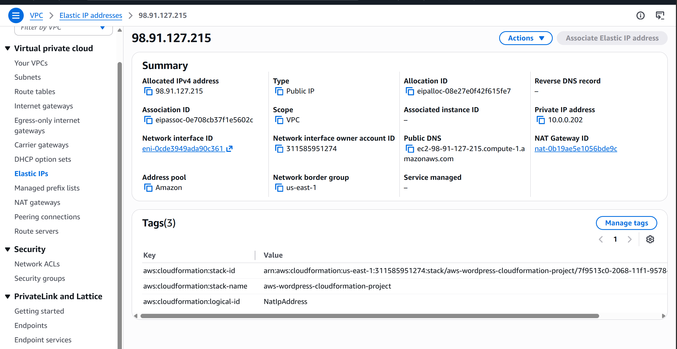
NAT Gateway:
